
Sanjot DALVI
Adrien JOLY
http://joly.adrien.free.fr/proximate/

Proximate
proximity peer-to-peer framework

User Manual
version 1.0

Table of contents
I. User manual 2
1) Installation 2
a. Procedure 2
b. Required files for Proximate 2
2) Running Proximate 2
3) Creating a New profile 3
4) Editing Profiles 4
5) Framework Screen 4
a. Users tab 5
b. Creating a Space 5
c. Entering a Space 7
6) Chat application 8
a. Sending a Text message 8
b. Sending a Picture message 9
c. Sending a File 10

User manual

Installation

Procedure
Transfer on your PocketPC and run the cabinet (CAB) file corresponding to the processor of your device. It will be installed under the “Program Files” directory. Please note that Proximate will not run from any other Flash memory.

Required files for Proximate
- Proximate.exe
- App.Chat.dll
- Network.Broadcast.dll
- Framework.dll
- Proximate.xml (this is an optional file which contains the Profiles. If not present the file will be created when the Proximate is run).

Running Proximate
Once you have the Proximate files copied to the device, run the Proximate.exe file to start the Application. It will show you the Main screen.
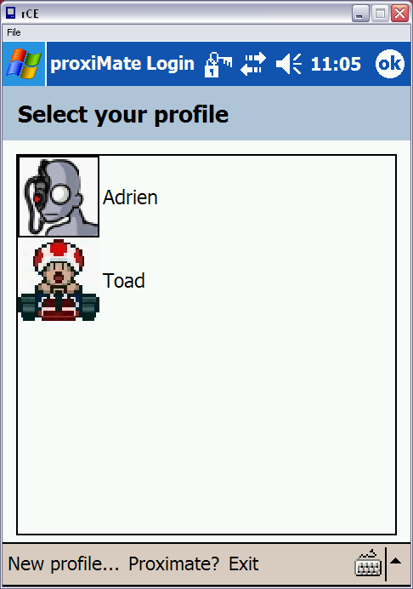
Main Screen

The main screen shows the existing Profiles along with other Menu options. To exit Proximate just tap on Exit at any time and the Application will exit.
Clicking on “Proximate?” option displays a form showing the “About” details of Proximate.
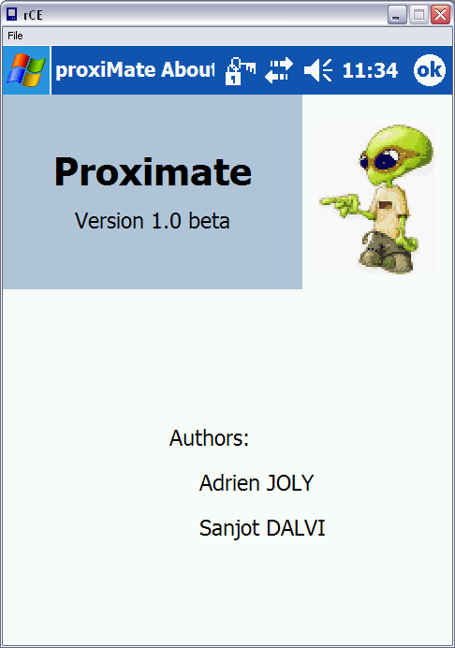
About screen

Creating a New profile
If you want to create a new profile click on the “New profile…” menu option. This will take you to the Profile creation screen.
The new profiles window is shown below.
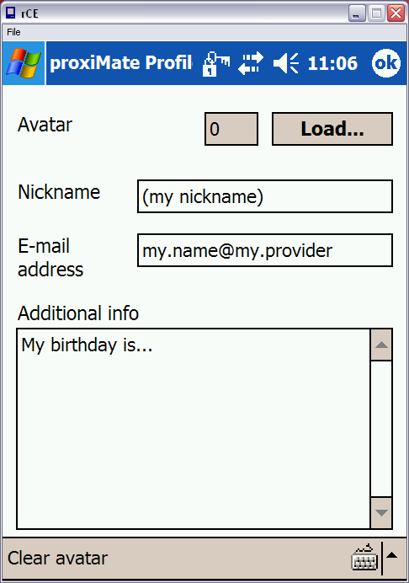
Profile creation Screen

In the Profile creation Screen you can enter a Nickname , email address, other additional information that you want to display as your profile to other users. You can load a picture (.bmp,.jpg,.png,.gif) as an Avatar for your Profile using the Load… option. The Clear Avatar option clears any loaded pictures for your avatar.
Click on Ok once you have finished editing your profile. The profile will be saved.
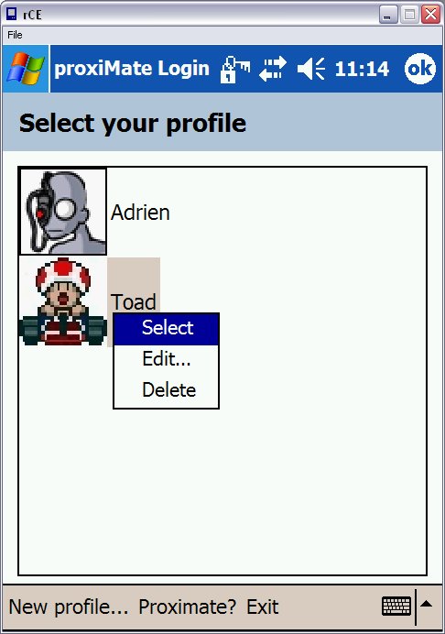
Main screen optional menu.

Editing Profiles
To edit a profile Tap and hold on the profile you want to edit to display an optional menu. Select Edit… from the menu and it will show the edit profile Screen where you can edit profile details. Selecting Delete will delete the profile.

Framework Screen
To enter the Framework Double Tap on a profile or Tap and Hold on a profile and choose Select from the optional menu.
The Framework screen is shown below:
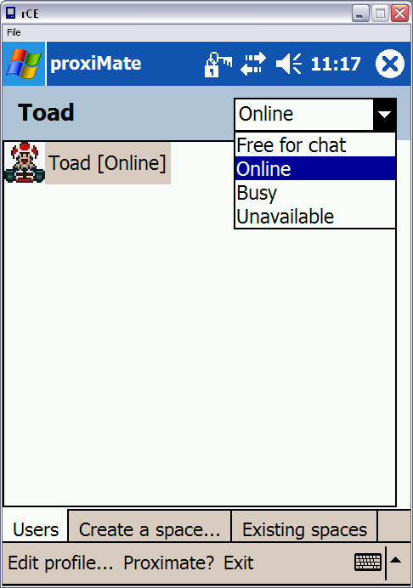
Framework Screen

You can change your Status to Online, Busy etc. by selecting a status from the List on the Top right corner of the window.
The Framework is divided into 3 tabs.
- The first tab, Users displays a list of online users.
- The 2nd tab, Create a space… displays a list of spaces.
- The 3rd tab, Existing spaces shows a list of spaces that have been created and which can be joined.

Users tab
The Users tab shows a list of online users with their Status. You can view a User’s profile by Tap and Hold on the user and selecting Profile… from the optional menu.
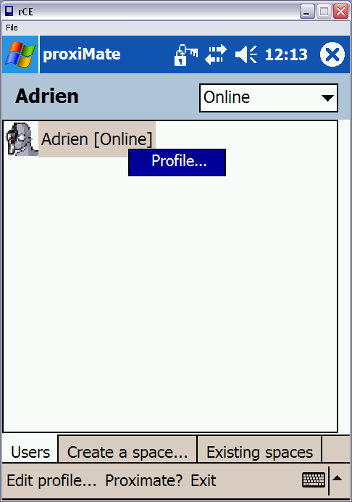
Framework screen (viewing a user’s profile)

Creating a Space
The Create a Space… tab is shown below.

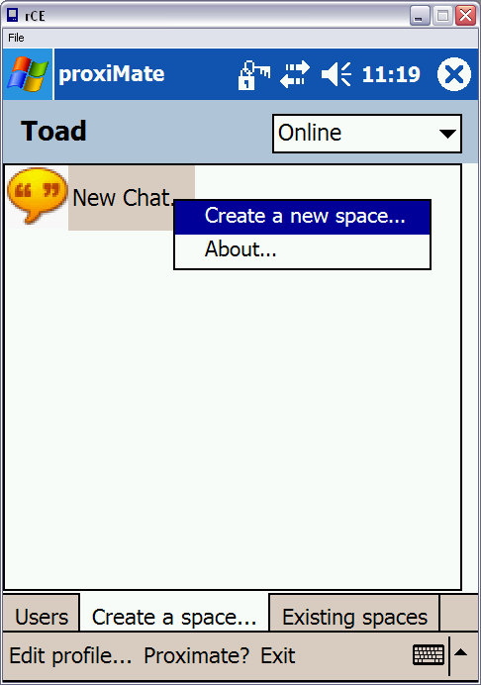
Space creation screen

This tab shows a list of applications that can be Run. Currently Proximate only implements a “Chat program” which is shown in the spaces list as “New Chat..”
Tap and hold on the “New Chat..” to see an optional menu. Clicking on About.. will show an About dialog box displaying information about the Application (in this case chat application.

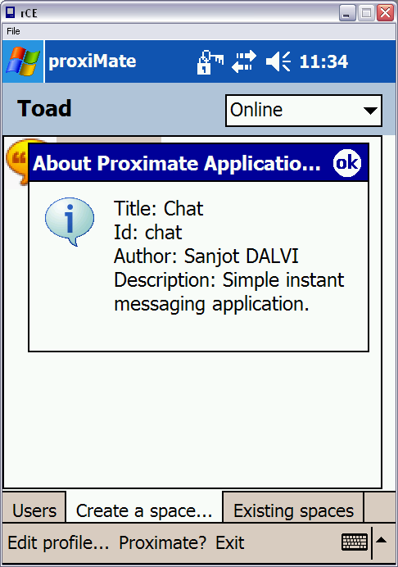
Chat App About screen

To create a Space, Double tap on the Space name or Select “Create a new space…” from the optional menu. This will take you to the Space creation screen as shown below.

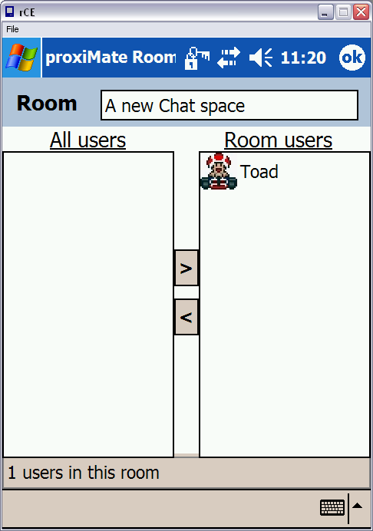
Space creation screen

The space creation screen for the Chat application shows a Room name on the top which you can edit. In addition there are two list of Users. The All Users list shows a list of all online users. The Room users list is the list of users that space will be shared with. You can add/remove users from All users to Room users and vice versa by selecting a user and clicking on the move buttons provide in the middle of the screen.
To create a space just click Ok.

Entering a Space
Once a space has been created (by the user or by some other user who has invited the user in the space), under the Existing Spaces you will see a list spaces that you can join.
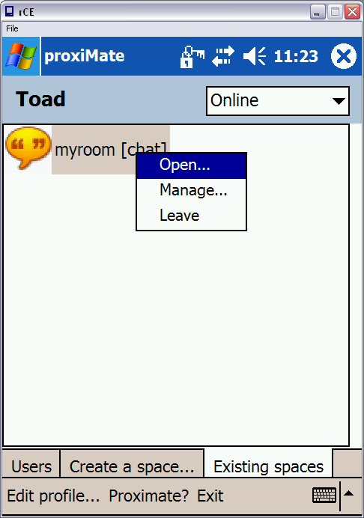
Existing Spaces

To interact with the Space just Tap and Hold on the Space to see the optional menu. Clicking on Leave will remove the space. Manage… takes you back to the Space editing screen. To enter a space select Open…(optionally you can Double tap on the Space).

Chat application
This section shows you how to use the Chat application. The chat application is a Peer to peer chatting program which can be used to chat with users (Text/picture chat) as well as send files to users.

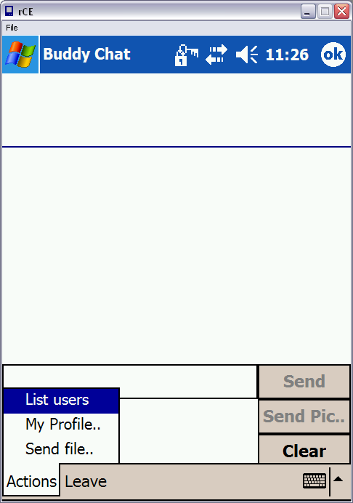
Chat Window

The chat window consists of the chat message display area, Text input area, Write pad area, Send/Send Pic.. and Clear Write pad buttons. Additional menu options are available through the Actions menu.
Clicking on the Leave menu option terminates the chat application.

Sending a Text message
To send a text message, just click in the Text input area and use the Soft input pane (SIP) to type in the message. Once you enter something the Send button gets activated. Click on the Send button to send the message to all users of the space.
Notice that when you click the Soft input panel, the main chat message display area and, Text input area and the Send button are shifted up so that you can see what exactly you are typing. Deactivating the SIP will restore the components to their original state.
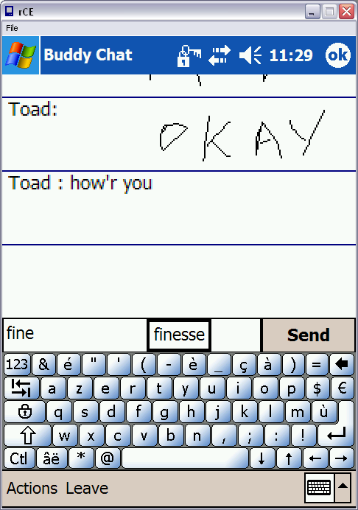
Text messaging.

Sending a Picture message
Why type when you can scribble?
To send a picture message just scribble on the WritePad area (just below the text input box). As you start scribbling the Send Pic.. button gets activated. Once you are done scribbling, just click the Send Pic.. button and the Picture message is delivered to all users of the space.

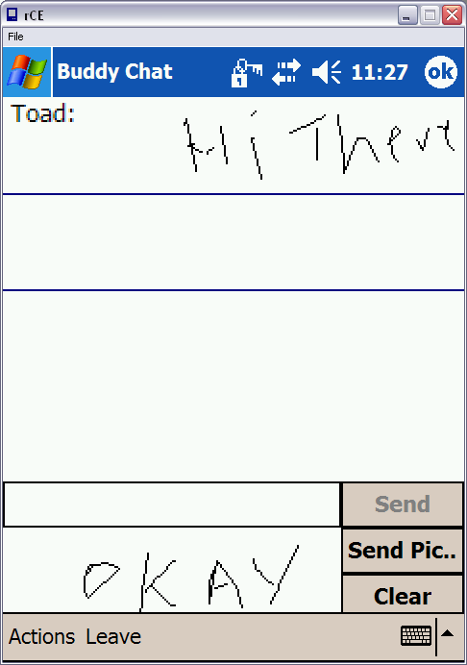
Picture Messaging

Sending a File
To send a file to all users of the space go to Actions -> Send file… .A file selection dialog box is displayed. You can send select a file to be sent or Cancel the dialog. Selecting a file will send the file to all users of the space
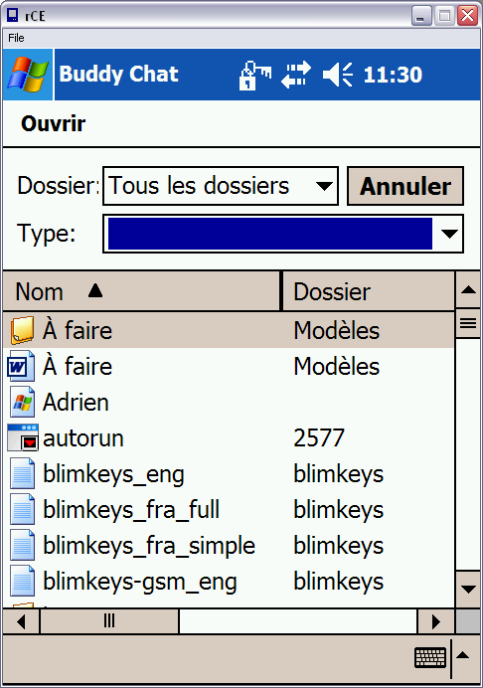
File Select Dialog box

A dialog box confirming the File transfer is shown to you (as below).
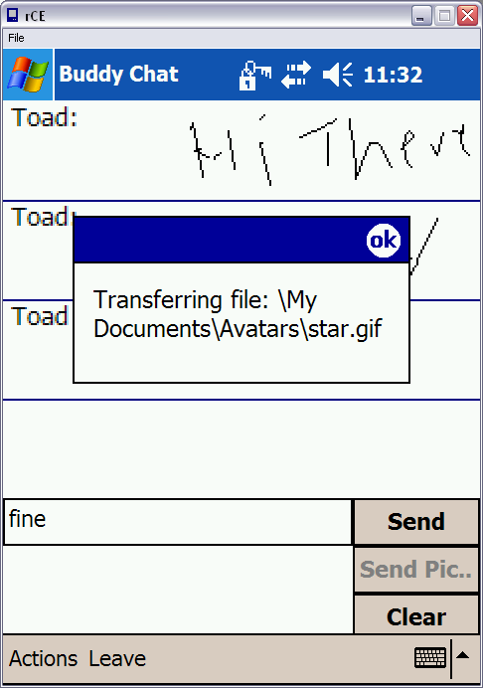

On the receivers’ end a Save dialog box is displayed which allows the user to Save the file on his/her device. The user can opt to not Save the file by choosing cancel.

You can also access your Profile information from the Actions menu (same as that of the profile screen in Framework).

