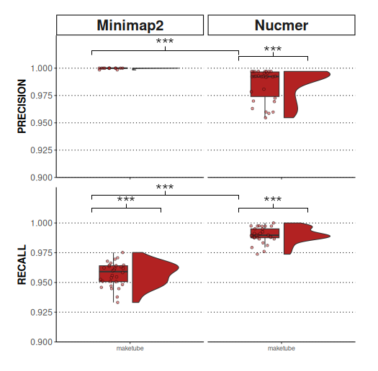
Sup. Figure 1 : Precision and recall of genome aligners assessed using Maketube genomes without the large duplication region. The level of statistical significance between variant calling strategies, taking into account Bonferroni corrections, is indicated by asterisks. *** p<3,33×10⁻⁵.

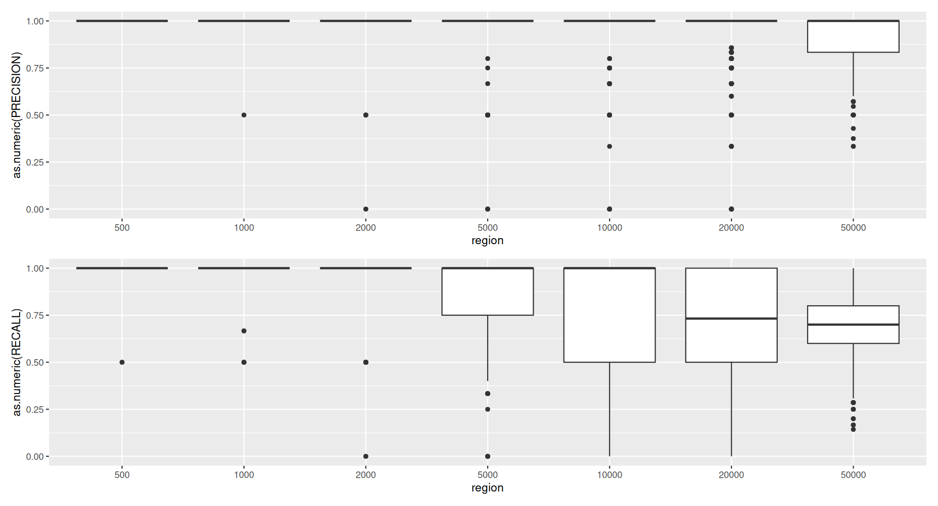
Sup. Figure 2 : Distribution of observed theoretical precision with different region size For each region size, the number of TP, FP, and FN was taken from a binomial distribution using PTP (probability of having a TP), PFP (probability of having a FP), PFN (probability of having a FP), PV (probability of having a variant) and PIV (probability of having an invariant) from the total number of TP, FP and FP found using genotube on maketube genomes. This illustrates the dispertion of precision and recall on small regions vs larger regions.

Supplementary figure 3 : Nucmer vs minimap2 performance in antibiotic resistance gene, PE/PPE vs TOTAL
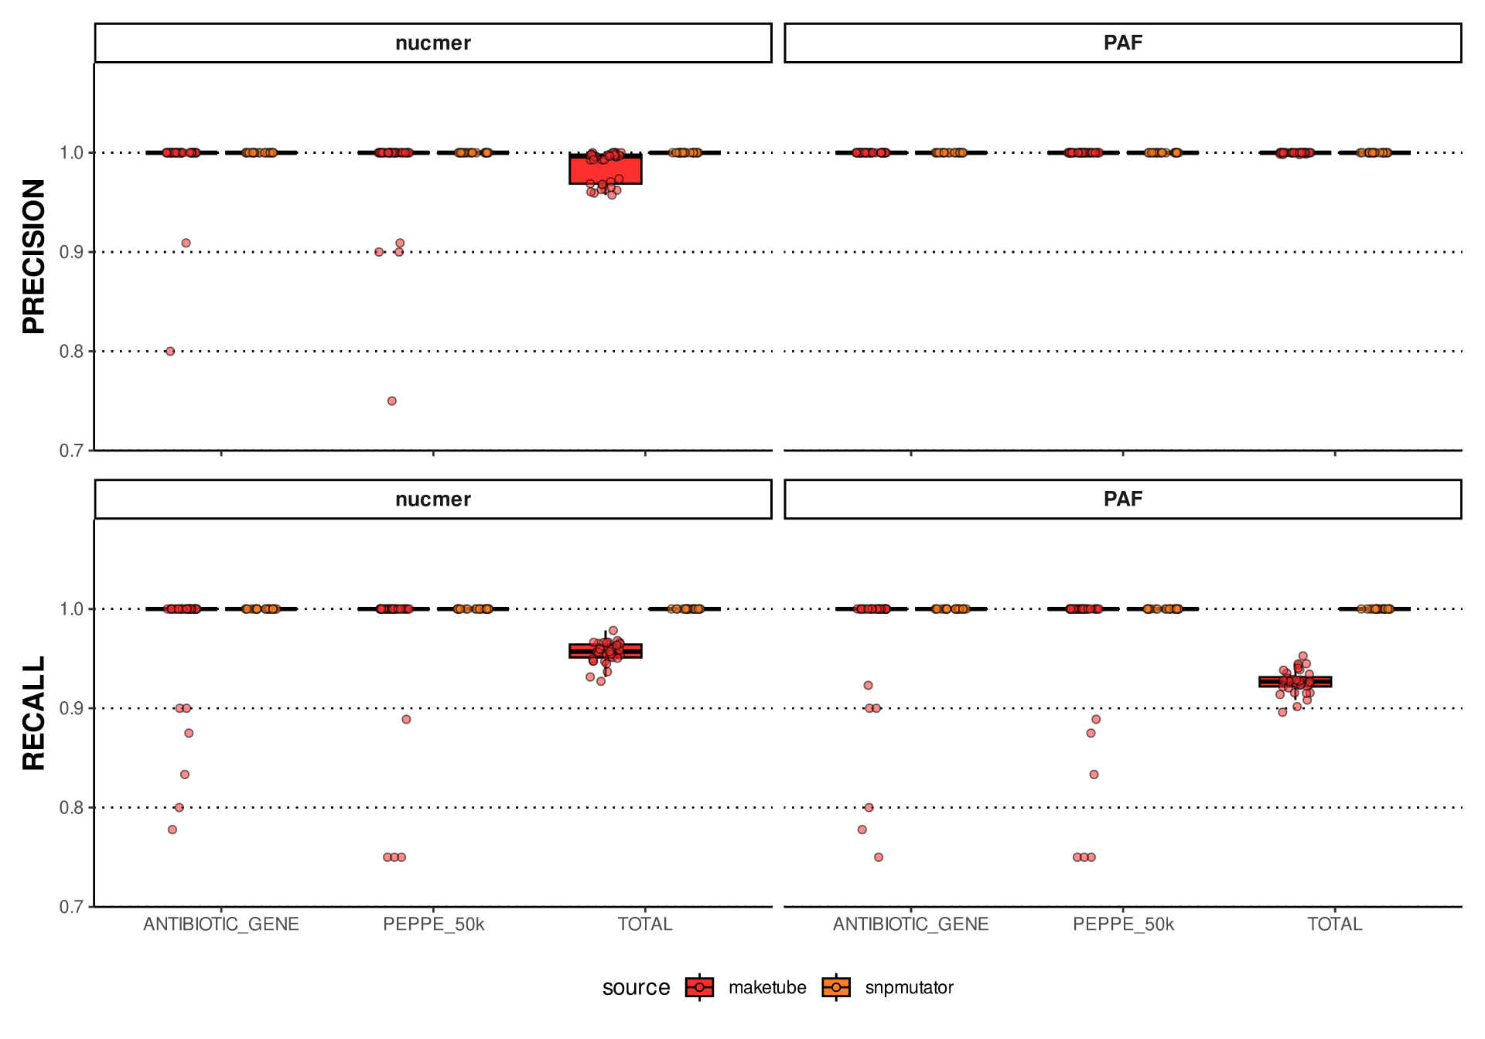
Sup. Figure 3 : Precision and recall of numer and minimap2 using maketube genomes (red) and snpmutator genome (in orange) in different subsets of the genome. Each region (antibiotic genes as a negative controle, PEPPE and TOTAL) was subsampled to 50k to circumvent the effect of region size. PE/PPE do not seem to behave differently than the controle (non-significantly).

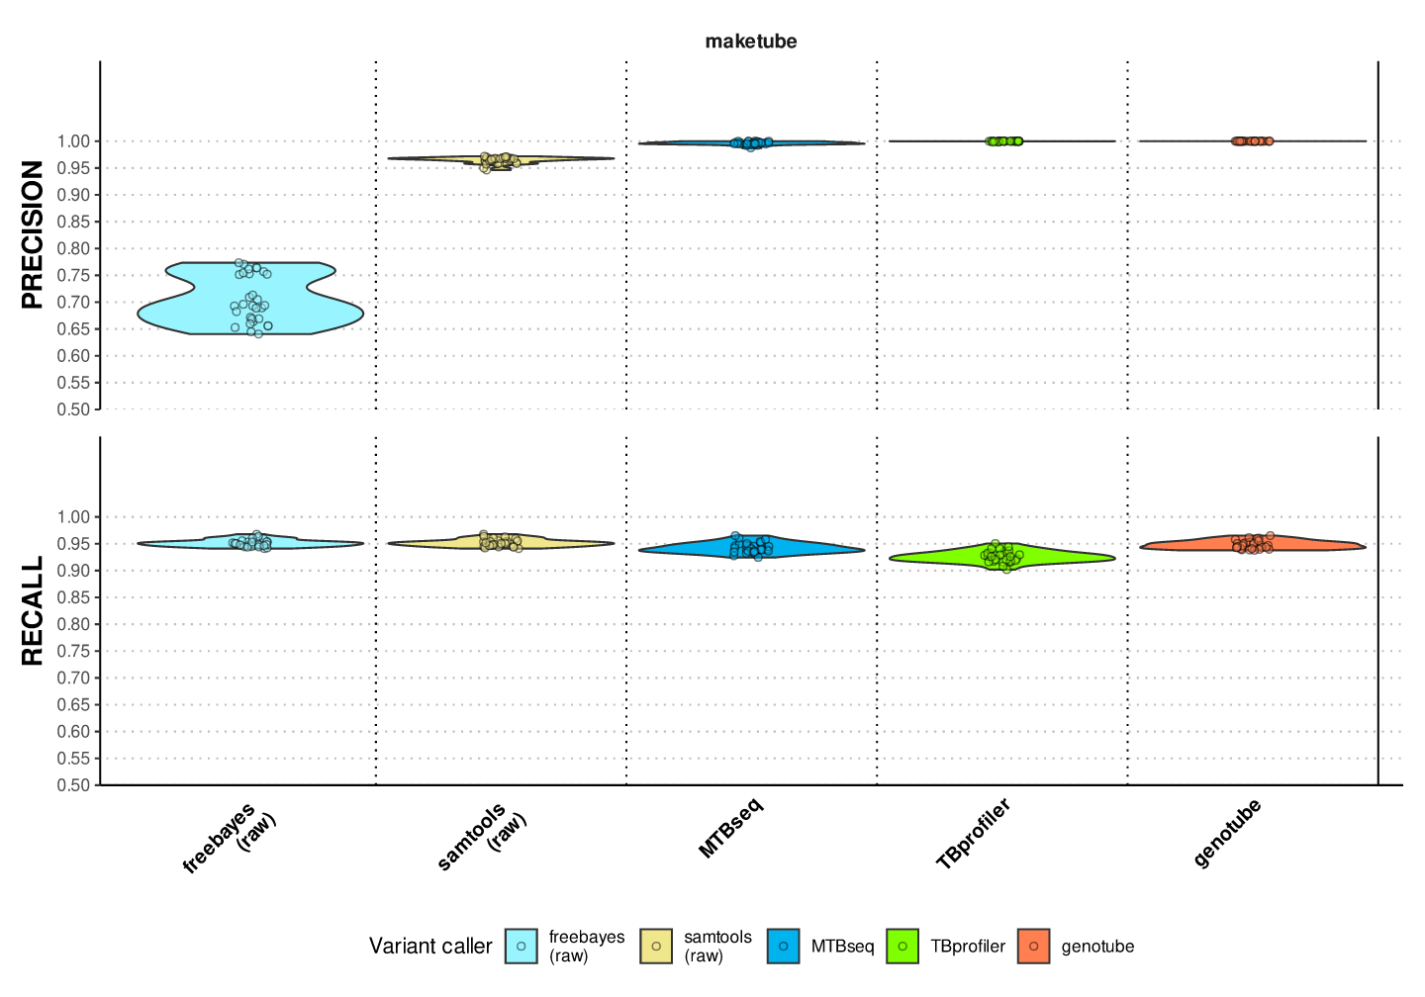
Sup. Figure 4 : Precision and recall of the tree tested pipeline using maketube genome, without the large duplication regions The removal of these regions does not change the performance ranking of the three pipelines.
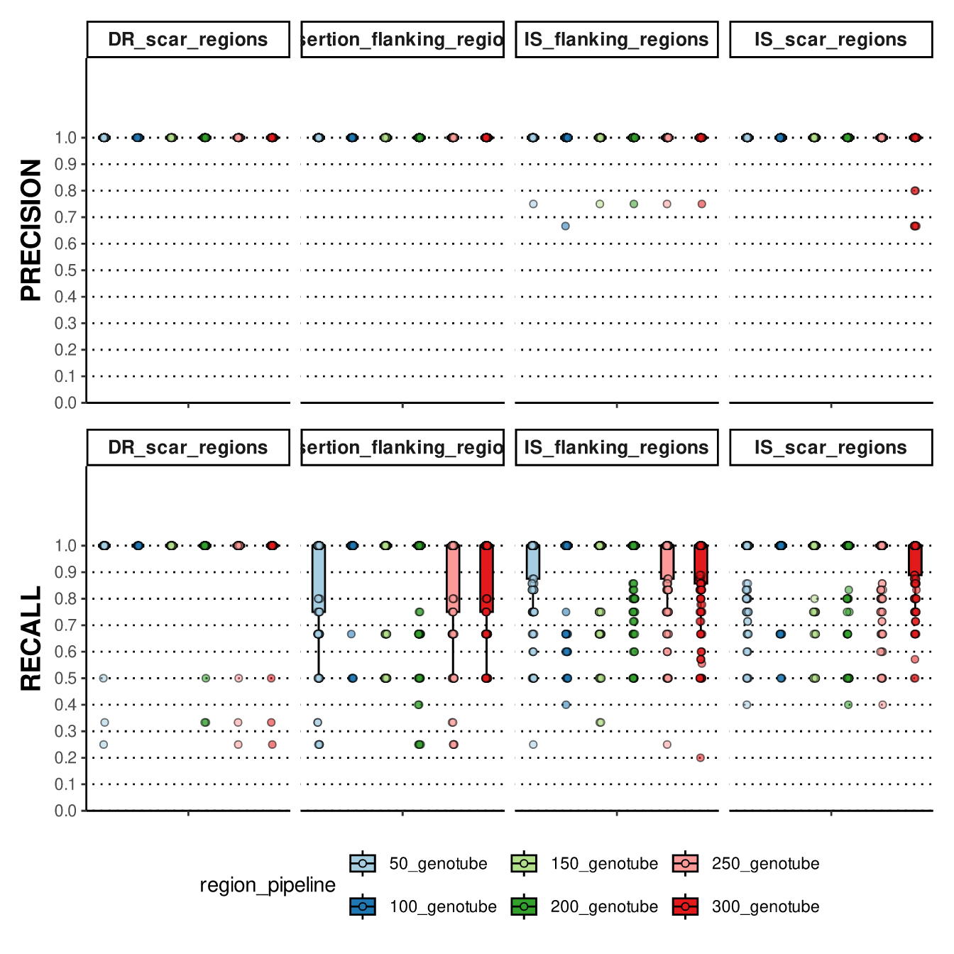
Sup. Figure 5 : Precision and recall at the border of structural variant when using genotube on maketube genome (set C) at 50, 100, 150, 200, 250 and 300bp around structural variants

