# How to read this document

This document aims at introducing the basic functionalities of Digital Micrograph 3 (DM3).

Two files are provided with this document:

* Beginner_low_loss.dm4   
  **Courtesy of the authors of:** XIONG, Jianhan, DUPRÉ, Nicolas, MOREAU, Philippe, *et al.* From the Direct Observation of a PAA‐Based Binder Using STEM‐VEELS to the Ageing Mechanism of Silicon/Graphite Anode with High Areal Capacity Cycled in an FEC‐Rich and EC‐Free Electrolyte. *Advanced Energy Materials*, p. 2103348.
* Beginner_core_loss.dm3  
  **Courtesy of Cécile Marcelot**

You’re expected to complete this practical on either of those datasets depending on what you are interested in. Next are a few questions to guide you through the practical:

## Core loss

* What is the characteristic of the background ? Of an absorption edge ?
* There are three absorption edges in this spectrum. Can you identify all of them ?
* Which function is used for the modelling of the background ?
* Try to extract the three different edges and plot them together.

## Low loss

* Can you identify the different parts of the spectrum ? What are their approximate energy range ?
* There is an absorption edge in this spectrum. Can you identify it ?
* Which function is used for the modelling of the background ?
* Try to extract the edge. Can you get the edge onset ?

# Open Digital Micrograph

Double click on the digitial micrograph icon: 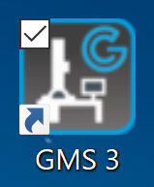

# Open a file

You can use File 🡪 open and a file explorer window will pop open. You can then select a file or several files and they will all be displayed in the interface of DM3. You can also drag files from the file explorer to the interface of DM3.

# The spectrum

The horizontal axis corresponds to the energy dispersing direction. For EELS spectra, an energy loss in eV is represented:

* At 50 eV in this scale the measured electrons had an energy of 199 950 eV for an experiment at 200 keV.
* At 100 eV in this scale the measured electrons had an energy of 199 900 eV for an experiment at 200 keV.

The vertical axis corresponds to the intensity at that energy loss. It does not have a unit.

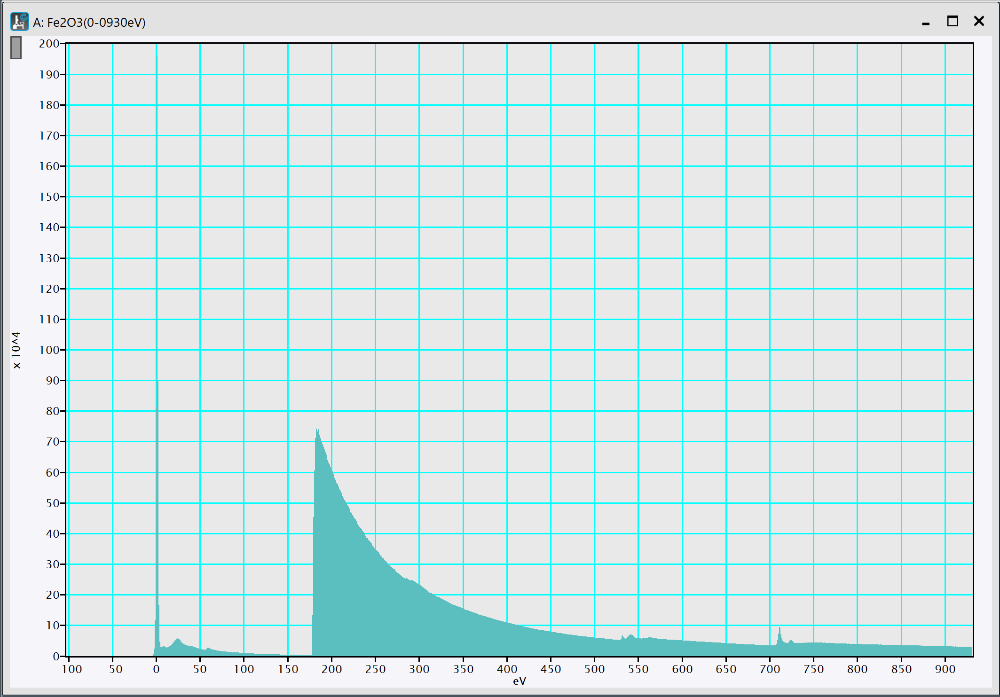

## Zooming and moving around

* **Zoom on an axis:** Left click and hold on an axis (e.g. below the spectrum, on the ticks), then hold down the ctrl key. Finally while still holding your ctrl key and your left mouse button, move around with your mouse. You will see that the displayed range changes.
* **Moving on an axis:** Left click and hold on an axis (e.g. below the spectrum, on the ticks). Then move your mouse around while still holding the left mouse button. You will see that the displayed range changes.
* **Going back to home display:** Right click on the spectrum, a menu will appear. Go to Display🡪Home display and click on it. It will go back to the original values.

## Selecting energy ranges and putting a marker

* **Select an energy range:** Left click and drag in the spectrum window. A rectangle will appear displaying starting energy, span energy and ending energy. You can click and drag on the brown point in the middle top, the left or right side. It will change the selected energy range.  
  push delete to remove it.
* **Put a marker:** Simply click on the spectrum. A vertical line appears on the spectrum.

On a spectrum there can be only one marker and one energy range.

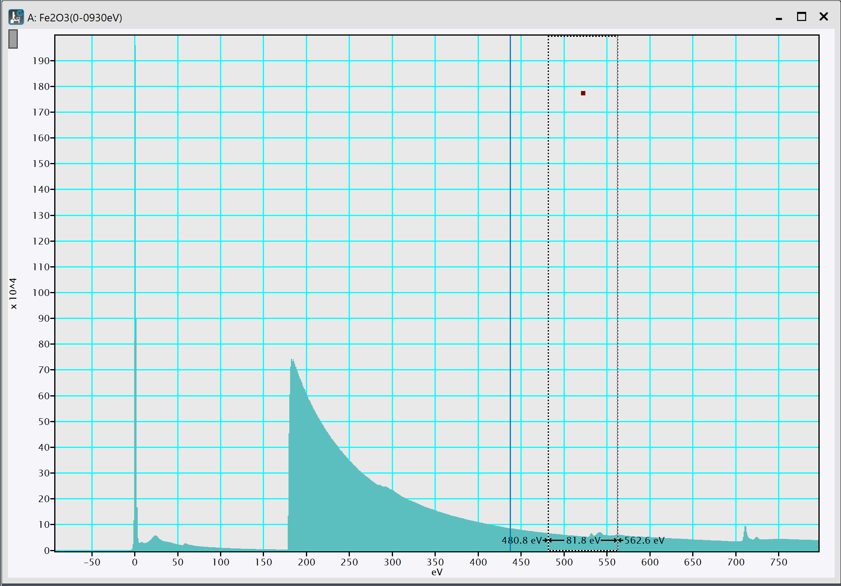

## Taking out spectral ranges

You can take out spectral ranges of a complete spectrum in the following way: Select an energy range as described above and do ctrl + c then do ctrl + alt + v. A new window will appear with the selected energy range.   
If you do ctrl + c, click on an existing window and do ctrl + v, there will be two spectral ranges in the same window.

# Extracting edges

## Identifying edges

* **EELS atlas:** DM3 has a built-in library of elemental EELS spectra. You can use them to help you identify the elements present in your sample. Go to EELS 🡪 EELS Atlas… A window will pop-up with a list of spectra with an elemental composition and a spectral range. Click on one or several and on open file(s) to open them in new windows. *Note that when both the low loss and core loss are present, the core loss is multiplied by some factor*.
* **Elemental quantification:** DM3 provides a tool to identify absorption edges on a spectrum. First make sure that the technique manager is on by going to Window 🡪 Floating windows and ensure that technique manager is checked.  
  In the technique manager, click on Analytical and then on Elemental Quantification. Then click on the small periodic table and choose the elements that you think their edges are present. Their name will appear at their onset energy with blue tags.  
  I don’t advise to use the Auto ID which often fails.

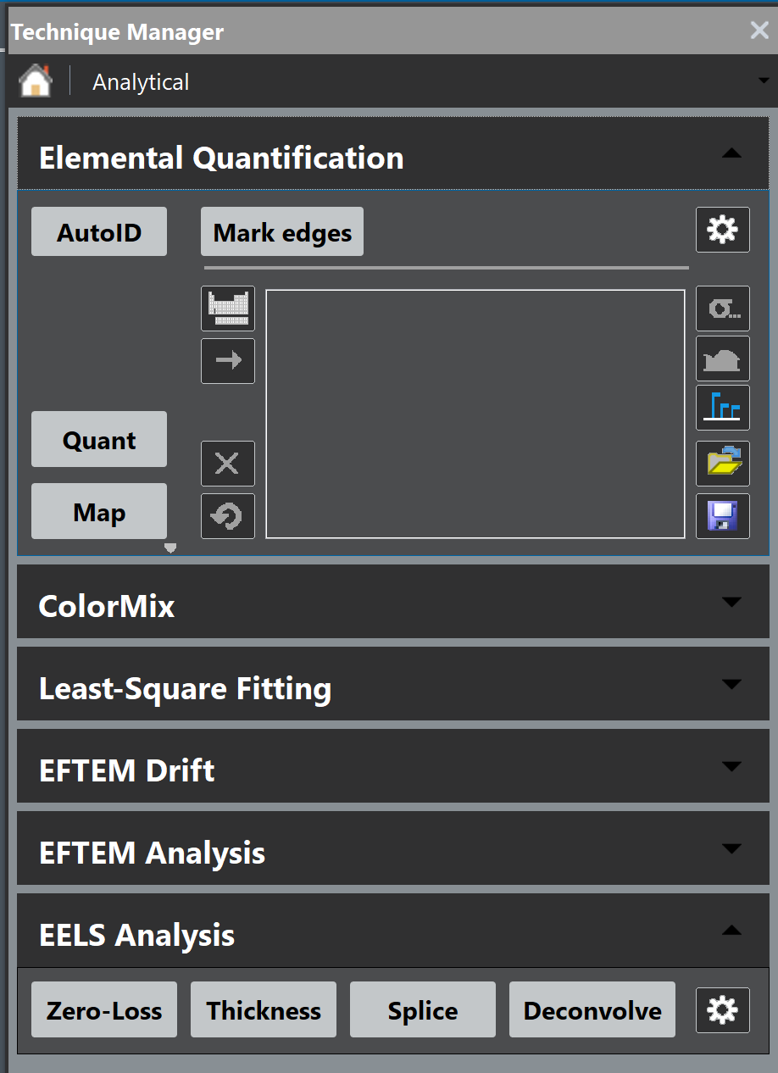

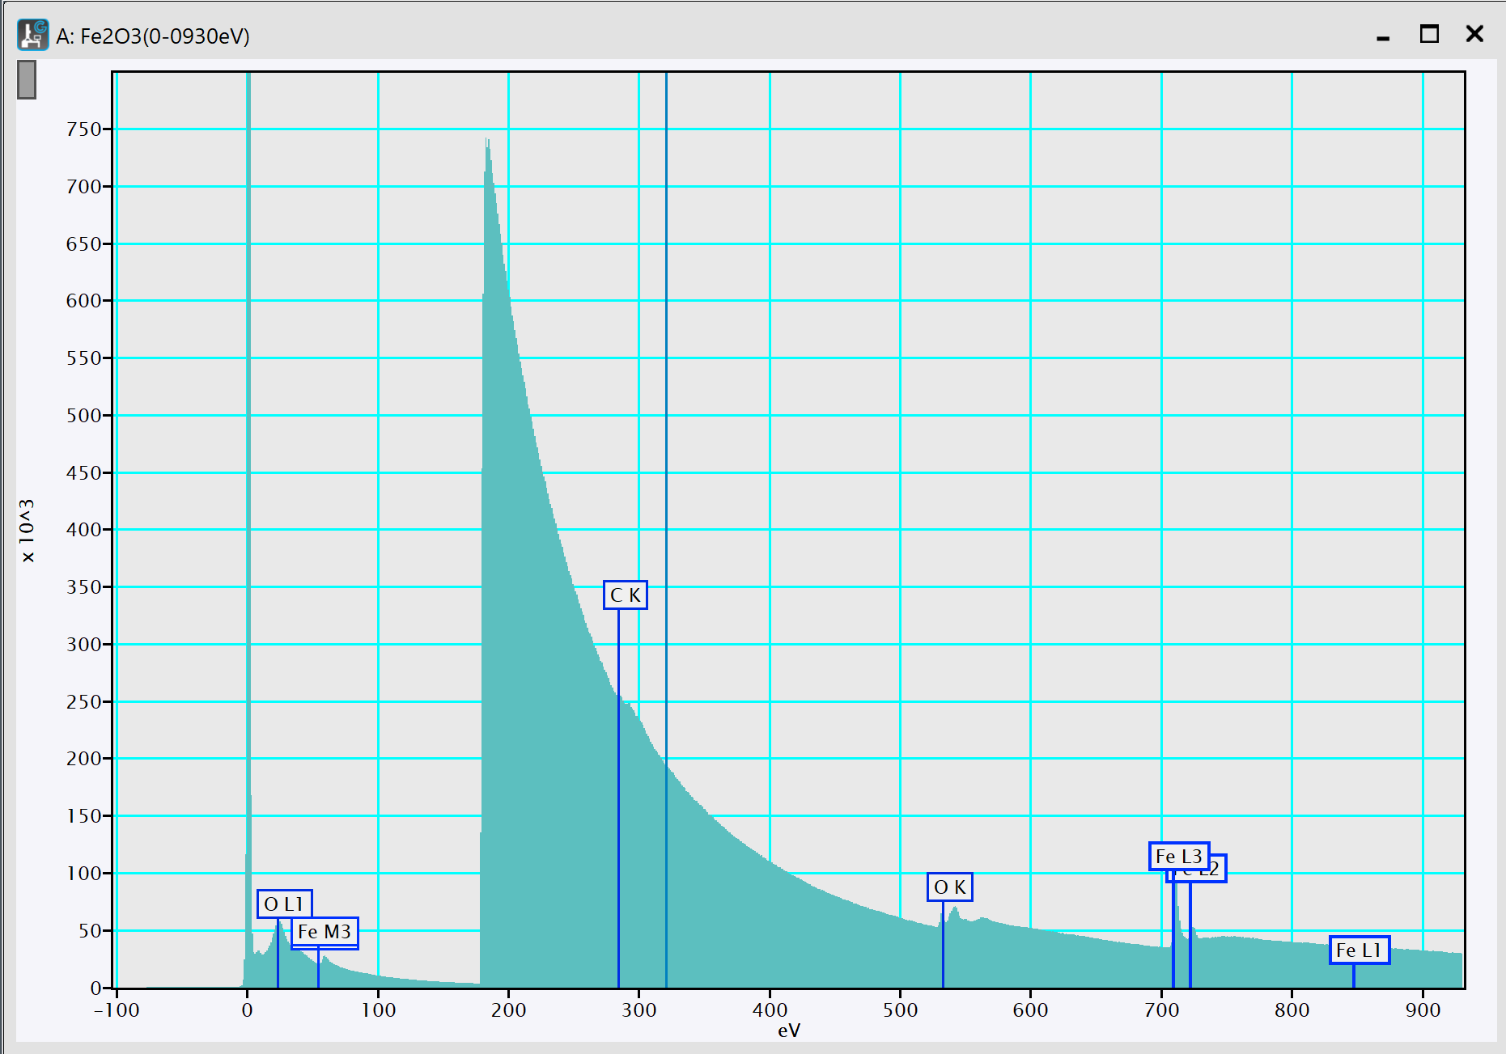

## Subtracting background

* **Get a background window:** Click and drag on a spectrum while holding the ctrl key. A red window label bkgd, a fitted power law in red and an extracted signal in green will appear.   
  You can control, the position and width of the bkgd window in the same way as the range selection tool.   
  The best is to selected the widest possible area and position it close to the edge.
* **Extracting the edge:** Click on Edge on the right side of the spectrum to select the background subtracted spectrum. Then use ctrl + c and ctrl + alt + v to get the edge in a new window.

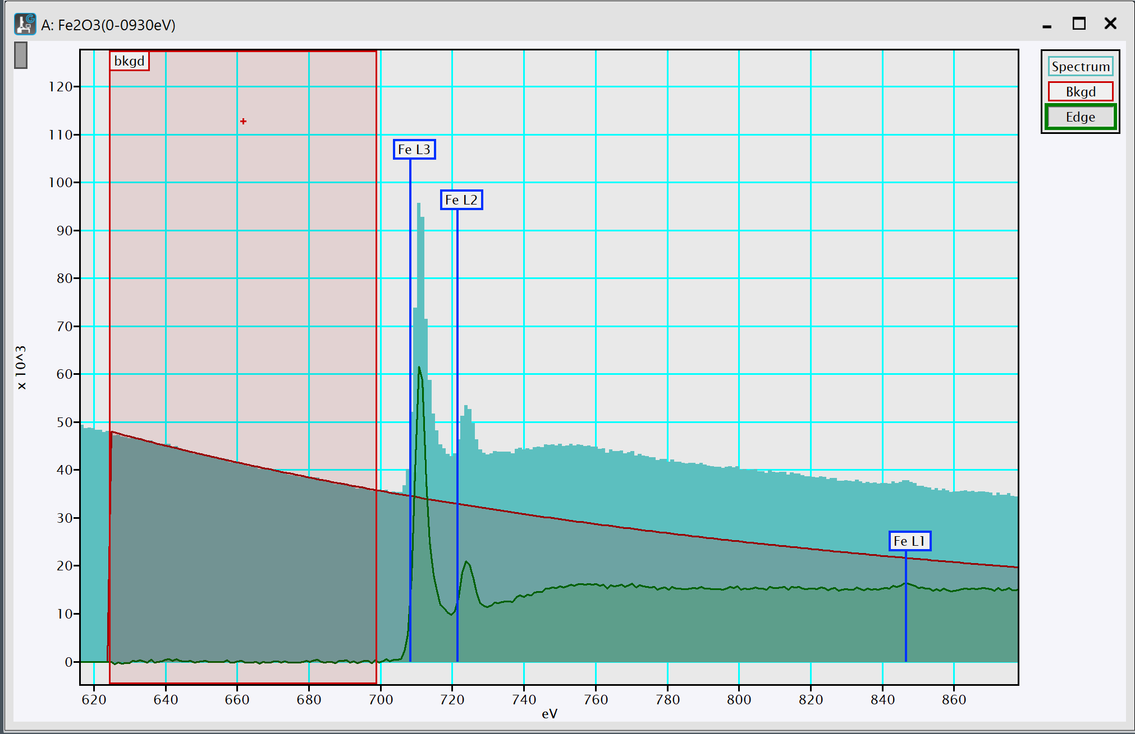

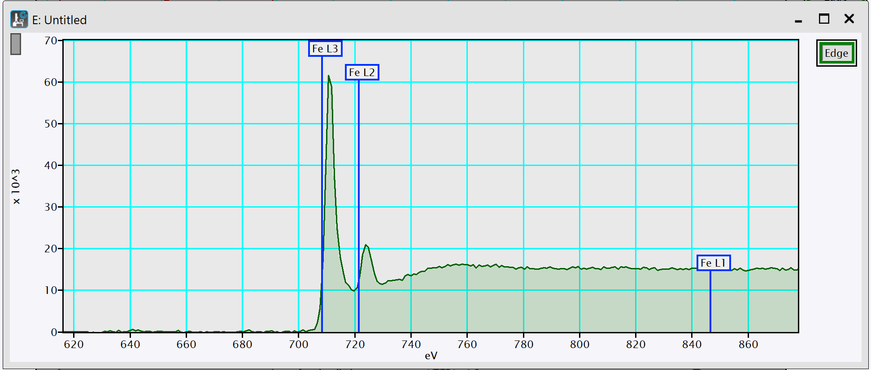

* **Plotting several edges together:** Use ctrl + c and ctrl + v from different sources to plot them together in one window. They are all going to be labeled Edge. To change that right clik on the labels and go to Image Info. In that window you can change the display options of each extracted edge. **In Image Info, you can both change the display of spectra and of the image background. Spectra display options are in Line Plot, while the rest can be found in Options.**  
  To plot together several edges, you can offset them manually. Left click on of the labels in the top right of your spectrum window. Then right click to get the menu. In the menu go to Vertical constraints and click on detached. Clicking once on the spectrum will make a marker appear. Then click and drag the marker to offset vertically the selected spectrum.   
  (see the display example below)

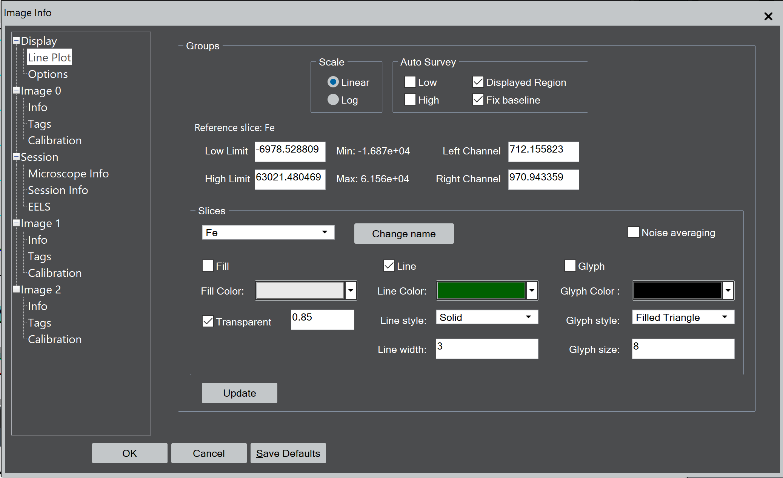

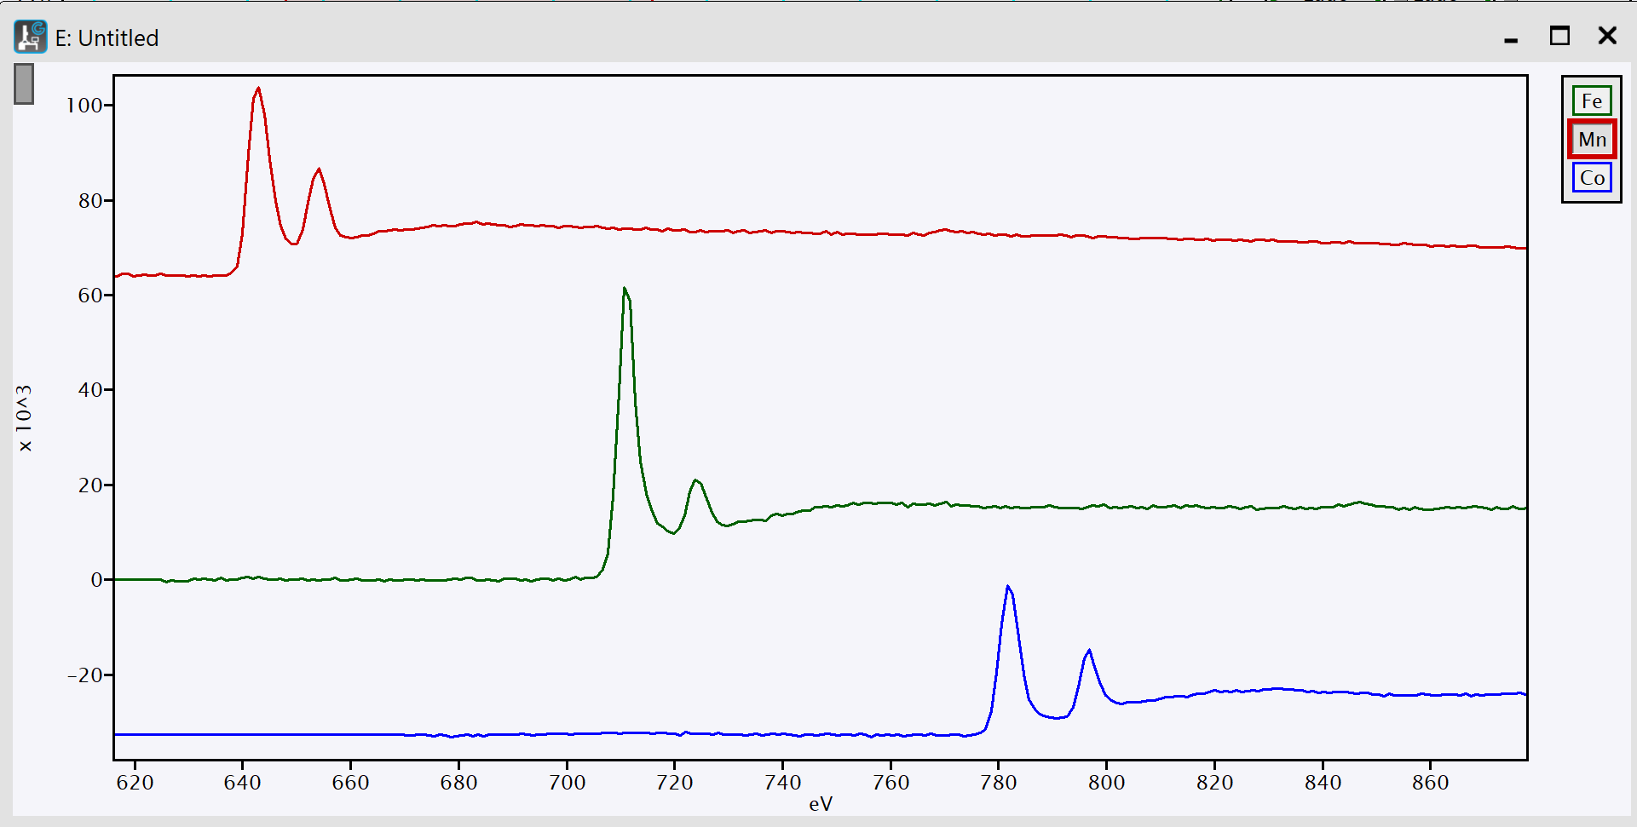

# Calibrate spectrum

When you have identified two features of the spectrum you can calibrate the spectrum.

* Select a region of the spectrum you want to calibrate. Position the two extremities of this window on the known features (Typically two edge onsets).
* A window will pop-up. You can input the two know energies.

The spectrum is calibrated. You don’t need to apply this calibration to the low-losses.

# Saving data

* DM format: Either ctrl+s or File 🡪 save.
* Image format: Go to File 🡪 Save Display as…