EELS data analysis practical QEM2021

Authors: Hugo Lourenço-Martins, Adrien Teurtrie and Maya Marinova

# Reminder of Electron Energy-Loss Spectroscopy principles:

This practical is about the analysis of STEM/EELS data. We give you in the first part a quick reminder of what is measured in EELS, its important parameters and also about spectrum imaging.

## EELS

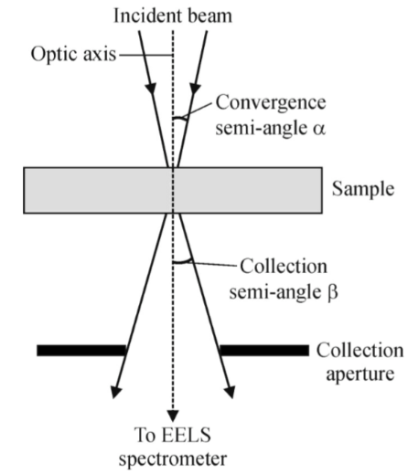In the transmission electron microscope, as the electron beam passes through the sample, it interacts with it. During some of these interactions, the electron will lose some energy. (For a detailed understanding of electron/mater interaction refer to the lectures of Demie Kepaptsoglou and Sean Collins). These inelastically scattered electrons are collected along the optical axis. The collection is limited by a collection aperture at the entrance of the EELS spectrometer. The collection semi-angle is called β (from a few mrad to a few tens of mrad).

In the EELS spectrometer, a magnetic prism (along with an optical system) spreads the electrons according to their energy loss onto a detector. The electrons that did not lose energy travel along the spectrometer optical axis. The inelastically scattered electrons are further away from the optical axis the more energy they lost.

The EELS spectrum is divided in two parts. The low losses which correspond to energy losses approximately below 100 eV. It mainly contains the zero-loss peak (electrons that did not lose energy) and the plasmon peaks (Interaction with valence electrons). The core losses which correspond to energy losses approximately above 100 eV. It contains the core loss absorption edges (Interactions with core electrons from atoms.).

The important experimental parameters to consider in EELS are:

* The primary energy of the electron beam. It spans usually between 60 keV to 300 keV.
* The convergence semi-angle α (from a few mrad to a few tens of mrad) and collection semi-angle β. The α and β values are tabulated for every microscope.
* The thickness of the sample (t). If the sample is too thick (t/>0.5, with lambda the inelastic mean free path of typically 100 nm.), the low loss spectrum has to be recorded so that a deconvolution of the multiple scattering can be performed (see figure below).

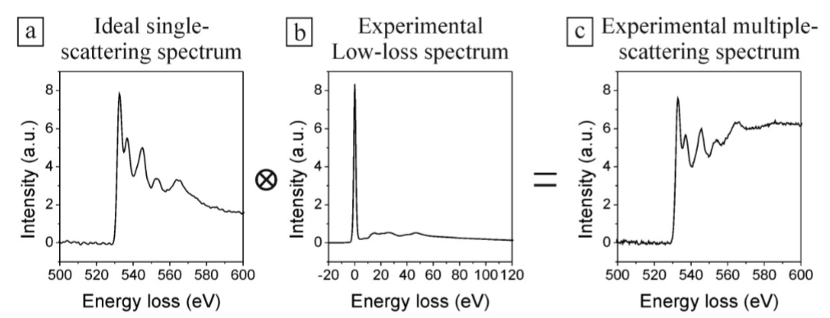

single scattering core loss spectrum low loss spectrum multiple scattering core loss spectrum

General purpose book on EELS: EGERTON, Ray F. Electron energy-loss spectroscopy in the electron microscope. Springer Science & Business Media, 2011.

## The EELS spectrum

The EELS spectrum (as the ones you can see above) is actually a histogram with the horizontal axis corresponding to the energy dispersing direction and the vertical axis correspond to the number of detected electrons. For example, at 50 eV energy-loss in this scale the measured electrons had an energy of 199 950 eV for an experiment at a primary energy of 200 keV.

## Spectrum imaging

In the STEM mode, subsequent EELS spectra are recorded from individual positions by scanning the focused electron beam. Each EELS spectrum (sketched as a vertical column in the first figure) has the full energy resolution determined by the spectrometer and the electron source. Using this technique, EELS spectra can be recorded along a line (e.g., across an interface or grain boundary) or, two-dimensionally, from a certain specimen area – pixel by pixel. Then, a spectrum line corresponds to a vertical slice (a series of vertical columns) of the data cube and a spectrum-image is a series of vertical slices (the whole data cube).

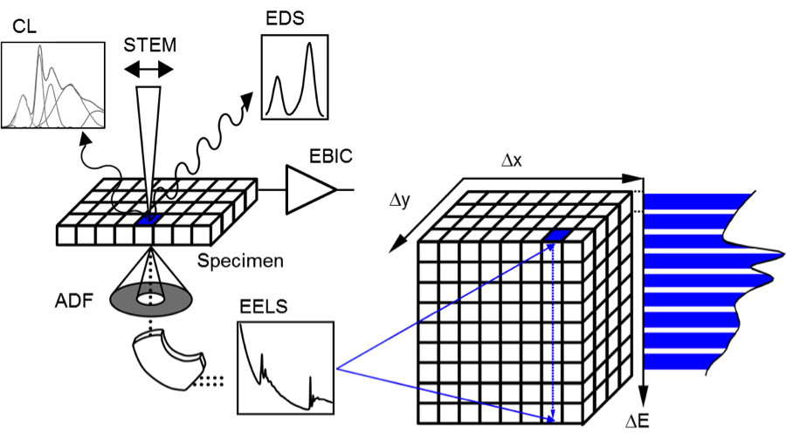

Image taken from: https://www.gatan.com/techniques/spectrum-imaging

# Data analysis using Digital Micrograph

This document aims at introducing some functionalities of Digital Micrograph 3 (DM3). This tutorial does not aim to be an exhaustive demonstration of DM3 functionalities. For additional questions, please reach for your teacher.

We will first use already published core-loss STEM-EELS data as a data analysis example throughout this practical. The associated publication on which we base a part of this practical is:   
**Probing the core and surface composition of nanoalloy to rationalize its selectivity: Study of Ni-Fe/SiO2 catalysts for liquid-phase hydrogenation**

The studied sample are 50% Ni, 50% Fe nanoparticle catalysts prepared on SiO2 substrate. The STEM-EELS data analysis will help us answer the following questions:

* What is the shape and size of my sample?
* What chemical elements are present in my sample?
* What is the distribution of those chemical elements?

The list above is not exhaustive and more questions such as “What is the oxidation state of my sample?” can also be answered using STEM-EELS.

In the case of catalyst samples, we are particularly interested in the elemental distribution in the nanoparticles.

The data were kindly provided by Maya Marinova.

# Browsing data

## Open Digital Micrograph

Double click on the digital micrograph icon: 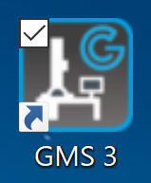

## Load the data

Click on File 🡪 Open

From the file browser go to “practical_EELS_QEM\analysis\data\core_loss”

You can then click and drag to select all the .dm4 files and click “open”

You can also drag files from the file explorer to the interface of DM3.

## Data types

* SI survey image: STEM-HAADF image in which the spectrum image was acquired. It provides an overview of the acquisition area.
* Dark-Field image: STEM-HAADF intensity at each position of the probe during the spectrum image acquisition.
* Spectrum-image: The spectrum-image was acquired in dual-EELS which means that two energy ranges were acquired simultaneously.
  + Low-loss: It is helpful for the determination of thickness and for energy alignment.
  + High-loss or core-loss : The energy range that contains the elemental information we are interested in.

Now that we are familiar with the data, we can inspect the spectra and start the analysis.

## Extracting spectra

Right click on the core-loss (high-loss) spectrum-image. The box below will appear.

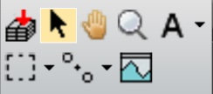

Click on the top left icon and then click and drag on the spectrum-image. A red rectangle (Region Of Interest or ROI) is displayed on the spectrum-image and a new window will appear with the extracted spectrum. You can extend the number of picked spectra by click and drag of on of the green dots at the ends of the ROI.

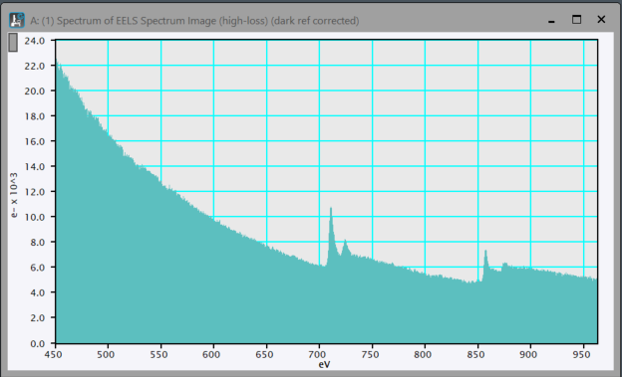

## Zooming and moving around

* **Zoom on an axis:** Left click and drag on an axis (e.g., below the spectrum, on the ticks), then hold down the ctrl key. You will see that the displayed range changes.
* **Moving on an axis:** Left click and drag on an axis (e.g., below the spectrum, on the ticks). You will see that the displayed range changes.
* **Going back to home display:** Right click on the spectrum, a menu will appear. Go to Display🡪Home display and click on it. It will go back to the original values.

## Mirror ROIs

It is possible to link ROIs between different data, e.g., low-losses and core-losses. You have to have a ROI active on one of your datasets. You can then right click on the spectrum-image (or ADF for instance) and click on Miror Pickers ROIs. This window will appear: 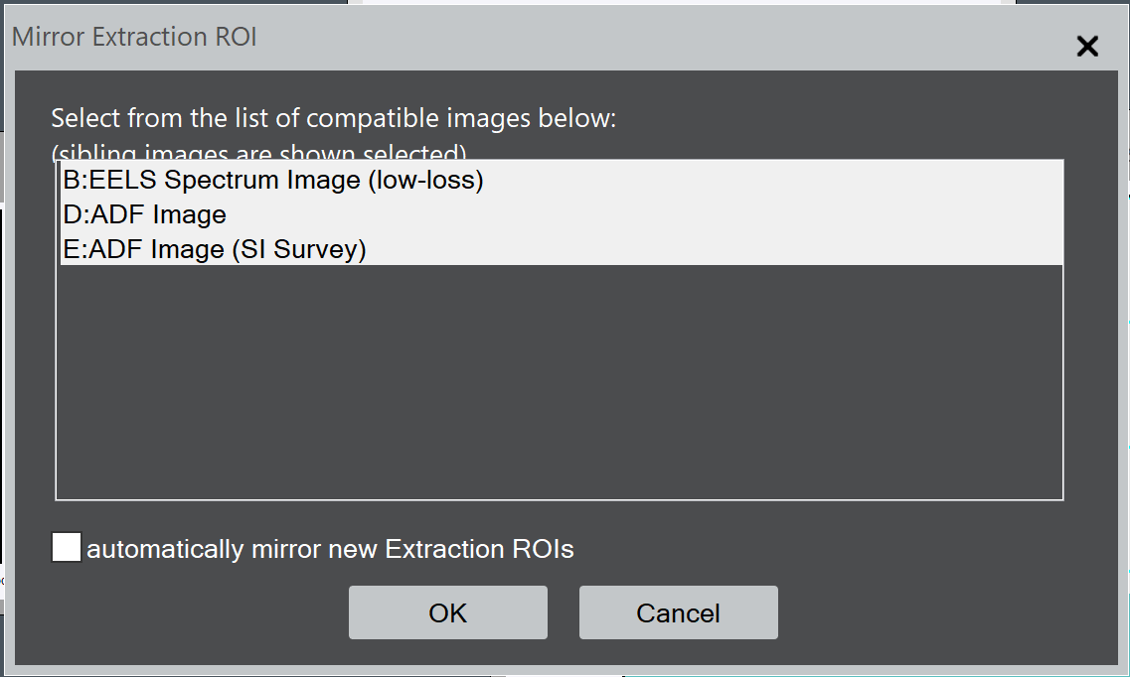

Clicking on Ok will locate interactively the first ROI you created on the other signals.

## Comparing spectra at different locations

1. Extract a spectral range:   
   Select an energy range by left click and drag on the spectrum and do ctrl + c then do   
   ctrl + alt + v. A new window will appear with the selected energy range.
2. Overlay different areas:   
   Move the SI ROI around to another spot you would like to compare (e.g., the core and the shell). Select the extract spectrum again and ctrl + c, click on an existing window and do ctrl + v in the previously opened window. There will be two spectral ranges in the same window.
3. Compare the spectra:
   1. Show the different extracted ranges: Display🡪Show legend
   2. Select a ROI in the background
   3. Compare the spectra: Align Slice Vertically By🡪Maximum

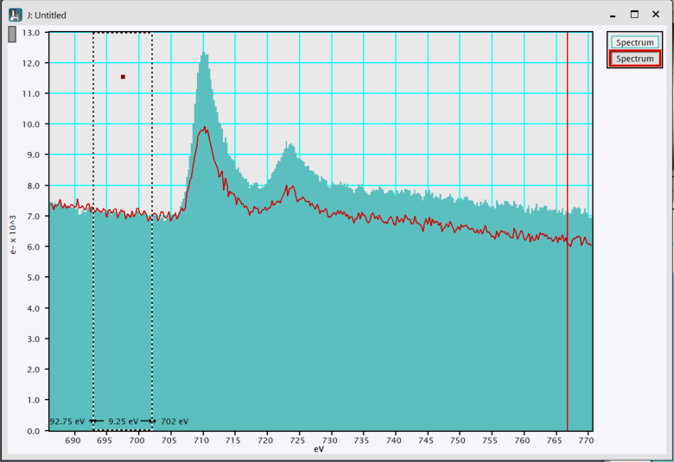

# Pre-processing data

## (Optional) Calibration

The dataset is already correctly calibrated. Thus, we will not go through the calibration step. However, since it is an important step, you can come back to it here.

You have two options for calibration:

* Left click once on the spectrum and go to the top menu Spectrum🡪Calibrate..  
  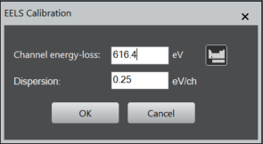  
  That works in the case you are confident in dispersion calibration of your spectrometer.
* Select a spectral range and go to the top menu Spectrum🡪Calibrate.. 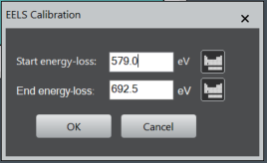  
  That works in the case there are two features with known energies.

## X-ray removal

Spectrum-images are long acquisition and thus may be crippled by cosmic x-rays hitting the EELS camera. While selecting an EELS spectrum-image, at the top menu bar, click on Volume 🡪 Remove X-Rays From Stack… a window will pop open and ask for a sigma value (i.e. a variation rate value between neighboring energy values). A sigma value around 10.0 usually works. You can then get a summary of the results in the “Output” tab of the terminal below.

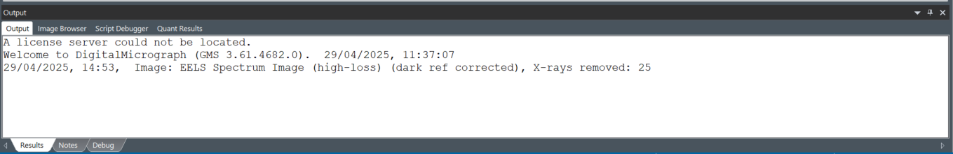

## Zero-loss energy alignment

Due to instabilities in the electron beam apparent energy (de-scan, high-tension jittering, etc…), the zero-loss might not be at 0 eV. There is an algorithm to correct the zero-loss peak position.

* Select the low loss spectrum that you obtained from the previous step and select an energy range around the zero-loss peak.
* In the top bar menus, click on SI 🡪 Align SI by Peak
* Say yes to the first window popping-up and in the second window make sure to also apply to the dual EELS sibling.

Two new datasets are created with a “(aligned)” addition to their title.

It depends on the microscope you are using (e.g., if there is a de-scan or not) but the energy shifts should look somewhat like that:

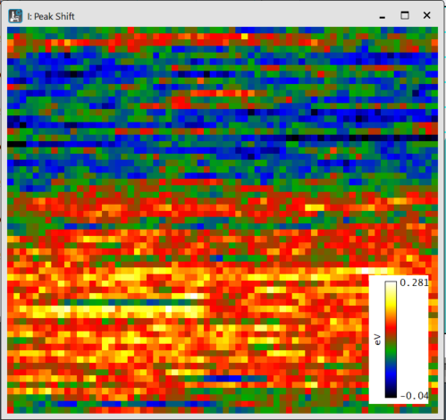

For instance here, the energy shifts should not be more than a few eV and you see distinguish the fast and slow scan directions.  
**/!\ This calibration of the data is not guaranteed to be correct for the core-losses. In general, the energy dispersion of the spectrometer is non-linear over extended energy range.**

# Compute thickness

To know whether you need to account for plural scattering you can compute the relative thickness in the region of the acquisition thanks to the low-losses.

* Select the extracted low loss spectrum.
* Click on EELS 🡪 Compute Thickness 🡪 Log ratio (relative)

A t/λ ratio will be displayed interactively in the bottom left corner of the low loss spectrum. When you move the ROI of the spectrum-image, the t/λ ratio will be recomputed.

The average number of interaction in the sample is given by the t/λ ratio based on a Poisson law. Here are the probability of multiple interaction for different t/λ: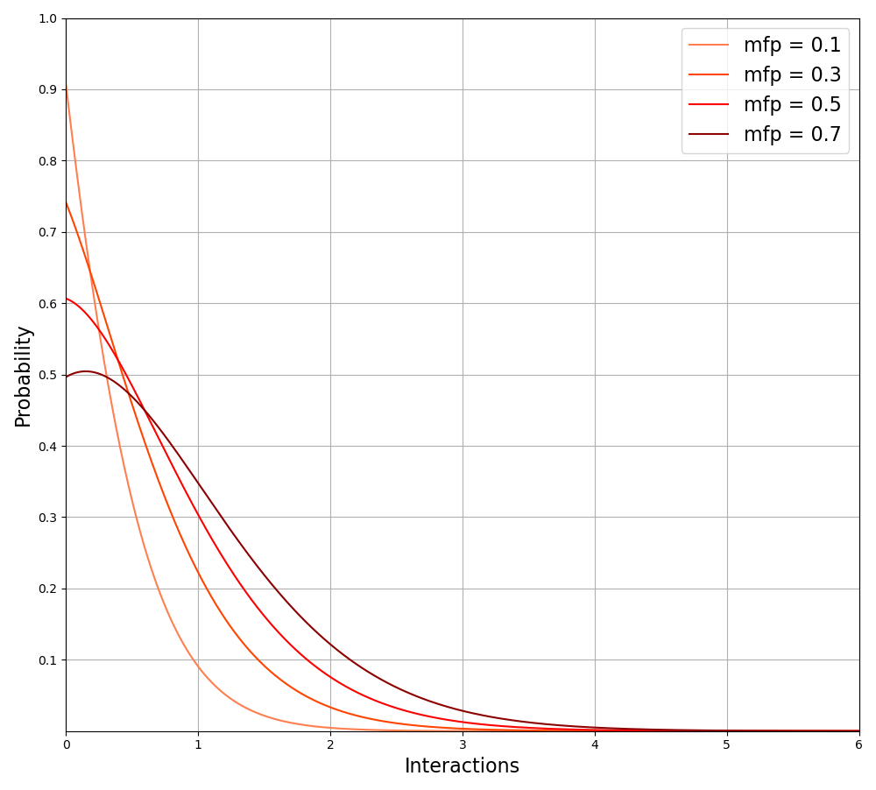

For instance, for a t/λ of 0.5, roughly a 25% of the scattered electrons are scattered twice.

# Edge extraction and identification

## Identifying edges

* **EELS atlas:** DM3 has a built-in library of elemental EELS spectra. You can use them to help you identify the elements present in your sample. Go to EELS 🡪 EELS Atlas… A window will pop-up with a list of spectra with an elemental composition and a spectral range. Click on one or several and on open file(s) to open them in new windows. *Note that when both the low loss and core loss are present, the core loss is multiplied by some factor*.
* **Elemental quantification:** DM3 provides a tool to identify absorption edges on a spectrum. *(optional) First make sure that the technique manager is on by going to Window 🡪 Floating windows and ensure that technique manager is checked.*  
  In the technique manager, click on Analytical and then on Elemental Quantification. Click on the small periodic table and choose the elements that you think their edges are present. Their name will appear at their onset energy with blue tags.  
  I don’t advise to use the Auto ID which often fails.

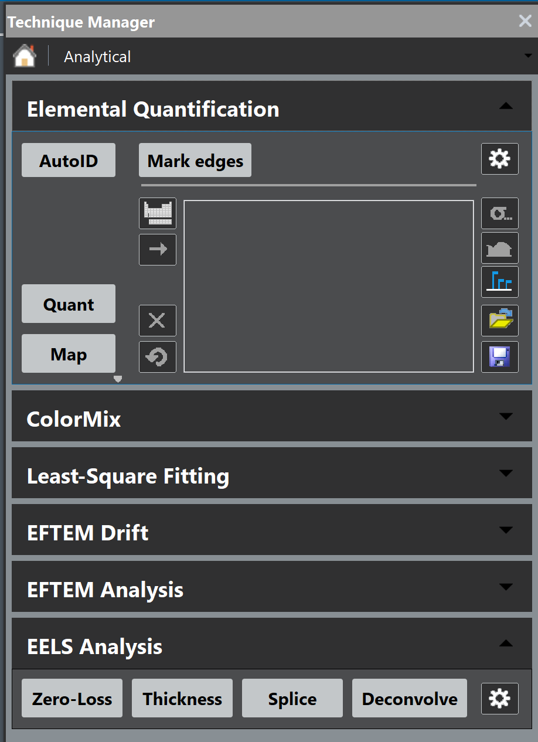

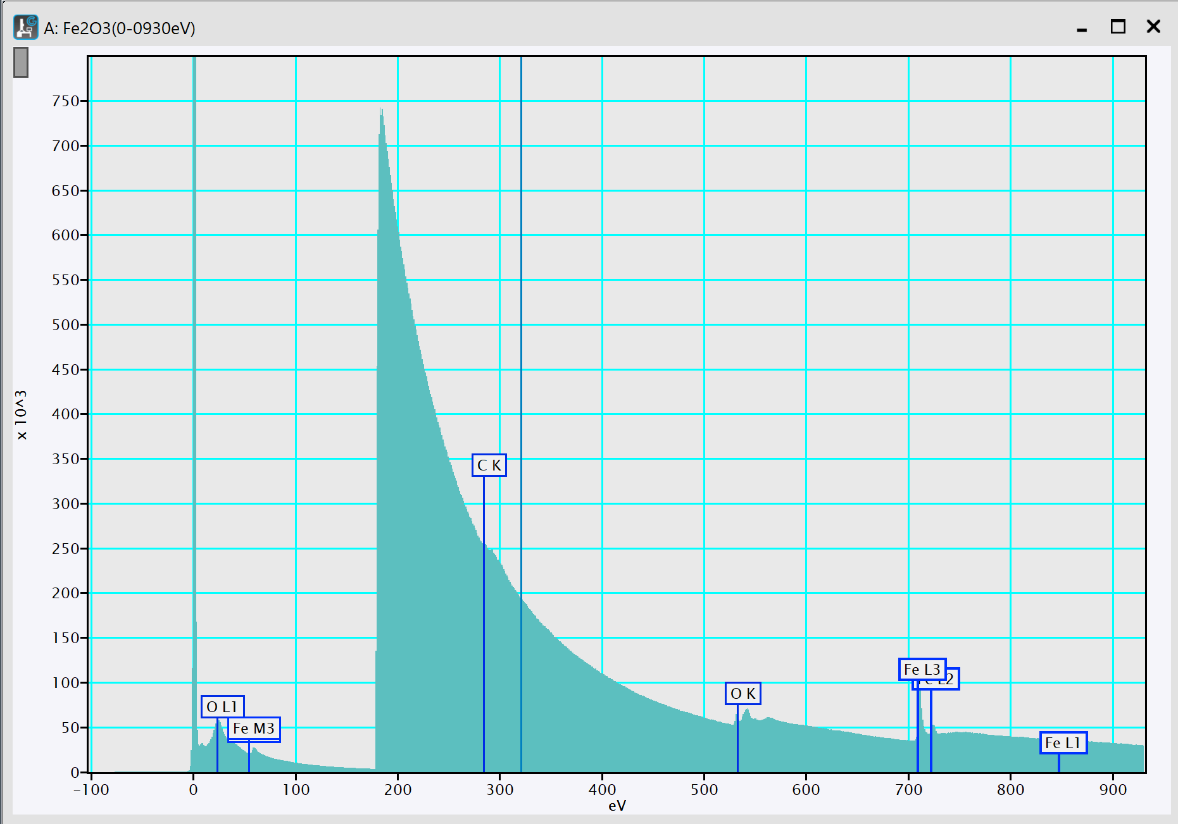

## Subtracting background

* **Get a background window:** Click and drag on a spectrum while holding the ctrl key. A red window label “bkgd”, a fitted power law in red and an extracted signal in green will appear.   
  You can control, the position and width of the “bkgd” window in the same way as the range selection tool.   
  The best is to selected the widest possible area and position it close to the edge.
* **Extracting the edge:** Click on Edge on the right side of the spectrum to select the background subtracted spectrum. Then use ctrl + c and ctrl + alt + v to get the edge in a new window.

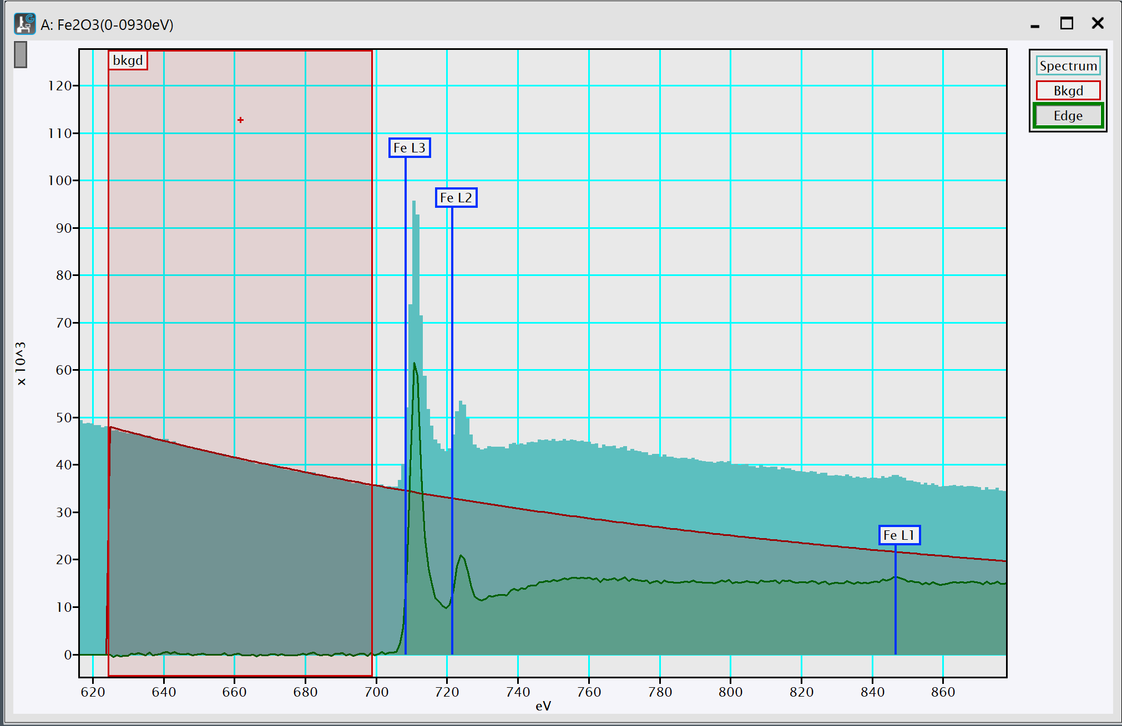

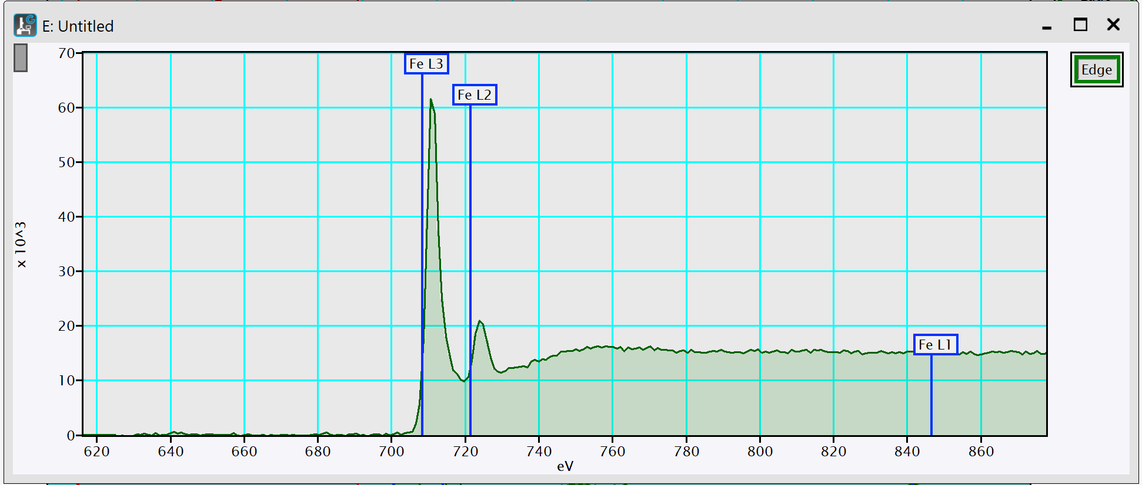

# Elemental quantification

## Cross sections

The atomic proportion of elements are determined through cross-section calculations. For core-loss, there are two types of cross-section models: "hydrogenic" or "Hartree-Slater".

* **Hydrogenic**: This a simple atomic model with hydrogenic wave functions where the screening of the electrons is taken into account with a constant. This model is suitable for K edges of light elements and can be adapted empirically for L edges.
* **Hartree-Slater**: This model is more accurate and uses an Hartree-Slater central field model. The elements are considered in their atomic form. Thus, the solid-state effects are not taken into account.
* For more details check: Hofer1991_cs_cl_eels.pdf

## Quantification tool

* Go to technique manager 🡪 Analytical 🡪 Elemental Quantification.
* Add the elements you identified using the small periodic table 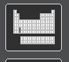.
* Click on the small sigma button on the right . A window will pop with a lot of options. There is a tab for each selected edge. For each edges check those options:
  + Cross Section 🡪 Cross Section model
    - On white lines (mostly transition metal-L edges), it is better to use Hydrogenic (white lines)
    - On K edges, it is better to use Hydrogenic
  + In Signal Extraction, when available chose the option overlaps X, where X is the previous edge.
  + For t/λ ratio below 0.3, you may disable the include plural scattering option
  + It is better to exclude the Energy Loss Near Edge Structures (ELNES) for the chemical quantification.
  + Feel free to test the other options.
* To visualize the models on the spectrum, click on .

Note: We don’t have access to detailed information of the inner workings of the algorithm. For instance, it is unclear how the difference in energy window sizes affects the quantification.

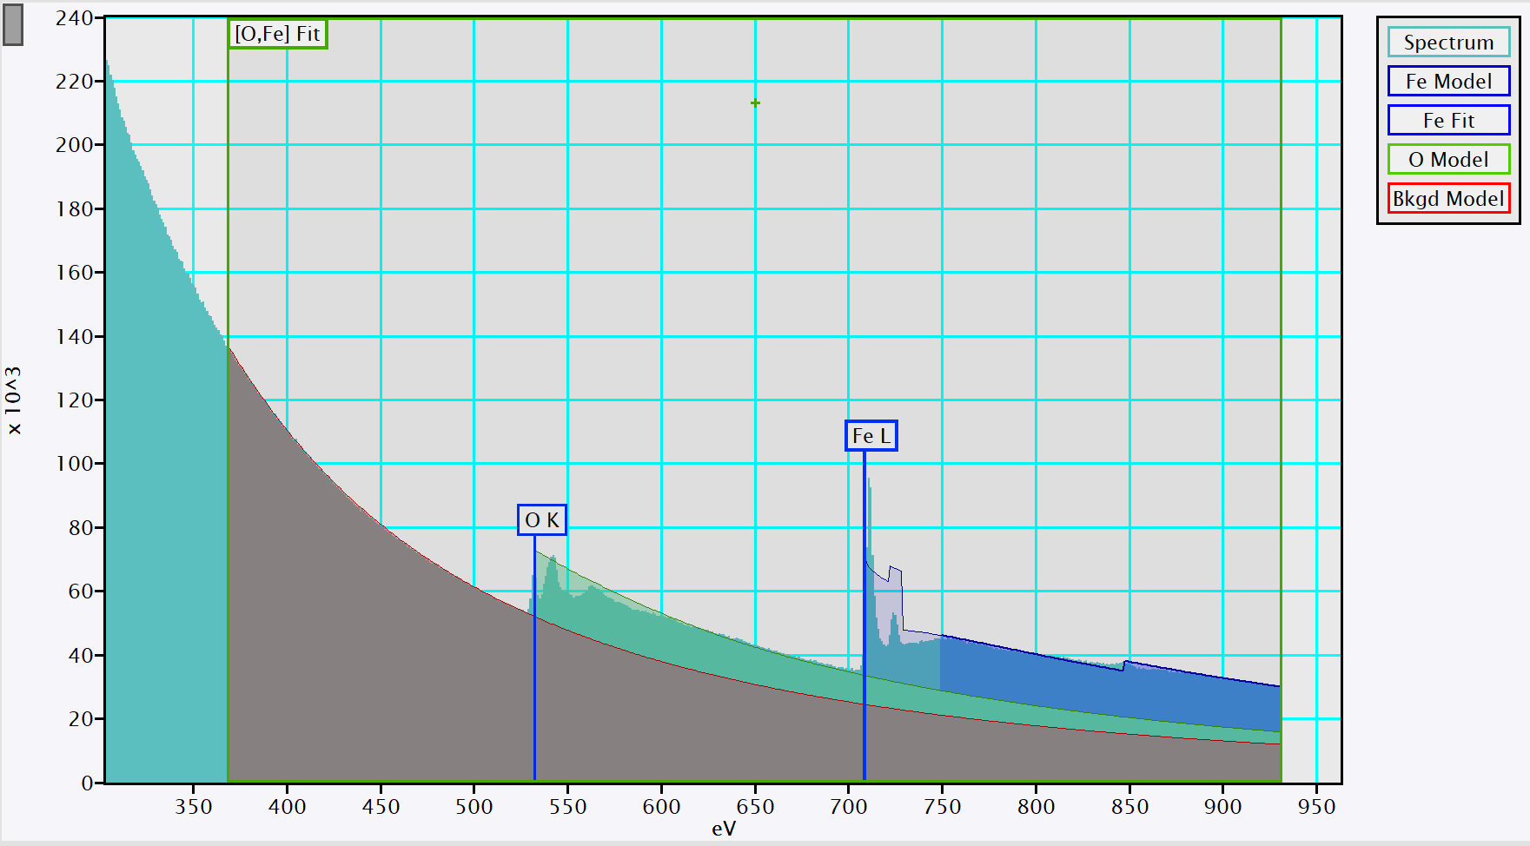

## Display of the results

### Single spectrum quantification

Click on Quant Results in the bottom left. A summary of the results will be displayed in the output at the bottom. *(optional) If you can’t find the output go to Window 🡪 Floating Windows 🡪 Output.*

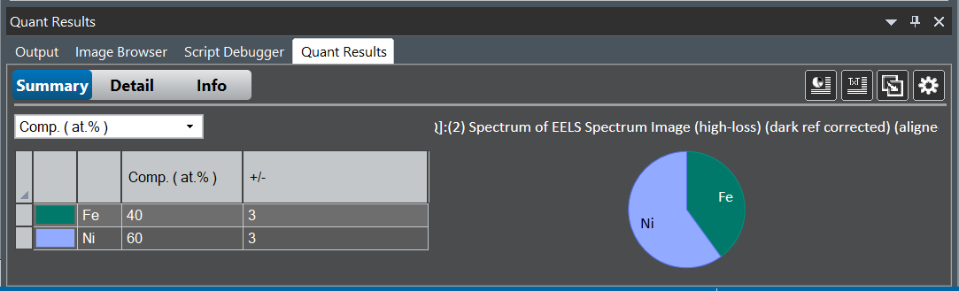

### Quantification maps

Click on Map in the bottom left of the “Elemental quantification” window. A window will open, I recommend selecting “Edge Integral” and “Elemental Quantification”. Plotting the edge integral enables to locate areas with very low signal that can produce artefacts. A new workspace will be created containing the maps, with a quantification at each point of the profile.

### Extracting profiles from maps

* Right click on a map and then left click on the little graph icon that appeared (bottom right).  
  
* You can then left click and drag a line profile on the map.
  + You can increase the integration width by pressing the “+” key.
  + You can select a range in the profile by left click and drag. The selected span will also appear on the map.

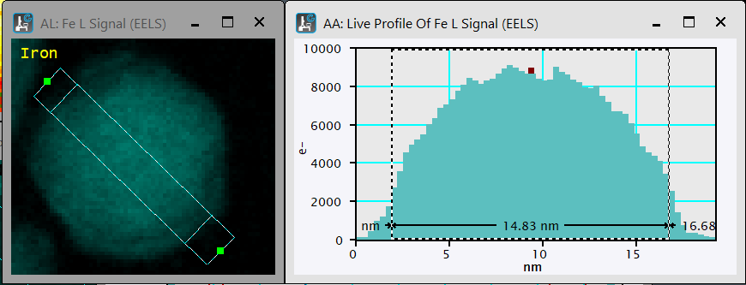

* You can compare different profile by selecting the profile on the map (it is selected when the little squares are green) and copy and paste to another map.

# Understanding the results

Here are a few tables to understand the results obtained from data analysis on the nanoparticles. They were picked from the associated publication and supplementary materials.

