# How to read this document

This document aims at introducing advanced functionalities of Digital Micrograph 3 (DM3). We assume here that you are familiar with the basic functionalities of DM3.

Four files are provided with this document. They all correspond to a line spectra acquisition in dual EELS mode:

* ADF Image (SI Survey).dm3: Survey image in which the line spectra was acquired.
* ADF Image.dm3: Profile of the ADF intensity along the line spectra.
* EELS Spectrum Image (high-loss).dm3: Core-loss part of the line spectra.
* EELS Spectrum Image (low-loss).dm3: Low loss part of the line spectra.

**Courtesy of Cécile Marcelot**

Next are a few questions to guide you through the practical:

## Questions

* What are the different scales of the dataset ?
* What are the different elements ?
* Where are they located and in which proportions ?
* Can you identify a compound from the quantification results ? (Ask the supervisors to check your answer).

# Open Digital Micrograph

Double click on the digitial micrograph icon: 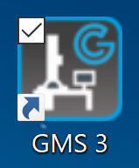

# Extracting spectra

Right click on the line spectra. The box below will appear.

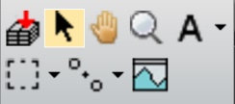

Click on the top left icon and then click on the line spectra. A red line is displayed on the line spectra and a new window will appear with the extracted spectrum. You can extend the number of picked spectra by click and drag of on of the green dots at the ends of the ROI.

## Mirror ROIs

* You have the survey image, the ADF profile and the low losses also opened.
* You started a spectrum extraction as described above.

You can right click again on the line spectra and click on Miror Pickers ROIs. This window will appear: 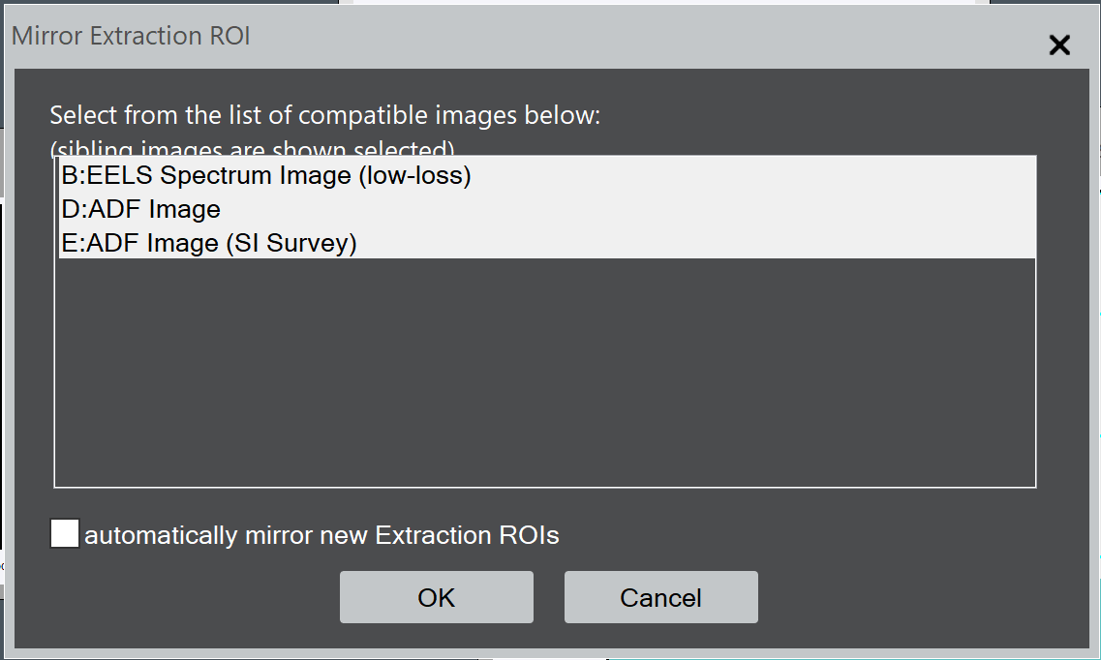

Clicking on Ok will locate interactively the first ROI you created (The red line on the line spectra) on the other signals.

# Zero-loss energy alignement

Due to instabilities in the energy of the high tension or errors in the GIF calibration, the zero-loss might not be at 0 eV. There is an algorithm to correct the zero-loss peak position.

* Select the low loss spectrum that you obtained from the previous step and select an energy range around the zero-loss peak.
* Click on SI 🡪 Align SI by Peak
* Say yes to the first window popping-up and in the second window make sure to also apply to the dual eels sibling.

Two new datasets are created with a “(aligned)” addition to their title.   
**/!\ This calibration of the data is not guaranteed to be correct for the core-losses. In general, the energy dispersion of the spectrometer is non-linear over extended energy range.**

# Extracting edges

## Identifying edges

* **EELS atlas:** DM3 has a built-in library of elemental EELS spectra. You can use them to help you identify the elements present in your sample. Go to EELS 🡪 EELS Atlas… A window will pop-up with a list of spectra with an elemental composition and a spectral range. Click on one or several and on open file(s) to open them in new windows. *Note that when both the low loss and core loss are present, the core loss is multiplied by some factor*.
* **Elemental quantification:** DM3 provides a tool to identify absorption edges on a spectrum. First make sure that the technique manager is on by going to Window 🡪 Floating windows and ensure that technique manager is checked.  
  In the technique manager, click on Analytical and then on Elemental Quantification. Click on the small periodic table and choose the elements that you think their edges are present. Their name will appear at their onset energy with blue tags.  
  I don’t advise to use the Auto ID which often fails.

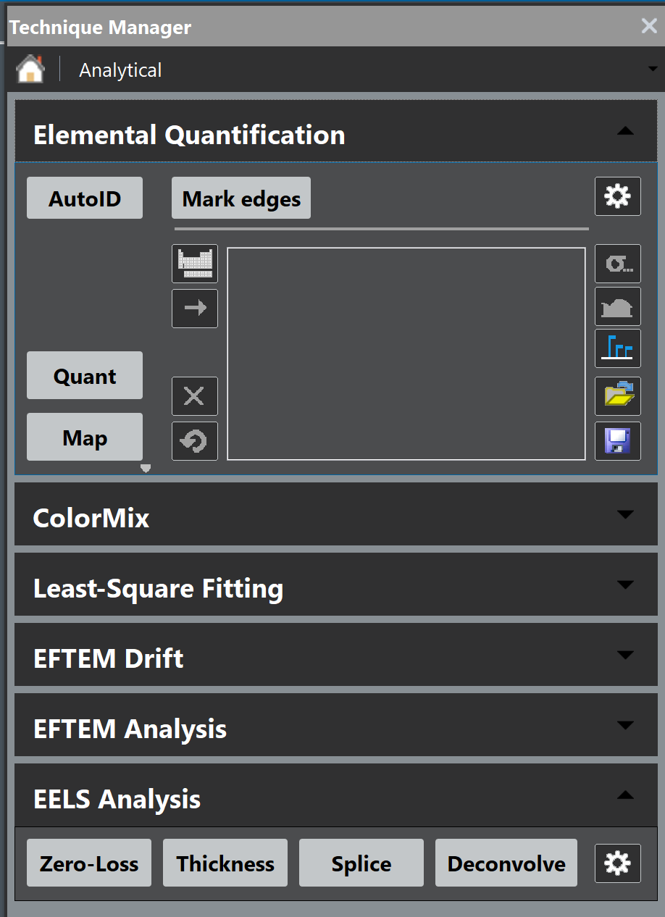

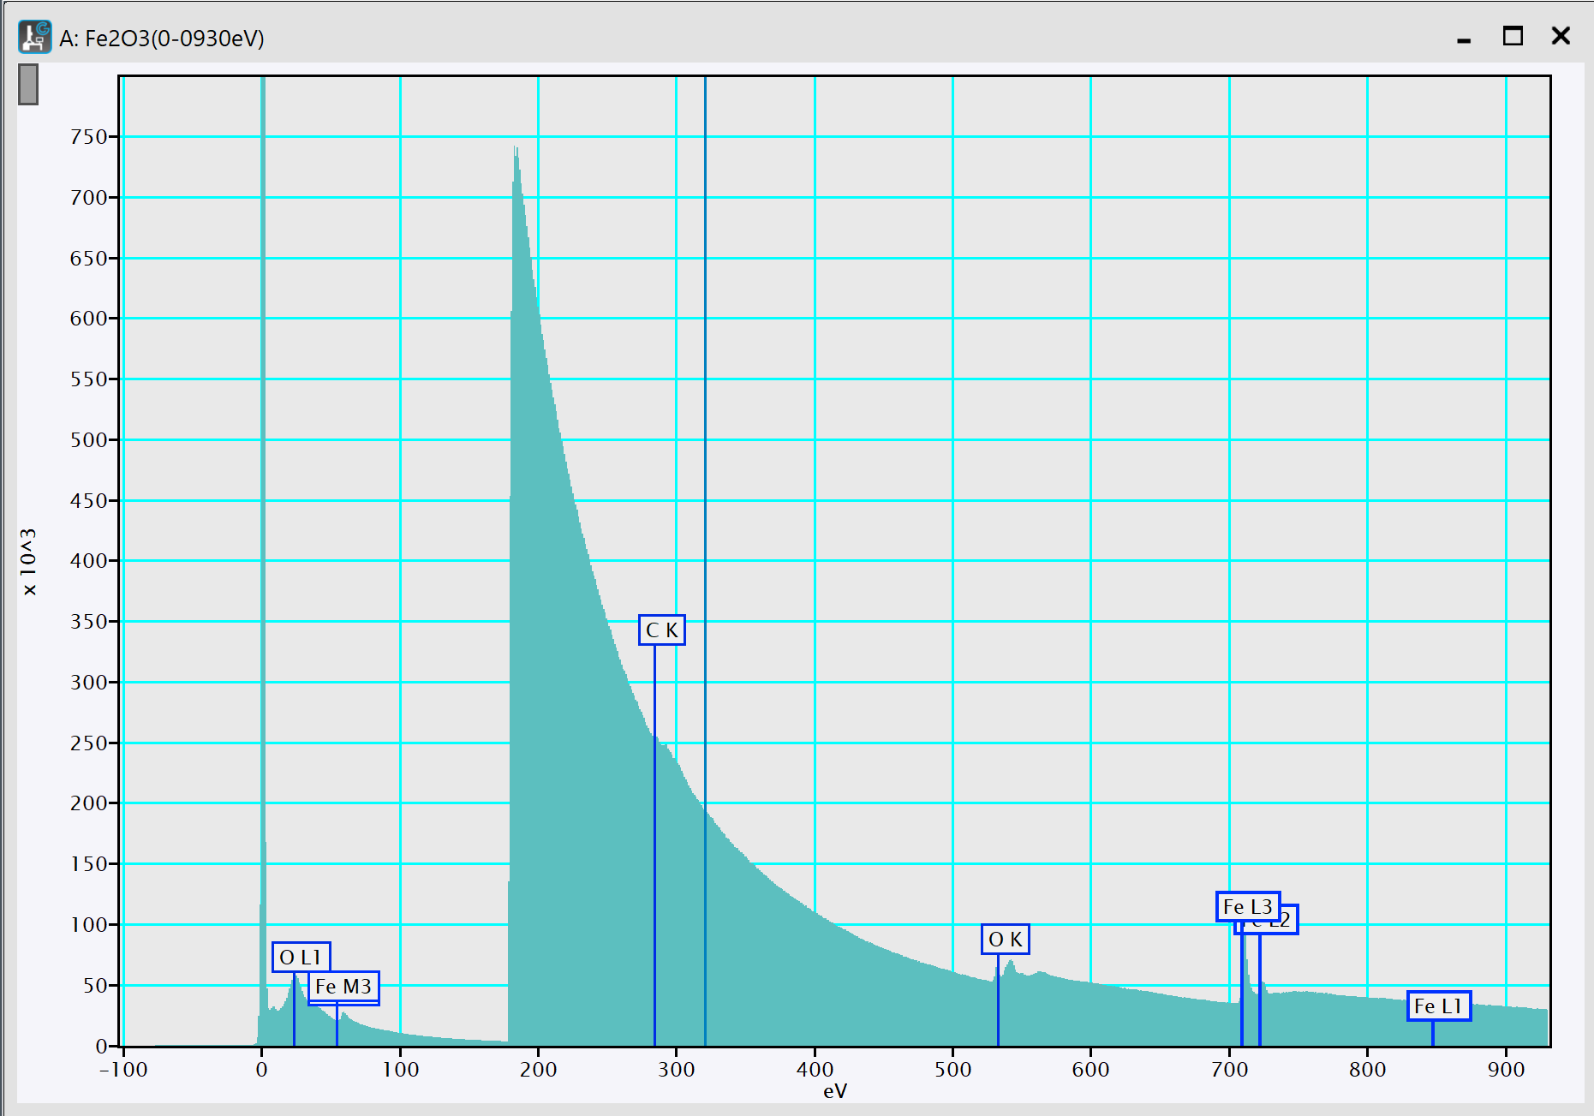

## Subtracting background

* **Get a background window:** Click and drag on a spectrum while holding the ctrl key. A red window label bkgd, a fitted power law in red and an extracted signal in green will appear.   
  You can control, the position and width of the bkgd window in the same way as the range selection tool.   
  The best is to selected the widest possible area and position it close to the edge.
* **Extracting the edge:** Click on Edge on the right side of the spectrum to select the background subtracted spectrum. Then use ctrl + c and ctrl + alt + v to get the edge in a new window.

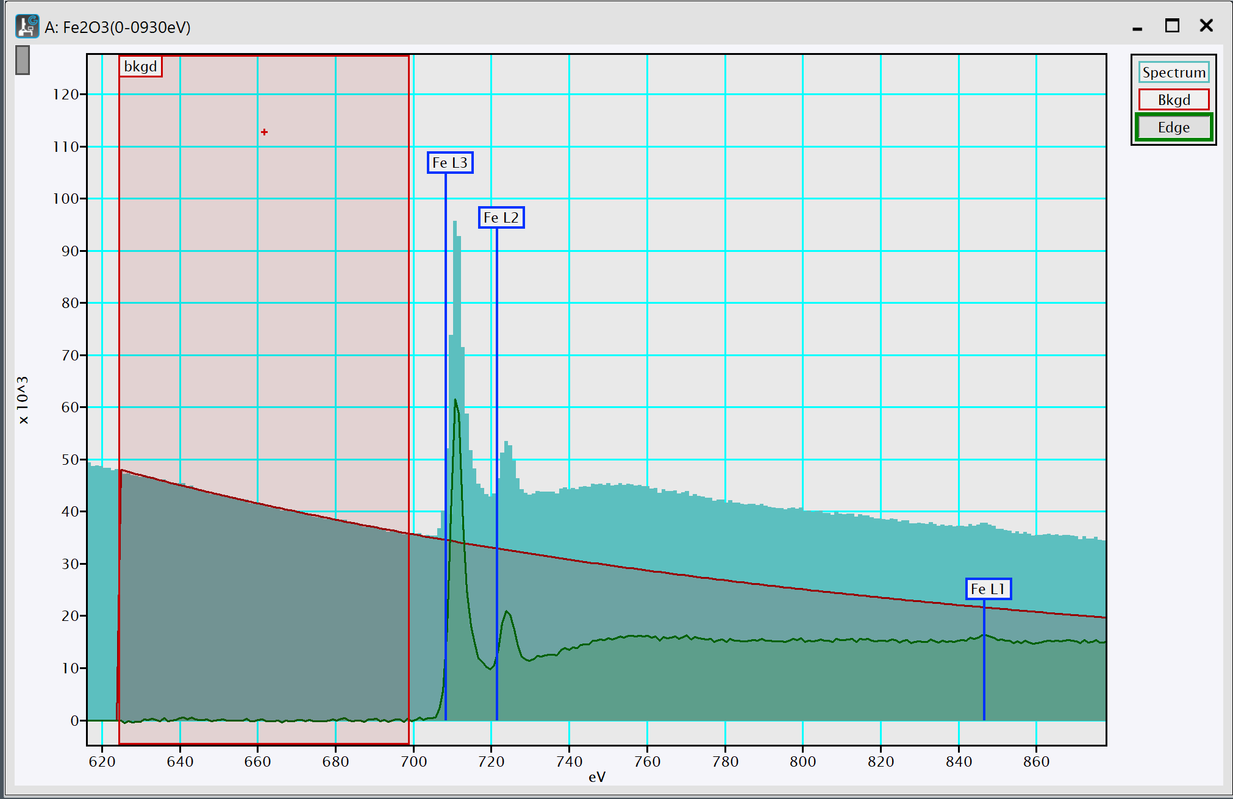

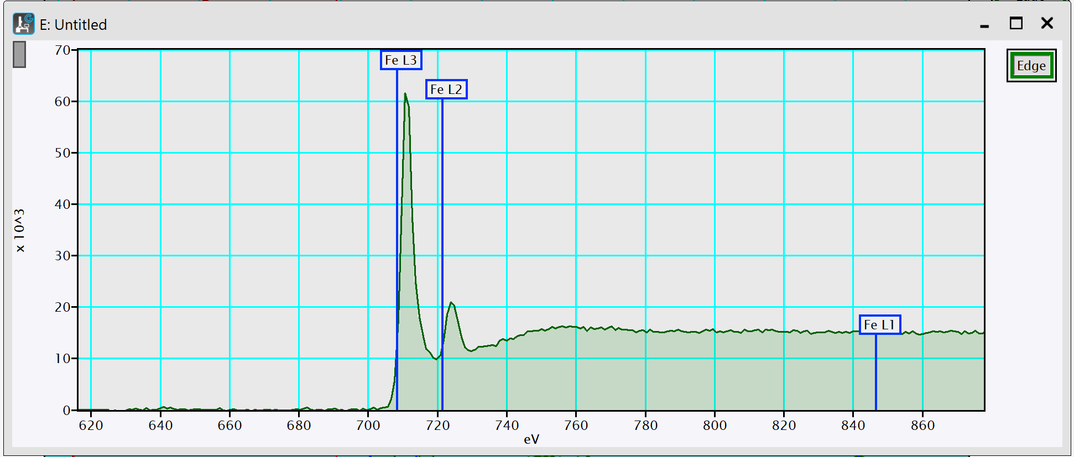

# Calibrate spectrum

When you have identified two features of the spectrum you can calibrate the spectrum.

* Select a region of the spectrum you want to calibrate. Position the two extremities of this window on the known features (Typically two edge onsets).
* A window will pop-up. You can input the two know energies.

The spectrum is calibrated. You don’t need to apply this calibration to the low-losses.

# Compute thickness

To know whether you need to account for plural scattering you can compute the relative thickness in the region of the acquisition thanks to the low-losses.

* Select the extracted low loss spectrum.
* Click on EELS 🡪 Compute Thickness 🡪 Log ratio (relative)

A t/λ ratio will be displayed interactively in the top left corner of the low loss spectrum. When you move the ROI of the line spectra, the t/λ ratio will be recomputed.

The average number of interaction in the sample is given by the t/λ ratio. For a t/λ ratio below one, it is not necessary to account for plural scattering.

# Elemental quantification

## Cross sections

The atomic proportion of elements are determined through cross-section calculations. For core-loss, there are two types of cross-section models : "hydrogenic" or "Hartree-Slater".

* **Hydrogenic**: This a simple atomic model with hydrogenic wave functions where the screening of the electrons is taken into account with a constant. This model is suitable for K edges of light elements and can be adapted empirically for L edges.
* **Hartree-Slater**: This model is more accurate and uses an Hartree-Slater central field model. The elements are considered in their atomic form. Thus, the solid state effects are not taken into account.
* For more details check: Hofer1991_cs_cl_eels.pdf

## Quantification tool

* Go to technique manager 🡪 Analytical 🡪 Elemental Quantification.
* Add the elements you identified using the small periodic table 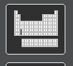.
* Click on the small sigma button on the right . A window will pop with a lot of options. There is a tab for each selected edges. For each edges check those options:
  + Cross Section 🡪 Cross Section model
    - On white lines (mostly transition metal-L edges), it is better to use Hydrogenic (white lines)
    - On K edges, it is better to use Hartree-Slater
  + In Signal Extraction, when available chose the option overlaps X, where X is the previous edge.
  + For t/λ ratio below 1, disable the include plural scattering option
  + It is better to exclude the Energy Loss Near Edge Structures (ELNES) for the chemical quantification.
  + Feel free to test the other options.
* To visualize the models on the spectrum, click on .

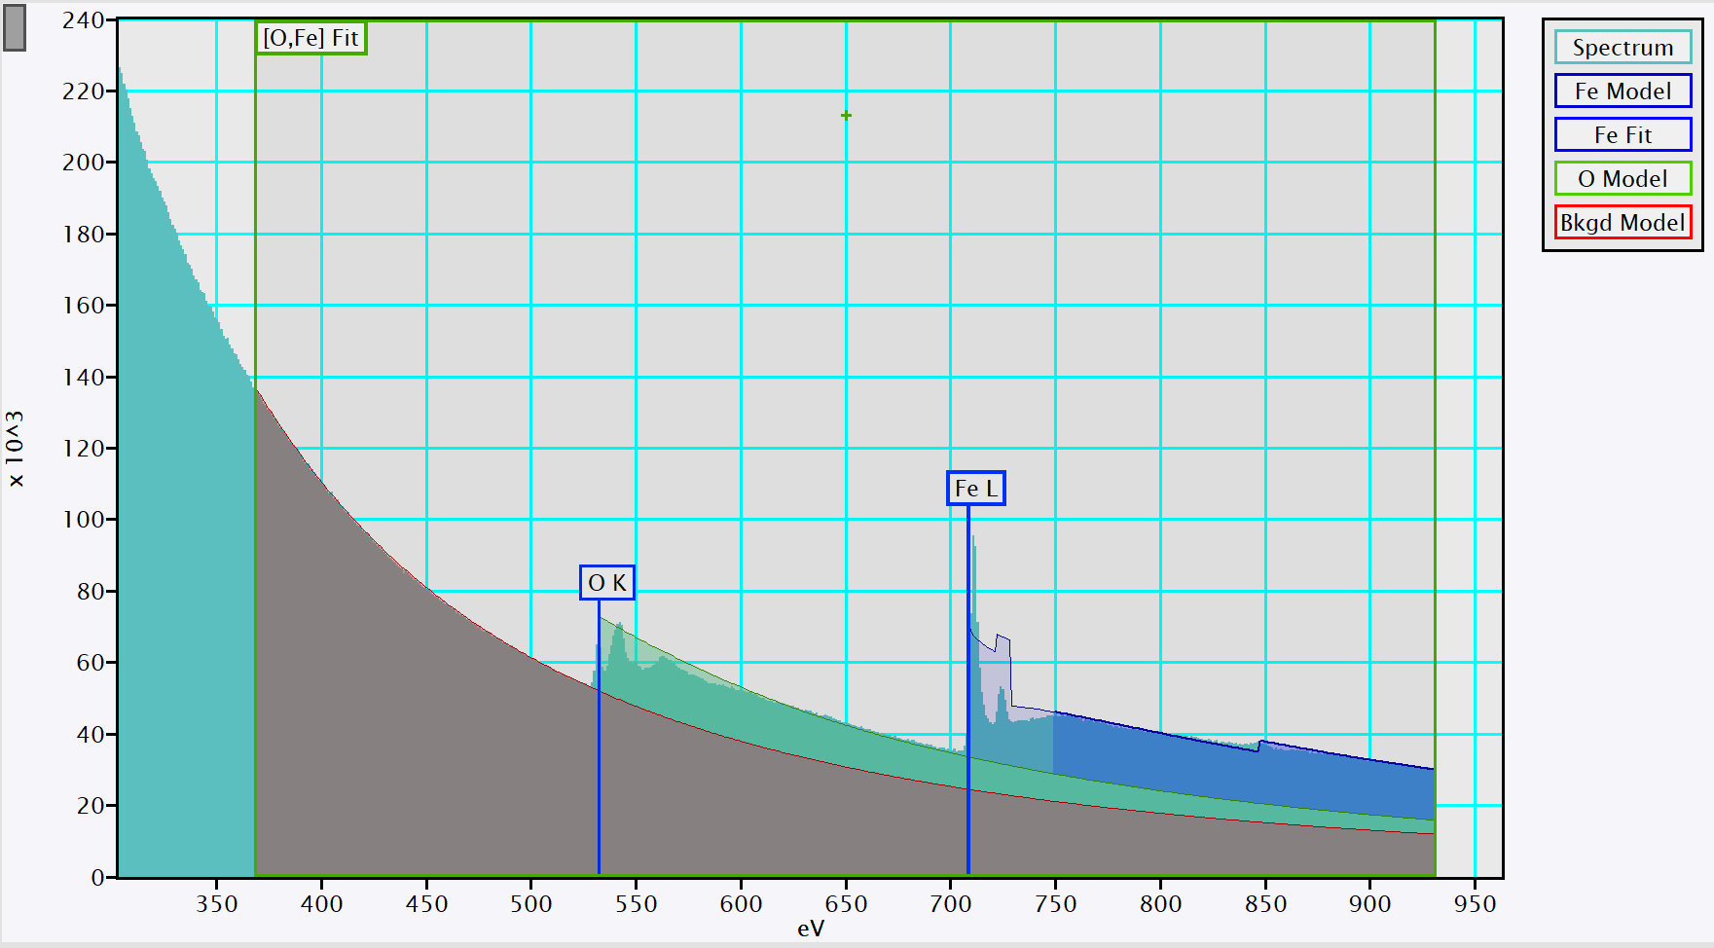

## Display of the results

### Single spectrum quantification

* Click on Quant in the bottom left. A summary of the results will be displayed in the output at the bottom. If you can’t fin the output go to Window 🡪 Floating Windows 🡪 Output.



### Quantification profiles

* Click on Map in the bottom left. A window will open, Click on OK. A new workspace will be created with the profiles, with a quantification at each point of the profile.