EELS data analysis practical QEM2021

Authors: Laura Bocher, Hugo Lourenço-Martins, Cécile Marcelot, Sophie Meuret, Adrien Teurtrie, Bénédicte Warot-Fonrose

# Reminder of Electron Energy-Loss Spectroscopy principles:

This practical is about the analysis of STEM/EELS data. We give you in the first part a quick reminder of what is measured in EELS, its important parameters and also about spectrum imaging.  
After this introduction, the practical is divided into different levels depending on how familiar you are with EELS. In these different parts you’ll be guided through the utilization of Digital Micrograph or Hyperspy for the analysis of STEM/EELS data. Generic examples will be given in these documents and to complete this practical you’re supposed to apply what you have learned and analyze unknown data.

## EELS

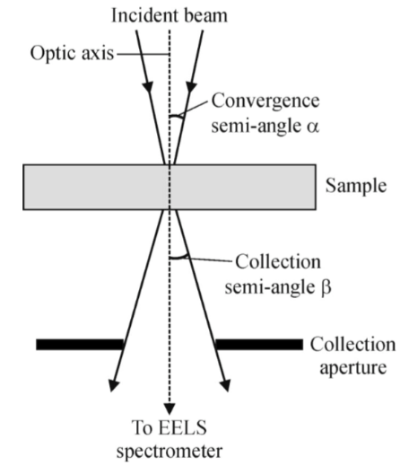In the transmission electron microscope, as the electron beam passes through the sample, it interacts with it. During some of these interactions, the electron will lose some energy. (For a detailed understanding of electron/mater interaction refer to the lectures of G. Kothleitner, H. Lourenço-Martins, L. Galvao-Tizei). These inelastically scattered electrons are collected along the optical axis. The collection is limited by a collection aperture at the entrance of the EELS spectrometer. The collection semi-angle is called β (from a few mrad to a few tens of mrad).   
In the EELS spectrometer, a magnetic prism (along with an optical system) spreads the electrons according to their energy loss onto a detector. The electrons that did not lose energy travel along the spectrometer optical axis. The inelastically scattered electrons are further away from the optical axis the more energy they lost.

The EELS spectrum is divided in two parts. The low losses which correspond to energy losses approximately below 100 eV. It mainly contains the zero-loss peak (electrons that did not lose energy) and the plasmon peaks (Interaction with valence electrons). The core losses which correspond to energy losses approximately above 100 eV. It contains the core loss absorption edges (Interactions with core electrons from atoms.).

The important experimental parameters to consider in EELS are :

* The primary energy of the electron beam. It spans usually between 60 keV to 300 keV.
* The convergence semi-angle α (from a few mrad to a few tens of mrad) and collection semi-angle β. The α and β values are tabulated for every microscope.
* The thickness of the sample (t). If the sample is too thick (t/>0.5, with lambda the inelastic mean free path of typically 100 nm.), the low loss spectrum has to be recorded so that a deconvolution of the multiple scattering can be performed (see figure below).

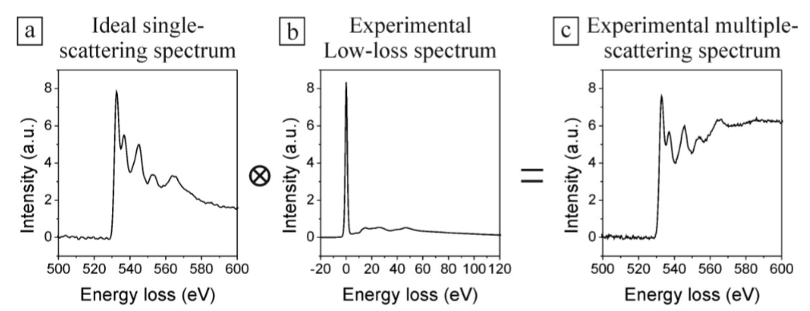

single scattering core loss spectrum low loss spectrum multiple scattering core loss spectrum

General purpose book on EELS: EGERTON, Ray F. Electron energy-loss spectroscopy in the electron microscope. Springer Science & Business Media, 2011.

## Spectrum imaging

In the STEM mode, subsequent EELS spectra are recorded from individual positions by scanning the focused electron beam. Each EELS spectrum (sketched as a vertical column in the first figure) has the full energy resolution determined by the spectrometer and the electron source. Using this technique, EELS spectra can be recorded along a line (e.g. across an interface or grain boundary) or, two-dimensionally, from a certain specimen area – pixel by pixel. Then, a spectrum line corresponds to a vertical slice (a series of vertical columns) of the data cube and a spectrum-image is a series of vertical slices (the whole data cube).

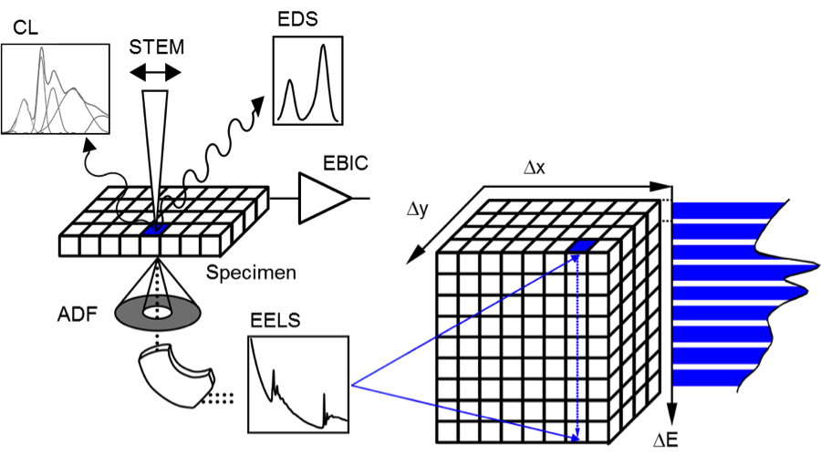

Image taken from: https://www.gatan.com/techniques/spectrum-imaging

# The different practical levels

The practical is divided in three levels, with each a dedicated document and data. You are supposed to do one of those practical. However, you are welcome to do as many of the proposed practicals as you want. If ever you are stuck somewhere, please call a supervisor.

* **Beginner level:** This practical is designed to make you acquainted with the EELS spectrum and the tools to extract simple information from them. You will also learn how to use the basic tools of Digital Micrograph.  
  🡪 Go to Beginner level and open the Beginner_level.pdf
* **Intermediate level:** This practical is designed to make acquainted with the STEM/EELS spectrum image and how to extract maps from it (plasmon maps or chemical maps). You will do it using hyperspy. This practical is divided in two: core loss and low loss:  
  🡪 Open Anaconda prompt and type “conda activate qem”. Then type “jupyter lab”. Open the intermediate_level/core_loss/intermediate_level_core_loss.ipynb or the intermediate_level/low_loss/intermediate_level_low_loss.ipynb.  
  🡪 DM to be done…..
* **Expert level:** This practical is more exploratory and is addressed to people familiar with the basic data analysis. It will only take place on hyperspy and thus it is highly suggested that you go through the low loss intermediate level ipython notebook. You will learn how to use machine learning tools to analyze EELS data.   
  🡪 Open Anaconda prompt and type “conda activate qem”. Then type “jupyter lab”. Open the expert_level/expert_level.ipynb