FooCity Project Requirements Document
CS300 Team 4
Table of Contents
Introduction
Purpose and Scope
Target Audience
Terms and Definitions
Product Overview
Users and Stakeholders
End User
Development Team
Use cases
Continuous Time Mode
Incremental Time Mode
Tile Placement/Zoning Mode
New Game
Load Game
Save Game
Pause Game
Increment Time
Tax Modification
Reports
Exit Game
Functional Requirements
User Interaction
The Game
Nonfunctional Requirements
Cross Platform Support
Performance
Milestones and Deliverables
Milestone 1: Initial Requirements
Milestone 2: Initial Design
Milestone 3: Test Plan
Milestone 4: Product Delivery

Introduction

Purpose and Scope
This document describes the requirements for Team 4’s project, a City Simulation Game. This document defines the user base, use cases, requirements, and lays out milestones for tracking the progress of the project.

Target Audience
This document is intended for users, designers, and developers of the FooCity product.

Terms and Definitions
Map: The map in the game consists of a square grid area with 128x128 tiles, for 16,384 individual locations.
Zone Tiles: Tiles placed by the user on the map that have specific properties. See https://projects.cecs.pdx.edu/attachments/873/table.PNG

Product Overview

Users and Stakeholders
The parties involved in this project are the end user and the development team.

End User
The end user is also the customer. The end user is responsible for interacting with the development team to refine requirements and use cases, and provide feedback as parts of the system are delivered.

Development Team
The development team is responsible for delivering the product. This includes working with the end user to define and refine the product’s requirements, verifying use cases with the end user, and designing, implementing, and testing the product before delivery. The development team must, at a minimum, provide opportunities for feedback at the milestone points.

Use cases
These use cases provide a way to describe the City Game’s interactions with the end user on a case by case basis.

Continuous Time Mode
- In the background:
  - The game updates on a continuous basis
- Game waits for user input

Incremental Time Mode
- Game waits for user input

Tile Placement/Zoning Mode
- User selects tile type to apply
- User selects place on map to apply tile
  - If enough money:
    - Tile is placed at location
  - If not enough money:
    - Error dialog is displayed
- Placement continues until user changes to another mode

New Game
- User selects new game
- New game dialog is displayed with maps
  - If new game is selected:
    - Clear existing game
    - Initialize new game
    - Return to game
  - If user cancels:
    - Return to game

Load Game
- User selects load game
- Load game dialog is displayed with saved games
  - If file is chosen:
    - Clear existing game
    - Load saved game
    - Return to game
  - If user cancels:
    - Return to game

Save Game
- User selects save game
- Save game dialog is displayed
  - If file name is entered:
    - Save game state to file
    - Return to game
  - If user cancels:
    - Return to game

Pause Game
- User selects pause game
- Game is paused until:
  - User selects unpause
- Return to game in continuous mode

Increment Time
- User selects increment time
- The clock is advanced by 1 month
- Return to game in incremental mode

Tax Modification
- User selects taxes
- Tax dialog is shown, including current revenue and tax rates
  - If tax rates are changed:
    - Update rate in game
- If user exists dialog:
  - Return to game

Reports
- User selects reports
- Reports are displayed
- When user confirms, return to game

Exit Game
- User selects exit game
- Validation dialog is shown
  - If user agrees to exit:
    - Unload game
    - Exit
  - If user does not agree:
    - Return to game

Functional Requirements
The following functional requirements describe functionality required of the product.

User Interaction
The product must provide the following functionality:
- Users are able to place zone tiles anywhere on the map, so long as the user has sufficient money to place the tile.
- Users are able to generate reports about the population of residents and businesses by zone, total population, happiness level, pollution level, tax revenue, employment and unemployment, property value, and an overall rating from 0 to 100%.
- Users are able to save and load the state of the game.
- Users are able to load new maps.
- The product must provide a micro and macro view of the map.
- Users should be able to advance the game’s time forward.
- Users should be able to pause the game.
- Users should be able to modify tax rates.
- Users should be able to exit the game.

The Game
The simulation must provide for the behavior of the zone tiles specified by the following table:
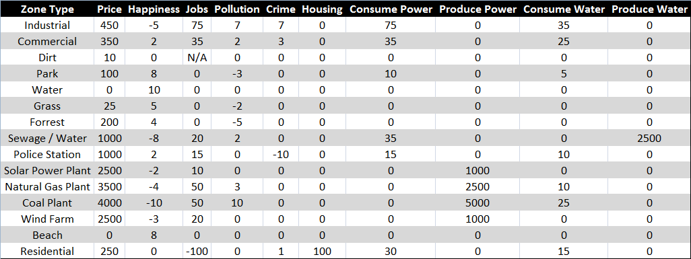

Nonfunctional Requirements
This section describes qualities of the product, rather than the functions of the product.

Cross Platform Support
The product must run on recent versions of Windows, OS X, and Linux. Recent is defined as release within the last 2 years.

Performance
The product must be responsive to user input. Delays on the order of more than 1 second in response time is undesirable.

Milestones and Deliverables
The various milestones are described here, to provide for project tracking and to enable interaction between the end user and the development team.

Milestone 1: Initial Requirements
This milestone represents the end user’s initial acceptance of the requirements: scope statements, use cases, functional and non-functional requirements, and milestone schedules.

Milestone 2: Initial Design
This milestone represents the end user’s initial acceptance of the design document, which will outline the specific architecture of the product. This document includes class and state diagrams from which implementation and testing will commence.

Milestone 3: Test Plan
This milestone represents the initial completion of the test plan, to minimize the number of defects and to ensure that the product matches the requirements and use cases.

Milestone 4: Product Delivery
This milestone is reached with the product satisfies the test plan, which indicates that the product meets requirements.

