## January 30, 2020

[name]

[company]

[address]

[city_province_postalcode]

Dear [prefix] [name]

My name is Adrien Tremblay. I am applying for [position] through Concordia University’s CO-OP program. I am keen to make valuable contribution to your organization through the key skills and qualifications I possess. I thrive in work environments that value teamwork and empower employees to take initiative. One of my core strengths is ability to learn new technologies quickly. I am eager to meet new challenges and make practical use of my software development experience.

I am knowledgeable in object-orientated programming as demonstrated by my CRC Robotics Simulation personal project in which I used Java and the JMonkey3 game engine to create an interactive 3D simulation. I also attained the grades of A- and A for Object Oriented Programming I, and Object Oriented Programming II during my studies.

Additionally, I have extensive Web Development knowledge in multiple languages and frameworks such as PHP, Django, and Flask. My work can be seen on my personal website www.adrientremblay.com or on the StudySpotter CodeJam hackathon project. I have experience using the command line, PostgreSQL, creating APIs and most importantly I am passionate about web app development!

Moreover, I greatly enjoy collaborative work because ultimately everyone has different strengths and knowledges to impart on one another. Some of the people I’ve met while working in teams have become great inspirations and good friends of mine. As a Space Concordia Software Team member, I also learned about the agile methodology, git workflow and conventions, as well as advanced my knowledge in good programming practice. Working with Space Concordia allowed me to further my appreciation for the process of critiquing code, solving issues, and watching software evolve.

Software has been my passion since childhood. I strive to be an out-of-the-box thinker, write high quality code, and to take initiative in everything that I do. Because of my object oriented programming experience, web experience, studies in theoretical computer science and work within agile teams, I believe I would contribute greatly to your company. Thank you very much for your consideration. I look forward to meeting for an interview.

Sincerely,

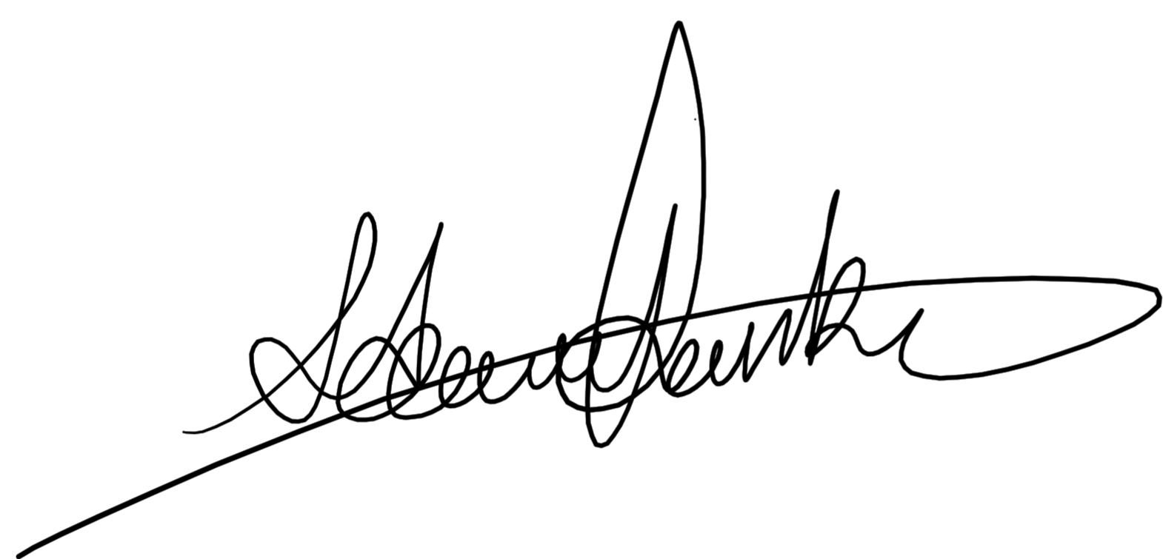

Adrien Tremblay