SPATIAL STORIES
Redesigning Instagram Story Creation for Mixed Reality
Name: ______________________________ Student ID: ____________________
APPLICATION  Instagram Story | CATEGORY  Creation · Editing · Social Connection | TARGET XR  Room-scale MR · Hand tracking
01 CONCEPT OVERVIEW
Spatial Stories transforms the phone-based Instagram Story workflow into an embodied mixed reality editing space. Photos and videos from the user’s album appear as floating cards in front of them. Using direct hand gestures, the user can select media, enlarge and inspect it, add text or stickers, discard unwanted elements, and publish the finished Story. The concept focuses on testing whether spatial manipulation can make Story creation more intuitive, expressive, and engaging than navigating several two-dimensional menus.
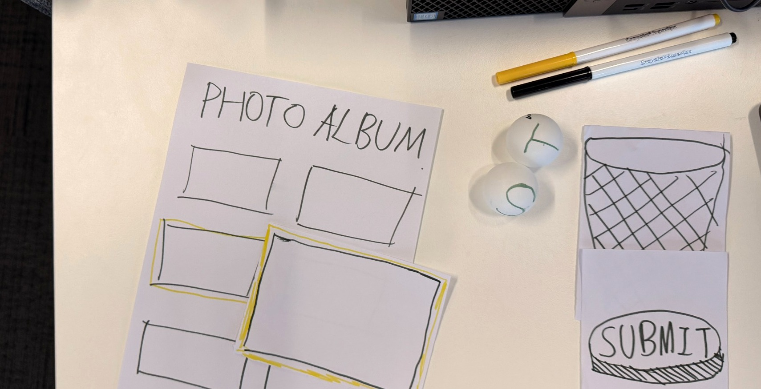
Figure 1. Week 2 low-fidelity prototype: floating album, highlighted media card, T/S tool spheres, trash bin and submit button.
02 USER TASKS AND GOALS
1 BROWSE & SELECT MEDIA  Task: Scan album photos and videos displayed as floating cards. Point or pinch to select; the chosen card receives a yellow outline.  Goal: Compare options and quickly choose suitable Story content. | 2 INSPECT & ORGANISE  Task: Grab a selected card so it enlarges in the centre of view. Inspect details by moving the head or body, then pinch to minimise and continue selecting.  Goal: Check visual details and prepare content without opening extra menus.
3 ADD TEXT & STICKERS  Task: Select the floating T or S sphere, create the element, then grab, place, scale or rotate it directly on the media.  Goal: Personalise the Story through expressive spatial editing. | 4 REMOVE & PUBLISH  Task: Throw unwanted media or overlays into the trash bin on the left. When editing is complete, strike the large red submit button.  Goal: Correct mistakes and complete publishing through clear physical actions.

HOW THE CONCEPT WORKS
A spatial workflow built around direct manipulation rather than a floating copy of the mobile interface.
03 IMMERSIVE INTERACTION FLOW AND AFFORDANCES
01 ENTER  A curved album wall appears at comfortable viewing and reaching distance. | 02 SELECT  Point or pinch a card. A yellow outline makes the current selection visible. | 03 GRAB  Directly grab the card; it follows the hand and expands into the centre of view.
04 INSPECT  Move the head or body to examine details. Pinch inward to minimise the media. | 05 EDIT  Choose the T or S sphere, then place and transform text or stickers on the Story. | 06 FINISH  Throw unwanted objects left into the bin. Strike the red button to publish.
Key affordances: spatial organisation (album wall and fixed zones) · direct manipulation (grab, move, scale and throw) · embodied inspection (head/body movement) · visible feedback (yellow highlight, tool glow, object disappearance and publish-state change).
04 IDEATION AND REFINEMENT
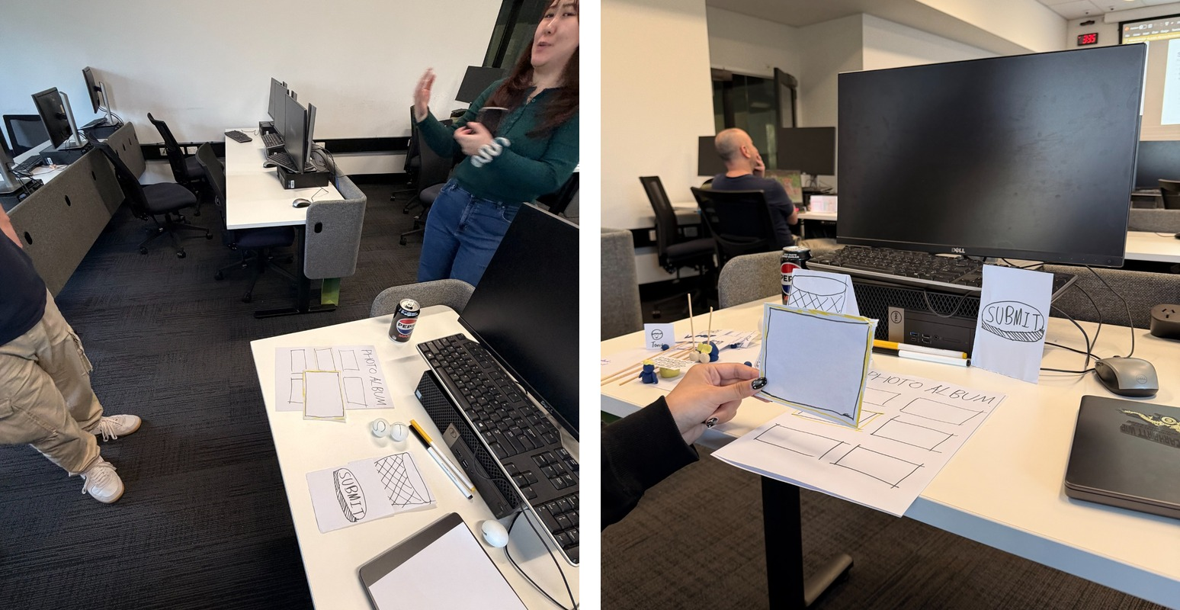  Figure 2. Play-acting the spatial selection and direct-grab interaction in the studio. | The initial idea was a simple floating album from which a user could choose one image. The Week 2 paper prototype expanded this into a complete spatial Story workflow.  Refinement 1 — A yellow border was added so users can recognise selected media.  Refinement 2 — Grabbing now enlarges media for close inspection; pinching returns it to the album.  Refinement 3 — Text and sticker functions became two separate T/S tool spheres for clearer discovery.  Refinement 4 — The bin stays on the left and the red submit button appears only after editing, creating a readable sequence: browse → inspect → edit → discard → publish.
05 INITIAL TESTING PLAN
Method: Conduct a think-aloud, Wizard-of-Oz walkthrough with 4–6 people who have previously created Instagram Stories. A facilitator will reveal and move the paper elements to simulate system responses while each participant completes the full workflow.
INTERACTION / FEATURE | ASSUMPTION TO VALIDATE | DATA TO COLLECT
Select and grab a media card | The yellow highlight communicates selection, and users understand that the card can be directly grabbed. | Time to first correct action; task success; wrong selections/gestures; prompts; think-aloud comments.
Enlarge, inspect and pinch to minimise | Direct enlargement and pinch-to-minimise feel natural and give enough control to inspect details. | Completion time; failed attempts; head/body movement observed; 1–5 naturalness rating.
Use T/S spheres and place overlays | Users can infer the meaning of the two tool spheres and manipulate text/stickers without a conventional menu. | Correct tool choice; placement/scale errors; prompts; ease rating; interview feedback.
Throw away content and publish | The left-side bin clearly means delete, and the large red button clearly means publish without causing accidental submission. | Deletion/publish success; hesitation time; accidental actions; confidence rating; final preference comments.
Initial success indicator: an interaction is promising when at least 80% of participants complete it without facilitator help, with no repeated critical error and an average naturalness/ease rating of 4/5 or higher.

