

INSTITUO TECNOLÓGICO TECSUP
ENTREGA 3
“BASE DE DATOS”
- Docente: Gonzalo Suarez García.

- Integrantes:
- Abad Anchiraico Luis Pablo.
- Abad Mejia Jordan Alonso.
- Yldefonso Solis Becker.

- Sección: 2-C24-A.

- Fecha de Entrega: 29 de noviembre.

- Ciclo: 2025-2.

- Tema de su Preferencia: Desarrollo de un Sistema de Gestión de Estudiantes con Conexión a Base de Datos.

- Main.java:
package view;
import Controller.CourseController;
import Controller.ProfessorController;
import Controller.StudentController;
import java.util.Scanner;
public class Main {
public static void main(String[] args) {
Scanner scanner = new Scanner(System.in);
StudentController studentController = new StudentController();
ProfessorController professorController = new ProfessorController();
CourseController courseController = new CourseController();
int option;
do {
System.out.println("\n=== SISTEMA ACADEMICO ===");
System.out.println("1. Gestionar Estudiantes");
System.out.println("2. Gestionar Profesores");
System.out.println("3. Gestionar Cursos");
System.out.println("0. Salir");
System.out.print("Seleccione una opcion: ");
String input = scanner.nextLine();
try {
option = Integer.parseInt(input.trim());
} catch (NumberFormatException e) {
option = -1;
}
switch (option) {
case 1 -> studentController.showMenu(scanner);
case 2 -> professorController.showMenu(scanner);
case 3 -> courseController.showMenu(scanner);
case 0 -> System.out.println("Saliendo del sistema...");
default -> System.out.println("Opción inválida.");
}
} while (option != 0);
scanner.close();
}
}

- DatabaseConnection.java:
- package config;
import java.sql.Connection;
import java.sql.DriverManager;
import java.sql.SQLException;
public class DatabaseConnection {
private static final String URL =
"jdbc:mysql://localhost:3306/sistema_academico?useSSL=false&serverTimezone=UTC";
private static final String USER = "root";
private static final String PASSWORD = "";
public static Connection getConnection() throws SQLException {
return DriverManager.getConnection(URL, USER, PASSWORD);
}
}

- CourseController.java:
- package Controller;
import dao.CourseDAO;
import model.Course;
import java.sql.SQLException;
import java.util.HashMap;
import java.util.List;
import java.util.Map;
import java.util.Scanner;
public class CourseController {
private final CourseDAO courseDAO = new CourseDAO();
public void showMenu(Scanner scanner) {
Map<Integer, Runnable> actions = new HashMap<>();
actions.put(1, () -> listCourses());
actions.put(2, () -> createCourse(scanner));
actions.put(3, () -> updateCourse(scanner));
actions.put(4, () -> deleteCourse(scanner));
actions.put(5, () -> findCourse(scanner));
int option;
do {
System.out.println("\n--- GESTIONAR CURSOS ---");
System.out.println("1. Listar cursos");
System.out.println("2. Registrar curso");
System.out.println("3. Actualizar curso");
System.out.println("4. Eliminar curso");
System.out.println("5. Buscar curso por ID");
System.out.println("0. Volver al menú principal");
System.out.print("Seleccione una opción: ");
option = readInt(scanner);
if (option == 0) {
System.out.println("Volviendo al menú principal...");
} else {
Runnable action = actions.get(option);
if (action != null) {
action.run();
} else {
System.out.println("Opción inválida.");
}
}
} while (option != 0);
}
private void listCourses() {
try {
List<Course> list = courseDAO.findAll();
if (list.isEmpty()) {
System.out.println("No hay cursos registrados.");
return;
}
System.out.println("\nID | Nombre | Créditos | Semestre");
System.out.println("------------------------------------------");
for (Course c : list) {
System.out.printf(
"%d | %s | %d | %d%n",
c.getId(),
c.getName(),
c.getCredits(),
c.getSemester()
);
}
} catch (SQLException e) {
System.out.println("Error al listar cursos: " + e.getMessage());
}
}
private void createCourse(Scanner scanner) {
try {
Course course = readCourseData(scanner);
courseDAO.create(course);
System.out.println("Curso registrado correctamente.");
} catch (SQLException e) {
System.out.println("Error al registrar curso: " + e.getMessage());
}
}
private void updateCourse(Scanner scanner) {
System.out.print("Ingrese el ID del curso a actualizar: ");
int id = readInt(scanner);
try {
Course existing = courseDAO.findById(id);
if (existing == null) {
System.out.println("No existe un curso con ese ID.");
return;
}
Course course = readCourseData(scanner);
course.setId(id);
courseDAO.update(course);
System.out.println("Curso actualizado correctamente.");
} catch (SQLException e) {
System.out.println("Error al actualizar curso: " + e.getMessage());
}
}
private void deleteCourse(Scanner scanner) {
System.out.print("Ingrese el ID del curso a eliminar: ");
int id = readInt(scanner);
try {
courseDAO.delete(id);
System.out.println("Curso eliminado correctamente.");
} catch (SQLException e) {
System.out.println("Error al eliminar curso: " + e.getMessage());
}
}
private void findCourse(Scanner scanner) {
System.out.print("Ingrese el ID del curso: ");
int id = readInt(scanner);
try {
Course c = courseDAO.findById(id);
if (c == null) {
System.out.println("No existe un curso con ese ID.");
return;
}
System.out.println("\nID: " + c.getId());
System.out.println("Nombre: " + c.getName());
System.out.println("Créditos: " + c.getCredits());
System.out.println("Semestre: " + c.getSemester());
} catch (SQLException e) {
System.out.println("Error al buscar curso: " + e.getMessage());
}
}
private Course readCourseData(Scanner scanner) {
Course course = new Course();
System.out.print("Nombre del curso: ");
course.setName(readNonEmptyText(scanner));
course.setCredits(readPositiveInt(scanner, "Créditos (1-20): ", 1, 20));
course.setSemester(readPositiveInt(scanner, "Semestre (1-12): ", 1, 12));
return course;
}
private int readInt(Scanner scanner) {
while (true) {
String line = scanner.nextLine();
try {
return Integer.parseInt(line.trim());
} catch (NumberFormatException e) {
System.out.print("Número inválido, intente de nuevo: ");
}
}
}
private int readPositiveInt(Scanner scanner, String label, int min, int max) {
while (true) {
System.out.print(label);
int value = readInt(scanner);
if (value >= min && value <= max) {
return value;
}
System.out.println("Valor inválido. Debe estar entre " + min + " y " + max + ".");
}
}
private String readNonEmptyText(Scanner scanner) {
while (true) {
String text = scanner.nextLine().trim();
if (!text.isEmpty()) {
return text;
}
System.out.print("Este campo es obligatorio, intente de nuevo: ");
}
}
}

- ProfessorController.java:

- package Controller;
import dao.ProfessorDAO;
import model.Professor;
import java.sql.SQLException;
import java.util.HashMap;
import java.util.List;
import java.util.Map;
import java.util.Scanner;
import java.util.regex.Pattern;
public class ProfessorController {
private final ProfessorDAO professorDAO = new ProfessorDAO();
public void showMenu(Scanner scanner) {
Map<Integer, Runnable> actions = new HashMap<>();
actions.put(1, () -> listProfessors());
actions.put(2, () -> createProfessor(scanner));
actions.put(3, () -> updateProfessor(scanner));
actions.put(4, () -> deleteProfessor(scanner));
actions.put(5, () -> findProfessor(scanner));
int option;
do {
System.out.println("\n--- GESTIONAR PROFESORES ---");
System.out.println("1. Listar profesores");
System.out.println("2. Registrar profesor");
System.out.println("3. Actualizar profesor");
System.out.println("4. Eliminar profesor");
System.out.println("5. Buscar profesor por ID");
System.out.println("0. Volver al menú principal");
System.out.print("Seleccione una opción: ");
option = readInt(scanner);
if (option == 0) {
System.out.println("Volviendo al menú principal...");
} else {
Runnable action = actions.get(option);
if (action != null) {
action.run();
} else {
System.out.println("Opción inválida.");
}
}
} while (option != 0);
}
private void listProfessors() {
try {
List<Professor> list = professorDAO.findAll();
if (list.isEmpty()) {
System.out.println("No hay profesores registrados.");
return;
}
System.out.println("\nID | Nombre completo | DNI | Especialidad | Horas dictadas");
System.out.println("---------------------------------------------------------------------");
for (Professor p : list) {
System.out.printf(
"%d | %s %s %s | %s | %s | %d%n",
p.getId(),
p.getFirstName(),
p.getLastName(),
p.getMiddleName(),
p.getDocumentNumber(),
p.getSpecialty(),
p.getTaughtHours()
);
}
} catch (SQLException e) {
System.out.println("Error al listar profesores: " + e.getMessage());
}
}
private void createProfessor(Scanner scanner) {
try {
Professor professor = readProfessorData(scanner);
professorDAO.create(professor);
System.out.println("Profesor registrado correctamente.");
} catch (SQLException e) {
System.out.println("Error al registrar profesor: " + e.getMessage());
}
}
private void updateProfessor(Scanner scanner) {
System.out.print("Ingrese el ID del profesor a actualizar: ");
int id = readInt(scanner);
try {
Professor existing = professorDAO.findById(id);
if (existing == null) {
System.out.println("No existe un profesor con ese ID.");
return;
}
Professor professor = readProfessorData(scanner);
professor.setId(id);
professorDAO.update(professor);
System.out.println("Profesor actualizado correctamente.");
} catch (SQLException e) {
System.out.println("Error al actualizar profesor: " + e.getMessage());
}
}
private void deleteProfessor(Scanner scanner) {
System.out.print("Ingrese el ID del profesor a eliminar: ");
int id = readInt(scanner);
try {
professorDAO.delete(id);
System.out.println("Profesor eliminado correctamente.");
} catch (SQLException e) {
System.out.println("Error al eliminar profesor: " + e.getMessage());
}
}
private void findProfessor(Scanner scanner) {
System.out.print("Ingrese el ID del profesor: ");
int id = readInt(scanner);
try {
Professor p = professorDAO.findById(id);
if (p == null) {
System.out.println("No existe un profesor con ese ID.");
return;
}
System.out.println("\nID: " + p.getId());
System.out.println("Nombre: " + p.getFirstName());
System.out.println("Apellido paterno: " + p.getLastName());
System.out.println("Apellido materno: " + p.getMiddleName());
System.out.println("DNI: " + p.getDocumentNumber());
System.out.println("Especialidad: " + p.getSpecialty());
System.out.println("Correo: " + p.getEmail());
System.out.println("Teléfono: " + p.getPhone());
System.out.println("Horas dictadas: " + p.getTaughtHours());
} catch (SQLException e) {
System.out.println("Error al buscar profesor: " + e.getMessage());
}
}
private Professor readProfessorData(Scanner scanner) {
Professor professor = new Professor();
System.out.print("Nombre: ");
professor.setFirstName(readNonEmptyText(scanner));
System.out.print("Apellido paterno: ");
professor.setLastName(readNonEmptyText(scanner));
System.out.print("Apellido materno: ");
professor.setMiddleName(readNonEmptyText(scanner));
professor.setDocumentNumber(readDocumentNumber(scanner));
System.out.print("Especialidad: ");
professor.setSpecialty(readNonEmptyText(scanner));
professor.setEmail(readEmail(scanner));
professor.setPhone(readPhone(scanner));
professor.setTaughtHours(readNonNegativeInt(scanner, "Horas dictadas: "));
return professor;
}
private int readInt(Scanner scanner) {
while (true) {
String line = scanner.nextLine();
try {
return Integer.parseInt(line.trim());
} catch (NumberFormatException e) {
System.out.print("Número inválido, intente de nuevo: ");
}
}
}
private int readNonNegativeInt(Scanner scanner, String label) {
while (true) {
System.out.print(label);
int value = readInt(scanner);
if (value >= 0) {
return value;
}
System.out.println("El valor no puede ser negativo.");
}
}
private String readNonEmptyText(Scanner scanner) {
while (true) {
String text = scanner.nextLine().trim();
if (!text.isEmpty()) {
return text;
}
System.out.print("Este campo es obligatorio, intente de nuevo: ");
}
}
private String readDocumentNumber(Scanner scanner) {
Pattern pattern = Pattern.compile("^[0-9]{8}$");
while (true) {
System.out.print("DNI (8 dígitos): ");
String value = scanner.nextLine().trim();
if (pattern.matcher(value).matches()) {
return value;
}
System.out.println("DNI inválido. Debe tener exactamente 8 dígitos numéricos.");
}
}
private String readEmail(Scanner scanner) {
while (true) {
System.out.print("Correo (ENTER si no tiene): ");
String email = scanner.nextLine().trim();
if (email.isEmpty()) {
return null;
}
if (email.contains("@") && email.contains(".") && email.length() >= 5) {
return email;
}
System.out.println("Correo inválido. Debe contener '@' y '.'.");
}
}
private String readPhone(Scanner scanner) {
Pattern pattern = Pattern.compile("^[0-9]{9}$");
while (true) {
System.out.print("Teléfono (9 dígitos): ");
String phone = scanner.nextLine().trim();
if (pattern.matcher(phone).matches()) {
return phone;
}
System.out.println("Teléfono inválido. Debe tener exactamente 9 dígitos numéricos.");
}
}

- StudentController.java:
- package Controller;
import dao.StudentDAO;
import model.Student;
import java.sql.SQLException;
import java.time.LocalDate;
import java.time.Period;
import java.time.format.DateTimeParseException;
import java.util.HashMap;
import java.util.List;
import java.util.Map;
import java.util.Scanner;
import java.util.regex.Pattern;
public class StudentController {
private final StudentDAO studentDAO = new StudentDAO();
public void showMenu(Scanner scanner) {
Map<Integer, Runnable> actions = new HashMap<>();
actions.put(1, () -> listStudents());
actions.put(2, () -> createStudent(scanner));
actions.put(3, () -> updateStudent(scanner));
actions.put(4, () -> deleteStudent(scanner));
actions.put(5, () -> findStudent(scanner));
int option;
do {
System.out.println("\n--- GESTIONAR ESTUDIANTES ---");
System.out.println("1. Listar estudiantes");
System.out.println("2. Registrar estudiante");
System.out.println("3. Actualizar estudiante");
System.out.println("4. Eliminar estudiante");
System.out.println("5. Buscar estudiante por ID");
System.out.println("0. Volver al menú principal");
System.out.print("Seleccione una opción: ");
option = readInt(scanner);
if (option == 0) {
System.out.println("Volviendo al menú principal...");
} else {
Runnable action = actions.get(option);
if (action != null) {
action.run();
} else {
System.out.println("Opción inválida.");
}
}
} while (option != 0);
}
private void listStudents() {
try {
List<Student> students = studentDAO.findAll();
if (students.isEmpty()) {
System.out.println("No hay estudiantes registrados.");
return;
}
System.out.println("\nID | Nombre completo | DNI | Edad | Carrera | Ciclo | Estado");
System.out.println("---------------------------------------------------------------------");
for (Student s : students) {
System.out.printf(
"%d | %s %s %s | %s | %d | %s | %d | %s%n",
s.getId(),
s.getFirstName(),
s.getLastName(),
s.getMiddleName(),
s.getDocumentNumber(),
s.getAge(),
s.getMajor(),
s.getCycle(),
s.getStatus()
);
}
} catch (SQLException e) {
System.out.println("Error al listar estudiantes: " + e.getMessage());
}
}
private void createStudent(Scanner scanner) {
try {
Student student = readStudentData(scanner);
studentDAO.create(student);
System.out.println("Estudiante registrado correctamente.");
} catch (SQLException e) {
System.out.println("Error al registrar estudiante: " + e.getMessage());
}
}
private void updateStudent(Scanner scanner) {
System.out.print("Ingrese el ID del estudiante a actualizar: ");
int id = readInt(scanner);
try {
Student existing = studentDAO.findById(id);
if (existing == null) {
System.out.println("No existe un estudiante con ese ID.");
return;
}
Student student = readStudentData(scanner);
student.setId(id);
studentDAO.update(student);
System.out.println("Estudiante actualizado correctamente.");
} catch (SQLException e) {
System.out.println("Error al actualizar estudiante: " + e.getMessage());
}
}
private void deleteStudent(Scanner scanner) {
System.out.print("Ingrese el ID del estudiante a eliminar: ");
int id = readInt(scanner);
try {
studentDAO.delete(id);
System.out.println("Estudiante eliminado correctamente.");
} catch (SQLException e) {
System.out.println("Error al eliminar estudiante: " + e.getMessage());
}
}
private void findStudent(Scanner scanner) {
System.out.print("Ingrese el ID del estudiante: ");
int id = readInt(scanner);
try {
Student s = studentDAO.findById(id);
if (s == null) {
System.out.println("No existe un estudiante con ese ID.");
return;
}
System.out.println("\nID: " + s.getId());
System.out.println("Nombre: " + s.getFirstName());
System.out.println("Apellido paterno: " + s.getLastName());
System.out.println("Apellido materno: " + s.getMiddleName());
System.out.println("DNI: " + s.getDocumentNumber());
System.out.println("Correo: " + s.getEmail());
System.out.println("Teléfono: " + s.getPhone());
System.out.println("Edad: " + s.getAge());
System.out.println("Carrera: " + s.getMajor());
System.out.println("Ciclo: " + s.getCycle());
System.out.println("Estado: " + s.getStatus());
} catch (SQLException e) {
System.out.println("Error al buscar estudiante: " + e.getMessage());
}
}
private Student readStudentData(Scanner scanner) {
Student student = new Student();
System.out.print("Nombre: ");
student.setFirstName(readNonEmptyText(scanner));
System.out.print("Apellido paterno: ");
student.setLastName(readNonEmptyText(scanner));
System.out.print("Apellido materno: ");
student.setMiddleName(readNonEmptyText(scanner));
student.setDocumentNumber(readDocumentNumber(scanner));
System.out.print("Dirección: ");
student.setAddress(scanner.nextLine().trim());
student.setEmail(readEmail(scanner));
student.setPhone(readPhone(scanner));
LocalDate birthDate = readBirthDate(scanner);
student.setBirthDate(birthDate);
int age = Period.between(birthDate, LocalDate.now()).getYears();
student.setAge(age);
student.setGender(readGender(scanner));
System.out.print("Distrito: ");
student.setDistrict(readNonEmptyText(scanner));
System.out.print("Carrera: ");
student.setMajor(readNonEmptyText(scanner));
student.setCycle(readCycle(scanner));
student.setStatus(readStatus(scanner));
return student;
}
private int readInt(Scanner scanner) {
while (true) {
String line = scanner.nextLine();
try {
return Integer.parseInt(line.trim());
} catch (NumberFormatException e) {
System.out.print("Número inválido, intente de nuevo: ");
}
}
}
private String readNonEmptyText(Scanner scanner) {
while (true) {
String text = scanner.nextLine().trim();
if (!text.isEmpty()) {
return text;
}
System.out.print("Este campo es obligatorio, intente de nuevo: ");
}
}
private String readDocumentNumber(Scanner scanner) {
Pattern pattern = Pattern.compile("^[0-9]{8}$");
while (true) {
System.out.print("DNI (8 dígitos): ");
String value = scanner.nextLine().trim();
if (pattern.matcher(value).matches()) {
return value;
}
System.out.println("DNI inválido. Debe tener exactamente 8 dígitos numéricos.");
}
}
private String readEmail(Scanner scanner) {
while (true) {
System.out.print("Correo (ENTER si no tiene): ");
String email = scanner.nextLine().trim();
if (email.isEmpty()) {
return null;
}
if (email.contains("@") && email.contains(".") && email.length() >= 5) {
return email;
}
System.out.println("Correo inválido. Debe contener '@' y '.'.");
}
}
private String readPhone(Scanner scanner) {
Pattern pattern = Pattern.compile("^[0-9]{9}$");
while (true) {
System.out.print("Teléfono (9 dígitos): ");
String phone = scanner.nextLine().trim();
if (pattern.matcher(phone).matches()) {
return phone;
}
System.out.println("Teléfono inválido. Debe tener exactamente 9 dígitos numéricos.");
}
}
private LocalDate readBirthDate(Scanner scanner) {
while (true) {
System.out.print("Fecha de nacimiento (yyyy-MM-dd): ");
String input = scanner.nextLine().trim();
try {
LocalDate date = LocalDate.parse(input);
int age = Period.between(date, LocalDate.now()).getYears();
if (age < 16) {
System.out.println("El estudiante debe tener al menos 16 años.");
continue;
}
if (age <= 0 || age > 99) {
System.out.println("Edad inválida.");
continue;
}
return date;
} catch (DateTimeParseException e) {
System.out.println("Formato de fecha inválido.");
}
}
}
private String readGender(Scanner scanner) {
while (true) {
System.out.print("Sexo (M/F): ");
String gender = scanner.nextLine().trim().toUpperCase();
if (gender.equals("M") || gender.equals("F")) {
return gender;
}
System.out.println("Sexo inválido.");
}
}
private int readCycle(Scanner scanner) {
while (true) {
System.out.print("Ciclo: ");
int cycle = readInt(scanner);
if (cycle >= 1 && cycle <= 20) {
return cycle;
}
System.out.println("Ciclo inválido. Debe estar entre 1 y 20.");
}
}
private String readStatus(Scanner scanner) {
while (true) {
System.out.print("Estado (activo/inactivo, ENTER=activo): ");
String status = scanner.nextLine().trim().toLowerCase();
if (status.isEmpty()) {
return "activo";
}
if (status.equals("activo") || status.equals("inactivo")) {
return status;
}
System.out.println("Estado inválido.");
}
}
}

- CourseDAO.java:
- package dao;
import config.DatabaseConnection;
import model.Course;
import java.sql.*;
import java.util.ArrayList;
import java.util.List;
public class CourseDAO {
public void create(Course course) throws SQLException {
String sql = "INSERT INTO curso (nombre_curso, creditos, semestre) VALUES (?, ?, ?)";
try (Connection connection = DatabaseConnection.getConnection();
PreparedStatement statement = connection.prepareStatement(sql)) {
statement.setString(1, course.getName());
statement.setInt(2, course.getCredits());
statement.setInt(3, course.getSemester());
statement.executeUpdate();
}
}
public void update(Course course) throws SQLException {
String sql = "UPDATE curso SET nombre_curso=?, creditos=?, semestre=? WHERE id_curso=?";
try (Connection connection = DatabaseConnection.getConnection();
PreparedStatement statement = connection.prepareStatement(sql)) {
statement.setString(1, course.getName());
statement.setInt(2, course.getCredits());
statement.setInt(3, course.getSemester());
statement.setInt(4, course.getId());
statement.executeUpdate();
}
}
public void delete(int id) throws SQLException {
String sql = "DELETE FROM curso WHERE id_curso=?";
try (Connection connection = DatabaseConnection.getConnection();
PreparedStatement statement = connection.prepareStatement(sql)) {
statement.setInt(1, id);
statement.executeUpdate();
}
}
public Course findById(int id) throws SQLException {
String sql = "SELECT * FROM curso WHERE id_curso=?";
try (Connection connection = DatabaseConnection.getConnection();
PreparedStatement statement = connection.prepareStatement(sql)) {
statement.setInt(1, id);
try (ResultSet rs = statement.executeQuery()) {
if (rs.next()) {
return mapRow(rs);
}
}
}
return null;
}
public List<Course> findAll() throws SQLException {
String sql = "SELECT * FROM curso ORDER BY id_curso";
List<Course> list = new ArrayList<>();
try (Connection connection = DatabaseConnection.getConnection();
PreparedStatement statement = connection.prepareStatement(sql);
ResultSet rs = statement.executeQuery()) {
while (rs.next()) {
list.add(mapRow(rs));
}
}
return list;
}
private Course mapRow(ResultSet rs) throws SQLException {
Course course = new Course();
course.setId(rs.getInt("id_curso"));
course.setName(rs.getString("nombre_curso"));
course.setCredits(rs.getInt("creditos"));
course.setSemester(rs.getInt("semestre"));
return course;
}
}

- ProfessorDAO.java :
- package dao;
import config.DatabaseConnection;
import model.Professor;
import java.sql.*;
import java.util.ArrayList;
import java.util.List;
public class ProfessorDAO {
public void create(Professor professor) throws SQLException {
String sql = "INSERT INTO profesor " +
"(nombre, apellido_paterno, apellido_materno, dni, especialidad, correo, telefono, horas_dictadas) " +
"VALUES (?, ?, ?, ?, ?, ?, ?, ?)";
try (Connection connection = DatabaseConnection.getConnection();
PreparedStatement statement = connection.prepareStatement(sql)) {
statement.setString(1, professor.getFirstName());
statement.setString(2, professor.getLastName());
statement.setString(3, professor.getMiddleName());
statement.setString(4, professor.getDocumentNumber());
statement.setString(5, professor.getSpecialty());
statement.setString(6, professor.getEmail());
statement.setString(7, professor.getPhone());
statement.setInt(8, professor.getTaughtHours());
statement.executeUpdate();
}
}
public void update(Professor professor) throws SQLException {
String sql = "UPDATE profesor SET nombre=?, apellido_paterno=?, apellido_materno=?, dni=?, " +
"especialidad=?, correo=?, telefono=?, horas_dictadas=? WHERE id_profesor=?";
try (Connection connection = DatabaseConnection.getConnection();
PreparedStatement statement = connection.prepareStatement(sql)) {
statement.setString(1, professor.getFirstName());
statement.setString(2, professor.getLastName());
statement.setString(3, professor.getMiddleName());
statement.setString(4, professor.getDocumentNumber());
statement.setString(5, professor.getSpecialty());
statement.setString(6, professor.getEmail());
statement.setString(7, professor.getPhone());
statement.setInt(8, professor.getTaughtHours());
statement.setInt(9, professor.getId());
statement.executeUpdate();
}
}
public void delete(int id) throws SQLException {
String sql = "DELETE FROM profesor WHERE id_profesor=?";
try (Connection connection = DatabaseConnection.getConnection();
PreparedStatement statement = connection.prepareStatement(sql)) {
statement.setInt(1, id);
statement.executeUpdate();
}
}
public Professor findById(int id) throws SQLException {
String sql = "SELECT * FROM profesor WHERE id_profesor=?";
try (Connection connection = DatabaseConnection.getConnection();
PreparedStatement statement = connection.prepareStatement(sql)) {
statement.setInt(1, id);
try (ResultSet rs = statement.executeQuery()) {
if (rs.next()) {
return mapRow(rs);
}
}
}
return null;
}
public List<Professor> findAll() throws SQLException {
String sql = "SELECT * FROM profesor ORDER BY id_profesor";
List<Professor> list = new ArrayList<>();
try (Connection connection = DatabaseConnection.getConnection();
PreparedStatement statement = connection.prepareStatement(sql);
ResultSet rs = statement.executeQuery()) {
while (rs.next()) {
list.add(mapRow(rs));
}
}
return list;
}
private Professor mapRow(ResultSet rs) throws SQLException {
Professor professor = new Professor();
professor.setId(rs.getInt("id_profesor"));
professor.setFirstName(rs.getString("nombre"));
professor.setLastName(rs.getString("apellido_paterno"));
professor.setMiddleName(rs.getString("apellido_materno"));
professor.setDocumentNumber(rs.getString("dni"));
professor.setSpecialty(rs.getString("especialidad"));
professor.setEmail(rs.getString("correo"));
professor.setPhone(rs.getString("telefono"));
professor.setTaughtHours(rs.getInt("horas_dictadas"));
return professor;
}
}

- StudentDAO.java :

- package dao;
import config.DatabaseConnection;
import model.Student;
import java.sql.CallableStatement;
import java.sql.Connection;
import java.sql.Date;
import java.sql.ResultSet;
import java.sql.SQLException;
import java.util.ArrayList;
import java.util.List;
public class StudentDAO {
public void create(Student student) throws SQLException {
String sql = "{ CALL sp_insertar_estudiante(?, ?, ?, ?, ?, ?, ?, ?, ?, ?, ?, ?, ?) }";
try (Connection connection = DatabaseConnection.getConnection();
CallableStatement statement = connection.prepareCall(sql)) {
statement.setString(1, student.getFirstName());
statement.setString(2, student.getLastName());
statement.setString(3, student.getMiddleName());
statement.setString(4, student.getDocumentNumber());
statement.setString(5, student.getAddress());
statement.setString(6, student.getEmail());
statement.setString(7, student.getPhone());
statement.setDate(8, Date.valueOf(student.getBirthDate()));
statement.setString(9, student.getGender());
statement.setString(10, student.getDistrict());
statement.setString(11, student.getMajor());
statement.setInt(12, student.getCycle());
statement.setString(13, student.getStatus());
statement.executeUpdate();
}
}
public void update(Student student) throws SQLException {
String sql = "{ CALL sp_actualizar_estudiante(?, ?, ?, ?, ?, ?, ?, ?, ?, ?, ?, ?, ?, ?) }";
try (Connection connection = DatabaseConnection.getConnection();
CallableStatement statement = connection.prepareCall(sql)) {
statement.setInt(1, student.getId());
statement.setString(2, student.getFirstName());
statement.setString(3, student.getLastName());
statement.setString(4, student.getMiddleName());
statement.setString(5, student.getDocumentNumber());
statement.setString(6, student.getAddress());
statement.setString(7, student.getEmail());
statement.setString(8, student.getPhone());
statement.setDate(9, Date.valueOf(student.getBirthDate()));
statement.setString(10, student.getGender());
statement.setString(11, student.getDistrict());
statement.setString(12, student.getMajor());
statement.setInt(13, student.getCycle());
statement.setString(14, student.getStatus());
statement.executeUpdate();
}
}
public void delete(int id) throws SQLException {
String sql = "{ CALL sp_eliminar_estudiante(?) }";
try (Connection connection = DatabaseConnection.getConnection();
CallableStatement statement = connection.prepareCall(sql)) {
statement.setInt(1, id);
statement.executeUpdate();
}
}
public Student findById(int id) throws SQLException {
String sql = "{ CALL sp_buscar_estudiante(?) }";
try (Connection connection = DatabaseConnection.getConnection();
CallableStatement statement = connection.prepareCall(sql)) {
statement.setInt(1, id);
try (ResultSet rs = statement.executeQuery()) {
if (rs.next()) {
return mapRow(rs);
}
}
}
return null;
}
public List<Student> findAll() throws SQLException {
String sql = "{ CALL sp_listar_estudiantes() }";
List<Student> list = new ArrayList<>();
try (Connection connection = DatabaseConnection.getConnection();
CallableStatement statement = connection.prepareCall(sql);
ResultSet rs = statement.executeQuery()) {
while (rs.next()) {
list.add(mapRow(rs));
}
}
return list;
}
private Student mapRow(ResultSet rs) throws SQLException {
Student student = new Student();
student.setId(rs.getInt("id_estudiante"));
student.setFirstName(rs.getString("nombre"));
student.setLastName(rs.getString("apellido_paterno"));
student.setMiddleName(rs.getString("apellido_materno"));
student.setDocumentNumber(rs.getString("dni"));
student.setAddress(rs.getString("direccion"));
student.setEmail(rs.getString("correo"));
student.setPhone(rs.getString("telefono"));
if (rs.getDate("fecha_nacimiento") != null) {
student.setBirthDate(rs.getDate("fecha_nacimiento").toLocalDate());
}
student.setAge(rs.getInt("edad"));
student.setGender(rs.getString("sexo"));
student.setDistrict(rs.getString("distrito"));
student.setMajor(rs.getString("carrera"));
student.setCycle(rs.getInt("ciclo"));
student.setStatus(rs.getString("estado"));
return student;
}
}

- Course.java :

- package model;
public class Course {
private int id;
private String name;
private int credits;
private int semester;
public int getId() {
return id;
}
public void setId(int id) {
this.id = id;
}
public String getName() {
return name;
}
public void setName(String name) {
this.name = name;
}
public int getCredits() {
return credits;
}
public void setCredits(int credits) {
this.credits = credits;
}
public int getSemester() {
return semester;
}
public void setSemester(int semester) {
this.semester = semester;
}
}

- Enrollment.java :

- package model;
import java.time.LocalDate;
public class Enrollment {
private int id;
private int studentId;
private LocalDate enrollmentDate;
private String academicTerm;
private String status;
public int getId() {
return id;
}
public void setId(int id) {
this.id = id;
}
public int getStudentId() {
return studentId;
}
public void setStudentId(int studentId) {
this.studentId = studentId;
}
public LocalDate getEnrollmentDate() {
return enrollmentDate;
}
public void setEnrollmentDate(LocalDate enrollmentDate) {
this.enrollmentDate = enrollmentDate;
}
public String getAcademicTerm() {
return academicTerm;
}
public void setAcademicTerm(String academicTerm) {
this.academicTerm = academicTerm;
}
public String getStatus() {
return status;
}
public void setStatus(String status) {
this.status = status;
}
}

- Professor.java :
- package model;
public class Professor {
private int id;
private String firstName;
private String lastName;
private String middleName;
private String documentNumber;
private String specialty;
private String email;
private String phone;
private int taughtHours;
public int getId() {
return id;
}
public void setId(int id) {
this.id = id;
}
public String getFirstName() {
return firstName;
}
public void setFirstName(String firstName) {
this.firstName = firstName;
}
public String getLastName() {
return lastName;
}
public void setLastName(String lastName) {
this.lastName = lastName;
}
public String getMiddleName() {
return middleName;
}
public void setMiddleName(String middleName) {
this.middleName = middleName;
}
public String getDocumentNumber() {
return documentNumber;
}
public void setDocumentNumber(String documentNumber) {
this.documentNumber = documentNumber;
}
public String getSpecialty() {
return specialty;
}
public void setSpecialty(String specialty) {
this.specialty = specialty;
}
public String getEmail() {
return email;
}
public void setEmail(String email) {
this.email = email;
}
public String getPhone() {
return phone;
}
public void setPhone(String phone) {
this.phone = phone;
}
public int getTaughtHours() {
return taughtHours;
}
public void setTaughtHours(int taughtHours) {
this.taughtHours = taughtHours;
}
}

- Student.java:
- package model;
import java.time.LocalDate;
public class Student {
private int id;
private String firstName;
private String lastName;
private String middleName;
private String documentNumber;
private String address;
private String email;
private String phone;
private LocalDate birthDate;
private int age;
private String gender;
private String district;
private String major;
private int cycle;
private String status;
public int getId() {
return id;
}
public void setId(int id) {
this.id = id;
}
public String getFirstName() {
return firstName;
}
public void setFirstName(String firstName) {
this.firstName = firstName;
}
public String getLastName() {
return lastName;
}
public void setLastName(String lastName) {
this.lastName = lastName;
}
public String getMiddleName() {
return middleName;
}
public void setMiddleName(String middleName) {
this.middleName = middleName;
}
public String getDocumentNumber() {
return documentNumber;
}
public void setDocumentNumber(String documentNumber) {
this.documentNumber = documentNumber;
}
public String getAddress() {
return address;
}
public void setAddress(String address) {
this.address = address;
}
public String getEmail() {
return email;
}
public void setEmail(String email) {
this.email = email;
}
public String getPhone() {
return phone;
}
public void setPhone(String phone) {
this.phone = phone;
}
public LocalDate getBirthDate() {
return birthDate;
}
public void setBirthDate(LocalDate birthDate) {
this.birthDate = birthDate;
}
public int getAge() {
return age;
}
public void setAge(int age) {
this.age = age;
}
public String getGender() {
return gender;
}
public void setGender(String gender) {
this.gender = gender;
}
public String getDistrict() {
return district;
}
public void setDistrict(String district) {
this.district = district;
}
public String getMajor() {
return major;
}
public void setMajor(String major) {
this.major = major;
}
public int getCycle() {
return cycle;
}
public void setCycle(int cycle) {
this.cycle = cycle;
}
public String getStatus() {
return status;
}
public void setStatus(String status) {
this.status = status;
}
}

- Tablas Creadas:
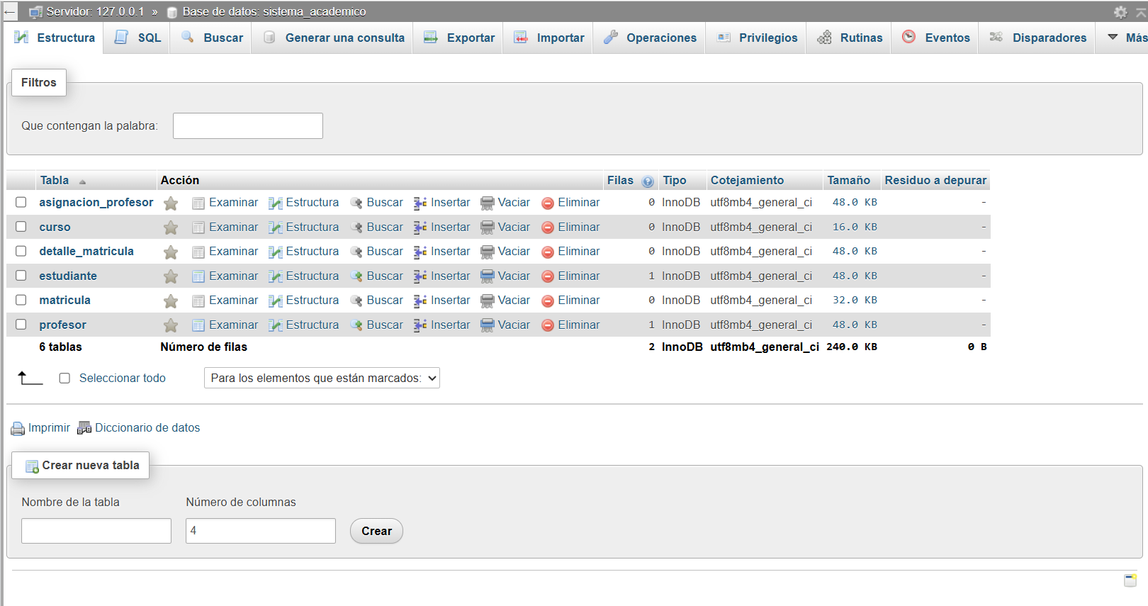

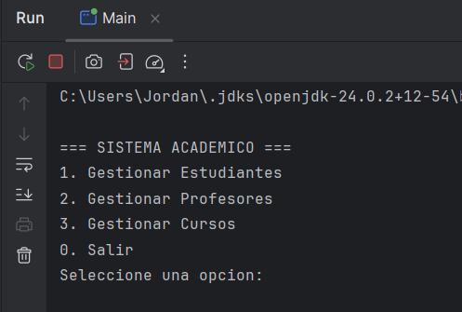
- Vista :

- Procedimiento y Operaciones Almacenadas:
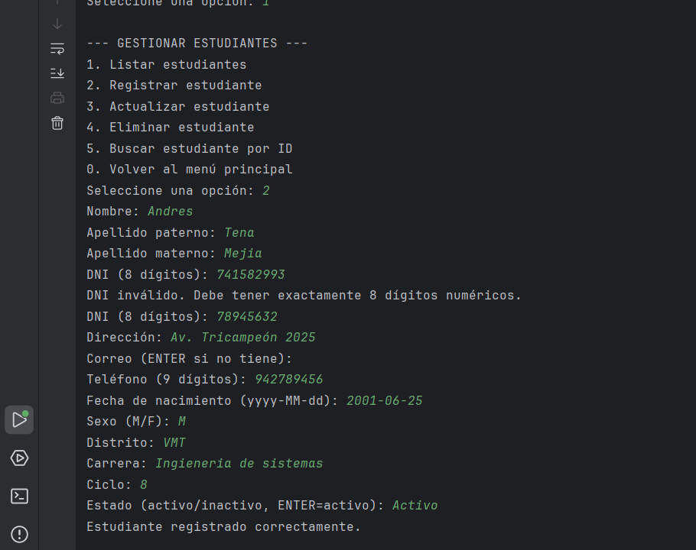

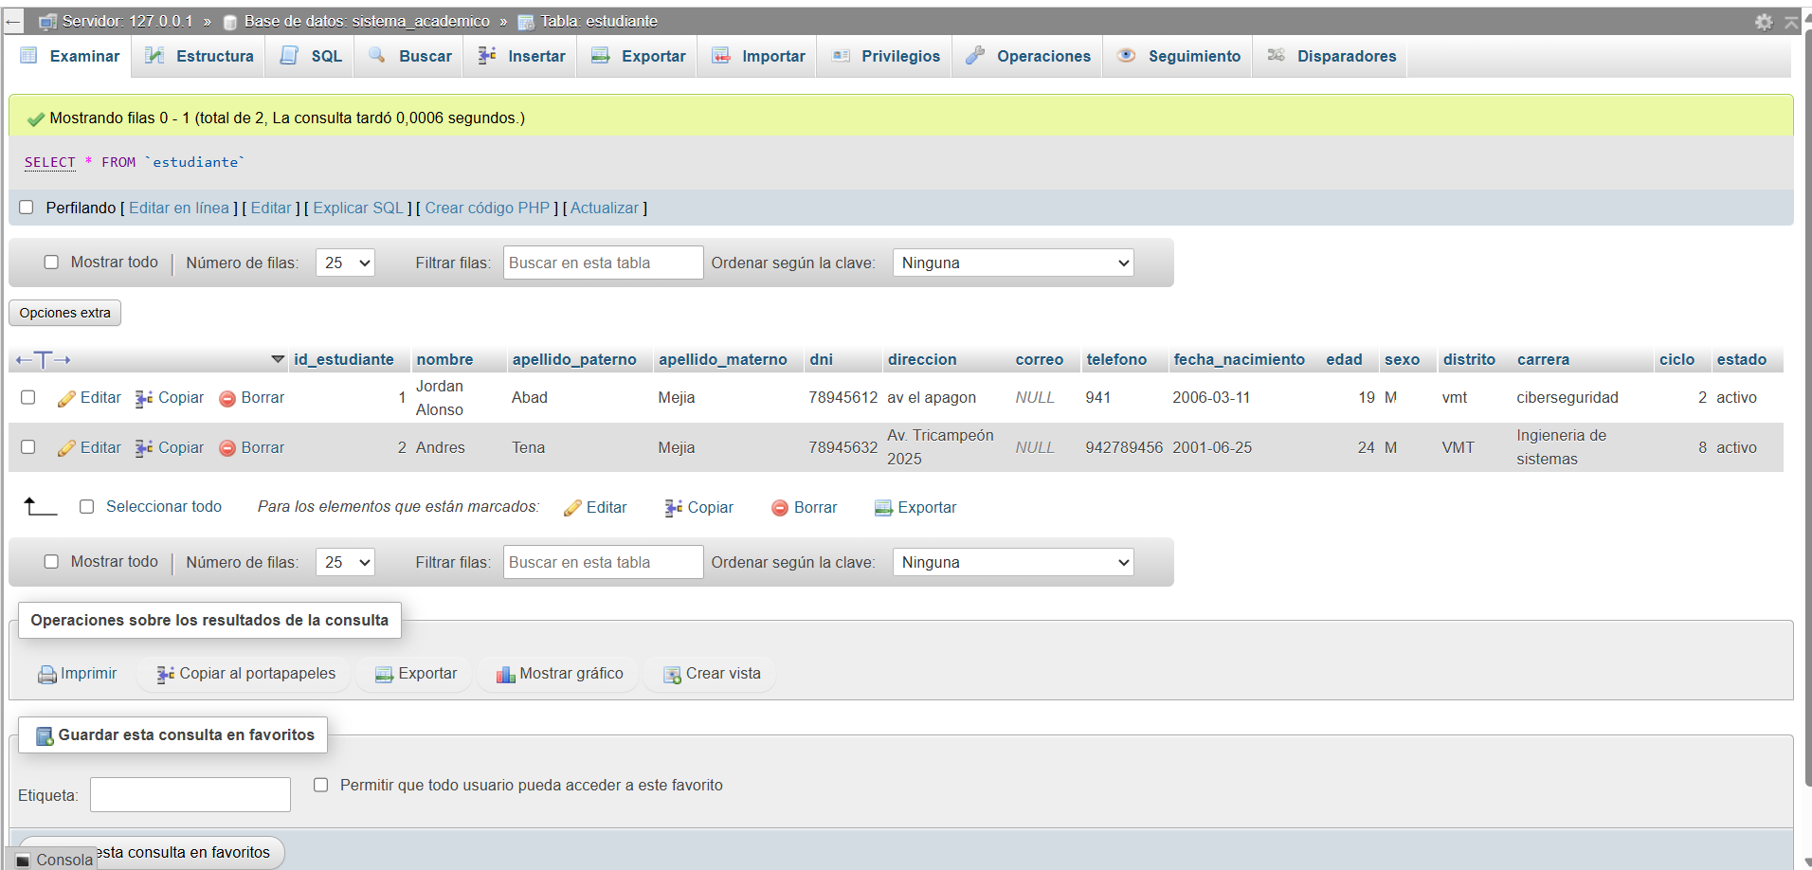

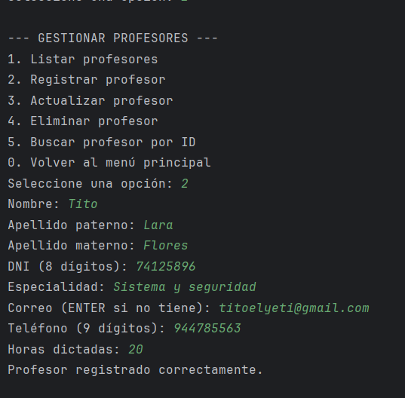

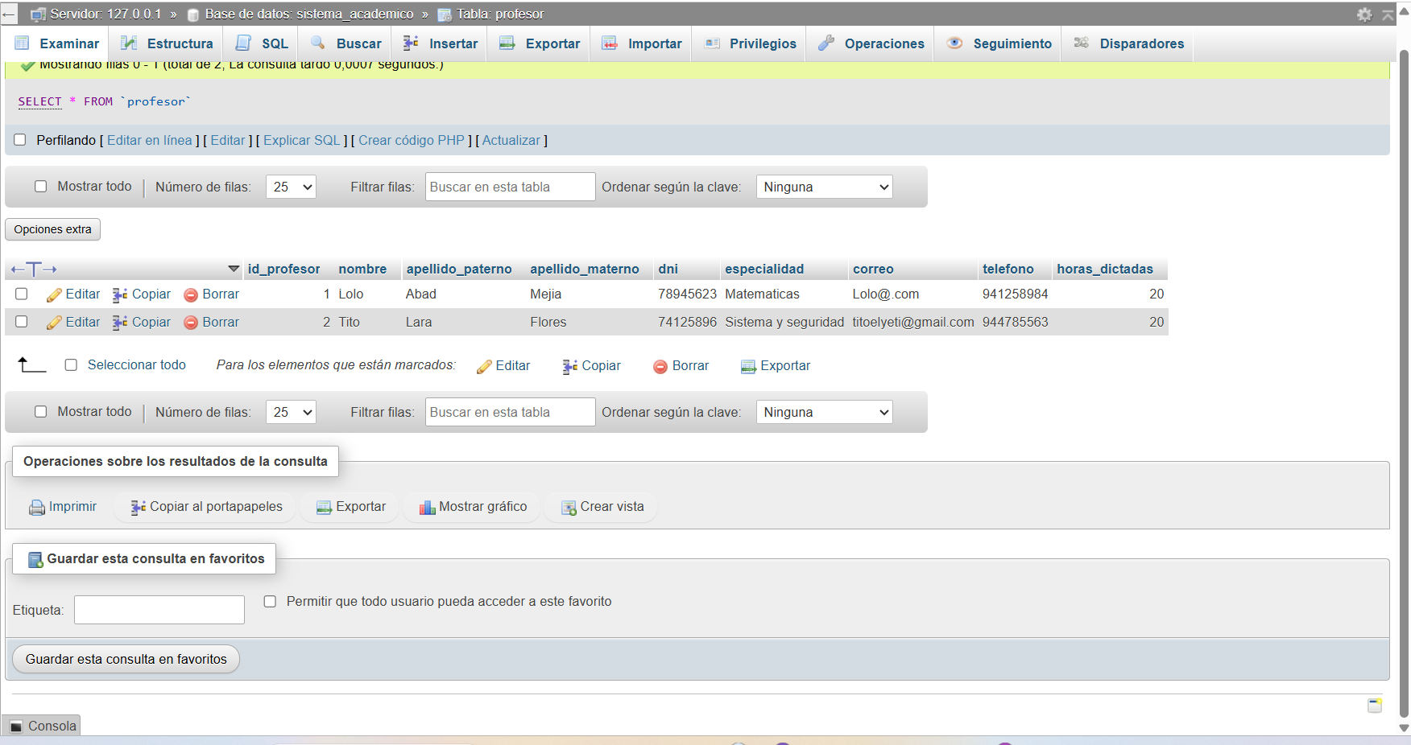

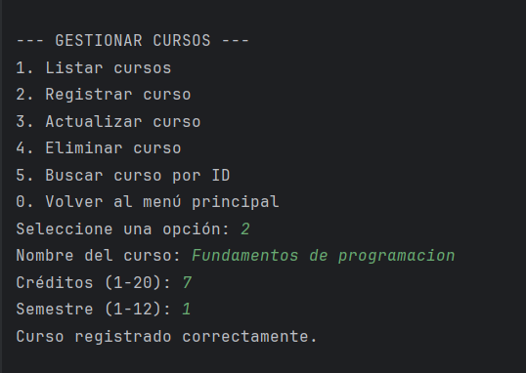

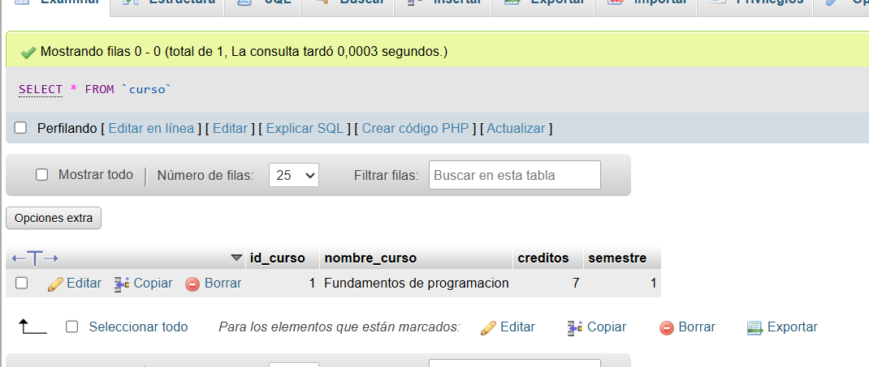

- Validaciones:
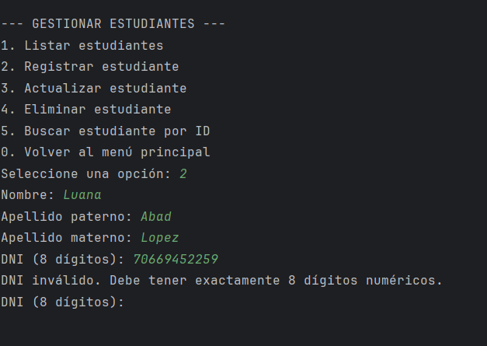
- DNI:

- Número de teléfono:
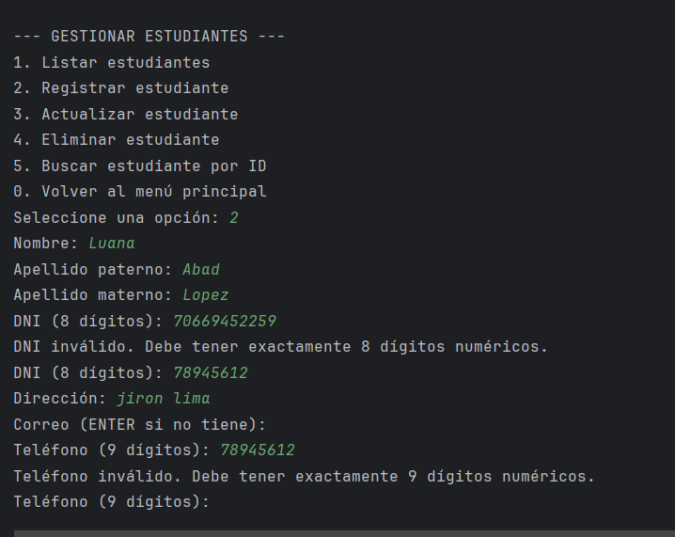

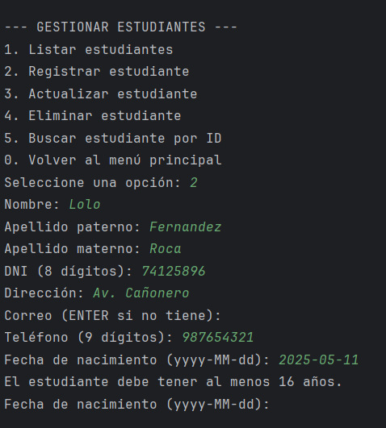
- Edad:

- Creación de triggers básicos:
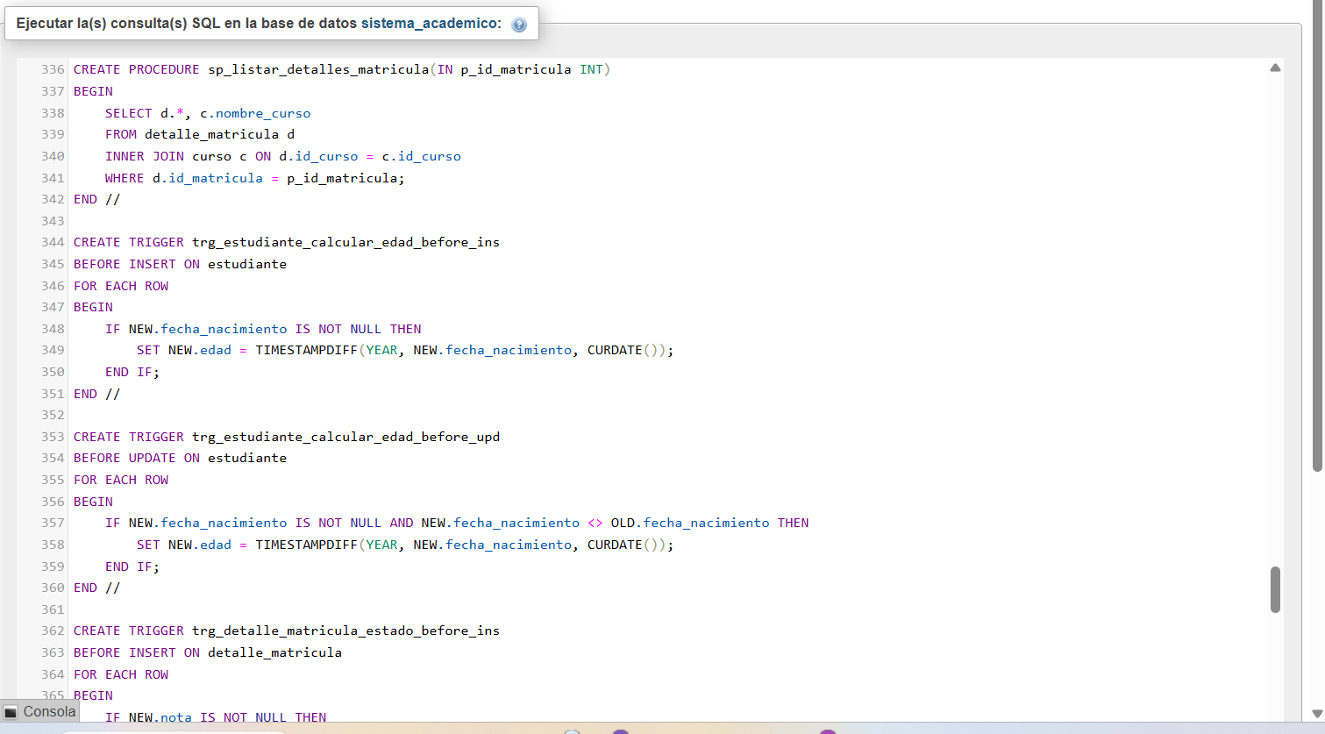

- La edad se genera automáticamente a partir de insertar la fecha de nacimiento:
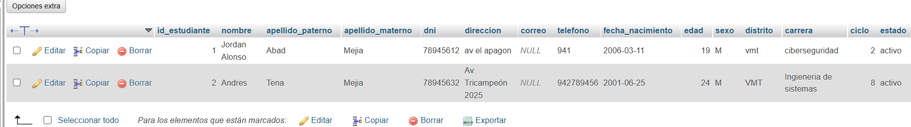

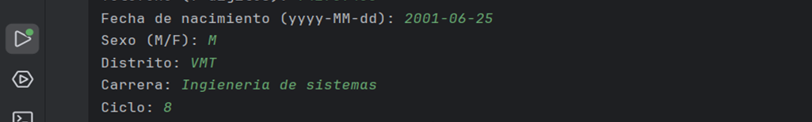

- Conclusiones:

- En este proyecto implementé un sistema de gestión de estudiantes usando Java en IntelliJ IDEA y MySQL en XAMPP, aplicando separación de capas con modelo, vista, controlador y DAO. Logré registrar y administrar estudiantes, profesores, cursos, matrículas y detalles de matrícula, respetando las reglas académicas básicas y la estructura de una institución educativa.

- Para los estudiantes separé correctamente los apellidos paterno y materno, incluí el estado activo o inactivo, el ciclo académico, la edad, el sexo, el distrito y la carrera. Además, relacioné a los estudiantes con los cursos que llevan, mientras que para los profesores registré su especialidad, la cantidad de horas dictadas y los cursos que enseñan. Todo esto se apoya en procedimientos almacenados, triggers básicos y validaciones a nivel de base de datos.

- A nivel de lógica de programación utilicé operaciones CRUD, el patrón DAO, colecciones como ArrayList y Map, y CallableStatement para ejecutar procedimientos almacenados. De esta manera, conseguí un código más organizado y mantenible, con un menú en español que permite al usuario gestionar la información de forma estructurada y cumpliendo con las restricciones de no duplicar datos, validar el DNI de 8 dígitos y el formato básico del correo electrónico.

