Content Index
1. Analysis 1
1.1. ADT specifications: 1
2. Design 2
2.1. Representation of the ADTs in memory 2
2.1.1. Stack 3
2.1.2 Queue 4
2.2. UML diagram and class diagram 5
2.2.1. Use cases diagram 6
2.2.2. Class diagram 6
2.3. Explanation of the classes 7
2.3.1. Stack explanation 7
2.3.2 Queue explanation 7
2.4. Explanation of the program 8
3. Implementation 8
3.1 Difficult sections 9

1. Analysis
This section will detail the specifications of the selected ADTs, as well as their operations and the justifications for these decisions.

1.1. ADT specifications:
This section deals with both the specifications of the selected ADTs and their justifications. It also includes the definition of the operations of each ADT.
We have to distinguish two different ADT's, according to the kind of element they
will hold. Both of them will use a pointer implementation, since we need them
to change their size dynamically.

Positive odd numbers:
As a requirement, positive odd numbers will be held into a stack. This stack will hold natural numbers only, and will use only the basic operations push, pop, makenull and empty.

spec STACK
genres stack, natural
Operations
push: stack natural -> stack
pop: stack -> natural
makenull: stack -> stack
empty: stack -> boolean
endspec

With this ADT, we can easily handle incoming positive odd numbers, adding them to the stack through the use of push. We can then use pop to obtain the content of the first position, which will be deleted. makenull and empty exist for auxiliary purposes; namely, makenull will be used to initialize the stack and empty will potentially be used in some checks.

Positive even numbers and negative numbers:

ADT will be shared amongst both types of number, as they will be both held into queues with the same function. They will, however, use multiple instances of it, thus complying with the requirement for the assignment.This ADT will use the standard enqueue, dequeue, makenull and empty, as well as a new operation named list, which will handle printing the contents of the queue.

spec QUEUE
genres queue, integer
Operations
enqueue: queue integer -> queue
dequeue: queue -> integer
makenull: queue -> queue
empty: queue -> boolean
list: queue -> string
endspec

enqueue will handle number insertion, and dequeue will handle number extraction (used, for instance, for saving). makenull and empty will have a similar use to their counterparts in the stack. Finally, list will create a string representing the contents of the queue, so that they can be easily printed.

2. Design
This section includes a variety of diagrams and explanations which cover the complete design of the program.

2.1. Representation of the ADTs in memory
This section includes multiple diagrams representing both the stack and queue ADTs, as well as some of their operations using boxes, which represent memory positions occupied by cell elements.

2.1.1. Stack
This subsection covers the representation of the stack and some of its operations.
Top

Stack

Top

Push operation
2
1
3

1- Create new cell
2- Point new cell to top
3- Change top

Pop operation
Top

aux
1
3
2
4
1- Create aux pointing to top
2- Change top
3- Get aux value
4- Dispose aux
5- Return aux value

Top

Makenull operation

Empty operation

Top equals NULL?
true
false
Yes

2.1.2 Queue
This subsection covers the box diagrams corresponding to the queue ADT and some of its operations.
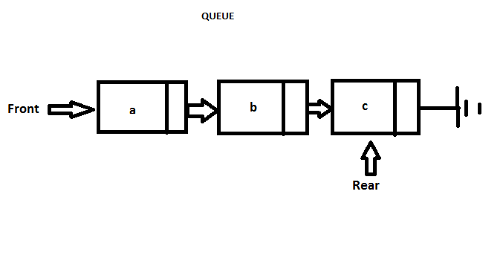
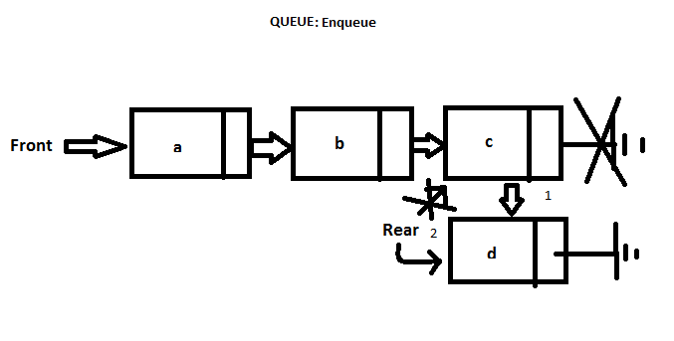
1: Make current rear point to new cell.
2: Make rear pointer point to new cell.
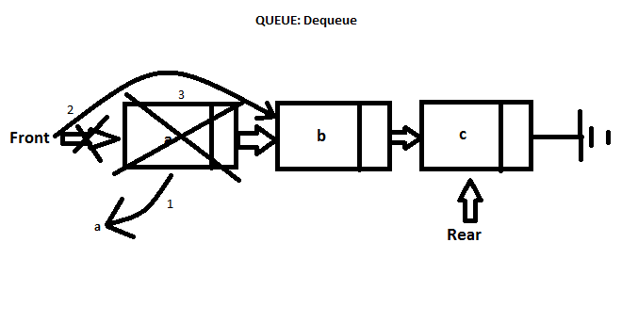
1: Copy content of cell being removed to auxiliary variable.
2: Make front point to second cell.
3: Dispose of former front.

Makenull:
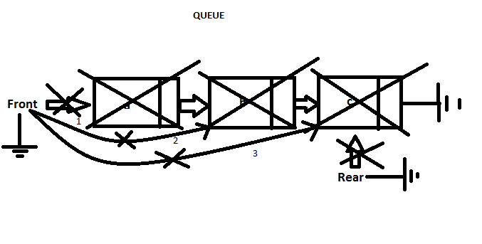
1: Make front point to second cell and dispose of former front.
2: Repeat until front and rear point to null and every cell has been disposed of.

2.2. UML diagram and class diagram
This section covers the diagrams representing the use cases and the classes designed for implementation.

2.2.1. Use cases diagram
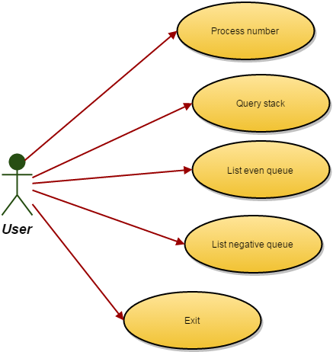
This subsection covers the use cases diagram.

Selecting 'Process number' results in the program prompting the user for an integer, which will then be deemed as positive or negative and, should it be positive, classified as even or odd. Said number is then inserted in the correspondin structure, be it one of the queues or the stack.
Selecting 'Query stack' will result in the program poping the stack and displaying the result onscreen.
Selecting 'List even queue' will result in the program showing all the numbers contained within said queue.
Selecting 'List negative queue' will result in a list of all the numbers stored within the negative queue being displayed.
Selecting 'Exit' will save data and exit the program.

2.2.2. Class diagram
This subsection contains the class diagram for the ADTs. In this case, it is fairly simple, due to there not being inheritance and the cellType classes being place holders representing their actual implementation as structs.

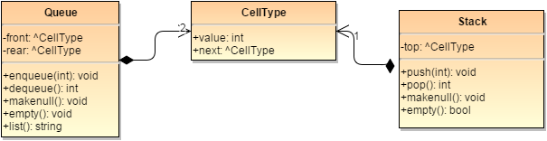
2.3. Explanation of the classes
This section covers the explanation of the classes used, as well as their methods.

2.3.1. Stack explanation
The stack will be implemented in a fairly standard way. In this case, we don't need any additional operations, as push and pop cover our needs to insert and retrieve data from
it. makenull and empty will be kept as auxiliary operations: makenull will allow us to initialize the stack, while empty will allow us to make certain security checks in order to prevent null pointer operations, for example. This class will have a pointer to a cellType element called top, which will keep track of the last element inserted in the stack. Each cellType is made up of a value, in this case an integer, and a pointer to the next cellType, with the last cellType in the stack (this is, the first one to be inserted) pointing to null as the following cell.

- push works as usual: it takes an integer (which we will have checked prior to insertion) and makes it the new top of the stack, pointing to the previous top.
- pop, also, works the standard way: it retrieves the current top and returns its value, disposing of the cell and making top point to the following element in line.
- makenull simply pops the elements held in the stack until there are not anymore. The value of said elements is never saved, as what we want is to make top point to null while freeing the memory occupied by the cells previously created.
- empty simply returns true if top points to null and false any other wise.

2.3.2 Queue explanation
For the queues, we use an slightly modified ADT: it adds an operation, called list, which will now be explained. Queue contains two pointers, front and rear, to cellType elements,
composed of a value (integer) and a pointer to the following one, to keep track of where insertion and deletion will take place. Aside from the already mentioned list operation, the queue class implements the enqueue, dequeue, makenull and empty methods.

- enqueue simply creates a new cell, receiving an integer as parameter, and sets it as the new rear.
- dequeue returns the value of the cell pointed to by front, and makes front point to the next cell while disposing of the former front.
- makenull, once again, dequeues every element of the queue in order to make both front and rear point to null while freeing the memory used by them.
- empty will return true if both front and rear point to null, and false any other wise.
- list iterates through the whole queue, registering each value and formating it into a string. Then, it returns the string.

2.4. Explanation of the program
This section describes the program's general behaviour.
The program itself will read a file, "input.numbers.txt" and parse its contents to add them to either the stack or one of the queues. It will then present a menu to the user, in which the following operations will be listed:
1.-PROCESS NUMBER: takes a number and, depending on its value, determines where it
will be stored. It is then inserted in the corresponding data structure.
2.-QUERY STACK: this operation simply pops the stack and display the result.
3.-LIST EVEN QUEUE: this operation displays the result of executing the list method
of the even queue.
4.-LIST NEGATIVE QUEUE: this operation displays the result of executing the list
method of the negative queue.
5.-EXIT: this operation simply finishes execution.
If the user selects an invalid option (such as option 6), an error will be issued and the user will be asked to select again.
The program loops between the menu and the execution of operations until EXIT is selected.
At that time, the loop breaks and the program is terminated. Rigth before termination, the program will save data in a text file called “output. numbers.txt”.

3. Implementation
This section covers the implementation used in the program.
{Stack implementation here.}

The queue uses a rather standard implementation as a C++ class, albeit it has some differences to a standard queue implementation. Namely, this differences are the lack of a front method, which would not be used by the program, so it was deemed unnecessary; and the inclusion of a list method, which returns a string representing all the content of the queue. The rest of the included methods (sans constructor and destructor, which were required by the language) belong to the standard implementation and were included either because they were going to be used from the beginning or because they might end up being used auxiliarly at some points.
The main.c file contains multiple functions that handle the internal operations of the program.
This was done to improve readability of the program, as well as being able to re-use certain functions in different contexts.
For instance, the function used to determine in which structure a number inputted by the user must be save, is also used to insert the contents of the input file in their corresponding structure.
The functions found in this file belong to either of two classes: user interface and data processing.
For instance, drawMenu presents the user with a list of options and asks them to select one of them by entering its assigned number. This number is then sent to executeOption, where it is checked to see if it is valid or not and, if it is, execute the corresponding command. Said commands are, for the most part, additional functions, such as processNumber, showEven, showNegative and Exit.

3.1 Difficult sections
This section of the document is devoted to explaining diffcult pieces of codes which, although necessary for the program to work properly, may be hard to understand at first sight.
The only difficult section found in one of the data types (namely the queue data type) is the list method included to obtain a string reflecting its contents. This method simply iterates through the whole queue using an auxiliary celltype pointer and inserts the value of each cell into a string stream, the content of which is then appended to the result string and purged. The method then checks if the current cell is the last one or not; should it be the last one, a period will be appended; else, a comma is appended instead. No spaces are appended in the process. Once the auxiliary cell arrives at the end of the queue, execution finishes and the created string is returned.
The inner workings of the user interface may be a bit hard to understand at first, so we will take a look at them:
The menu is designed as a loop that prints the interface, catches user input and interprets it constantly. For stetic reasons, the screen is cleared on each loop, after allowing the user to see the results of their selected operation on screen. This loop keeps on going until execution is finished, with this moment being defined by a change on a boolean flag, handled by the exit function. So, basically, the menu behaves as follows:
- Present interface to the user (drawMenu() function).
- Catch input (drawMenu() function).
- Interpret input (executeOption() function).
- Execute command, if valid (executeOption() function).
- Check if program has to exit or not (loop in main() function).
- Keep going until program has to exit.
Finally, input and output file handling may also present some difficulties. Let's start with the input:
On program start, the input file “input.numbers.txt” is opened, if available. If it is correctly opened, it is then read a line after another. This lines, now strings, are then parsed using the parse() function found in auxiliary.h and auxiliary.c within a loop. Each time a number is extracted, said number is passed to the insertInStructure() function, which actually handles it as though it was user's input and decides the correct structure for it to be stored in. Now, this may not be necessary, seeing as the input file should follow a given format, but this allows the program to read files more flexibly.
As per the output, it is actually quite simpler. After confirming the user's desire to exit the program, the saveData function is called. This function calls each structures corresponding string creation function or method and creates a large string holding the contents of the new file. It then opens up the default output file “output.numbers.txt” and writes this string in it, effectively overwriting anything that may have previously been there. Every operation is described onscreen, along with an status report when any of them is finished. Should there be any kind of error, it will be told to the user.

