Index
1. Analysis 1
1.1 ADT specifications 1
1.1.1 Selection and justification of the ADT's 1
1.1.2 Definition and specification of the ADT's 1
2. Design 2
2.1 Block representation in memory: 3
2.2 UML diagram and class diagram 9
2.3 Explanation of the classes 11
2.3.1 Doubly-Linked List 11
2.3.2 Doubly-Linked Circular List 12
2.4 Explanation of the behaviour of the program 13
3. Implementation 13
3.1 Difficult sections 14
4. Review 14
4.1 Running time of the solution 15
4.2 Possible enhancements for the solution 16
5. Bibliography 16

1. Analysis
This section will cover the analysis phase of the development of the program.

1.1 ADT specifications
This subsection will refer to the specifications of the ADT's used in the program, as well as the reasoning behind those specifications.

1.1.1 Selection and justification of the ADT's
This program will be built around two main ADT's: a doubly-linked list, which will hold odd positive numbers, and a doubly-linked circular list, which will cointain even positive numbers. Both of them will have pointers to their head and last cell, and a boolean attribute to determine whether their insertion and deletion points have been swapped. They will also have, alongside their insert, extract, locate, makenull and empty methods, a swap, list and cut methods to ease the implementation of some of the functionalities required for the program. Swap will be used to switch insertion and deletion points, whereas cut will be used to delete everything from a given point in the list to the end. Finally, list will create a string with the contents of its corresponding list.

1.1.2 Definition and specification of the ADT's
The ADT's are defined as follows:

spec DLIST[NATURAL]
genres dlist, position, natural
operations
insert: dlist position natural -> dlist
extract: dlist postion -> natural
swap: dlist -> dlist
empty: dlist -> boolean
makenull: dlist -> dlist
list: dlist -> string
cut: dlist position -> dlist
locate: dlist natural -> position
endspec

spec DCLIST[NATURAL]
genres dclist, position, natural
operations
insert: dclist position natural -> dclist
extract: dclist position -> natural
swap: dclist -> dclist
makenull: dclist -> dclist
list: dclist -> string
cur: dclist position -> dclist
locate: dclist natural -> position
endspec

2. Design
This section will be devoted to documenting the design phase of our development.

2.1 Block representation in memory:

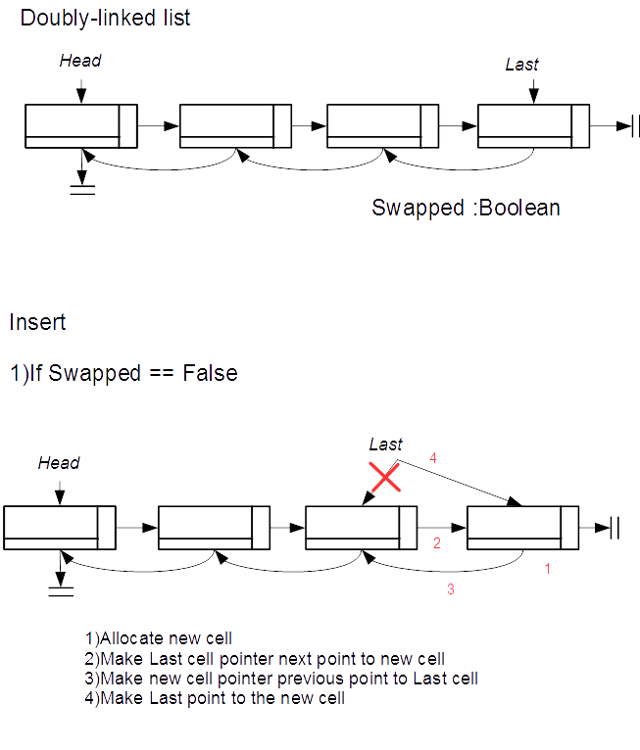
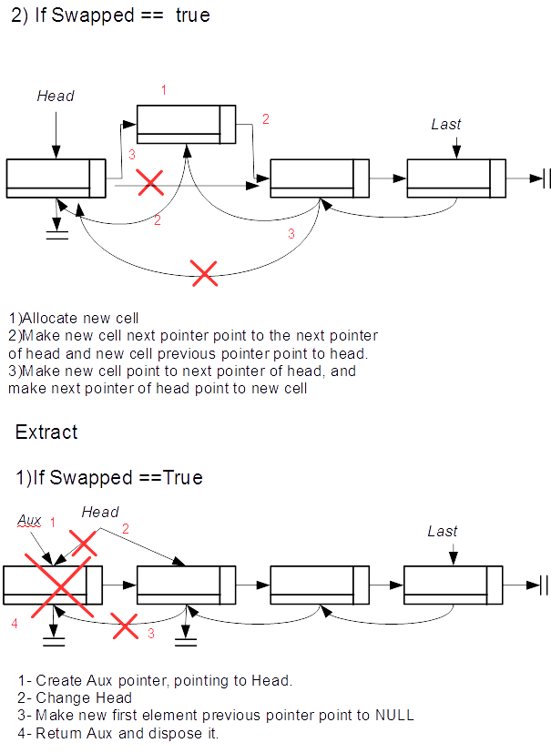

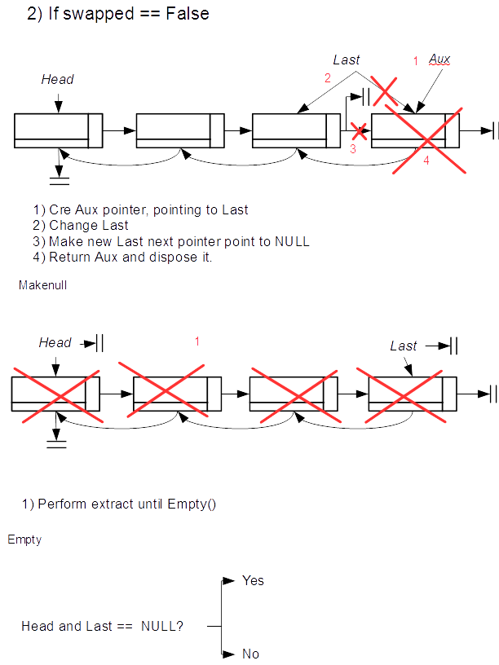

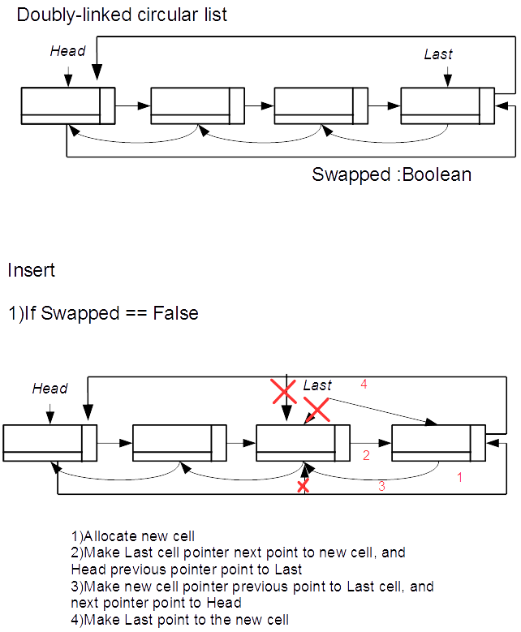

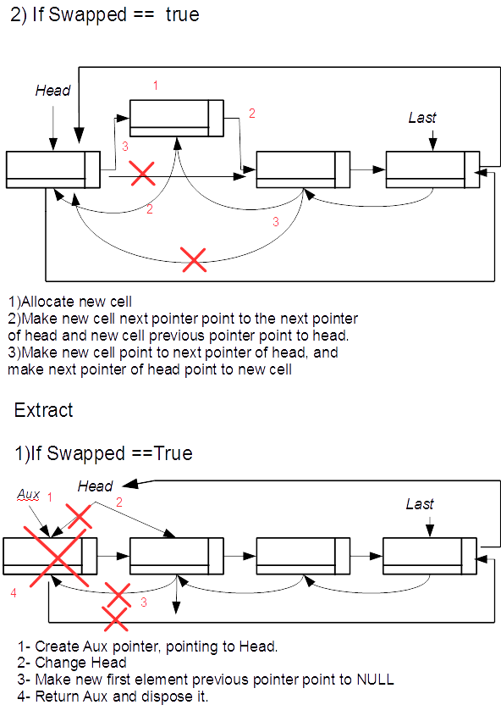
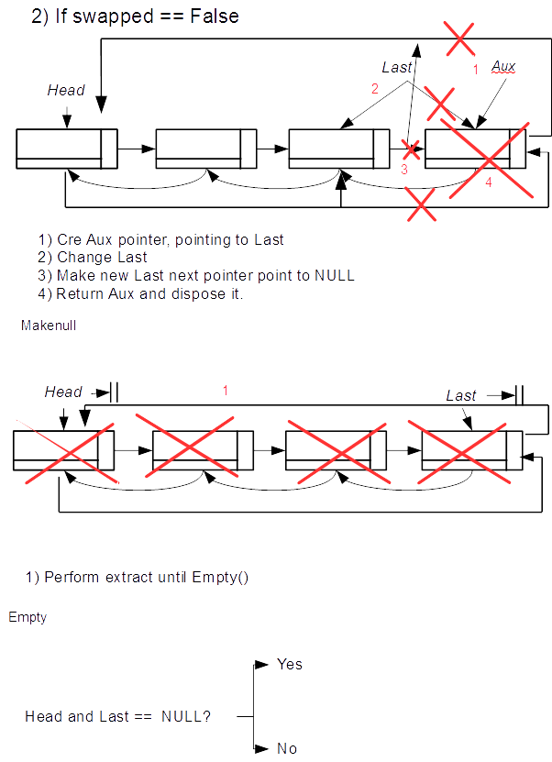

2.2 UML diagram and class diagram
This section will cover the use cases diagram and the class diagram for this project.

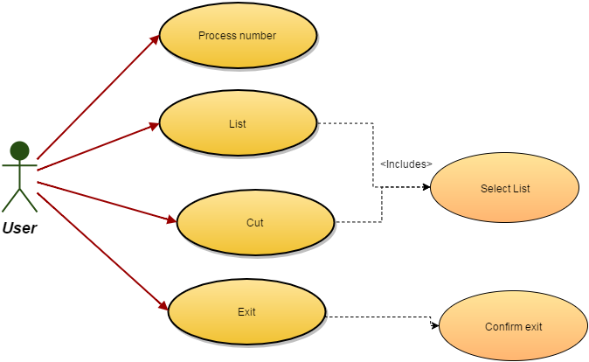
The user will have four options at their disposal:
- Process number: the user is asked to enter a number wich will be processed and stored in the corresponding list if it is positive, or discarded while the deletion and insertion points of the lists are changed if negative.
- List: the user is prompted to select a list. The contents of said list are printed on-screen.
- Cut: the user is prompted to select a list and insert a value. The elements from that value onwards are then destroyed.
- Exit: the user is asked to confirm they want to exit. Should their answer be affirmative, the program will save data and finish execution.

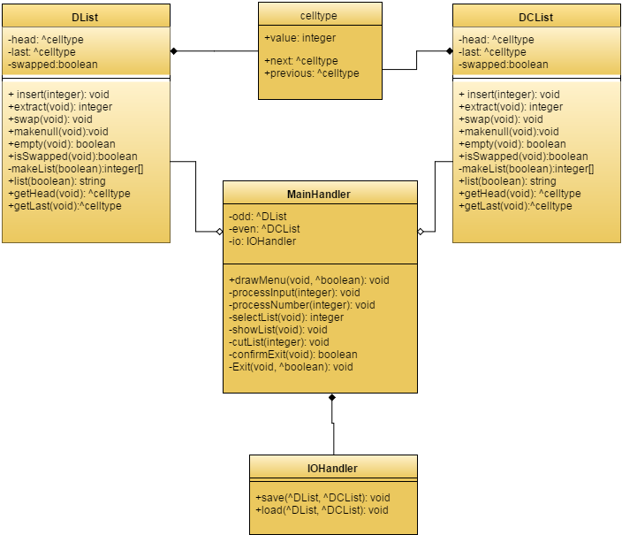

As it can be seen, this program will be completely based on Object-Oriented Programming. The IOHandler class will be used to save the current data into files and load previous data from files. The MainHandler class will be used to run the program, it will set the program to a neutral state, drawing the menu and giving the user access to the main methods of the program (Procces number, List, Cut and Exit). The celltype class exists for the sake of storing the data contained in the lists. Finally, both lists, DList and DCList will store the data. It shall be remarked that there are a few more methods that in the specification: getters for head, last and swapped have been implemented, as well as a makeList method which will be used to correctly obtain the data properly ordered to create a string in list.

2.3 Explanation of the classes
This section will be used to explain the implementation of the already defined data types as classes.
It should be noted that both lists use slightly modified implementations to adapt them to the requirements of the assignment.

2.3.1 Doubly-Linked List
This list uses the standard insert, extract, makenull, locate and empty methods. It also uses some non-standard methods, namely swap, isSwapped, makeList, list and cut, to fulfill its desired functionality. Insertion and deletion take place in either head or last positions; which of them is decided by a swapped attribute.
- insert is used to create a new cell in the corresponding position. If swapped is false, this will happen after last, with the new cell effectively becoming the new last. If swapped is true, this happens after head.
- extract is used to take out the cell located in the extraction point. If swapped is false, head is taken out. If swapped is true, last is taken out.
- makenull simply iterates through the whole list extracting every cell.
- locate is used to find a value in the list. It iterates through the list until it finds the first position in which said value appears; this position is then returned. If the value is not found, NULL is returned.
- empty returns true when both the head and the last pointers are set to NULL.
- swap simply changes the value of swapped from true to false and viceversa.
- isSwapped returns the value of swapped.
- makeList creates an integer array using the values found in the list. This method exists only to be used with list.
- list creates an string from the contents of the list, which are gathered using makeList. The order in which these values appear depends on a boolean variable which is passed as argument to the method. This method is used both to print the contents of the list to the screen and to save them in a file.
- cut uses the locate method to find the position from which to start erasing. It then deletes everything from that point onwards.

2.3.2 Doubly-Linked Circular List
This list uses the standard insert, extract, makenull, locate and empty methods. It also uses some non-standard methods, namely swap, isSwapped, makeList, list and cut, to fulfill its desired functionality. Insertion and deletion take place in either head or last positions; which of them is decided by a swapped attribute. The only real difference with the doubly-linked list is that head and last point to each other.
- insert is used to create a new cell in the corresponding position. If swapped is false, this will happen after last, with the new cell effectively becoming the new last. If swapped is true, this happens after head.
- extract is used to take out the cell located in the extraction point. If swapped is false, head is taken out. If swapped is true, last is taken out.
- makenull simply iterates through the whole list extracting every cell.
- locate is used to find a value in the list. It iterates through the list until it finds the first position in which said value appears; this position is then returned. If the value is not found, NULL is returned.
- empty returns true when both the head and the last pointers are set to NULL.
- swap simply changes the value of swapped from true to false and viceversa.
- isSwapped returns the value of swapped.
- makeList creates an integer array using the values found in the list. This method exists only to be used with list.
- list creates an string from the contents of the list, which are gathered using makeList. The order in which these values appear depends on a boolean variable which is passed as argument to the method. This method is used both to print the contents of the list to the screen and to save them in a file.
- cut uses the locate method to find the position from which to start erasing. It then deletes everything from that point onwards.

2.4 Explanation of the behaviour of the program
This section describes the program's general behaviour.
The program itself will read a file, "input.numbers.txt" and parse its contents to add them to one of the lists or call swap for both of them. It will then present a menu to the user, in which the following operations will be listed:
1.-PROCESS NUMBER: takes a number and, depending on its value, determines where it
will be stored. It is then inserted in the corresponding data structure. Negative numbers make the program call swap in both lists.
2.-LIST: the user is prompted to select a list and an order, and the contents of said list are then showed in the selected order.
3.-CUT: the user is prompted to insert the value from which to cut and select a list. If the value may be found in said list, it is then located, and the contents from that point onwards, destroyed.
4.-EXIT: this operation simply finishes execution, should the user confirm they want to exit.
If the user selects an invalid option (such as option 6), an error will be issued and the user will be asked to select again.
The program loops between the menu and the execution of operations until EXIT is selected.
At that time, the loop breaks and the program is terminated. Rigth before termination, the program will save data in a text file called “output. numbers.txt”.

3. Implementation
Both of the lists used in the program, while fairly standard, have a common peculiarity worth noting: the include a boolean attribute, swapped, used to determine where insertion and deletion should take place. Another peculiarity of our implementation is insertion and deletion points happening only at the head or the last position. The constructor and destructor were included because they are required by C++; likewise, insert, extract, locate, makenull and empty were deemed, not only as basic for the program, but also as some of the basic functionalities expected in any list. Finally, in order to ease handling strings, the methods makeList and list were included; cut was a requirement of the practice, as including a way to delete a list from a certain point to the end was mandatory; and isSwapped, getHead and getLast act as getters for the classes' private attributes, so that they can be accessed.
The class celltype was designed to handle data contained inside each list, so it is composed of three attributes (value, next and previous) and the strictly necessary methods: its constructor and destructor, as well as the getters and setters for its attributes.
The class IOHandler exists to manage loading and saving data from and to a file, although it also includes the processNumber method, used to interpret input numbers, either during the initial load operation or during execution; this method belongs to the IOHandler class in order to be able to access it directly. This class includes as attributes references to both list to increase readability of the program, mostly in the mainHandler methods.
mainHandler implements all the methods necessary to handle the main loop. Said methods are divided in user interface methods and internal processing methods. Belonging to the user interface methods, we can find drawMenu, selectList, selectOrder, processnumber and confirmExit. processInput, showList, cutList and Exit are all internal processing methods.
Thus, drawMenu presents the user with a list of options and waits for input; said input is the passed to processInput, which decides what operation must be called. The corresponding method is then called.

3.1 Difficult sections
There are only two methods in the list that may be difficult to understand: list and cut. list creates an integer array using makeList and then inserts its contents in a string in an order determined by the boolean argument inverted, also inserting commas and periods when necessary; this string is then returned. cut tries to find the argument integer value and, if found, it determines whether its position is the head of the list; should that be the case, makenull is called; otherwise, the last pointer of the list is set to the previous cell to the position in which the value was found and everything from that point forward is deleted.
It might also be good to explain how the mainHandler works: the program is designed as a loop consisting of the following steps:
- Present menu to the user (drawMenu() method).
- Catch input (drawMenu() method).
- Interpret input (processInput() method).
- Execute command, if valid (processInput() method).
- Check if program has to exit or not (loop in main() function).
- Keep going until program has to exit.

Input consists only of parsing a file as a string and passing each integer found using a istringstream to processNumber. This is done by finding each number, erasing it from the string and passing it as argument. Data is loaded from a file called “input.numbers.txt”.
Output is fairly simpler, as it just creates strings with the content of each list, if they are not empty, and writes it into a file. The file is called “output.numbers.txt”, and this method overwrites anything that may have been written in it prior to being written.

4. Review
This section will be used to describe the efficiency of the solution in big-Oh notation and to try to devise different ways to improve it.

4.1 Running time of the solution
Since most functionalities' running time will be defined by the running time of the operations found in the data types used to store information, we will begin by analyzing the running time in both lists. However, we first need to take a look to the celltype operations:
- celltype:
- celltype(int, celltype*, celltype*): disjoint simple statements. O(1).
- ~celltype(): nothing. O(1)
- int getValue(): simple statement. O(1)
- celltype* getNext(): simple statement. O(1)
- celltype* getPrevious(): simple statement. O(1)
- void setNext(celltype*): simple statement. O(1)
- void setPrevious(celltype*): simple statement. O(1)
- void setValue(int): simple statement. O(1)
2. Lists. Both have the same running times:
- int makeList(int*): this method has to iterate through all elements in the list. Its running time is O(N), with N being the number of elements in the list.
- Dlist(): simple disjoint statements. O(1).
- ~Dlist(): empty. O(1).
- void insert(int): simple conditionals and simple statements. O(1).
- int extract(void): simple conditionals and simple statements. O(1).
- void swap(void): one simple statement. O(1).
- void makenull(void): this method has to iterate through all elements in the list. Its running time is O(N), with N being the number of elements in the list.
- bool empty(void): one simple statement. O(1).
- bool isSwapped(void): one simple statement. O(1).
- std::string list(bool): this method uses makeList. It does not use it in nested loops, nor has any loop larger than makeList, so its running time is O(N), with N being the number of elements in the list..
- void cut(int): this method uses locate (analyzed below) and may call makenull. In the worst case, its running time is O(N), with N being the number of elements in the list..
- celltype* getHead(void): one simple statement. O(1).
- celltype* getLast(void): one simple statement. O(1).
- celltype* locate(int): in the worst case, this method has to iterate through all elements in the list. Its running time is O(N), with N being the number of elements in the list.

We should now take a look at the IOHandler methods before moving on to the mainHandler:
- IOHandler(DList*, DCList*): disjoint simple statements. O(1).
- ~IOHandler(): nothing. O(1).
- void save(): this method calls list in both lists. Its running time is O(N), with N being the number of elements in the largest list.
- void load(): this method has to read and interpret a whole file. Its running time is O(N), with N being the length of the file.
- void processNumber(int): this method is composed of simple conditionals and simple statements. It calls inserts and swap in both lists. Its running time will be O(1).

Finally, we can now compute the running time of the functions in mainHandler:
- void processInput(int, bool*): simple conditionals, and statements of varying running time. Its running time can be O(1) or O(N), so, in the worst case, running time is O(N).
- void processnumber(): simple statement. Calls IOHandler's processNumber. Its running time is O(1).
- int selectList(void): simple statements and simple conditional. Running time of O(1).
- bool selectOrder(void): simple statements and simple conditional. Running time of O(1).
- void showList(void): calls selectList, selectOrder and corresponding's list list method. Its running time is O(N).
- void cutList(int): calls selectList and corresponding list's cut method. Running time of O(N).
- bool confirmExit(void): simple conditionals and statements. Its running time is O(1).
- void Exit(bool*): calls confirmExit and IOHandler's save method. Running time of O(N).
- void drawMenu(bool*): simple statements and calls processInput. Its running time can be O(1) or O(N), so, in the worst case, running time is O(N).
The solution's running time will depend, then, on user's input, and can vary between O(1) and O(N).

4.2 Possible enhancements for the solution
It should be possible to improve the user interface using even more extended ASCII to create an overall better look. There are also some help texts that could be added to the program to improve user interaction.
It should also be noted that some of the program's behaviour is tied to system calls only found in Windows. Devising a way to clear the screen and pause execution without using them would make the program more portable.
It might also be possible to make the list method's running time O(1) by using two strings as attributes of the lists. This would, however, most definitely lead to insert and extract having running times of at least O(N) in order to maintain the lists.

5. Bibliography
ADT's:
Theory class slides
C++ programming:
http://www.cplusplus.com/reference/fstream/ifstream/
http://www.cplusplus.com/reference/string/string/?kw=string
http://www.cplusplus.com/reference/sstream/istringstream/?kw=istringstream

