DATA STRUCTURES ASSIGNMENT 3:
Binary search trees

Mario Cobos Maestre 03205195F
Adrián de Juan Lora 53569674Y

Content Index
1. Analysis 2
1.1 ADT specification 2
1.1.1 Selection and justification 2
1.1.2 Definition of the ADT's 2
2. Design 3
2.1 Box diagrams 3
2.2 UML diagrams 5
2.2.1 Use cases 6
2.2.2 Classes diagram 6
2.3 Explanation of the classes 7
2.3.1 Explanation of the ADT methods 8
2.4 Behavior of the program 8
3. Implementation 9
3.1 Difficult section 9

1. Analysis
This section will be devoted to the analysis phase of the development cycle.

1.1 ADT specification
This subsection will be used to explain the selected specifications for the ADT's, as well as justify them.

1.1.1 Selection and justification
Due to the requirements, we have decided to use two different types of binary search trees: one will be based upon a “simple” node, containing only a value and the number of times said value has appeared (this is, aside from the pointers to its children), and a “complex” node, whose value will consist of an absolute value and will keep track of the number of times said value has appeared in a negative number and in a positive number. Both kinds will only contain integers.
As already stated, these data types were selected to comply with the requirements, as having two different structures, one with two trees (negative and positive) and another with a single tree holding all data, meant that it would be necessary to define two different kinds of binary seach tree.

1.1.2 Definition of the ADT's
We will now take a look at the ADT's as they have initially been defined.
spec simpleBST
genres simpleBST, simpleNode, integer
operations
insert: simpleBST integer simpleNode -> simpleBST
delete: simpleBST integer simpleNode -> simpleBST
search: simpleBST integer -> boolean
list: simpleBST -> string
endspec

spec complexBST
genres complexBST, complexNode, integer
operations
insert: complexBST integer complexNode -> complexBST
search: complexBST complexNode -> complexNode
delete: complexBST integer -> boolean
list: complexBST -> string
endspec

As it can be seen, both trees will use nodes to hold information. It will actually be these nodes that will be used for the most part, as recursive calls will be an integral part of interation through the stored data.

2. Design
This section will cover the design phase of the development cycle.

2.1 Box diagrams
This section covers the representation of the ADT's in memory. Whilst their implementation will differ due to their nodes, the logic followed in their processes is the same in both binary search trees; thus, their representation will be the same:
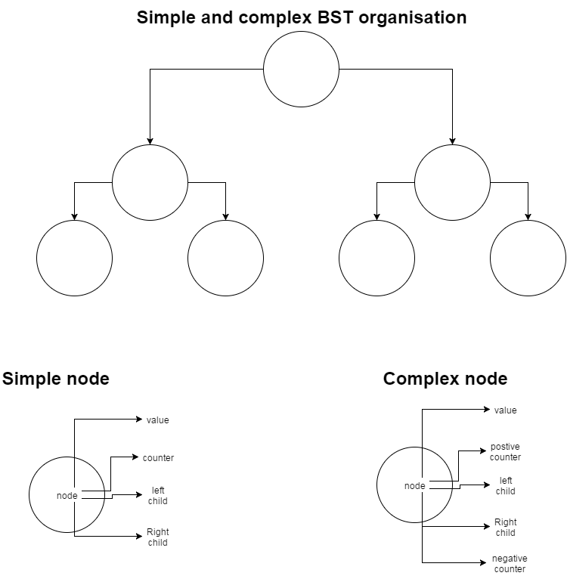

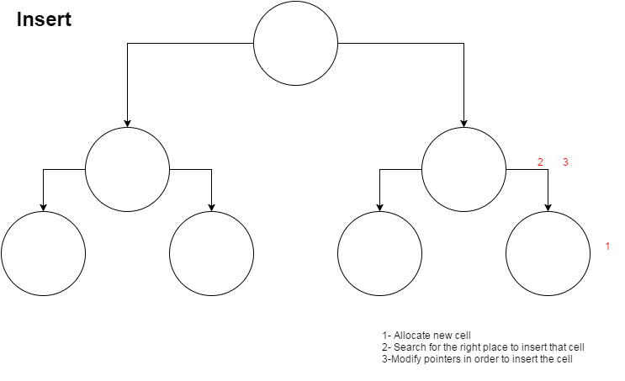
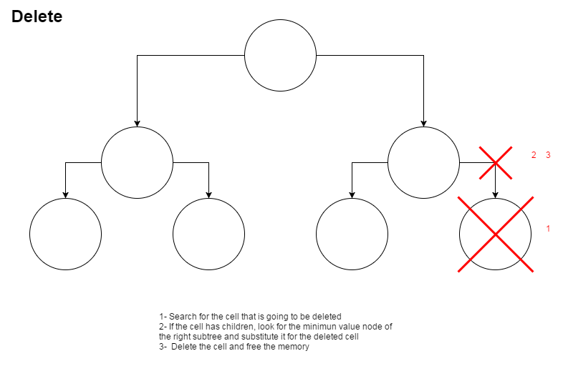

2.2 UML diagrams
This section will cover the UML diagrams created during the design phase.

2.2.1 Use cases
Here, the use cases diagram will be presented:
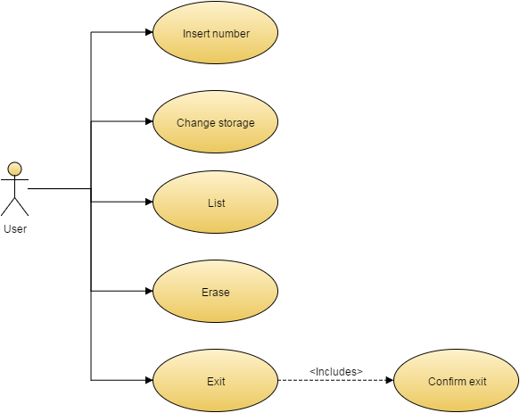

2.2.2 Classes diagram
This section will cover the classes diagram representing the classes designed for this project.
Said diagram will be presented on next page due to space contraints.

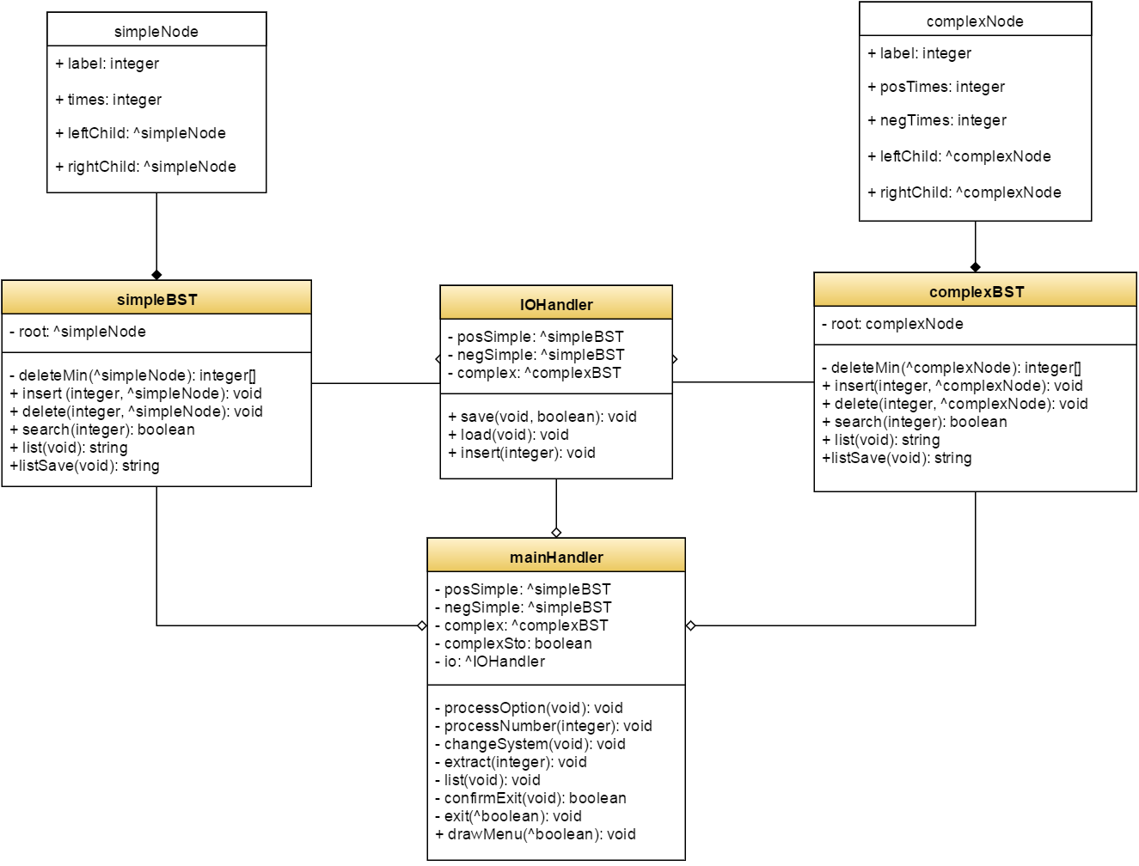

2.3 Explanation of the classes
This section will try to explain the classes that will be used:
- simpleNode, as well as complexNode, will be used to store information. simpleNode will act as the basis for the simpleBST class, holding only the value of each node and the number of instances of said value. complexNode, on the other hand, will act as the basis for the complexBST class, holding the absolute value; and number of positive and negative instances for a given number.
- simpleBST and complexBST will be used to actually hold and retrieve information, organising their corresponding nodes into a tree like structure. They will actually only hold a reference to their root nodes, and will be updated simultaneously to ensure that, should the storage organization be changed without modifying the contents of the storage, the output of the list operation will always be the same.
- IOHandler will be used, as its name implies, to manage input and output interactions; this is, it will be used to save and load data, as well as to determine where new data should be stored.
- mainHandler will be used to manage user interaction. It will draw the menu and interpret commands issued by the user. The main loop of the program will be handled by this class.

2.3.1 Explanation of the ADT methods
Both binary search trees will implement the same methods, although with major differences due to how their nodes will be structured. Their function, as well as the logic behind them, will, however, be the same in both cases, so we will explain them both together:
- deleteMin[]: will be used to re-structure the tree whenever a node is removed. This will be used by moving relocating the minimum value found in the right child of the node being taking out to the now vacant position.
- insert: will determine where the new integer should be store based on its absolute value or, there was a node holding said value prior to ir being inserted, update the corresponding count.
- delete: will decrease the count of the selected value. If it reaches 0, the node will be taken out and, should the tree need to be re-structured, deleteMin[] will be called. If the value cannot be found within the tree (this is, search returns false), an error will be used.
- search: will attempt to locate a given value within the tree. If it is found, true will be returned. Otherwise, the return value will be false.
- list: will create a string holding each number's absolute value, along with its sign and number of instances, formatted according to the requirements. Said string will be the return value.
- listSave: just like list, this method will create a string with the contents of the tree. This one will, however, display the real value of each number, as many times as it was originally inserted.

2.4 Behavior of the program
This section will try to explain how the program will behave during runtime:
On start-up, the program will try to retrieve the file “input.numbers.txt”; should it be found, its contents will be read and stored in the already instatiated BST's.
Then, a menu will be presented to the user as the main loop starts. Said menu will present the options to process a number, change storage, list, erase and exit, along with a number, representing each of the operations. The program will then wait for the user to insert the number corresponding to the desired operation. If an invalid number is inserted, an error will be issued, and the user will be asked to select another option.
If the user decides to process a number, they will be asked to input its value, which will be then interpreted and inserted in the corresponding simpleBST, as well as the complexBST, so that both storage systems are up to date at every given time.
Changing storage will simply switch the value of a boolean variable, which will be used to decide what structure(s) should run the list and listSave operations when they are requested.
Deciding to list will make the program call the list operation for all aplicable cases and display the result to the user.
Erase will ask the user what value they desire to erase, and will call the delete method of both the corresponding simpleBST and the complexBST. Again, this is done independently of the storage currently being used to ensure that both storage organizations will always be up to date.
Finally, exit will ask the user to confirm they want to exit. If the answer is negative, the loop will start all over again. If the user confirms their desire to exit the program, data will be saved and the loop will end.

3. Implementation
This section covers the implementation of the program.
Binary search trees were a requirement for this project and, due to having to implement two different storage organizations, we decided to also implement two different types of nodes: simple and complex node. Both kind of BST's are named after the type of node they use and, while for the most part both are fairly standard implementations of binary search trees, the differences in the behavior of their nodes were enough for us to decide against using inheritance, as it would complicate development instead of easing it.
The main differences, in both trees, when compared when an standard BST designed to hold integers are the appearance of getter and setter methods (required by the C++ language in order to acces certain private attributes) and the list method present in both binary search trees, which exists for the sake of creating an string with the contents of the storage by traversing the tree inorder, thus ensuring that numbers would appear ordered according to their absolute value, as this was set as the criteria to determine the location of each new node.
Two more classes were used: IOHandler, which contains methods to load and save data, as well as to process and insert new numbers inside the corresponding trees (which was implemented here because load required it) and MainHandler, which contains methods used to interact with the user.
MainHandler is the class that defines how the user interface works, and defines when and how should each operation take place, what objects should have a role in the process, and how these objects should interact. This class was almost entirely taken from previous projects, and modified to fit whatever new needs arose during development. The same happened to IOHandler.

3.1 Difficult section
Probably, the most complex code is found in the insert and delete methods of both trees, although they follow the same logic: compare inserted value with current node's label, decide whether it is less, more or the same, and, depending on that, move on to the left or right child of the node if the value differs or update the counter of the node if it is the same. If the node reached is NULL, behavior changes slightly: if we are inserting, a new node will be added to the vacant position; if we are deleting, nothing happens.
Deletion has another special case: if the node's counter reaches zero, the program tries to find any suitable replacement for the node; if they are found, they are moved and replace the node that has just been taken out; else, the node is simply left vacant as a NULL pointer.
The need to modify the value of pointers is also the reason that getter's referring to nodes return a pointer to the pointer to the node instead of the pointer to the node: that way, the pointer can easily be updated to avoid problems such as nodes with counters set to zero that have not disappeared and values not being added to the tree.
It might also be good to explain how the mainHandler works: the program is designed as a loop consisting of the following steps:
- Present menu to the user (drawMenu() method).
- Catch input (drawMenu() method).
- Interpret input (processInput() method).
- Execute command, if valid (processInput() method).
- Check if program has to exit or not (loop in main() function).
- Keep going until program has to exit.

Input consists only of parsing a file as a string and passing each integer found using a istringstream to processNumber. This is done by finding each number, erasing it from the string and passing it as argument. Data is loaded from a file called “input.numbers.txt”.
Output is fairly simpler, as it just creates strings with the content of the complexBST, changing the sotrage organization if necessary to ensure that data will be stored in said tree, and writes it into a file. The file is called “output.numbers.txt”, and this method overwrites anything that may have been written in it prior to being written.

4. Review
This section will be used to describe the efficiency of the solution in big-Oh notation and to try to devise different ways to improve it.

4.1 Running time of the solution
Since most functionalities' running time will be defined by the running time of the operations found in the data types used to store information, we will begin by analyzing the running time in both BST's. However, we first need to take a look to the node operations:
- simpleNode:
- simpleNode(int): constructor. Made of disjoint simple statements, which makes it run on O(1).
- ~simpleNode(): destructor. Unused. It is left empty, so O(1).
- int getLabel(): simply returns a value. O(1).
- int getTimes(): simply returns a value. O(1).
- simpleNode** getLeftChild(): simply returns a value. O(1).
- simpleNode** getRightChild(): simply returns a value. O(1).
- void setLabel(int): simply sets a value. O(1).
- void setTimes(int): simply sets a value. O(1).
- void increaseTimes(): simply increases a value. O(1).
- void decreaseTimes(): simply increases a value. O(1).
- void setLeftChild(simpleNode*): simply sets a value. O(1).
- void setRightChild(simpleNode*): simply sets a value. O(1).
- ComplexNode:
- complexNode(int): constructor. Made of disjoint simple statements, which makes it run on O(1).
- ~complexNode(): destructor. Unused. It is left empty, so O(1).
- int getLabel(): simply returns a value. O(1).
- int getPosTimes(): simply returns a value. O(1).
- int getNegTimes(): simply returns a value. O(1).
- complexNode** getLeftChild(): simply returns a value. O(1).
- complexNode** getRightChild(): simply returns a value. O(1).
- void setLabel(int): simply sets a value. O(1).
- void setPosTimes(int): simply sets a value. O(1).
- void setNegTimes(int): simply sets a value. O(1).
- void increasePosTimes(): simply increases a value. O(1).
- void decreasePosTimes(): simply increases a value. O(1).
- void increaseNegTimes(): simply increases a value. O(1).
- void decreaseNegTimes(): simply increases a value. O(1).
- void setLeftChild(complexNode*): simply sets a value. O(1).
- void setRightChild(complexNode*): simply sets a value. O(1).
- simpleBST:
- void deleteMin(int[], simpleNode**): might have to iterate through the whole tree. In the worst case, O(N), with N being the number of nodes in the tree.
- simpleBST(): constructor. Made of disjoint simple statements, which makes it run on O(1).
- ~simpleBST(): destructor. Unused. It is left empty, so O(1).
- simpleNode** getRoot(): simply returns a value. O(1).
- void insert(simpleNode**, simpleNode*): might have to iterate through the whole tree. In the worst case, O(N), with N being the number of nodes in the tree.
- void Delete(int, simpleNode**): might have to iterate through the whole tree. In the worst case, O(N), with N being the number of nodes in the tree.
- bool search(int, simpleNode*): might have to iterate through the whole tree. In the worst case, O(N), with N being the number of nodes in the tree.
- std::string list(simpleNode*): has to iterate through the whole tree. In the worst case, O(N), with N being the number of nodes in the tree.
- void getNode(int[], simpleNode**): might have to iterate through the whole tree. In the worst case, O(N), with N being the number of nodes in the tree.
- complexBST:
- void deleteMin(int[], complexNode**): might have to iterate through the whole tree. In the worst case, O(N), with N being the number of nodes in the tree.
- std::string createList(bool, complexNode*): has to iterate through the whole tree. In the worst case, O(N), with N being the number of nodes in the tree.
- complexBST(): constructor. Made of disjoint simple statements, which makes it run on O(1).
- ~complexBST(): destructor. Unused. It is left empty, so O(1).
- complexNode** getRoot(): simply returns a value. O(1).
- void insert(complexNode**, complexNode*): might have to iterate through the whole tree. In the worst case, O(N), with N being the number of nodes in the tree.
- void Delete(int, bool, complexNode**): might have to iterate through the whole tree. In the worst case, O(N), with N being the number of nodes in the tree.
- bool search(int, complexNode*): might have to iterate through the whole tree. In the worst case, O(N), with N being the number of nodes in the tree.
- std::string list(): calls makeList(complexNode*) twice, although these are disjoint statements. O(N).
- std::string listSave(complexNode*): has to iterate through the whole tree. In the worst case, O(N), with N being the number of nodes in the tree.
- void getNode(int[], complexNode**): might have to iterate through the whole tree. In the worst case, O(N), with N being the number of nodes in the tree.
- IOHandler:
- IOHandler(simpleBST*, simpleBST*, complexBST*): constructor. Made of disjoint simple statements, which makes it run on O(1).
- ~IOHandler(): destructor. Unused. It is left empty, so O(1).
- void save(): calls complexBST's listSave method, which makes it run on O(N).
- void load(): has to call processNumber until every number found in the file has been inserted. Its running time will be O(N^2) due to the possibility of processNumber being constantly in its worst case.
- void processNumber(int, bool): calls insert in one of the trees, depending on the number to be inserted and the storage organization used. Thus, its running time is O(N) in the worst case.
- MainHandler:
- void processInput(int, bool*): it might call changeOrganization or Exit, which makes it run on O(N^2) in the worst case.
- void processnumber(): calls IOHandler's processNumber method. O(N) in the worst case.
- void list(void): calls list in the corresponding tree or trees. Running time of O(N).
- void extract(void): calls Delete in the corresponding BST. Running time of O(N).
- void changeOrganization(void): repeatedly calls getNode in one BST and processNumber to insert in the other storage system. Due to this loop, its running time is O(N^2).
- bool confirmExit(void): simple disjoint statements. O(1).
- void Exit(bool*): calls confirmExit and complexBST's saveList method. It might also call changeOrganization, which makes it run in O(N^2).
- void drawMenu(bool*): calls processInput, which makes its worst case's running time O(N^2).

