TEMPERATURE MONITORING
AND ALERT SYSTEM
NAME: ADRIJA PAUL
REG NO:26BVD0056

1. Aim
To design a circuit simulation which will detect the temperature using a temperature sensor, and display it on an LCD. When temperature exceeds a certain threshold (eg: 25 degrees) an LED will light up in simulation software such as Tinkercad or Wokwi.

2. Components and software
Component | Quantity | Purpose
Arduino Uno | 1 | Reads the sensor and controls the LCD and LED.
DS18B20 digital temperature sensor | 1 | Measures temperature and sends a digital reading.
16×2 LCD (LCD 1602) | 1 | Displays temperature and status.
Red LED | 1 | Visual high-temperature alert.
220 Ω resistor | 1 | Limits current through the LED.
4.7 kΩ resistor | 1 | Pull-up between DS18B20 DATA and 5V.
10 kΩ potentiometer | 1 | Adjusts LCD contrast.
Breadboard and jumper wires | As required | Connect components and distribute power.

Software: Wokwi online simulator.
Libraries: OneWire and DallasTemperature; LiquidCrystal .

3. Working principle
The DS18B20 measures temperature and sends the reading to the Arduino through pin D7. A 4.7 kΩ resistor connects the DATA pin to 5V.The Arduino reads the temperature and displays it on the LCD.
Conditions:
- Above 25°C: LED turns ON and LCD displays HIGH TEMP ALERT.
- 25°C or below: LED stays OFF and LCD displays Temperature OK.
At exactly 25°C, the LED stays OFF.

4. Complete circuit connections
- Connect Arduino 5V to the breadboard positive (+ / red) rail.
- Connect an Arduino GND pin to the negative (− / blue) rail.
- If using both top and bottom power rails, link the positive rails together and link the ground rails together.

DS18B20 temperature sensor
DS18B20 pin | Connection
VCC | Arduino 5V / positive rail
GND | Ground rail
DQ / DATA | Arduino digital pin D7
4.7 kΩ pull-up resistor | One end to the DQ/DATA node; other end to 5V

16×2 LCD (LCD 1602)
LCD pin label | Connection
VSS | Ground rail
VDD | 5V rail
VO | Middle pin (SIG) of potentiometer
RS | Arduino D12
RW | Ground rail (write-only mode)
E | Arduino D11
D0, D1, D2, D3 | Leave unconnected (4-bit mode)
D4 | Arduino D5
D5 | Arduino D4
D6 | Arduino D3
D7 | Arduino D2
A / LED+ | 5V
K / LED− | GND

Potentiometer (LCD contrast)
Potentiometer pin | Connection
VCC | 5V rail
GND | Ground rail
SIG / middle pin | LCD VO

LED indicator
Connection point | Connect to
Arduino D8 | One end of the 220 Ω resistor
Other end of 220 Ω resistor | LED anode (+)
LED cathode (−), usually the shorter leg | Ground rail

5. Arduino program

#include <LiquidCrystal.h>
#include <OneWire.h>
#include <DallasTemperature.h>
// LCD pins: RS, E, D4, D5, D6, D7
LiquidCrystal lcd(12, 11, 5, 4, 3, 2);
const int tempPin = 7;
const int ledPin = 8;
const float threshold = 25.0;
OneWire oneWire(tempPin);
DallasTemperature sensors(&oneWire);
void setup() {
pinMode(ledPin, OUTPUT);
digitalWrite(ledPin, LOW);
lcd.begin(16, 2);
sensors.begin();
lcd.setCursor(0, 0);
lcd.print("Temp Monitoring");
delay(1500);
lcd.clear();
}
void loop() {
sensors.requestTemperatures();
float temperature = sensors.getTempCByIndex(0);
lcd.setCursor(0, 0);
if (temperature == DEVICE_DISCONNECTED_C) {
lcd.print("Sensor Error ");
lcd.setCursor(0, 1);
lcd.print("Check wiring ");
digitalWrite(ledPin, LOW);
delay(1000);
return;
}
lcd.print("Temp: ");
lcd.print(temperature, 1);
lcd.print((char)223);
lcd.print("C ");
lcd.setCursor(0, 1);
if (temperature > threshold) {
digitalWrite(ledPin, HIGH);
lcd.print("HIGH TEMP ALERT ");
} else {
digitalWrite(ledPin, LOW);
lcd.print("Temperature OK ");
}
delay(1000);
}

6. Explanation of the program
- LiquidCrystal controls the LCD using pins RS, E, D4, D5, D6 and D7.
- OneWire and DallasTemperature enable communication with the DS18B20 through Arduino pin D7.
- In setup(), the LED is set as an output, and the LCD and temperature sensor are initialized.
- In loop(), the sensor is asked to measure the temperature, and the reading is retrieved in Celsius.
- If the sensor is disconnected, an error is displayed and the LED remains OFF.
- If the temperature is above 25°C, the LED turns ON and a high-temperature alert is displayed. Otherwise, the LED stays OFF and the LCD displays Temperature OK.
- The process repeats every second.

7. Simulation procedure
- Open Wokwi and create a new Arduino Uno project.
- Add the DS18B20, LCD 1602, LED, two resistors, potentiometer and breadboard.
- Wire the components according to Section 4.
- Paste the program into sketch.ino.
- Add OneWire and DallasTemperature through the Library Manager if required.
- Start the simulation and select the DS18B20 component to change its simulated temperature.
- Set 20°C and check that the LCD shows Temperature OK and the LED is OFF.
- Set 30°C and check that the LCD shows HIGH TEMP ALERT and the LED is ON.
- Capture screenshots of the normal and alert conditions for the final report.

8. Expected outputs
Test temperature | LCD status | LED
20°C | Temperature OK | OFF
25°C | Temperature OK | OFF
30°C | HIGH TEMP ALERT | ON

Temperature OK condition: HIGH TEMP ALERT condition:

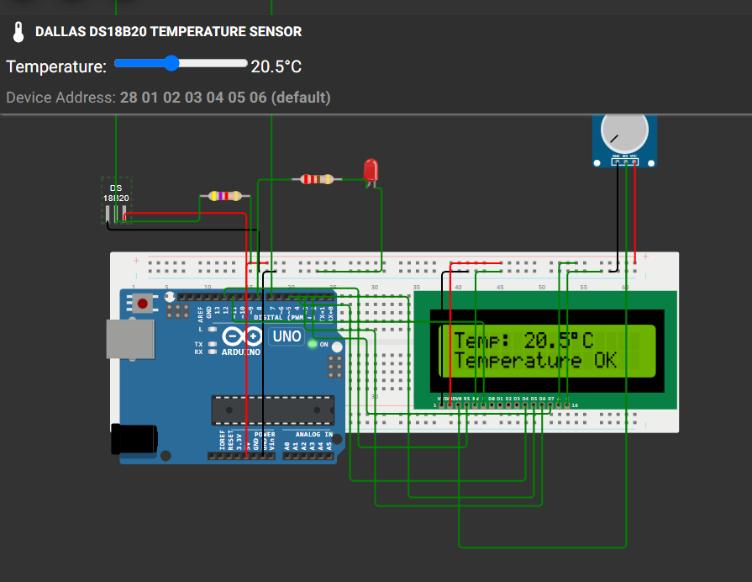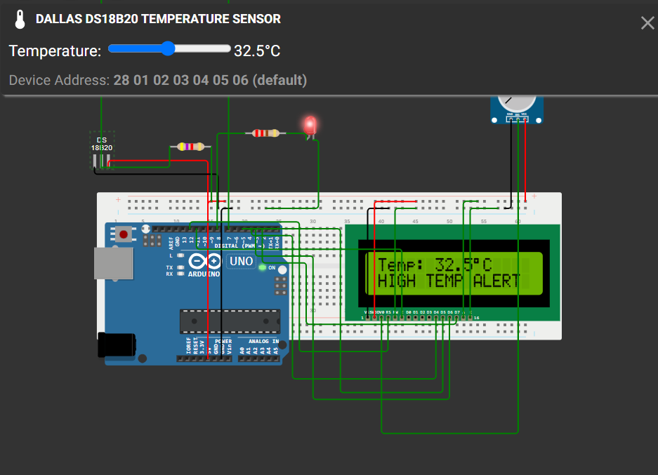

9. Project link
https://wokwi.com/projects/479223658920589313

