TEMPERATURE MONITORING
AND ALERT SYSTEM

1. Aim
To design and simulate a temperature monitoring system using an Arduino Uno and a DS18B20 digital temperature sensor. The measured temperature is displayed on a 16×2 LCD. When the temperature rises above 25°C, a red LED turns ON as a high-temperature warning.

2. Components and software
Component | Quantity | Purpose
Arduino Uno | 1 | Reads the sensor and controls the LCD and LED.
DS18B20 digital temperature sensor | 1 | Measures temperature and sends a digital reading.
16×2 LCD (LCD 1602) | 1 | Displays temperature and status.
Red LED | 1 | Visual high-temperature alert.
220 Ω resistor | 1 | Limits current through the LED.
4.7 kΩ resistor | 1 | Pull-up between DS18B20 DATA and 5V.
10 kΩ potentiometer | 1 | Adjusts LCD contrast.
Breadboard and jumper wires | As required | Connect components and distribute power.

Software: Wokwi online simulator. Libraries: OneWire and DallasTemperature; LiquidCrystal .

3. Working principle
The DS18B20 is a digital temperature sensor. It communicates with the Arduino through the OneWire protocol using a single data line connected to digital pin D7. A 4.7 kΩ pull-up resistor connects the DATA line to 5V, keeping the data bus at a defined HIGH level when it is idle.
The Arduino requests a temperature conversion and reads the value in degrees Celsius using the DallasTemperature library. It displays the reading on the LCD and compares it with the preset threshold of 25°C.
- If temperature is greater than 25°C, Arduino pin D8 goes HIGH, the LED turns ON, and the LCD displays “HIGH TEMP ALERT”.
- If temperature is 25°C or below, D8 goes LOW, the LED remains OFF, and the LCD displays “Temperature OK”.
At exactly 25°C the LED remains OFF because the program uses a strict greater-than comparison.

4. Complete circuit connections

4.1 Breadboard power rails
- Connect Arduino 5V to the breadboard positive (+ / red) rail.
- Connect an Arduino GND pin to the negative (− / blue) rail.
- If using both top and bottom power rails, link the positive rails together and link the ground rails together. Do not assume separate rails are internally connected.
- On a standard breadboard, each group of five holes on one side of the centre gap is connected internally. The two sides of the centre gap are isolated.

4.2 DS18B20 temperature sensor
DS18B20 pin | Connection
VCC | Arduino 5V / positive rail
GND | Ground rail
DQ / DATA | Arduino digital pin D7
4.7 kΩ pull-up resistor | One end to the DQ/DATA node; other end to 5V

Important: DQ, Arduino D7, and one end of the 4.7 kΩ resistor must share the same electrical node. The resistor connects from this node to 5V; it is not in series between DQ and D7. Follow the pin labels on the Wokwi sensor model.

4.3 16×2 LCD (LCD 1602)
LCD pin label | Connection
VSS | Ground rail
VDD | 5V rail
VO | Middle pin (SIG) of potentiometer
RS | Arduino D12
RW | Ground rail (write-only mode)
E | Arduino D11
D0, D1, D2, D3 | Leave unconnected (4-bit mode)
D4 | Arduino D5
D5 | Arduino D4
D6 | Arduino D3
D7 | Arduino D2
A / LED+ | 5V, if exposed by the LCD model
K / LED− | GND, if exposed by the LCD model

4.4 Potentiometer (LCD contrast)
Potentiometer pin | Connection
VCC | 5V rail
GND | Ground rail
SIG / middle pin | LCD VO

Adjust the potentiometer if the LCD backlight is on but the characters are difficult to see.

4.5 LED indicator
Connection point | Connect to
Arduino D8 | One end of the 220 Ω resistor
Other end of 220 Ω resistor | LED anode (+), usually the longer leg
LED cathode (−), usually the shorter leg | Ground rail

The resistor and LED are connected in series. The resistor limits current through the LED.

5. Arduino program
#include <LiquidCrystal.h>
#include <OneWire.h>
#include <DallasTemperature.h>
// LCD pins: RS, E, D4, D5, D6, D7
LiquidCrystal lcd(12, 11, 5, 4, 3, 2);
const int tempPin = 7;
const int ledPin = 8;
const float threshold = 25.0;
OneWire oneWire(tempPin);
DallasTemperature sensors(&oneWire);
void setup() {
pinMode(ledPin, OUTPUT);
digitalWrite(ledPin, LOW);
lcd.begin(16, 2);
sensors.begin();
lcd.setCursor(0, 0);
lcd.print("Temp Monitoring");
delay(1500);
lcd.clear();
}
void loop() {
sensors.requestTemperatures();
float temperature = sensors.getTempCByIndex(0);
lcd.setCursor(0, 0);
if (temperature == DEVICE_DISCONNECTED_C) {
lcd.print("Sensor Error ");
lcd.setCursor(0, 1);
lcd.print("Check wiring ");
digitalWrite(ledPin, LOW);
delay(1000);
return;
}
lcd.print("Temp: ");
lcd.print(temperature, 1);
lcd.print((char)223);
lcd.print("C ");
lcd.setCursor(0, 1);
if (temperature > threshold) {
digitalWrite(ledPin, HIGH);
lcd.print("HIGH TEMP ALERT ");
} else {
digitalWrite(ledPin, LOW);
lcd.print("Temperature OK ");
}
delay(1000);
}

6. Explanation of the program
- LiquidCrystal controls the LCD. The pin order in lcd(12, 11, 5, 4, 3, 2) is RS, E, D4, D5, D6 and D7.
- OneWire creates the communication bus on Arduino D7. DallasTemperature uses this bus to communicate with the DS18B20.
- In setup(), the LED is configured as an output, the LCD is initialized, and the sensor is started.
- In loop(), requestTemperatures() asks the sensor to measure temperature. getTempCByIndex(0) reads the first detected sensor in Celsius.
- The program checks for a disconnected sensor. If the reading is invalid, it displays an error and keeps the LED OFF.
- The temperature is printed to one decimal place. The if/else statement compares it with 25.0°C and controls the LED.
- The loop repeats approximately once per second.

7. Simulation procedure
- Open Wokwi and create a new Arduino Uno project.
- Add the DS18B20, LCD 1602, LED, two resistors, potentiometer and breadboard.
- Wire the components according to Section 4.
- Paste the program into sketch.ino.
- Add OneWire and DallasTemperature through the Library Manager if required.
- Start the simulation and select the DS18B20 component to change its simulated temperature.
- Set 20°C and check that the LCD shows Temperature OK and the LED is OFF.
- Set 30°C and check that the LCD shows HIGH TEMP ALERT and the LED is ON.
- Optionally test 25°C; the LED should remain OFF.
- Capture screenshots of the normal and alert conditions for the final report.

8. Expected outputs
Test temperature | LCD status | LED
20°C | Temperature OK | OFF
25°C | Temperature OK | OFF
30°C | HIGH TEMP ALERT | ON

Temperature OK condition: HIGH TEMP ALERT condition:

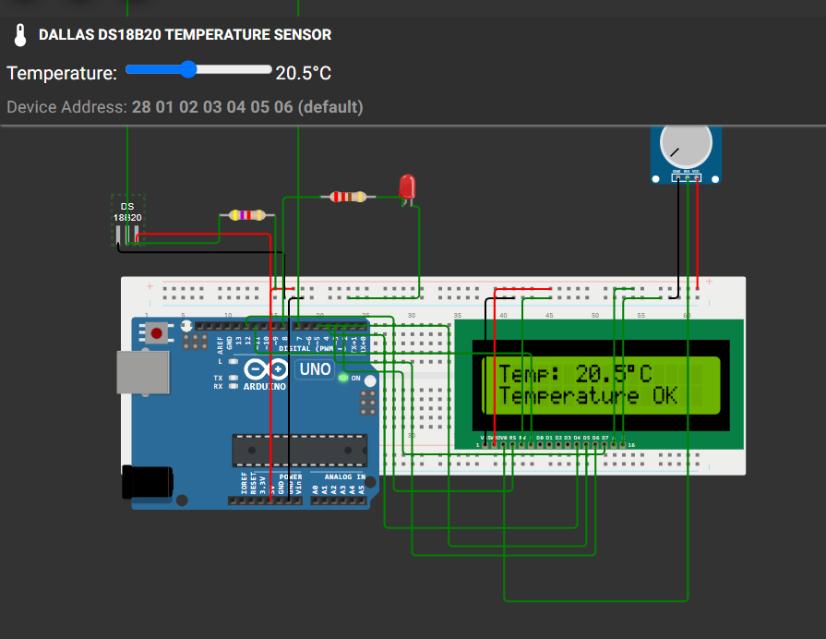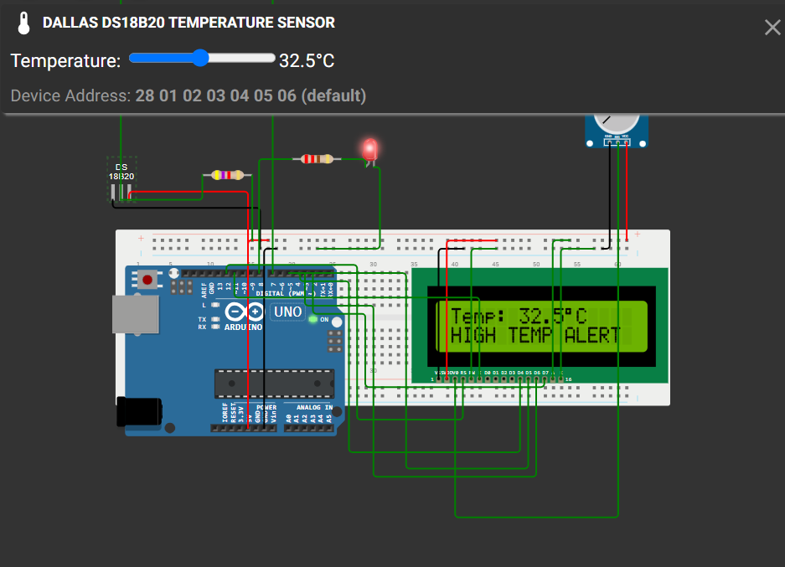

9. Project link
https://wokwi.com/projects/479223658920589313

