Categories: secret
File number：D0000-PPCMT012

Detailed Design Templates
version：0.8.0-0.0.0
2009-11-9

Neusoft Ltd Training Centre
(All rights reserved pirated reserved)

Total pages |  | Body |  | Appendix |  | Date of entry into force
Edit |  |  |  | Approved

Catalog

1 Document Summary 4
1.1 Document purpose and scope 4
1.2 Terms/abbreviations 4
1.3 Reference documentation 4
2 Module Functional Description 4
2.1 Data Structure Definitions 4
2.2 Custom types of data-structure 5
2.2.2 The Global Variable Definition 5
2.2.3 Constant definitions 5
2.3 Class Function 5
2.3.1 Class Data Members 5
2.3.2 Class Member Function 5
2.3.3 (Appending each function description and flow chart) 7
2.3.4 (Appending each function description and flow chart) 7
2.3.5 (Appending each function description and flow chart) 7

Document Summary

Document purpose and scope
This document has for purpose the detailed functional and technical description of our conception for the License Plate Recognition project. We are going to describe all the architecture and the functionality of both, server and client.
Moreover, a entire use case diagram of all functionality, a class and sequence diagram will explain the architecture of our project.
The protocol between server and client are going to be explaining too.

Terms/abbreviations

Sequence number | Terms/avvreviation | Description
1 | OCR | Optical Character Recognition
2

Reference documentation

ID | Document Name | Author | Time | Version
1 | DetailedDesign | Mercie | 06/11/12 | .1.0
2

Module Functional Description
User case diagram

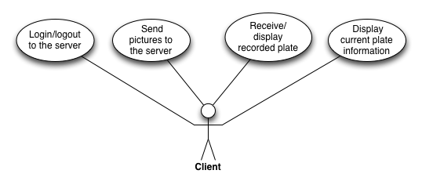

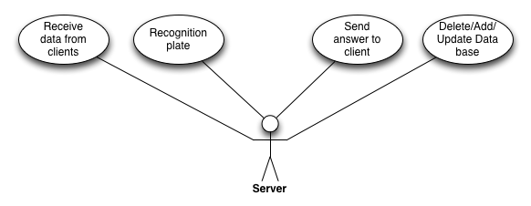

Use Case Diagram

Class diagram
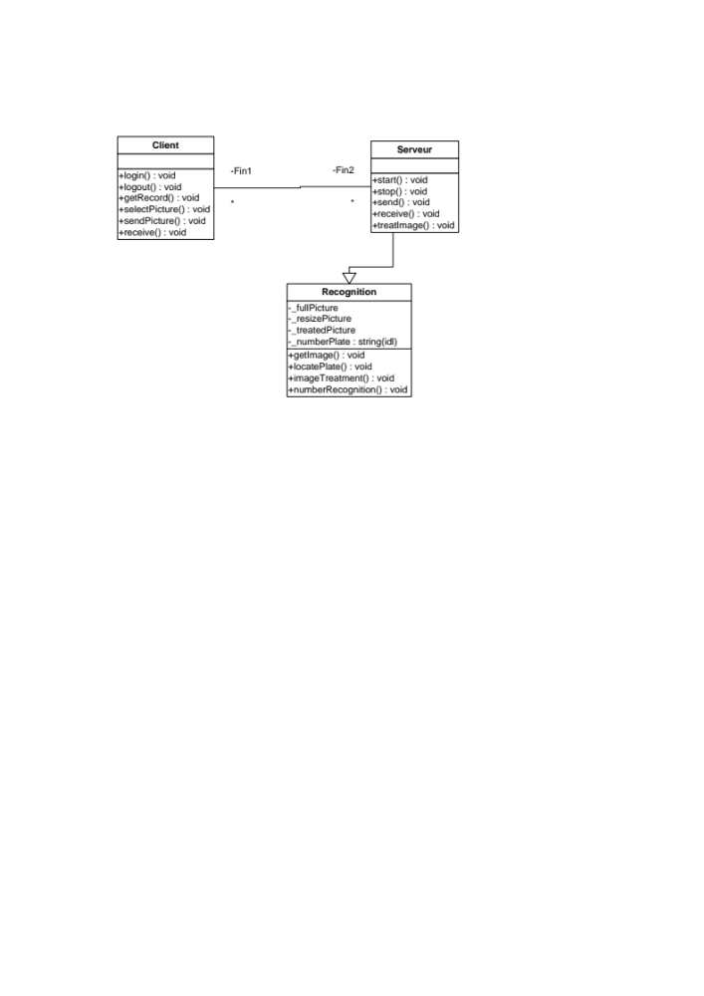
Class Diagram

Sequence diagram

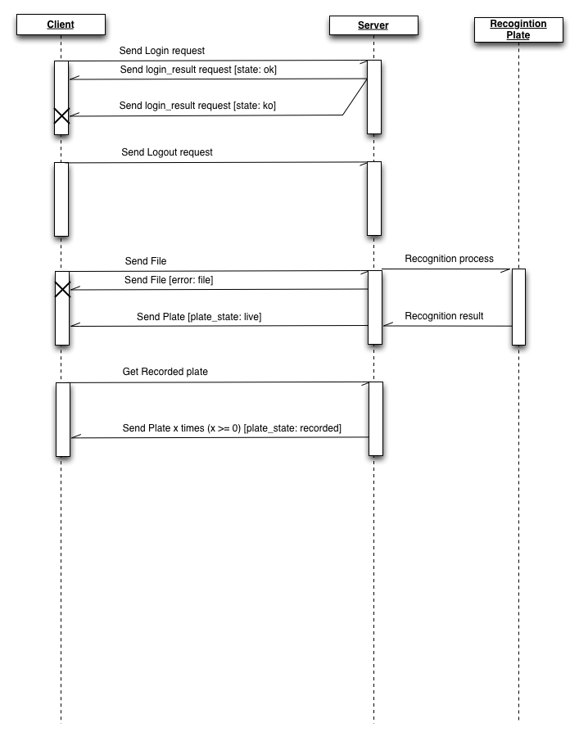
Sequence Diagram

Data Structure Definitions
Protocol Client / Server
A binary protocol will be use, describe below.
List of packet’s type:
- Login
- Logout
- Login_result
- Plate
- File

Enum’s details:
State:
- ok
- ko
Plate_state:
- recorded
- live
Error:
- none
- file
Packet’s details:
Header:
- data type (1 byte)
- body_size (integer)
- error (1 byte)
Login:
- login (char *)
- password (char *)
Logout: (no data)
Login_result:
- state (1 byte)
Plate: (no action enable from client side about plate)
- plate_id (int)
- plate_state (1 byte)
- name (char *)
- code_image _plate (char *)
File:
- file_id (int)
- file_name (char *)
- parts (integer)
- total_parts (integer)
- content (void *)

Custom types of data-structure
For each packet transmit between the client and the server, a data package composed of a Header and a Body is used. There are 6 data body type available (all are describe in 2.1 section).

The Global Variable Definition

None

Constant definitions
none

Class Function

Server

Function name | Start |  | Function scope |  |  | public
File name | Server.cpp
Function Summay | Start the server connection
Style
Parameters
Type | Variables Name |  |  | I/O | Description
Return value | Type | void |  | Description
Return value | Value
Detailed Description
1．
2．
3．
4．
Note the use of

Function name | Stop |  | Function scope |  |  | public
File name | Server.cpp
Function Summay | Stop the server connection
Style
Parameters
Type | Variables Name |  |  | I/O | Description
Return value | Type | void |  | Description
Return value | Value
Detailed Description
1．
2．
3．
4．
Note the use of

Function name | Send |  | Function scope |  |  | public
File name | Server.cpp
Function Summay | Send data package to the client
Style
Parameters
Type | Variables Name |  |  | I/O | Description
Return value | Type | void |  | Description
Return value | Value
Detailed Description
1．
2．
3．
4．
Note the use of

Function name | receive |  | Function scope |  |  | public
File name | Server.cpp
Function Summay | Receive data package from the client
Style
Parameters
Type | Variables Name |  |  | I/O | Description
Return value | Type | void |  | Description
Return value | Value
Detailed Description
1．
2．
3．
4．
Note the use of

Function name | treatImage |  | Function scope |  |  | public
File name | Server.cpp
Function Summay | Treat the current image
Style
Parameters
Type | Variables Name |  |  | I/O | Description
Return value | Type | void |  | Description
Return value | Value
Detailed Description
1．
2．
3．
4．
Note the use of

Client

Function name | Login |  | Function scope |  |  | public
File name | Client.cpp
Function Summay | Send login request to the server
Style
Parameters
Type | Variables Name |  |  | I/O | Description
Return value | Type | void |  | Description
Return value | Value
Detailed Description
1．
2．
3．
4．
Note the use of

Function name | Logout |  | Function scope |  |  | public
File name | Client.cpp
Function Summay | Send logout request
Style
Parameters
Type | Variables Name |  |  | I/O | Description
Return value | Type | void |  | Description
Return value | Value
Detailed Description
1．
2．
3．
4．
Note the use of

Function name | getRecord |  | Function scope |  |  | public
File name | Client.cpp
Function Summay | Get recorded plate
Style
Parameters
Type | Variables Name |  |  | I/O | Description
Return value | Type | void |  | Description
Return value | Value
Detailed Description
1．
2．
3．
4．
Note the use of

Function name | Select Picture |  | Function scope |  |  | public
File name | Client.cpp
Function Summay | Select the picture to send.
Style
Parameters
Type | Variables Name |  |  | I/O | Description
Return value | Type | void |  | Description
Return value | Value
Detailed Description
1．
2．
3．
4．
Note the use of

Function name | sendPicture |  | Function scope |  |  | public
File name | Client.cpp
Function Summay | Send picture to the server
Style
Parameters
Type | Variables Name |  |  | I/O | Description
Return value | Type | void |  | Description
Return value | Value
Detailed Description
1．
2．
3．
4．
Note the use of

Function name | receive |  | Function scope |  |  | public
File name | Client.cpp
Function Summay | Receive data from the server
Style
Parameters
Type | Variables Name |  |  | I/O | Description
Return value | Type | void |  | Description
Return value | Value
Detailed Description
1．
2．
3．
4．
Note the use of

Class Data Members
None.

Class Member Function
None.

CFunctionName(Function Name)

(Appending each function description and flow chart)
……

(Appending each function description and flow chart)
……

(Appending each function description and flow chart)
……

