Logging using SLF4J

# **Exercise 1: Logging Error Messages and Warning Levels:**

**Task:** Write a Java application that demonstrates logging error messages and warning levels using SLF4J.

**Step-by-Step Solution:**

1. **Add SLF4J and Logback dependencies to your `pom.xml` file:**

<dependency>

<groupId>org.slf4j</groupId>

<artifactId>slf4j-api</artifactId>

<version>1.7.30</version>

</dependency>

<dependency>

<groupId>ch.qos.logback</groupId>

<artifactId>logback-classic</artifactId>

<version>1.2.3</version> </dependency>

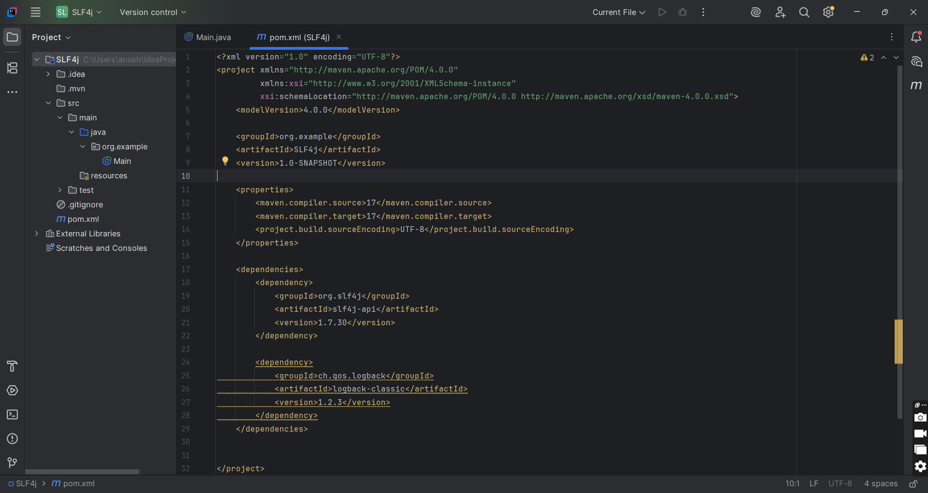

1. **Create a Java class that uses SLF4J for logging:**

package org.example;  
  
import org.slf4j.Logger;  
import org.slf4j.LoggerFactory;  
  
public class LoggingExample {  
 private static final Logger *logger* = LoggerFactory.*getLogger*(LoggingExample.class);  
  
 public static void main(String[] args) {  
  
 *logger*.error("This is an error message");  
  
 *logger*.warn("This is a warning message");  
 }  
}

