**Lab: Heaps and BST**

This document defines the lab for ["Data Structures – Fundamentals (Java)" course @ Software University](https://softuni.bg/trainings/4275/data-structures-fundamentals-with-java-september-2023). Please submit your solutions (source code) of all below described problems in [Judge](https://judge.softuni.bg/Contests/2210/05-Heaps-and-BST).

Write Java code for solving the tasks on the following pages. Code should compile under the Java 8 and above standards you can write and locally test your solution with the Java 13 standard, however **Judge will run the submission with Java 10 JRE**. Avoid submissions with **features included after Java 10** release doing **otherwise** will result in **compile time error**.

Any code files that are part of the task are provided as **Skeleton**. In the beginning import the project skeleton, do not change any of the interfaces or classes provided. You are free to add additional logic in form of methods in both interfaces and implementations you are not allowed to delete or remove any of the code provided. Do not change the names of the files as they are part of the tests logic. **Do not change the packages** or move any of the files provided inside the skeleton if you have to add new file add it in the same package of usage.

Some **tests may be provided** within the skeleton – use those for local **testing and debugging**, however there **is no guarantee that there are no hidden tests added inside Judge**.

Please follow the exact instructions on uploading the solutions for each task. Submit as **.zip archive** the files contained inside **"...\src\main\java"** folder this should work for all tasks regardless of current DS implementation.

In order for the solution to compile the tests **successfully** the project **must** have **single** **Main.java** file containing single **public static void main(String[] args)** method even empty one within the **Main class**.

Some of the problem will have simple **Benchmark** **tests** inside the skeleton. You can try to run those with **different** **values** and **different** **implementations** in order to **observe** behaviour. However **keep** in mind that the result comes **only as numbers** and this data may be **misleading** in some situations. Also the tests are not started from the command prompt which may **influence** the **accuracy** of the results. Those tests are only added as an **example** of **different** **data** **structures** **performance** on their **common** operations.

The Benchmark tool we are using is **JMH** (Java Microbenchmark Harness) and that is Java harness for building, running, and analyzing, **nano/micro/milli/macro** benchmarks written in Java and other languages targeting, the JVM.

**Additional** **information** can be found here: [JMH](https://openjdk.java.net/projects/code-tools/jmh/) and also there are other examples over the **internet**.

**Important:** when importing the skeleton **select** **import** **project** and then **select** **from** **maven** **module**, this way any following **dependencies** will be **automatically** **resolved**. The project has **NO** **default** **version** of **JDK so after the import you may (depends on some configurations) need to specify the SDK, you can download** **JDK 13** from [**HERE**](https://jdk.java.net/13/)**.**

## Binary Tree

Inside the given skeleton. You should implement the **BinaryTree<E>** class with the following operations:

* **E getKey() –** returns the **key** of a node
* **AbstractBinaryTree<E> getLeft() –** returns the **left sub tree** of a node
* **AbstractBinaryTree<E> getRight() –** returns the **left right tree** of a node
* **void setKey(E key) – sets** the **key** of a node
* **String asIndentedPreOrder(int indent) –** returns the tree as **String** each inner level is **idented with 2** **spaces** as **padding**
* **List<AbstractBinaryTree<E>> preOrder() –** returns the **tree** in **preOrder** – first we **add** the **visiting** node then we **continue** with the **left** and **right** child
* **List<AbstractBinaryTree<E>> inOrder() –** returns the **tree** in **inOrder** – first we move **left** as **much** as we **can** then **add** the **visiting** node and then we continue the **right** child
* **List<AbstractBinaryTree<E>> postOrder()** – returns the **tree** in **postOrder** – first we move **left**, then **right** and at the end as we **have no path**, we **add** the **visiting** node
* **void forEachInOrder(Consumer<E> consumer) – applies** a **Consumer<E>** on **each** node traversed **inOrder**

### Examples

**Look at the provided tests inside the skeleton.**

This problem is really a lot like **DFS** or **BFS** we already **know** **how** to **solve**. With a little **twist** we can reuse **recurrence** and **solve** all of them, think about the **definition** which **action** is **before** the **next** one and the **other** **way** **around** etc…

**Hints:**

There are of course **hints** inside the **presentation** if you are **stuck** **somewhere**.

## MaxHeap

## Inside the given skeleton. You should implement the MaxHeap<E> class with the following operations:

* int size() – returns the **number** of **elements** in the structure
* void add(E element) – **adds** an **element**
* E peek() – returns the **maximum** **element** **without** **removing** it

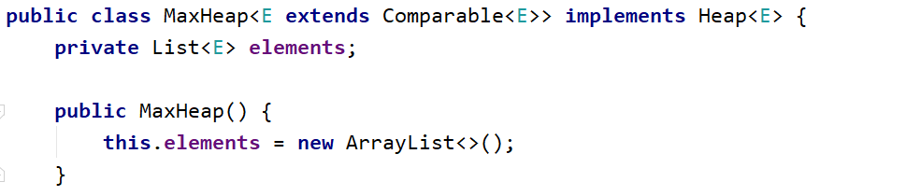

### Examples

Look at the provided tests inside the skeleton.

### Peek

In a **max heap**, the max element should always stay at index 0. Peek should return that element, without removing it. Verify that the structure is not empty, otherwise throw **IllegalStateException** with some message.

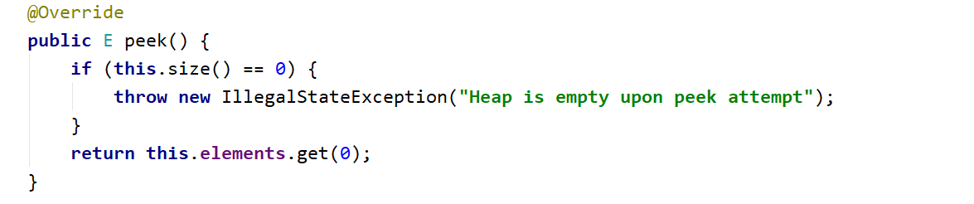

### Add

Adding an element should put it at the end and then bubble it up to its correct position. HeapifyUp receives as a parameter the index of the element that will bubble up towards the top of the pile.

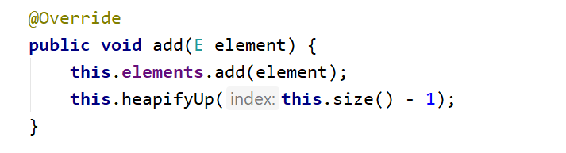

Time to implement HeapifyUp. While the index is greater than 0 (the element has a parent) and is greater than its parent, swap child with parent. Implement the helper methods (parent() and less()) by yourself.

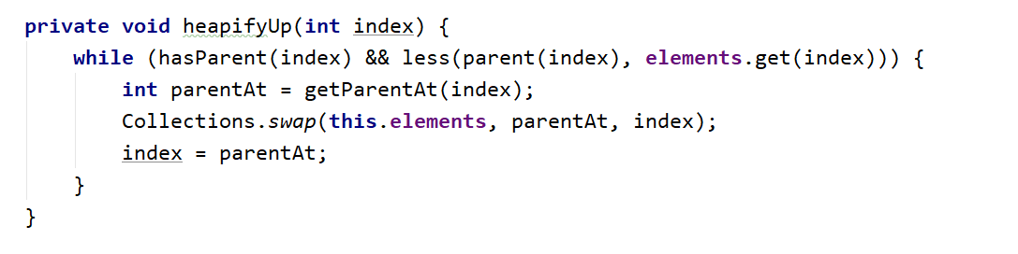

## PriorityQueue

Inside the given skeleton. You should implement the **PriorityQueue<E>** class with the following operations:

* **int size()** – returns the **number** of **elements** in the structure
* **void add(E element)** – **adds** an **element**
* **E peek()** – returns the **maximum** **element** **without** **removing** it
* **E poll() –** returns the **maximum** **element** **and** **removes** it

### Examples

**Look at the provided tests inside the skeleton.**

**Add, Peek and Size**

**How different are those methods to the once implemented for the MaxHeap problem? Can you reuse those methods?**

**Poll**

In a **PriorityQueue**, the max element should always stay at index 0. **Peek** should return that element, and remove it. Verify that the structure **is not empty**, otherwise throw **IllegalStateException** with some message.

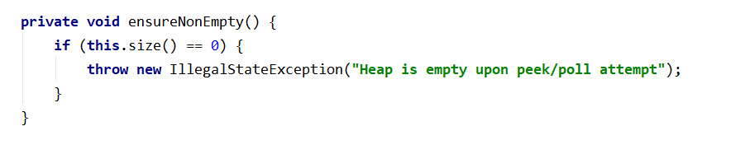

Next, we need to save the element on the top of the heap (index 0), **swap** the **first** and **last elements**, **exclude** the **last element** and **demote** the one **at the top until it has correct position**

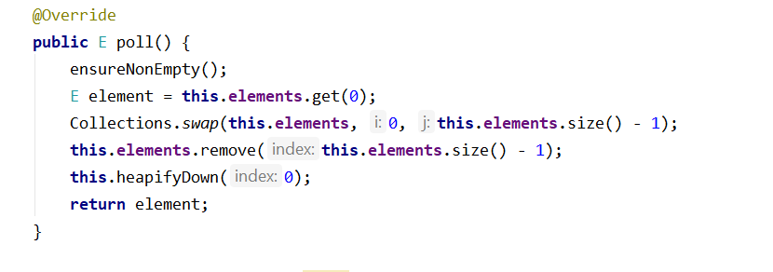

The HeapifyDown() function will demote the element at a given index until it has no children or it is greater than its both children. The first check will be our loop condition

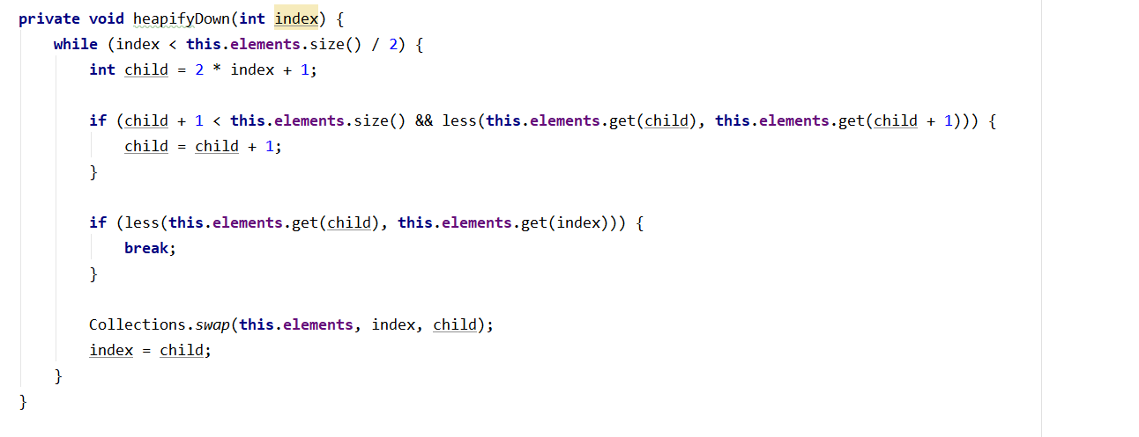

## Binary Search Tree (BST)

Inside the given skeleton. You should implement the **BinarySearchTree<E>** class with the following operations:

* **void insert(E** **element)** – **adds** an **element**
* **boolean contains(E element)** – returns the **maximum** **element** **without** **removing** it
* **AbstractBinarySearchTree<E> search(E element) –** returns the **tree with given** **element value** **as** **root** if exists if not return **empty** tree
* **Node<E> getRoot()** – returns the **root** of a tree
* **Node<E> getLeft()** – returns the **leftChildren** of a tree node
* **Node<E> getRight()** – returns the **rightChildren** of a tree node
* **E getValue()** – returns the **value** of a tree node

### Examples

**Look at the provided tests inside the skeleton.**

This time you have to solve the problem on **your own**. Think about it we **know** all we **need** to so **far**. It is **pretty** **simple**. Use the **tests** provided and create **new** **test** cases for **debugging** and code **correctness** validation.

**Hints:**

There are of course **hints** inside the **presentation** if you are **stuck** **somewhere**.

"Somewhere, something incredible is waiting to be known."

― Carl Sagan