Targeted [MultiSequence Alignment] Masking Reshapes Structural Sampling in Mutant Voltage-Gated Ion Channels
Adriana Hernandez-Gonzalez, Diego Lopez-Mateos, Brandon Harris, Kush Narang, Aleena Siritanapivat, Vladimir Yarov-Yarovoy *preliminary order*

Abstract
Many disease-associated mutations in voltage-gated ion channels are expected to alter gating through relatively small, state-dependent structural changes. These changes are difficult to capture experimentally, and default AlphaFold2 predictions are often nearly identical for a wild-type channel and its point mutant. Here, we hypothesized that this similarity arises in part from evolutionary constraints encoded in their largely shared multiple sequence alignments (MSAs) and studied whether targeted MSA masking could broaden mutation-relevant structural sampling. We generated AlphaFold2 structural ensembles spanning both sequence and MSA-processing conditions, comparing wild-type and mutant channels under the default (“vanilla”) and targeted-masking protocols. We evaluated these comparisons in three channel-specific case studies spanning mechanistic benchmark mutants and disease-associated variants: voltage-gated potassium Kv2.1 (L403A and F412L in the S6/pore-coupling region), voltage-gated sodium Nav1.5 (the QQQ mutant in the fast-inactivation gate), and voltage-gated calcium Cav1.2 (G402S and G406R at the DI-S6/DIV-S6 interface). We evaluated structural variability by channel, mutation, and masking strategy. In Kv2.1, masking increased access to the experimentally observed direction of the L403A displacement at the pore–VSD interface and generated contact-specific alternative packing arrangements around the unresolved F412L mutation. In Nav1.5, masking disrupted the wild-type IFM–receptor proximity supported by experimental structures, demonstrating that weakening evolutionary constraints can remove useful structural information. In Cav1.2, G402S altered local DI-S6/DIV-S6 packing and showed protocol-dependent redistribution of local partner selection, whereas unrelaxed G406R predictions included heterogeneous mutation-centered geometries and a substantial mutation-centered severe-overlap subset; neither mutation produced a uniform global pore shift. Overall, masking reshaped mutation-relevant local sampling in a channel- and region-dependent manner, increasing access to local alternatives in some cases while disrupting wild-type structural constraints in others. Together, these results support the use of targeted MSA masking as a context-dependent, hypothesis-generating strategy for exploring mutation-associated conformational alternatives, while emphasizing that sampled structures must be evaluated against channel-specific experimental data, mechanistic coordinates, and steric quality controls rather than interpreted as unique mutant conformations.

Introduction
Voltage-gated ion channels (VGICs) control electrical signaling in neurons, muscle, and the heart by coupling changes in membrane potential to selective ion flow [1,2]. Despite differences in subunit organization, potassium, sodium, and calcium channels share a modular architecture in which voltage-sensor domains (VSDs) are coupled to a central pore through S4–S5 linkers and S6 helices [3–6]. A single-residue substitution can alter activation, inactivation, ion permeation, or channel regulation, leading to severe neurological, muscular, and cardiac channelopathies [7,8]. However, even when the functional effect of a mutation is well established, the molecular mechanism and related structural changes that produce it are often unknown [9].

Cryogenic electron microscopy (cryo-EM) has greatly expanded the number of VGIC structures resolved at high resolution in different functional states [2,10,11]. However, experimentally determined structures of disease-associated VGIC variants remain scarce, reflecting the substantial technical challenges associated with structural characterization of mutant channels [9–13]. Mutations can further complicate experimental structure determination by altering VGIC stability, expression, or conformational behavior, thereby limiting the ability to obtain well-resolved structures [12,13]. Experimental structures also capture only a limited subset of the conformations accessible to channels that transition among closed, open, and inactivated states. Examples of experimentally resolved VGIC mutants capturing disease-linked or disease-informed conformational rearrangements include the Kv2.1 L403A inactivation mutant [12] and NaVAb channels carrying substitutions equivalent to human NaV1.7 inherited-erythromelalgia mutations in the S4–S5 linkers and voltage sensors [14,15]. Mutations can also be introduced deliberately to facilitate structural determination of particular states; for example, the IFM-to-QQQ substitution stabilized an open conformation of Nav1.5 for structural determination, although the substituted III–IV-linker segment remained unresolved [16]. A mutation may therefore alter a local gating interface without producing a large change in the overall channel structure. For this reason, modeling mutant ion channels requires generating and examining structural ensembles rather than relying on a single predicted model.

Deep-learning methods provide a practical approach for exploring structural hypotheses for ion-channel conformations that have not been experimentally resolved [17]. Although AlphaFold2 (AF2) predicts overall protein architecture with high accuracy [18], including ion channels [9], subtle effects of amino-acid substitutions remain difficult to capture. Wild-type and mutant models often remain highly similar, reflecting the tendency of AF2 to favor a dominant structural solution, and standard confidence metrics provide limited information about mutation-induced changes in local structure or function [19–24]. For VGICs, this is particularly relevant because mechanistically important changes may be confined to the pore, VSD, S4–S5 linker, or coupling interfaces without altering the global channel fold [12,14,15].

Several approaches have been developed to improve AlphaFold2 sampling diversity, mostly by modifying the Multiple Sequence Alignment (MSA) input [17,25–32]. Subsampling and shallow-MSA approaches reduce the amount of evolutionary information supplied to the network, whereas sequence clustering separates subsets that may encode different structural states [25,27,28]. Subsampled AlphaFold approaches have been successfully applied to model multiple states of voltage-gated sodium and potassium channels [17,33]. Other approaches perturb selected MSA positions through in silico mutagenesis or random column masking [26,29,30]. For large multidomain proteins such as VGICs, randomly perturbing MSA information may also disrupt long-range allosteric effects outside the region of interest. This tradeoff highlights the need for sampling strategies that preserve global evolutionary information while selectively perturbing alignment positions near the mutant sites and within functionally connected gating and coupling regions [34].

MSA column masking perturbs the evolutionary information provided to AlphaFold2 differently. Rather than removing entire sequences from the alignment, selected residue positions are replaced with X, denoting an unknown amino acid. This locally weakens the evolutionary constraints encoded at those residue positions while preserving most of the alignment and its broader sequence context. For example, in AFsample2 [29], columns are randomly masked, allowing different subsets of coevolutionary constraints to be disrupted across predictions, thereby promoting the sampling of alternative conformations. However, the structural regions that diversify in a given prediction depend on whether the random mask disrupts constraints associated with the relevant conformational transition. For many protein families, structural and functional studies have already identified specific regions that drive switching between functional states [35]. This prior knowledge motivated us to investigate targeted masking as a hypothesis-guided strategy for structurally unresolved variants, with potential precision-medicine applications. Rather than masking columns randomly, we restricted masking to predefined mechanistically relevant or disease-associated sequence regions.

Here, we introduce and evaluate “Targeted MSA masking” (Fig. 1), a hypothesis-guided approach in which mask positions are selected a priori using both mechanistic knowledge of protein conformational transitions and the structural context of the mutation. By selectively weakening evolutionary constraints in these regions while preserving the query sequence and most of the alignment, we tested whether AlphaFold2 could broaden sampling of structural alternatives relevant to both the mutation and the conformational mechanism being investigated. Importantly, our analysis considered two complementary comparisons: wild type versus mutant under the same prediction protocol, and vanilla versus masked predictions within the same sequence background. This design allowed us to separate structural differences associated with introducing a mutation from changes in sampling caused by MSA masking itself, and to ask whether the effect of masking depended on the sequence context in which it was applied. We evaluated targeted masking in three VGIC systems as separate case studies (Fig. 2), each defined by a different level of experimental evidence and a channel-specific structural question. Kv2.1 provides a mutation-matched structural benchmark in the S6/pore-coupling region because structures are available for wild type and L403A, whereas the disease-associated F412L mutant remains unresolved [12,36]. Nav1.5 tests the relationship among the fast-inactivation gate formed by the III–IV-linker IFM motif, its receptor site, and pore opening using the engineered QQQ construct and newer wild-type open and intermediate structures [16,37–39]. Cav1.2 examines the Timothy syndrome substitutions G402S and G406R in DI-S6 at the DI-S6/DIV-S6 interface, for which strong functional effects are known but mutation-matched structures are unavailable [40–45]. Across these case studies, we asked whether the mutation altered the structural ensemble under otherwise matched conditions, whether targeted masking further redistributed that ensemble, and whether the resulting structural alternatives were supported by experimental structures or mutation-centered mechanistic coordinates. Overall, targeted masking expanded access to mutation-relevant local geometries in some systems but disrupted experimentally supported native constraints in others, indicating that its effects depend on the protein, mutation, and mask design.

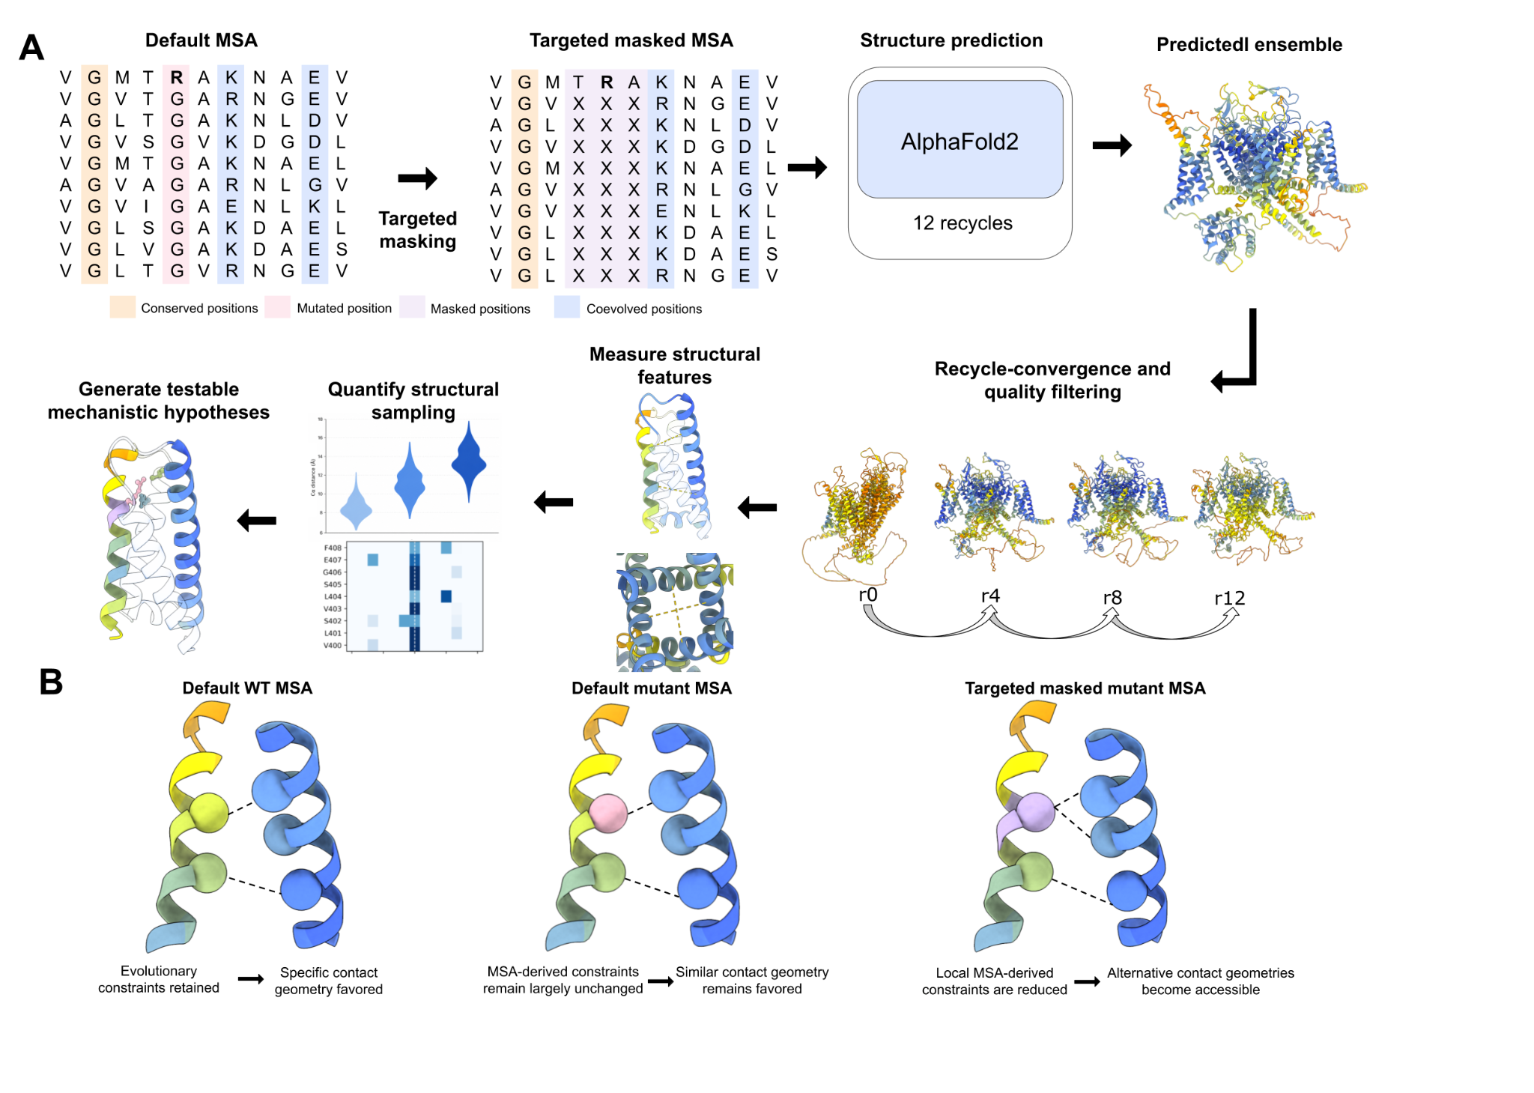
Figure 1. Overview and conceptual rationale of targeted MSA masking for structural ensemble sampling. (A) Schematic of the targeted masking workflow. Starting from the default multiple sequence alignment (MSA), selected columns centered on the mutation and/or mechanistically relevant regions are masked to reduce local evolutionary constraints before AlphaFold2 structure prediction. Predictions were generated using 12 recycles to produce a structural ensemble, followed by recycle-convergence and model-quality filtering. Retained structures were then analyzed using structural features and distance measurements to quantify the range and distribution of conformations sampled and to generate testable mechanistic hypotheses. (B) Conceptual model for how targeted MSA masking can alter structural sampling. In the default WT condition, evolutionary information in the MSA favors specific contact geometries. Introduction of a mutation changes the query sequence while leaving most MSA-derived constraints largely unchanged, potentially favoring a geometry similar to that sampled for WT. Targeted masking reduces selected local MSA-derived constraints, allowing alternative contact geometries to become accessible during structure prediction. Schematics are illustrative and are not intended to represent a specific protein or residue interaction.
[PLACEHOLDER FOR FIGURE 2: overview of the three channel-specific case studies; final panel content and legend under development, Diego’s working on it]
Figure 2. Experimental context and channel-specific questions for the three VGIC case studies.

Methods
Structure prediction and targeted MSA masking
We generated AlphaFold2 structural ensembles for both wild-type and mutant channel sequences under either the default workflow (referred to here as vanilla) or targeted MSA masking. Thus, the principal experimental design varied two factors: sequence background (wild type versus mutant) and MSA treatment (vanilla versus masked). Wherever matched masks were available, this yielded four directly interpretable conditions—WT vanilla, WT masked, mutant vanilla, and mutant masked—allowing us to distinguish mutation-associated differences under the same MSA treatment from masking-dependent changes within the same sequence background. The query sequence was preserved in all conditions, and selected query-mapped positions were replaced with X only in homologous MSA rows. For Kv2.1, wild type, L403A, and F412L were evaluated with the same targeted mask spanning three functionally connected regions: the S4 voltage-sensor helix and S4–S5 linker (model residues 288–328), the pore-helix/selectivity-filter-adjacent region (370–384), and the mutation-proximal S6 activation-gate segment containing L403 and F412 (401–417). Nav1.5 was evaluated with several mask designs targeting portions of the pore, III–IV linker, IFM region, and receptor-coupling elements, including a no-IFM control in which the three IFM columns were retained. Cav1.2 used channel- and condition-specific masks centered on the DI-S6 mutation interface and nearby gating elements. The shared Kv2.1 mask permitted direct sequence-by-masking interaction contrasts. In Nav1.5 and Cav1.2, WT–mutant vanilla comparisons were treated as the primary sequence contrasts, whereas masked WT–mutant comparisons were treated as protocol-specific explorations because the masked columns were not established to be identical between sequence backgrounds. More broadly, the three channels were treated as channel-specific case studies rather than as replicates of one generalized masking design (Fig. 2). The exact channel- and condition-specific mask mappings are shown in Fig. 3A–C and Table S1.

Each condition included multiple AlphaFold model parameterizations and random seeds, with structures collected over multiple recycling iterations. All conditions were processed through the same convergence and quality-control framework. Recycle convergence was assessed from Cα RMSD between consecutive recycled models after superposition of a predefined stable core, and principal analyses were restricted to retained snapshots from trajectories satisfying the ≤3 Å converged-suffix criterion, valid residue and chain mapping, structural-integrity checks, and analysis-specific filters. Recycle snapshots from the same model–seed trajectory, and multiple subunits within one model, are correlated and were not treated as independent replicates.

Structural ensembles were generated with LocalColabFold version 1.6.1 [46], which uses AlphaFold2 [18] for structure prediction and the MMseqs2-based ColabFold pipeline for MSA generation. Nav1.5 (rat Nav1.5C structural construct) and Cav1.2 were modeled with the alphafold2_ptm configuration as single-chain pore-forming α subunits, with Cav1.2 auxiliary subunits omitted, whereas tetrameric Kv2.1 was modeled with multimer_v3 [47,48]. Template use was disabled, and all principal structural measurements reported here were performed on unrelaxed AlphaFold2 outputs; Amber relaxation was not applied. Mutation-centered side-chain proximities, particularly for G406R, were therefore interpreted together with explicit local-overlap quality control and were not treated as energetic evidence for stable contacts. All other parameters were kept at the defaults.

For each sequence and masking condition, five AlphaFold2 model parameterizations were evaluated with 100 random seeds, producing 500 model–seed trajectories per condition. Numbered recycle outputs were saved as snapshots r0–r10, together with an additional final prediction, yielding up to 12 saved structures per model–seed trajectory. Saved structures from the same model–seed combination were treated as correlated members of a single trajectory rather than as independent replicates.

Targeted masking was applied to the input A3M alignments before prediction. At selected query-mapped positions, residues in homologous sequence rows were replaced with X, while the query sequence itself was preserved. Kv2.1 wild type, L403A, and F412L used a shared mask spanning model residues 288–328, 370–384, and 401–417. Nav1.5 and Cav1.2 used channel- and condition-specific masks designed around the IFM region, gating elements, or mutation-centered S6 interfaces. Exact constructs, mutations, mask positions, and residue-number transformations are provided in Supplementary Table S1.

Recycle convergence and structural quality control
Recycle convergence was evaluated independently for each model–seed trajectory using the Cα RMSD between consecutive numbered recycle snapshots after optimal rigid-body least-squares superposition of a predefined channel-specific stable structural core. The exact residue ranges and chain selections defining the recycle-convergence core for each channel are provided in Supplementary Table S2. The ≤3 Å criterion refers specifically to the stable-core Cα RMSD between successive recycle snapshots and not to RMSD against an experimental structure or to the complete protein. A successive-recycle comparison was considered valid when at least 90% of the expected stable-core Cα atoms were available for alignment. A converged suffix began at the earliest qualifying recycle for which the incoming successive-recycle RMSD was ≤3 Å and every subsequent transition through r10 also remained ≤3 Å. All numbered recycle snapshots from that point through r10 were retained in the ≤3 Å recycle-convergence set; therefore, a single transition below 3 Å was insufficient to establish convergence. The separately written final prediction was not used to determine recycle convergence. Generated and retained trajectory and snapshot counts for each condition are reported in Supplementary Table S1.
Valid residue mapping required residues used for alignment or structural measurements to correspond to the intended positions in the modeled channel sequence. For Kv2.1, all four predicted subunits were required to be present, mutation-site residue identities were verified, and predicted tetramers were mapped to experimental structures using sequence-matched residues and the spatial ordering of subunits around the pore rather than assuming correspondence between predicted and experimental chain letters. NaV1.5 and Cav1.2 were modeled as single-chain pore-forming α subunits and were analyzed using their corresponding model residue numbering. Structural-integrity quality control required successful coordinate parsing, the expected chains, at least 90% Cα coverage of the configured structural core, and no Cα–Cα discontinuities greater than 4.5 Å within contiguous core intervals. For Kv2.1, an additional pore–VSD interface filter excluded model–seed trajectories containing any predefined K427/E423/K420-to-N179/V182 Cα distance greater than 27 Å. This filter was applied independently of the ≤3 Å recycle-convergence criterion. Analyses requiring specific residues or atoms were performed only when those coordinates were available. Exact stable-core definitions are provided in Supplementary Table S2, and retention after each quality-control stage is summarized in Supplementary Table S1.
A master per-structure cohort table recorded channel, sequence background, MSA protocol, seed, AlphaFold2 model parameterization, recycle, mapping-QC status, convergence status, final structural/interface-QC status, analysis-specific inclusion, and exclusion reason. Alignment metadata were joined by channel, dataset, and PDB basename. All 125,994 manifest structures had a mapping record and passed the recorded alignment checks. Mapping, convergence, final QC, and analysis-specific retention were reported as separate stages because metric availability and the Kv2.1 interface filter produced legitimate analysis-specific denominators.
Structural alignment, RMSF, and RMSD
Predicted structures were placed in a common channel-specific coordinate frame using a single rigid-body Cα alignment to a stable structural scaffold. These downstream analysis-alignment selections were defined separately from the recycle-convergence cores where necessary to avoid fitting away motion in the region being measured. Regions under direct investigation, including the Kv2.1 pore-coupling region, the Nav1.5 IFM-containing linker, and the Cav1.2 G402/G406-centered IS6 segment, were excluded from the corresponding alignment cores where appropriate. Exact residue selections, chain definitions, numbering conventions, and reference structures for both recycle-convergence and downstream structural alignments are provided in Supplementary Table S2.
Per-residue ensemble RMSF was calculated from aligned Cα coordinates relative to the ensemble-mean structure for each condition. RMSF therefore describes per-residue variability among retained AlphaFold2 structures and does not represent molecular-dynamics time fluctuations.
RMSDs were calculated using sequence-matched Cα atoms versus the experimental reference structure. Core-aligned regional RMSDs were calculated after applying the common structural-core transformation without independently refitting the region being measured; locally aligned regional RMSDs, where reported, used an additional fit restricted to that region. Experimental structures and alignment selections are listed in Supplementary Table S2, and regional RMSD definitions are listed in Supplementary Table S3.

Structural-distance and across-subunit analysis
Cα distances were calculated between predefined residue pairs to quantify larger-scale structural changes. Residue-level side-chain proximity was assessed separately using either shortest non-hydrogen side-chain distances or predefined side-chain tip distances, depending on the analysis. The shortest non-hydrogen side-chain distance was defined as the minimum Euclidean distance between any pair of non-hydrogen side-chain atoms in the specified residue pair. Because hydrogen atoms were not present in the analyzed AlphaFold2 coordinate files, these measurements correspond to minimum side-chain heavy-atom distances. Side-chain tip distances were defined separately as the Euclidean distance between predefined terminal atoms representing the distal end of the two side chains. The exact atoms used for tip-based measurements are provided in Supplementary Table S4.
Chain-resolved measurements were calculated before any across-subunit summary operation. For multimeric Kv2.1, each relevant measurement was therefore first evaluated for all four subunits of each predicted tetramer. When a single structure-level value was required, the four subunit-resolved measurements were combined using a predefined operation specific to that analysis rather than treating the four subunits as independent observations. Because chain identifiers in predicted Kv2.1 homotetramers are arbitrary, these summaries did not assume that predicted chains A–D corresponded to particular experimental protomers.
For the Kv2.1 L403A pore–VSD analysis, the E423–N179 Cα distance was measured independently in all four subunits and the maximum distance within each tetramer was retained as the structure-level value, thereby reporting the most displaced pore–VSD interface without relying on chain identity. Thus, each predicted tetramer contributed one value to distributions of this metric rather than four chain-level observations. Mutation-centered hydrophobic-nexus measurements were handled separately because they depend on defined intersubunit geometry: distances from residue 412 to L316 were measured within the same subunit, whereas the L329- and L403-centered measurements used the defined neighboring-subunit relationship. For F412L, the corresponding measurements were centered on L412. These Kv2.1 hydrophobic-nexus measurements used shortest non-hydrogen side-chain distances.
Nav1.5 IFM–receptor engagement was evaluated using predefined side-chain tip atoms for selected motif–receptor proximities, together with Cα-based measurements of motif separation and intracellular-gate geometry. Cav1.2 mutation-centered packing was assessed using shortest non-hydrogen side-chain distances between the substituted residue and selected surrounding residues. Complete residue, atom, chain, neighboring-subunit, distance-definition, and across-chain summary definitions for each measurement are provided in Supplementary Table S4.
Statistical analysis and sampling hierarchy
The input random seed was the primary resampling unit. Recycle snapshots from one seed-model trajectory and multiple subunits within one predicted structure were treated as correlated observations. For primary continuous structural outcomes, retained recycle snapshots were first reduced to the within-trajectory median. Available AlphaFold2 model parameterizations were then weighted equally within each seed, and seeds were weighted equally between conditions. For categorical outcomes, the within-trajectory reduction was specified explicitly as a fraction, earliest retained recycle, or latest retained recycle. Snapshot-level medians, percentiles, correlations, and frequencies were retained only as descriptive summaries and were not interpreted as independent observations or thermodynamic occupancies. Contributing seeds, correlated model-seed trajectories, and retained snapshots were reported separately.
Ninety-five-percent confidence intervals were estimated from 2,000 nonparametric bootstrap resamples of complete seeds. In each resample, the five AlphaFold2 model parameterizations remained fixed, equal-weight strata within the sampled seed. Primary geometry comparisons included all analysis-qualified survivors in each condition and did not condition on the same model-seed trajectory surviving in both conditions. Paired common-survivor comparisons and leave-one-AF2-model-out analyses were used as sensitivity analyses. These intervals quantify variability among prediction runs under the specified inputs and modeling protocol; they do not quantify biological, thermodynamic, or equilibrium-state uncertainty.
For the expanded Kv2.1 L403A experimental-recovery analysis, retained model/recycle observations were summarized within each seed and mapped subunit, and WT and L403A conditions were paired by seed. Uncertainty for these protocol-matched comparisons was estimated by resampling complete seed blocks 2,000 times while retaining the within-seed model/recycle observations. The analysis included 93 paired vanilla seeds and 100 paired masked seeds per subunit. This seed-level paired analysis was used specifically for the subunit-resolved comparison with the experimental 8SD3-to-8SDA conformational changes.
For each metric and mapped subunit, the experimental change was defined as the 8SDA value minus the corresponding 8SD3 value, and the predicted change was defined as the protocol-matched L403A-minus-WT ensemble difference. For metrics displayed as recovery fractions, the predicted change was divided by the corresponding experimental change, such that 1 indicated recovery of the experimental magnitude and direction, 0 indicated no predicted change, and negative values indicated a change opposite to experiment. I405 pore-facing changes were retained in raw score units because the experimental change in subunit C was near zero. Normalized experimental-target error was calculated as |Δpred − Δexp|/(|Δpred| + |Δexp|), using circular differences for angular metrics and bounding values at 1.

Analysis-specific thresholds and structural filters
The primary L403A pore–VSD outcome was the continuous maximum E423–N179 Cα distance across the four subunits of each tetramer. A secondary shifted-interface cutoff of 12.8 Å was calculated from the unrounded experimental coordinates as the midpoint between the maximum 8SD3 WT value (reported as 11.5 Å) and the lower of the two shifted 8SDA L403A values (reported as 14.2 Å). Threshold summaries included the absolute masked-minus-vanilla risk difference, a secondary log-scale risk ratio, earliest- and latest-recycle sensitivities, and the complete distribution of zero to four shifted subunits. For Cav1.2 G406R, severe local overlap was defined as any R406-centered shortest non-hydrogen distance below 2 Å; contact summaries were repeated after excluding those snapshots. Outside the explicitly defined focal and reduced-depth analyses below, no formal hypothesis-test P values were used. We instead emphasized effect sizes, whole-seed confidence intervals, trajectory-reduced sensitivities, full distributions, and steric quality control.
Seed-block distributional comparisons
For the all-distance discovery panel, retained recycle snapshots were first reduced to one median per seed-model trajectory. Available AlphaFold2 model parameterizations were weighted equally within seed and seeds were weighted equally. One-dimensional Wasserstein distance (W1), weighted medians, weighted IQRs, pooled weighted IQRs, and normalized W1 used the same hierarchical weights. Primary comparisons included every analysis-qualified survivor in each condition; paired common-survivor comparisons were sensitivities because QC survival was protocol dependent. Leave-one-AF2-model-out ranges assessed whether effects were driven by one parameterization. The 35,602-coordinate panel was interpreted as an effect-size discovery analysis and did not use mass-univariate P or q values. For the prespecified L403A maximum-distance coordinate, uncertainty used 2,000 whole-seed bootstrap replicates and the W1 test used 9,999 whole-seed permutations. Mechanistic interpretations were based on directed mutation-centered coordinates and available experimental references, whereas the broad distance-panel screen was treated as exploratory evidence.
Descriptive reduced-depth analyses
For the cross-channel analysis shown in Supplementary Fig. S8, we evaluated one predefined deterministic First100 cohort separately for wild-type Kv2.1, Nav1.5, and Cav1.2. Each cohort comprised the first 20 ordered seeds across the five AlphaFold2 model parameterizations, yielding 100 nominal model-seed trajectories per protocol before final quality control. Trajectories excluded by final quality control were not replaced by later trajectories. For the structural-breadth analyses in Supplementary Fig. S8A–D, each retained trajectory contributed one representative structure, defined as the latest numbered recycle surviving final quality control. The Nav1.5 comparison used the wild-type nav15_v2 condition.
Structural breadth was quantified as the interquartile range of each eligible chain-label-safe structural-distance coordinate. Each coordinate IQR was normalized by its corresponding pooled vanilla–masked IQR in the complete final-QC wild-type ensemble. Within each seed, normalized coordinate-level breadth values were summarized by the median within the intracellular-gate, selectivity-filter, VSD, and Other regional groups and across the complete channel-specific coordinate panel. First100 and complete final-QC ensembles were summarized separately. Recycle-specific retention was quantified as the number of model-seed trajectories contributing a qualifying retained snapshot at each numbered recycle. Because this analysis used one deterministic subset and normalization denominators estimated from the complete ensemble, it was treated as a retrospective descriptive illustration rather than as repeated-sampling evidence or a prospective stopping rule. Masks and coordinate panels differed across channels, so cross-channel comparisons were interpreted qualitatively.
Separately, reduced-depth stability of the L403A maximum E423–N179 distance and shifted-interface fraction was evaluated in 1,000 repeated draws of 20 seed identifiers shared by vanilla and masked ensembles. Each draw represented 100 nominal model-seed trajectories per protocol because the five AlphaFold2 model parameterizations were retained within each sampled seed. For each draw, we recorded the effect direction, relative error versus the complete-ensemble effect, coverage of the complete-ensemble effect by a subset interval, and, for the shifted-interface outcome, whether any masked rare state was detected. This was a retrospective sensitivity analysis, not a prospective stopping rule.

AlphaFold2 training context and experimental reference selection
All experimental structures used for comparison were released after the structural-training cutoff of the model weights used for that channel. Kv2.1 was modeled with multimer_v3 weights, which have a cutoff of 30 September 2021, whereas the monomer_ptm models used for Nav1.5 and Cav1.2 derive from weights trained on structures released before 30 April 2018 [18,47,48]. Templates were disabled. These comparisons are therefore post-training, although not fully prospective as AlphaFold2 was trained on homologous channel structures and shared architectural features.

Results
Targeted MSA masking produces channel and region-specific changes in structural sampling
We first compared representative structural landmarks in the wild-type channels. Masking did not uniformly increase structural variability. Kv2.1 showed pronounced expansion of selected intracellular-gate coordinates as shown by Cα distances of key residues, Nav1.5 showed no global expansion, with several VSD coordinates becoming narrower, and Cav1.2 showed smaller and more selective changes (Fig. 3D–F). Selectivity-filter geometry remained consistently constrained across all three systems. Masking therefore changed which regions sampled the broadest structural distributions, and the effect differed across channels and mask designs.

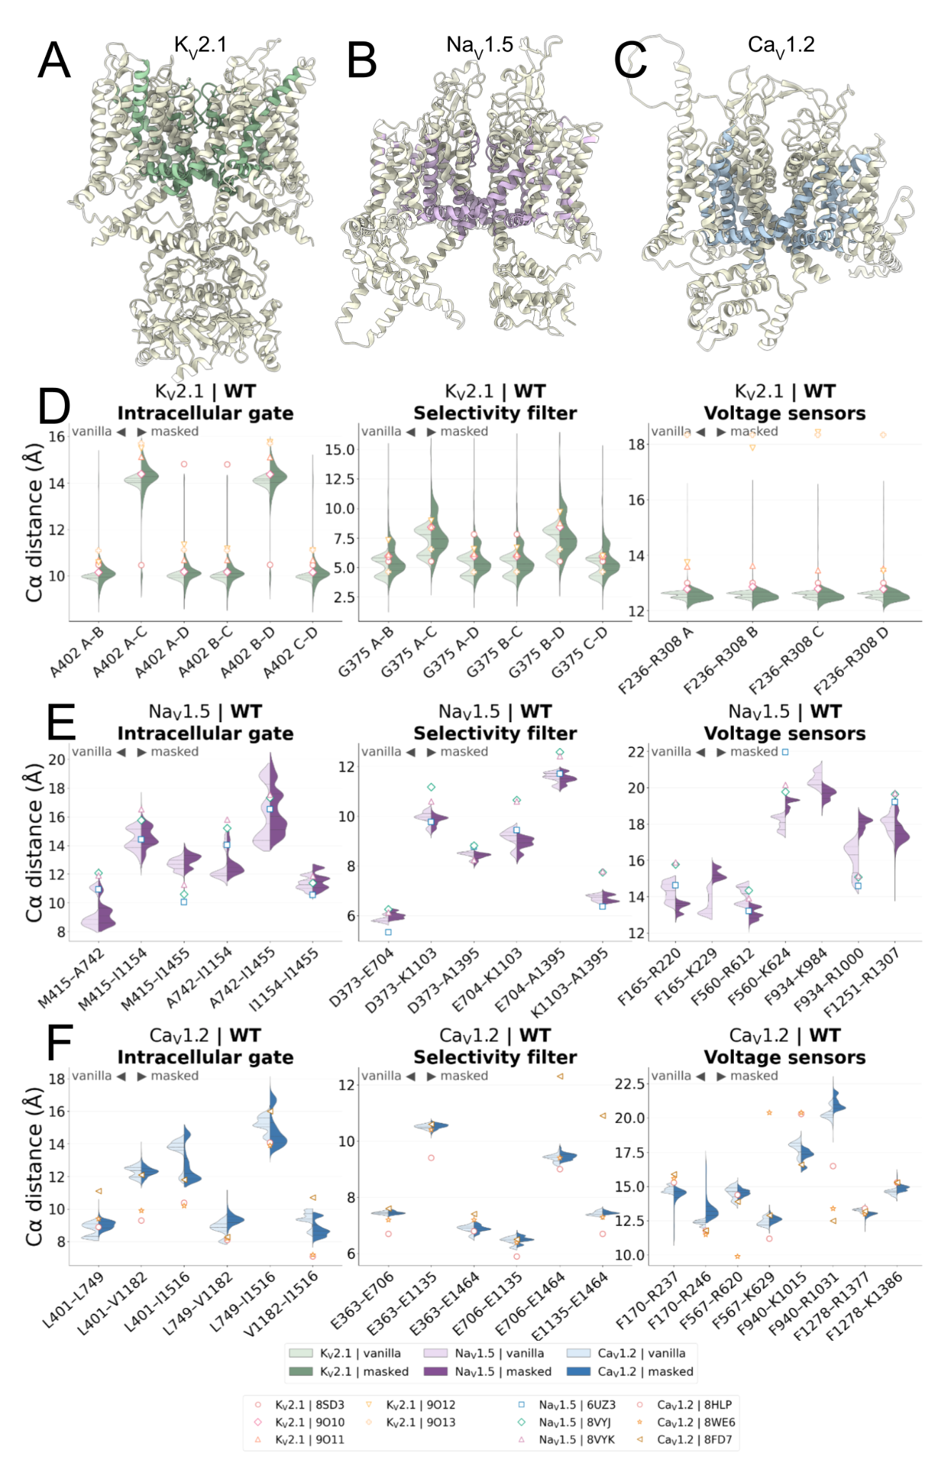
Figure 3. Channel-specific targeted masks redistribute wild-type structural sampling.
(A–C) Structural mapping of the targeted MSA masks in Kv2.1, Nav1.5, and Cav1.2, respectively. Directly masked regions are shown in channel-specific colors, while the remainder of each channel is shown in a neutral color. Because the Nav1.5 and Cav1.2 masks were condition specific, their exact definitions are listed in Table S1. (D–F) Vanilla and masked distributions of representative intracellular-gate, selectivity-filter, and voltage-sensor-domain Cα distances in wild-type Kv2.1, Nav1.5, and Cav1.2, respectively. Experimental structures are shown as reference markers. The Nav1.5 baseline comparison in panel E uses the wild-type mask v2 condition. Masking strongly expanded selected Kv2.1 intracellular-gate coordinates, produced smaller and more selective changes in Cav1.2, and narrowed several Nav1.5 voltage-sensor-domain distributions. Selectivity-filter coordinates remained comparatively constrained across the three systems.

A predefined reduced-depth subset shows similar qualitative channel-specific masking patterns
We next examined whether the qualitative channel-specific masking patterns observed in the complete wild-type ensembles were also visible in one predefined First100 cohort comprising 100 nominal model-seed trajectories per protocol. Regional summaries showed a pattern similar to the complete ensembles: Kv2.1 had greater breadth in intracellular-gate and selected VSD coordinates, whereas Nav1.5 and Cav1.2 had lower global breadth under masking with coordinate-specific regional exceptions (Supplementary Fig. S8A,C,D). The masked-to-vanilla global-breadth ratios had the same qualitative direction in the First100 and complete ensembles—greater than one for Kv2.1 and below one for Nav1.5 and Cav1.2 (Supplementary Fig. S8B). The subset therefore provided a descriptive illustration of channel-dependent redistribution rather than evidence for a universal broadening response.
Recycle-resolved retention provided a separate quality-control perspective. Masked Kv2.1 retained fewer model–seed trajectories than vanilla in both the First100 and complete cohorts, whereas Nav1.5 and Cav1.2 retained nearly all nominal trajectories under both protocols (Supplementary Fig. S8E). The increased Kv2.1 breadth therefore did not arise from retaining more masked predictions, and retention and structural breadth should be evaluated independently for each system.

In this single deterministic subset, the qualitative direction and regional distribution of the wild-type masking response were similar to those observed in the complete ensembles. This comparison does not quantify repeated-sampling stability or establish the sufficiency of a 100-trajectory budget. Because each coordinate was normalized using the pooled vanilla–masked IQR from the complete final-QC ensemble, the First100 analysis remains a retrospective descriptive illustration rather than a prospective stopping rule. Reduced-depth ensembles also remain insufficient for establishing the prevalence of rare, multimodal, or coordinated structural alternatives.

In the seed-block all-distance discovery panel, primary WT–mutant sequence contrasts under the unmodified MSA had median W1 values of 0.1 Å for Cav1.2 G402S, 0.1 Å for Cav1.2 G406R, 0.2 Å for Kv2.1 L403A, 0.2 Å for Kv2.1 F412L, and 0.1 Å for Nav1.5 QQQ. Based on the unrounded estimates used for ranking, F412L showed the largest median separation among the primary vanilla sequence contrasts. Within the clean Kv2.1 shared-mask design, the masked WT–F412L comparison also exceeded the masked WT–L403A comparison (reported as 0.5 versus 0.1 Å). Masked WT–mutant comparisons in Cav1.2 and Nav1.5 were retained as protocol-specific explorations because their condition-specific masks do not support a factorial sequence contrast (Supplementary Fig. S6).

Despite the modest global separation observed for several mutants, the exploratory coordinate-level effect-size ranking localized the largest recurrent changes to specific structural regions rather than throughout the complete channel. Candidate effects included the Cav1.2 G406R 401–408/1530–1534 interface and a K429–V184/N181-centered region in Kv2.1 F412L, with the latter recurring across multiple tetramer subunits. Nav1.5 effects were similarly concentrated around the inactivation machinery, although their magnitude depended strongly on mask design. Because the all-distance panel was designed for effect-size discovery rather than mass-univariate hypothesis testing, these individual coordinates were used to localize candidate regions and were not treated as independently validated effects.

Kv2.1 shows mutation-relevant responses to masking

Having first established the effects of masking in each wild-type channel (Fig. 3D–F), we next evaluated the mutant ensembles using both axes of the experimental design. We compared each mutant with its corresponding wild-type sequence under the same prediction protocol to identify mutation-associated changes, and compared vanilla with masked ensembles within each sequence background to determine how targeted masking redistributed sampling. We therefore do not interpret a masked-versus-vanilla difference in a mutant, by itself, as evidence of a mutation-specific effect. Instead, we ask whether the mutation changes the accessible structural landscape and whether masking subsequently increases or decreases access to experimentally supported or mutation-centered geometries. Kv2.1 provided the strongest direct test because wild-type and L403A experimental structures are both available, whereas the disease-associated F412L mutant remains structurally unresolved.

Across the Kv2.1 ensembles, masking produced the largest expansion in distances describing S6, the intracellular gate, and the pore–VSD interface (Fig. 3D). In a secondary model-seed trajectory-block sensitivity analysis, the median masked-to-vanilla standard-deviation ratio for S6-related coordinates was 2.85x for wild type (trajectory-block bootstrap 95% CI, 2.56–3.08), 1.90x for L403A (95% CI, 1.71–2.08), and 2.90x for F412L (95% CI, 2.65–3.16). VSD and intracellular-gate coordinates also sampled broader distributions, whereas selectivity-filter distances changed comparatively little. Mask-centered ensemble RMSF profiles further showed that the increased structural variability was concentrated around the directly masked pore-coupling region rather than distributed uniformly throughout the channel. Within the directly masked positions, median masked-minus-vanilla RMSF differences were +1.5 Å for wild type (95% CI, +1.2 to +1.7 Å), +1.3 Å for L403A (95% CI, +1.0 to +1.6 Å), and +1.3 Å for F412L (95% CI, +1.1 to +1.5 Å). Outside the directly masked positions, median differences were negative in all three backgrounds, but the bootstrap intervals overlapped zero for wild type and L403A (Supplementary Fig. S2). The substantial response of wild-type Kv2.1 demonstrates that increased structural dispersion is an effect of the masking protocol itself and therefore cannot, on its own, be interpreted as mutation-specific; mutation relevance was instead assessed by comparing how the resulting distributions differed across sequence backgrounds and by relating them to experimentally defined structural coordinates. These S6 breadth and RMSF estimates were obtained by resampling model-seed trajectories and were interpreted as secondary sensitivity summaries rather than as primary whole-seed inference.
Masking also reduced analysis-final trajectory retention from 97.4% to 83.8% in WT Kv2.1, from 95.8% to 85.2% in L403A, and from 94.6% to 82.4% in F412L. The corresponding masked-minus-vanilla differences were −13.6 percentage points (95% CI, −16.8 to −10.4), −10.6 percentage points (−13.8 to −7.2), and −12.2 percentage points (−15.6 to −8.6), respectively. Retention was therefore analyzed separately from structural geometry among survivors.

L403A masking increases access to an experimental pore–VSD displacement but does not recover the complete inactivated-state rearrangement
L403A provided the most direct experimental test because both WT and mutation-matched Kv2.1 structures are available. Our objective was therefore not simply to determine whether masking broadened the L403A ensemble, since masking also broadened several coordinates in WT Kv2.1, but to test whether the L403A sequence background gained increased access to a structural displacement observed specifically in the experimental mutant. The experimental 8SDA (L403A) structure contains an asymmetric pore–VSD rearrangement in which two E423–N179 Cα distances remain near the 8SD3 wild-type range, whereas the other two increase to 14.2 Å and 16.2 Å, respectively (Fig. 4A) [12]. Because subunit labels are arbitrary in the predicted homotetramers, we evaluated both the chain-resolved distributions and the largest E423–N179 distance across all four subunits in each predicted structure.
Under the default vanilla protocol, the L403A sequence remained largely concentrated in a WT-like pore–VSD regime and only rarely sampled the elongated geometry observed in 8SDA. Its 95th and 99th percentiles for the maximum subunit distance were 11.3 Å and 12.4 Å, respectively, although a small number of retained structures reached a maximum of 14.8 Å. In contrast, masking produced a substantially broader high-distance subgroup of L403A models. The corresponding 95th and 99th percentiles increased to 13.6 and 14.5 Å, and the largest masked structure reached 15.6 Å, approaching the 16.2 Å displacement in the most shifted experimental subunit. Thus, within the L403A sequence background, weakening the targeted MSA constraints increased access to the experimentally observed direction of the mutant pore–VSD rearrangement rather than simply shifting the complete ensemble toward 8SDA.
Using the continuous maximum E423–N179 Cα distance as the primary outcome, targeted masking increased the seed-balanced mean of the trajectory-median maximum from 10.2 to 11.3 Å, a difference of 1.1 Å (95% whole-seed bootstrap CI, 1.0–1.2 Å). The corresponding seed-balanced W1 was 1.1 Å (95% CI, 1.0–1.2 Å; whole-seed permutation P = 0.0001). A formal masking-by-L403A interaction contrast was 0.1 Å, and its 95% CI included zero; this did not establish that the masking response for this coordinate differed from the corresponding WT response.
Using the independently derived 12.8 Å cutoff, the seed-balanced within-trajectory shifted-interface fraction increased from 0.605% in vanilla to 12.951% after masking, an absolute increase of 12.346 percentage points (95% CI, 10.040–14.892 percentage points). The secondary risk ratio was 21.4, but its 95% CI was wide (10.0–209.5) because the vanilla frequency was close to zero. Earliest- and latest-recycle sensitivity differences were +19.117 and +9.367 percentage points, respectively.
The threshold-positive increase was dominated by tetramers with all four interfaces above the cutoff: this category increased from 0.563% in vanilla to 10.755% after masking, whereas tetramers with exactly two shifted interfaces increased from 0.022% to 0.836%. Thus, masking increased access to the experimental direction of the local displacement, but the most frequent threshold-positive masked geometry was more symmetric than the two-shifted/two-WT-like arrangement observed in 8SDA. Consistent with partial rather than complete recovery, the ordered four-distance RMSE to 8SDA decreased from 3.7 to 3.0 Å, a difference of −0.7 Å (95% CI, −0.8 to −0.7 Å), while only 0.514% of vanilla and 5.476% of masked seed-balanced summaries were closer to 8SDA than to 8SD3 by this four-distance vector.
Across 1,000 repeated draws of 20 common seeds, corresponding to 100 nominal model-seed trajectories per protocol, the direction of the L403A continuous maximum-distance effect was reproduced in every draw, with a median relative error of 6.9%. The shifted-interface effect also retained its direction in every draw, although its median relative error was larger at 14.1%. Subset intervals covered the complete-ensemble effect in 94.4% and 95.1% of draws, respectively, and a masked shifted-interface observation was detected in every rare-state draw. These results show retrospective stability for these two L403A outcomes and do not establish that 100 trajectories are sufficient for other channels, coordinates, or multimodal structural alternatives (Supplementary Table S6).
Whole structure RMSDs calculated against experimental structures provided complementary context for this local response. Most vanilla L403A structures remained closer to experimental 8SD3 (WT) than to 8SDA (L403A), as indicated by their positions above the equal-similarity diagonal in Fig. 4C and by the predominantly positive RMSD differences in Fig. 4D. The masked ensemble also remained predominantly closer to 8SD3, but its distribution broadened and included a larger subset of structures approaching or crossing into greater similarity to 8SDA. Thus, the directed pore–VSD shift did not represent uniform conversion of the complete channel toward the mutant structure. Instead, masking increased the access to the experimental displacement within a more heterogeneous whole-channel ensemble.
To determine whether the increased E423–N179 separation reflected recovery of the broader experimental L403A rearrangement, we quantified PIP/S6 kink geometry, I401 and I405 orientation, whole-S6 rotation, S4–S5-linker displacement, and F412-centered displacement, together with a normalized metric-by-subunit experimental-target error summary (Supplementary Fig. S7A–D, F–H). Protocol-matched, seed-resampled comparisons did not show general recovery of the experimental conformational program. The clearest masking-dependent directional response involved I405: targeted masking produced small changes toward the experimental direction for selected pore-facing and angular measures, but their magnitudes remained substantially smaller than the experimental reorientation (Supplementary Fig. S7C,D). Because the experimental I405 pore-facing change in subunit C was near zero, the low normalized error for that metric–subunit combination was not interpreted as strong recovery.
Most other experimental signatures were not recovered. Neither protocol reproduced the pronounced PIP/S6 kink straightening observed in 8SDA (Supplementary Fig. S7A). I401 orientation remained close to no predicted change relative to experiment (Supplementary Fig. S7B,D), and whole-S6 rotation, S4–S5-linker displacement, and F412-centered displacement showed limited recovery under either protocol (Supplementary Fig. S7D,F–H). Subunit-resolved analysis was essential because the experimental changes differed in magnitude and direction among protomers. Together, the expanded analysis indicates that masking enriched the E423–N179 shifted-interface geometry (Supplementary Fig. S7E) and produced small experimental-direction I405 changes (Supplementary Fig. S7C,D), but did not reproduce the coordinated conformational program of the most rearranged 8SDA protomers.
To determine whether the L403A response extended beyond E423–N179, we also measured shortest non-hydrogen distances from F412 to the same-subunit S4–S5 linker and the neighboring S5 and S6 helices (Fig. 4E). Analyzing the contacts separately allowed us to identify local rearrangements that would be obscured by a single pocket-level score. Experimental 8SD3 and chain-resolved 8SDA values were used as structural references.
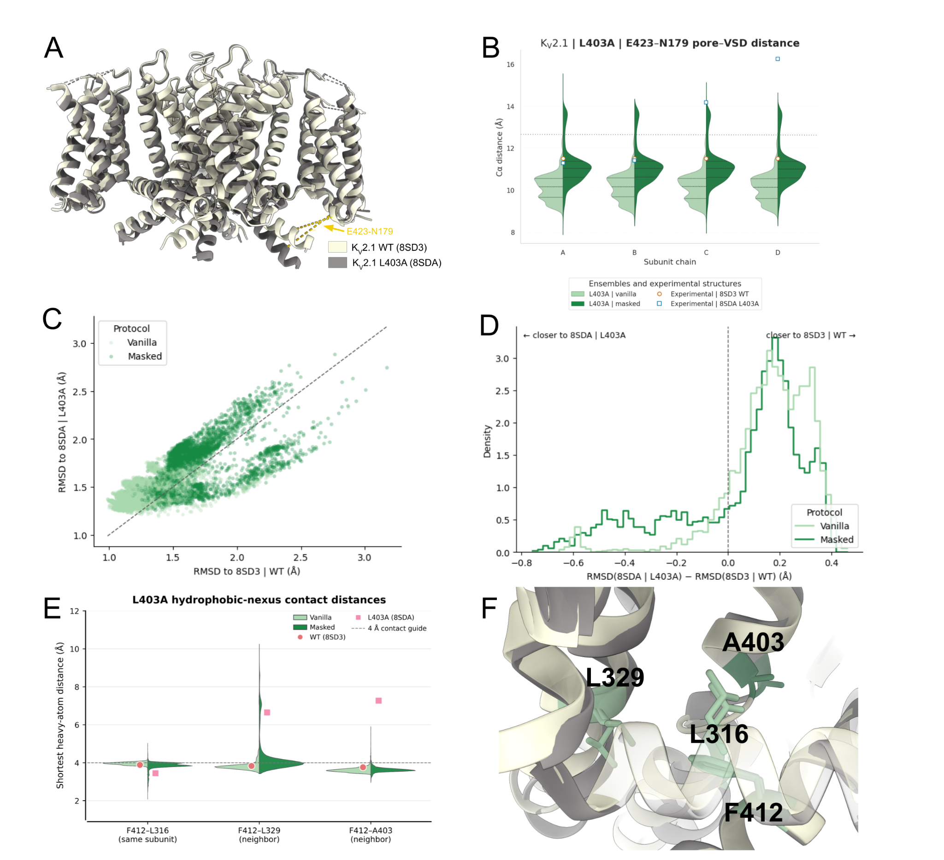
Figure 4. Targeted MSA masking reveals mutation-relevant pore–VSD alternatives in Kv2.1 L403A.
(A) Structural comparison of experimental wild-type Kv2.1, 8SD3, and experimental L403A Kv2.1, 8SDA, aligned using a stable transmembrane core. The superposition highlights the asymmetric rearrangement at the pore–VSD interface in 8SDA. E423 and N179 Cα atoms are shown with dashed lines indicating the measured subunit-resolved distances (B) Chain-resolved distributions of the E423–N179 Cα distance in vanilla and masked L403A ensembles. Experimental values from 8SD3 and 8SDA are shown as reference markers, and the dashed horizontal line at 12.8 Å indicates the shifted-interface threshold used in the analysis. Because subunit labels are arbitrary in predicted homotetramers, chains A–D are not interpreted as corresponding directly to the experimental chain identities (C) RMSD of each predicted L403A structure to experimental 8SD3 and 8SDA. The diagonal indicates equal RMSD to the two references; structures above the diagonal are closer to 8SD3, whereas structures below it are closer to 8SDA (D) Distribution of ΔRMSD, calculated as RMSD to 8SDA minus RMSD to 8SD3 for the complete structure. Positive values indicate greater similarity to the wild-type reference, whereas negative values indicate greater similarity to the L403A reference (E) F412-centered hydrophobic-nexus distances in the L403A ensembles. Split violins show the shortest non-hydrogen distances from F412 to L316 in the same-subunit S4–S5 linker, L329 in the neighboring S5 helix, and A403 in the neighboring S6 helix. The corresponding wild-type F412–L403 measurements from 8SD3 and chain-resolved F412–A403 measurements from 8SDA are shown as experimental references. The dashed line at 4 Å is a proximity guide (F) Close-up superposition of a quality-controlled masked L403A model with experimental 8SDA. The displayed model illustrates the experimentally directed local rearrangement without implying complete recovery of the mutant structure.

Masking redistributes alternative local packing arrangements around the unresolved F412L mutation
F412L provided the unresolved disease-associated mutant test that originally motivated the Kv2.1 structural comparison. The F412L substitution is associated with KCNB1-related epileptic encephalopathy and was implicated in disruption of the hydrophobic electromechanical-coupling nexus. A previous experimental study attempted to determine the F412L structure but did not obtain suitable Kv2.1-like two-dimensional particle classes and subsequently used the experimentally tractable L403A mutant to capture a related inactivated conformation [12]. Because no Kv2.1 F412L structure is available, we did not evaluate F412L predictions against a mutation-matched reference structure. Instead, 8SD3 (WT) and 8SDA (L403A) were used as channel-matched experimental references defining local coupling geometries known to be accessible in Kv2.1 (Fig. 5A).
Masking redistributed the F412L hydrophobic nexus in a contact-specific manner (Fig. 5B). The seed-balanced fraction of L412–L316 distances within 4 Å increased from 0.513% to 13.929%, a difference of 13.416 percentage points (95% whole-seed bootstrap CI, 11.564–15.321). L412–L329 remained outside 4 Å in both protocols. The L412–L403 fraction within 4 Å decreased from 95.774% to 84.097%, a difference of −11.677 percentage points (95% CI, −14.026 to −9.346). These opposing changes support contact-specific redistribution rather than uniform expansion or contraction of the pocket. Distances below 2 Å were retained as a local-overlap quality flag and were not interpreted as plausible packing.
Mutation-centered ensemble RMSF profiles supported a local redistribution of structural sampling (Fig. 5C). Masking increased structural variability through much of the S6 segment surrounding F412, including the directly masked region, but the effect was not uniform across the helix. The masked-minus-vanilla difference decreased toward the distal end of the analyzed segment and became negative at several C-terminal positions. Thus, masking did not simply make S6 globally more flexible; it changed where along the helix alternative conformations were sampled.
The contact-distance and RMSF analyses therefore show that masking redistributed F412L packing in a contact-specific, multimodal manner rather than favoring one dominant geometry. The ensemble-level distributions, rather than any individual representative, provide the current support for this interpretation.

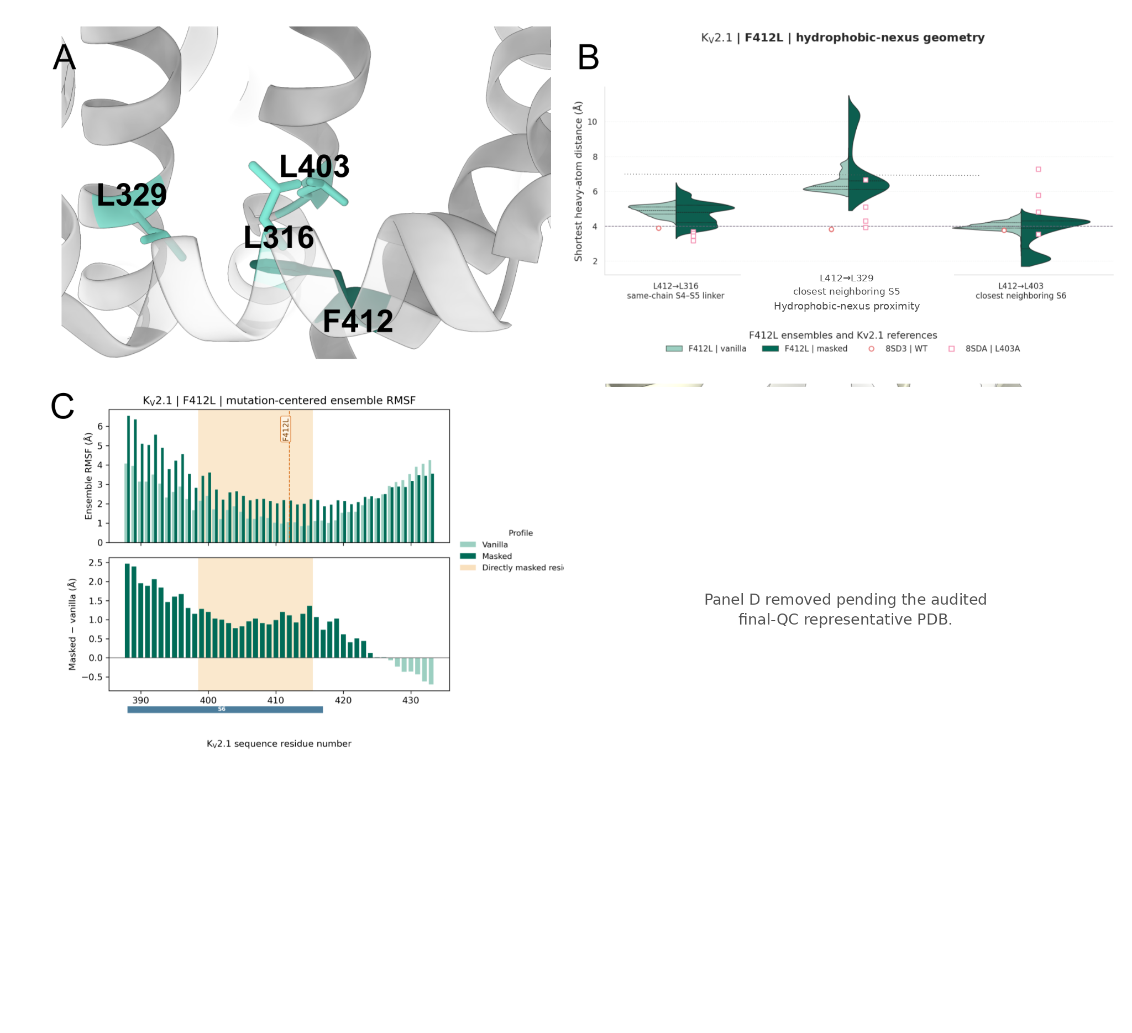
Figure 5. Targeted masking redistributes local S6 packing around the unresolved Kv2.1 F412L mutation. (A) Structural location of F412 within the Kv2.1 S6 and pore-coupling region. L316 in the same-subunit S4–S5 linker, L329 in the closest neighboring S5 helix, and L403 in the closest neighboring S6 helix define the analyzed hydrophobic nexus. (B) L412-centered shortest non-hydrogen distances in F412L vanilla and masked ensembles. Experimental markers indicate the corresponding F412 measurements in wild-type 8SD3 and chain-resolved L403 measurements in the L403A structure 8SDA. The dashed line at 4 Å is a proximity guide; distances below 2 Å indicate severe atomic overlap and were not interpreted as plausible contacts. Masking produced contact-specific and multimodal redistribution rather than uniform expansion or contraction of the nexus. (C) Mutation-centered ensemble RMSF across the S6 region surrounding F412. The directly masked interval and mutation site are indicated. The lower plot shows the masked-minus-vanilla RMSF difference, demonstrating that masking redistributed structural variability along S6 rather than increasing it uniformly.

Targeted masking disrupts native IFM–receptor engagement in Nav1.5

Nav1.5 did not show broad masking-dependent expansion. Fig. 3E shows the WT nav15_v2 condition, whereas Fig. 6 compares WT nav15_standard with QQQ nav15_standard_plus_IFM. Because these two masked designs were not identical, their WT–QQQ comparison was treated as a protocol-specific exploration rather than as a factorial sequence contrast; the vanilla WT–QQQ comparison was treated as the primary sequence comparison. WT nav15_v2, WT nav15_v2_noIFM, and QQQ nav15_v2 were analyzed separately as follow-up mask-placement controls. In the no-IFM control, the three IFM columns were retained. Under these named mask designs, many distance distributions remained similar to vanilla or became narrower, particularly within the VSDs, while the clearest broadening occurred locally at the intracellular gate. We therefore focused on whether masking altered IFM–receptor engagement and whether those changes were coordinated with activation-gate geometry.

In the vanilla ensembles, replacing the hydrophobic IFM motif with QQQ produced a pronounced change in motif–receptor geometry. The ensemble median of the per-structure mean of the two Cα distances connecting the central motif position to N1659 in DIV-S5 and N1765 in DIV-S6 increased from 11.9 Å in WT to 29.0 Å in QQQ. These values are snapshot-level descriptive medians from 500 model-seed trajectories and 5,000 retained snapshots per condition. Terminal-atom measurements independently resolved receptor-proximal and receptor-distal configurations: WT vanilla predictions retained a receptor-proximal subensemble overlapping the experimental WT references, whereas QQQ vanilla predictions predominantly occupied the long-distance regime (Fig. 6B). The median maximum intracellular-gate span changed much less, from 15.8 Å in WT to 16.0 Å in QQQ. At the snapshot level, QQQ–receptor separation showed a weak positive association with gate span (Spearman ρ = 0.134); however, the association was not stable across earliest (ρ = −0.157; 95% whole-seed bootstrap CI, −0.239 to −0.081), latest (ρ = 0.014; 95% CI, −0.055 to 0.079), and trajectory-median (ρ = 0.147; 95% CI, 0.068 to 0.229) summaries. We therefore found no consistent evidence that progressive QQQ displacement was coupled to progressive intracellular-gate opening.

Unexpectedly, masking also disrupted IFM–receptor engagement in the wild-type channel. Under the mask condition, masked wild-type predictions entered the same long-distance IFM–receptor regime occupied by QQQ, despite retaining the native IFM sequence (Fig. 6D). Follow-up mask designs were generated to test whether preserving evolutionary information at the three IFM positions would maintain the native receptor-proximal geometry. However, in the no-IFM control, leaving the IFM columns unmasked was insufficient to restore receptor-proximal geometry when evolutionary constraints in the surrounding III–IV linker and receptor-coupling region were weakened (Supplementary Fig. S4). These results indicate that AlphaFold2’s representation of the receptor-engaged IFM conformation depends on distributed sequence constraints rather than only on the three motif residues.

The long-distance wild-type Nav1.5 predictions should not be interpreted simply as open-state structures. In the original engineered QQQ open structure 7FBS, the III–IV linker containing the substituted motif is unresolved, so an experimental QQQ–receptor distance cannot be measured directly [16]. More recent wild-type Nav1.5 open and intermediate structures retain the IFM motif within or near its receptor pocket while showing changes in the activation gate, VSDs, linker, and C-terminal domain [38,39]. The 2026 intermediate-open Nav1.5 structure further shows that ion accessibility near the IFM region can occur without complete motif disengagement [39]. Together, these structures argue against treating full IFM–receptor separation as a necessary structural marker of pore opening.

The wild-type RMSF profile clarified that masking did not simply increase structural variability around the III–IV linker. Vanilla predictions showed a highly variable region immediately following the IFM motif, consistent with coexistence of receptor-proximal and receptor-distal linker arrangements. In the masked ensemble, RMSF in this region decreased because most structures sampled a more consistently receptor-distal geometry (Fig. 6C). Therefore, reduced RMSF did not indicate preservation of the native receptor-proximal geometry; it reflected concentration of the masked ensemble in a different linker arrangement.

Regional RMSD analysis provided an orthogonal view of the structural tradeoff. Relative to native-open 8VYJ, the original WT mask lowered seed-balanced DII-S6 RMSD by 0.4 Å (masked-minus-vanilla 95% whole-seed bootstrap CI, −1.0 to −0.2 Å), while increasing IFM-motif RMSD by 16.4 Å (16.1–16.9 Å) and IFM-receptor-set RMSD by 0.4 Å (0.3–0.4 Å). Relative to the QQQ reference 7FBS, the original QQQ mask lowered S5/S6 pore-helix RMSD by 0.1 Å (95% CI, −0.2 to 0.0 Å; the upper bound remained below zero before rounding) and DII-S6 RMSD by 0.9 Å (95% CI, −1.2 to −0.8 Å), while increasing receptor-set RMSD by 0.2 Å (0.2–0.3 Å). The 7FBS IFM/QQQ-motif cell was unavailable because that reference contains no aligned motif Cα coordinates. These regional effects show that modest pore-region changes can coexist with much larger disruption of the native IFM-containing linker geometry (Supplementary Fig. S5).

These findings show that masking can remove sequence constraints that already support an experimentally consistent IFM arrangement. In wild-type Nav1.5, the vanilla MSA preserved receptor-proximal IFM geometry, whereas masking favored receptor-distal linker conformations. For the QQQ mutant, weakening the wild-type Nav1.5 constraints may still help explore alternative linker arrangements, but the frequency with which the prediction protocol sampled these arrangements should not be interpreted as state occupancy.
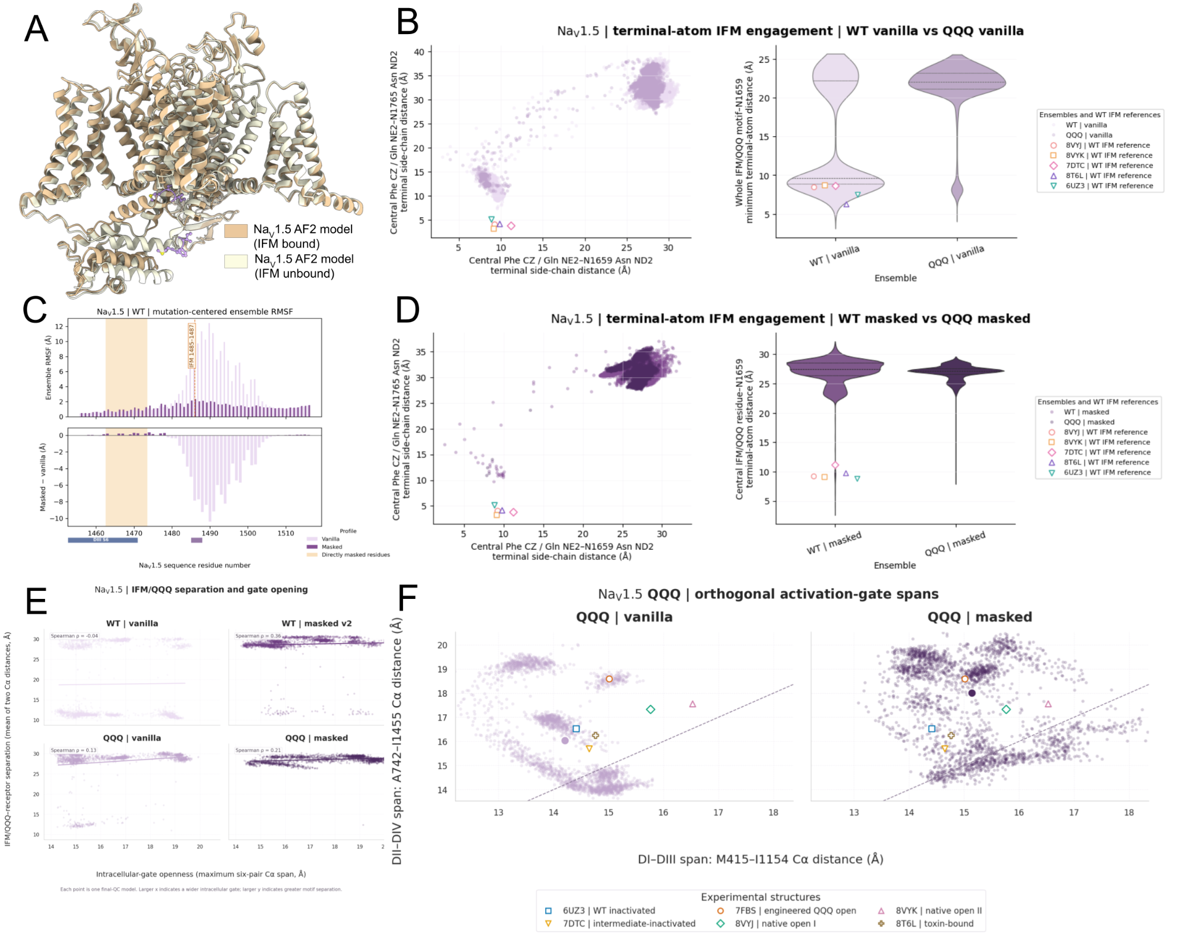
Figure 6. Targeted MSA masking disrupts native IFM–receptor engagement without producing a single coordinated activation-gate transition in Nav1.5. (A) Structural comparison of receptor-engaged and receptor-distal IFM configurations sampled by WT AlphaFold2 models. The III–IV linker and IFM motif are highlighted relative to the receptor region. (B) Terminal-atom measurements of IFM–receptor engagement in WT and QQQ vanilla ensembles. The left plot shows the joint distribution of distances from the central IFM or QQQ residue to N1659 in DIV-S5 and N1765 in DIV-S6. The right plot summarizes the minimum terminal-atom distance between the complete IFM or QQQ motif and N1659. Experimental WT Nav1.5 structures are shown as reference markers. The engineered QQQ open structure 7FBS is not assigned an experimental motif distance because the QQQ-containing III–IV linker is unresolved. (C) Mutation-centered ensemble RMSF for WT Nav1.5 vanilla and nav15_standard predictions. Directly masked positions and the IFM-containing segment are indicated. Masking reduces RMSF immediately following the IFM motif because the masked ensemble becomes concentrated in a receptor-distal linker arrangement. (D) Terminal-atom measurements for WT nav15_standard and QQQ nav15_standard_plus_IFM. These masked designs are not identical and are shown as protocol-specific sampling comparisons. Masking shifts WT Nav1.5 toward the long-distance receptor-distal regime occupied by QQQ despite preservation of the native IFM sequence. (E) Relationship between IFM or QQQ separation from the receptor and intracellular-gate openness. Motif separation is the per-structure mean of the two Cα distances to N1659 in DIV-S5 and N1765 in DIV-S6, and gate openness is the maximum of six opposing-domain Cα spans. Each point represents one retained structure. Long-distance motif configurations occur across a broad range of gate widths, indicating that reduced IFM–receptor engagement alone is insufficient to detect progressive gate opening. (F) Orthogonal activation-gate geometry in QQQ vanilla and masked ensembles. The DI–DIII and DII–DIV Cα spans report the two principal opposing-domain dimensions of the intracellular gate. Experimental Nav1.5 structures are shown as reference markers. Masking broadens the QQQ gate-shape distribution but does not shift the entire ensemble toward a single experimental pore geometry. The vanilla WT–QQQ comparison is the primary sequence contrast; masked WT–QQQ comparisons are protocol-specific demonstrations of the named mask designs.

Timothy syndrome mutations in Cav1.2 reorganize local DI-S6/DIV-S6 packing without selecting a single pore state
Cav1.2 provided a third case focused on two disease-associated substitutions, G402S and G406R, originally identified in exon 8 of CACNA1C in patients with Timothy syndrome type 2 (TS2) [41]. Both mutations strongly impair voltage-dependent inactivation and produce sustained inward Ca²⁺ current, but the structural changes underlying these gating defects remain unresolved. Masking produced comparatively modest and region-selective changes across the wild-type Cav1.2 ensemble (Fig. 3F; Supplementary Fig. S8A–D). Although selected VSD and intracellular-gate coordinates broadened, the global structural-breadth summary was lower under masking and the median intracellular-gate geometry remained close to that of vanilla wild type. We therefore focused on whether G402S and G406R altered local packing at the interface between the mutation-containing DI-S6 helix and the opposing DIV-S6 helix.
G402S altered local DI-S6/DIV-S6 packing, but the pair-specific proximity and nearest-partner analyses quantify different aspects of that change. At the descriptive snapshot level, the frequent WT G402–M1524 proximity was observed in 31.1% of vanilla and 58.0% of masked WT snapshots and was nearly absent after G402S, occurring in 0.0% of vanilla and 1.58% of masked mutant snapshots. An S402–I1523 proximity was observed in 19.24% of vanilla and 12.11% of masked G402S snapshots, with a median shortest non-hydrogen distance of 4.8 Å in both protocols (Fig. 7D). These pair-specific frequencies support mutation-associated alteration of local packing but do not define the complete nearest-partner distribution. Within the G402S ensemble, the seed-block categorical analysis showed that masking redistributed the nearest DIV-S6 partner to S402: I1523 decreased from 60.8% to 47.7%, whereas M1524 increased from 4.8% to 35.1% and V1520 increased from 0% to 12.2%. This categorical result was therefore interpreted as protocol-dependent redistribution within the G402S background, while mutation-associated alteration of packing was inferred separately from the WT-to-G402S pair-specific comparisons. Because I1523 is hydrophobic, the S402–I1523 arrangement was not interpreted as a hydrogen bond.
The strongest G406R result was protocol-dependent local structural validity. The seed-balanced fraction of snapshots passing the prespecified R406-centered local-overlap criterion fell from 67.420% in vanilla to 21.887% after masking, a difference of −45.533 percentage points (95% whole-seed bootstrap CI, −47.400 to −43.720). The fraction of seed-model trajectories containing any locally valid snapshot fell from 95.0% to 51.6%, a difference of −43.4 percentage points (95% CI, −47.0 to −39.6). Thus, before relaxation, masking greatly increased the frequency of mutation-centered severe-overlap geometries. Among snapshots that passed the local-overlap criterion, the R406–D1528 within-4 Å frequency decreased from 21.625% in vanilla to 4.236% after masking, a difference of −17.389 percentage points (95% CI, −19.755 to −14.509). The corresponding R406–D1533 frequency decreased from 33.070% to 25.200%, a difference of −7.870 percentage points (95% CI, −12.220 to −3.236). These conditional frequencies are secondary because the conditioning event was itself strongly affected by the protocol; they do not define unconditional occupancies or a unique stable salt-bridge arrangement.
G402S and G406R mutants altered the DI-S6/DIV-S6 interface in different ways. G402S altered local packing and showed protocol-dependent redistribution of nearest-partner categories, whereas the unrelaxed G406R ensemble contained heterogeneous local packing arrangements together with frequent mutation-centered severe overlap. In both cases, the changes were primarily local and did not converge on a single open-pore geometry.

To determine whether this altered packing reflected axial sliding of the mutant-bearing S6 helix, we quantified register displacement, residue-partner reassignment, and the closest DI-S6/DIV-S6 contact using one retained structure per model–seed trajectory. Neither mutation produced a coherent register shift. In this analysis, G402S sampled a broader range of DI-S6/DIV-S6 partner assignments, whereas G406R produced the greatest interhelical separation (Supplementary Fig. S3).
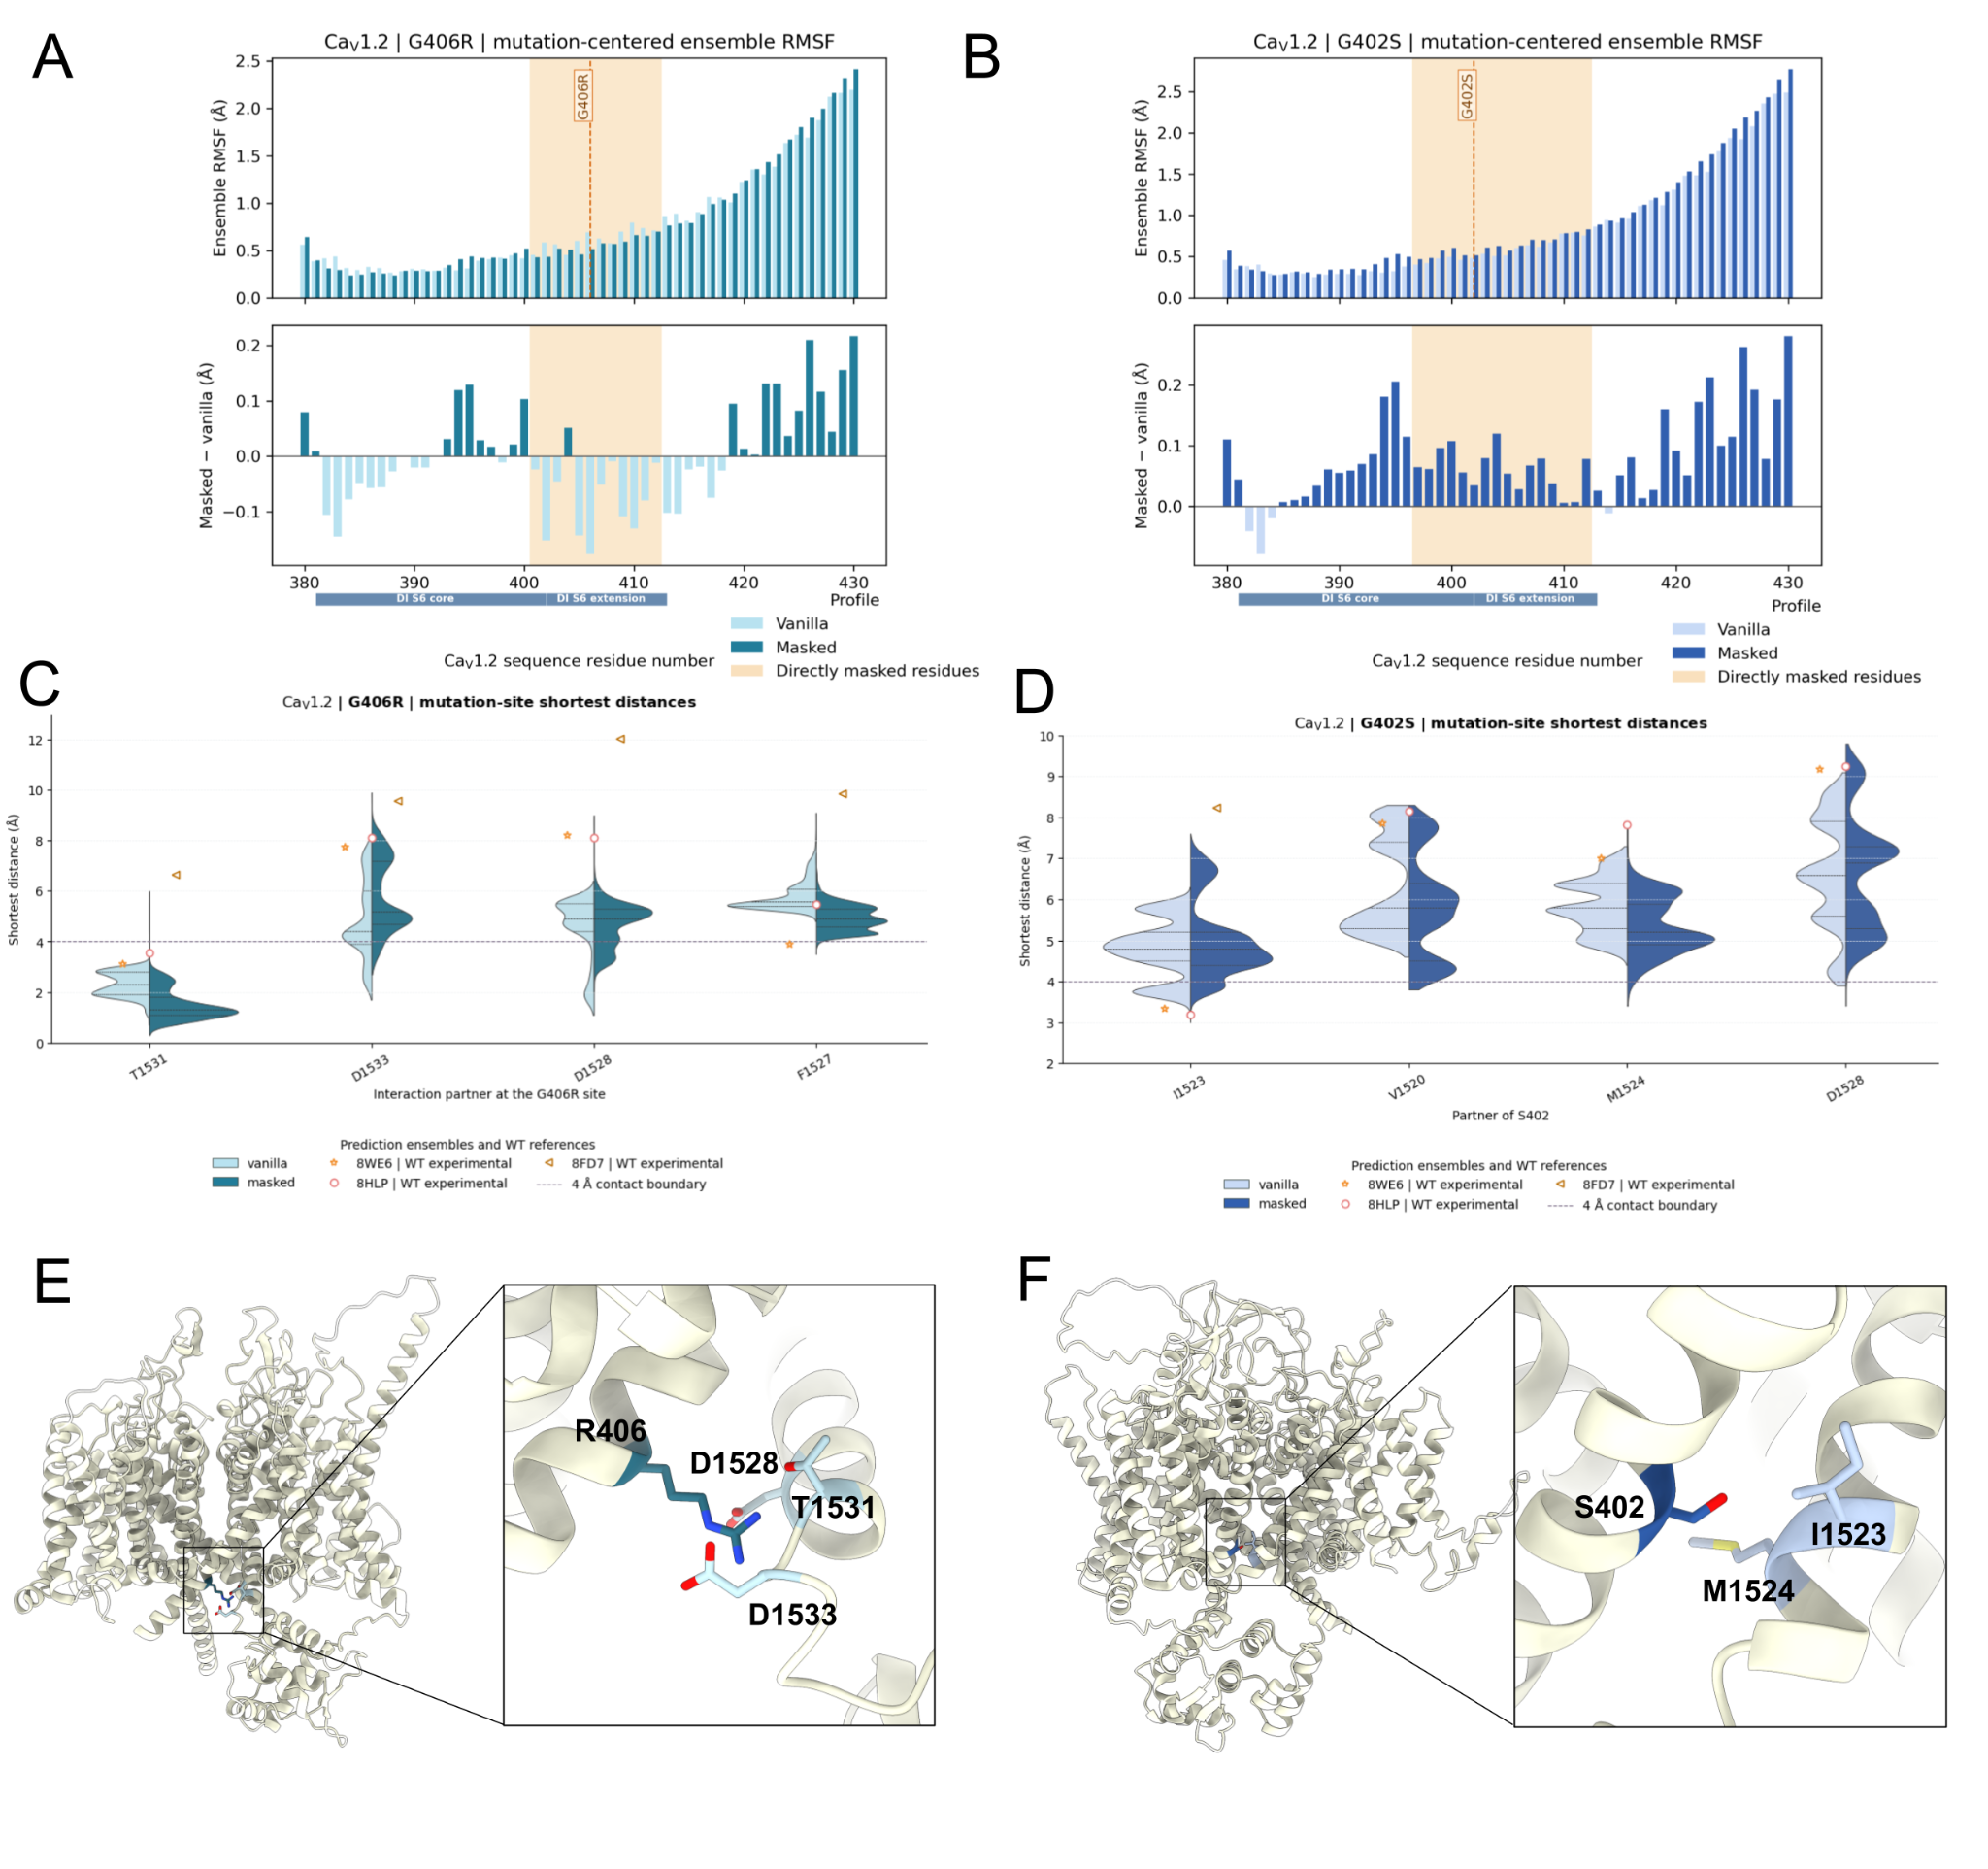
Figure 7. Timothy syndrome mutations produce distinct local packing disruptions at the Cav1.2 DI-S6/DIV-S6 interface. (A, B) Mutation-centered ensemble RMSF profiles for G406R and G402S, respectively. Vanilla and masked RMSF values are shown across the DI-S6 core and adjacent S6 extension, with the directly masked interval shaded and the mutation position indicated. The lower plots show masked-minus-vanilla RMSF differences and describe positional dispersion among AlphaFold2 structures rather than physical time-dependent flexibility. (C) Shortest non-hydrogen distances between R406 and selected residues surrounding the G406R mutation site. Split violins compare vanilla and masked ensembles, while experimental WT Cav1.2 structures are shown as reference markers [49,50]. The dashed line at 4 Å is a proximity guide. Very short R406-centered distances identify a substantial local-overlap subset, particularly in the masked ensemble, and were not interpreted as plausible contacts. Conditional contact summaries include only snapshots passing the prespecified R406-centered local-overlap criterion and are interpreted separately from the overall frequency of locally valid predictions. (D) Shortest non-hydrogen distances between S402 and selected residues surrounding the G402S mutation site. Experimental WT structures are shown as references [49,50], and the dashed line indicates the 4 Å proximity guide. The pair-specific distances illustrate mutation-associated alteration of local packing, while the nearest-partner categorical analysis identifies protocol-dependent redistribution within the G402S ensemble. (E) Structural context and close-up of a selected G406R pocket geometry showing R406 relative to candidate acidic partners D1528 and D1533 and to T1531. The displayed geometry illustrates competing local packing constraints and should not be interpreted as evidence of a stable salt bridge without structural relaxation. (F) Structural context and close-up of a selected G402S geometry showing S402 relative to I1523 and M1524. The representative illustrates one sampled local arrangement. The structures in panels E and F are hypothesis-generating representatives rather than experimentally validated mutant conformations.

Discussion
Targeted MSA masking changed the structures sampled by AlphaFold2, but these changes depended on both sequence background and mask design. Only Kv2.1 used a shared mask across WT and mutant sequence backgrounds and therefore supported direct sequence-by-masking interaction contrasts. In Nav1.5 and Cav1.2, vanilla WT–mutant comparisons were treated as the primary sequence contrasts, whereas masked WT–mutant comparisons were treated as protocol-specific explorations. Across all three systems, vanilla-versus-masked comparisons within a sequence background quantified redistribution caused by the masking protocol itself. In some cases, masking increased access to mutation-relevant local alternatives; in others, it disrupted constraints that were already supported experimentally, including in the WT sequence. Many channel mutations are expected to perturb local packing, alter coupling between modules, or change access to a minority structural alternative rather than produce a different global fold. The value of masking is therefore not that it identifies a single correct mutant structure, nor that every masked-versus-vanilla difference is mutation-specific, but that it can reshape the accessible structural hypotheses in ways that can be evaluated against experimental and mechanistic information. Accordingly, targeted masking is best viewed as a directed perturbation of AlphaFold2 structural sampling rather than as a general procedure for improving mutant-structure accuracy.
The seed-block all-distance analysis further showed that mutation effects were better described as selective perturbations of structural relationships than as global reorganization of the complete channel ensemble. Overall WT–mutant separation was generally modest under the primary vanilla sequence contrasts, whereas larger effect sizes were concentrated in selected mutation- or mechanism-proximal regions. Because the all-distance panel was treated as an effect-size discovery analysis without mass-univariate P or q values, interpretation focused on W1 magnitude, direction, leave-one-model-out robustness, recurrence across structurally related coordinates, and experimental or mechanistic context. Statistical detectability alone therefore did not establish a mechanistically important transition.
Kv2.1 provided the clearest opportunity to distinguish increased access to an individual experimental coordinate from recovery of a broader conformational transition. For L403A, targeted masking increased the continuous maximum E423–N179 distance and the frequency of threshold-positive interfaces. However, the formal masking-by-L403A interaction for this maximum-distance coordinate did not establish a response different from the WT masking effect. Moreover, threshold-positive masked tetramers were dominated by structures with all four interfaces elongated rather than by the two-shifted/two-WT-like pattern observed in 8SDA. Masking therefore increased access to the experimental direction of one local coordinate, frequently in more symmetric geometries that did not reproduce the experimental subunit-resolved state. The expanded subunit-resolved analysis likewise showed no coordinated recovery of the PIP/S6 kink, I401 orientation, whole-S6 rotation, S4–S5-linker displacement, or F412-centered displacement, although selected I405 measures changed modestly in the experimental direction. Targeted masking therefore did not recover the complete experimental inactivated conformation. Instead, it increased access to selected components of the rearrangement while leaving other state-defining features absent or WT-like. This distinction illustrates why mutation-relevant AlphaFold ensembles should be evaluated using multiple mechanistically specific and jointly assessed coordinates rather than assigning conformational states from a single distance. For F412L, which has not been structurally resolved, masking produced contact-specific multimodal redistribution of the hydrophobic nexus rather than improving one central prediction.

The ensemble-level F412L contact distributions suggest a possible mechanistic distinction from L403A. Rather than producing uniform disengagement of the complete hydrophobic nexus, masking increased access to L412–L316 proximity while decreasing L412–L403 proximity and leaving L412–L329 outside the 4 Å guide. We therefore hypothesize that replacement of the central aromatic F412 side chain with leucine redistributes coupling among the S4–S5 linker, S5, and S6 rather than simply loosening the entire pocket. Such reorganization could interfere with productive electromechanical coupling and contribute to the reported loss-of-function phenotype [12]. Because no experimental F412L structure is available, this remains a working hypothesis supported by ensemble-level contact distributions rather than by an individual predicted structural endpoint.

Nav1.5 revealed an important limitation of the same approach: masking disrupted the wild-type receptor-proximal geometry that vanilla AlphaFold2 already reproduced consistently. Weakening constraints around the III–IV linker displaced the wild-type IFM motif from its receptor even in wild type, whereas multiple experimental structures support receptor engagement or proximity in open and intermediate conformations [37–39]. These comparisons also show that pore opening, IFM position, VSD movement, and C-terminal-domain coupling could change independently. A perturbation can modestly improve one pore-related coordinate while substantially worsening the wild-type linker geometry. Because the Nav1.5 masks differed among the primary and follow-up comparisons, the result should be interpreted in the context of the exact mask design rather than as a generic effect of masking Nav1.5.

Cav1.2 showed a more modest and predominantly local response to masking. G402S altered local DI-S6/DIV-S6 packing, and masking redistributed the nearest partner within the G402S ensemble. This categorical redistribution was interpreted as protocol dependent rather than as a complete mutation-specific nearest-partner switch. For G406R, the strongest result was the large protocol-dependent reduction in mutation-centered local structural validity. Among snapshots that passed the R406-centered local-overlap criterion, both prespecified acidic-contact frequencies were lower after masking and did not identify a unique preferred partner. These observations suggest a possible structural basis for impaired Cav1.2 inactivation, but the current unrelaxed side-chain geometries do not establish stable salt-bridge geometry and will require reassessment after relaxation. Both substitutions reduce voltage-dependent inactivation and experimentally maintain inward calcium current, and chemically diverse substitutions at G406 support the importance of the small, conformationally permissive glycine residue rather than a single glycine-specific contact [40–45].
Previous functional and modeling studies linked G402 and G406 to Cav1.2 activation–inactivation coupling and local S6 packing. Substitutions at the G402-equivalent position disrupt activation–inactivation coupling [43], while modeling studies proposed that flexibility around G402 and G406 facilitates DI-S6 bending during gate closure and that Timothy syndrome substitutions may resist this rearrangement by favoring open-state contacts [44]. Our ensembles are consistent with distinct local consequences of the two mutations: G402S was associated with altered DI-S6/DIV-S6 partner relationships, whereas G406R increased interhelical separation and introduced competing steric and electrostatic constraints. We hypothesize that these substitutions impair inactivation by perturbing the local rearrangement associated with normal gate closure rather than by stabilizing a single static open pore. This interpretation is consistent with previous models implicating G402 and G406 in activation–inactivation coupling, but our ensemble analysis suggests that the two substitutions may perturb this process through different structural mechanisms. Because AlphaFold2 does not provide energetic or kinetic information, the models cannot determine whether either mutation preferentially stabilizes a particular functional state, and the G406R side-chain proximities require further evaluation after R406-centered local-overlap screening and structural relaxation.
The Timothy syndrome Cav1.2 mutations altered packing between DI-S6 and DIV-S6 without producing a coherent axial displacement of the mutated helix. G402S mutant sampled a broader range of residue-partner relationships, particularly after masking, whereas G406R mutant increased the separation between neighboring helix and produced substantial steric crowding. Consistent with this, the estimated axial register displacement remained centered near zero for most models, aside from a minority of G402S mutant conformations (Supplementary Fig. S3). These results indicate that the mutations primarily reorganize local helix–helix packing rather than uniformly shifting DI-S6 along its axis. Such local disruption could interfere with the coordinated S6 rearrangements required for normal activation and inactivation without stabilizing a single open-pore geometry.

Several limitations affect the interpretation of these ensembles. Recycle snapshots and subunits within a predicted structure are correlated. Primary uncertainty therefore resampled complete input seeds, retained the five AlphaFold2 model parameterizations as equal-weight within-seed strata, and reduced recycles within each seed-model trajectory before condition comparison. These intervals quantify prediction-run variability under a fixed modeling protocol and input alignment rather than biological or thermodynamic uncertainty. QC retention remained protocol dependent and was analyzed separately from geometry among survivors. Only Kv2.1 used a shared mask across WT and mutant backgrounds; consequently, formal sequence-by-masking interaction contrasts were restricted to Kv2.1, whereas masked WT–mutant comparisons in Nav1.5 and Cav1.2 were interpreted as protocol-specific explorations. L403A was the only case with a mutation-matched experimental structure. F412L and the Cav1.2 variants were evaluated using channel-matched structural references and functional context, whereas the QQQ-containing III–IV linker is unresolved in 7FBS. These cases therefore support hypothesis generation rather than mutation-specific structural validation. This study compares targeted masking with vanilla prediction and therefore does not establish that targeted masking outperforms matched-size random masking, nonmechanistic regional masking, or MSA subsampling. In addition, threshold-based frequencies depend on the selected geometric cutoffs, and the unrelaxed structures cannot support detailed side-chain mechanisms when severe overlaps are present. Representative models should therefore be viewed as illustrations of ensemble-supported hypotheses rather than unique mutant conformations. Finally, ensemble frequencies report how often the prediction protocol reached a geometry, not its equilibrium occupancy [51].

The sampling-depth analysis adds a practical consideration to this interpretation. In the single predefined cross-channel First100 subset, the qualitative direction of the complete-ensemble masking response was similar for WT Kv2.1, Nav1.5, and Cav1.2. Because this analysis used complete-ensemble normalization denominators and only one deterministic subset, it was interpreted as a retrospective descriptive illustration rather than as evidence of repeated-sampling stability or a prospective stopping criterion. A separate repeated common-seed analysis was performed for the two focal L403A outcomes. Across 1,000 draws of 20 common seeds, the continuous maximum-distance effect and shifted-interface effect retained their direction in every draw, with median relative errors of 6.9% and 14.1%, respectively. These results support retrospective stability for those two L403A outcomes but do not establish that 100 trajectories are sufficient for other channels, coordinates, or rare coordinated alternatives. Deeper sampling remains important when conclusions depend on multimodal or low-frequency structural geometries.
Taken together, targeted masking appears most useful when the vanilla ensemble is concentrated near one geometry, the mutation is expected to affect a known gating or coupling region, and experimental structures or mechanistic coordinates are available to evaluate the alternatives. It is harder to interpret when the masked region contains a conserved native contact geometry that AlphaFold2 already predicts correctly. For unresolved mutants, the analysis should combine global quality checks with regional RMSD, directed distances, coordinated state variables, mutation-centered contacts, steric filtering, relaxation, and follow-up molecular simulation or experiment. This approach does not produce a definitive mutant structure, but it can help prioritize structural hypotheses for further testing. These AlphaFold2 ensembles are not Boltzmann ensembles, and the frequency of a sampled conformation should therefore not be interpreted as its equilibrium occupancy.

The same targeted MSAs can be tested using newer MSA-aware structure-prediction models [52]. AlphaFold3 and Boltz-2 provide natural platforms for matched vanilla-versus-masked comparisons, but the effect of masking cannot be assumed to transfer directly because the architectures, training procedures, and sampling algorithms differ [53,54]. Future work should evaluate seed-level reproducibility, state coverage, local structural shifts, and steric quality before concluding that the approach generalizes beyond AlphaFold2 [18].

Looking forward, targeted MSA masking could extend deep-learning structure prediction for mechanistic interpretation of disease-associated variants. In a precision-medicine setting, variant-specific structural ensembles could be guided by prior structural, electrophysiological, or clinical information to explore which local structural relationships or conformational transitions are most likely to be affected. Targeted masking provides one way to reshape structural sampling when standard predictions remain close to the wild-type structure, while retaining most of the evolutionary information used to define the overall fold. These predictions would not establish pathogenic mechanisms or therapeutic response on their own, but when combined with electrophysiology, molecular simulation, and experimental structures, they could help prioritize variant-specific structural hypotheses for further testing.

Data and code availability
Analysis scripts, notebooks, intermediate tables, and current figures are maintained in the project repository at github.com/adrishg/vgci_mutants while the targeted masking code to generate MSAs and selectively mask columns as well as colab notebooks to test the full pipeline are in https://github.com/adrishg/targetedMasking
The models generated are available as a huggingface dataset at https://huggingface.co/datasets/adrishgz/vgic-mutant-structural-ensembles

References
1. Catterall WA. Ion channel voltage sensors: structure, function, and pathophysiology. Neuron. 2010;67(6):915–928. doi:10.1016/j.neuron.2010.08.021.
2. Huang J, Pan X, Yan N. Structural biology and molecular pharmacology of voltage-gated ion channels. Nat Rev Mol Cell Biol. 2024;25:904–925. doi:10.1038/s41580-024-00763-7.
3. Catterall WA, Wisedchaisri G, Zheng N. The chemical basis for electrical signaling. Nat Chem Biol. 2017;13(5):455–463. doi:10.1038/nchembio.2353.
4. Long SB, Campbell EB, MacKinnon R. Crystal structure of a mammalian voltage-dependent Shaker family K+ channel. Science. 2005;309(5736):897–903. doi:10.1126/science.1116269.
5. Payandeh J, Scheuer T, Zheng N, Catterall WA. The crystal structure of a voltage-gated sodium channel. Nature. 2011;475(7356):353–358. doi:10.1038/nature10238.
6. Wu J, Yan Z, Li Z, et al. Structure of the voltage-gated calcium channel CaV1.1 at 3.6 Å resolution. Nature. 2016;537(7619):191–196. doi:10.1038/nature19321.
7. Harraz OF, Delpire E. Recent insights into channelopathies. Physiol Rev. 2024;104(1):23–31. doi:10.1152/physrev.00022.2023.
8. Mantegazza M, Cestèle S, Catterall WA. Sodium channelopathies of skeletal muscle and brain. Physiol Rev. 2021;101(4):1633–1689. doi:10.1152/physrev.00025.2020.
9. Nguyen PT, Harris BJ, Lopez-Mateos D, Hernandez-Gonzalez A, Murray AM, Yarov-Yarovoy V. Structural modeling of ion channels using AlphaFold2, RoseTTAFold2, and ESMFold. Channels (Austin). 2024;18(1):2325032. doi:10.1080/19336950.2024.2325032.
10. Yao X, Gao S, Yan N. Structural biology of voltage-gated calcium channels. Channels (Austin). 2024;18(1):2290807. doi:10.1080/19336950.2023.2290807.
11. Lopez-Mateos D, Harris BJ, Hernández-González A, Yarov-Yarovoy V, Wulff H. Recent advances in the pharmacology of voltage-gated ion channels. Pharmacol Rev. 2025;77(6):100090. doi:10.1016/j.pharmr.2025.100090.
12. Fernández-Mariño AI, Tan XF, Bae C, Huffer K, Jiang J, Swartz KJ. Inactivation of the Kv2.1 channel through electromechanical coupling. Nature. 2023;622(7982):410–417. doi:10.1038/s41586-023-06582-8.
13. Errasti-Murugarren E, Bartoccioni P, Palacín M. Membrane protein stabilization strategies for structural and functional studies. Membranes (Basel). 2021;11(2):155. doi:10.3390/membranes11020155.
14. Wisedchaisri G, Gamal El-Din TM, Zheng N, Catterall WA. Structural basis for severe pain caused by mutations in the S4-S5 linkers of voltage-gated sodium channel NaV1.7. Proc Natl Acad Sci U S A. 2023;120(14):e2219624120. doi:10.1073/pnas.2219624120.
15. Wisedchaisri G, Gamal El-Din TM, Powell NM, Zheng N, Catterall WA. Structural basis for severe pain caused by mutations in the voltage sensors of sodium channel NaV1.7. J Gen Physiol. 2023;155(12):e202313450. doi:10.1085/jgp.202313450.
16. Jiang D, Banh R, Gamal El-Din TM, et al. Open-state structure and pore gating mechanism of the cardiac sodium channel. Cell. 2021;184(20):5151–5162.e11. doi:10.1016/j.cell.2021.08.021.
17. Lopez-Mateos D, Narang K, Yarov-Yarovoy V. Exploring voltage-gated sodium channel conformations and protein-protein interactions using AlphaFold2. J Gen Physiol. 2026;158(2):e202413705. doi:10.1085/jgp.202413705.
18. Jumper J, Evans R, Pritzel A, et al. Highly accurate protein structure prediction with AlphaFold. Nature. 2021;596(7873):583–589. doi:10.1038/s41586-021-03819-2.
19. Akdel M, Pires DEV, Pardo EP, et al. A structural biology community assessment of AlphaFold2 applications. Nat Struct Mol Biol. 2022;29(11):1056–1067. doi:10.1038/s41594-022-00849-w.
20. Buel GR, Walters KJ. Can AlphaFold2 predict the impact of missense mutations on structure? Nat Struct Mol Biol. 2022;29(1):1–2. doi:10.1038/s41594-021-00714-2.
21. Pak MA, Markhieva KA, Novikova MS, et al. Using AlphaFold to predict the impact of single mutations on protein stability and function. PLoS One. 2023;18(3):e0282689. doi:10.1371/journal.pone.0282689.
22. McBride JM, Polev K, Abdirasulov A, Reinharz V, Grzybowski BA, Tlusty T. AlphaFold2 can predict single-mutation effects. Phys Rev Lett. 2023;131(21):218401. doi:10.1103/PhysRevLett.131.218401.
23. Jiang T, Zhang H, Monteiro Da Silva G, Gyawali YP, Feng C. Deciphering mutational effects on inducible NO synthase conformational dynamics via quantitative cross-linking mass spectrometry and AlphaFold2 subsampling. J Biol Chem. 2025;301(11):110673. doi:10.1016/j.jbc.2025.110673.
24. Saldaño T, Escobedo N, Marchetti J, et al. Impact of protein conformational diversity on AlphaFold predictions. Bioinformatics. 2022;38(10):2742–2748. doi:10.1093/bioinformatics/btac202.
25. del Alamo D, Sala D, McHaourab HS, Meiler J. Sampling alternative conformational states of transporters and receptors with AlphaFold2. eLife. 2022;11:e75751. doi:10.7554/eLife.75751.
26. Stein RA, McHaourab HS. SPEACH_AF: Sampling protein ensembles and conformational heterogeneity with AlphaFold2. PLoS Comput Biol. 2022;18(8):e1010483. doi:10.1371/journal.pcbi.1010483.
27. Wayment-Steele HK, Ojoawo A, Otten R, et al. Predicting multiple conformations via sequence clustering and AlphaFold2. Nature. 2024;625(7996):832–839. doi:10.1038/s41586-023-06832-9.
28. Monteiro da Silva G, Cui JY, Dalgarno DC, Lisi GP, Rubenstein BM. High-throughput prediction of protein conformational distributions with subsampled AlphaFold2. Nat Commun. 2024;15(1):2464. doi:10.1038/s41467-024-46715-9.
29. Kalakoti Y, Wallner B. AFsample2 predicts multiple conformations and ensembles with AlphaFold2. Commun Biol. 2025;8(1):373. doi:10.1038/s42003-025-07791-9.
30. Sala D, Engelberger F, McHaourab HS, Meiler J. Modeling conformational states of proteins with AlphaFold. Curr Opin Struct Biol. 2023;81:102645. doi:10.1016/j.sbi.2023.102645.
31. Vani BP, Aranganathan A, Wang D, Tiwary P. AlphaFold2-RAVE: From sequence to Boltzmann ranking. J Chem Theory Comput. 2023;19(14):4351–4354. doi:10.1021/acs.jctc.3c00290.
32. Mirabello C, Wallner B, Nystedt B, Azinas S, Carroni M. Unmasking AlphaFold to integrate experiments and predictions in multimeric complexes. Nat Commun. 2024;15(1):8724. doi:10.1038/s41467-024-52951-w.
33. Tao E, Corry B. AlphaFold2 captures conformational transitions in the voltage-gated channel superfamily. Biophys J. 2025;124(19):3291–3303. doi:10.1016/j.bpj.2025.08.033.
34. Schafer JW, Lee M, Chakravarty D, Thole JF, Chen EA, Porter LL. Sequence clustering confounds AlphaFold2. Nature. 2025;638(8051):E8–E12. doi:10.1038/s41586-024-08267-2.
35. Ngo K, Yang P-C, Yarov-Yarovoy V, Clancy CE, Vorobyov I. Harnessing AlphaFold to reveal hERG channel conformational state secrets. eLife. 2025;13:RP104901. doi:10.7554/eLife.104901.3.
36. de Kovel CGF, Syrbe S, Brilstra EH, et al. Neurodevelopmental disorders caused by de novo variants in KCNB1: genotypes and phenotypes. JAMA Neurol. 2017;74(10):1228–1236. doi:10.1001/jamaneurol.2017.1714.
37. Li Z, Jin X, Wu T, et al. Structure of human NaV1.5 reveals the fast inactivation-related segments as a mutational hotspot for the long QT syndrome. Proc Natl Acad Sci U S A. 2021;118(11):e2100069118. doi:10.1073/pnas.2100069118.
38. Biswas R, Lopez-Serrano AL, Purohit A, et al. Structural basis of human NaV1.5 gating mechanisms. Proc Natl Acad Sci U S A. 2025;122(20):e2416181122. doi:10.1073/pnas.2416181122.
39. Biswas R, Lopez-Serrano AL, Purohit A, et al. Structural and functional mechanisms underlying activation gate dynamics and IFM motif accessibility in human NaV1.5. Nat Commun. 2026;17(1):2820. doi:10.1038/s41467-026-69672-x.
40. Splawski I, Timothy KW, Sharpe LM, et al. CaV1.2 calcium channel dysfunction causes a multisystem disorder including arrhythmia and autism. Cell. 2004;119(1):19–31. doi:10.1016/j.cell.2004.09.011.
41. Splawski I, Timothy KW, Decher N, et al. Severe arrhythmia disorder caused by cardiac L-type calcium channel mutations. Proc Natl Acad Sci U S A. 2005;102(23):8089–8096. doi:10.1073/pnas.0502506102.
42. Barrett CF, Tsien RW. The Timothy syndrome mutation differentially affects voltage- and calcium-dependent inactivation of CaV1.2 L-type calcium channels. Proc Natl Acad Sci U S A. 2008;105(6):2157–2162. doi:10.1073/pnas.0710501105.
43. Depil K, Beyl S, Stary-Weinzinger A, et al. Timothy mutation disrupts the link between activation and inactivation in CaV1.2 protein. J Biol Chem. 2011;286(36):31557–31564. doi:10.1074/jbc.M111.255273.
44. Korkosh VS, Kiselev AM, Mikhaylov EN, Kostareva AA, Zhorov BS. Atomic mechanisms of Timothy syndrome-associated mutations in calcium channel CaV1.2. Front Physiol. 2019;10:335. doi:10.3389/fphys.2019.00335.
45. Dick IE, Joshi-Mukherjee R, Yang W, Yue DT. Arrhythmogenesis in Timothy syndrome is associated with defects in Ca2+-dependent inactivation. Nat Commun. 2016;7:10370. doi:10.1038/ncomms10370.
46. Mirdita M, Schütze K, Moriwaki Y, Heo L, Ovchinnikov S, Steinegger M. ColabFold: making protein folding accessible to all. Nat Methods. 2022;19(6):679–682. doi:10.1038/s41592-022-01488-1.
47. Evans R, O'Neill M, Pritzel A, et al. Protein complex prediction with AlphaFold-Multimer. bioRxiv. 2021. doi:10.1101/2021.10.04.463034.
48. Žídek A. AlphaFold v2.3.0. GitHub technical note. 2022. Available from: https://github.com/google-deepmind/alphafold/blob/main/docs/technical_note_v2.3.0.md.
49. Gao S, Yao X, Chen J, et al. Structural basis for human CaV1.2 inhibition by multiple drugs and the neurotoxin calciseptine. Cell. 2023;186(24):5363–5374.e16. doi:10.1016/j.cell.2023.10.007.
50. Wei Y, Yu Z, Wang L, et al. Structural bases of inhibitory mechanisms of CaV1.2 channel inhibitors. Nat Commun. 2024;15(1):2772. doi:10.1038/s41467-024-47116-8.
51. Schmidt L, Kopec W. Deep learning as a generator of sodium channel state hypotheses. J Gen Physiol. 2026;158(3):e202513938. doi:10.1085/jgp.202513938.
52. Kalakoti Y, Wallner B. AFsample3: Generating and selecting multiple conformational states with AlphaFold3. bioRxiv. 2026. doi:10.64898/2026.01.16.699904.
53. Abramson J, Adler J, Dunger J, et al. Accurate structure prediction of biomolecular interactions with AlphaFold 3. Nature. 2024;630(8016):493–500. doi:10.1038/s41586-024-07487-w.
54. Passaro S, Corso G, Wohlwend J, et al. Boltz-2: Towards accurate and efficient binding affinity prediction. bioRxiv. 2025. doi:10.1101/2025.06.14.659707.
Supplementary Table S1. Channel constructs, targeted-mask definitions, and final-QC ensemble sizes.
Channel / variant | Sequence source / construct | AF2 config | Mask | Masked positions (model/construct numbering) | Mask size | Retained trajectories / snapshots (V; M)
Kv2.1 WT | Human KCNB1; 600 aa/subunit; homotetramer | multimer_v3 | kv21_common | 288–328; 370–384; 401–417 | 73 | V 498 / 4,644; M 477 / 4,025
Kv2.1 L403A | Human KCNB1; 600 aa/subunit; homotetramer | multimer_v3 | kv21_common | 288–328; 370–384; 401–417 | 73 | V 498 / 4,521; M 482 / 4,073
Kv2.1 F412L | Human KCNB1; 600 aa/subunit; homotetramer | multimer_v3 | kv21_common | 288–328; 370–384; 401–417 | 73 | V 498 / 4,618; M 474 / 4,021
Cav1.2 WT | Human CACNA1C α1 (exon 8); residues 1–1685; auxiliary subunits omitted | alphafold2_ptm | cav12_wt_common | 127; 160; 163; 173; 199; 213; 235–287; 401; 407–412; 557; 570; 594; 602; 607; 617–671; 750; 753; 755; 757; 937; 947; 993; 1013–1068; 1181; 1185; 1187; 1189; 1242; 1275; 1285; 1301; 1307; 1317; 1369–1426; 1519; 1521–1522; 1524; 1527; 1533 | 263 | V 500 / 5,000; M 500 / 4,996
Cav1.2 G402S | Human CACNA1C α1 (exon 8); residues 1–1685; auxiliary subunits omitted | alphafold2_ptm | cav12_g402s | 127; 160; 163; 173; 199; 213; 235–287; 397–412; 557; 570; 594; 602; 607; 617–671; 750; 753; 755; 757; 937; 947; 993; 1013–1068; 1181; 1185; 1187; 1189; 1242; 1275; 1285; 1301; 1307; 1317; 1369–1426; 1519; 1521–1522; 1524; 1527; 1533 | 272 | V 500 / 5,000; M 500 / 4,995
Cav1.2 G406R | Human CACNA1C α1 (exon 8); residues 1–1685; auxiliary subunits omitted | alphafold2_ptm | cav12_g406r | 127; 160; 163; 173; 199; 213; 235–287; 401–412; 557; 570; 594; 602; 607; 617–671; 750; 753; 755; 757; 937; 947; 993; 1013–1068; 1181; 1185; 1187; 1189; 1242; 1275; 1285; 1301; 1307; 1317; 1369–1426; 1519; 1521–1522; 1524; 1527; 1533 | 268 | V 500 / 5,000; M 500 / 4,997
Nav1.5 WT | Rat Nav1.5C structural construct; 1,572 aa; single-chain α subunit | alphafold2_ptm | nav15_standard | 293-position standard production mask; exact coordinates are defined by the archived standard production A3M. | 293 | V 500 / 5,000; M 500 / 5,000
Nav1.5 WT | Rat Nav1.5C structural construct; 1,572 aa; single-chain α subunit | alphafold2_ptm | nav15_v2 | 159; 162; 165; 172; 198; 209; 220; 223; 226; 229; 231–239; 246–257; 267–270; 370–376; 407–419; 524; 541; 550–551; 554; 557; 560; 564; 567; 571; 586; 589; 599; 612; 615; 618; 621; 624–630; 640–649; 660–663; 701–707; 736–748; 887; 892; 909; 914–915; 924; 927; 930; 934; 937; 941; 959; 964; 984; 987; 990; 993; 996; 999–1002; 1100–1106; 1147–1157; 1164–1176; 1215; 1232; 1234; 1248; 1251; 1255; 1258; 1262; 1276; 1279; 1294; 1307; 1310; 1313; 1316; 1319; 1358–1361; 1392–1398 | 193 | V 500 / 5,000; M 500 / 4,999
Nav1.5 WT | Rat Nav1.5C structural construct; 1,572 aa; single-chain α subunit | alphafold2_ptm | nav15_v2_noIFM | 159; 162; 165; 172; 198; 209; 220; 223; 226; 229; 231–239; 246–257; 267–270; 370–376; 407–419; 524; 541; 550–551; 554; 557; 560; 564; 567; 571; 586; 589; 599; 612; 615; 618; 621; 624–630; 640–649; 660–663; 701–707; 736–748; 887; 892; 909; 914–915; 924; 927; 930; 934; 937; 941; 959; 964; 984; 987; 990; 993; 996; 999–1002; 1100–1106; 1147–1157; 1215; 1232; 1234; 1248; 1251; 1255; 1258; 1262; 1276; 1279; 1294; 1307; 1310; 1313; 1316; 1319; 1358–1361; 1392–1398 | 180 | V 500 / 5,000; M 500 / 5,000
Nav1.5 IFM→QQQ | Rat Nav1.5C structural construct; 1,572 aa; single-chain α subunit | alphafold2_ptm | nav15_standard_plus_IFM | Standard production mask (293 positions) + 1164–1176; exact standard-mask coordinates are defined by the archived standard production A3M. | 306 | V 500 / 5,000; M 500 / 4,999
Nav1.5 IFM→QQQ | Rat Nav1.5C structural construct; 1,572 aa; single-chain α subunit | alphafold2_ptm | nav15_v2 | 159; 162; 165; 172; 198; 209; 220; 223; 226; 229; 231–239; 246–257; 267–270; 370–376; 407–419; 524; 541; 550–551; 554; 557; 560; 564; 567; 571; 586; 589; 599; 612; 615; 618; 621; 624–630; 640–649; 660–663; 701–707; 736–748; 887; 892; 909; 914–915; 924; 927; 930; 934; 937; 941; 959; 964; 984; 987; 990; 993; 996; 999–1002; 1100–1106; 1147–1157; 1164–1176; 1215; 1232; 1234; 1248; 1251; 1255; 1258; 1262; 1276; 1279; 1294; 1307; 1310; 1313; 1316; 1319; 1358–1361; 1392–1398 | 193 | V 500 / 5,000; M 500 / 5,000
V, vanilla; M, masked. Mask coordinates are 1-based model/construct positions. Kv2.1 model numbering = displayed numbering +2. Nav1.5 displayed aliases follow structure-specific sequence alignment rather than one global offset; IFM/QQQ construct positions 1169–1171 correspond to displayed residues 1485–1487. CaV1.2 model and displayed numbering are identical. Retained trajectory and snapshot counts in this table refer to final-QC membership. Analysis-specific denominators can be smaller when a required metric is unavailable or when the Kv2.1 pore–VSD interface filter is applied; stage-specific cohort flow and exclusion reasons are reported in Supplementary Table S5.
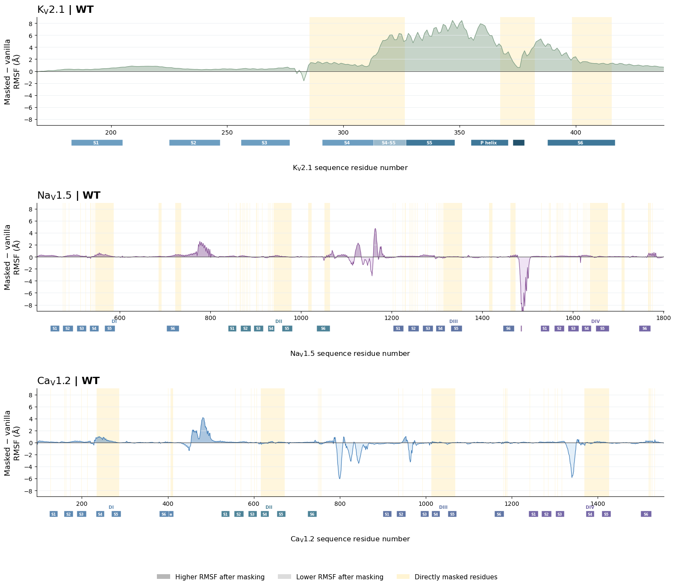

Figure S1. Masked-minus-vanilla ensemble RMSF profiles for wild-type Kv2.1, Nav1.5, and Cav1.2. (A) Per-residue Cα ensemble RMSF differences are shown after alignment to the corresponding channel-specific stable structural core. Directly masked positions are shaded. Positive values indicate greater positional dispersion in the masked ensemble, whereas negative values indicate reduced dispersion after masking. Secondary-structure annotations are shown beneath each profile to relate masking-dependent changes in structural variability to the channel architecture.

Figure S2. Targeted masking redistributes Kv2.1 ensemble variability toward the pore-coupling region. (A–C) Per-residue Cα ensemble RMSF profiles for wild-type, L403A, and F412L Kv2.1, respectively. Vanilla and masked values are shown after alignment to the same stable structural core. Directly masked positions are shaded, and the L403 and F412 mutation sites are indicated where applicable. The lower plots show the masked-minus-vanilla RMSF difference. Positive values indicate greater positional dispersion after masking, whereas negative values indicate reduced dispersion. Masking increases variability through much of the directly targeted S6 and pore-coupling region while reducing or minimally changing variability across several positions outside the mask. RMSF describes dispersion among retained AlphaFold2 structures and does not represent time-dependent molecular flexibility.
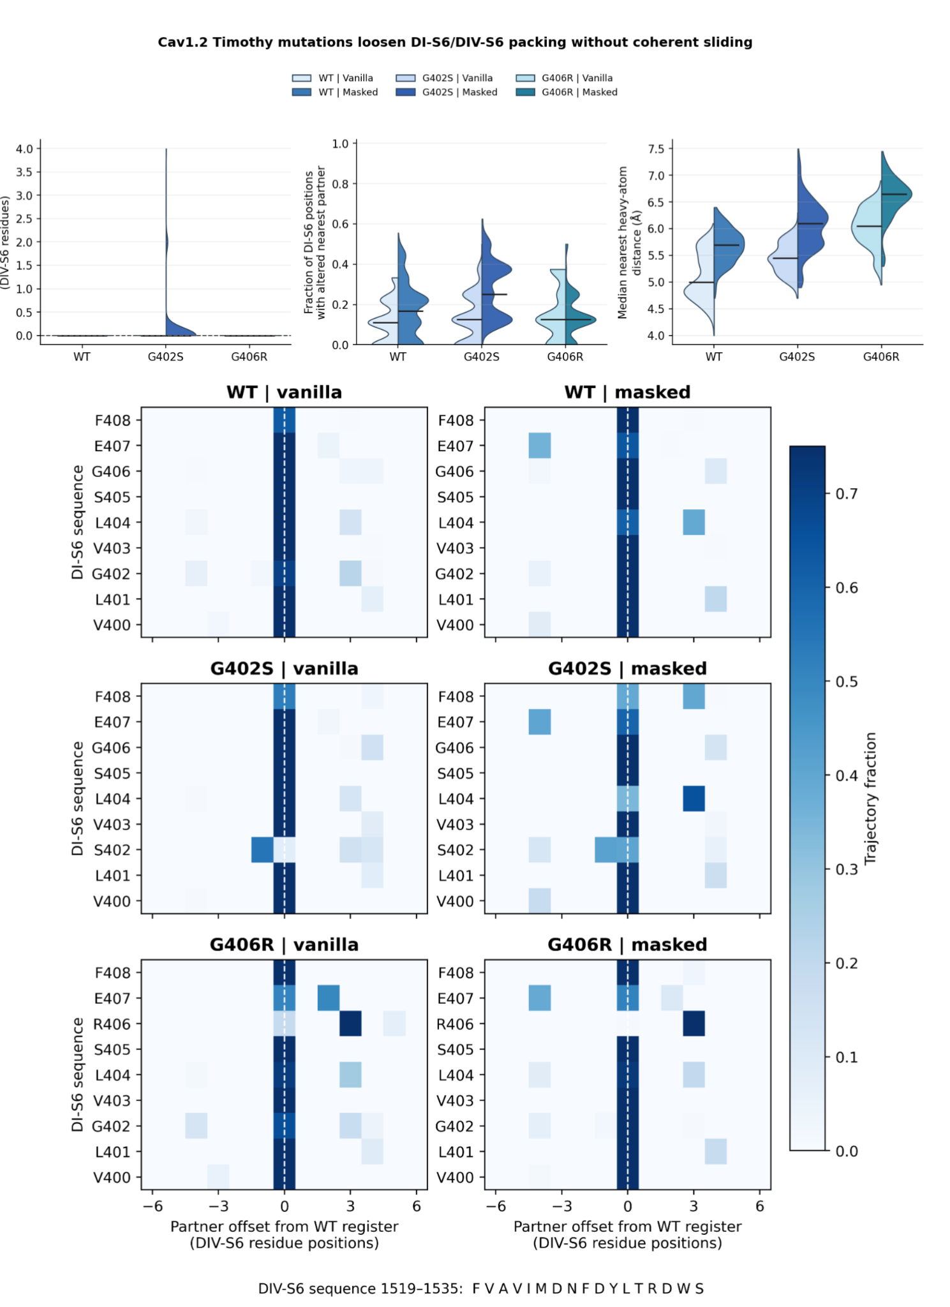
Supplementary Figure S3. Timothy-syndrome mutations alter DI-S6/DIV-S6 packing without producing coherent S6 sliding. Split violins compare vanilla and targeted-MSA-masked Cav1.2 ensembles for WT, G402S, and G406R using one final retained structure per model–seed trajectory. Left, axial register displacement of DIV-S6 relative to DI-S6. Center, fraction of DI-S6 positions whose nearest DIV-S6 residue differs from the WT reference relationship. Right, median nearest non-hydrogen distance between DI-S6 and DIV-S6. G402S samples multiple residue-partner reassignment, particularly in masked ensembles, whereas G406R increases interhelical separation without a consistent axial-register displacement. Horizontal bars indicate medians. The lower residue-pair maps show, for each DI-S6 position, the fraction of retained model–seed trajectories whose nearest DIV-S6 partner lies at each offset from the WT reference register. An offset of zero denotes the WT reference partner, whereas negative and positive offsets indicate partners shifted along the DIV-S6 sequence. Maps are shown for WT, G402S, and G406R under vanilla and masked protocols and provide a pair-resolved view of the same partner-reassignment analysis; they do not indicate a coherent axial slide.

Supplementary Table S2. Channel-specific convergence/alignment cores and experimental reference frames.
Channel | Analysis purpose | Predicted chain(s) | Alignment/stable-core residues* | Experimental reference/frame | Alignment procedure / rationale
Kv2.1 | Recycle-convergence assessment | A–D | 184–422 in each chain | None; consecutive recycle structures were compared directly | Cα atoms from all four subunits were combined into a single tetrameric alignment selection. Successive recycle RMSDs were calculated after rigid-body superposition using this core.
Kv2.1 | Experimental-reference RMSD | A–D | 184–422 in each chain | 8SD3 (WT) and 8SDA (L403A) | Predicted tetramers were mapped to each experimental tetramer and aligned using the common Cα core before whole-structure or regional RMSD calculation. Experimental chains were treated in spatial pore order: 8SD3, A–B–D–C; 8SDA, A–B–C–D.
Kv2.1 | Mutation-centered conformational analysis | A–D | Model: 184–208, 231–247, 262–277; corresponding 8SD3/8SDA numbering: 182–206, 229–245, 260–275 | 8SD3 common coordinate frame; 8SDA used as experimental L403A comparison | Narrow S1–S3 scaffold used to avoid fitting away the pore/S6 rearrangements under investigation. All four subunits were fitted simultaneously rather than independently.
NaV1.5 | Recycle-convergence assessment | A | 132–282; 359–426; 505–665; 690–749; 870–1112; 1128–1164; 1200–1405; 1429–1466 | None; consecutive recycle structures compared directly | Discontinuous Cα core spanning stable regions across the four homologous domains.
NaV1.5 | Ensemble RMSF and experimental-reference RMSD | A | 132–282; 359–426; 505–665; 690–749; 870–1112; 1128–1164; 1200–1405; 1429–1466 | 6UZ3 (rat) common frame; 7FBS and 8T6L (rat); 7DTC, 8VYJ, and 8VYK (human) | Same stable core as recycle convergence. Each model was transformed once into the 6UZ3 frame; models were not independently refitted to each additional experimental reference.
CaV1.2 | Recycle-convergence assessment | A | 112–410; 524–759; 901–1145; 1160–1197; 1239–1323; 1370–1534 | None; consecutive recycle structures compared directly | Discontinuous Cα core spanning stable regions across the four homologous domains.
CaV1.2 | Mutation-centered ensemble RMSF and experimental-reference comparison | A | 112–381; 524–759; 901–1145; 1160–1197; 1239–1323; 1370–1534 | 8WE6 chain A common frame; 8HLP chain A and 8FD7 chain K (human) | The original 112–410 convergence-core block was shortened to 112–381. Residues 382–426 were excluded from the fit so that motion surrounding G402/G406 was not fitted away.

Supplementary Table S3. Experimental-reference RMSD definitions.
Channel | RMSD metric / region | Residues* | Atoms | Alignment applied before RMSD | Interpretation
Kv2.1 | Whole matched tetramer RMSD | All sequence-matched measurable residues | Cα | Tetramer first aligned using the 184–422 core | Reports overall structural deviation after a common core alignment; the complete structure is not independently refitted.
Kv2.1 | Stable/convergence-core RMSD | 184–422 | Cα | Same residues used for the fit | Reports agreement of the core used to establish the global tetramer alignment.
Kv2.1 | S6-bundle RMSD | 389–422 | Cα | Reported after the common core alignment; an additional locally aligned value was also calculated diagnostically | Measures structural differences within the S6 bundle.
Kv2.1 | Distal-S6 RMSD | 398–414 | Cα and backbone | Common core alignment; additional regional fit available as a diagnostic | Measures local S6 rearrangement around the mutation-coupling region.
Kv2.1 | L403-centered region RMSD | 398–409 | Cα and backbone | Common core alignment; additional regional fit calculated separately | Mutation-proximal structural comparison around L403A.
Kv2.1 | F412-centered region RMSD | 407–417 | Cα and backbone | Common core alignment; additional regional fit calculated separately | Mutation-proximal structural comparison around F412/F412L.
Kv2.1 | Hydrophobic-nexus regional RMSD | 314–318; 327–331; 401–405; 410–414 | Cα and backbone | Common core alignment; additional regional fit calculated separately | Combined local region containing the S4–S5/S5/S6 hydrophobic-coupling elements.
NaV1.5 | Whole-model experimental-reference RMSD | Sequence-matched measurable residues | Cα | Single transformation into the 6UZ3 common frame; no subsequent fit to each comparison reference | Measures deviation from experimental structures without allowing each reference comparison to define a new coordinate frame.
NaV1.5 | Alignment-core RMSD | Stable-core ranges listed in Supplementary Table S2 | Cα | 6UZ3-frame core alignment | Reports structural agreement specifically within the stable scaffold.
CaV1.2 | Whole-model experimental-reference RMSD | Sequence-matched measurable residues | Cα | Single transformation into the 8WE6 common frame | Measures whole-model deviation from 8WE6, 8HLP, or 8FD7 after a common alignment.
CaV1.2 | Alignment-core RMSD | Mutation-excluded analysis core listed in Supplementary Table S2 | Cα | 8WE6-frame core alignment | Reports agreement of the stable scaffold while leaving G402/G406-proximal motion outside the fitting region.
RMSD residue labels are model/construct numbering unless otherwise indicated. Backbone RMSD uses N, Cα, C, and O atoms. Experimental-reference comparisons use sequence-matched atoms; unresolved or unmapped coordinates are omitted rather than imputed. Mutation-centered side-chain atoms are not forced into identity-mismatched WT-versus-mutant RMSD calculations.

Supplementary Table S4. Structural-distance and residue-proximity definitions.
Channel | Measurement | Residues / numbering | Atom definition | Chain/domain relationship | Summary / use
Kv2.1 | Intracellular-gate ring | Displayed A402 (model A404) in all six intersubunit pairs: A-B, A-C, A-D, B-C, B-D, C-D | Cα-Cα | Tetramer; cross-subunit ring | Six pairwise distances retained as distributions.
Kv2.1 | Selectivity-filter ring | Displayed G375 (model G377) in all six intersubunit pairs: A-B, A-C, A-D, B-C, B-D, C-D | Cα-Cα | Tetramer; cross-subunit ring | Six pairwise distances retained as distributions.
Kv2.1 | VSD coordinate | Displayed F236-R308 (model F238-R310) in each subunit A-D | Cα-Cα | Same subunit | Chain-resolved distances.
Kv2.1 | Pore-VSD separation | Displayed E423-N179; model E425-N181 | Cα-Cα | Same subunit | Measured in all four subunits; maximum per tetramer is the structure-level coordinate.
Kv2.1 | Pore-VSD structural QC | Displayed K427/E423/K420 to N179/V182; model numbering = displayed +2 | Cα-Cα | Same subunit | Trajectory excluded if any predefined distance >27 Å.
Kv2.1 | Hydrophobic nexus | Displayed 412-L316; model 414-318 | Shortest non-H side-chain distance | Same subunit | Chain-resolved local proximity.
Kv2.1 | Hydrophobic nexus | Displayed 412-L329 and 412-L403; model 414-331 and 414-405 | Shortest non-H side-chain distance | Closest adjacent subunit defined from tetramer geometry | Chain-resolved adjacent-subunit proximity.
Nav1.5 | Intracellular-gate span | Model landmarks M415, A742, I1154, I1455; all six pairs: M415-A742, M415-I1154, M415-I1455, A742-I1154, A742-I1455, I1154-I1455 | Cα-Cα | DI-DIV S6 gate landmarks | Maximum of the six spans when a single gate-width coordinate is required. Rat-reference mapping: 415/939/1472/1773; human-reference mapping: 414/936/1470/1771.
Nav1.5 | Orthogonal gate dimensions | M415-I1154 (DI-DIII) and A742-I1455 (DII-DIV) | Cα-Cα | Opposing S6 domains | Two spans analyzed separately for gate shape (Fig. 6F).
Nav1.5 | Selectivity-filter geometry | D373-E704; D373-K1103; D373-A1395; E704-K1103; E704-A1395; K1103-A1395 | Cα-Cα | Across pore domains | Six pairwise distances retained as distributions.
Nav1.5 | VSD coordinates | F165-R220; F165-R229; F560-R612; F560-R624; F934-K984; F934-R1000; F1251-R1307 | Cα-Cα | Within the corresponding VSD/domain | Individual distances retained as distributions.
Nav1.5 | IFM/QQQ-receptor proximity | F1486/Q1486 (model 1170) to N1659 (1343) and N1765 (1449) | F CZ / Q NE2 to N ND2 | III-IV linker to receptor region | Two terminal-atom distances analyzed separately.
Nav1.5 | Whole-motif-receptor proximity | IFM 1485-1487 / QQQ (model 1169-1171) to N1659 (1343) | Predefined residue-specific terminal side-chain tip atoms to N ND2 | III-IV linker to receptor region | Minimum across the three motif residues.
Nav1.5 | Motif separation | F1486/Q1486 (model 1170) to N1659 (1343) and N1765 (1449) | Cα-Cα | III-IV linker to receptor region | Mean of the two Cα distances.
CaV1.2 | Intracellular-gate geometry | L401-L749; L401-V1182; L401-I1516; L749-V1182; L749-I1516; V1182-I1516 | Cα-Cα | Across the four pore domains | Six pairwise gate distances retained as distributions.
CaV1.2 | Selectivity-filter geometry | E363-E706; E363-E1135; E363-E1464; E706-E1135; E706-E1464; E1135-E1464 | Cα-Cα | Across the four pore domains | Six pairwise filter distances retained as distributions.
CaV1.2 | VSD coordinates | F170-R237; F170-R246; F567-R620; F567-K629; F940-K1015; F940-R1031; F1278-R1377; F1278-K1386 | Cα-Cα | Within the corresponding VSD/domain | Individual distances retained as distributions.
CaV1.2 | G402S-centered packing | S402-I1523 and S402-M1524; WT comparison uses G402 | Shortest non-H side-chain distance | DI-S6 to DIV-S6 | Individual residue-pair proximities.
CaV1.2 | G406R-centered packing | R406-T1531; R406-D1528; R406-D1533 | Shortest non-H side-chain distance | DI-S6 to DIV-S6 | Individual residue-pair proximities; any R406-centered distance <2 Å marks the severe-overlap subset for local-overlap-filtered interpretation.

Notes: Labels use displayed biological numbering unless a model/construct alias is shown. Cα distances are Euclidean Cα-Cα distances; shortest non-H distances are the minimum between non-hydrogen side-chain atoms; tip distances use the specified terminal atoms. The 4 Å line is a descriptive proximity guide, <2 Å denotes severe atomic overlap where specified, and 27 Å is the Kv2.1 structural-QC cutoff. Principal measurements used unrelaxed AlphaFold2 models.
Supplementary Table S5. Cohort flow and analysis-specific retention.
[PLACEHOLDER: Insert the cohort-flow table generated from seed_block/master_cohort_flow_summary.csv. Suggested columns: Channel/condition, nominal seeds, nominal model-seed trajectories, mapping QC, converged, final QC, analysis final, retained snapshots, and principal exclusion reason.]
Supplementary Table S6. Repeated common-seed reduced-depth stability of focal L403A outcomes.
L403A outcome | Same effect direction | Median relative error | Subset CI covered complete effect | Detected masked rare state
Continuous maximum distance | 100% | 6.9% | 94.4% | Not applicable
Shifted-interface fraction | 100% | 14.1% | 95.1% | 100%

[FIGURE INSERTION REQUIRED: Insert seed_block/nav15_regional_rmsd/Figure_S5_Nav15_regional_RMSD_seed_block]
Supplementary Figure S5. Seed-block regional RMSD sensitivity of Nav1.5 WT and QQQ ensembles to targeted masking. Models and six experimental references were placed in the fixed 6UZ3 stable-core coordinate frame before RMSD was calculated without independently refitting each measured region. Rows show the S5/S6 pore helices, DII-S6, the IFM/QQQ motif, and the six-residue IFM receptor set. Points are seed-balanced masked-minus-vanilla effects after reducing each seed-model trajectory to its median retained final-QC recycle, weighting available AF2 models equally within seed, and weighting seeds equally. Error bars are 95% intervals from 2,000 whole-seed bootstrap replicates. The 7FBS IFM/QQQ-motif cell is unavailable because the motif is unresolved in that reference. WT and QQQ masks are shown as separate protocol-specific analyses because the original mask designs are not identical.
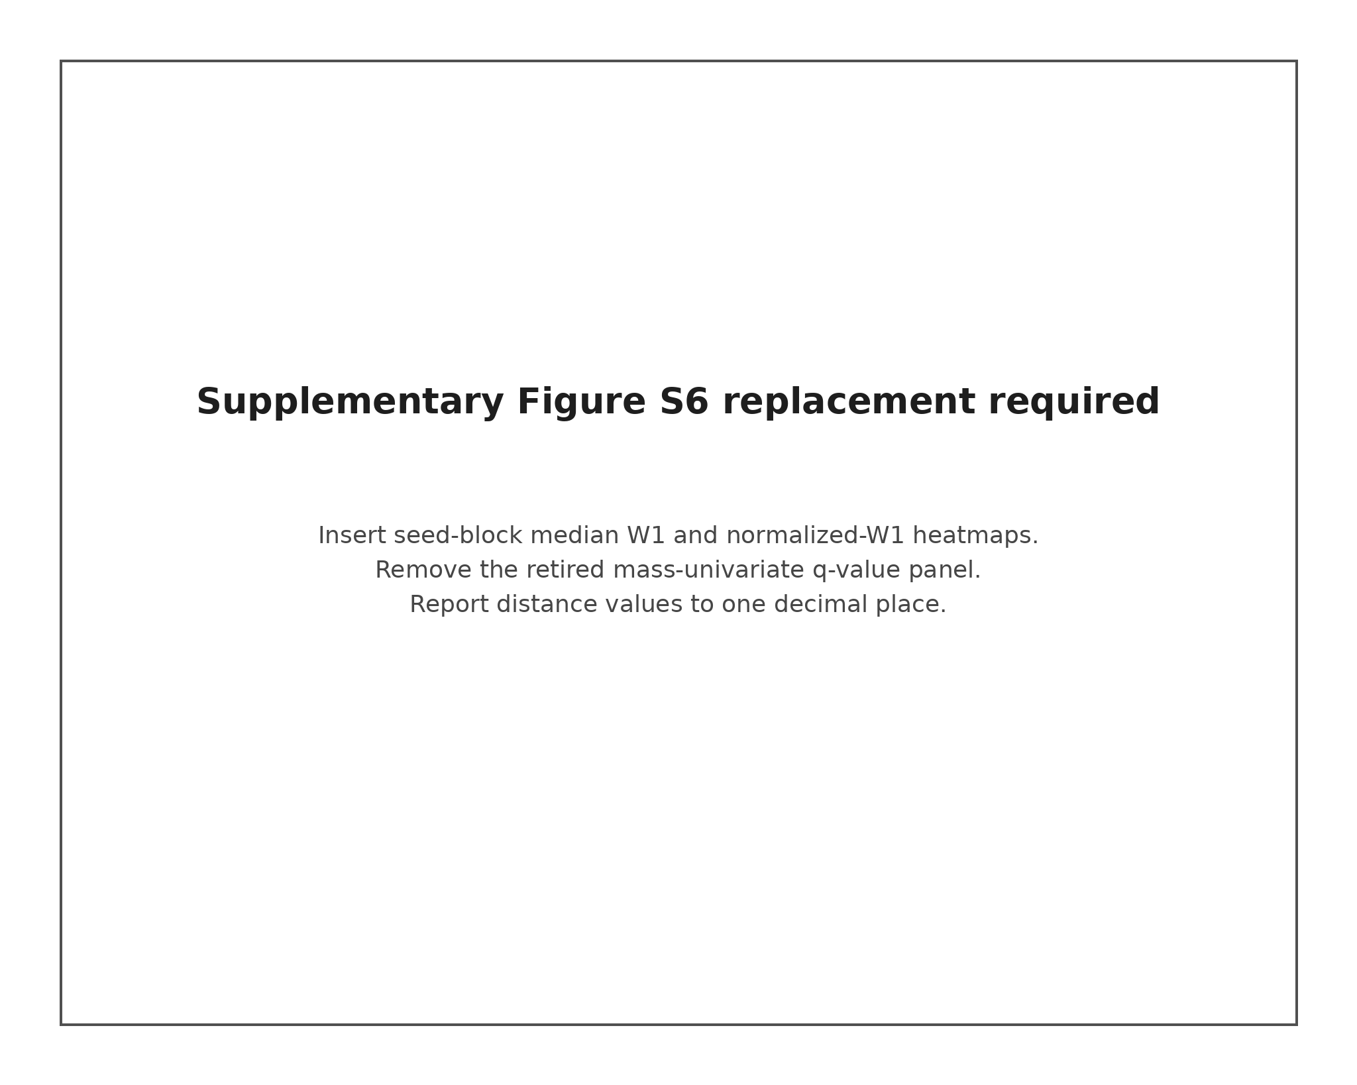
[ToDo: fully ReDo figure S6 → idea is to have the seed-block W1 and normalized-W1 heatmaps generated from the full-panel outputs before next version]
Supplementary Figure S6. Seed-block effect-size comparison of WT and mutant structural-distance distributions. (A) Heatmaps summarize WT–mutant comparisons across the available MSA-protocol combinations for Cav1.2 G402S and G406R, Kv2.1 L403A and F412L, and Nav1.5 QQQ. The upper heatmap shows the median seed-balanced one-dimensional Wasserstein distance (W1) across shared structural-distance observables, reported in ångströms. The lower heatmap shows median W1 normalized by the pooled weighted IQR. Retained recycles were reduced to trajectory medians, available AlphaFold2 model parameterizations were weighted equally within each seed, and seeds were weighted equally. Primary sequence contrasts used vanilla WT versus vanilla mutant. The shared-mask Kv2.1 masked contrasts are directly interpretable, whereas masked WT–mutant comparisons in Cav1.2 and Nav1.5 are protocol-specific explorations. The panel was treated as an effect-size discovery analysis and did not use mass-univariate P or q values; leave-one-AF2-model-out ranges are reported in the accompanying source table.

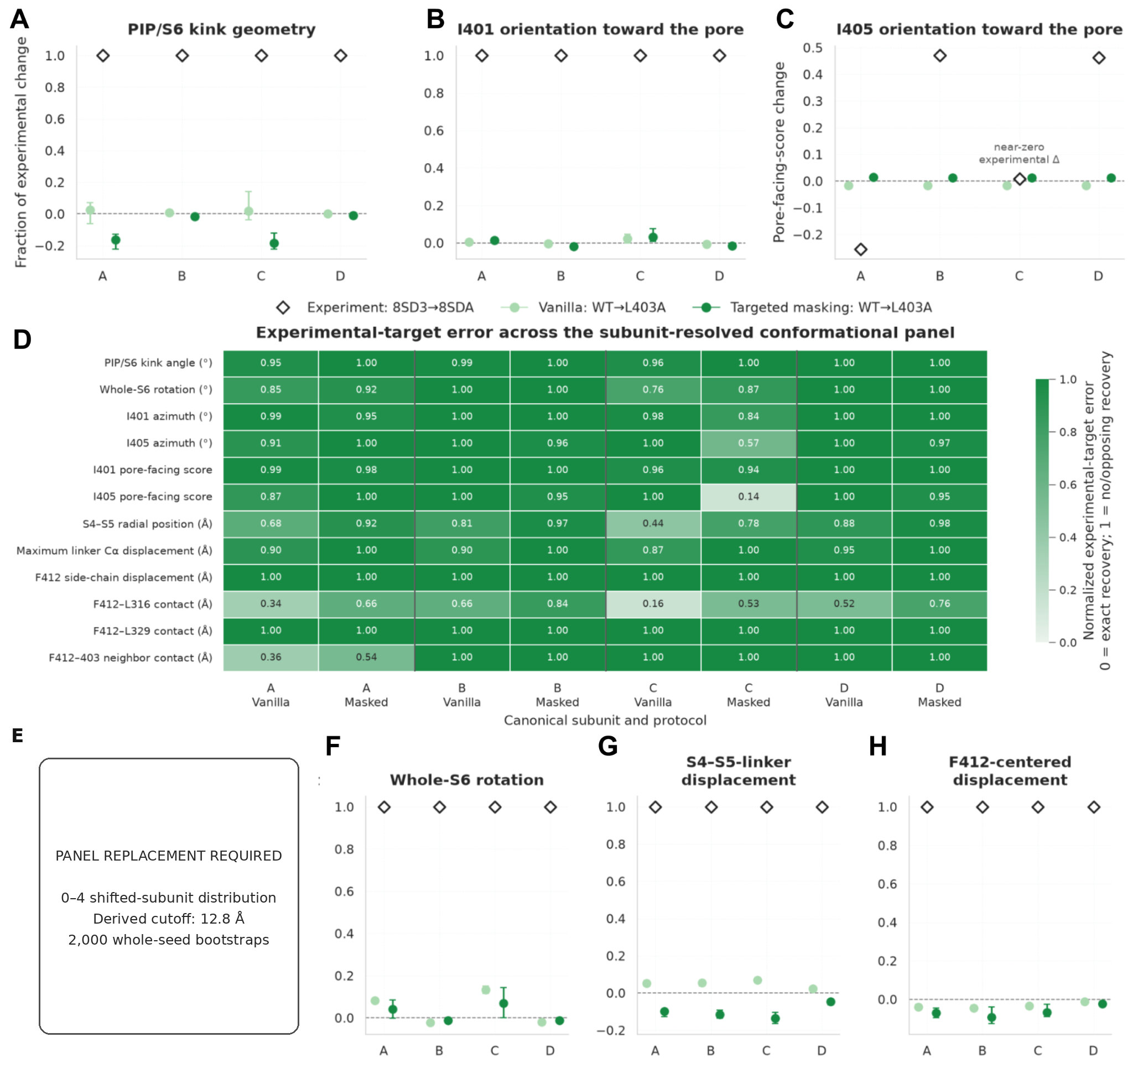
[ToDo decided to switch Panel E is currently so rn is just a placeholder and must be replaced with the final seed-block zero-to-four shifted-subunit distribution in the next version]
Supplementary Figure S7. Subunit-resolved analysis of experimental Kv2.1 L403A conformational signatures. (A) Chain-resolved PIP/S6 kink geometry. (B, C) Changes in I401 and I405 orientation toward the pore. In panels A, B, and F–H, predicted changes are expressed as a fraction of the corresponding experimental 8SD3-to-8SDA change; the experimental target is therefore 1, zero indicates no predicted change, and negative values indicate a change opposite to experiment. I405 pore-facing changes in panel C are shown in raw pore-facing-score units because the experimental change in subunit C is near zero, making a recovery ratio unstable. (D) Normalized experimental-target error across the complete subunit-resolved metric panel, calculated as |pred − exp|/(|pred| + |exp|), using circular differences for angular metrics and bounding values at 1. (E) Seed-balanced distribution of zero to four subunits exceeding the independently derived 12.8 Å E423–N179 shifted-interface cutoff. Each categorical outcome was first summarized within seed-model trajectories and then combined using equal AlphaFold2-model weights within seed and equal seed weights. Error bars show 95% intervals from 2,000 whole-seed bootstrap replicates. Both conditions contained 100 independent input seeds; 484 vanilla and 459 masked model-seed trajectories contributed correlated within-seed observations. Masked threshold-positive tetramers were dominated by structures with all four interfaces elongated rather than by the two-shifted/two-WT-like arrangement observed in 8SDA. (F–H) Whole-S6 rotation, S4–S5-linker displacement, and F412-centered displacement, respectively. Metrics and subunits are structurally correlated and are not interpreted as independent validation tests, and near-zero experimental changes were not interpreted as strong recovery from normalized error alone. Together, these analyses show increased access to the local E423–N179 displacement without coordinated recovery of the broader experimental 8SDA conformational transition.
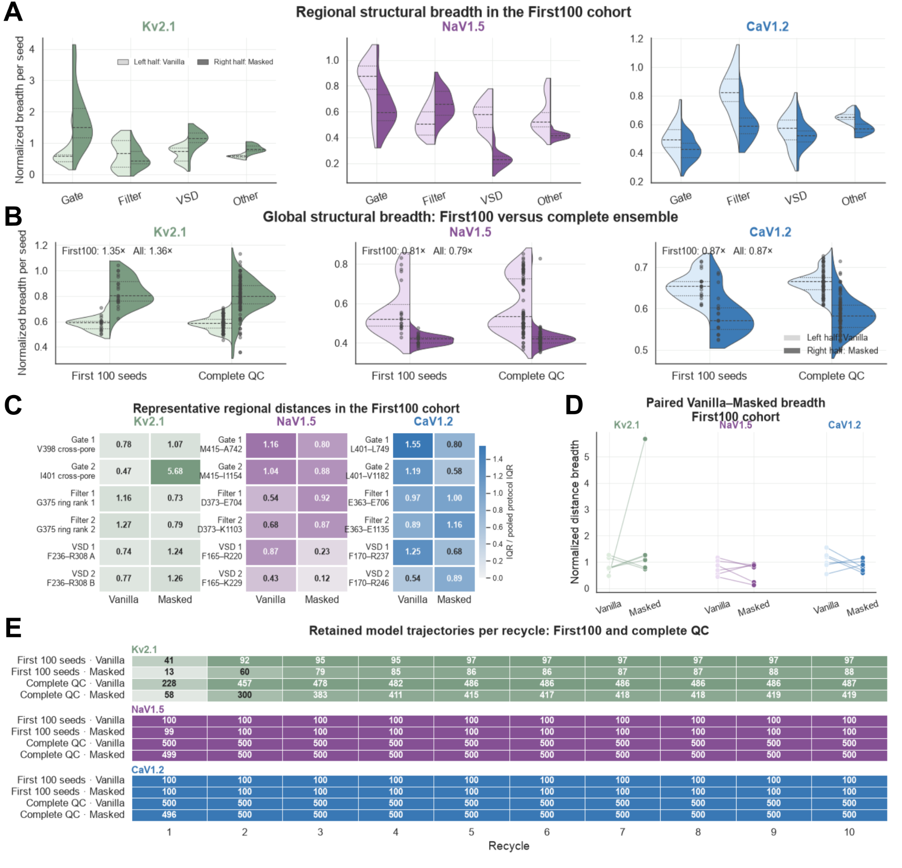

Supplementary Figure S8. Masking-dependent structural breadth at reduced sampling depth across wild-type voltage-gated ion channels. Wild-type Kv2.1, Nav1.5, and Cav1.2 vanilla and targeted-masking ensembles were evaluated using a predefined First100 cohort comprising the first 20 ordered seeds across five AlphaFold2 model parameterizations, yielding 100 nominal model–seed trajectories per protocol before final quality control, and were compared with the corresponding complete final-QC ensembles. Trajectories excluded by final QC were not replaced. For panels A–D, each retained trajectory contributed one representative structure, defined as the latest numbered recycle surviving final QC. Structural breadth was quantified using the interquartile range (IQR; 75th–25th percentile) of chain-label-safe structural-distance coordinates. For Kv2.1, the intracellular-gate and selectivity-filter analyses used chain-label-invariant cross-pore measurements and sorted ring spans, respectively, whereas VSD measurements were intrachain. To place coordinates with different absolute scales on a common scale, each coordinate IQR was normalized by its corresponding pooled vanilla–masked IQR in the complete final-QC WT ensemble. The Nav1.5 comparison used the WT mask v2 condition. (A) Regional composite structural breadth in the First100 cohorts. For each seed, normalized coordinate-level breadth values were summarized within the intracellular gate, selectivity filter, VSD, or remaining eligible “Other” coordinates. Split violins show the resulting seed-level regional distributions; left and right halves represent vanilla and targeted-masking predictions, respectively. (B) Global seed-level structural breadth in the First100 and complete final-QC ensembles. Points represent seed-level summaries, and split violins show their distributions. Annotations report the ratio of the masked to vanilla median breadth; values above one indicate broader sampling after masking, whereas values below one indicate narrower sampling. Kv2.1 shows increased global breadth after masking at both sampling depths, whereas Nav1.5 and Cav1.2 show lower global breadth after masking. (C) Representative First100 coordinate-level breadth values, including two intracellular-gate, two selectivity-filter, and two VSD coordinates per channel. Cell values are normalized IQRs, and darker shading indicates greater normalized breadth. (D) Coordinate-matched vanilla-to-masked changes for the representative distances shown in panel C. Each line connects the vanilla and masked breadth of the same coordinate; upward and downward slopes indicate increased and decreased breadth after masking, respectively. (E) Number of model–seed trajectories contributing a retained snapshot at each numbered recycle in the First100 and complete nominal cohorts. Cell labels report trajectory counts, whereas shading represents the fraction of the corresponding nominal cohort retained. In this single predefined deterministic subset, the qualitative direction of the masking response was similar to that observed in the complete ensembles: Kv2.1 showed greater global breadth after masking, whereas Nav1.5 and Cav1.2 showed lower global breadth with region-specific exceptions. Because normalization used complete-ensemble denominators and only one First100 subset was evaluated, this analysis is a retrospective descriptive illustration and does not quantify repeated-sampling stability or establish that reduced sampling is sufficient for rare, multimodal, or coordinated structural alternatives.

