Executive Summary: Predictive Churn Risk Scoring for Bank Customers

Audience: Government and policy stakeholders
Dataset: 10,000 European bank customers | Churn rate: 20.37% | Best model: XGBoost

Purpose
This project builds a predictive churn intelligence system that helps a bank identify customers likely to leave before they actually churn. The system supports proactive retention, efficient campaign targeting, and explainable customer-risk decisions.

Why This Matters
- Customer churn reduces lifetime value, revenue stability, and competitiveness.
- Reactive retention campaigns are costly because they act after customer dissatisfaction has already escalated.
- Risk scoring enables earlier and more targeted customer engagement.
- Explainability improves trust, auditability, and responsible use of machine learning in financial services.

Methodology Snapshot
Stage | Action
Preprocessing | Dropped identifiers, encoded categories, scaled numerical variables
Feature engineering | Created balance-to-salary, product-density, engagement-product, and age-tenure interactions
Modeling | Compared Logistic Regression, Decision Tree, Random Forest, Gradient Boosting, and XGBoost where available
Evaluation | Used accuracy, precision, recall, F1-score, ROC-AUC, and confusion matrix
Deployment | Delivered Streamlit app with risk calculator, feature importance, probability distribution, what-if simulator

Key Results
Model performance summary
Model | Accuracy | Precision | Recall | F1-Score | ROC-AUC
XGBoost | 0.8695 | 0.7897 | 0.4889 | 0.6039 | 0.8691
Gradient Boosting | 0.8700 | 0.7928 | 0.4889 | 0.6049 | 0.8682
Random Forest | 0.8320 | 0.5723 | 0.6904 | 0.6258 | 0.8641
Decision Tree | 0.7570 | 0.4452 | 0.7887 | 0.5691 | 0.8384
Logistic Regression | 0.7095 | 0.3827 | 0.6978 | 0.4943 | 0.7759
The selected model is XGBoost. It achieved ROC-AUC 0.869 on the holdout test set. A tuned churn-flag threshold of 0.252 was selected to reduce false positive churn alarms while preserving practical churn detection.
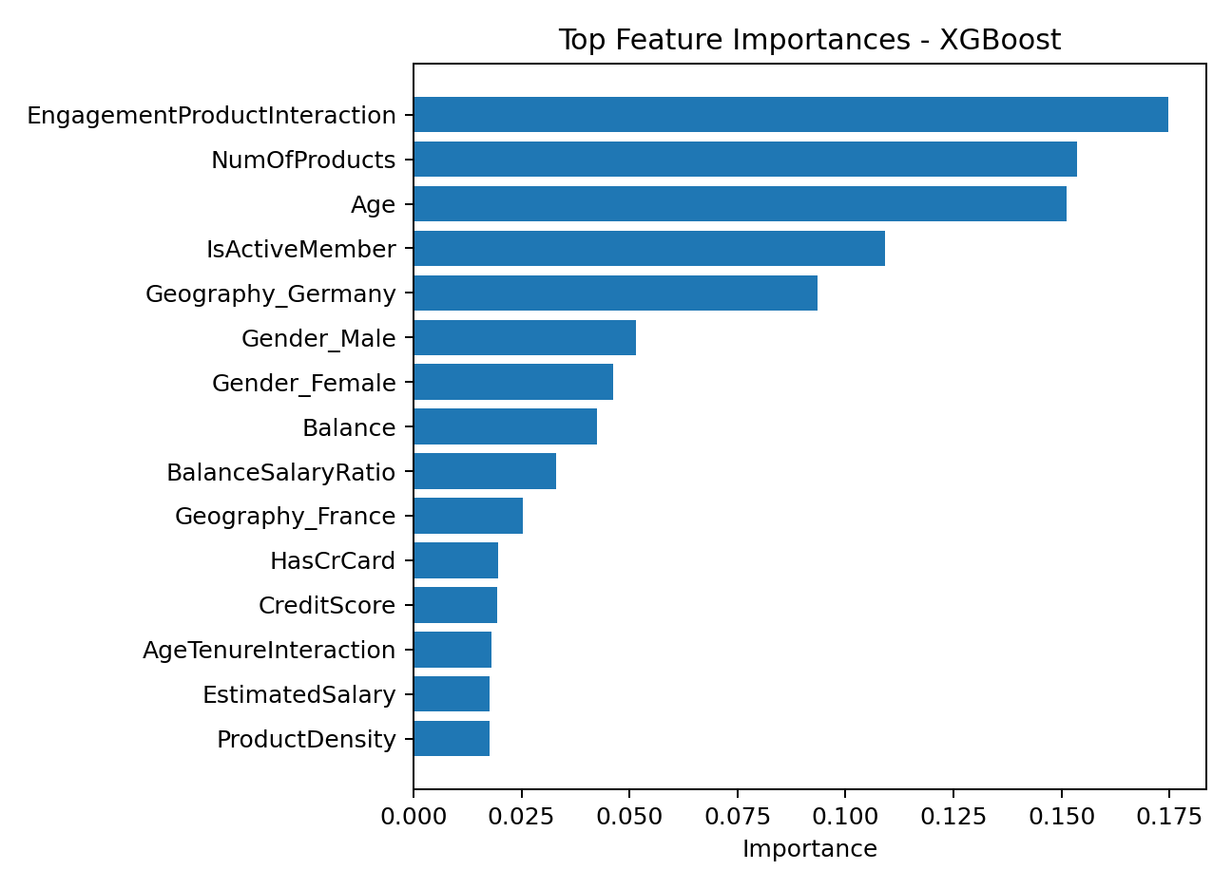
Top churn drivers identified by the final model
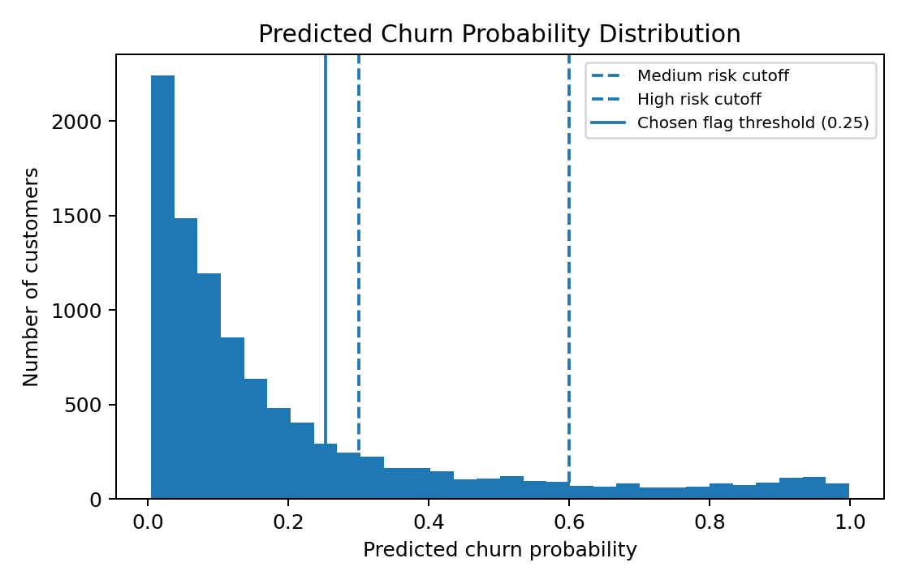
Distribution of predicted churn probability across customers

Operational Risk Bands
Risk Band | Probability Range | Recommended Action
Low | Below 30% | Normal loyalty monitoring
Medium | 30% to 60% | Targeted engagement campaign
High | Above 60% | Immediate retention outreach and personalized intervention

Policy and Governance Recommendations
- Use churn scores as decision-support tools, not as fully automated customer treatment decisions.
- Review high-risk cases with human oversight before expensive or sensitive interventions.
- Monitor false positives because incorrect churn flags can waste retention budget and create unnecessary customer contact.
- Audit model performance across geography and gender segments to prevent unfair or uneven outcomes.
- Refresh the model periodically as customer behavior and economic conditions change.

Conclusion
The project delivers a practical churn intelligence framework that moves banks from reactive churn reporting to proactive risk-based retention. It combines prediction, explainability, risk scoring, and what-if simulation in one deployable Streamlit application.

