Predictive Modeling and Risk Scoring for Bank Customer Churn

Research Paper | EDA, Predictive Modeling, Explainability, and Retention Recommendations
Prepared for: Unified Mentor Project Submission
Dataset: European Bank Customer Churn Dataset
Sample size: 10,000 customers | Target: Exited | Overall churn rate: 20.37%

Abstract
This study develops a predictive churn intelligence system for retail banking customers. The dataset contains 10,000 customer records and a binary churn target, Exited. The analysis combines exploratory data analysis, engineered relationship-strength features, stratified model development, probability-based risk scoring, and explainable churn-driver interpretation. The best-performing model, XGBoost, achieved a ROC-AUC of 0.869 on the holdout test set. The final solution converts predicted probabilities into risk scores and risk bands so that retention teams can prioritize proactive engagement.

1. Background and Context
Customer churn affects Customer Lifetime Value, revenue stability, cross-sell potential, upsell potential, and long-term competitiveness in retail banking. Traditional analysis describes churn after it has occurred, but modern banking needs early identification of customers at risk so that proactive retention action can be taken.
This project reframes churn as a predictive and explainable risk-scoring problem. Instead of only asking why customers left, the system estimates the probability that each customer will churn and highlights the drivers behind that risk.

2. Problem Statement
Banks often hold rich customer-level data but lack accurate churn prediction models, quantitative risk scores, and explainable insights into churn drivers. As a result, retention actions become reactive, broad, inefficient, and costly. This project addresses that gap by delivering an interpretable churn prediction pipeline and a Streamlit dashboard for operational use.

3. Objectives
Primary objectives: predict customer churn with high accuracy, generate churn probability scores, and identify key churn drivers.
Secondary objectives: reduce false positives in churn detection, improve model interpretability, and enable scenario-based churn risk analysis through a web application.

4. Dataset Description
Column | Description
CustomerId | Unique customer identifier
Surname | Customer surname
CreditScore | Customer creditworthiness
Geography | France, Spain, Germany
Gender | Male / Female
Age | Customer age
Tenure | Years with the bank
Balance | Account balance
NumOfProducts | Number of bank products
HasCrCard | Credit card ownership
IsActiveMember | Activity indicator
EstimatedSalary | Estimated annual salary
Exited | Churn indicator target
Year | Dataset year; constant in this file
The file contains 10,000 records and no missing values. The target distribution is imbalanced: 7,963 retained customers and 2,037 churned customers, giving an overall churn rate of 20.37%.
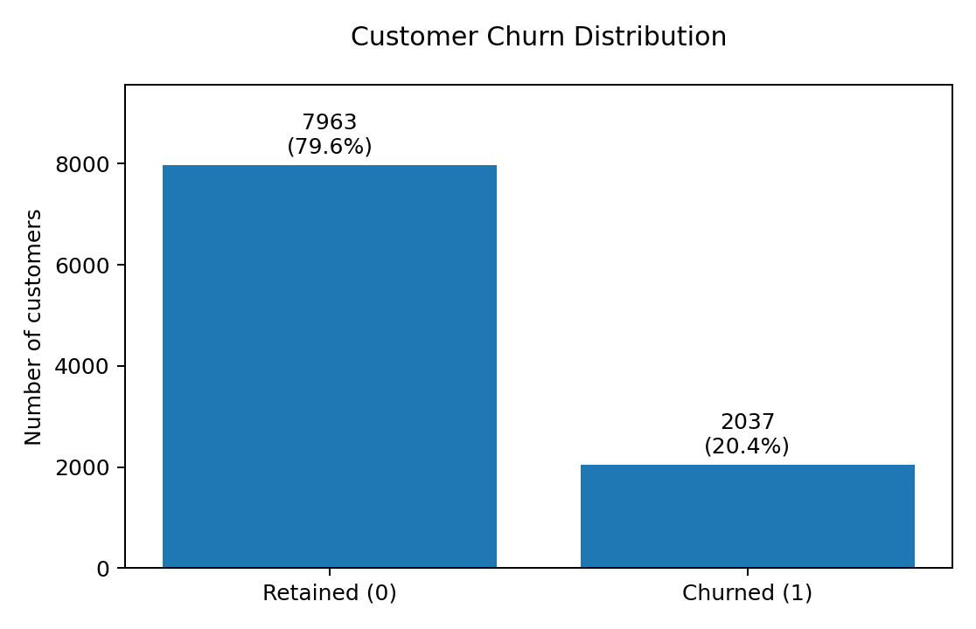
Figure 1. Customer churn distribution
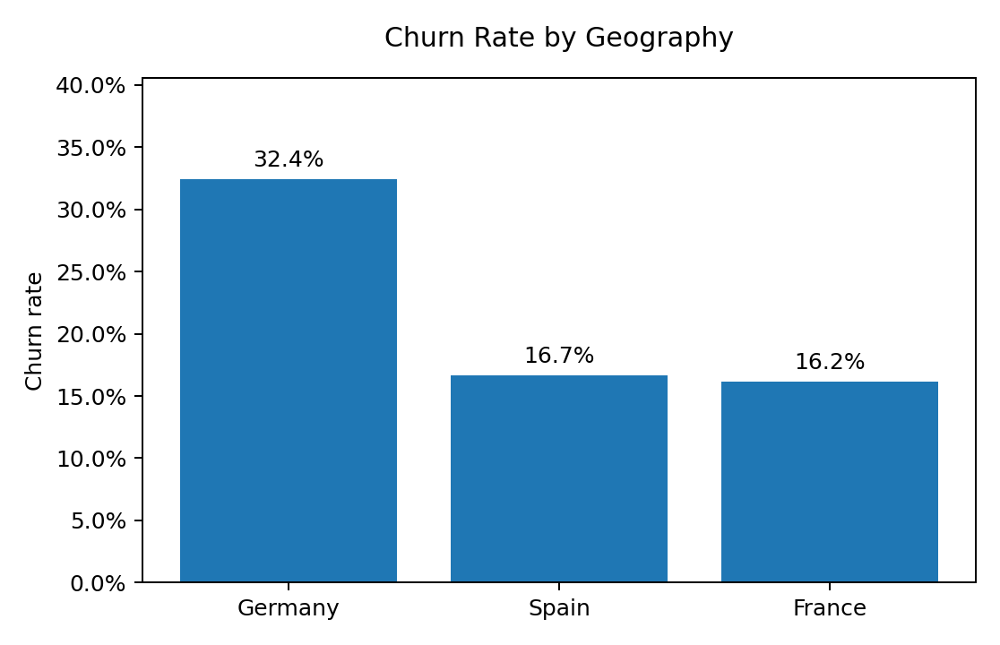
Figure 2. Churn rate by geography
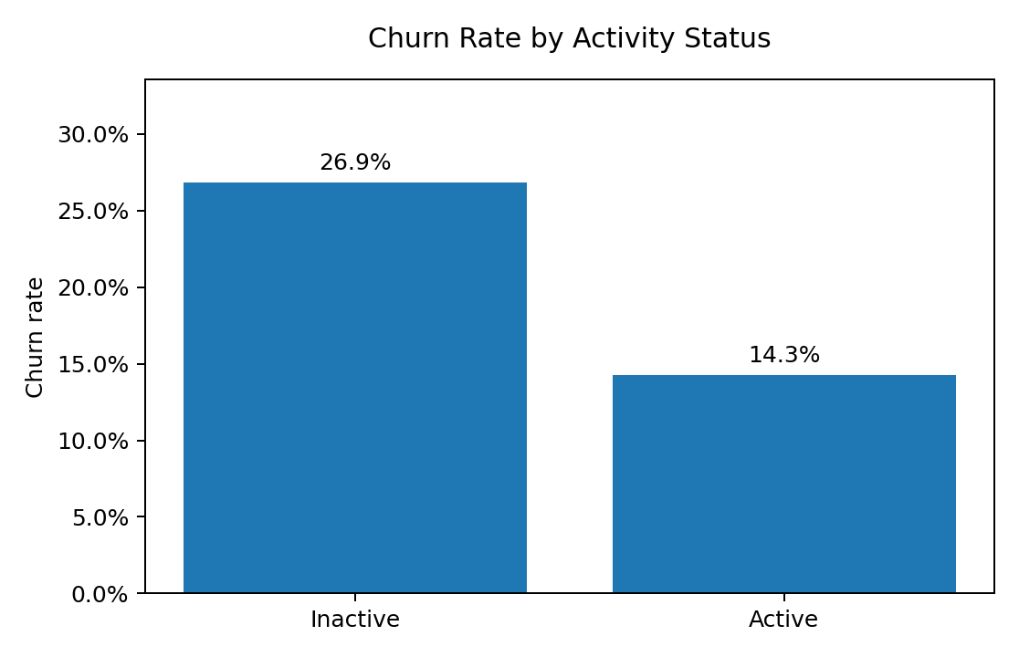
Figure 3. Churn rate by activity status
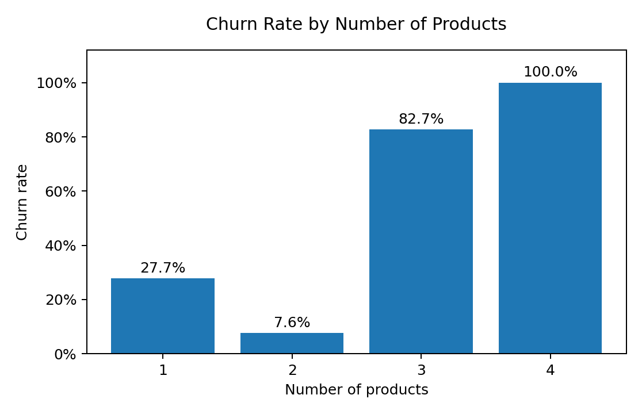
Figure 4. Churn rate by number of products

5. Analytical Methodology

5.1 Data Preprocessing
The preprocessing workflow checks for missing values, removes non-informative identifiers, encodes categorical variables, and scales numerical variables. CustomerId and Surname are removed because they identify customers but do not explain churn behavior. Year is also removed because it has a single constant value in the dataset.
Categorical variables Geography and Gender are one-hot encoded. Numerical features are standardized for models such as Logistic Regression, and the same preprocessing pipeline is retained for all models to ensure consistent comparison.

5.2 Feature Engineering
Derived Feature | Definition | Business Meaning
BalanceSalaryRatio | Balance / (EstimatedSalary + 1) | Relationship value relative to annual salary
ProductDensity | NumOfProducts / (Tenure + 1) | Product concentration adjusted by tenure
EngagementProductInteraction | IsActiveMember x NumOfProducts | Combined engagement and product utilization
AgeTenureInteraction | Age x Tenure | Lifecycle relationship maturity

5.3 Train-Test Strategy
The data is split using a stratified 80/20 train-test strategy to preserve the churn class distribution in both sets. The best model is additionally assessed using 5-fold stratified cross-validation on ROC-AUC to reduce dependence on a single split.

5.4 Model Development
A Logistic Regression model is used as an interpretability benchmark. Tree-based and ensemble models are then developed to capture non-linear churn behavior: Decision Tree, Random Forest, Gradient Boosting, and XGBoost where available.
Table 1. Model comparison on holdout test set
Model | Accuracy | Precision | Recall | F1-Score | ROC-AUC
XGBoost | 0.8695 | 0.7897 | 0.4889 | 0.6039 | 0.8691
Gradient Boosting | 0.8700 | 0.7928 | 0.4889 | 0.6049 | 0.8682
Random Forest | 0.8320 | 0.5723 | 0.6904 | 0.6258 | 0.8641
Decision Tree | 0.7570 | 0.4452 | 0.7887 | 0.5691 | 0.8384
Logistic Regression | 0.7095 | 0.3827 | 0.6978 | 0.4943 | 0.7759
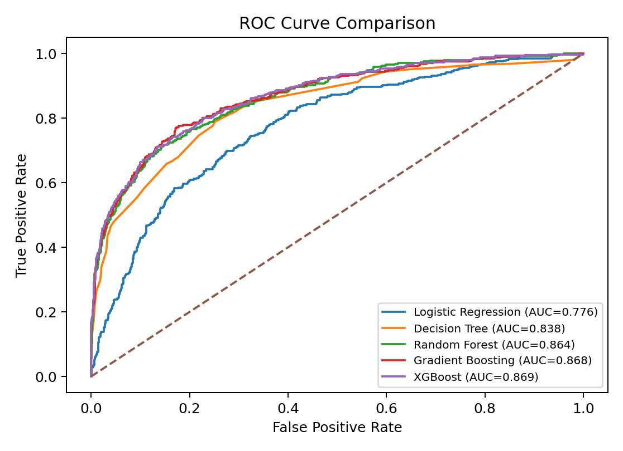
Figure 5. ROC curve comparison across models

6. Model Evaluation and Threshold Strategy
The selected model is XGBoost. It is selected using ROC-AUC and F1-score because churn prediction requires both discrimination and useful positive-class detection. At the default threshold, the model achieved ROC-AUC 0.869.
To reduce false churn alarms while maintaining useful detection, the binary churn flag threshold is tuned to 0.252. The tuned threshold achieved precision 0.556, recall 0.717, and F1-score 0.627 on the test set.
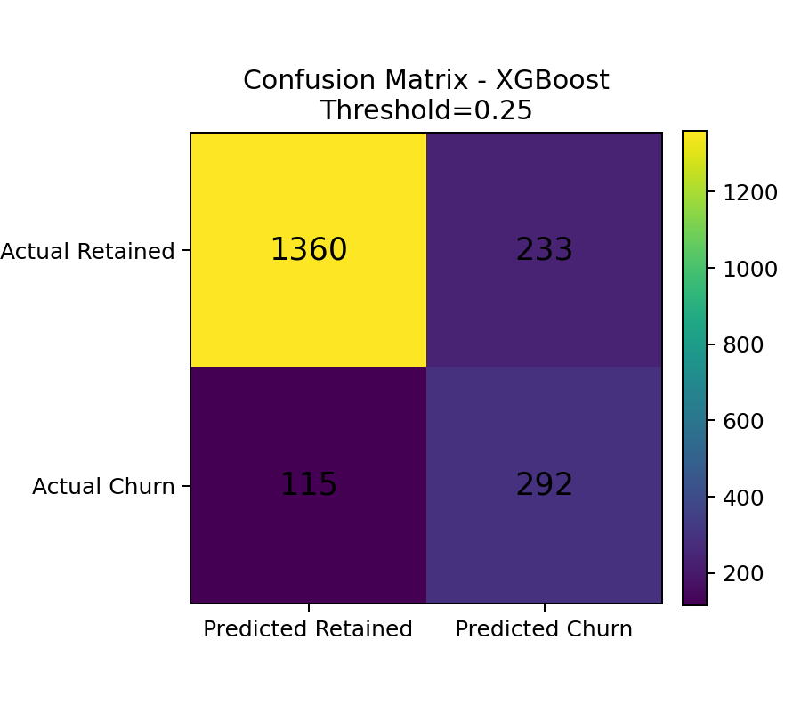
Figure 6. Confusion matrix at tuned threshold
Five-fold cross-validation produced a mean ROC-AUC of 0.868 with standard deviation 0.007, indicating stable model discrimination across folds.

7. Model Explainability
Explainability is necessary for business trust and regulatory confidence. The final solution includes ranked feature importance, SHAP value analysis, and partial dependence charts. Feature importance identifies which variables contributed most to predictions, SHAP summarizes average feature impact on model output, and partial dependence shows how churn probability changes as a feature varies.
Table 2. Top churn drivers
Feature | Importance
EngagementProductInteraction | 0.1748
NumOfProducts | 0.1536
Age | 0.1511
IsActiveMember | 0.1092
Geography_Germany | 0.0936
Gender_Male | 0.0515
Gender_Female | 0.0463
Balance | 0.0426
BalanceSalaryRatio | 0.0330
Geography_France | 0.0252
HasCrCard | 0.0196
CreditScore | 0.0194
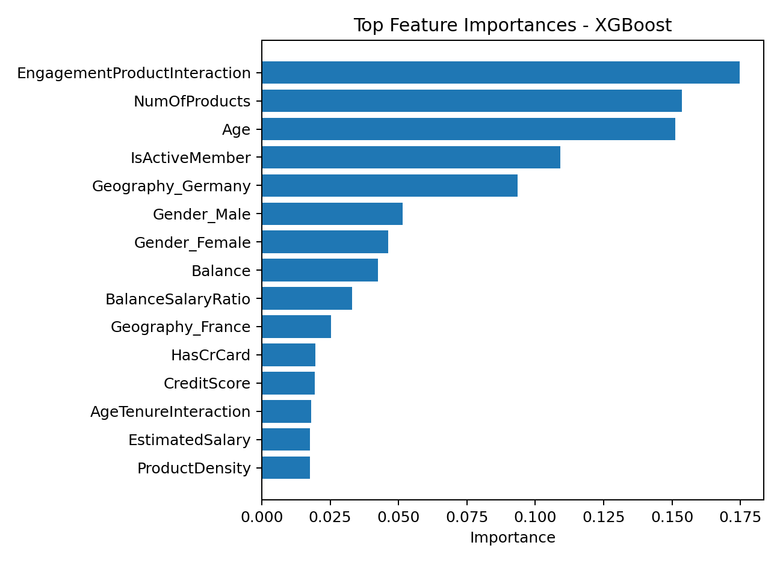
Figure 7. Top feature importances
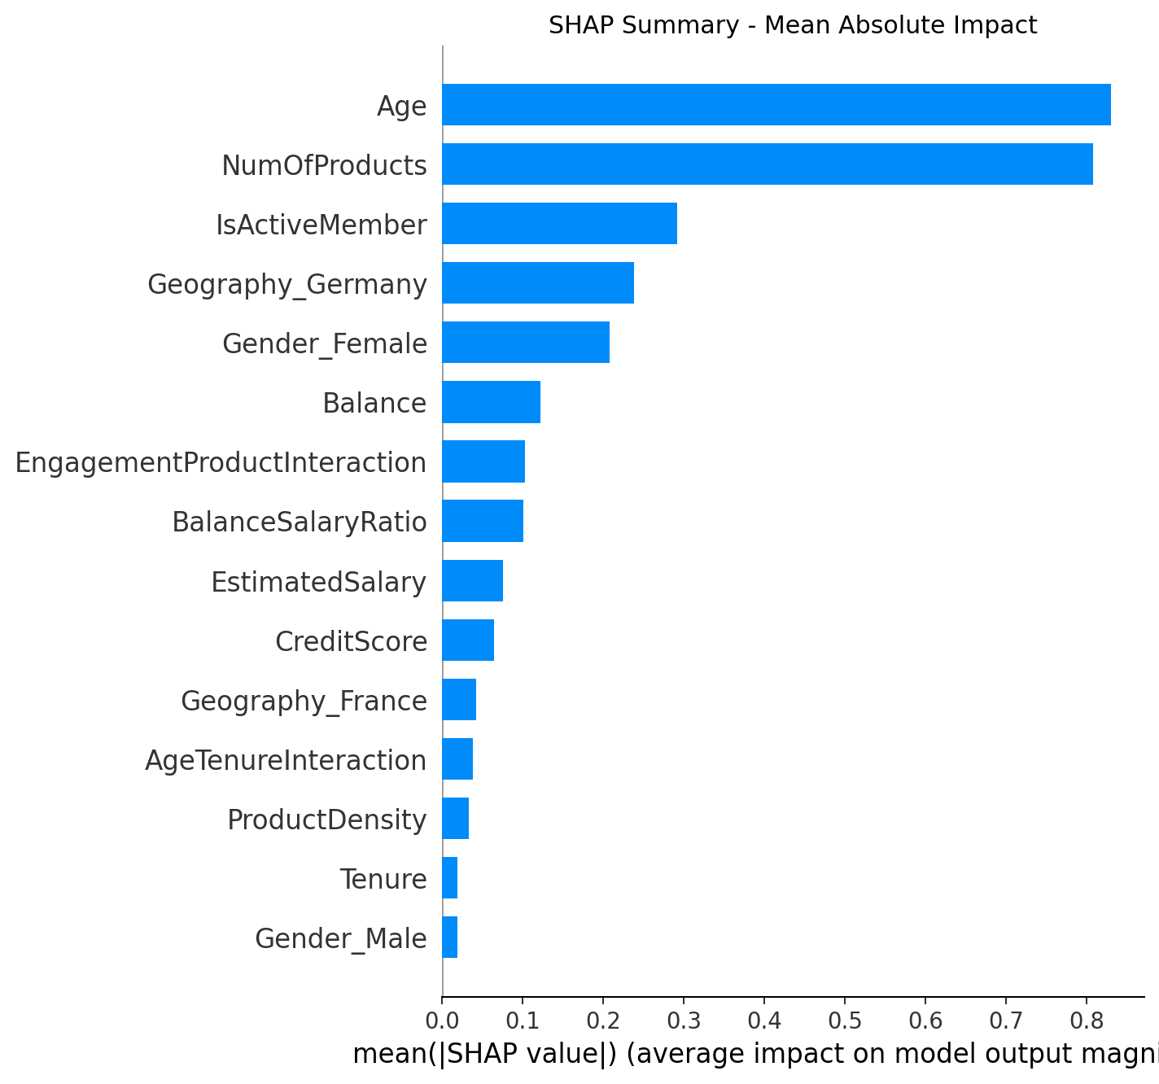
Figure 8. SHAP summary showing mean absolute impact on churn predictions
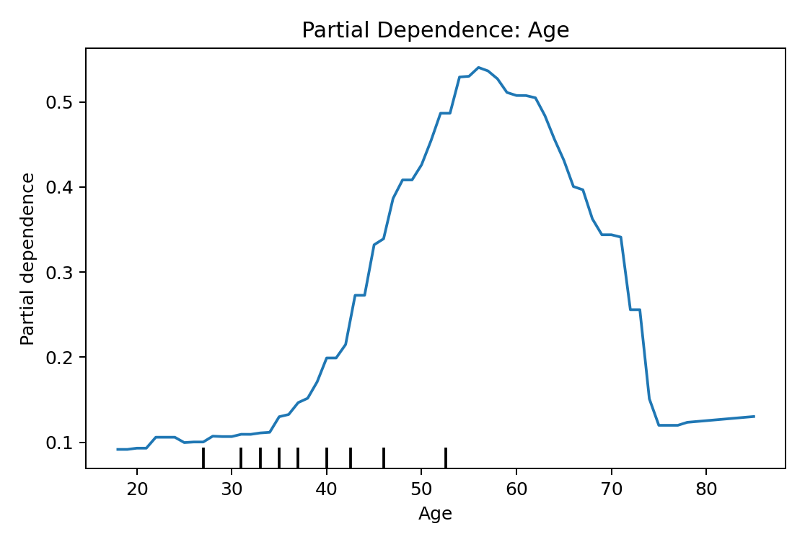
Figure 9. Partial dependence of age
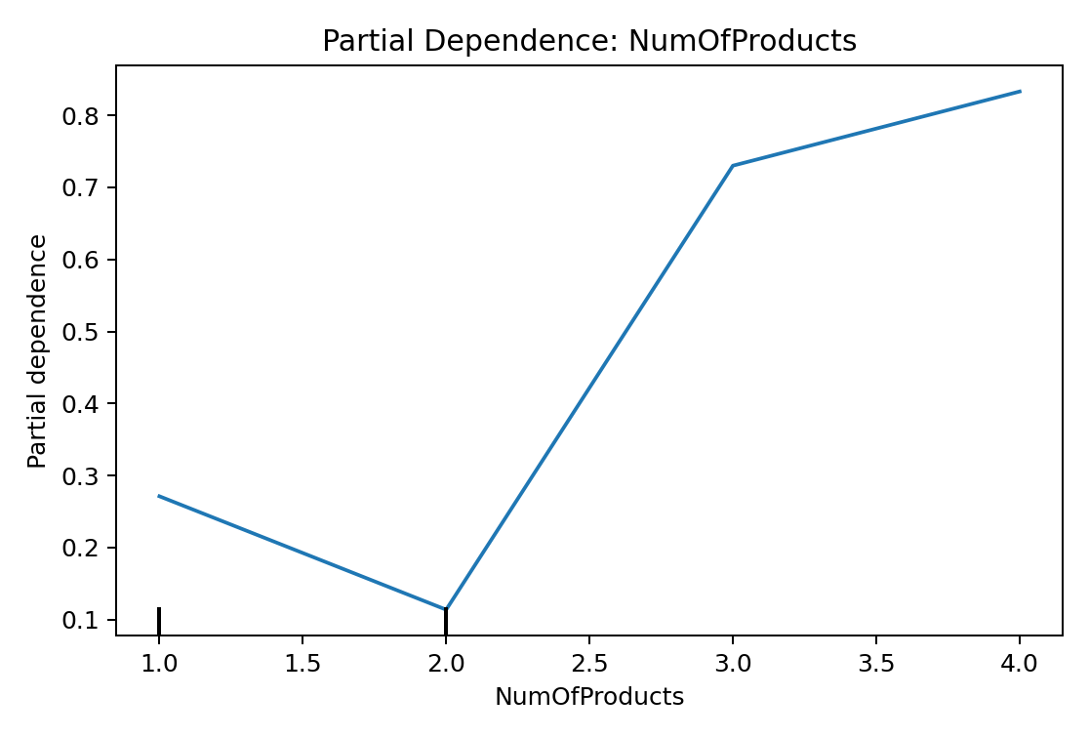
Figure 10. Partial dependence of number of products
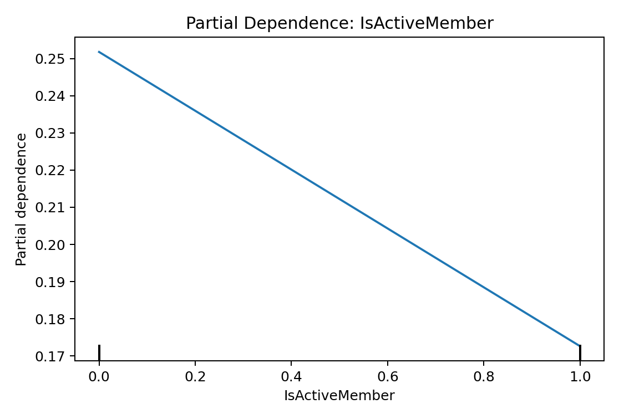
Figure 11. Partial dependence of activity status
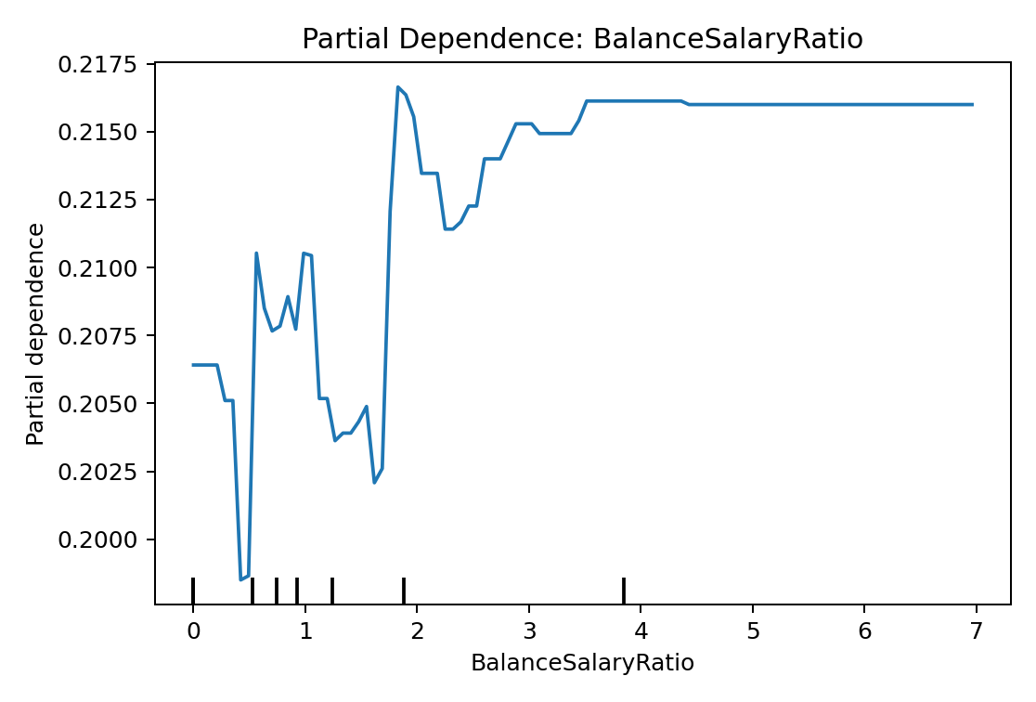
Figure 12. Partial dependence of balance-to-salary ratio

8. Churn Risk Scoring Framework
The prediction output is a churn probability between 0 and 1. This probability is converted into a risk score from 0 to 100 and assigned to a risk band. Low risk is below 30%, medium risk is 30%-60%, and high risk is above 60%. The risk score supports prioritization rather than automatic decision-making.
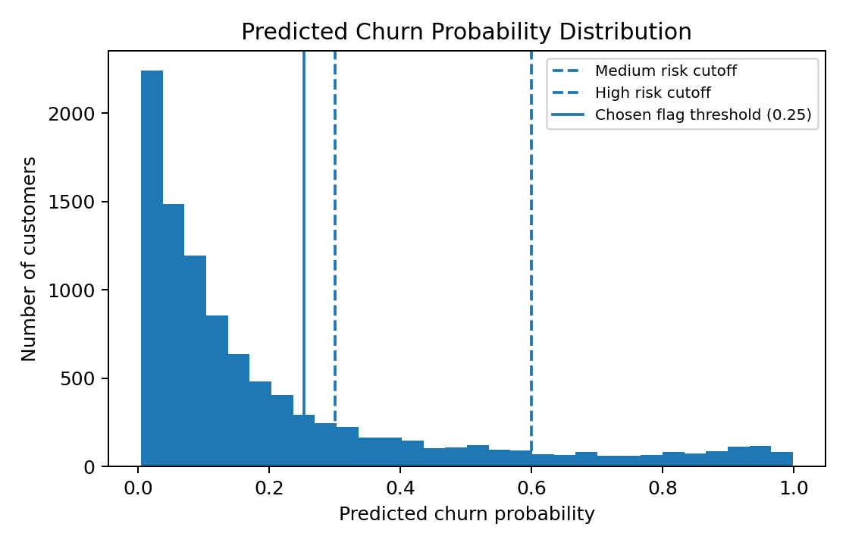
Figure 13. Predicted churn probability distribution
Table 3. Customers by risk band
RiskBand | Customers
Low | 7820
Medium | 1229
High | 951

9. Streamlit Web Application
The Streamlit dashboard implements four required modules: customer churn risk calculator, probability distribution visualization, feature importance dashboard, and what-if scenario simulator. It also includes a portfolio risk table to support operational retention targeting.
Module | Purpose
Customer churn risk calculator | Input customer profile and estimate churn probability
Probability distribution visualization | Show full portfolio risk-score distribution
Feature importance dashboard | Explain top churn drivers
What-if scenario simulator | Adjust engagement/product values and observe probability changes
Portfolio risk table | Export customer-level risk prioritization

10. Insights and Recommendations
Key analytical insights from the dataset and model are summarized below:
- Overall churn rate is 20.37%, so class imbalance must be managed with stratified splitting and probability-based evaluation.
- Geography shows material segmentation differences, with the highest churn observed in Germany at 32.44%.
- Inactive customers churn at 26.85% compared with active customers at 14.27%, making engagement a major retention lever.
- Age and product usage patterns are among the most useful churn signals, showing that relationship maturity and product fit matter more than simple demographics alone.
- The risk-scoring approach enables targeted retention instead of broad campaigns, reducing cost and improving actionability.
Recommended retention actions:
- Prioritize high-risk customers for proactive outreach within seven days.
- Create engagement campaigns for inactive customers, especially those with high balances or product-risk patterns.
- Use the what-if simulator before offering discounts to understand which engagement or product changes are likely to reduce churn probability.
- Monitor threshold performance monthly to prevent unnecessary false churn alarms.
- Use model explanations in retention-review meetings so that business teams understand the reason behind each risk score.

11. Ethical, Compliance, and Governance Notes
The model should support retention prioritization and customer service improvement, not unfair exclusion. Churn probabilities should be reviewed with human oversight, especially where retention offers involve differential treatment. Model performance should be monitored across geography and gender segments to identify potential fairness issues.

12. Conclusion
This project converts bank churn analysis into a predictive, explainable, and action-oriented risk-scoring system. The final XGBoost model estimates churn probability, assigns customers to risk bands, identifies top churn drivers, and powers a Streamlit dashboard for scenario analysis. The result is a practical retention intelligence framework aligned with the project requirement to move from reactive churn reporting to proactive customer retention.

Appendix: Submitted Artifacts
- Bank_Churn_Project_Notebook.ipynb
- streamlit_app.py
- models/bank_churn_model.joblib
- risk_scored_customers.csv
- feature_importance.csv
- model_metrics.csv
- reports/Executive_Summary_Government_Stakeholders.docx

