Product Line Profitability & Margin Performance Analysis
for Nassau Candy Distributor

Research Paper | Exploratory Data Analysis, Insights, and Recommendations
Dataset analyzed: 10,194 valid order-line records from 2024-01-02 to 2025-12-31.
Prepared for: Unified Mentor Project Submission

Abstract
This study evaluates product-line profitability for Nassau Candy Distributor using order, product, sales, cost, unit, division, region, and factory mapping data. The analysis validates the dataset, computes gross margin, profit per unit, revenue contribution, profit contribution, and margin volatility, and ranks products by financial contribution and efficiency. The cleaned dataset contains 10,194 valid records, $141,783.63 in sales, $93,442.80 in gross profit, and an overall gross margin of 65.91%. Results show that profitability is highly concentrated in Chocolate, which contributes 92.88% of revenue and 95.06% of profit. Five Chocolate products cross the 80% revenue and 80% profit thresholds. The strongest product by profit is Wonka Bar -Scrumdiddlyumptious, while the highest margin product is Everlasting Gobstopper. The highest margin risk is Kazookles, with only 7.69% gross margin. The paper recommends protecting high-margin Chocolate SKUs, repricing or renegotiating cost-heavy low-margin products, and using product rationalization for low-contribution SKUs.

1. Background and Context
For a distributor, sales volume alone can create a misleading view of business health. A product may sell frequently but still weaken the portfolio if it consumes too much manufacturing, sourcing, or operational cost. Nassau Candy Distributor therefore needs a profitability view that separates revenue growth from margin quality, identifies products that truly drive profit, and highlights product lines that create margin risk.

2. Problem Statement
The organization lacks a clear view of which product lines deliver the highest gross margin, whether high-sales products are genuinely profitable, how profitability varies across divisions, and which products represent margin risk. Without this insight, pricing, promotion, sourcing, and product portfolio decisions remain reactive rather than evidence-based.

3. Objectives
The project objectives are to clean and validate the raw order data, calculate product-level and division-level profitability KPIs, identify high-profit and high-margin products, detect high-sales but low-margin products, evaluate profit concentration using Pareto analysis, diagnose cost-heavy products, and convert the analysis into an interactive Streamlit dashboard for decision makers.

4. Analytical Methodology
Data cleaning and validation: Parsed Order Date and Ship Date using day-first date logic; validated Sales, Cost, Units, and Gross Profit as numeric fields; removed zero-sales, invalid-unit, and invalid-cost records; standardized product and division labels; and added factory information from the project brief.
Profitability metric calculation: Calculated Gross Margin (%), Profit per Unit, Revenue Contribution, Profit Contribution, Cost-to-Sales ratio, and monthly Margin Volatility.
Product-level profitability analysis: Ranked all products by gross profit and gross margin, separating high-profit/high-margin SKUs from low-contribution and margin-risk SKUs.
Division-level performance analysis: Aggregated sales, units, cost, gross profit, margin, revenue share, and profit share by Division.
Profit concentration analysis: Built Pareto tables to determine how many products contribute 80% of revenue and 80% of profit.
Cost structure diagnostics: Compared cost and sales at product level and flagged products needing repricing, cost renegotiation, or discontinuation review.

5. Data Cleaning and Validation Summary
Table 1. Data validation results
Validation Check | Result
Original records | 10,194
Valid records retained | 10,194
Records removed by validation | 0
Missing values in required numeric fields | 0
Zero or negative sales after cleaning | 0
Zero or negative units after cleaning | 0
Unmapped products after factory mapping | 0

A notable standardization correction was applied from the brief: Fizzy Lifting Drinks is mapped to the Other division and Sugar Shack factory according to the product-factory correlation table, even though the raw dataset labels it under Sugar. This keeps the analysis aligned with the project documentation.

6. Key Performance Indicators
Table 2. KPI definitions
KPI | Formula | Purpose
Gross Margin (%) | Gross Profit / Sales | Measures profitability efficiency
Profit per Unit | Gross Profit / Units | Shows unit-level profit economics
Revenue Contribution | Product Sales / Total Sales | Shows revenue dependency
Profit Contribution | Product Gross Profit / Total Gross Profit | Shows profit dependency
Margin Volatility | Std. deviation of monthly gross margin | Detects unstable margins over time
Cost to Sales (%) | Cost / Sales | Identifies cost-heavy products

7. Portfolio Financial Overview
Table 3. Portfolio summary
Metric | Value
Total Sales | $141,783.63
Total Gross Profit | $93,442.80
Total Cost | $48,340.83
Total Units | 38,654
Overall Gross Margin | 65.91%
Products | 15
Divisions | 3
Factories | 5

The portfolio generated $141,783.63 in sales and $93,442.80 in gross profit, implying a gross margin of 65.91%. Profit is concentrated in a limited number of products, so management should avoid treating product count and product impact as the same thing.

8. Product-Level Profitability Analysis
Table 4. Product profitability ranking
Product | Division | Sales | Gross Profit | Margin | Profit/Unit | Profit Share
Wonka Bar -Scrumdiddlyumptious | Chocolate | $27,874.80 | $19,357.50 | 69.44% | $2.50 | 20.72%
Wonka Bar - Triple Dazzle Caramel | Chocolate | $28,485.00 | $18,610.20 | 65.33% | $2.45 | 19.92%
Wonka Bar - Milk Chocolate | Chocolate | $26,867.75 | $17,443.37 | 64.92% | $2.11 | 18.67%
Wonka Bar - Nutty Crunch Surprise | Chocolate | $23,574.95 | $16,819.95 | 71.35% | $2.49 | 18.00%
Wonka Bar - Fudge Mallows | Chocolate | $24,890.40 | $16,593.60 | 66.67% | $2.40 | 17.76%
Lickable Wallpaper | Other | $7,860.00 | $3,930.00 | 50.00% | $10.00 | 4.21%
Wonka Gum | Other | $597.50 | $310.70 | 52.00% | $0.65 | 0.33%
Everlasting Gobstopper | Sugar | $130.00 | $104.00 | 80.00% | $8.00 | 0.11%
Kazookles | Other | $1,205.75 | $92.75 | 7.69% | $0.25 | 0.10%
Hair Toffee | Sugar | $76.50 | $59.50 | 77.78% | $3.50 | 0.06%
Fizzy Lifting Drinks | Other | $78.75 | $47.25 | 60.00% | $2.25 | 0.05%
Laffy Taffy | Sugar | $53.73 | $33.48 | 62.31% | $1.24 | 0.04%
SweeTARTS | Sugar | $61.50 | $28.70 | 46.67% | $0.70 | 0.03%
Nerds | Sugar | $15.00 | $7.00 | 46.67% | $0.70 | 0.01%
Fun Dip | Sugar | $12.00 | $4.80 | 40.00% | $0.60 | 0.01%

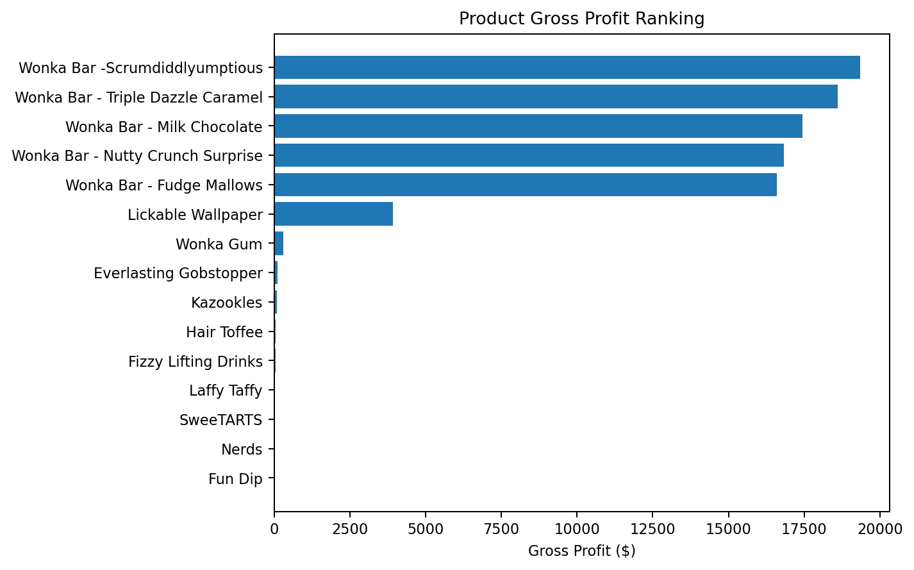
Figure 1. Product gross profit ranking
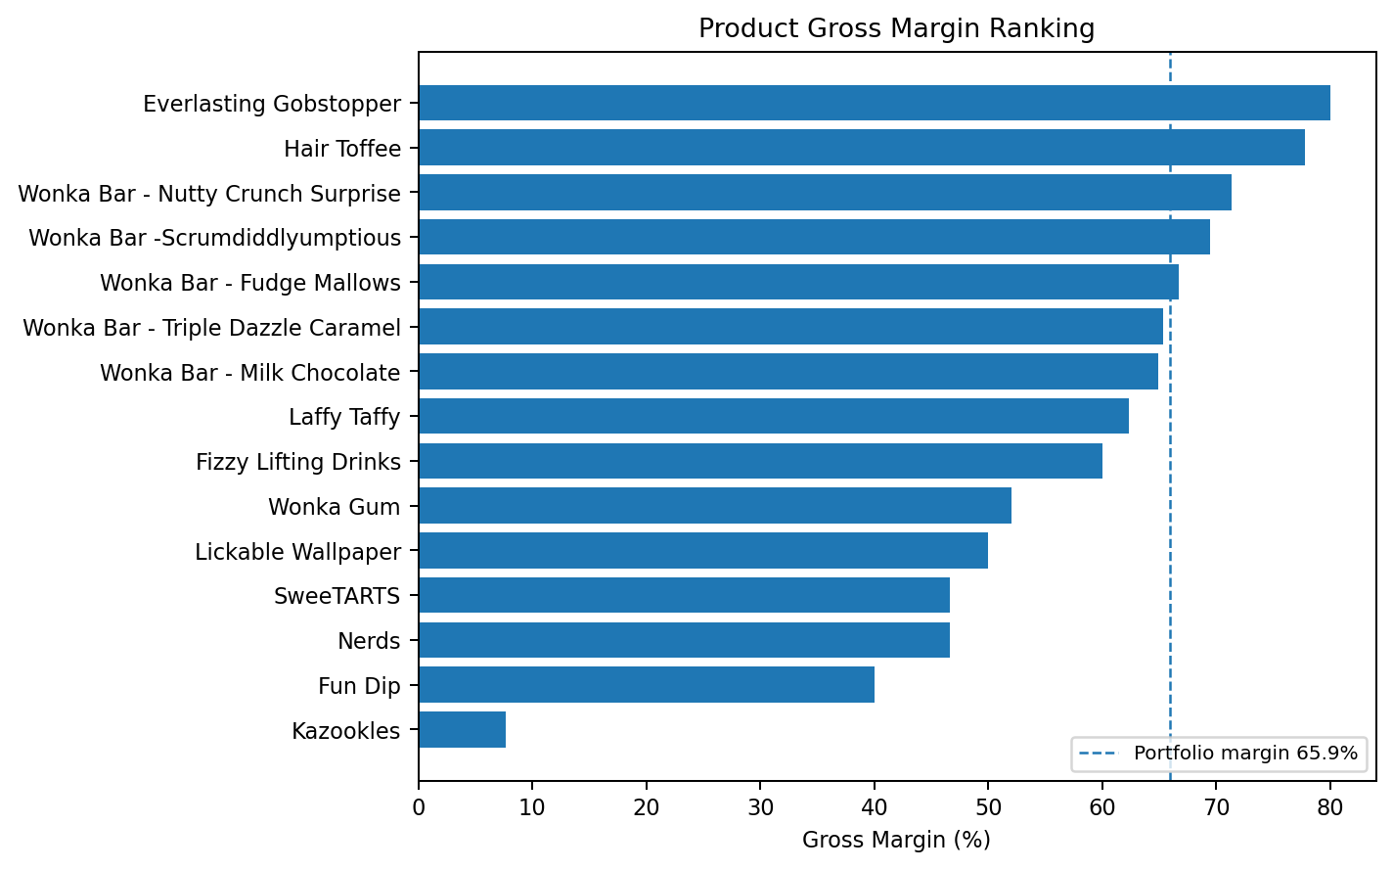
Figure 2. Product gross margin ranking
Wonka Bar -Scrumdiddlyumptious is the largest profit contributor with $19,357.50 in gross profit and a 69.44% gross margin. Everlasting Gobstopper has the highest gross margin at 80.00%, but its small sales base means it is not a major portfolio profit driver. Kazookles is the main margin concern at 7.69% gross margin and should be reviewed first for repricing or cost renegotiation.

9. Division-Level Performance Analysis
Table 5. Division performance
Division | Sales | Gross Profit | Margin | Revenue Share | Profit Share | Products
Chocolate | $131,692.90 | $88,824.62 | 67.45% | 92.88% | 95.06% | 5
Other | $9,742.00 | $4,380.70 | 44.97% | 6.87% | 4.69% | 4
Sugar | $348.73 | $237.48 | 68.10% | 0.25% | 0.25% | 6

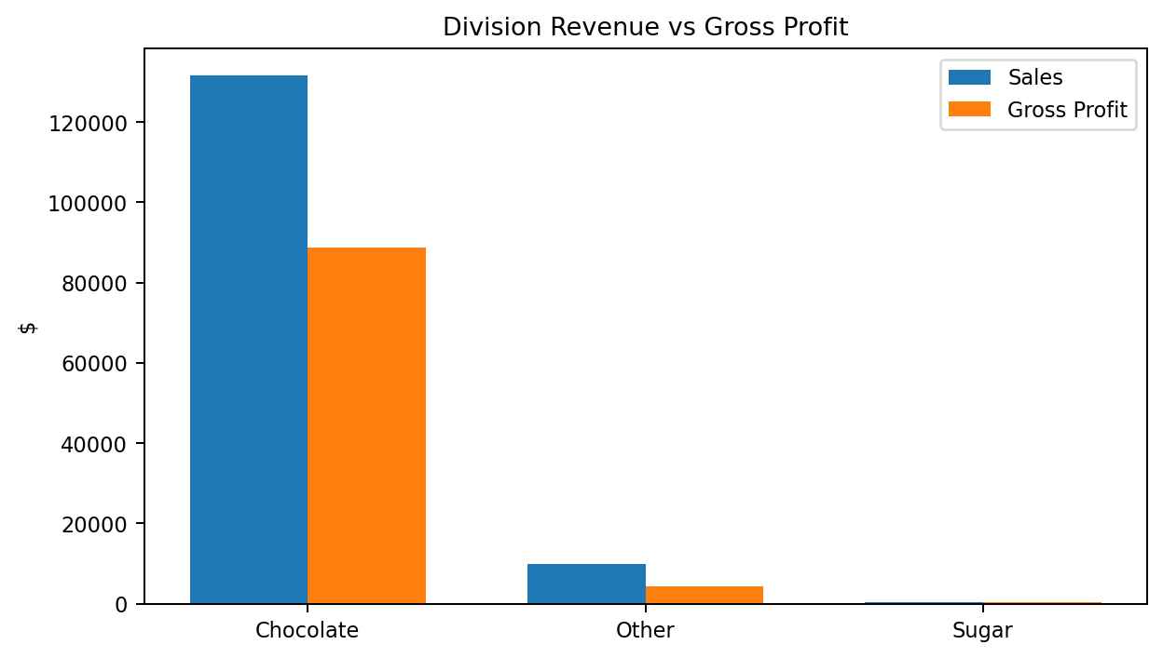
Figure 3. Division revenue versus gross profit
Chocolate is the strongest division by scale and contribution: it produces 92.88% of revenue and 95.06% of gross profit. Other contributes 6.87% of sales but only 4.69% of profit, indicating structural margin weakness. Sugar is financially efficient at 68.10% margin, but it is too small at only 0.25% of sales to materially offset portfolio risk.

10. Profit Concentration and Dependency Analysis
Table 6. Revenue Pareto analysis
Rank | Product | Division | Sales | Sales Share | Cumulative
1 | Wonka Bar - Triple Dazzle Caramel | Chocolate | $28,485.00 | 20.09% | 20.09%
2 | Wonka Bar -Scrumdiddlyumptious | Chocolate | $27,874.80 | 19.66% | 39.75%
3 | Wonka Bar - Milk Chocolate | Chocolate | $26,867.75 | 18.95% | 58.70%
4 | Wonka Bar - Fudge Mallows | Chocolate | $24,890.40 | 17.56% | 76.26%
5 | Wonka Bar - Nutty Crunch Surprise | Chocolate | $23,574.95 | 16.63% | 92.88%
6 | Lickable Wallpaper | Other | $7,860.00 | 5.54% | 98.43%
7 | Kazookles | Other | $1,205.75 | 0.85% | 99.28%
8 | Wonka Gum | Other | $597.50 | 0.42% | 99.70%

Table 7. Profit Pareto analysis
Rank | Product | Division | Gross Profit | Profit Share | Cumulative
1 | Wonka Bar -Scrumdiddlyumptious | Chocolate | $19,357.50 | 20.72% | 20.72%
2 | Wonka Bar - Triple Dazzle Caramel | Chocolate | $18,610.20 | 19.92% | 40.63%
3 | Wonka Bar - Milk Chocolate | Chocolate | $17,443.37 | 18.67% | 59.30%
4 | Wonka Bar - Nutty Crunch Surprise | Chocolate | $16,819.95 | 18.00% | 77.30%
5 | Wonka Bar - Fudge Mallows | Chocolate | $16,593.60 | 17.76% | 95.06%
6 | Lickable Wallpaper | Other | $3,930.00 | 4.21% | 99.26%
7 | Wonka Gum | Other | $310.70 | 0.33% | 99.60%
8 | Everlasting Gobstopper | Sugar | $104.00 | 0.11% | 99.71%

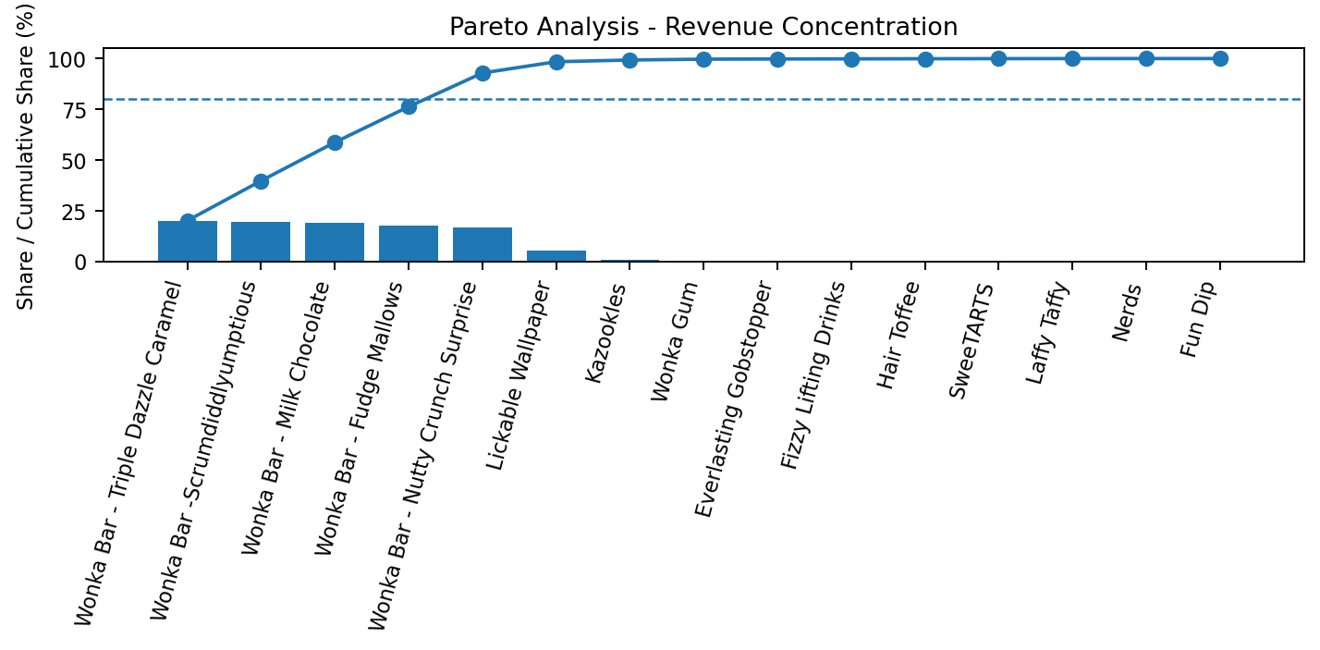
Figure 4. Revenue concentration Pareto chart
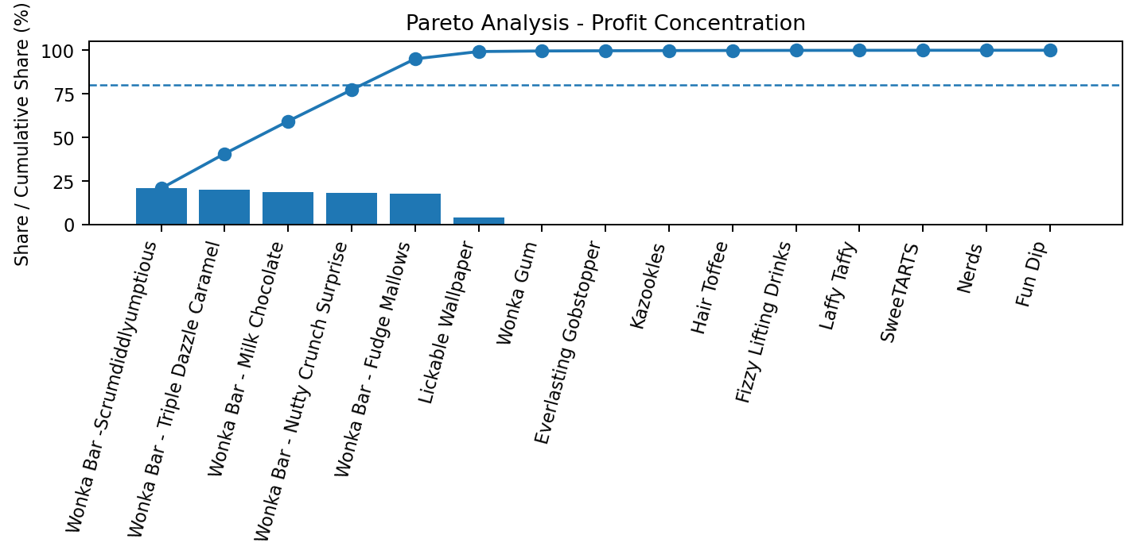
Figure 5. Profit concentration Pareto chart
The Pareto test shows that 5 products generate more than 80% of revenue and 5 products generate more than 80% of gross profit. In both cases, the products are Chocolate SKUs. This creates over-dependency risk: any disruption to Chocolate pricing, factory supply, demand, or promotion strategy can disproportionately affect the entire distributor portfolio.

11. Cost Structure Diagnostics and Margin Risk
Table 8. Top margin risk flags
Product | Division | Margin | Cost/Sales | Risk Category | Priority Action
Kazookles | Other | 7.69% | 92.31% | Critical margin risk | Reprice or renegotiate cost
Fun Dip | Sugar | 40.00% | 60.00% | Low margin / cost-heavy | Rationalize or reprice
Nerds | Sugar | 46.67% | 53.33% | Low margin / cost-heavy | Rationalize or reprice
SweeTARTS | Sugar | 46.67% | 53.33% | Low margin / cost-heavy | Rationalize or reprice
Lickable Wallpaper | Other | 50.00% | 50.00% | High sales, below margin | Review pricing and promotions
Wonka Gum | Other | 52.00% | 48.00% | High sales, below margin | Review pricing and promotions

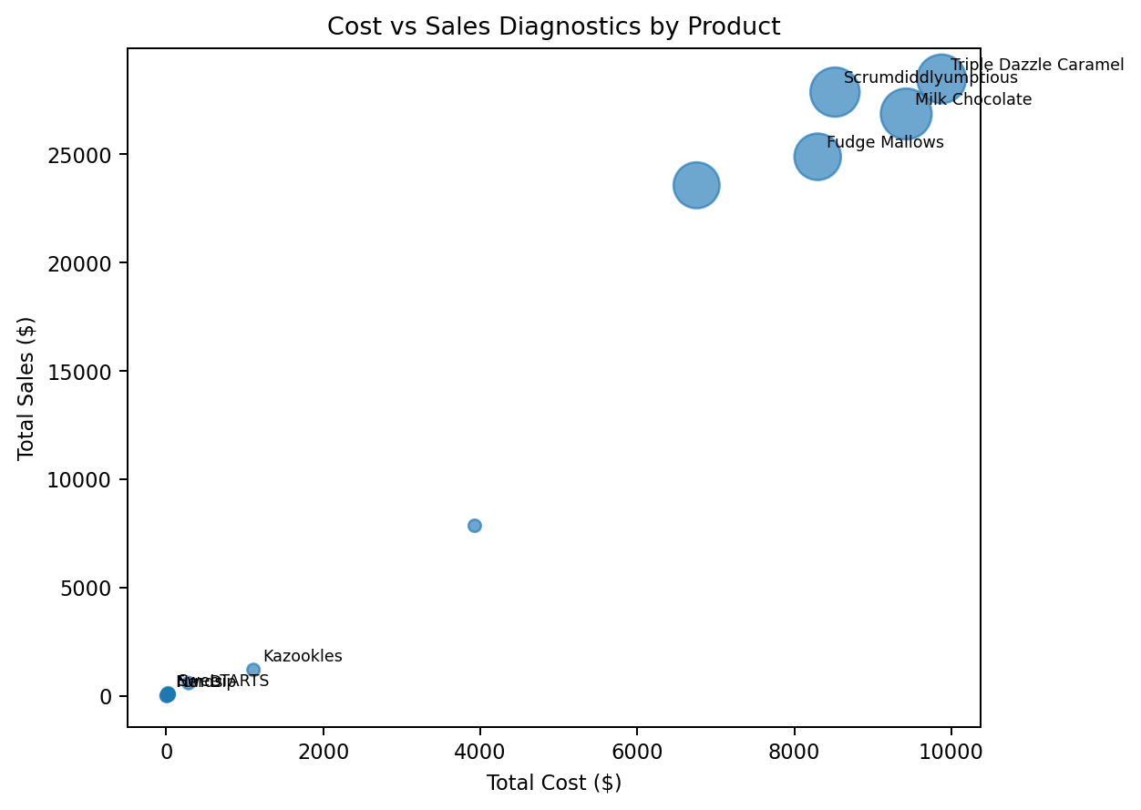
Figure 6. Cost versus sales scatter diagnostics
The clearest margin risk is Kazookles, which combines a very low margin with a high cost-to-sales ratio. Lickable Wallpaper has meaningful sales but below-portfolio margin, making it important for pricing and cost review. Several small Sugar and Other products have limited profit contribution; these should be evaluated for strategic role, bundling value, or rationalization.

12. Factory-Level View
Table 9. Factory performance from product-factory correlation
Factory | Sales | Gross Profit | Margin | Profit Share | Products
Lot's O' Nuts | $76,340.15 | $52,771.05 | 69.13% | 56.47% | 3
Wicked Choccy's | $55,352.75 | $36,053.57 | 65.13% | 38.58% | 2
Secret Factory | $8,587.50 | $4,344.70 | 50.59% | 4.65% | 3
The Other Factory | $1,282.25 | $152.25 | 11.87% | 0.16% | 2
Sugar Shack | $220.98 | $121.23 | 54.86% | 0.13% | 5

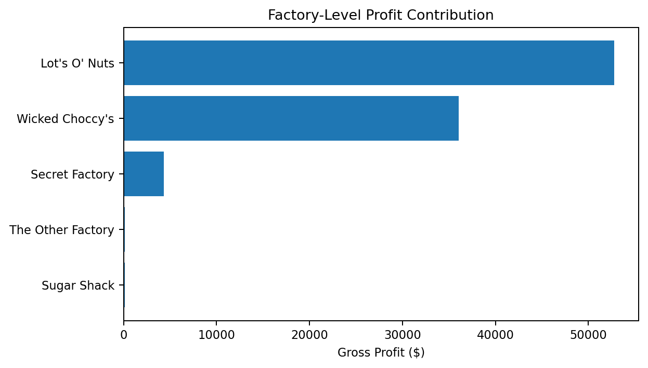
Figure 7. Factory-level profit contribution
The product-factory mapping shows that Lot's O' Nuts and Wicked Choccy's dominate profitability because they produce the key Chocolate products. This reinforces the need to protect supply stability, negotiate costs, and avoid stockouts for Chocolate SKUs.

13. Recommendations
- Protect the Chocolate profit engine: Maintain strong supply and pricing discipline for the five Chocolate products that dominate revenue and profit. Avoid unnecessary discounting on these SKUs.
- Reprice or renegotiate cost-heavy products: Prioritize Kazookles and Lickable Wallpaper for pricing review, supplier negotiation, packaging cost review, or promotional restrictions.
- Use contribution-based portfolio management: Do not judge product success by sales alone. Use profit contribution, revenue contribution, and gross margin together before expanding promotions.
- Rationalize low-contribution products carefully: Products such as Fun Dip, Nerds, SweeTARTS, and Laffy Taffy have low absolute contribution. Review whether they are needed for assortment completeness or should be bundled, repriced, or discontinued.
- Monitor dependency risk: Because only five products cross the 80% thresholds, create monthly alerts for sales decline, margin erosion, or factory disruption affecting Chocolate SKUs.
- Operationalize through dashboarding: Use the Streamlit dashboard to filter by date, division, product, and margin threshold, and to download updated risk lists for management review.

14. Limitations
The dataset includes order-line sales, units, gross profit, cost, division, region, and product attributes. It does not include detailed promotion spend, inventory holding cost, customer acquisition cost, supplier contract terms, or return rates. Therefore, the analysis focuses on gross profit and gross margin rather than net profit. Shipping dates exist in the dataset, but the business question is product profitability rather than route efficiency, so delivery performance is not treated as the core analytical outcome.

15. Conclusion
This project establishes a clear, data-driven understanding of product-line profitability for Nassau Candy Distributor. The analysis shows that the company is profitable overall, with a 65.91% gross margin, but heavily dependent on Chocolate products. The top five Chocolate SKUs generate more than 80% of both revenue and profit. At the same time, low-margin products such as Kazookles and below-portfolio-margin products such as Lickable Wallpaper create margin risk. By using the accompanying Streamlit dashboard, management can monitor product profitability, identify margin erosion, and make better pricing, sourcing, promotion, and product rationalization decisions.

Appendix A. Factory Mapping Availability
The full product-factory correlation table from the project brief has been operationalized inside the cleaned dataset, Streamlit dashboard, and output file named factory_performance.csv. This avoids duplicating a long mapping table in the paper while keeping the analysis aligned with the required factory coordinates and product-factory relationship.

