How to make a new project for sid (arm-7) and ecos with Eclipse in Linux

Sid
You can download the source code of sid from http://sourceware.org/sid/ and install it.
- Download and extract the source.
- Compile the source:
  - $cd sid/src
  - $./configure –prefix=/sid_installation_path
  - $make
- Install sid:
  - $sudo make install

Some issues about sid building:
- If tk component is not installed correctly you may have to remake and reinstall tk component.
  - $cd src/sid/component/tk
  - $make
  - $sudo make install
- You may also have to ./configure first in src/tk directory BEFORE executing ./configure in /src directory.

However, a modified version of sid is available at https://github.com/adritheone/SID-eCos. This version has a hexadecimal keyboard.

Executing SID
To execute sid, a configuration file must be edited. ($sid file.conf). To create the basic configuration file for a ARM PID7 little endian to execute the binary file “example”, the following instruction must be executed:
$amr-elf-sid --cpu arm --board=pid7t-normalmap --gdb=2000 -EL --tksm example –no-run
Configuration file saved to `example.conf'.
Execution:
$sid example.conf

Download and install eCos libraries.
Ecos and the full instructions for installation can be found at http://ecos.sourceware.org/:
- Download eCos installer: $wget --passive-ftp ftp://ecos.sourceware.org/pub/ecos/ecos-install.tcl
- Installation: $sh ecos-install.tcl
  - Note that ARM-EABI toolchain has to be installed
- Download configuration file from repository: wget... arm_pid.ecc
- Build the library
  - cd ecos-3.0/tools/bin
  - ./configtool ../(...)/arm_pid.ecc
  - make sure the build path (Tools->Paths->Build Path) is set to the toolchain path (…/ecos/gnutools/arm-eabi/bin)
  - Build the library: Build->Library

This will create the necessary eCos libraries under the name of arm_pid_build and arm_pid_install (in the same directory where arm_pid.ecc is saved). However, a built library is available at https://github.com/adritheone/SID-eCos.

Download Eclipse IDE
- Download Eclipse Helios 3.6 from http://www.eclipse.org/helios/
- Install CDT:
  - Help->Install new software
  - Add repository: http://download.eclipse.org/tools/cdt/releases/helios
  - Install CDT

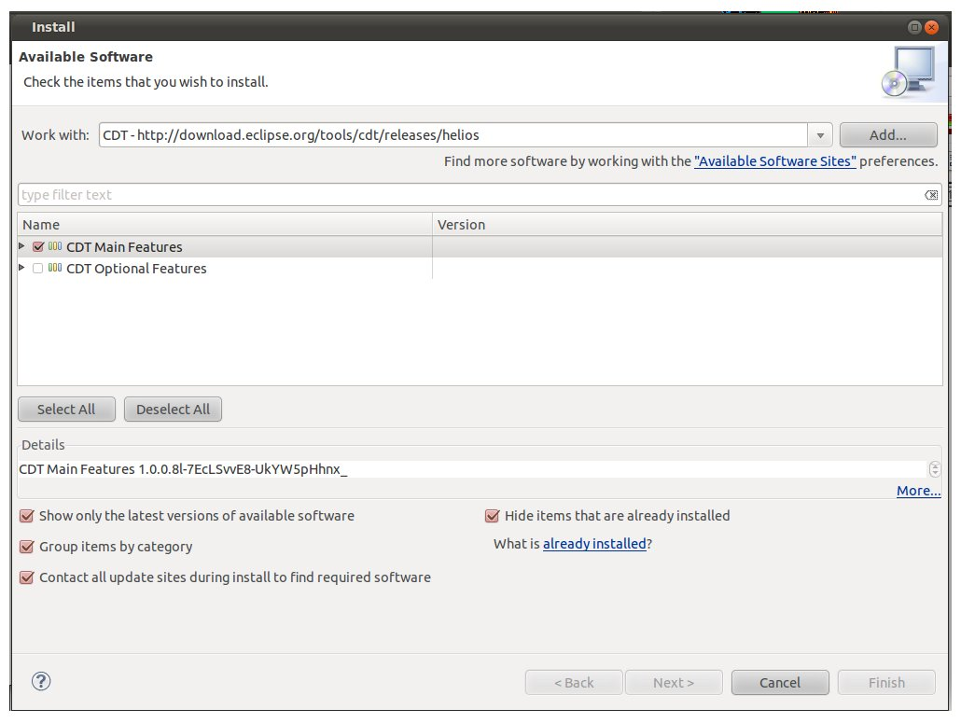

Configure eclipse
- Create a new C Makefile Project example
  - Import the Makefile and Make.params from (https://github.com/adritheone/SID-eCos)
  - Change the Make.params line to the eCos libraries path:
    - export PREFIX := …/arm_pid_install
  - Change the Makefile lines and include your program's name:
    - SRCS=example.c
OBJS=${SRCS:%.c=%.o}
DST=example
- Create the sid configuration file
  - $amr-elf-sid --cpu arm --board=pid7t-normalmap --gdb=2000 -EL --tksm example –no-run
  - Or import arm-pid7t.conf (from https://github.com/adritheone/SID-eCos) and change line 187 to include your program's name
    - set cpu-loader file "example"
- Configure building
  - Project->Properties->C/C++ Build (Behaviour tap)
    - Build(incremental build): delete 'all'

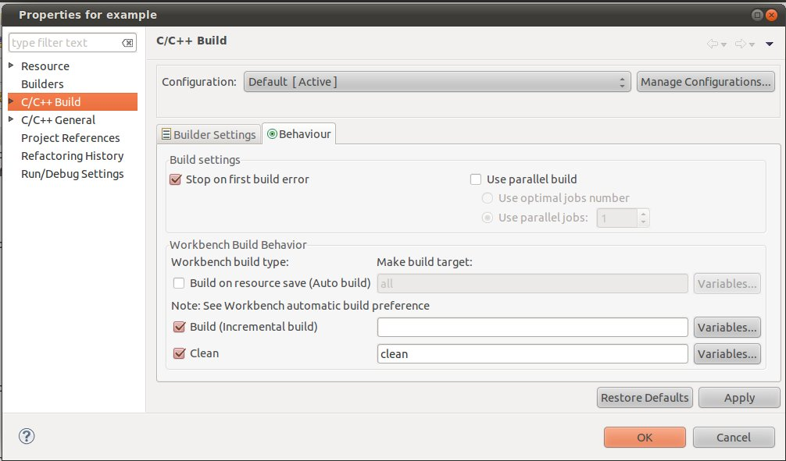

- Configure execution
  - Run->Run external tool->External tool configuration
  - Create a new Program called SID
    - Location: /path_to_sid_installation/bin/sid
    - Working Directory: ${workspace_loc:/${project_name}}
    - Arguments:arm-pid7t.conf (or the name of your sid configuration file)
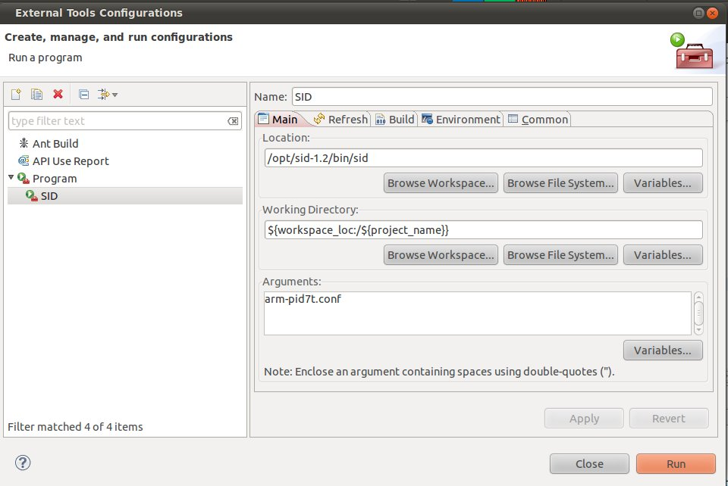

- Configure debug: We will launch a gdbserver on port 2000. If you have created your own sid configuration file, make sure the port is set properly.
  - Run->Debug Configurations
  - Create new C/C++ Aplication
    - Main
      - C/C++ Aplication: …/eclipse-workspace/example/example (or the path to your program)
      - Project: name of the project

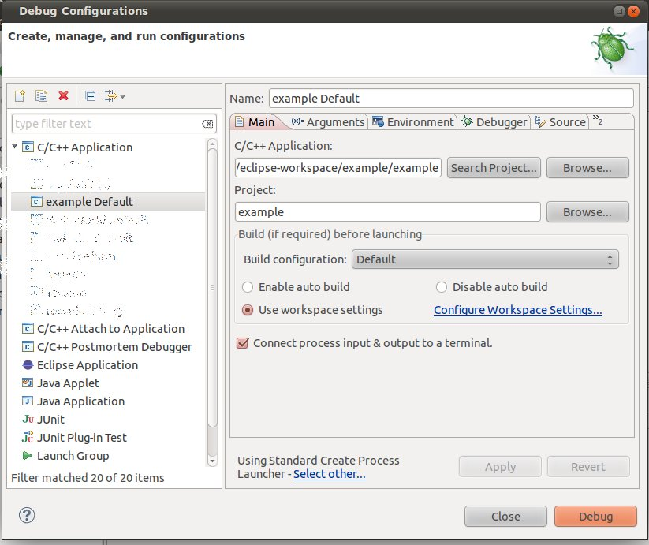
    - Debugger
      - Using Standard Create Process Launcher
      - Debugger: gdbserver
      - Stop on startup at: main (or cyg_user_start)
      - Debugger Options: Main
        - GDB debugger: /...path to arm-eabi toolchain.../bin/arm-eabi-gdb
      - Debugger Options: Connection
        - Type: TCP
        - Host name: localhost (or 127.0.0.1)
        - Port: 2000 (or whatever port you have chosen in sid configuration file)
    - Source
      - The source code of your program will be already added, but it is also very useful to add the eCos libraries (…/arm_pid_install/include).
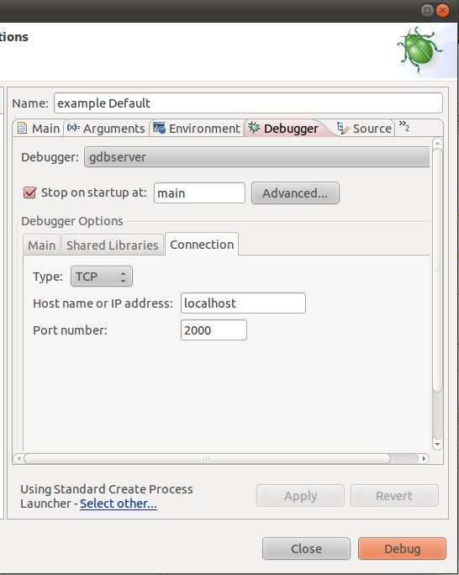

Some more issues
- Codesourcery toolchain can be used in stead of the one provided by eCos. Just make sure that it is accessible at PATH variable.
  - To use Codesourcery toolchain to compile, change Make.params variable:
export COMMAND_PREFIX := arm-eabi- to export COMMAND_PREFIX := arm-none-eabi
  - To use Codesourcery toolchain to debug, just put the correct path into GDB Debugger at Debugger configuration.
- Note that only one instance of sid can be open at the same time. Otherwise, the TCP port used for debugging will be unaccessible. So, once you have finished debugging, close both the debug server and the sid program form eclipse (or do $kill all sid).
- The standard output is set to the uart1 of sid. Therefore, when sid starts open the uart1 gui to see the program output.
