Lab 1
Python Basic Practice-1

Aditi Shrivastava – 210905244
Roll number - 44

Practice
1)
counter = 100
miles = 1000.0
name = "John"
print(counter)
print(miles)
print(name)

OUTPUT:
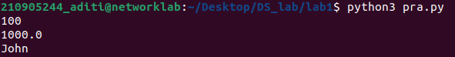

2)
a = 5
b = 4.56
print(5*a)
print(a/2)
print(a**2)

OUTPUT:
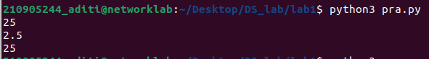
3)
str = 'Hello World'
print(str)
print(str[0])
print(str[2:5])
print(str[2:])
print(str*2)
print(str + "Test")

OUTPUT:
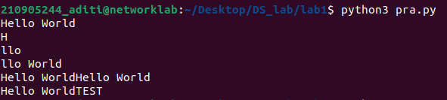

4)
str = 'Hello World'
print("Updates str: ", str[:6] + 'Python')

OUTPUT:

5)
str = "this is string example....wow!!!";
print (str.title())

OUTPUT:

6)
list = ['abcd', 786, 2.23, 'john', 70.2]
tinylist = [123, 'john']
print(list)
print(list[0])
print(list[1:3])
print(list[2:])
print(tinylist*2)
print(list + tinylist)

OUTPUT:
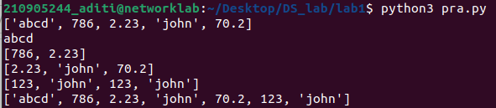

7)
list = ['physics', 'chemistry', 1997, 2000]
list.append('maths')
print(list)

OUTPUT:

8)
list = ['physics', 'chemistry', 1997, 2000]
list.append('maths')
del(list[2])
print(list)

OUTPUT:

9)
list = ['physics', 'chemistry', 1997, 2000]
list.reverse()
print(list)

OUTPUT:

10)
list = ['physics', 'chemistry', 1997, 2000]
list.insert(2, 'maths')
print(list)

OUTPUT:
11)
list = ['physics', 'chemistry', 1997, 2000]
list.remove('chemistry')
print(list)

OUTPUT:

12)
list = ['physics', 'chemistry', 1997, 2000]
list.pop()
print(list)

OUTPUT:

Examples:

Looping and Conditional Branches in Python

Eg1)
num = float(input('Enter a number: '))
if num>0:
print('pos number')
elif num==0:
print('zero')
else:
print('Neg number')

OUTPUT:

Eg2)
x = float(input('Enter a number: '))
if x<10:
print('smaller')
elif x>20:
print('bigger')
print('Finished')

OUTPUT:
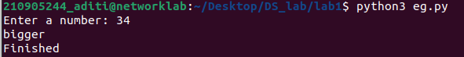
Eg3)
x = 5
print('before 5')
if x == 5:
print('this is 5')
print('still 5')
print('After 5')
print('Before 6')
if x==6:
print('this is 6')
print('After 6')

OUTPUT:
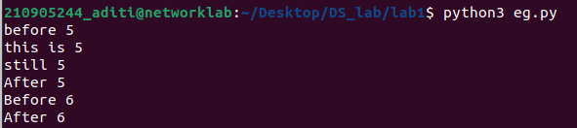

Eg4) which will never print?
x=float(input('Enter a number:'))
if x<20:
print('Below 20')
elif x<10:
print('Below 10')
else:
print('something else')

OUTPUT: Below 10 will never be printed

Eg5) Nested Decisions
x = 42
if x>1:
print('above one')
if x<100:
print('less than 100')
print('all done')

OUTPUT:
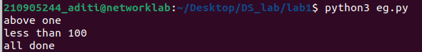
Eg6) Ternary Operator
age = 15
b = ('kid' if age<18 else 'adult')
print(b)

OUTPUT:

Usage of For-loop

Eg1)
for val in [5, 4, 3, 2, 1]:
print(val)
print('done')

OUTPUT:
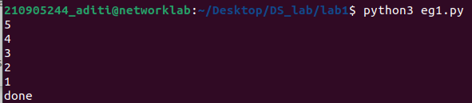
Eg2)
stud = ['ram', 'Vijay','Nithya', 'Anu', 'Ramesh', 'suja']
for k in stud:
print('Hello ', k)
print('done')

OUTPUT:
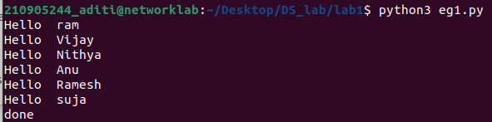

Eg3)
for i in range(5):
print(i)
if i<2:
print('Bigger than 2')
print('done with i', i)

OUTPUT:
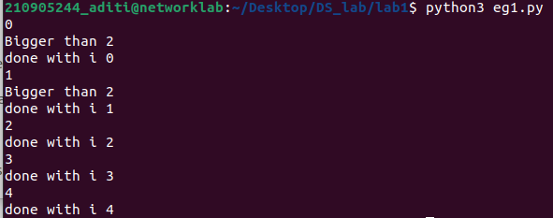

Eg4) Calculate factors of a number
x = int(input('Enter a number:'))
for i in range(1, x+1):
if x%i == 0:
print(i)

OUTPUT:
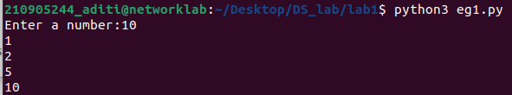

Eg5) Calculate largest number in an array
from math import *
x = [9, 41, 12, 3, 74, 15]
largest= -inf
for i in x:
if i>largest:
largest = i
print(largest)

OUTPUT:
Eg6) Calculate smallest number in an array
from math import *
x= [9, 41, 12, 3, 74, 15]
smallest = inf
for i in x:
if i<smallest:
smallest = i
print(smallest)

OUTPUT:

Eg7) Calculate the count, sum and average of numerical array
x = [9, 41, 12, 3, 74, 15]
count = sum = avg = 0

for i in x:
count = count +1
sum = sum +i
avg = sum/count
print(count)
print(sum)
print(avg)

OUTPUT:
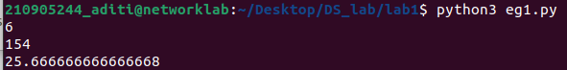

Eg8) Filtering in a loop(print all numbers > 20)
x = [9, 41, 12, 3, 74, 15]
for i in x:
if i>20:
print (i)

OUTPUT:
Eg9) For the above problem, instead of printing the result, store the elements in a variable (object)
x = [9, 41, 12, 3, 74, 15]
res = []
for i in x:
if i>20:
res.append(i)
print(res)

OUTPUT:
Eg10) For the above x, replace all elements <20 into zero. Store the result in different variable (object)
x = [9, 41, 12, 3, 74, 15]
res = []
for i in x:
if i>20:
res.append(i)
import numpy as np
y = np.zeros(len(x))
for i in range(len(x)):
if x[i] > 20:
y[i] = x[i]
print(y)

OUTPUT:

Exercise:
Q1) write a program to find area of rectangle. Take input from user
x = int(intput('Enter length: '))
y = int(intput('Enter breath: '))
area= x*y
print(area)

OUTPUT:
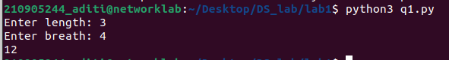
Q2) Write a program to swap the values of two variables.
a = 2
b = 3
temp = 0
temp = b
b = a
a = temp

print(a)
print(b)

OUTPUT:
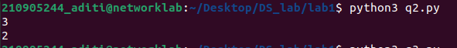
Q3) Write a program to find whether a number is even or odd.
x = int(input('Enter number'))
if x%2 == 0:
print('even number')
else:
print('odd number')

OUTPUT:
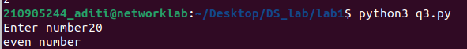
Q4) Write a program to check the largest among the given three numbers. (note: use elif here)
x = [12, 15, 3]
if x[0]>x[1] and x[0]>x[2]:
print(x[0])
elif x[1]>x[2] and x[1]>x[0]:
print(x[1])
else:
print(x[2])

OUTPUT:
Q6)Consider the tuple(1,3,5,7,9,2,4,6,8,10). Write a program to print half its values in one line and
the other half in the next line.
tp = (1, 3, 5, 7, 9, 2, 4, 6, 8, 10)
tp1 = tp[5:]
tp2 = tp[:5]
print(tp1)
print(tp2)

OUTPUT:

Q7)Consider the tuple (12, 7, 38, 56, 78 ). Write a program to print another tuple whose values are even number in the given tuple.
tp = (12, 7, 38, 56, 78)
for i in range(len(tp)):
if(tp[i]%2 == 0):
print(tp[i])

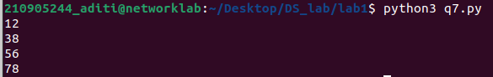
OUTPUT:

Q8)Write a Python program to print negative Numbers in a List using for loop. Eg. [11, −21, 0, 45,
66, −93].
list = [11, -21, 0, 45, 66, -93]
for i in range(len(list)):
if list[i]<0:
print(list[i])

OUTPUT:

Q9) Write a python program to count positive and negative numbers in a list
list =[11, -21, -1, 45, 66, -93]
countpos = countneg = 0
for i in range(len(list)):
if list[i]<0:
countneg=countneg+1
elif list[i]>0:
countpos=countpos+1
print(countpos)
print(countneg)

OUTPUT:
Q10) Write a python program to remove all even elements from a list
list =[11, -21, -1, 45, 66, -93]
for i in range(len(list)):
if list[i]%2 == 0:
list[i] = 0
print(list)

OUTPUT:

