Lab 1
Python Basic Practice-II

Aditi Shrivastava – 210905244
Roll number – 44

Practice
1)
import pandas as pd
import numpy as np
s = pd.Series([3, 9, -2, 10, 5])
print(s.sum())
print(s.min())
print(s.max())

OUTPUT:
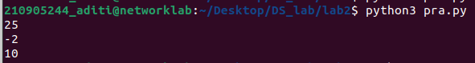
2)
import pandas as pd
data=[['Dinesh', 10], ['Nithya', 12], ['Ray', 13]]
df = pd.DataFrame(data, columns = ['Name', 'Age'])
print(df)

OUTPUT:
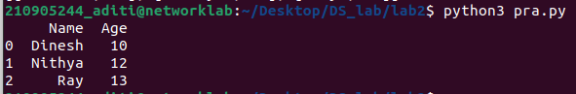
3)
import pandas as pd
data = {'Name': ['Kavitha', 'Sudha', 'Raju', 'Vignesh'], 'Age': [28, 34, 29, 42]}
df = pd.DataFrame(data, index= ['rank1', 'rank2', 'rank3', 'rank4'])
print(df)

OUTPUT:
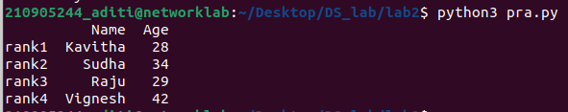
4)

