Lab-3
Socket Programming in ‘C’ using UDP and Network Monitoring and Analysis with
Wireshark

Visited Trivago.com

A. In the packet list pane, select the first DNS packet. In the packet detail pane, select the
User Datagram Protocol. The UDP hexdump will be highlighted in the packet byte lane.
Using the hexdump, Answer the following:
a. the source port number.
b. the destination port number.
c. the total length of the user datagram.
d. the length of the data.
e. whether the packet is directed from a client to a server or vice versa.
f. the application-layer protocol.
g. whether a checksum is calculated for this packet or not.
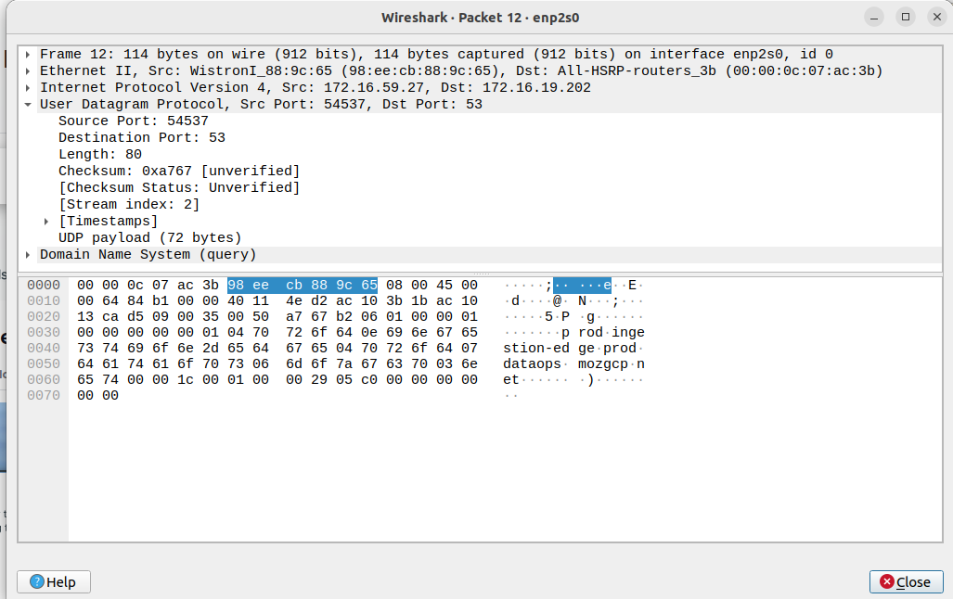

a. Source Port: 54537
b. Destination Port: 53
c. Total length of the user datagram: 80
d. The length of the data: 64
e. client to server
f. Application layer- protocol: UDP
g. Checksum: 0xa767

B. What are the source and destination IP addresses in the DNS query message? What are those
addresses in the response message? What is the relationship between the two?

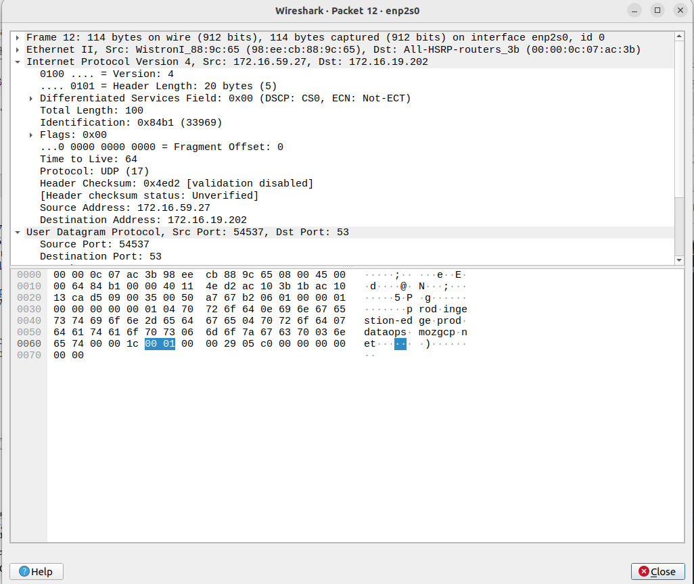

Source Address: 172.16.59.27
Destination Address: 172.16.19.202

C. What are the source and destination port numbers in the query message? What are those
addresses in the response message? What is the relationship between the two? Which port
number is a well-known port number?

