|  |  |
| --- | --- |
| **Ex No: 10**  **Date: 23th October 2024** | **Deploy on AWS- source code link** |

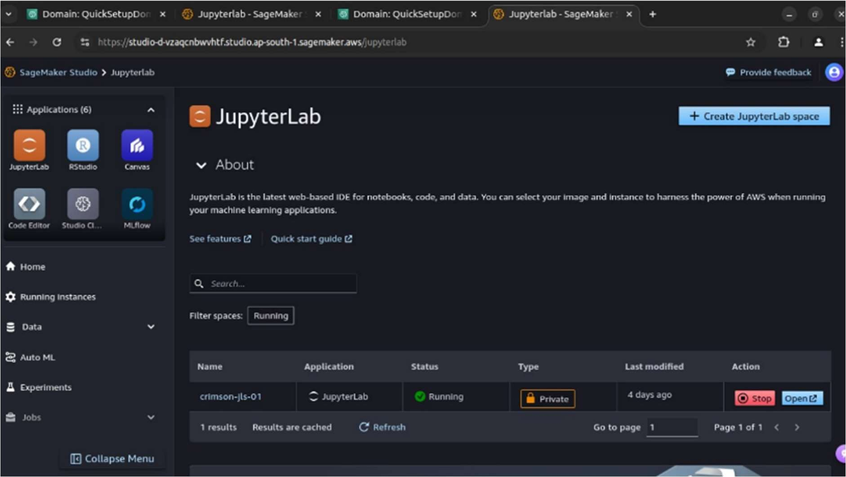

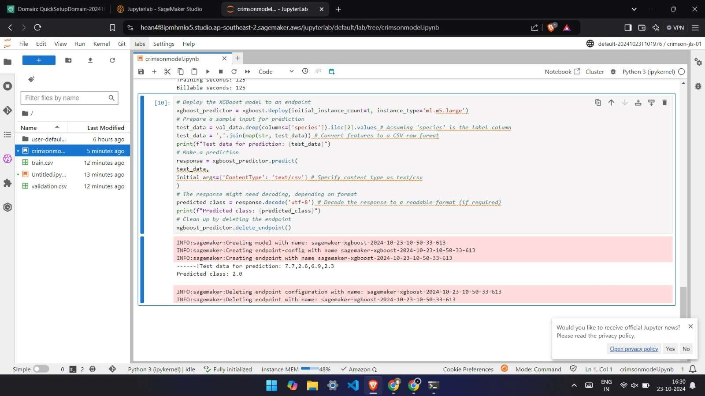

**GitHub Link:** <https://github.com/adrocx/DeepLearning>