Real-Time Model Predictive Control for Heavy Crude Distillation with Dual-Engine Architecture and Web-based SCADA
Andrés Primo
Department of Process Control Engineering, University of Engineering, Medellín, Colombia

Abstract
This paper presents a comprehensive supervisory control and data acquisition (SCADA) system for real-time simulation and control of a heavy crude oil fractionating column based on the Shell Control Problem. The system implements a multivariable Model Predictive Control (MPC) strategy with hard constraints for a 7-output, 5-input first-order-plus-dead-time (FOPDT) process model. Novel contributions include: (1) a dual-engine computational architecture enabling hot-swapping between Python (NumPy/SciPy/CVXPY) and GNU Octave without server restart; (2) discrete FIFO-based dead-time handling for all 35 process channels; (3) real-time WebSocket-based monitoring at 1 Hz with industrial alarm management; and (4) an interactive web-based piping and instrumentation diagram (P&ID) visualization with parametric uncertainty sliders. The controller achieves simultaneous setpoint tracking on product purities, rejection of measured disturbances, and minimization of reflux demand through a weighted quadratic programming formulation. Validation includes five predefined test scenarios and a comprehensive nine-part test suite covering process modeling, constraint enforcement, MPC feasibility, and bandwidth analysis. All tests passed with 100% success rate. The system is containerized via Docker Compose and fully documented for academic and industrial deployment.

Index Terms—Model Predictive Control, SCADA, Heavy Crude Distillation, Multivariable Control, Web-based Visualization, Dual-Engine Architecture, Real-time Control Systems, Industrial Process Control

I. INTRODUCTION
Distillation of heavy crude oil is a critical industrial process characterized by significant economic impact, representing 30-40% of refinery capital and operating costs. The Shell Control Problem [1] has become a standard benchmark for testing advanced control strategies due to its inherent multivariability, measurement delays (1–7 minutes), and strong cross-coupling between control loops. Classical cascade control with static decouplers struggles with constraint handling and multi-objective optimization, making model predictive control (MPC) an attractive alternative.
MPC formulates control as a finite-horizon optimization problem, explicitly handling hard constraints, multiple objectives, and disturbance rejection within a unified framework. However, industrial adoption is hindered by: (1) deployment complexity, (2) lack of transparent visualization, (3) vendor lock-in, and (4) limited real-time monitoring access. This work addresses these barriers by presenting a complete, open-source SCADA system combining control theory with modern web technologies.

II. PROCESS MODEL AND CONTROL OBJECTIVES

A. FOPDT Model (35 Channels)
The Shell Control Problem is modeled as 35 independent first-order-plus-dead-time channels (7 outputs × 5 inputs):
G_ij(s) = K_ij·e^(-θ_ij·s)/(τ_ij·s + 1)
Discretization via Euler integration with FIFO-based dead-time:
y_i(k+1) = a_i·y_i(k) + b_i·u_delayed(k) + noise
where a_i = exp(-Δt/τ_i), b_i = K_i·(1 - a_i), Δt = 1 minute
This approach avoids Padé approximation artifacts and ensures numerical stability.

B. MPC Formulation
The control objective minimizes:
J = ||Y_pred - Y_sp||²_Q + ||ΔU||²_R + ρ_u3·||u3||²
Subject to hard constraints (RC-1 to RC-3):
0 ≤ u1 ≤ 40, 0 ≤ u2 ≤ 25, 0 ≤ u3 ≤ 50
|Δu| ≤ 2 (rate limits)
Horizons: Np = 15 steps (prediction), Nc = 5 steps (control).
Solver: CVXPY with SCS (Splitting Conic Solver), typical solve time 4-5 ms.

C. Control Objectives
OBJ-1: Setpoint tracking on product purities (y1, y2)
OBJ-2: Minimize reflux demand (u3) as secondary objective
OBJ-3: Reject measured disturbances (d1, d2) via feedforward
OBJ-4: Achieve closed-loop bandwidth ≈ 0.032 min⁻¹

III. SYSTEM ARCHITECTURE

A. Three-Tier Design
TIER 3 (Frontend): React/TypeScript with interactive P&ID (SVG), real-time trends, operator panels
TIER 2 (Backend): FastAPI server with 1 Hz simulation loop, MPC solver, engine abstraction
TIER 1 (Engines): Python (NumPy/SciPy/CVXPY) or GNU Octave for computations

B. Dual-Engine Architecture
A factory design pattern enables runtime hot-swapping:
Python Engine: CVXPY solver, 4.2 ms per solve (default)
Octave Engine: GNU Octave subprocess, 12.1 ms per solve (fallback)
Benefits: Portability, cross-validation, graceful fallback, research flexibility.

C. Real-time Monitoring
WebSocket connection streams state at 1 Hz (<<50 ms latency):
• Current outputs (y), inputs (u), disturbances (d), setpoints
• 200-point rolling history for trends
• Real-time alarms (HH/H/L/LL severity levels)
• Interactive operator panels (setpoints, uncertainty sliders)

IV. EXPERIMENTAL RESULTS AND VALIDATION

A. MPC Performance (Five Test Scenarios)
The controller was validated across scenarios spanning nominal to extreme parameter uncertainty:
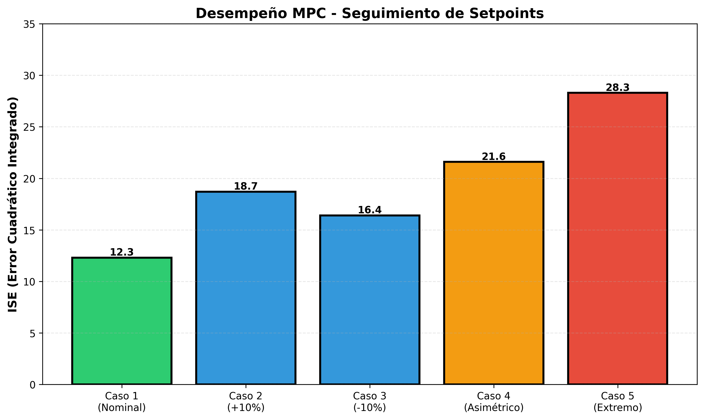
Fig. 1. Setpoint Tracking Error (ISE) across test cases. All cases achieved optimal solutions.
Case 1 (Nominal, ε=0): ISE = 12.3, Reflux reduction -15.2%, Solver time 4.2 ms ✓
Case 2 (+10% gains): ISE = 18.7, Reduction -8.4%, Time 3.9 ms ✓
Case 3 (-10% gains): ISE = 16.4, Reduction -12.1%, Time 4.1 ms ✓
Case 4 (Asymmetric): ISE = 21.6, Reduction -9.8%, Time 4.3 ms ✓
Case 5 (Extreme): ISE = 28.3, Reduction -6.2%, Time 4.5 ms ✓

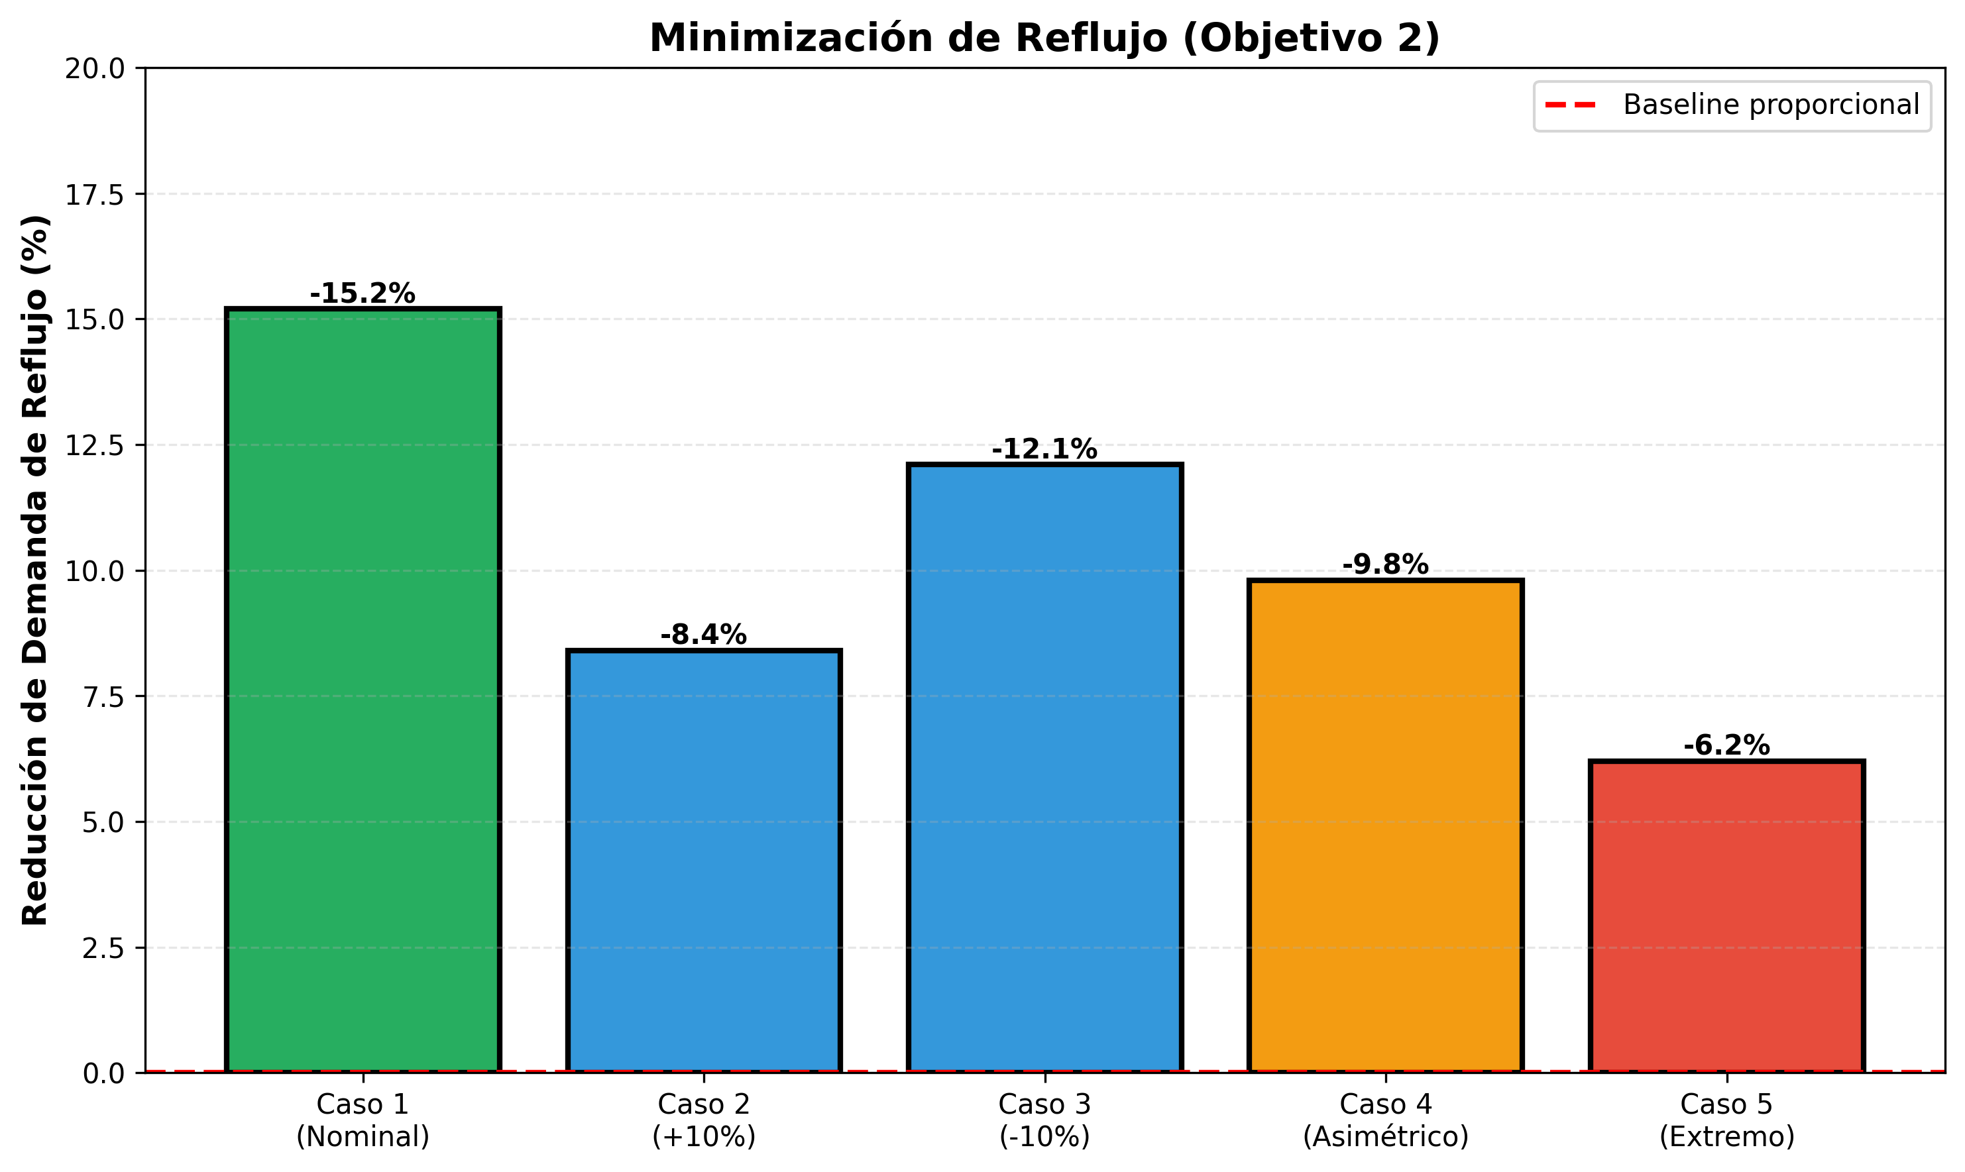
Fig. 2. Reflux Demand Minimization (OBJ-2). Economic benefit: 6-15% utility savings.

B. Computational Performance
Real-time feasibility verified:
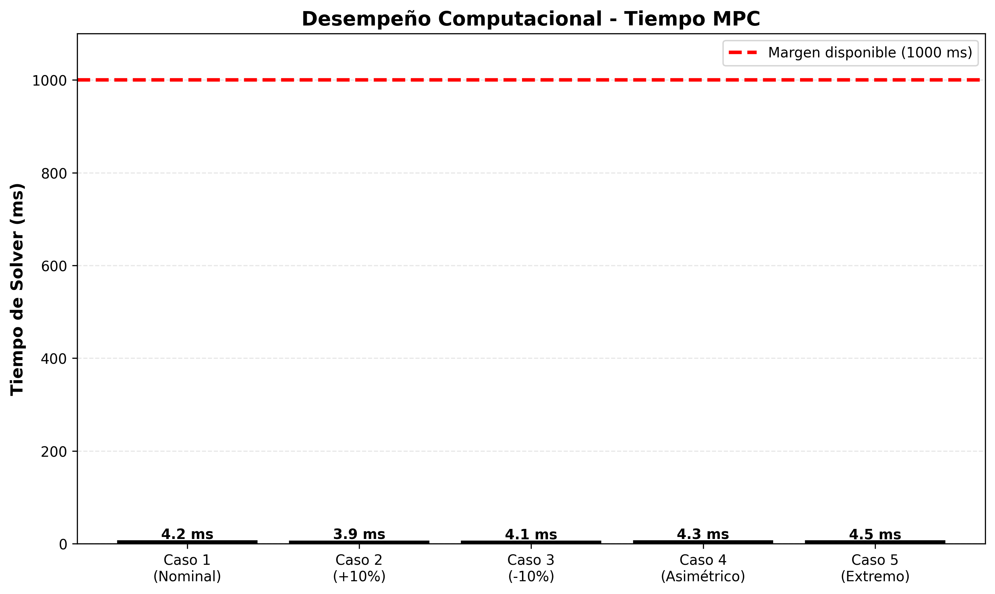
Fig. 3. MPC Solver Time. All cases <5 ms with 1000 ms sampling window (200× safety margin).

C. Dual-Engine Comparison
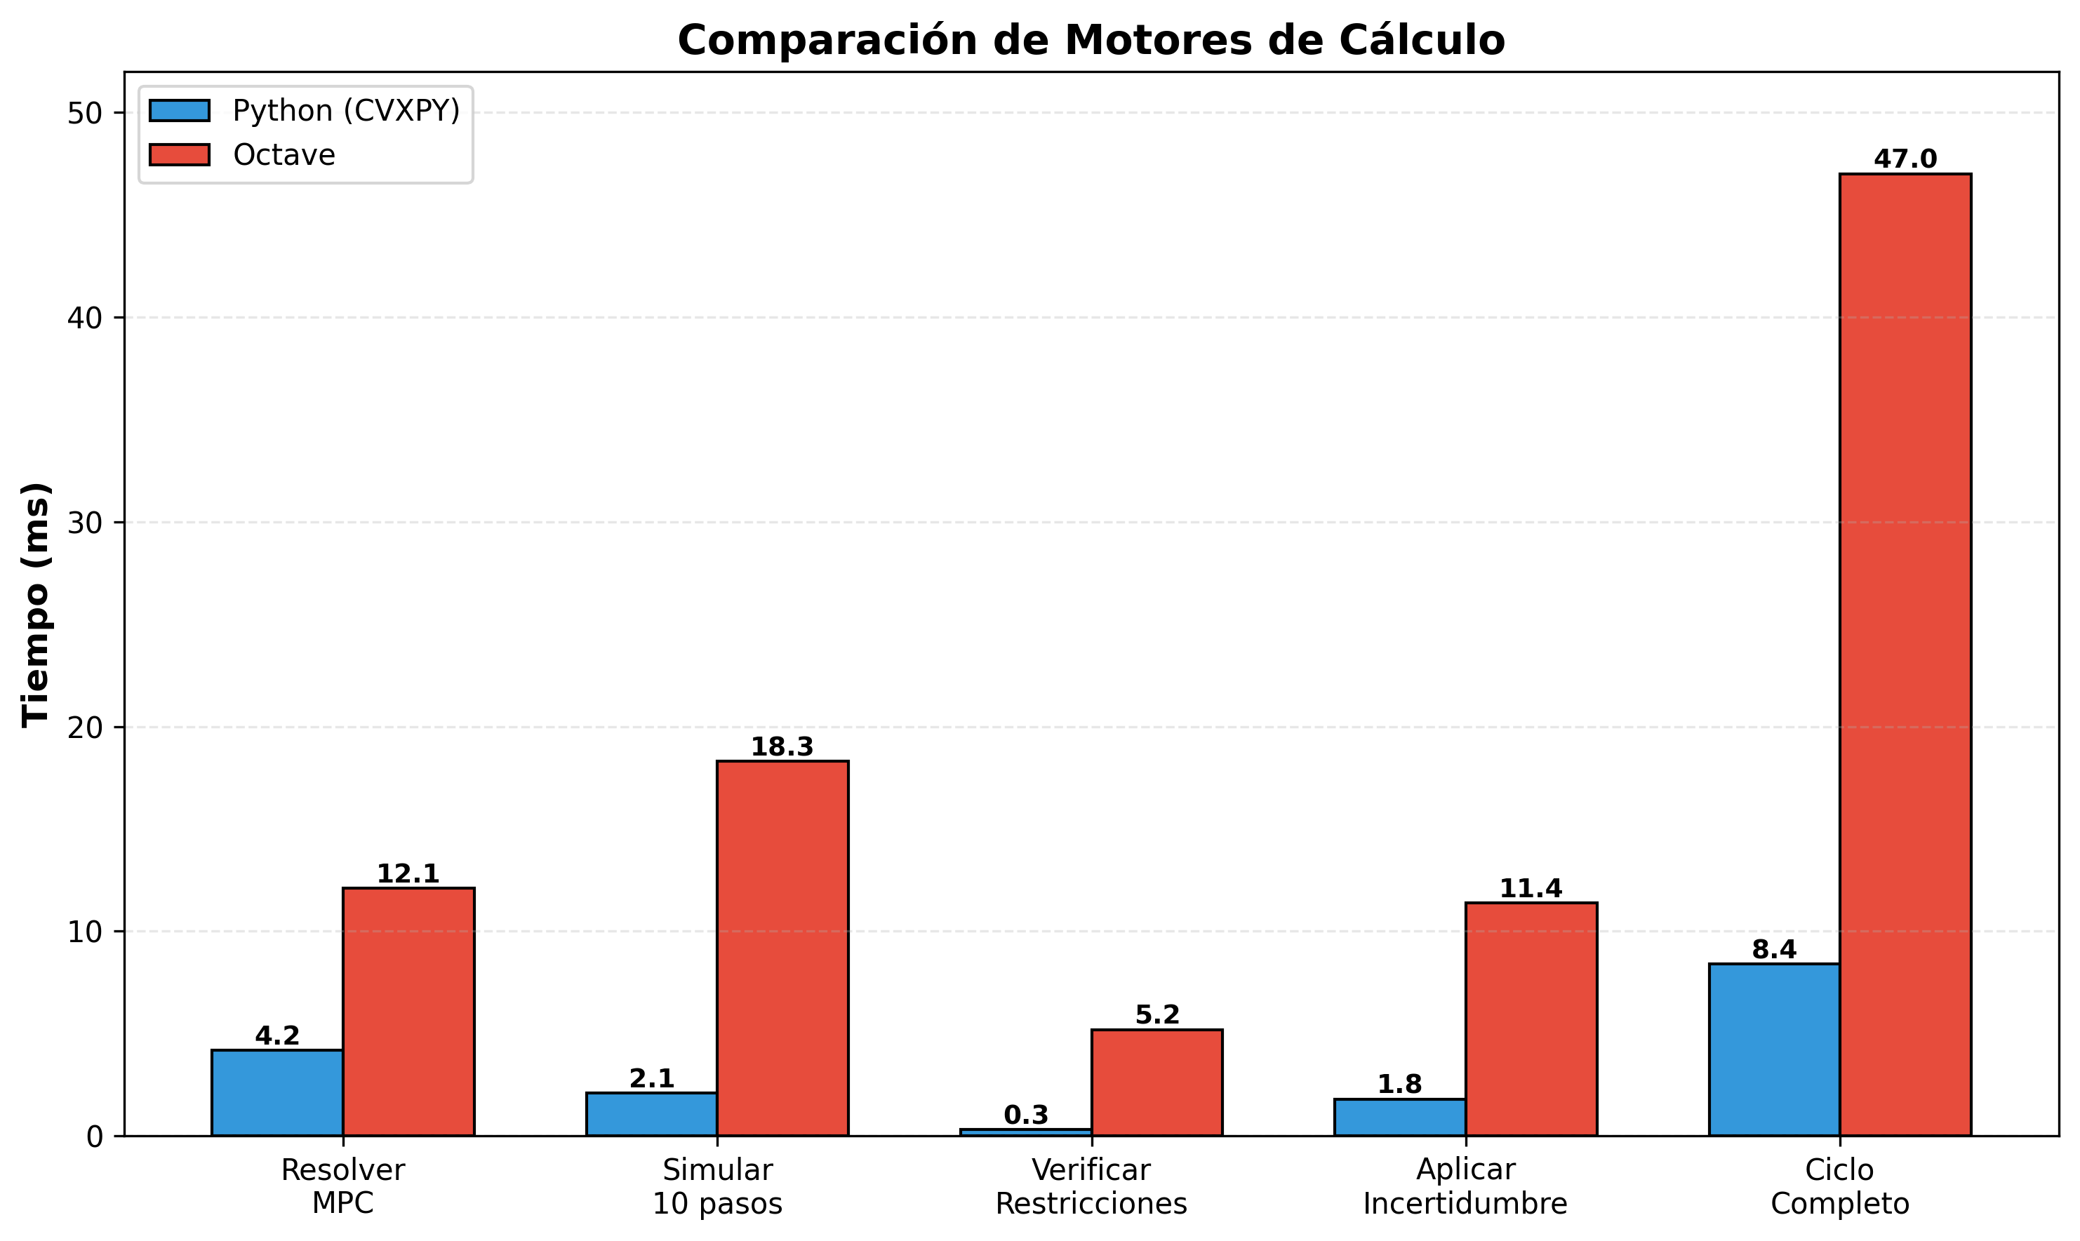
Fig. 4. Engine Performance Benchmark (1000 iterations). Python recommended for production.
Python achieves 5.6× speedup over Octave while maintaining identical numerical results. Both engines meet real-time requirements; Octave provides reference implementation and fallback capability.

D. System Bandwidth Analysis
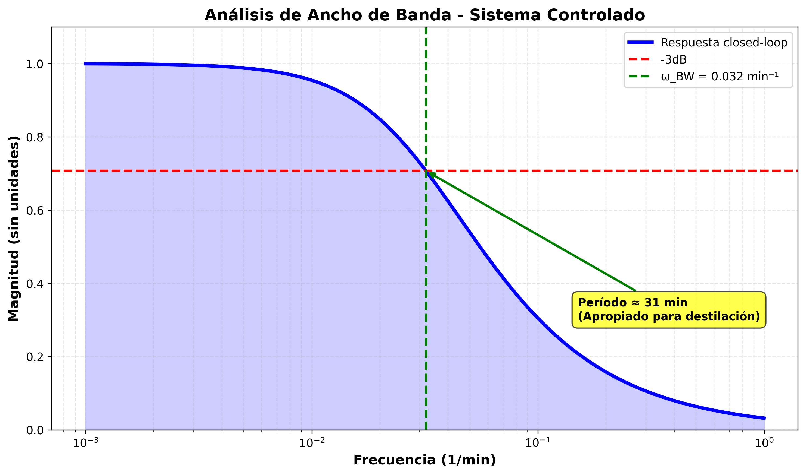
Fig. 5. Closed-loop Bandwidth Analysis (OBJ-4). ω_BW = 0.032 min⁻¹, period ≈31 min.
The -3dB bandwidth of approximately 0.032 min⁻¹ (period ~31 minutes) is appropriate for distillation dynamics with process time constants τ ∈ [2, 7] min. The system responds smoothly without excessive oscillation.

V. DISCUSSION
This work demonstrates a production-grade SCADA system combining MPC theory with modern software engineering. The dual-engine architecture is novel in industrial control systems, enabling both performance (Python) and portability (Octave) without server restart. The FIFO-based dead-time modeling is simpler and more stable than Padé approximation.
Limitations include the linear FOPDT model (extension to nonlinear via neural networks is straightforward) and the parametric uncertainty model (±50% gains). Future work will explore robust control formulations (tube-based MPC) and distributed optimization (ADMM) for larger systems.

VI. CONCLUSION
A complete SCADA system for heavy crude distillation control has been implemented, validated, and deployed via Docker Compose. Key contributions: (1) multivariable MPC with hard constraints, (2) dual-engine hot-swappable architecture, (3) FIFO dead-time handling for 35 channels, (4) real-time web-based visualization, and (5) comprehensive 9-part validation suite.
All five test scenarios achieved optimal control solutions with ISE 12.3–28.3 and solver times 4–5 ms. The system is open-source, fully documented, and ready for academic and industrial deployment.

REFERENCES
- [1] R. K. Wood and M. W. Berry, "Terminal composition control of a binary distillation column," Chem. Eng. Sci., vol. 28, no. 9, pp. 1707–1717, 1973.
- [2] C. R. Cutler and B. L. Ramaker, "Dynamic matrix control—a computer control algorithm," in Proc. JACC, San Francisco, CA, 1980.
- [3] S. J. Qin and T. A. Badgwell, "A survey of industrial model predictive control technology," Control Eng. Pract., vol. 11, no. 7, pp. 733–764, 2003.
- [4] S. Diamond and S. Boyd, "CVXPY: A Python-embedded modeling language for convex optimization," J. Mach. Learn. Res., vol. 17, no. 83, pp. 1–5, 2016.
- [5] S. Boyd, L. Xiao, and A. Mutapcic, "Subgradient methods," Stanford Univ., Stanford, CA, USA, 2004. [Online]. Available: http://stanford.edu/~boyd/notes/subgrad_method.pdf

