Master Thesis: FMI Support in ModelicaML

ModelicaML plug-ins and the example can be downloaded from: http://openmodelica.org/index.php/developer/tools/134.

Please follow the installation instructions described in the “ModelicaML: Getting Started” document that is also available form: http://openmodelica.org/index.php/developer/tools/134.

FMI specification: http://www.modelisar.com/fmi.html

What?
The main task of this project is enabling the design verification by using models (system component-, scenario- or requirement-models, etc.) that were created in different tools or formalisms and were exported in the FMI format. In order to do so the ModelicaML tools shall be enhanced to allow the user to:
- Import (or synchronize) FMI models that located in a specified project folder
- Use the imported FMI models as components in other models

High attention should be paid for the situation when imported FM I models need to be synchronized with newer versions of that models. Similar functionality is already implemented in ModelicaML for the import and synchronization of Modelica code (see screenshot below). It can be reused or serve as an example for this project.

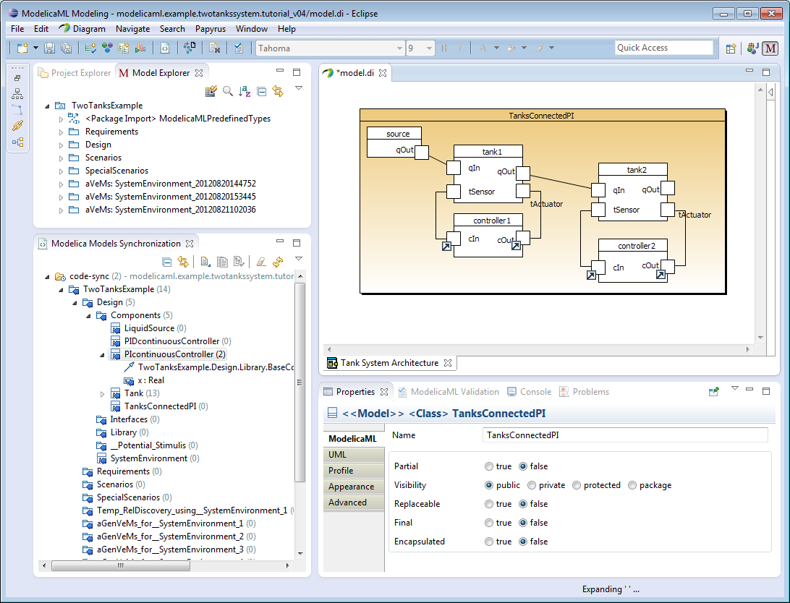

The implementation should be in Eclipse. It will be necessary to implement a new Eclipse ModelicaML plugin with a new view in Eclipse (see examples http://www.eclipse.org/articles/viewArticle/ViewArticle2.html).

How?
The Master thesis is done at Linköping University, Dept. for Computer Science and Information Science, in cooperation with EADS Innovation Works in Hamburg (Germany).

Location: Linköping

Supervisor: Dr. Adrian Pop, IDA, Linköping University, 58183 Linköping
E-mail: adrpo@ida.liu.se
Tel: +46 (0)13 285781
Other Contacts: Prof. Peter Fritzson, IDA, Linköping University, 58183 Linköping
E-mail: petfr@ida.liu.se

Contact person at EADS IW: Wladimir Schamai, EADS IW, Nesspriel 1, 21129 Hamburg, Germany
E-mail: Wladimir.Schamai@eads.net
Tel: +49 40 743 84 254

The Master thesis work is for one student.

