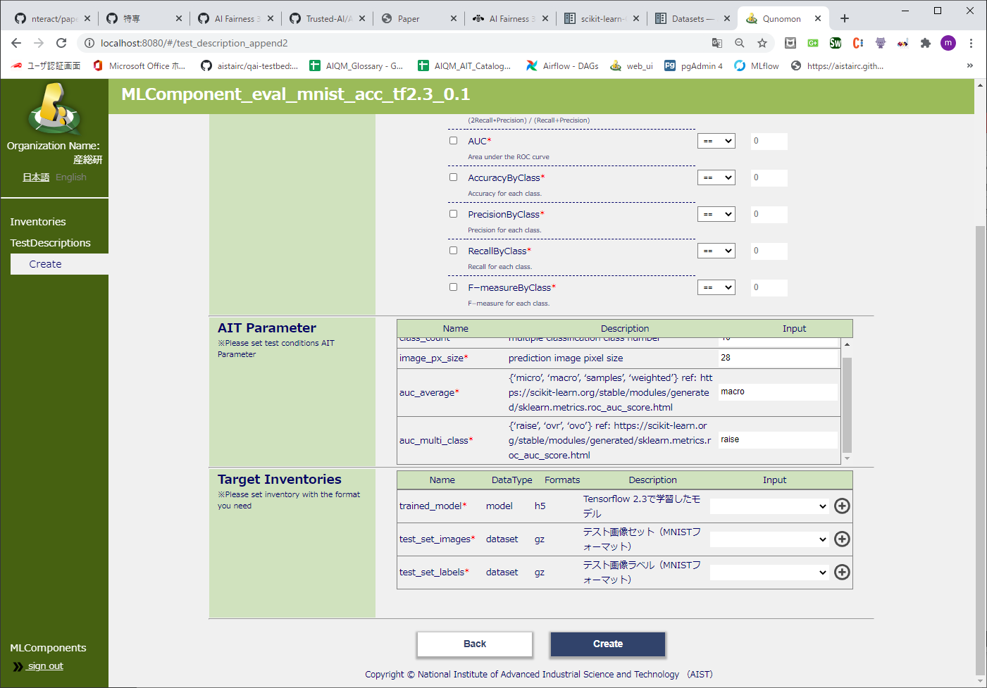

1. Button area
2. Target Inventories area