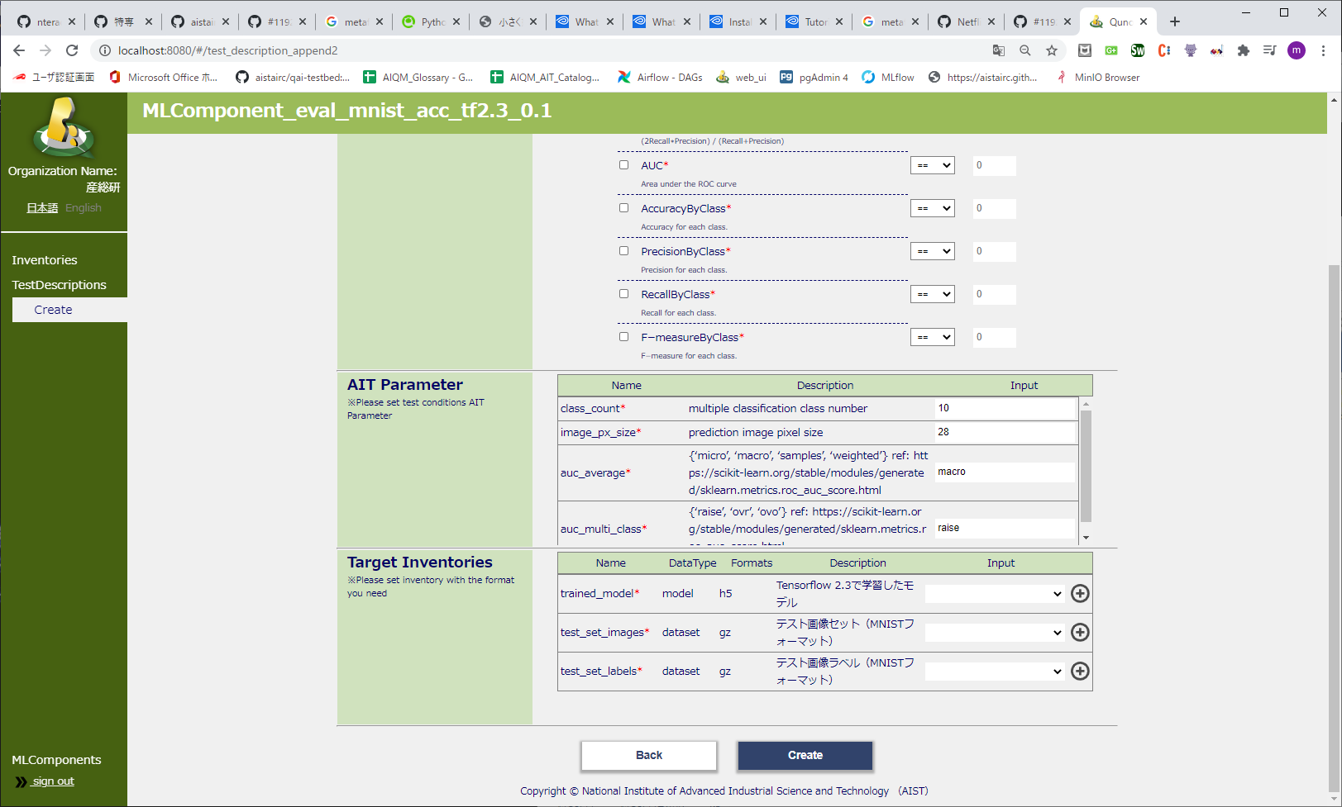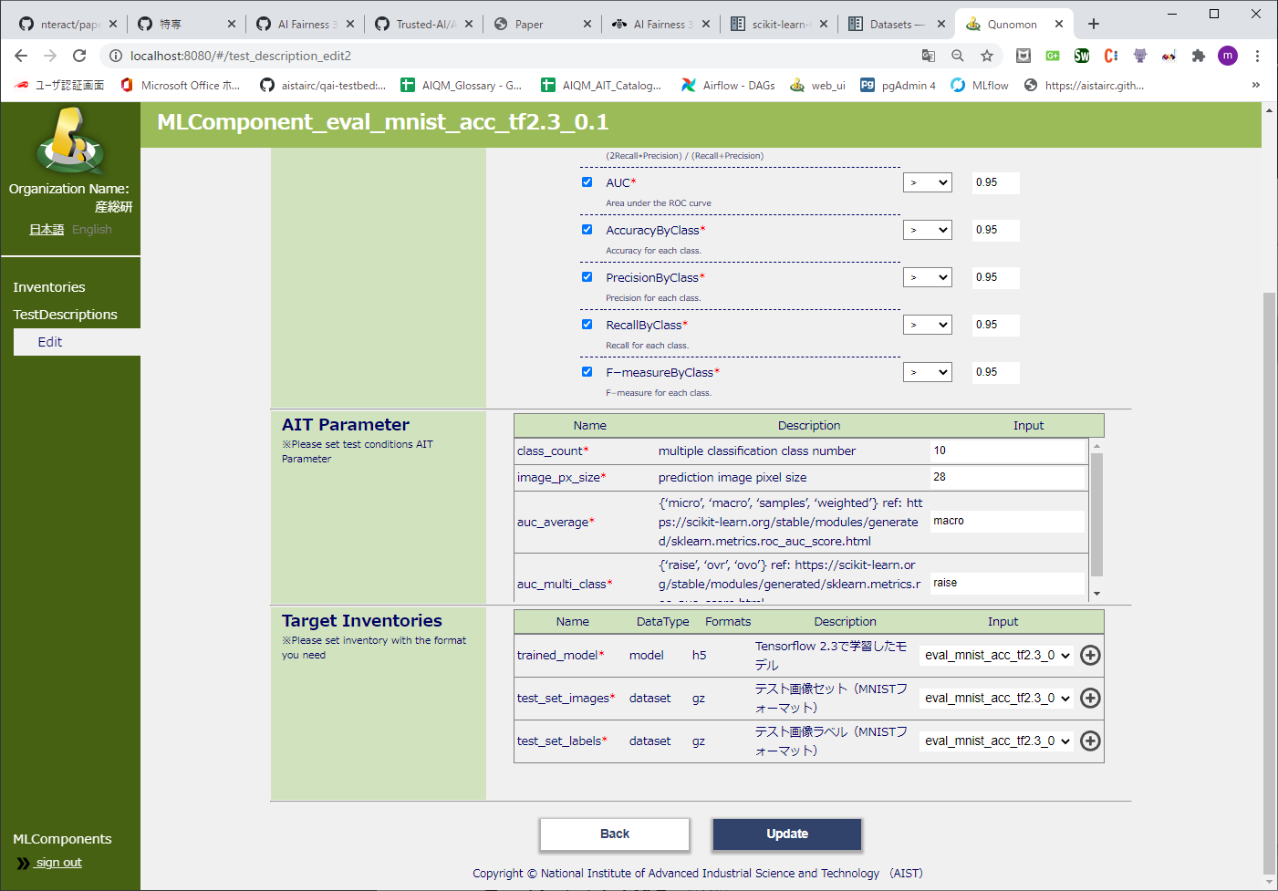

1. Button area
2. Target Inventories area
3. Target Inventories area
4. Button area