

**DFARS Cybersecurity Compliance Tracking System User Manual**

**G2 Ops Inc.**

**205 Business Park Drive, Ste. 200**

**Virginia Beach, VA 23462**

**(757) 965-8330**

**TABLE of CONTENTS**

INTRODUCTION 2

ARCHIVING and DATA COLLECTION SYSTEM 2

OVERVIEW 2

OPEN USER-FRIENDLY SYSTEM 3

NETWORK ARCHITECTURE 3

SYSTEM COMPONENTS 4

HARDWARE REQUIREMENTS 4

SOFTWARE and SYSTEM REQUIREMENTS 4

COMMUNICATION HARDWARE 4

SYSTEM NAVIGATION AND EDITING 4

ENTITY RELATIONSHIP DIAGRAM 5

SECURITY ACCESS LEVELS 5

USER ID/SYSTEM SETUP 6

LOGGING IN 8

CREATING REPORTS 8

IMPORTING STANDARDS, CATEGORIES and REQUIREMENTS 9

EXPORTING 11

**INTRODUCTION**

The DFARS Compliance Tracking System is a MYSQL and PHP based software package that monitors and manages customer compliance to NIST SP 800-171 Rev 1 and other standards. This system is designed to offer ease of use and access to common software packages. The DFARS Compliance Tracking System uses MySQL database, JQuery and PHP general-purpose scripting language.

**ARCHIVING and DATA COLLECTION SYSTEM**

The user interface allows the end user to record and document the artifacts which support particular compliance requirements. Managed service providers can select a business and review the artifacts for that business. This system ensures that end users associated with one organization are not able to access data associated with another organization. Data of all updates are stored and accessible for all reporting purposes. The database access is audited and logged showing date and time as to who initiated the access. This information is available on-demand.

**OVERVIEW**

This system operates independently of any other system running and provides the following functions:

* Database Maintenance
* User Authorization and Data Security
* Import Compliance Requirement from CSV file when new standards are identified
* Graphical User Interface (GUI)
* Exporting Data for Compliance Matrix to CSV file available for end-user downloading
* Host Communications

**OPEN USER-FRIENDLY SYSTEM**

The DFARS System has an “Open System” architecture which uses Microsoft Windows, MySQL server and PHP. Utilizing these tools provides for a flexible and user-friendly system.

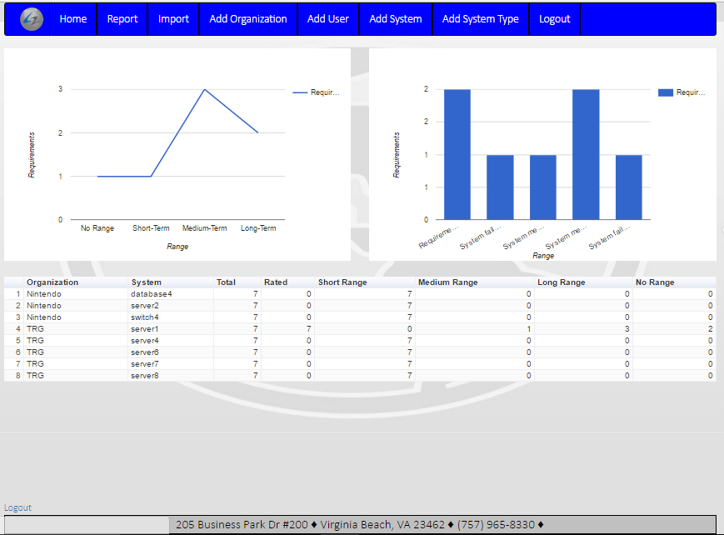

**NETWORK ARCHITECTURE**

The design allows for multiple serial or IP connections with other computers and office equipment. This network setup allows the system to work for small organizations as well as large businesses.

Here is a listing of components:

Server: PCs generally come with one or two serial communication ports. This IP to serial device provides for additional ports for the PC.

Printers: Any printer compatible with Windows can be used.

**SYSTEM COMPONENTS**

The DFARS System runs on any PC workstation or server with a minimum of 4GB RAM memory, 250GB hard disk and Microsoft Windows operating system.

**HARDWARE REQUIREMENTS**

* Intel Processor
* 4 GB RAM minimum
* 250 GB available hard disk space
* LCD Flat Panel Monitor
* Dual Network Ethernet Ports
* Printer Ports – Network connected
* Mouse and keyboard
* High speed internet connection
* Microsoft Windows operating system

**SOFTWARE and SYSTEM REQUIREMENTS**

* MySQL
* JQuery
* PHP

**COMMUNICATION HARDWARE**

The server provided allows for numerous serial interfaces. An IP network can also be used to communicate with devices.

**SYSTEM NAVIGATION AND EDITING**

This section describes the database navigation and editing procedure used throughout this system. The files allow for adding, deleting and updating. All filters are dropdown menus to minimize security risk and user error.

**ENTITY RELATIONSHIP DIAGRAM**

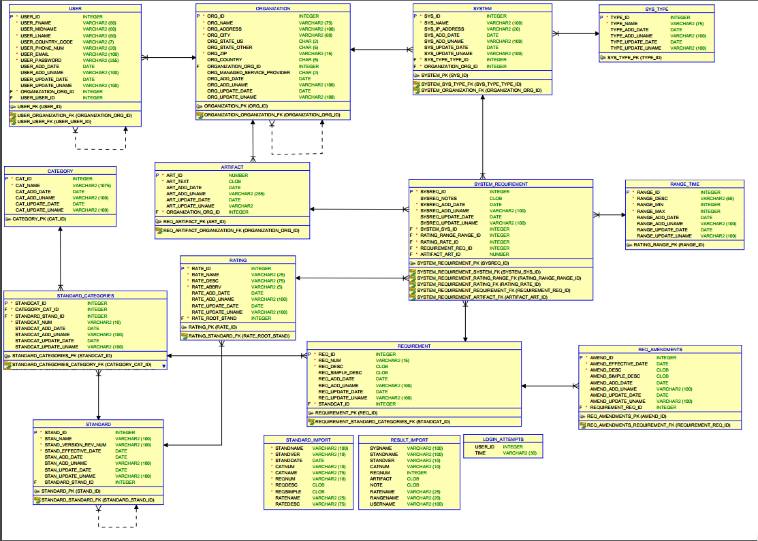

**SECURITY ACCESS LEVELS**

The UserID database maintains a list of authorized users and their corresponding level of access. Each user has a list of Objects that they are permitted to access.

When the user accesses the system, the user is prompted to enter their user id and password. The user gets logged off after a certain time of inactivity which is defaulted to 15 minutes. If a user is accidentally locked out, please contact the administrator for assistance.

**USER ID/SYSTEM SETUP**

This database contains a list of all authorized users. The “Administrator” has the highest level of access and cannot be deleted. Below form shows the required information. If a required field is not filled out, the screen will not advance, and the user will be prompted to complete the missing field(s).

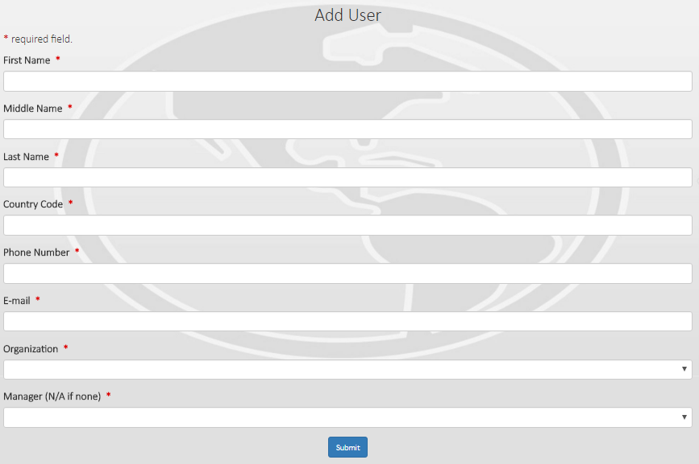

Minimum password requirements include a password which is at least 8 characters long and includes an uppercase letter, an alphanumeric number, and a special symbol. Passwords will not be allowed to begin with a 0, and cannot have the same numbers or letters within them. Every 45 days passwords will expire and the user will be directed to establish a new one.

Upon being granted a security access level to the tracking system by a top level Administrator, a welcoming email will be sent to the new user. This email will state that their G2 ops email address will be used their log-in ID for the system. The random password will be sent in a follow up secure email and from there they will be instructed to create a new password which will be hashed and stored in the USER table for future credential comparisons.

A table named “login attempts” is designated to record all unauthorized access to the database and application platform. Here failed login attempts will be stored along with successful login access. Once a user is logged in they will be granted access to the dashboard and other features based on their security level access. Inactivity greater the 15 minutes on the site will result in the user session being terminated. A user will terminate his session by means of a logout.php file. If a user is no longer needing access, the database manager needs to drop the user. Only G2 can add managed service providers.

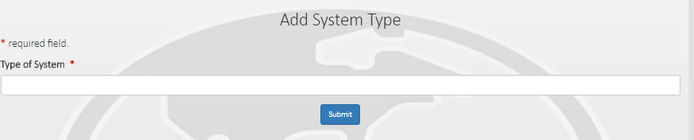

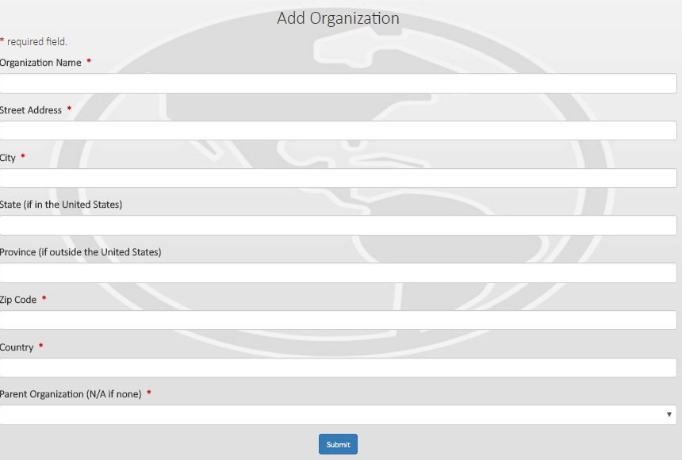

**LOGGING IN**

Enter user name which is the email address. Enter password - That met the previous requirements as stated above. If a user attempts to use any of the functions without having logged in, the user will be redirected to the login page.

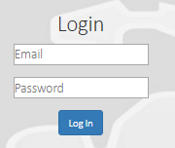

**CREATING REPORTS**

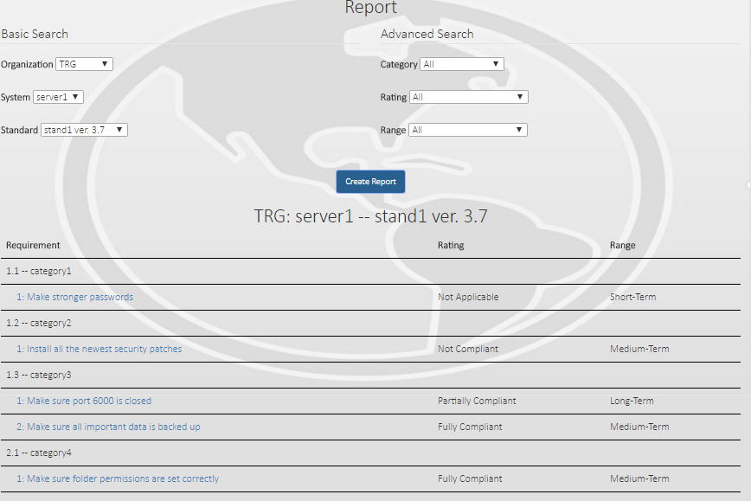

The Report page is the template for filtering and viewing standard reports. The basic filters are Organization, System, and Standard. The advanced filters are Category, Rating, and Range. Categories and Ratings will change by selecting a different Standard. The Rating filter will disable the Range filter when set to “NR-Not Reviewed” due to requirements will not appear in the system. Upon choosing a different rating selection, the range filter will be re enabled.

If the user does not know which Categories, Ratings, or Ranges are needed, it is advised that the filters remain on “All”. Once the report is generated, a separate page will open up where the user can input Artifacts, Ratings, Ranges, and comments that reflect the findings when each requirement is evaluated against the chosen system.

**IMPORTING STANDARDS, CATEGORIES and REQUIREMENTS:**

a) Standards - Add the name of the standard and its version number and press submit

b) Categories – First a CSV is needed. The CSV will contain the following columns:

* a. Standard – the exact spelling\punctuation\spacing for the standard the category belongs to.
* b. Category Number – the number for the category within the standard.
* c. Category Name – The name of the category in text.

Each row will contain the standard name and the remaining information should vary for each row. Once the file is created, the user will navigate to the Category Import Page. This page will display a browse button which will open the file browser and allow the user to select their CSV and also include a submit button to upload the information.

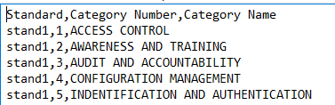

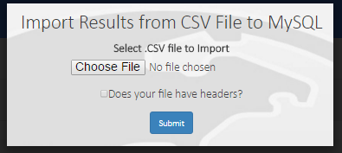

c) Requirements - First a CSV is needed. The CSV will contain the following columns:

* a. Requirement Number – The number of the requirement within the category it belongs to
* b. Requirement Description – The full textual description of the requirement
* c. Requirement Simple Description – An easier to read and understand description for the requirement
* d. Category Name – name of the category in text with exact spelling\punctuation\spacing as how the category was imported in the category import CSV
* e. Standard Name - the exact spelling\punctuation\spacing for the standard the requirement belongs to.

Each row will contain the same standard name. There will be multiple rows with a given category name, but all the requirement specific information will vary for each row. After the user successfully imports the categories, they are sent to the requirement import page. This page looks exactly the same as the category import page and functions exactly the same. The user can utilize the screenshot above as a placeholder until the actual page is created. Below is a screenshot of a sample CSV file:

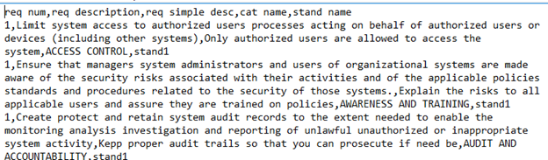

Final stage of the process:

When a CSV is submitted, it is uploaded to a folder named ‘Files’ on the server. Then the import table for the corresponding CSV is truncated (category_import and requirement_import tables). Subsequently, the file is loaded into its corresponding table via MYSQL’s load data local infile process. Next, an UPDATE statement is performed to update the user_name field of the import table with the ID of the user who uploaded the CSV. Finally, a procedure is called that inserts all the categories or requirements into their corresponding tables so that they can be used.

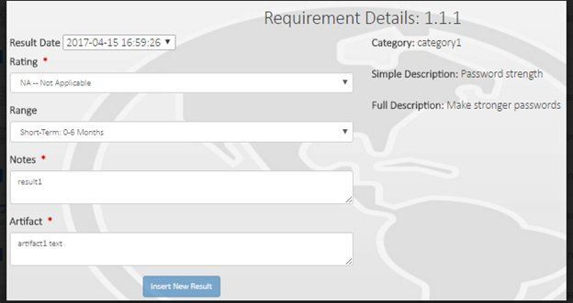

**EXPORTING**

Once the report has been developed, an export report button located in the bottom left corner of the page will appear. Once the button has been selected, it will export an entire report for a standard and/or system and send it as a CSV file to the users hard drive.