**自傳**

**求學時期**

我是郭景智，畢業於靜宜大學。喜歡挑戰新事物，擅長溝通協調。曾任博幼基金會國中數學課輔老師約莫3年。面對特殊成長背景的學生，如拒绝學習、情緒激動甚至暴怒翻桌，思考相對有效溝通且採差別教學方式，終讓學生情緒冷靜，並配合學習。

深深體會換位思考及教學相長之道。

**日月光任職 (TEX:2311)**

負責傳統打線封裝製程。

熟捻打線，金和銅線，如何連接晶片與載板，各式產品之間有不同的疊層設計，不同線弧與共晶模式設定，從參數的調整到機台基礎校正設定。爾後，延伸面對問題的邏輯判斷，當遇到產品異常時如何切入調整。用相對快速有效的方式縮短停機時間，閒暇之餘，常思考如何從根本解決問題。嘗試並實驗從硬體基準校正搭配軟體設定能否有效降低相關問題發生機率，目前也是部分異常機故負責人。常與產線人員、產品工程師、重大機故工程師協調討論如何降低部分機故在特定產品上觸發頻率。體驗出本位主義與換位思考的分工與合作。任職期間會嘗試跟不同部門接觸，理解各部門之間不同的出發點還有為難的地方。盡量在中間做到平衡，降低機故觸發頻率維持機台產能運作，增加公司產值，滿足客戶交期。

**和大工業任職 (TEX:1536)**

從品保工程師到國內外售服工程師。

接觸製程上下游廠商從一般耗材到精密治具，了解工具機體系。從入料檢驗至 出機測試，更了解相關部件在成機後的影響公差設計原理，再參與組裝異常檢測，協助設計人員判斷問題。此期間，需撰寫工作日誌，溝通工時問題及目前排程狀況。之後，被提拔轉換客服部門歷練。學習如何成為公司與客戶之間的堅實橋樑，善用換位思考來協助客戶處理問題並建立互信雙嬴關係。持品保經驗面對異常處理，思考方向更多且解決問題更佳。又參與多次國內外交機，從協助同事完成專案到主導印度專案進度，可與客戶明確溝通並完成交機流程，且協助訓練相關人員，讓印度籍售服能獨立作業。

**Autobiography**

This is KUO Ching-Chih. I graduated from the Department of Food and Nutrition, Providence University in 2015, Specialty is Food Processing.

Two companies work for Hota Industrial Mfg. Co., Ltd (TEX:1536) for three years and ASE Group (TEX:2311) for two years. Experiences cover from Quality Assurance, Customer Service and then Wire Bonding.

Be a wire bonding equipment engineer in ASE, besides package basic skill of gold and copper wire connections onto substrates and between chips, I have also learned product yield is the primary KPI measurement. Thus, handling balance of machine up time, familiar with machine output capability, trouble shooting, and mature service skill are the core of the equipment engineer. Further, need to familiar with the process then take fast response to the crisis management of the production line. Somehow, escalate and ask for help to ensure KPI target and cross support among product lines as a teamwork to meet entire factory top-down yield goal which is very important.

During the quality assurance period, I worked hard to learn various parts related inspection methods and standards, and often contacted process manufacturers to understand the machine tool system. In addition to incoming material inspection, it also participates in out-of-machine testing. Know more about the impact of important parts after assembly and the principle of tolerance design. It will also participate in assembly anomaly detection and assist designers in judging problems. Often write work diaries during work, communicate work time issues and schedule status. A clear solution. In the past, there were only import and export and inspection schedules, which caused mutual doubts and misunderstandings and departmental confrontations.

After Quality Assurance, I was qualified to be promoted to the Customer Service Department and appointed to dedicatedly to support company India salesperson. Need to do communication among India sales, designer and report to manager to resolve machine problems especially while onsite service and installation. Service engineer experience is helpful to think about when facing problem then solve problems logically and quickly. At that time, fortunately participation in many domestic and foreign projects, I work from assisting colleagues then step up to lead project individually to meet the goal as a service engineer. Finally, I can feedback my project delivery knowledge and communication skill for bringing value of training new company staff.

Hota is the project base business style and ASE is aimed for mass production SOP base. Both do value contribution is the same. To meet target with following well-defined SOP, study further then do well communication skillful and passionately that facilitate me to keep moving forward.

**研究計畫**

**製程管控與優化**

**探討焊針結構與銅線包覆材料對半導體IC打線之影響**

1. **摘要**

焊線接合(Wire Bonding)是IC封裝中的一道製程，現今多以銅線取代金線作為主要線材。雖然銅相較於金能有效大幅降低成本，但製程上也同樣受到其特性不同而有所影響。銅線硬度相較於金線高出許多，在打線過程中需要細緻調整製程參數才能讓共晶品質符合標準。實際生產過程中，從客戶下單到投產製造中間則經歷線材選用，不同焊針搭配最後實際投片測試。為了維持可靠度與一定的作業性大多都由過往累積經驗直接選用，最後實際生產後再調整改善。

此次針對可靠度 良率 作業性提升將透過不同密度、粗糙度焊針，不同電鍍材質的銅線 相互交疊測試找出一焊點與二焊點最佳化組合，用以提高製成能力。

1. **研究背景與動機**

過往有許多關於焊針磨耗之最佳化研究，也有不同銅球的鈀包覆銅線材對於焊線之影響。更有針對焊針粗糙鍍 材質對於IMC影響四大因素的探討，其目的都是導向良率提升，增加該製程的可靠度。

計畫則是針對焊針與線材共同探討出最適當條件，提高製程管控以利作業性品質提升。實務經驗上，製造流程不斷有新的想法與更嚴謹的SOP控管，但過程中還是需工程師花費較多時間做搭配測試，針對不同產品調整參數。新產品導入時實務則依經驗值測試選用做小量試產測試，但極高比率，當大量投產時還是有一定的差異發生，造成生產效率降低又必須回頭再次修正，常費時、工及力。

本計畫則是針對投產前對製程要素做優化動作，提前嚴謹做好搭配與適應性做最適合參數整合，增加整體調控作業性。也有助於降低生產與製程間部門衝突與相互對立，提高作業順暢度，提升良率與產值。



圖一 焊針結構圖 圖二 晶片打線外觀圖

1. **研究作業方法與流程**

計畫分成三個階段實施

|  |  |
| --- | --- |
| 階段 | 方法目的 |
| 1. 燒球穩定性測試 | 以不同材質 粗糙鍍焊針，不同鈀包覆線材，觀察打線燒銅球時。比較怎樣的組合能讓銅球外型完整穩定、硬度及可靠度最佳。 |
| 1. 產品參數對比 | 藉A階段比較數據後，配過往產品生產參數及作業性紀錄做比對。作業性較好之產品是否趨近於理論值。 |
| 1. 產品驗證 | 挑選適當產品加上所配出數值，觀察bond_1與bond_2作業性是否有實質上提升。再套上不同產品重複驗證。 |

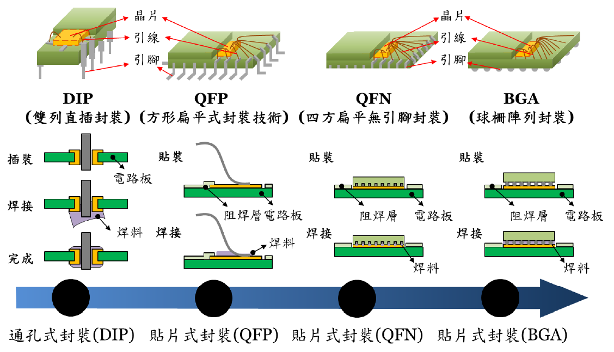

圖三 不同封裝產品示意圖

依PDCA方法執行研究

|  |  |
| --- | --- |
| **PLAN** | **DO** |
| 焊針類型選樣歸納(FA、CA、CD)  銅包覆線選樣歸納(材質鍍鈀或厚度)  最佳化銅球定義(外觀、可靠度，參考IPC)  實驗步驟 | 焊針、銅線、打線、燒球之理論、作業探討。  實驗紀錄 |
| **Action** | **CHECK** |
| 打線作業改良即提升 | 資料比對驗證 |

研究選讀探討計畫

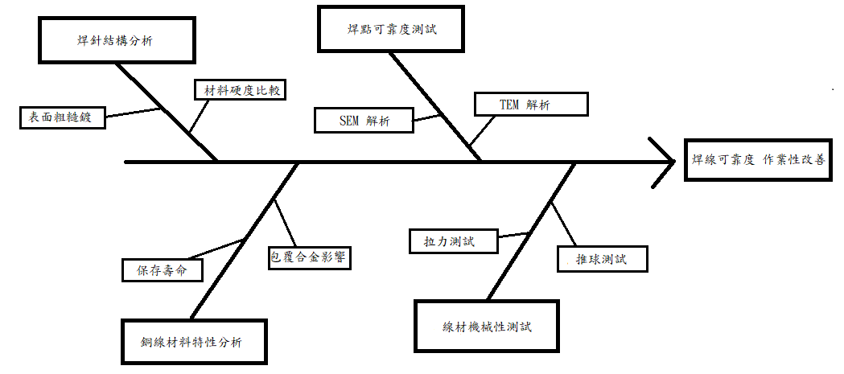

1. **預期成果**

打線製成材料部分主要由焊針與銅線相互搭配，現今多以鍍鈀銅線為主流。燒球過程中以(圖一)CA、CD兩數據為影響燒球大小與形狀。焊針內徑表面粗糙度為出發點，透過陶瓷與二氧化鋯比例提升粗糙度則(圖一)CA角度摩擦力增加可提升球型穩定。不同陶瓷結晶密度則牽涉到焊針結構強度與其壽命。以不同材料鍍層焊線為出發點則影響燒球結果與打線強度。上述因子綜合測試後，得到最優化組合能針對製程上bond_1與bond_2共晶能有效提升提高產品作業性、時效性。

1. **參考書目**

1. Che Wei Kang (2022), Thermal Stress Failure Analysis of Quad No-Lead Package under Wire bonding Process (QFN封裝打線接合過程之熱應力分析)

2. https://www.semanticscholar.org/paper/Copper-wire-off-center-ball-and-2nd-  
 smash-bond-on-Li-Han/7c3aa3c5a27231ea031f95f1bec5a016b38e252e  
 3. Lin Yen-Yi(2009), Influence of IC substrate surface finish joints with Pb-free  
 solder in reliability (IC封裝載板表面處理技術與無鉛錫球種類對焊接可靠度影  
 響)  
 4.https://tanaka-preciousmetals.com/tw/  
 5. <http://www.mke.co.kr/03_pro/index.php>  
 6. http://www2.peco.co.kr/product_en/capillary.php?loc=1

7. [Lai, Ming Yu](https://ndltd.ncl.edu.tw/cgi-bin/gs32/gsweb.cgi/ccd=Oasaeb/search?q=aue=%22Lai%2C%20Ming%20Yu%22.&searchmode=basic)(2010) , Process Capability Analysis for Wire Bonding of IC  
 Packaging(IC 封裝銲線製程能力分析)