Smart Dustbin With IOT Notifications

**Rationale:**

With increase in population we have an increase in the garbage around urban areas. Here we propose a smart dustbin that operates automatically to help solve this issue using IOT and sensor based circuitry. Usual dustbins require to be opened by pressing foot against its lever and then throwing garbage. Also a person needs to keep track when it is full so that it can be emptied and does not overflow. Here we propose a smart dustbin that does all this by itself. Our system consists of a sensor in order to detect human clap signal and on a clap of foot tap it opens automatically without anyone needing to press its lever.

**Features:**

* detect human clap signal and on a clap of foot tap it opens automatically without anyone needing to press its lever.
* The dustbin opens automatically when it receives the signal and closes its hatch.
* The dustbin now consists of a smart circuitry that transmits this information over the web to signal the main garbage collector of the facility to empty the particular garbage bin.
* we get a fully automated smart dustbin that allows for automated garbage cleaning.

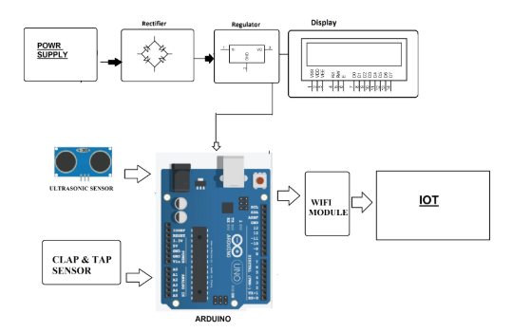

# Smart E Glasses For Voltage Measurement

**Rationale:**

Here we propose smart glasses for electrical works for easy voltage measurement while working. Usually while testing/troubleshooting electrical works/PCB the person faces issues while placing probes on 2 points and looking at the multimeter at the exact time. This consumes a lot of time as well leads to faulty/improper measurements. To solve this issue we propose to integrate voltage display through the users glasses for a virtual voltage display while troubleshooting/ testing the system. We use a raspberry pi based circuit for processing and displaying output.

**Features:**

The glass frame is made using a smartly constructed miniature frame. The frame is constructed to fit a mini display along with circuitry and the display lens used for desired reflection on the glass frame. The system is fabricated so as to fit easily on a persons ears and enable the person to view the circuitry along with voltage measured. The circuit consists of a voltage measurement circuit that is integrated to the glass in order to get the voltage inputs to the raspberry pi display. Thus we have an efficient voltage measurement display using raspberry pi.

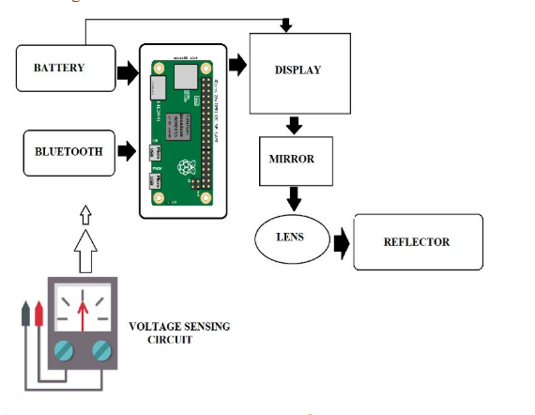

# IOT Garbage Monitoring With Weight Sensing

**Rationale:**

Keeping the city clean has been always an ongoing task which needs laborious efforts of people working on ground level emptying the garbage bins whenever they are full. The event of garbage bin getting full is not strictly dependent on a time pattern, instead it sometimes becomes rapidly full or sometimes requires more than normal time to become full. IOT Garbage Monitoring with Weight Sensing project is an innovative step towards making this process more smooth and efficient.

**Features:**

* This system monitors the garbage bins and informs about the level of garbage collected in the garbage bins via a web page.
* The advantage of this combo sensing is that the garbage bin lifting weight can also be known by the authorities. If the garbage bin is not filled up, but still the weight of fill has reached the limit of what the garbage lifting vehicles can pick up, the vehicles can be immediately driven towards that bin for evacuation.
* The LCD screen is used to display the status of the level and weight of garbage collected in the bins. Whereas a web page is built to show the status to the user monitoring it.
* The web page gives a graphical view of the garbage bins and highlights the garbage collected in colour in order to show the level of garbage collected.
* The LCD screen shows the status of the garbage level. The system puts on the buzzer when the level of garbage collected crosses the set limit.

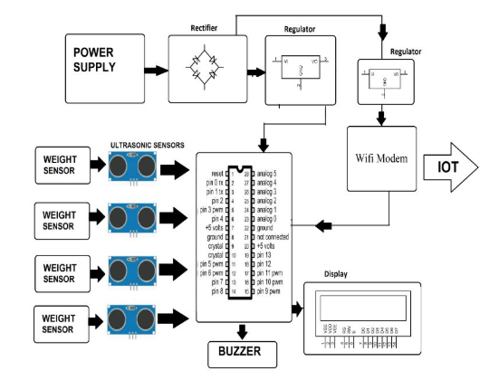

Smart Mirror: A Glance into the Future

**Rationale:**

In todays society, information is available to us at a glance through our phones, our laptops, our desktops, and more. But an extra level of interaction is required in order to access the information. As technology grows, technology should grow further and further away from the traditional style of interaction with devices. In the past, information was relayed through paper, then through computers, and in todays day and age, through our phones and multiple other mediums. Technology should become more integrated into our lives - more seamless and more invisible. We hope to push the envelope further, into the future. We propose a new simple way of connecting with your morning newspaper.

**Features:**

We present our idea, the SmartMirror, information at a glance. Our system aims to deliver your information quickly and comfortably, with a new modern aesthetic. While modern appliances require input through modules such as keyboards or touch screen, we hope to follow a model that can function purely on voice and gesture. We seek to deliver your information during your morning routine and throughout the day, when taking out your phone is not always possible. This will cater to a larger audience base, as the average consumer nowadays hopes to accomplish tasks with minimal active interaction with their adopted technology. This idea has many future applications, such as integration with new virtual or augmented reality devices, or simplifying consumer personal media sources.

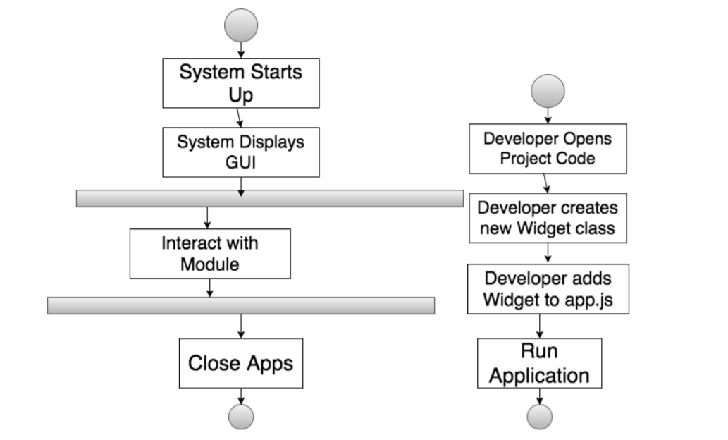

**UNIVERSITY OF CEBU-MAIN CAMPUS**

**COMPUTER ENGINEERING DEPARTMENT**

Osmeña Boulevard Corner Sanciangko Street , Cebu City

NAME : Ahrve Kim E. Jabonillo

DATE : June 26, 2019

TITLE : **Smart Dustbin With IOT Notifications**

Approved

Disapproved

Comments/Suggestions:

________________________________________________________________________________________________________________________________________________________________________________________________________________________________________________________________________________________________________________________________________________________________________________________________________________________________________________________________________________________________________________________________________________________________________

**­**____________________________________________________________________________________________

**Evaluators:**

**_______________________________________**

**(Signature over printed name)**

**_______________________________________**

**(Signature over printed name)**

**_______________________________________**

**(Signature over printed name)**

**UNIVERSITY OF CEBU-MAIN CAMPUS**

**COMPUTER ENGINEERING DEPARTMENT**

Osmeña Boulevard Corner Sanciangko Street , Cebu City

NAME : Ahrve Kim E. Jabonillo

DATE : June 26, 2019

TITLE : Smart E Glasses For Voltage Measurement

Approved

Disapproved

Comments/Suggestions:

________________________________________________________________________________________________________________________________________________________________________________________________________________________________________________________________________________________________________________________________________________________________________________________________________________________________________________________________________________________________________________________________________________________________________

**­**____________________________________________________________________________________________

**Evaluators:**

**_______________________________________**

**(Signature over printed name)**

**_______________________________________**

**(Signature over printed name)**

**_______________________________________**

**(Signature over printed name)**

**UNIVERSITY OF CEBU-MAIN CAMPUS**

**COMPUTER ENGINEERING DEPARTMENT**

Osmeña Boulevard Corner Sanciangko Street , Cebu City

NAME : Ahrve Kim E. Jabonillo

DATE : June 26, 2019

TITLE : IOT Garbage Monitoring With Weight Sensing

Approved

Disapproved

Comments/Suggestions:

________________________________________________________________________________________________________________________________________________________________________________________________________________________________________________________________________________________________________________________________________________________________________________________________________________________________________________________________________________________________________________________________________________________________________

**­**____________________________________________________________________________________________

**Evaluators:**

**_______________________________________**

**(Signature over printed name)**

**_______________________________________**

**(Signature over printed name)**

**_______________________________________**

**(Signature over printed name)**

**UNIVERSITY OF CEBU-MAIN CAMPUS**

**COMPUTER ENGINEERING DEPARTMENT**

Osmeña Boulevard Corner Sanciangko Street , Cebu City

NAME : Ahrve Kim E. Jabonillo

DATE : June 26, 2019

TITLE : Smart Mirror: A Glance into the Future

Approved

Disapproved

Comments/Suggestions:

________________________________________________________________________________________________________________________________________________________________________________________________________________________________________________________________________________________________________________________________________________________________________________________________________________________________________________________________________________________________________________________________________________________________________

**­**____________________________________________________________________________________________

**Evaluators:**

**_______________________________________**

**(Signature over printed name)**

**_______________________________________**

**(Signature over printed name)**

**_______________________________________**

**(Signature over printed name)**