MediCare Plus Web Application Development Report
Student Id: BT/HDCSE/14/12
Module Code: CSE5009
Module Title: Web Application Development
Assessment: WRIT1
System: MediCare Plus Healthcare Web Application

Table of Contents
MediCare Plus Web Application Development Report 2
1. Introduction 2
2. Task 01 – Planning and Design of the Web Application 3
2.1 Analysis and Comparison of Similar Web Systems 3
Website Comparison 3
Design Comparison 4
Apollo Hospitals provides a professional healthcare interface with a clean layout and well-organized navigation. The website allows users to quickly access services, doctors, and appointment booking options. The color scheme mainly uses blue and white which are commonly associated with trust and professionalism in healthcare. 4
Key Features Identified 4
2.2 User Interface Design and Mockups 4
Design Principles Used 5
The following design principles were applied: 5
Color Scheme 5
Main User Interface Pages 5
The following pages were designed for the MediCare Plus system: 5
2.3 Site Map 9
3. Task 02 – System Implementation 9
3.1 Front-End Development 9
Technologies Used 10
Front-End Features Implemented 10
3.2 Back-End Development 11
Technologies Used 11
Database Design 12
Back-End Functionalities 12
Security Features 13
4. Task 03 – System Testing and Evaluation 23
4.1 Testing Overview 23
4.2 Test Plan 24
4.3 Test Cases 24
Test Case 1 – User Login 24
Test Case 2 – Appointment Booking 25
5. Conclusion 25
Bibliography 26

1. Introduction

The healthcare sector plays an essential role in improving the quality of life of individuals by providing medical services and treatment. In recent years, the demand for digital healthcare services has increased significantly. Patients expect convenient access to healthcare services such as appointment booking, doctor information, and medical records through online platforms. Therefore, healthcare organizations must adopt modern digital technologies to improve service delivery and operational efficiency.

MediCare Plus is a private healthcare provider that offers a wide range of medical services including general consultations, specialist treatments, diagnostic services, and emergency care. In order to enhance patient experience and improve service management, MediCare Plus intends to develop a database-driven dynamic web application. This system will allow patients, doctors, and administrators to interact through an integrated online platform.

The purpose of the MediCare Plus web application is to simplify hospital management and patient interaction by offering features such as doctor profile viewing, appointment booking, patient registration, medical report access, and secure communication between patients and doctors. The system will also allow administrators to manage doctors, services, and patient information effectively.

The system will support three types of users:
• Admin – Responsible for managing doctors, patients, services, and reports.
• Doctors – Can view appointments, manage schedules, and communicate with patients.
• Patients – Can register, book appointments, and provide feedback.

2. Task 01 – Planning and Design of the Web Application

2.1 Analysis and Comparison of Similar Web Systems

Before developing the MediCare Plus web application, it is important to analyze existing healthcare websites that provide similar services. This helps identify best design practices and useful features that can be implemented in the new system.
Three healthcare websites were analyzed:
- Apollo Hospitals
- Mayo Clinic
- NHS (National Health Service)

These websites provide comprehensive healthcare services through their online platforms.

Website Comparison
Feature | Apollo Hospitals | Mayo Clinic | NHS
Appointment Booking | Available | Available | Available
Doctor Profiles | Detailed information | Basic profiles | Limited
Service Information | Categorized | Detailed medical articles | Categorized
Search Function | Available | Available | Available
Patient Portal | Available | Available | Limited
Mobile Friendly | Yes | Yes | Yes

Design Comparison

Apollo Hospitals provides a professional healthcare interface with a clean layout and well-organized navigation. The website allows users to quickly access services, doctors, and appointment booking options. The color scheme mainly uses blue and white which are commonly associated with trust and professionalism in healthcare.
The Mayo Clinic website focuses heavily on providing medical knowledge and information. It includes a large number of health articles and educational resources. The design is minimal and user friendly, with a strong emphasis on accessibility and readability.
The NHS website is a government healthcare platform that prioritizes accessibility and simplicity. The website is designed for a wide audience including elderly users. Therefore, it uses large fonts, simple navigation, and clear content organization.

Key Features Identified
Based on the analysis of these websites, several important features were identified for the MediCare Plus system:
• Easy navigation and clear menu structure
• Detailed doctor profiles
• Online appointment booking system
• Search functionality for doctors and services
• Patient portal for accessing medical records
• Responsive design for mobile devices

These features help improve user experience and ensure efficient healthcare service delivery.

2.2 User Interface Design and Mockups
The design of a web application plays an important role in ensuring usability and user satisfaction. The MediCare Plus system is designed with a clean and modern interface to provide a smooth experience for users.

Design Principles Used

The following design principles were applied:
• Consistency – All pages follow the same layout and design style.
• Usability – Navigation menus and buttons are easy to understand.
• Accessibility – Clear fonts and readable text sizes.
• Responsive Design – The system adapts to different screen sizes.

Color Scheme
The color scheme selected for the website includes:
• Blue – Represents trust and healthcare professionalism
• White – Represents cleanliness and simplicity
• Light grey – Used for background sections
These colors create a calm and professional medical environment.

Main User Interface Pages

The following pages were designed for the MediCare Plus system:
Home Page
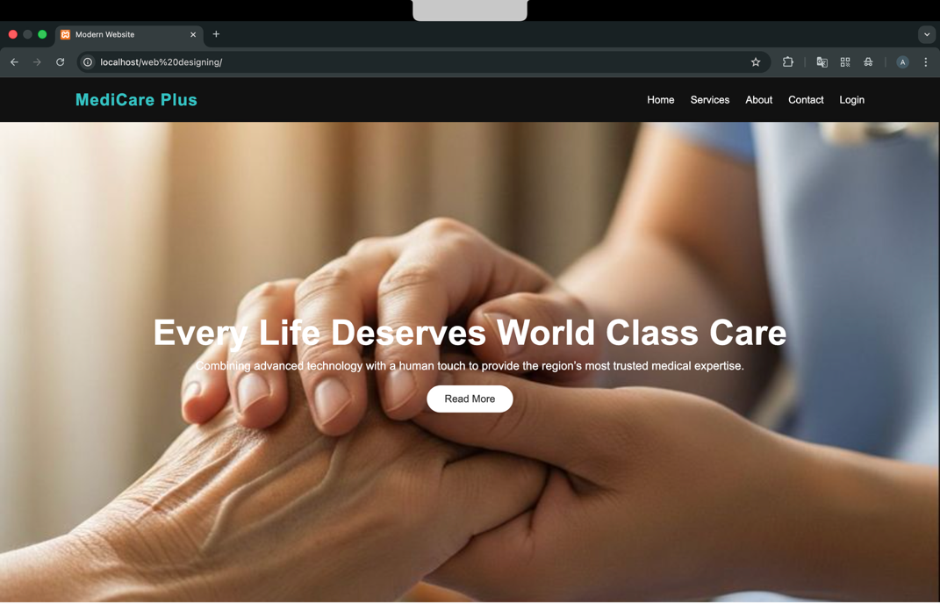
The homepage introduces the hospital and provides quick access to key features such as about us, appointment booking, and services. It includes a navigation menu, featured services section, and contact information.

Doctor Listing Page
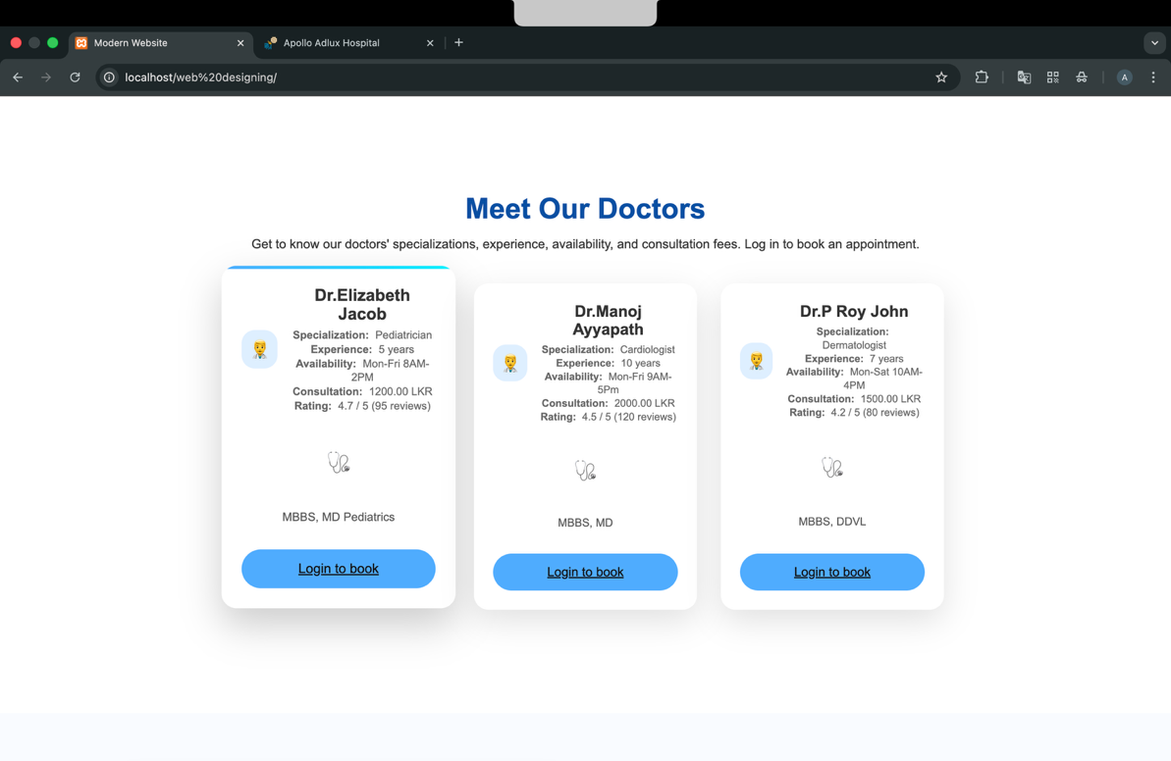
This page displays a list of doctors along with their specialization, experience, consultation fee, and availability. Patients can filter doctors based on specialization and schedule.

Appointment Booking Page
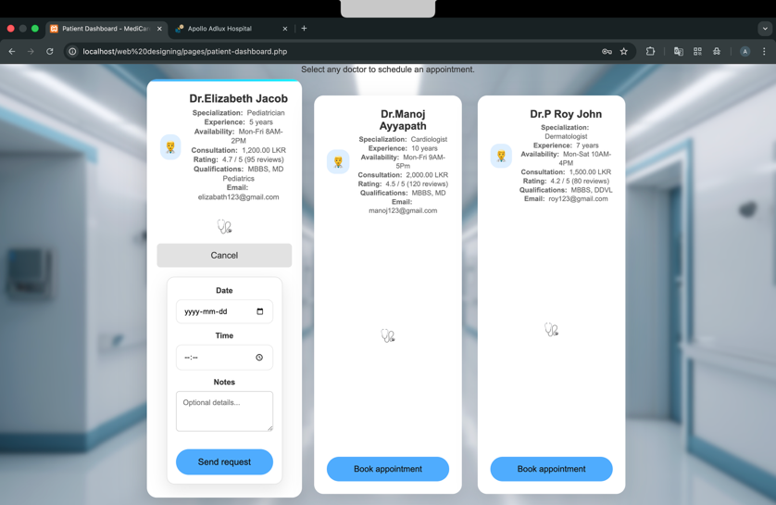
Patients can select a doctor and book an appointment based on available time slots. The system stores appointment information in the database.
Patient Dashboard
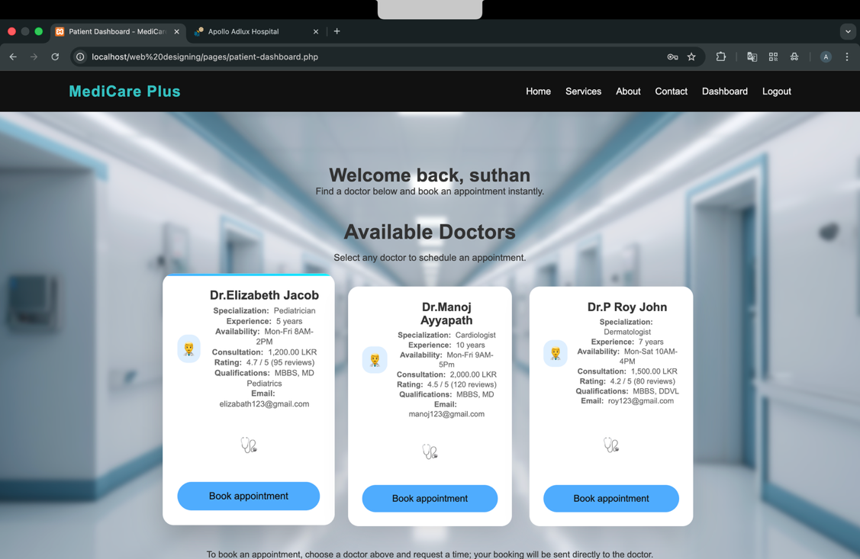
After logging in, patients can view:
• Appointment history
• Available doctors
• Messages from doctors
Doctor Dashboard
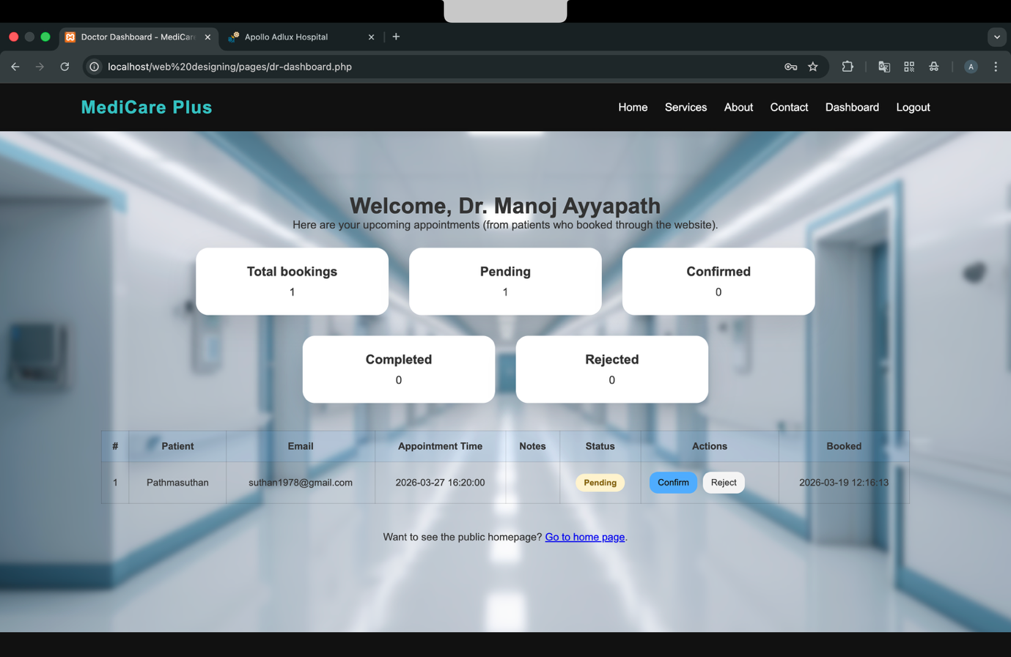
Doctors can:
• View scheduled appointments
• They can make actions for appointments
• Communicate with patients
Admin Dashboard
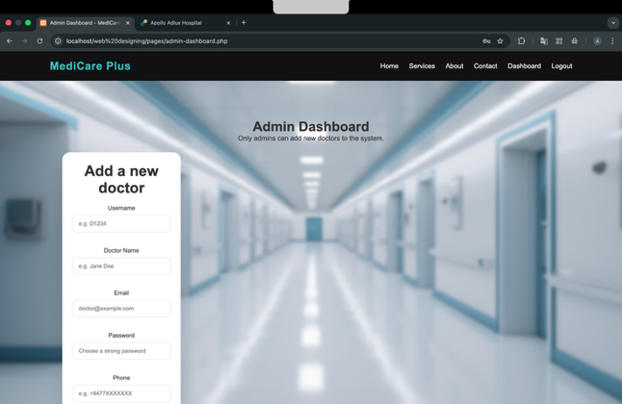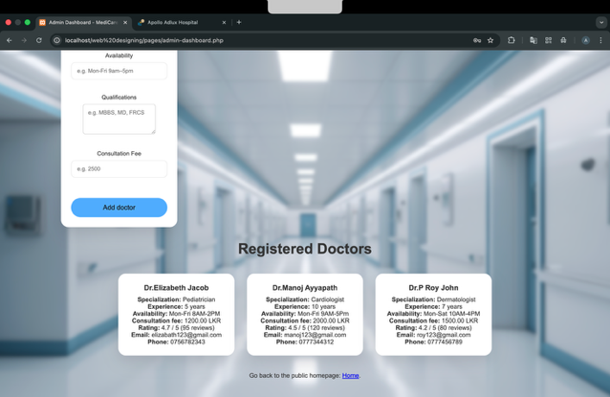

Administrators can manage:
• Add Doctors
• Patients
• Services
• System data

2.3 Site Map

A sitemap helps organize the structure of the website and ensures efficient navigation between pages.
The sitemap of MediCare Plus is structured as follows:
Home
• About Us
• Services
• Patient Portal
• Register
• Login
• Appointment History
• Doctor Dashboard
• Admin Dashboard
• Contact Us

3. Task 02 – System Implementation

3.1 Front-End Development

Front-end development focuses on creating the visual elements of the website that users interact with. The MediCare Plus web application was developed using modern web technologies to ensure an attractive and user-friendly interface.

Technologies Used
The following technologies were used:

HTML (HyperText Markup Language)
HTML was used to create the structure of web pages including headings, paragraphs, forms, navigation menus, and images.

CSS (Cascading Style Sheets)
CSS was used to design the layout of the website including colors, fonts, spacing, and page alignment.

JavaScript
JavaScript was used to add interactive features such as form validation, search filters, and dynamic content updates.

Bootstrap Framework
Bootstrap was used to implement responsive design and ensure that the website works properly on mobile phones, tablets, and desktops.

Front-End Features Implemented
The MediCare Plus interface includes several features to improve usability:

Navigation Menu
A fixed navigation bar allows users to easily access main sections of the website.

Search Functionality
Patients can search for doctors based on specialization and availability.

Responsive Layout
The system automatically adjusts its layout depending on screen size.

Interactive Forms
Registration and appointment forms include validation to prevent incorrect input.

User-Friendly Design
Images, icons, and white space are used to create a clean and organized interface.

Overall, the front-end design focuses on simplicity, accessibility, and ease of use.

3.2 Back-End Development

Back-end development handles the server-side operations and database management of the system. It ensures that user data is stored, processed, and retrieved securely.

Technologies Used
The back-end of the MediCare Plus system was developed using:
• PHP for server-side programming
• MySQL for database management

Database Design
Several database tables were created to store system information.
Table Name | Purpose
Users | Stores login credentials, doctor & patient informatin
Appointments | Stores appointment bookings

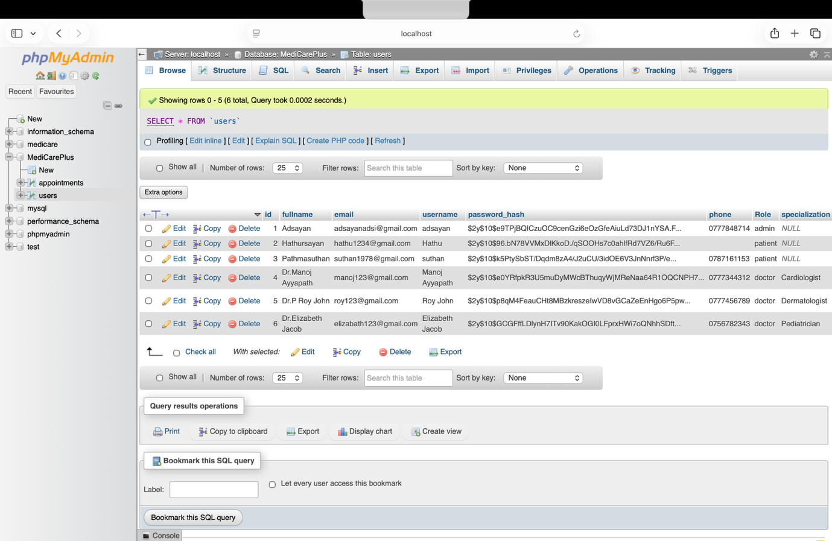

Back-End Functionalities
The system provides several important server-side functions.
User Authentication
Users must log in with a valid username and password. The system verifies credentials and grants access based on user role.
Patient Registration
New patients can create an account by entering personal details such as name, contact information, and password.
Appointment Booking
Patients can select a doctor and book available time slots. The appointment information is stored in the database.
Medical Report Management
Doctors can upload reports and prescriptions which patients can access securely through their accounts.

Security Features
The system includes several security mechanisms:
• Password encryption
• Role-based access control
• Input validation
• Error handling

These features help protect patient data and ensure system reliability.
Index.php
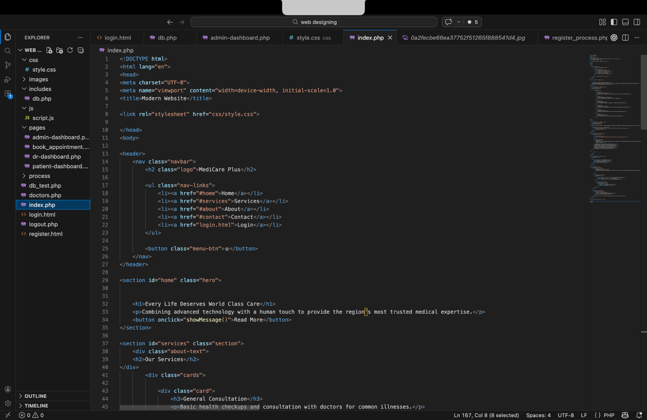
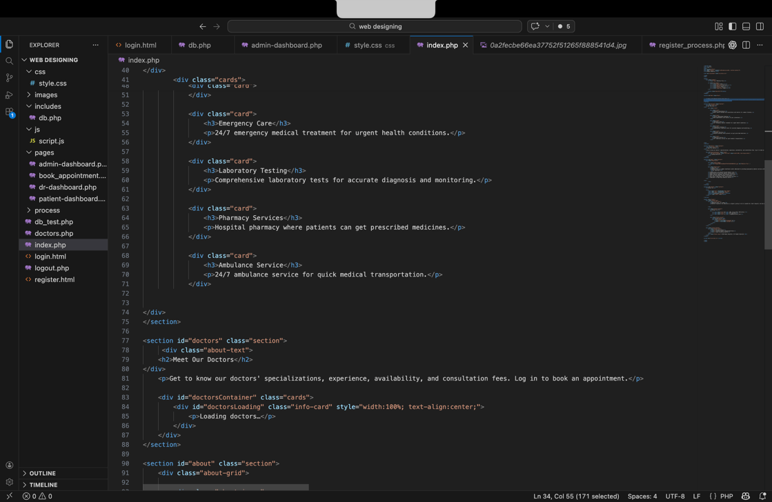
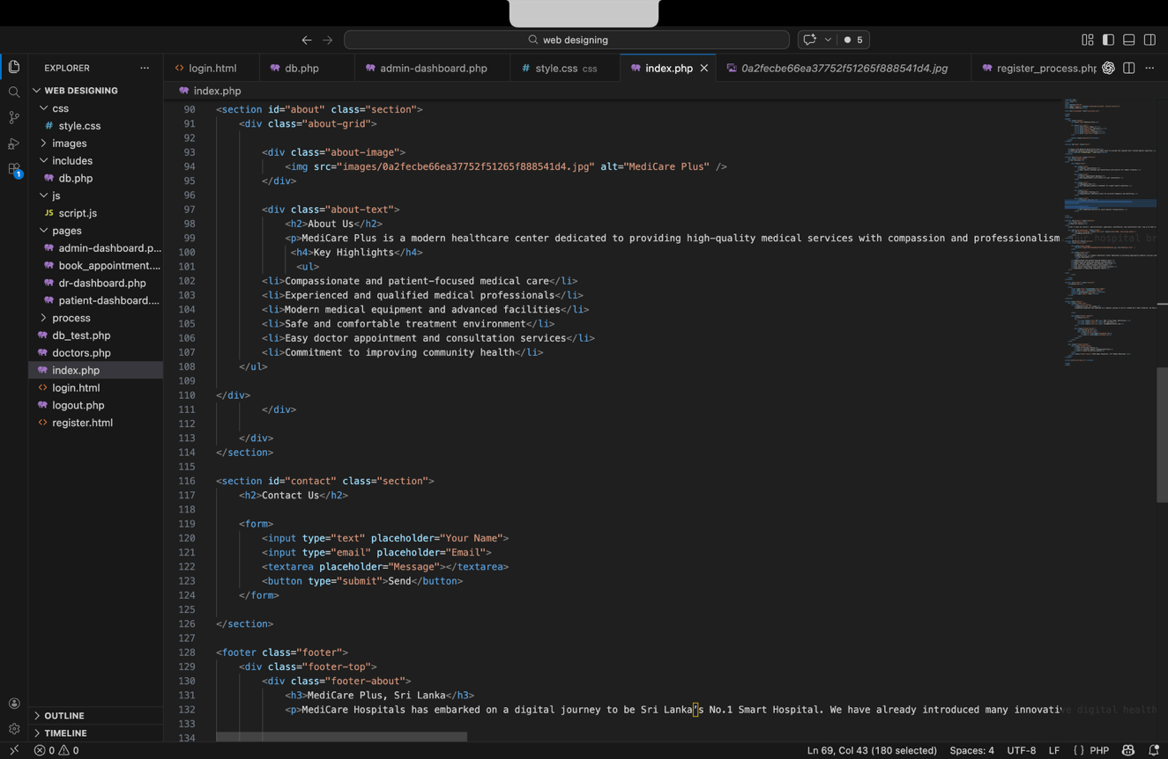

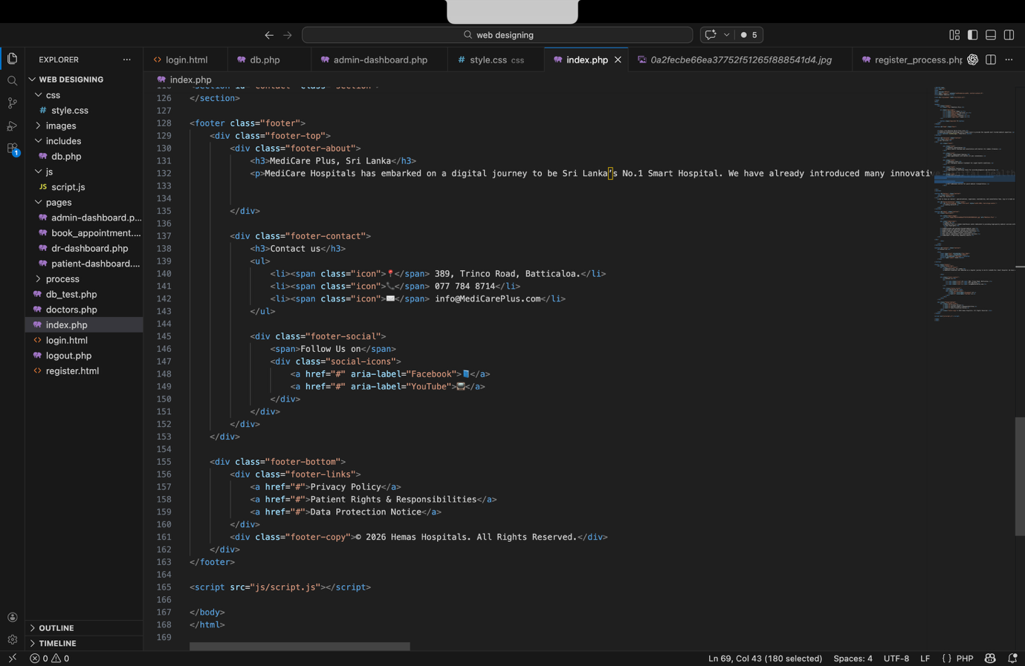

Logout.php

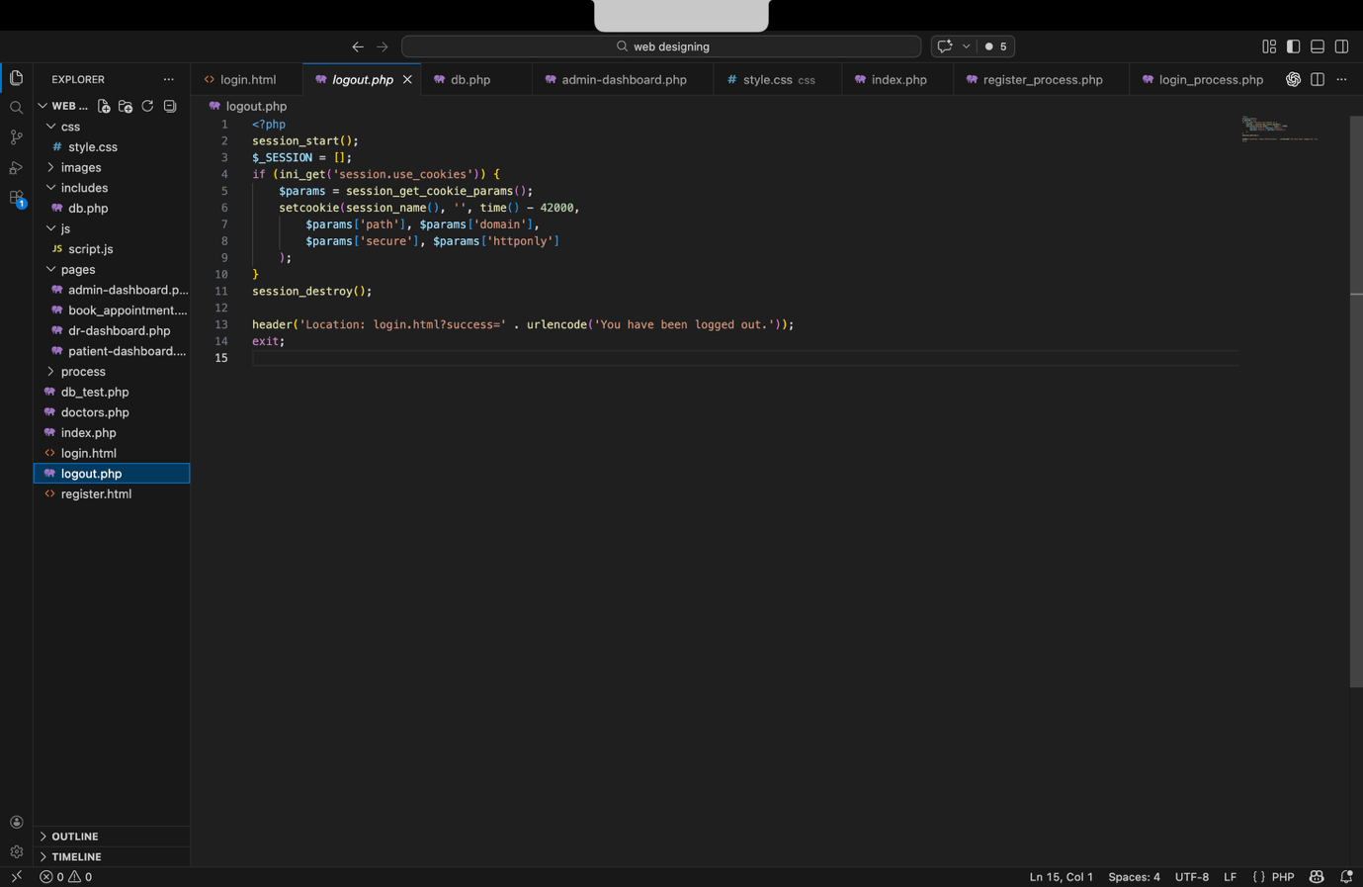

Database.php

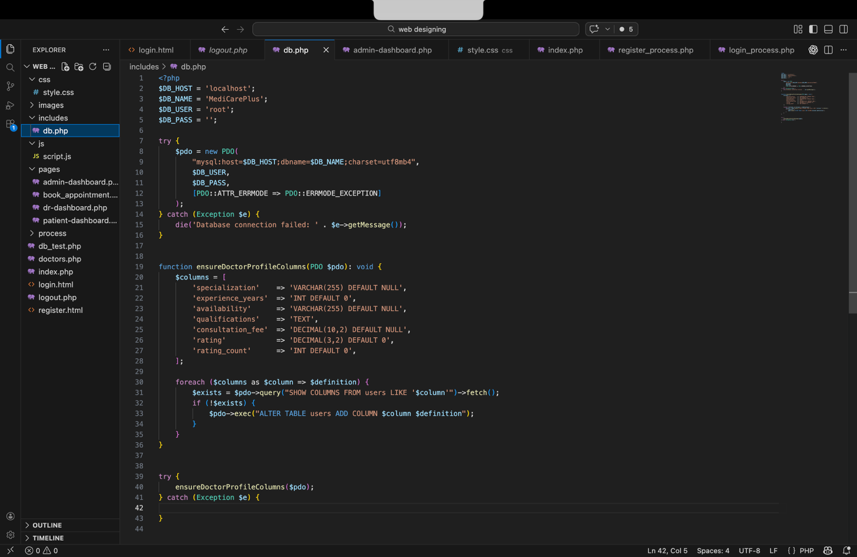

Admin dashboard.php

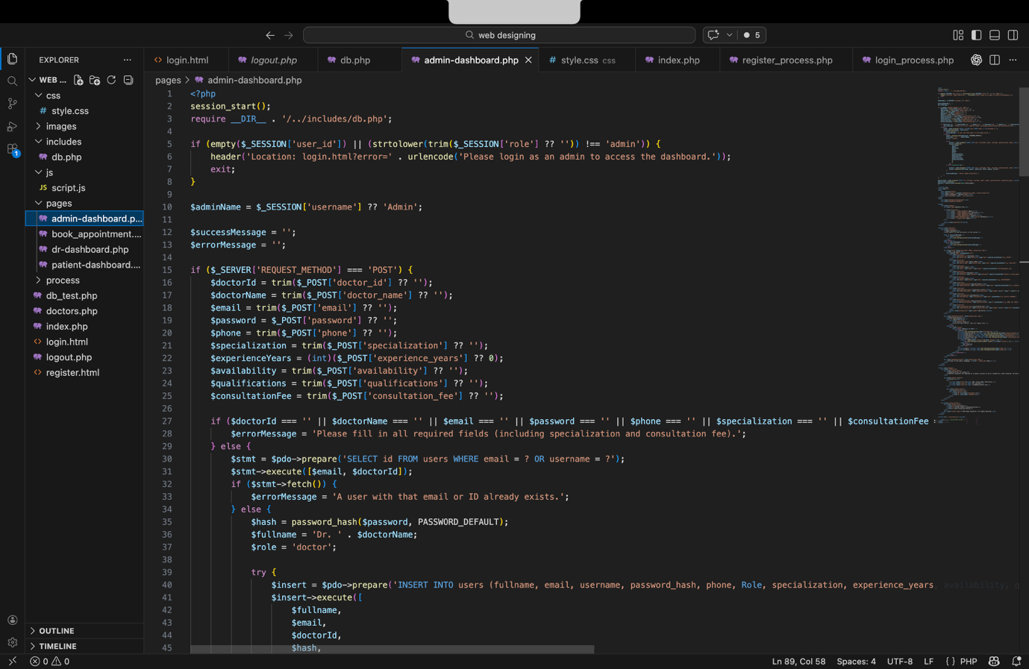

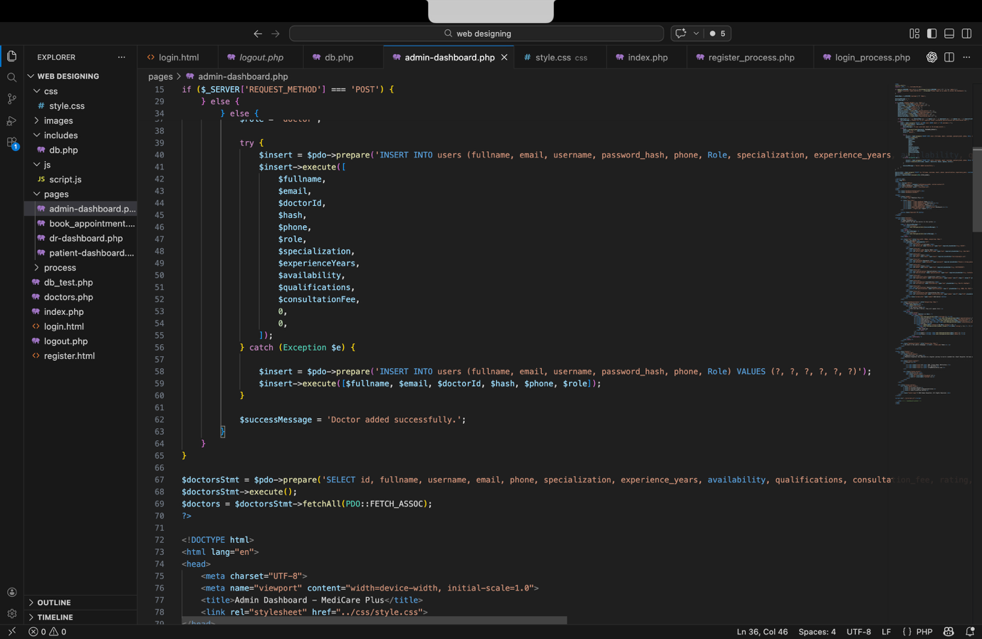
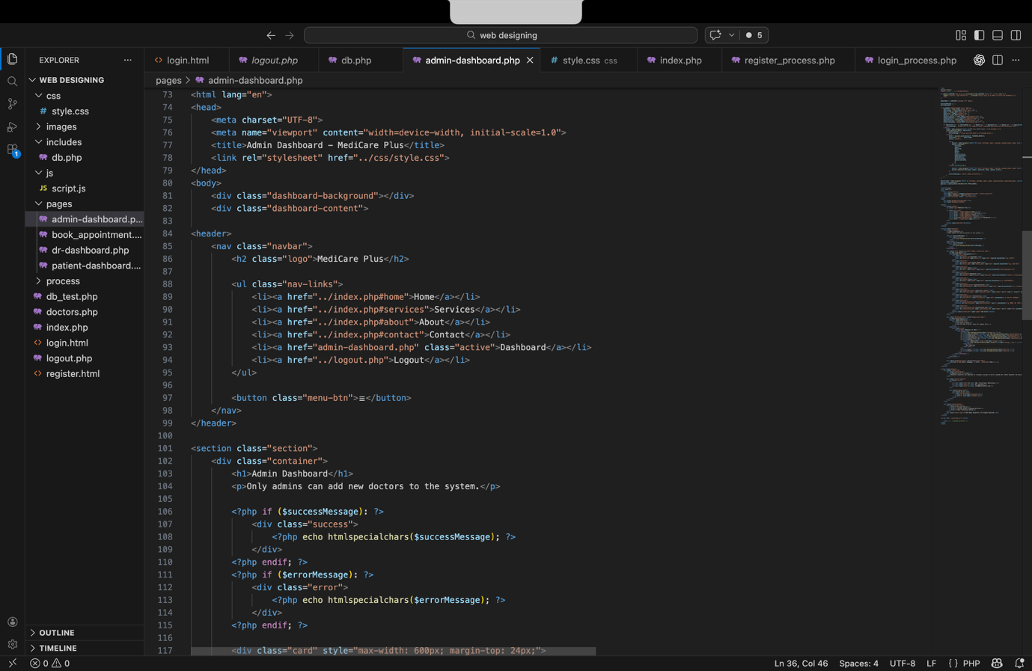
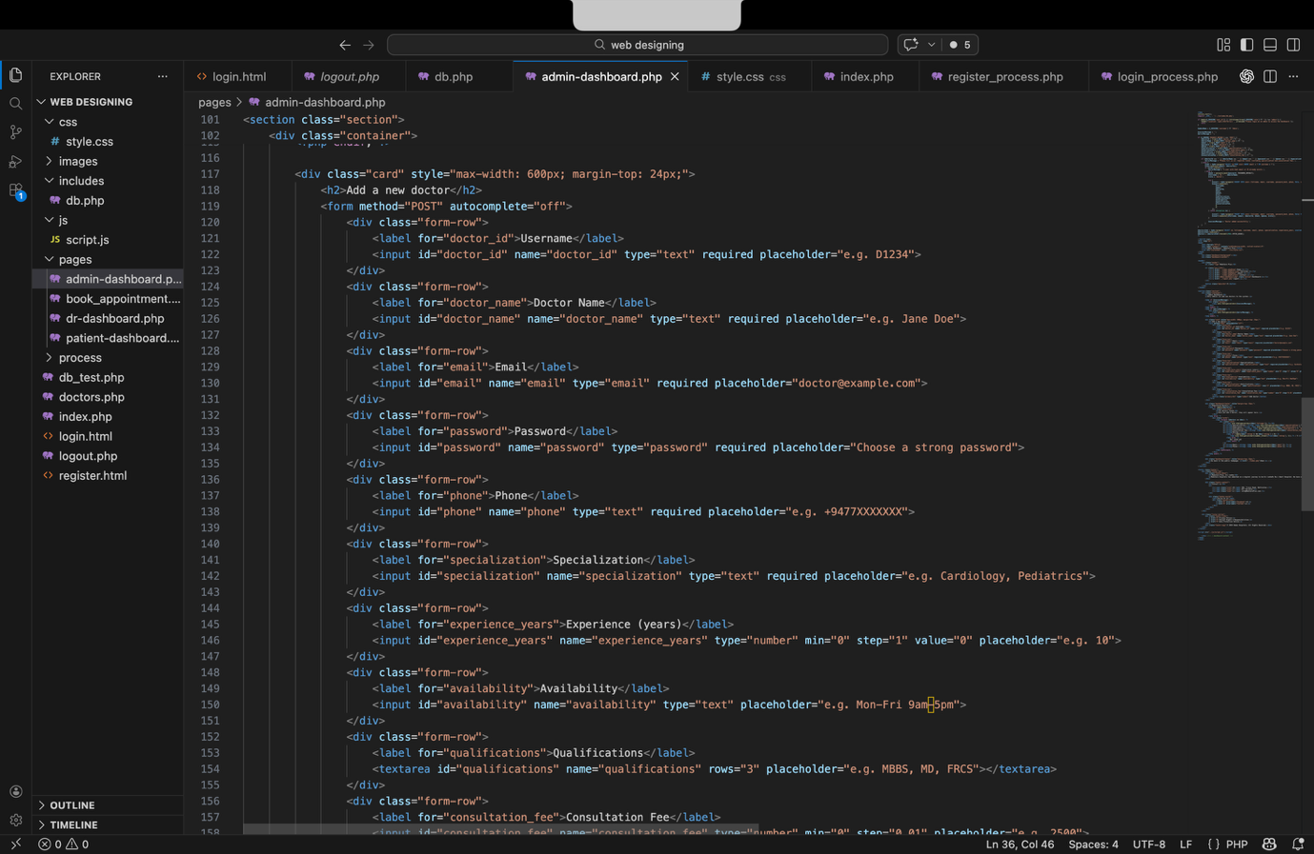
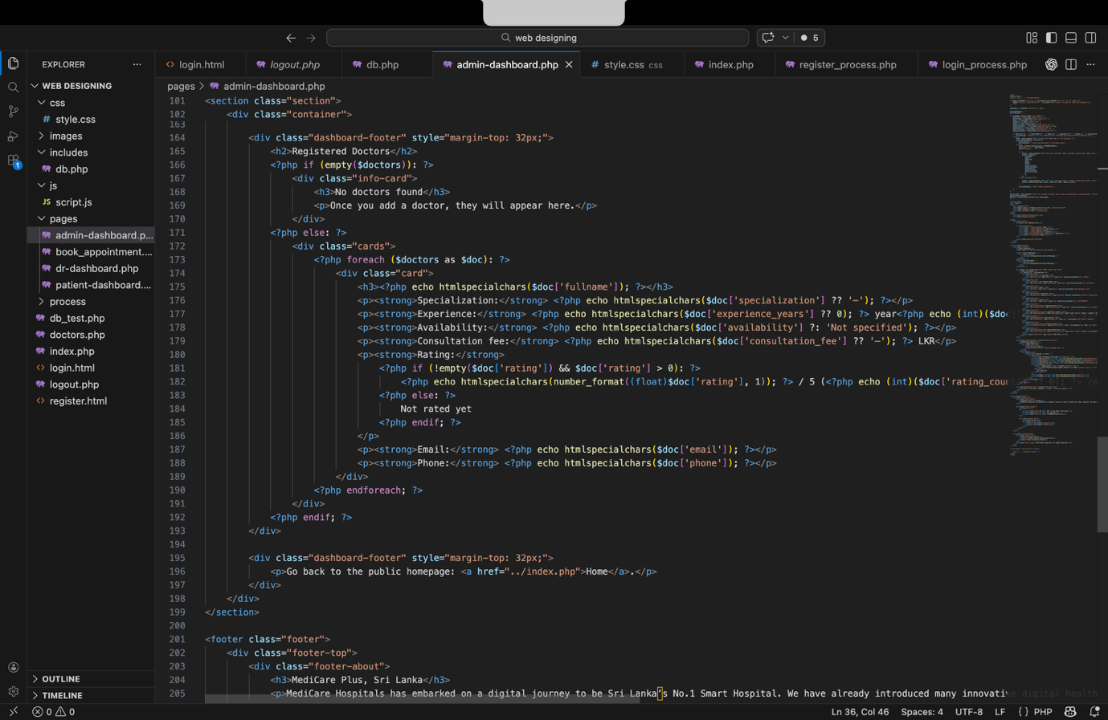
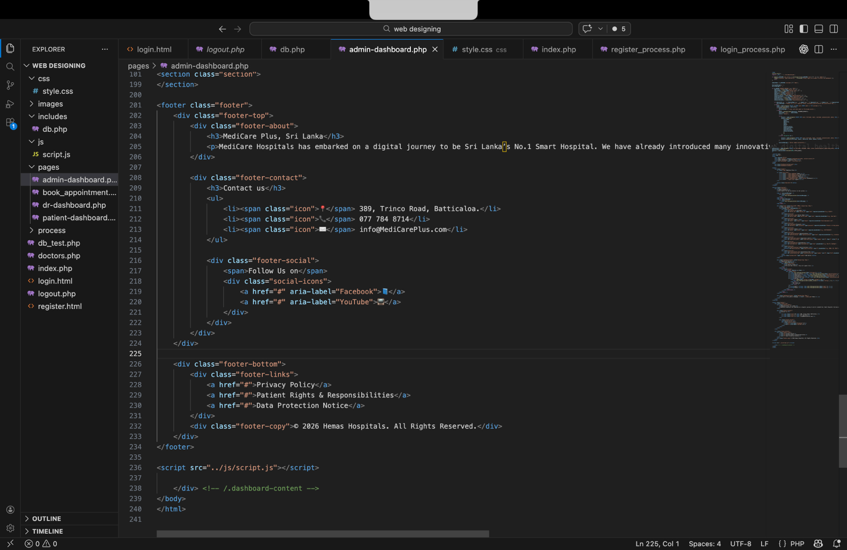

Appointment book.php

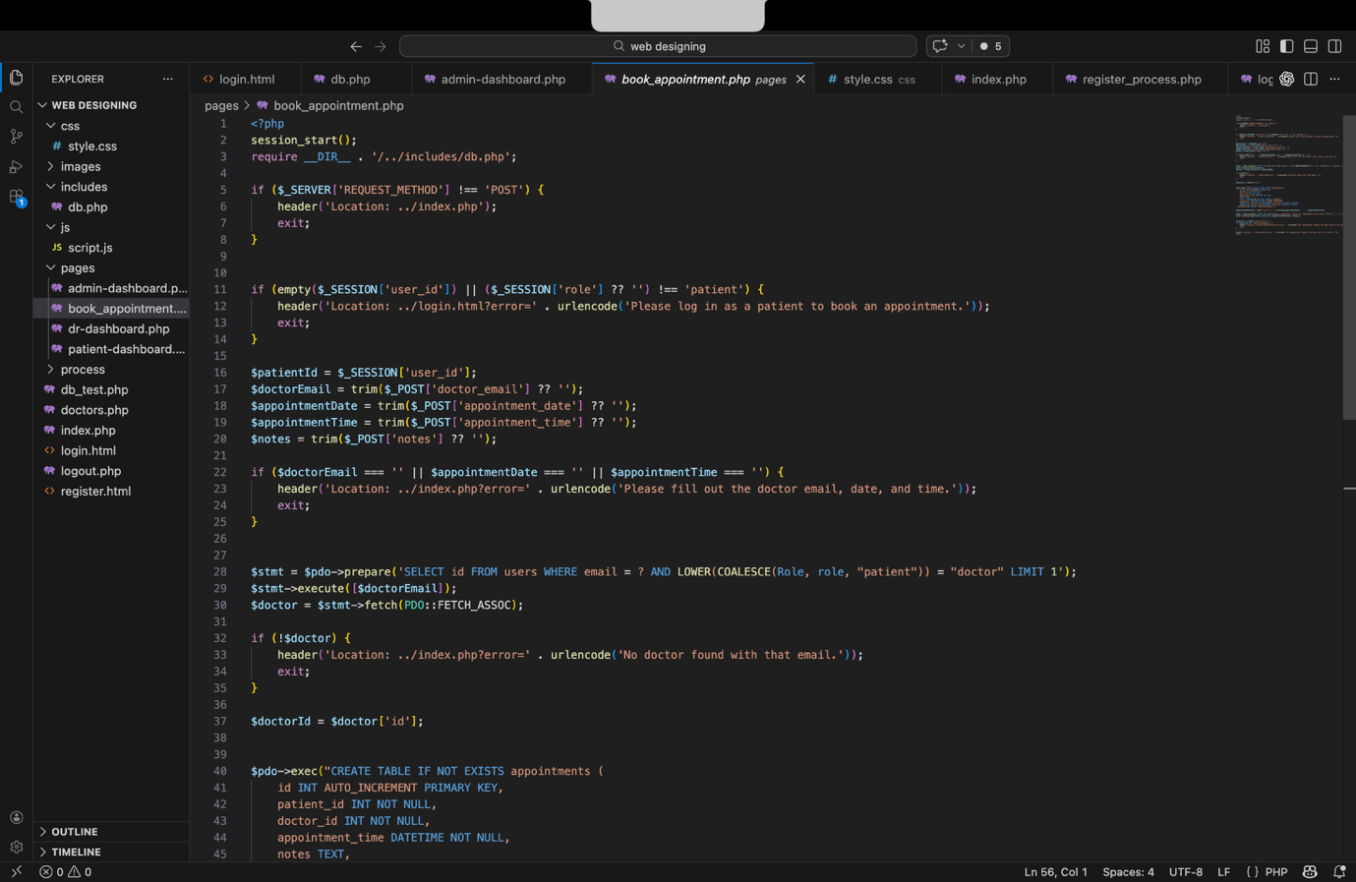
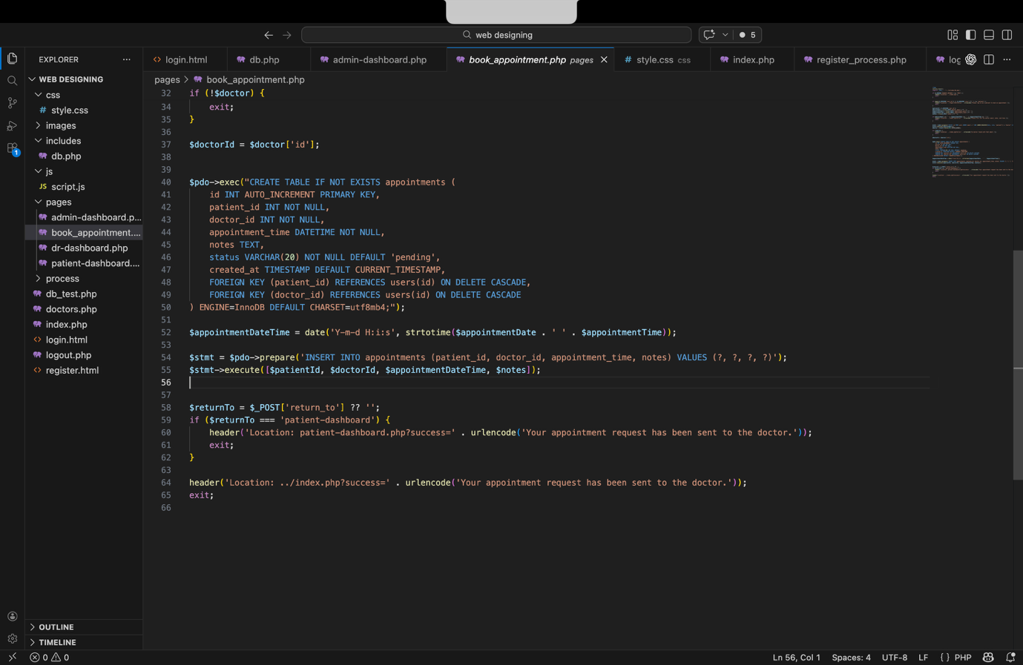

Doctor dashboard.php

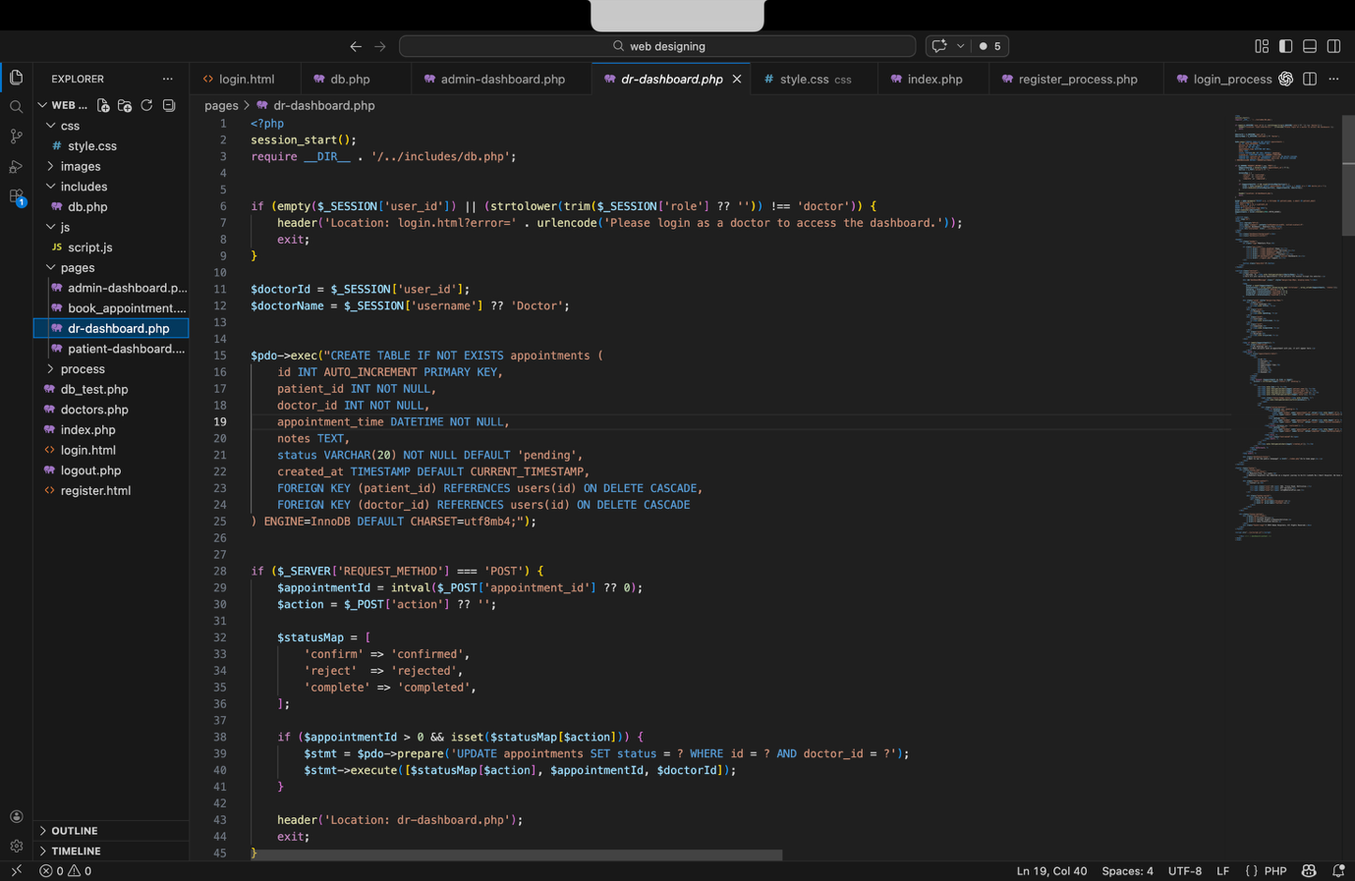
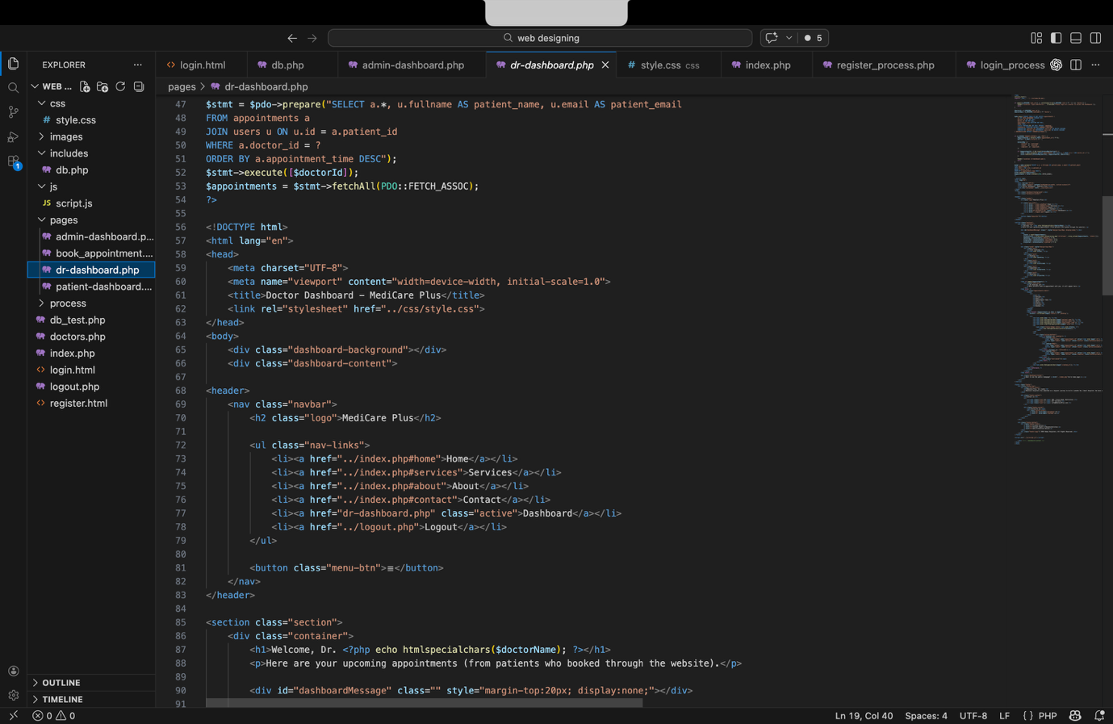
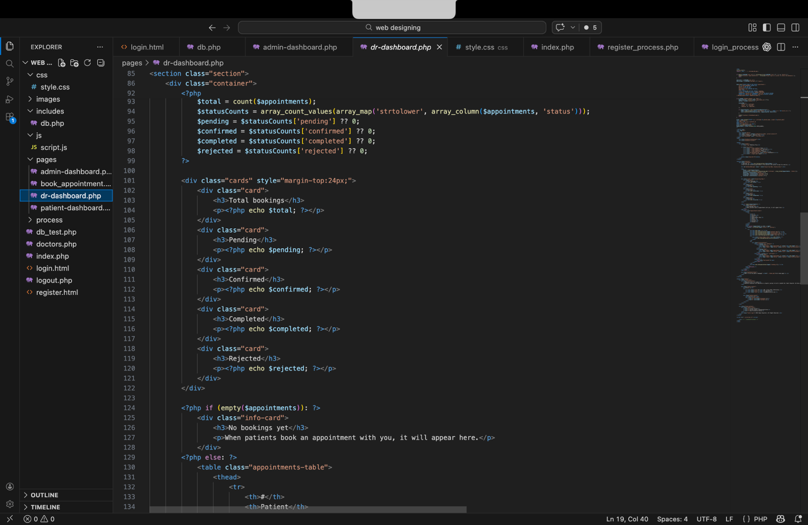
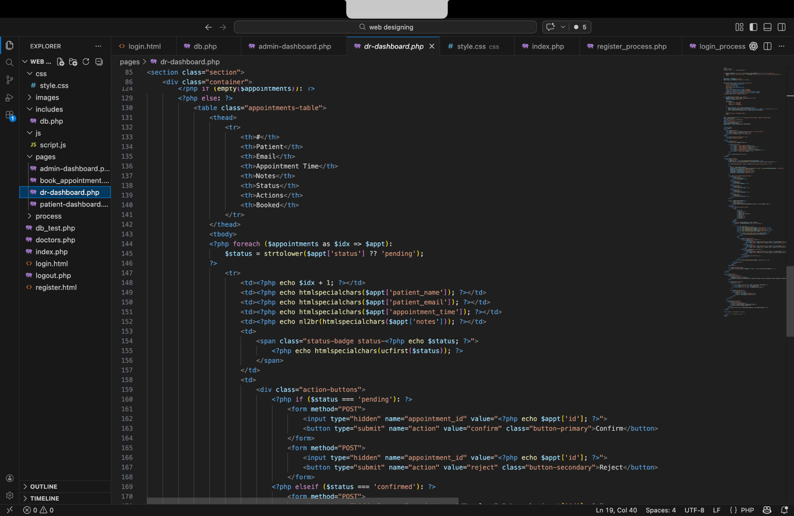
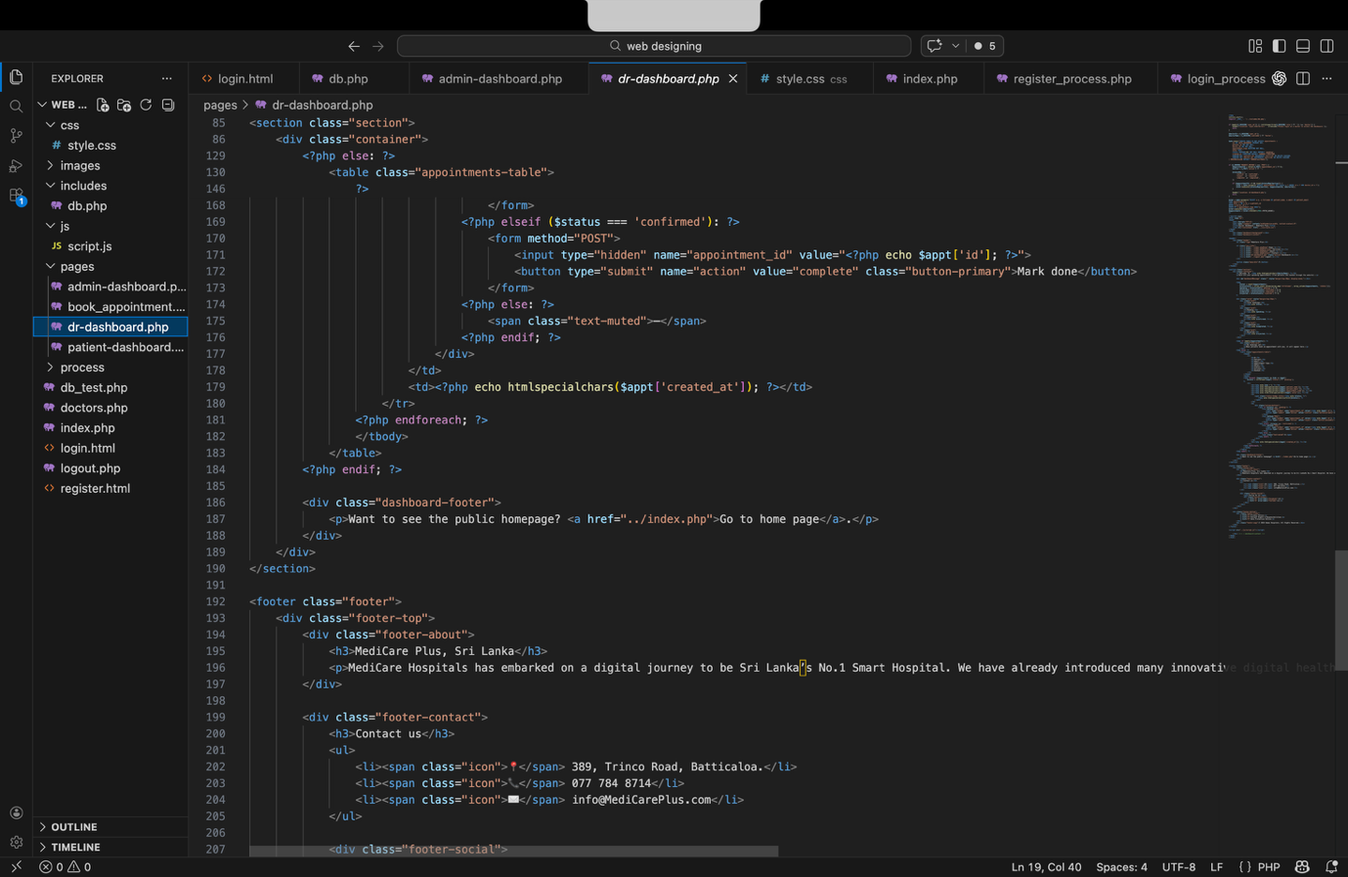
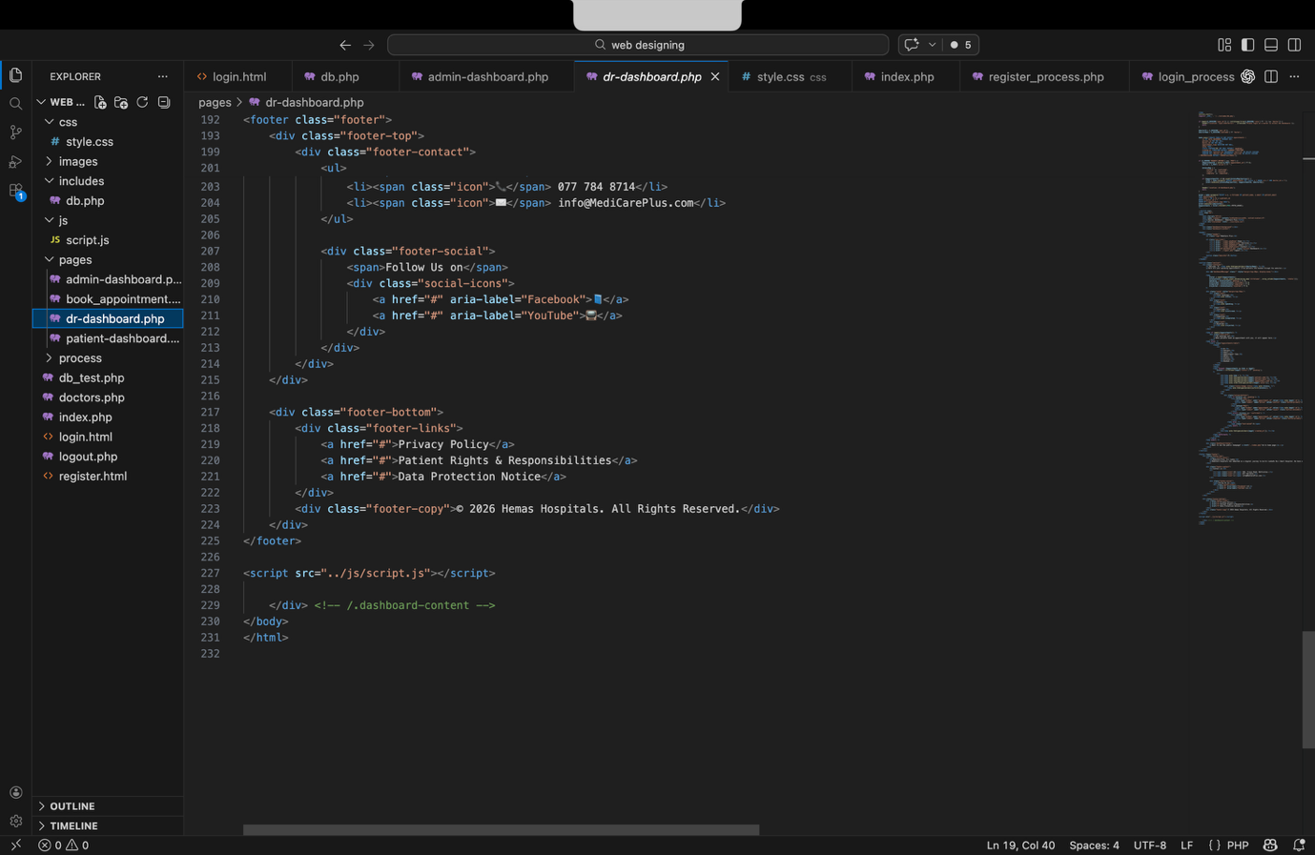

4. Task 03 – System Testing and Evaluation

Testing is an important stage in software development because it ensures that the system works correctly and meets user requirements.

4.1 Testing Overview
Several testing methods were used to evaluate the MediCare Plus system.
Functional Testing
Functional testing ensures that each feature of the system works correctly. This includes login functionality, appointment booking, and report access.
Usability Testing
Usability testing evaluates how easy it is for users to interact with the system.
User Acceptance Testing
Real users test the system and provide feedback about its performance and usability.

4.2 Test Plan
The test plan outlines the features to be tested and the expected outcomes.
Test ID | Feature | Expected Result
T01 | User Login | User successfully logs into system
T02 | Patient Registration | New patient account created
T03 | Appointment Booking | Appointment saved in database
T04 | Doctor Search | Correct doctor list displayed
T05 | Medical Report Access | Patient can download report

4.3 Test Cases

Test Case 1 – User Login
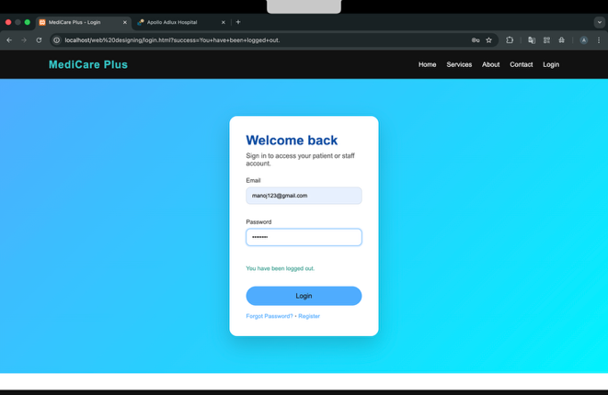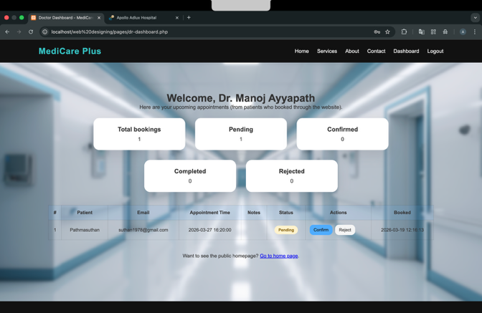
Input: Valid email and password
Expected Result: User redirected to dashboard
Actual Result: Login successful
Status: Pass

Test Case 2 – Appointment Booking
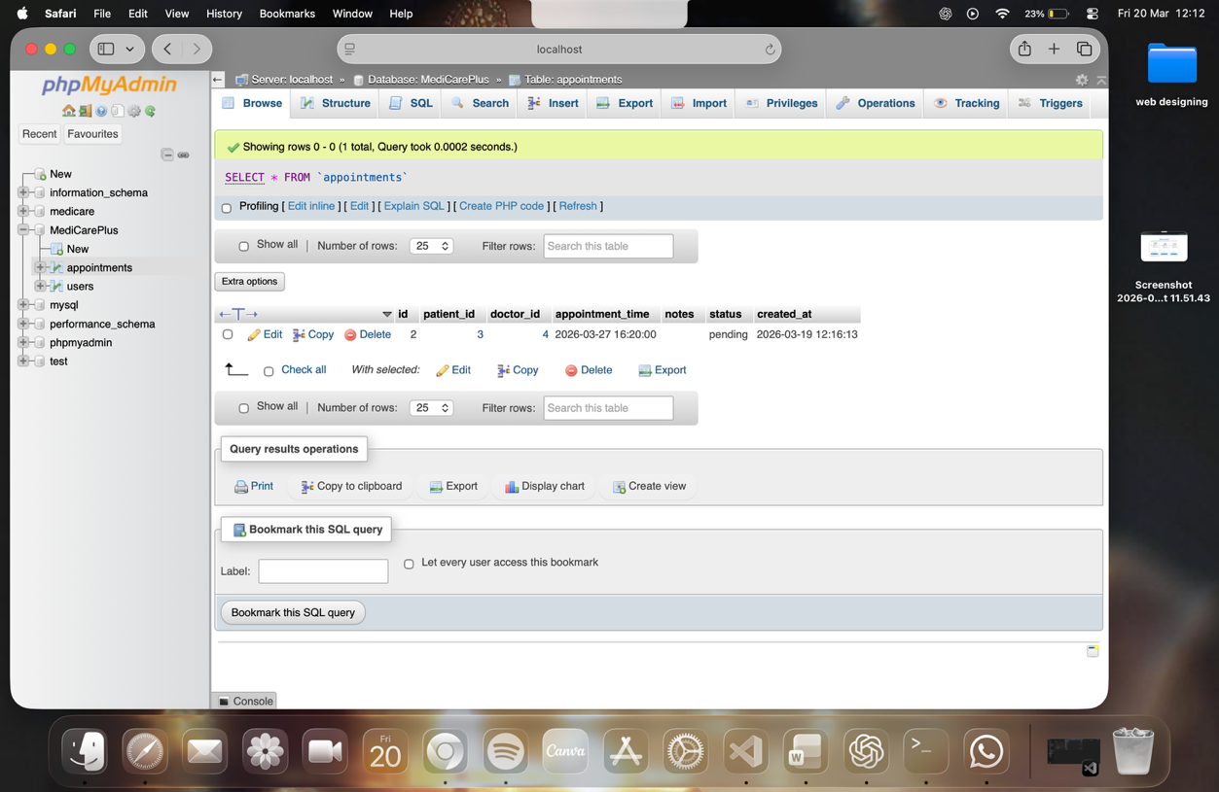
Input: Doctor selection and time slot
Expected Result: Appointment saved
Actual Result: Appointment stored in database
Status: Pass

5. Conclusion

The MediCare Plus web application was developed to improve healthcare service delivery through an integrated digital platform. The system allows patients to book appointments, access medical reports, and communicate with doctors online. At the same time, doctors and administrators can efficiently manage patient information and appointments.Through the planning and design phase, several existing healthcare websites were analyzed to identify useful features and best design practices. A user-friendly interface and clear website structure were created to ensure smooth navigation and accessibility.
The system was implemented using front-end technologies such as HTML, CSS, JavaScript, and Bootstrap, while back-end functionality was developed using PHP and MySQL. The system was tested using multiple testing techniques including functional testing, usability testing, and user acceptance testing.
The results show that the MediCare Plus system successfully meets the requirements of patients, doctors, and administrators. In the future, additional features such as online payment systems, telemedicine services, and mobile applications can be implemented to further improve the healthcare experience.

Bibliography
Hospitals, A., 2024. apollo hospital offical website. [Online]
Available at: https://www.apollohospitals.com
clinic, M., 2024. Mayo clinic official website. [Online]
Available at: https://www.mayoclinic.org
NHS, 2026. National Health Service website. [Online]
Available at: https://nhs.uk
W3School, 2026. web development tutorials. [Online]
Available at: https://www.w3school.com
network, m. d., 2026. Web development guide. [Online]
Available at: https://developer.mozilla.org

