

Mobile Application Development

CSE5011 WRIT1

Qualification |  | Module Number and Title
HD in Computing and Software Engineering |  | Mobile Application Development- CSE5011
Student Name & No. |  | Assessor
BT/HDCSE/CMU/14/12  Pathmasuthan Adsayan |  | Mr.Idhayaraja
Hand out date |  | Submission Date
2026-01-14 |  | 2026-05-29
Assessment type  Podcast Video |  | Weighting of Assessment  50%

Table of Contents
Table of Contents 1
TASK A — Comparison of Mobile Operating Systems and Technologies 1
1. Introduction 1
2. Comparison Between Android and iOS 1
3. Comparison Between Development Tools 1
4. Technologies Used 1
4.1 Java 1
4.2 XML 1
4.3 Firebase 1
4.4 RecyclerView 1
4.5 Activities and Intents 1
TASK B — UML and Database Design 1
1. Use Case Diagram 1
2. Activity Diagram 1
3. Class Diagram 1
4. ER Diagram 1
TASK C — User Interface Design 1
1. Splash Screen 1
2. Login Screen 1
3. Registration Screen 1
4. Home Screen 1
5. Booking Screen 1
6. Tracking Screen 1
7. Profile Screen 1
TASK D — Application Development 1
1. Application Architecture 1
2. Authentication Module 1
3. Database Integration 1
4. Validation Mechanisms 1
5. Notifications 1
TASK E — Testing 1
TASK F — Documentation 1
1. User Documentation 1
Step 1 — Install the Application 1
Step 2 — Register Account 1
Step 3 — Login 1
Step 4 — Book Repair Service 1
Step 5 — Track Repair Status 1
2. Technical Documentation 1
Conclusion 1
References 1

TASK A — Comparison of Mobile Operating Systems and Technologies

1. Introduction
The rapid growth of smartphone technology has increased the demand for mobile applications in various industries. Mobile applications help users perform tasks efficiently and conveniently through smartphones. The TechCare Services application was developed to provide electronic repair and maintenance services through a mobile platform. The application enables users to register, browse available services, book repairs, and track repair progress easily.

The application was developed using Android Studio with Java and XML technologies. Firebase database integration was used for storing and managing user information and service bookings.

2. Comparison Between Android and iOS
Mobile operating systems are essential for running applications on smartphones. The two most popular mobile operating systems are Android and iOS.

Feature | Android | iOS
Developer | Google | Apple
Source Type | Open-source | Closed-source
Device Support | Multiple brands | Apple devices only
Customization | Highly customizable | Limited customization
App Publishing Cost | Lower | Higher
Market Share | Higher global market share | Lower global market share
Security | Good security | Strong security
Flexibility | More flexible | Less flexible

Android is one of the most widely used mobile operating systems globally due to its flexibility and large market share. Android supports multiple device manufacturers such as Samsung, Xiaomi, Oppo, and Vivo. In contrast, iOS is limited only to Apple devices. Android also provides better customization and lower development costs for developers.

iOS provides strong security and optimized performance because both hardware and software are controlled by Apple. However, application publishing in iOS requires Apple devices and higher developer costs.

Android was selected for this project because it provides flexibility, larger user accessibility, and better support for native application development using Java and XML technologies.

References
StatCounter. (2025) Mobile Operating System Market Share Worldwide. Available at: StatCounter Market Share (Accessed: 29 May 2026).

3. Comparison Between Development Tools
Mobile application development requires Integrated Development Environments (IDEs). The main IDEs used for mobile application development are Android Studio and Xcode.

Feature | Android Studio | Xcode
Platform | Android | iOS
Programming Languages | Java, Kotlin | Swift, Objective-C
UI Design Tools | XML Layout Editor | SwiftUI
Emulator Support | Android Emulator | iOS Simulator
Firebase Integration | Easy integration | Moderate integration
Operating System Support | Windows, Linux, macOS | macOS only

Android Studio provides powerful tools for Android application development including emulators, layout editors, debugging tools, and database integration support. The IDE supports Java and XML which were used in this project.

Xcode is the official IDE for iOS application development and supports Swift programming. However, Xcode can only run on macOS devices.

Android Studio was selected for this project because it provides easy Firebase integration, flexible UI design support, and compatibility with Android devices.

References
Google Developers. (2025) Android Studio Overview. Available at: Android Studio Official Website (Accessed: 29 May 2026).

4. Technologies Used
The TechCare Services application was developed using several technologies to ensure better performance and functionality.

4.1 Java
Java was used as the main programming language for implementing application logic, validations, and backend functionality. Java provides object-oriented programming features and strong Android support.

4.2 XML
XML was used for designing the user interface layouts of the application. XML enables developers to create responsive and visually organized layouts.

4.3 Firebase
Firebase was used as the cloud database solution for storing user details, repair bookings, and notifications. Firebase provides real-time database functionality and authentication services.

4.4 RecyclerView
RecyclerView was used for displaying service categories and repair lists efficiently within the application.

4.5 Activities and Intents
Android Activities and Intents were used to manage navigation between application screens such as login, registration, booking, and profile pages.

References
Firebase. (2025) Firebase Documentation. Available at: Firebase Official Documentation (Accessed: 29 May 2026).
Oracle. (2025) Java Documentation. Available at: Java Documentation (Accessed: 29 May 2026).

TASK B — UML and Database Design

1. Use Case Diagram
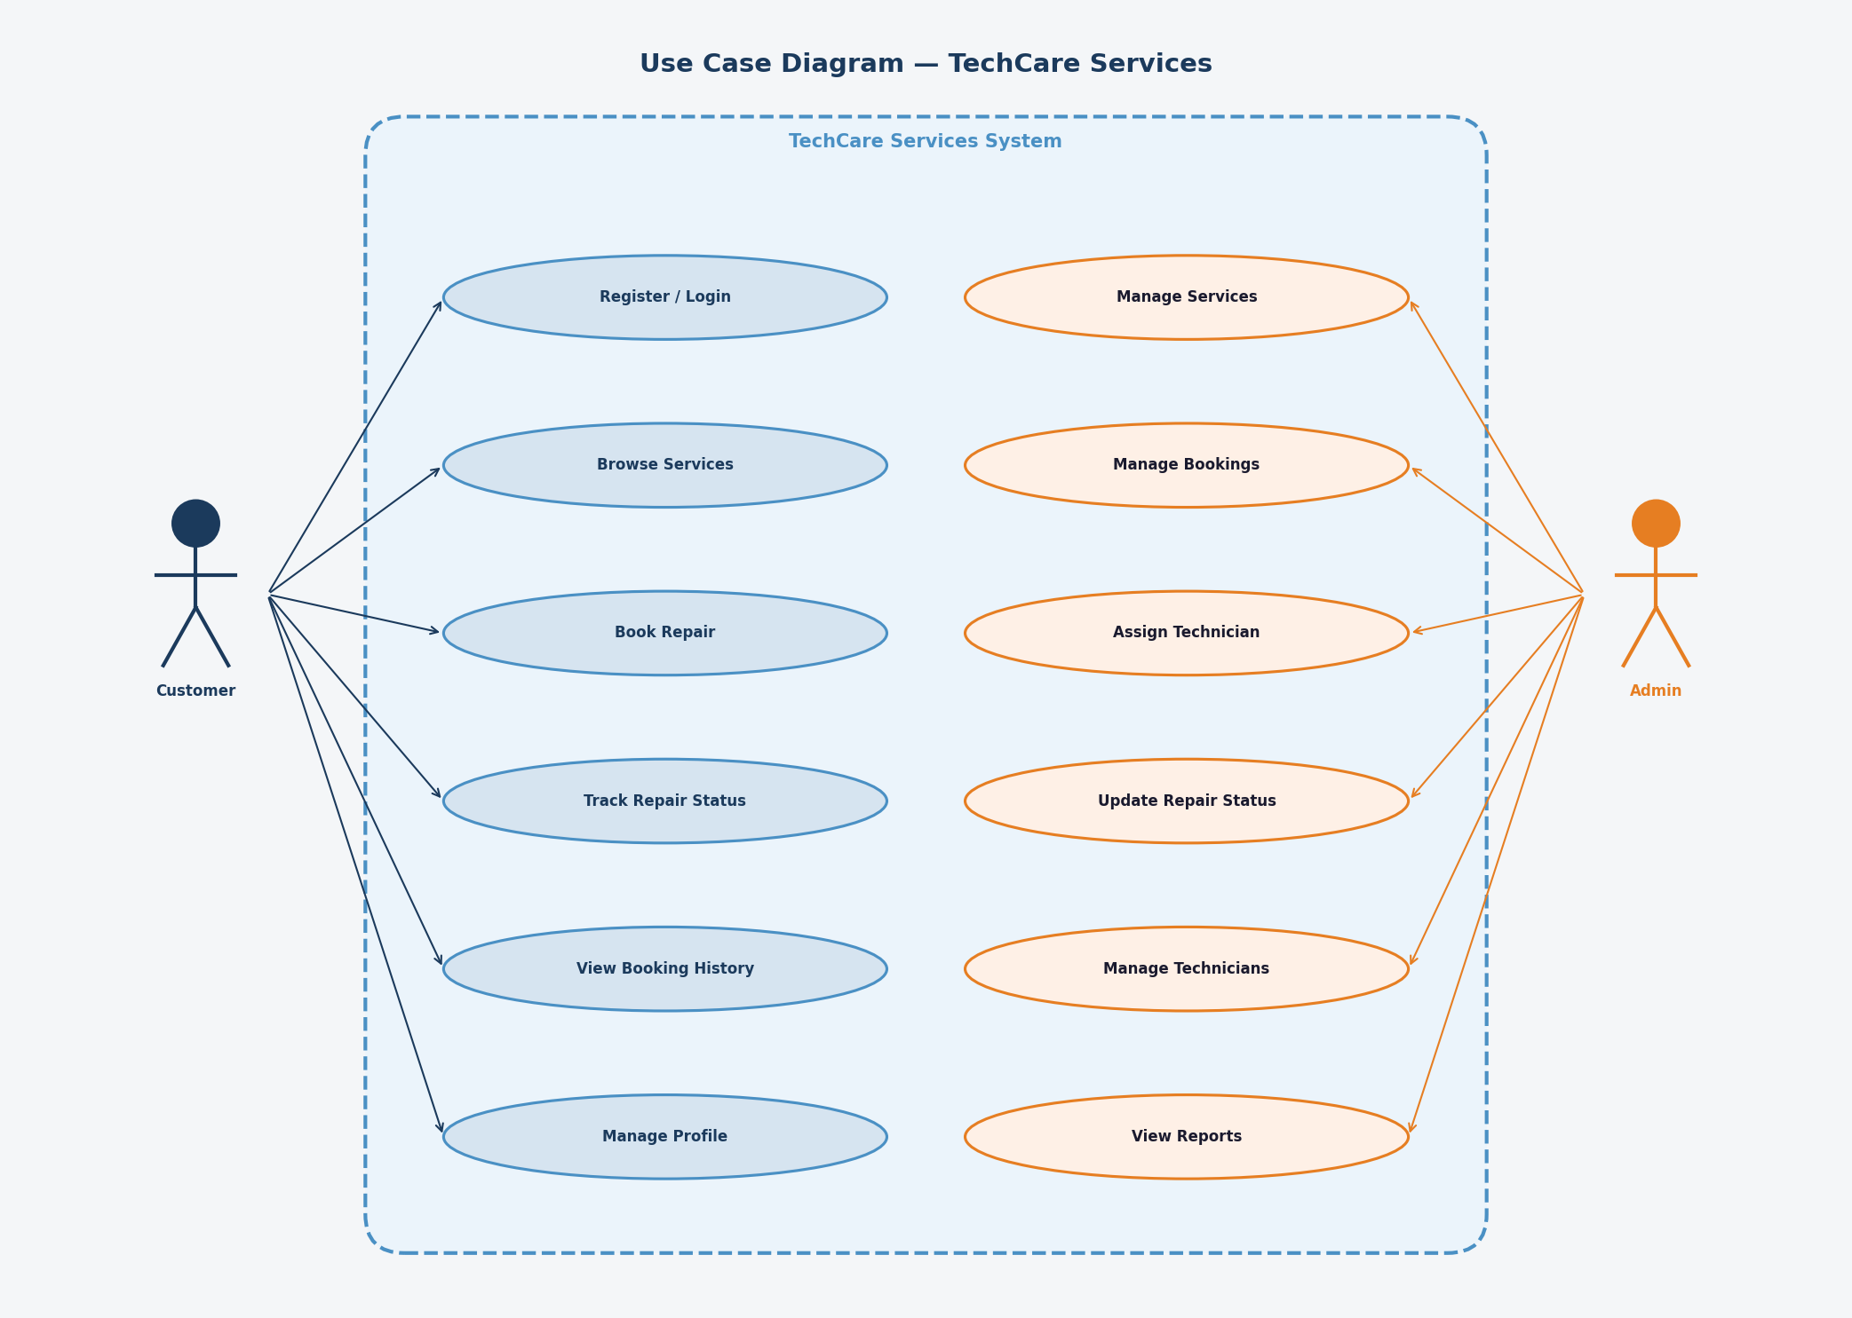
Figure: Use Case Diagram — TechCare Services
Explanation
The use case diagram illustrates the interactions between actors and the system. The Customer actor can register, log in, browse services, book a repair, track repair status, view booking history, and manage their profile. The Admin actor can manage services, manage bookings, assign technicians, update repair statuses, manage technicians, and view reports.

2. Activity Diagram
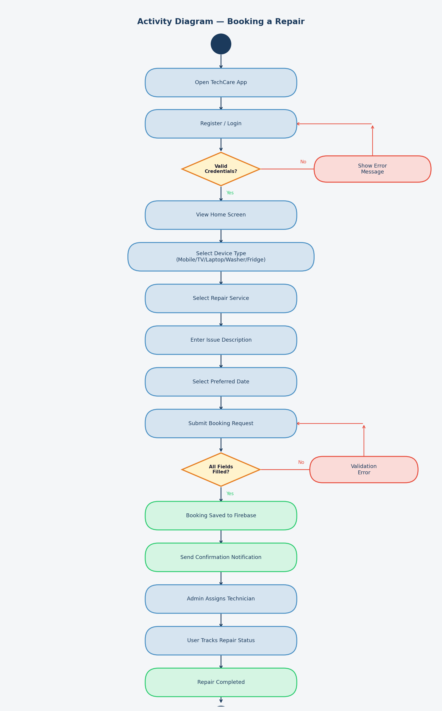
Figure: Activity Diagram — Booking a Repair
Explanation
The activity diagram demonstrates the step-by-step workflow of booking a repair. The process begins when the user opens the app and logs in. After successful credential validation, the user selects a device type (Mobile, TV, Laptop, Washer, or Fridge), chooses a repair service, describes the issue, and selects a date before submitting the booking. If any field is empty, a validation error is shown. On successful submission, the booking is saved to Firebase, a confirmation notification is sent, an admin assigns a technician, and the user can then track the repair status until completion.

3. Class Diagram
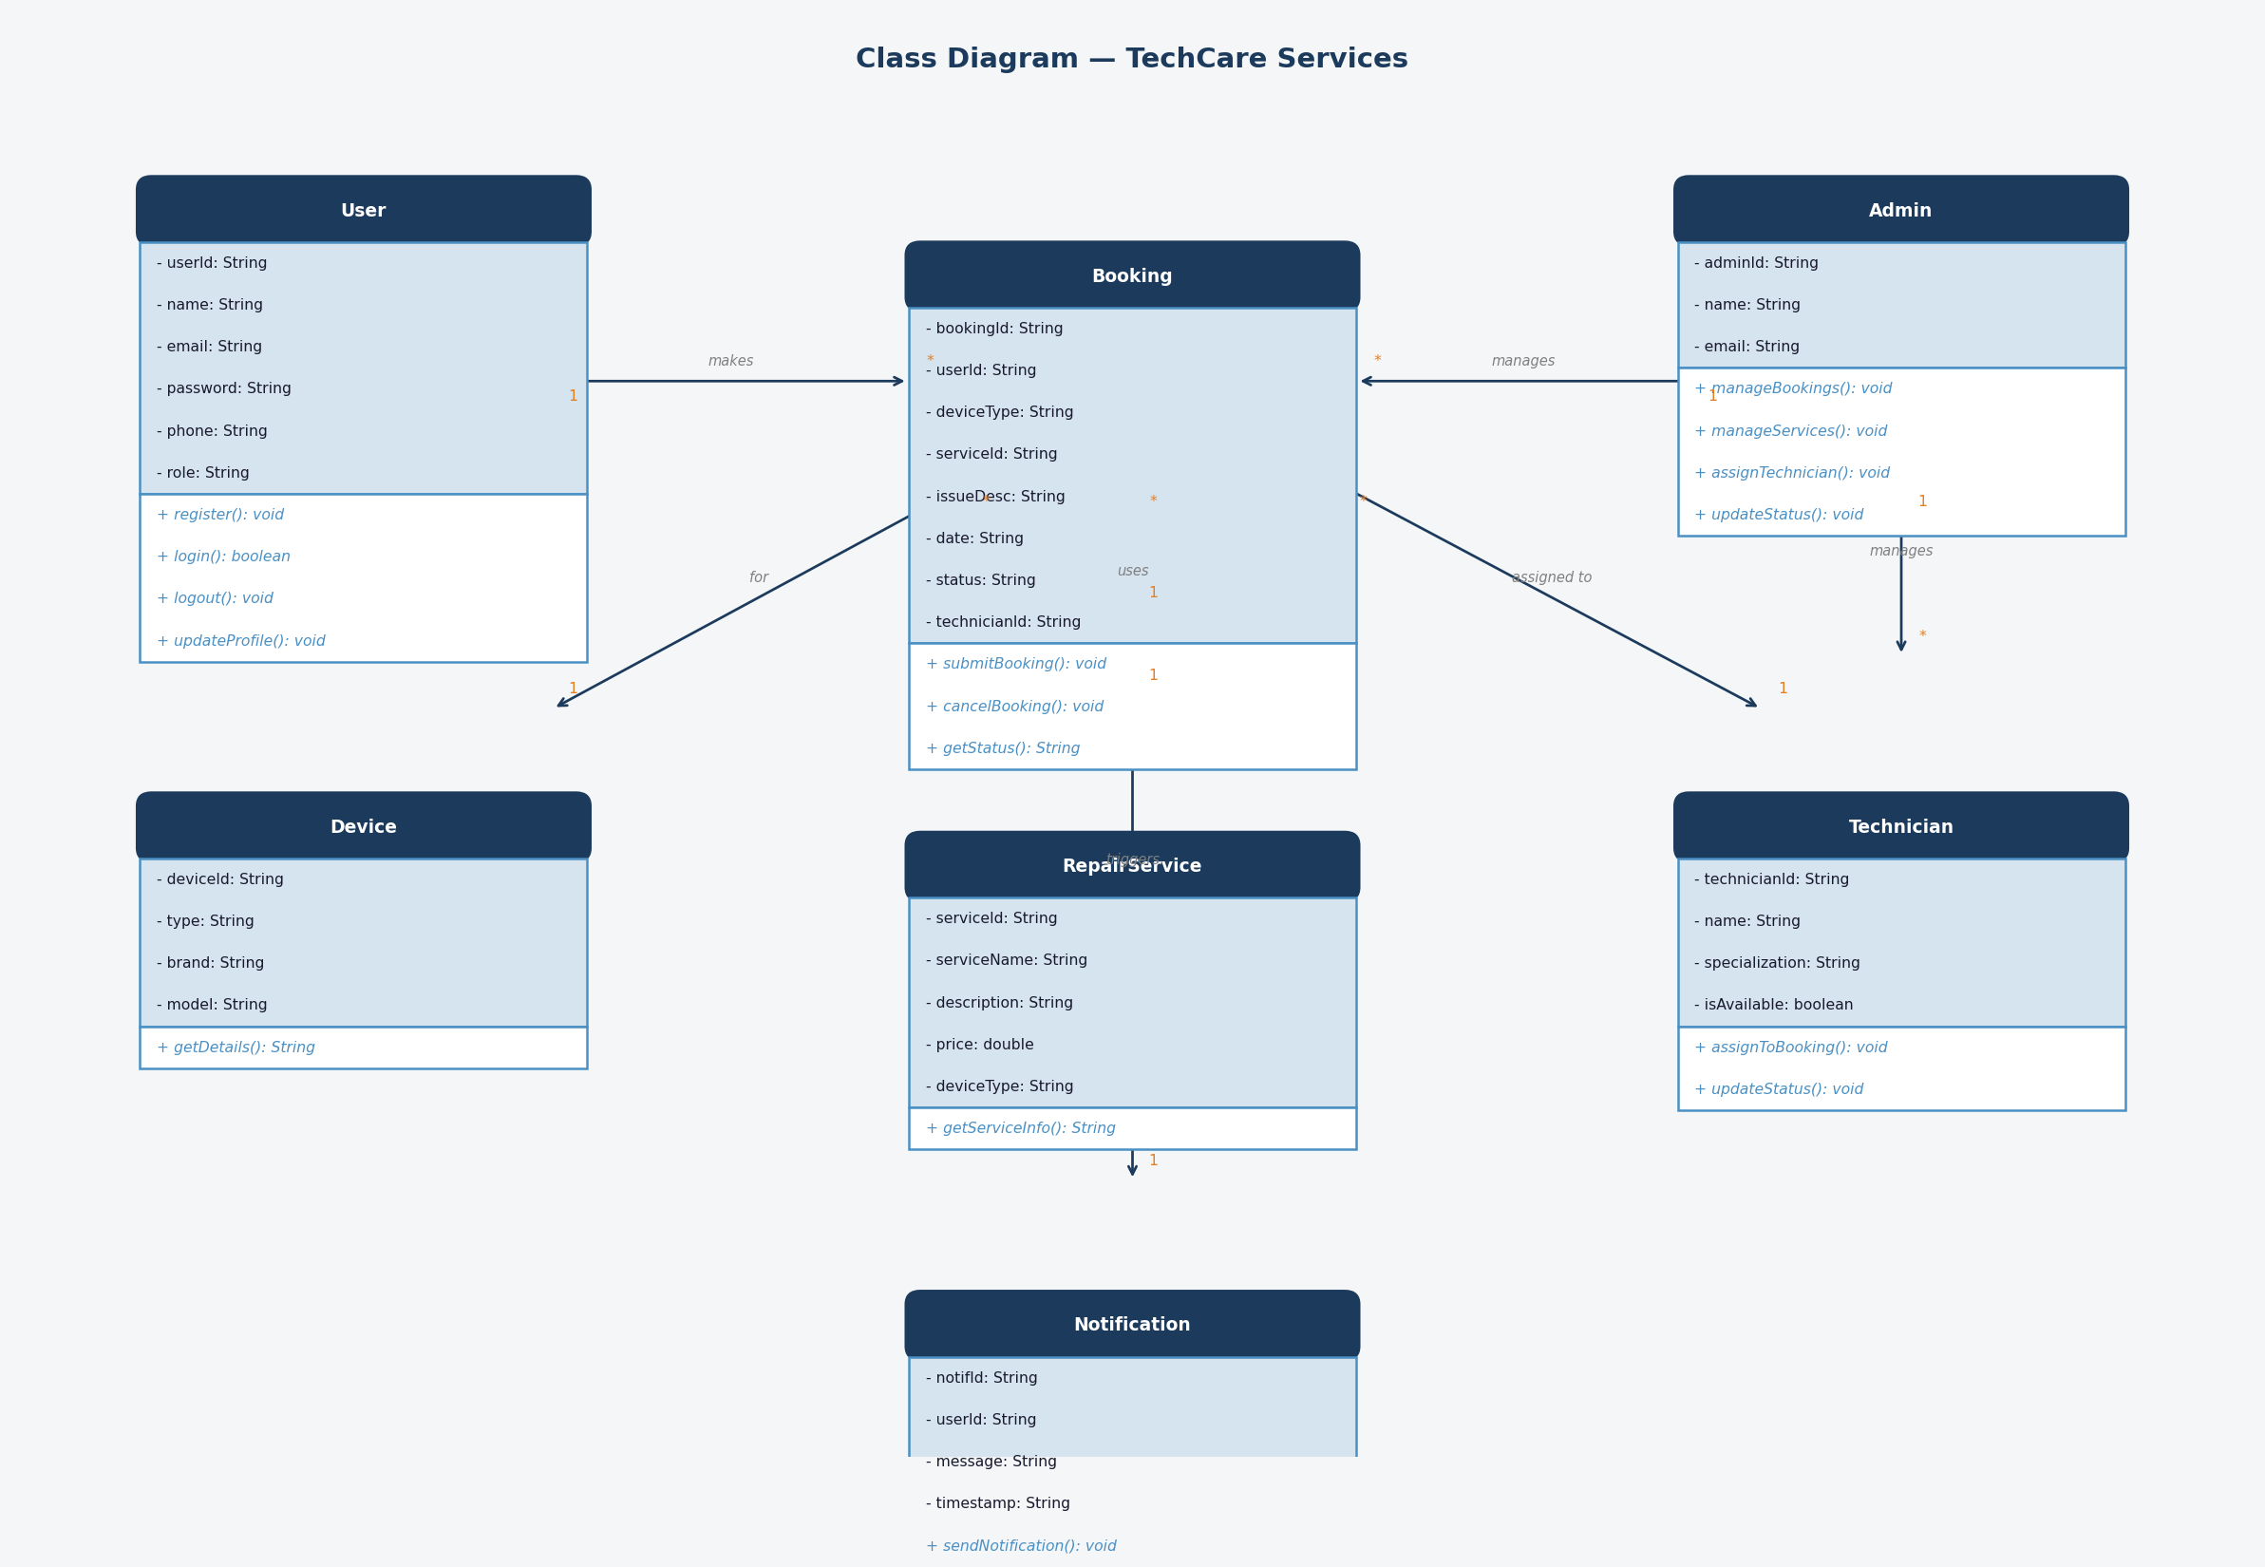
Figure: Class Diagram — TechCare Services
Explanation
The class diagram represents the object-oriented structure of the TechCare Services application. The main classes are User, Admin, Booking, Device, RepairService, Technician, and Notification. A User can make multiple Bookings (1 to many). Each Booking is associated with one Device, one RepairService, and one Technician. The Admin manages Bookings, Services, and Technicians. A Booking triggers one Notification to inform the user of updates.

4. ER Diagram
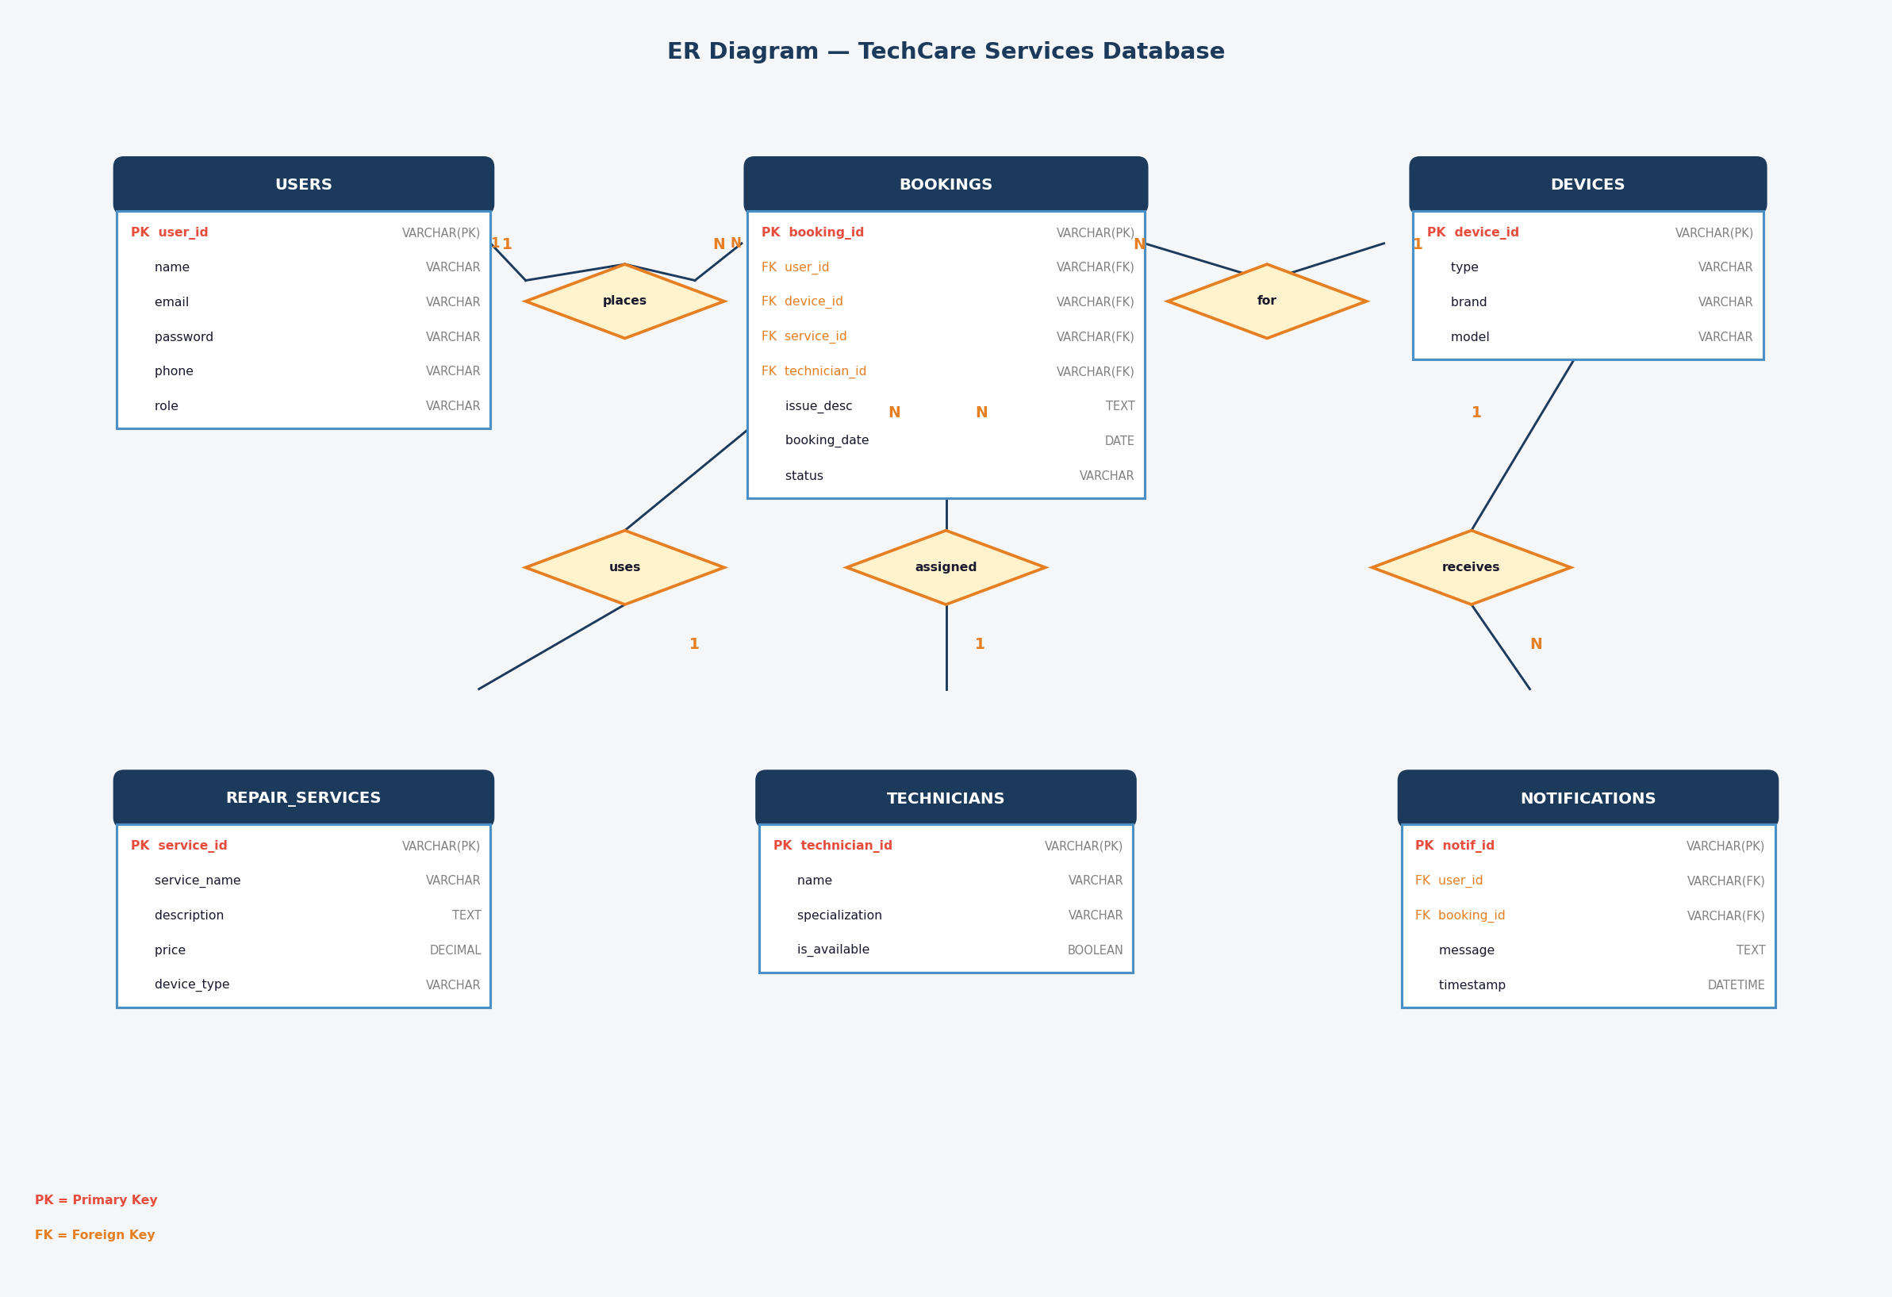
Figure: ER Diagram — TechCare Services Database
Explanation
The ER diagram represents the database structure of the TechCare Services application. The USERS table stores customer information and connects to BOOKINGS through a one-to-many relationship. The BOOKINGS table acts as the central entity, linking to DEVICES, REPAIR_SERVICES, and TECHNICIANS via foreign keys. The NOTIFICATIONS table stores messages triggered by booking events and references both USERS and BOOKINGS. All tables are normalized to avoid data redundancy.

TASK C — User Interface Design

1. Splash Screen

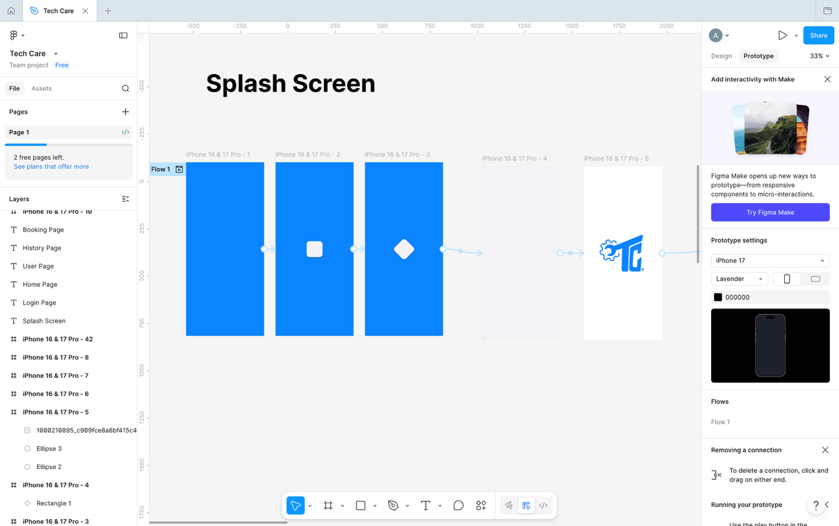SCREEN SCREENSHOT HERE

The splash screen was designed to provide branding and improve the first impression of the application. A minimal and modern design was used to create a professional appearance.

2. Login Screen

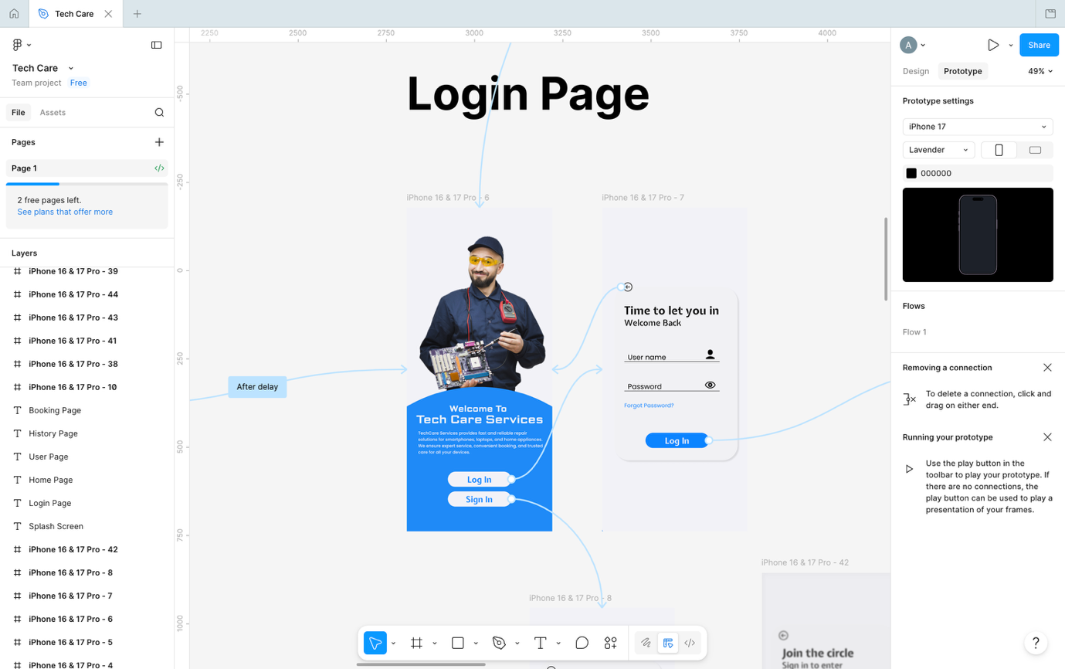
The login screen allows users to access their accounts securely. Input validation was implemented to prevent empty fields and invalid login attempts.

Key Elements:
- Email input field
- Password input field
- Login button
- Validation messages
- Simple UI design

3. Registration Screen

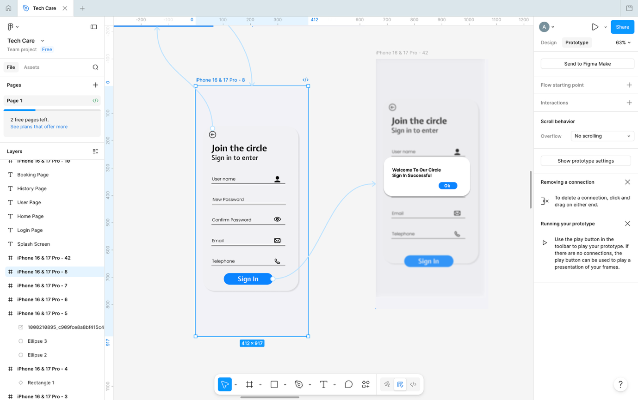

Explanation
The registration screen enables new users to create accounts. User details such as name, email, and password are validated before registration.

Key Elements:
- User registration form
- Password validation
- User-friendly interface
- Navigation to login page

4. Home Screen

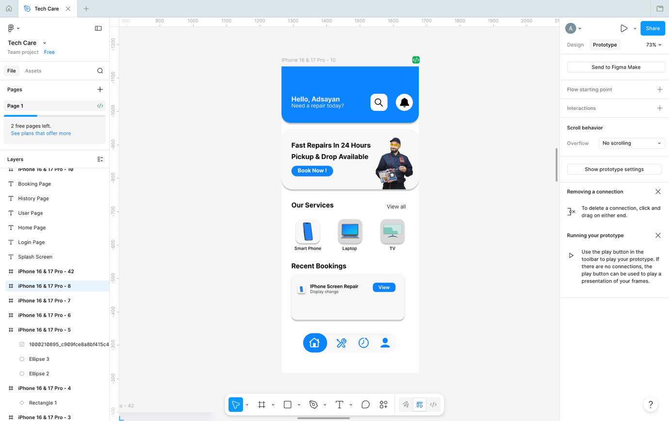

Explanation
The home screen displays available electronic repair services using card layouts and RecyclerView components for better navigation and user experience.

Key Elements:
- Service categories
- RecyclerView / cards
- Navigation menu
- Icons and colors

5. Booking Screen

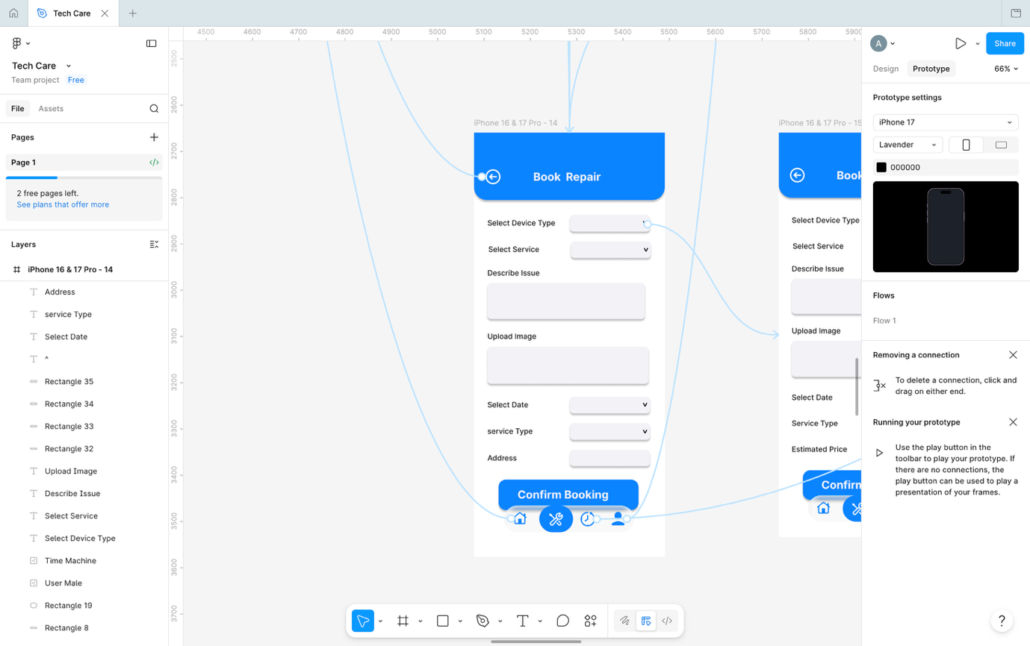

Explanation
The booking screen allows users to select repair services, enter issue descriptions, and submit repair requests.

Key Elements:
- Input fields
- Date selection
- Service selection
- Submit button

7. Profile Screen

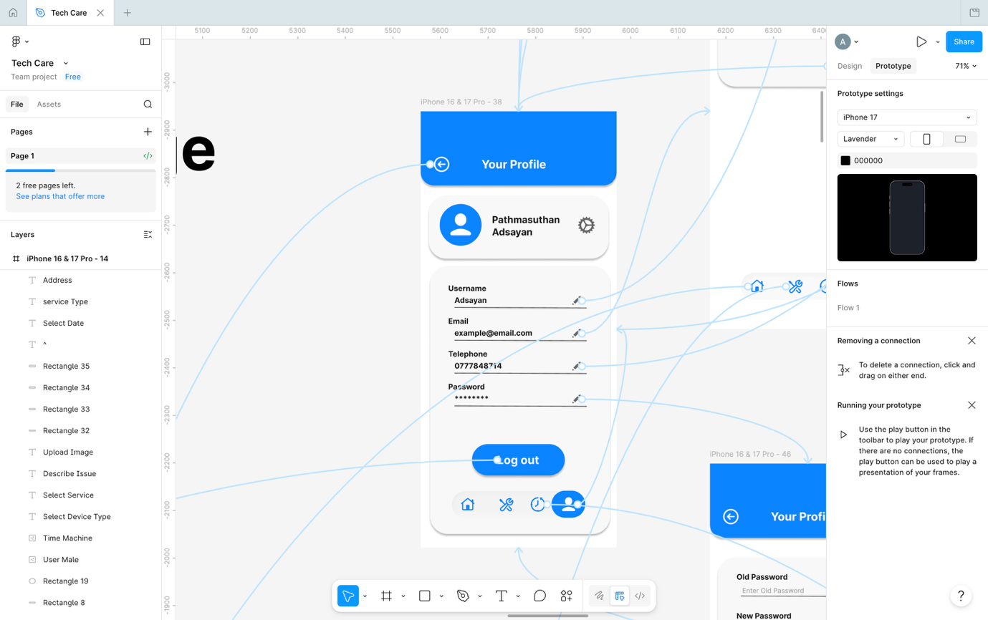

Explanation
The profile screen displays user information and provides logout functionality.

TASK D — Application Development

1. Application Architecture
The application architecture consists of frontend user interfaces developed using XML and backend logic implemented using Java. Firebase database integration was used for storing user information and repair bookings.

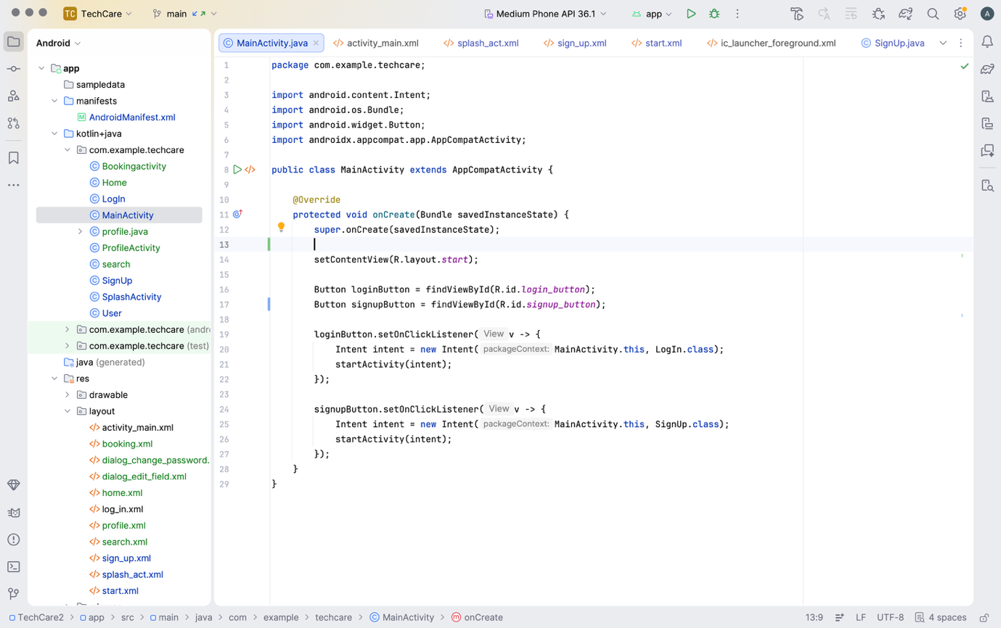

2. Authentication Module
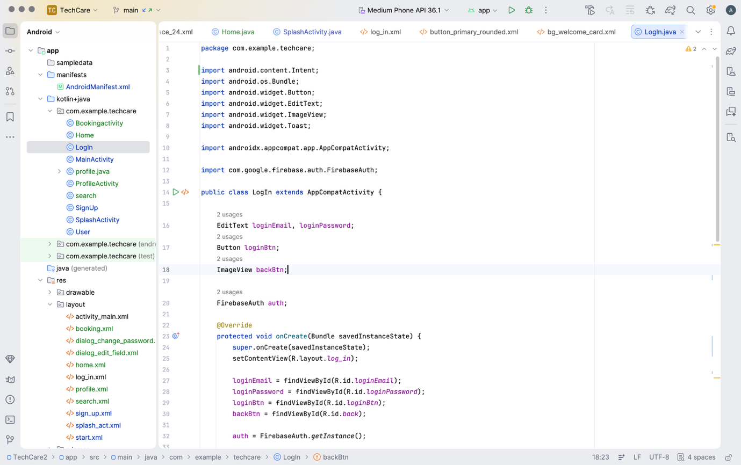
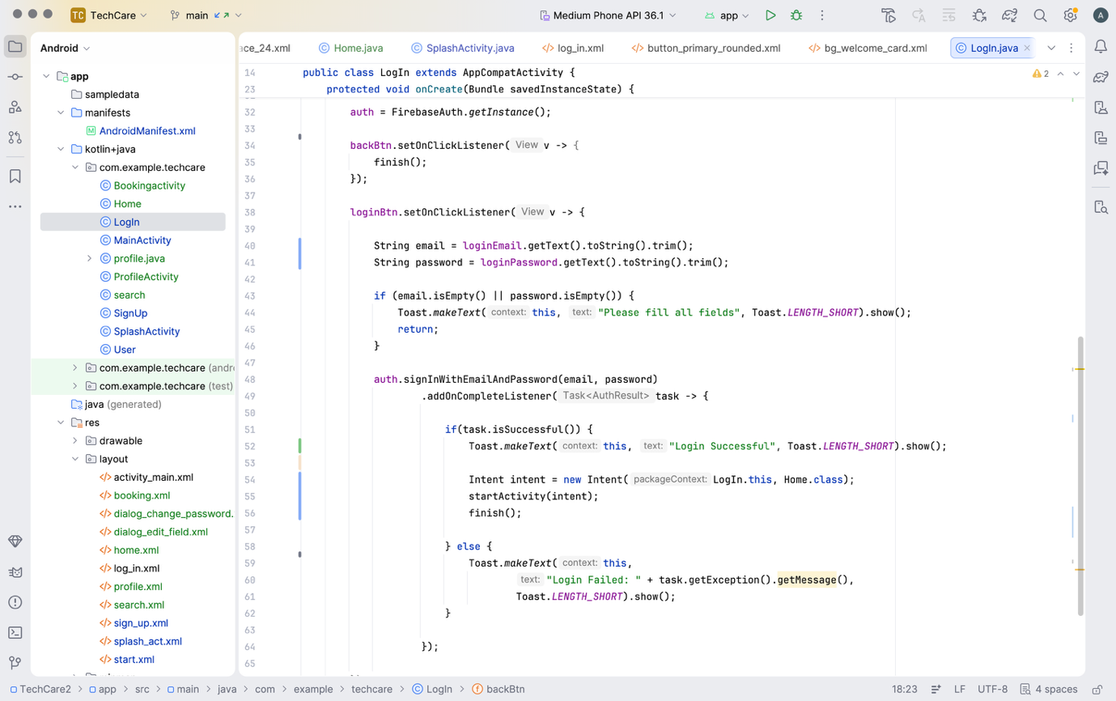

Explanation
The authentication module was developed using Firebase Authentication services. Users can register and log in securely using email and password authentication.

3. Database Integration

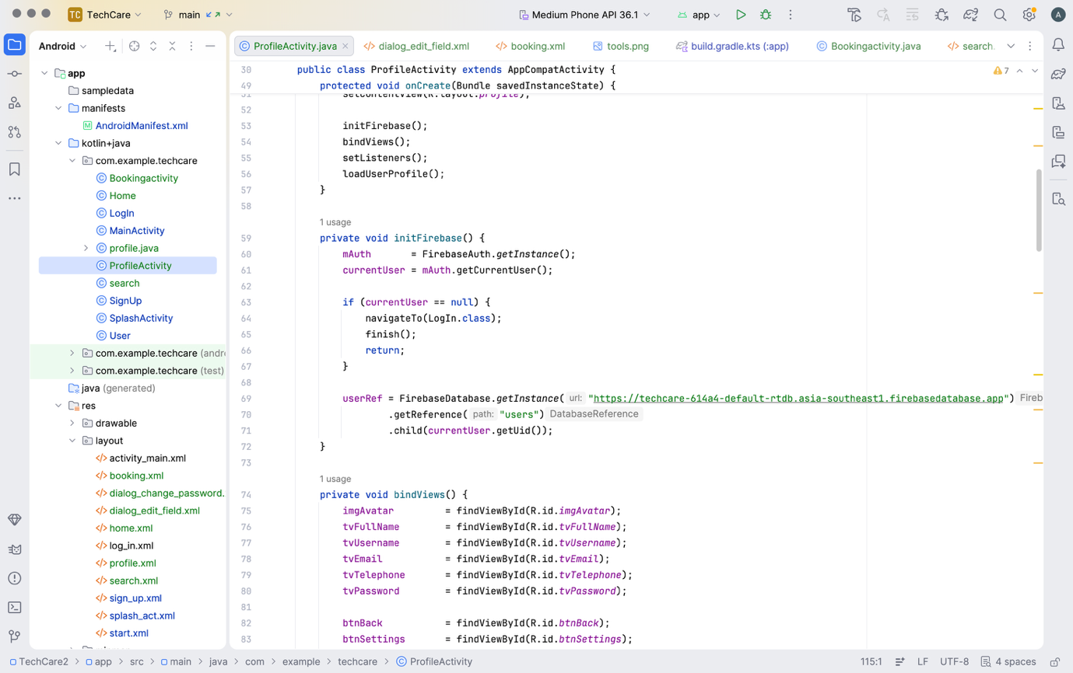

Explanation
Firebase Realtime Database was used to store user information, bookings, and notifications. CRUD operations were implemented for data management.

4. Validation Mechanisms

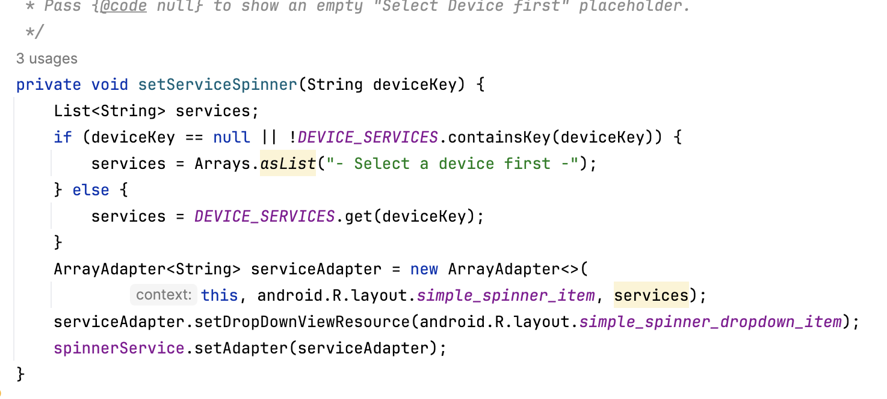
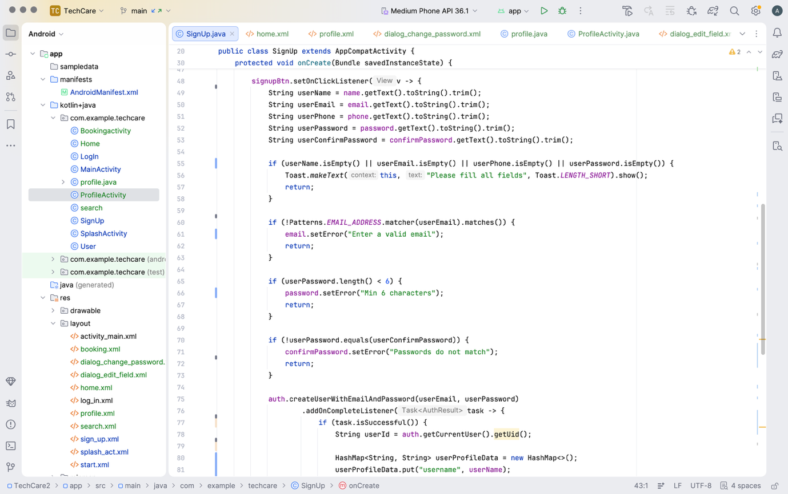
Explanation
Validation mechanisms were implemented to improve security and prevent invalid data submissions.

TASK E — Testing

Test Case ID | Function | Input | Expected Result | Actual Result | Status
TC01 | Login | Correct credentials | Login successful | Successful | PASS
TC02 | Login | Empty email | Error message | Displayed | PASS
TC03 | Registration | Invalid email | Validation error | Displayed | PASS
TC04 | Booking | Empty issue field | Error message | Displayed | PASS
TC05 | Booking | Valid details | Booking success | Successful | PASS
TC06 | Logout | Logout button click | User logged out | Successful | PASS

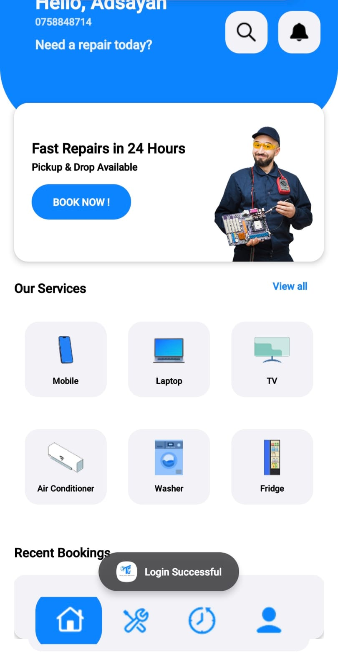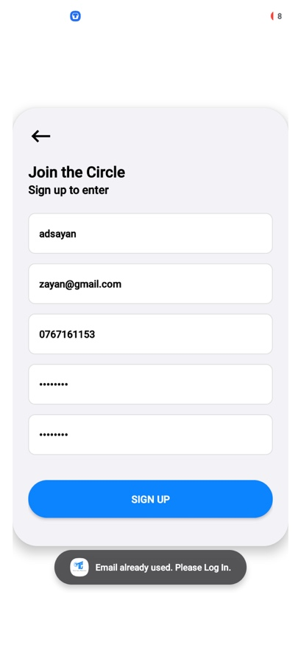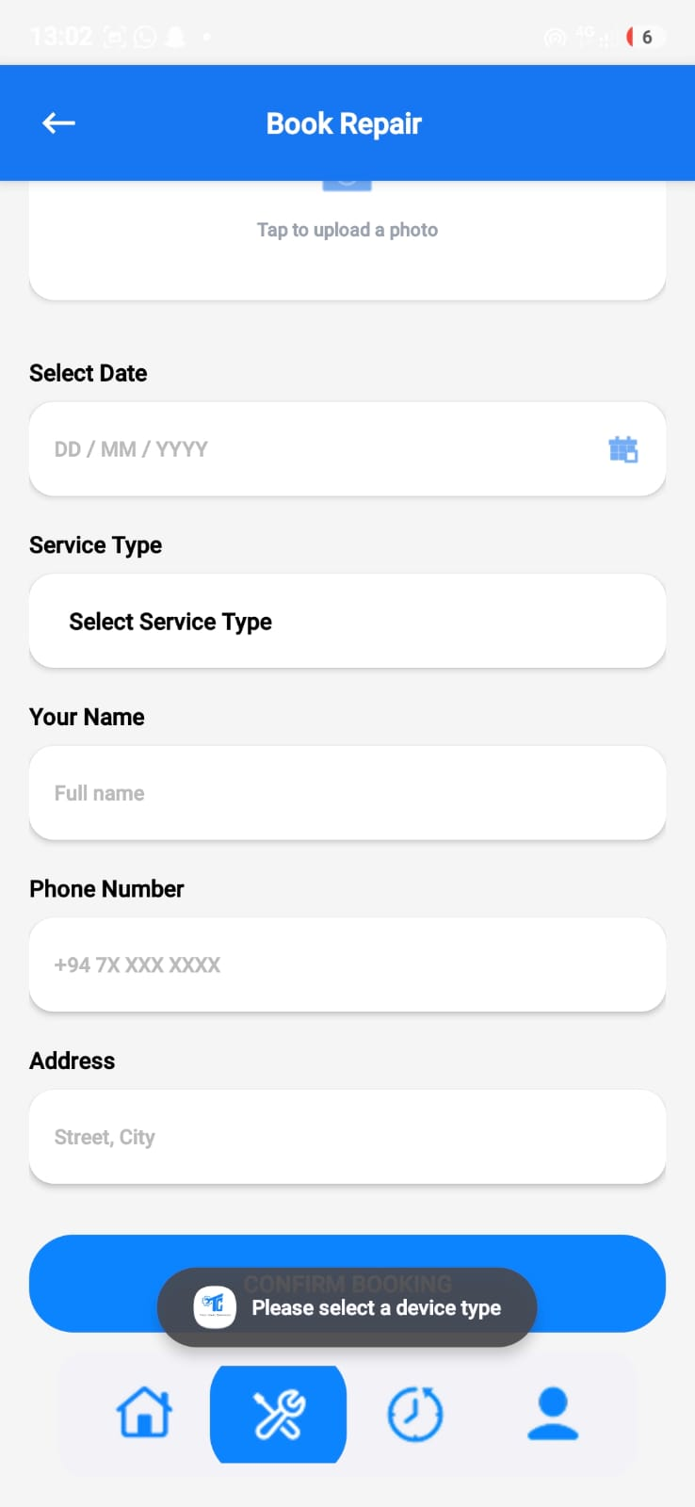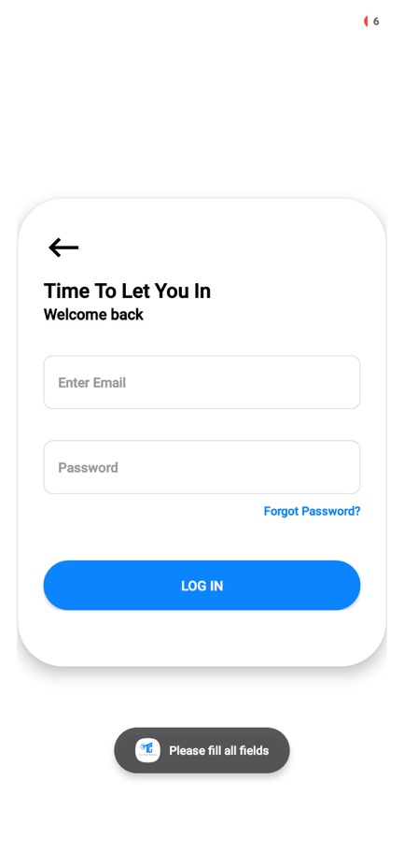

TASK F — Documentation

1. User Documentation

Step 1 — Install the Application
Users install the APK file on Android devices.

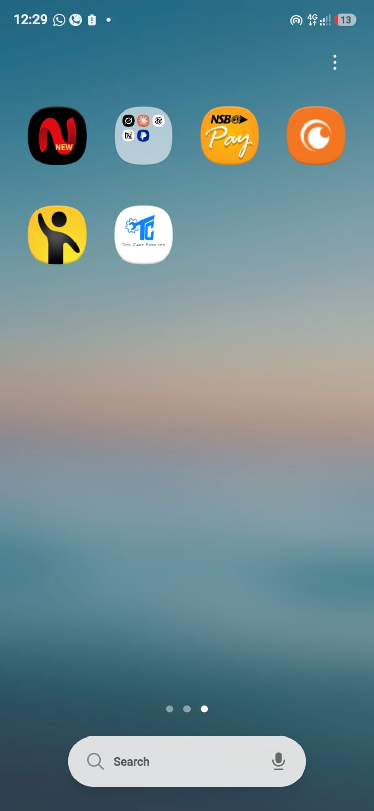

Step 2 — Register Account
Users create accounts using the registration form.
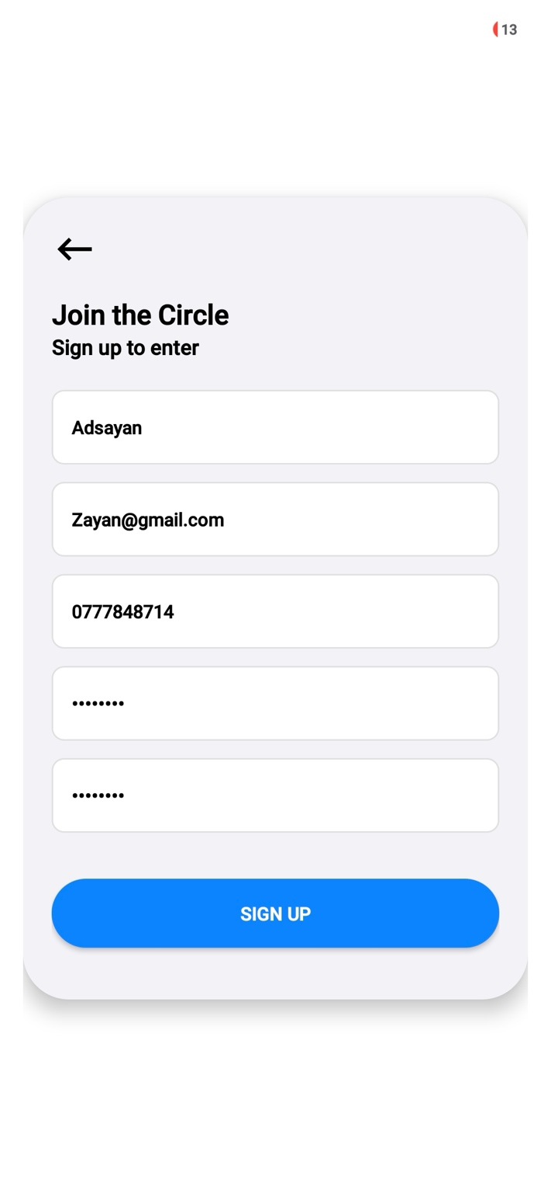

Step 4 — Search Service
Users can search any kind of services.
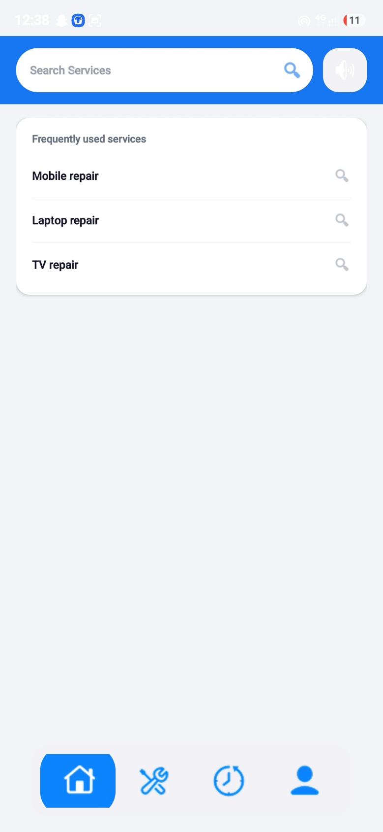

Step 5 — Book Repair Service
Users select services and submit repair requests.

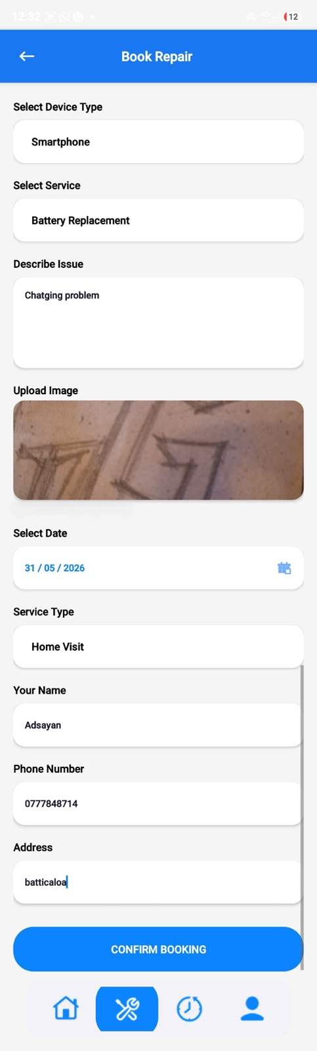

2. Technical Documentation

Component | Technology
IDE | Android Studio
Programming Language | Java
UI Design | XML
Database | Firebase
SDK | Android SDK 34

Conclusion

The TechCare Services mobile application was successfully developed to make it easier for users to request and manage electronic repair services through their mobile devices. Throughout the development process, technologies such as Java, XML, and Firebase were used to build a functional and user-friendly Android application. Features including user authentication, service booking, repair tracking, validations, and notifications were implemented to improve both usability and overall user experience. The project also helped in gaining practical knowledge in mobile application development, UI/UX design, database integration, and testing procedures. Overall, the application achieved its main objectives and provided a simple and efficient solution for electronic service management.

References

Firebase. (2025) Firebase Documentation. Available at: Firebase Official Site (Accessed: 29 May 2026).
Google Developers. (2025) Android Studio Overview. Available at: Android Developers Website (Accessed: 29 May 2026).
Oracle. (2025) Java Documentation. Available at: Oracle Java Documentation (Accessed: 29 May 2026).
StatCounter. (2025) Mobile Operating System Market Share Worldwide. Available at: StatCounter Website (Accessed: 29 May 2026).

