# 一、CocosCreator

#### 1、导入NBMediation.js

#### 2、初始化

* 1. this.nbsdk = new NBMediation();
  2. this.nbsdk.init(this.appid);

appid为聚合id，请联系运营同学。

#### 3、激励视频

if(this.nbsdk.isRewardedVideoReady()){

this.nbsdk.showRewardedVideo();

}

#### 4、插屏

if(this.nbsdk.isInterstitialReady()){

this.nbsdk.showInterstitial();

}

激励视频和插屏由Mediation自动管理库存，开发者不需要关心具体填充的广告位ID。

Banner为开发者手动管理。

#### 5、Banner

* 1. 调用this.nbsdk.loadBanner(this.bannerID);
  2. 监听isBannerReady(this.bannerID)
  3. 展示this.nbsdk.showBanner(this.bannerID);

可参考CocosCreatorSample中的RewardedVideo.js。

#### 6、开屏

this.nbsdk. showSplash (appid, appname, placementid);

参数全部为穿山甲广告位的信息

# 二、AndroidStudio

#### 1、构建发布，打开AndroidStudio工程

#### 2、proj.android-sutido/build.gradle添加源

maven **{** url "http://maven.mediamvp.cn/repository/maven-releases/" **}**maven **{** url "https://dl.bintray.com/sunjiangrong/maven"**}**maven **{** url "http://test.vlion.cn:8081/nexus/content/repositories/inland/"**}**

将上面源添加到如图所示位置

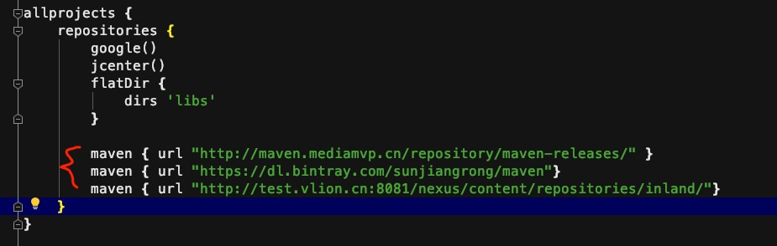

#### 3、app/build.gralde配置

#### 3.1配置到dependencies

implementation 'com.android.support:multidex:1.0.3'  
implementation 'com.android.support:support-v4:28.0.0'  
implementation 'com.android.support:recyclerview-v7:28.0.0'  
implementation 'com.zyt:mediation-only:1.1.7'  
implementation 'com.android.support:cardview-v7:27.1.1'  
  
implementation 'com.mintegral.msdk:videojs:10.2.41'  
implementation 'com.mintegral.msdk:mtgjscommon:10.2.41'  
implementation 'com.mintegral.msdk:playercommon:10.2.41'  
implementation 'com.mintegral.msdk:reward:10.2.41'  
implementation 'com.mintegral.msdk:videocommon:10.2.41'  
implementation 'com.mintegral.msdk:optimizedata:10.2.41'  
implementation 'com.mintegral.msdk:common:10.2.41'  
implementation 'com.mintegral.msdk:alphab:10.2.41'  
implementation 'com.mintegral.msdk:mtgdownloads:10.2.41'  
  
implementation 'com.github.bumptech.glide:glide:4.8.0'  
implementation 'com.android.support:design:28.0.0'  
implementation('cn.vlion.inland:inlandmix:8.4') **{** exclude group: 'cn.vlion.inland', module: 'inlandb'  
 exclude group: 'cn.vlion.inland', module: 'inlandg'  
 exclude group: 'cn.vlion.inland', module: 'inlandt'  
 exclude group: 'cn.vlion.inland', module: 'inlandtf'  
 exclude group: 'pl.droidsonroids.gif'  
 exclude group: 'cn.vlion.inland', module: 'inlandk'  
 exclude group: 'cn.vlion.inland', module: 'inlandimb'  
 exclude group: 'com.squareup.picasso'  
 exclude group: 'com.tuia'  
 exclude group: 'cn.vlion.inland', module: 'inlandhy'  
 exclude group: 'cn.vlion.inland' , module: 'inlandoaid'  
 exclude group: 'cn.vlion.inland', module: 'inlands'  
**}**

#### 3.2配置分包

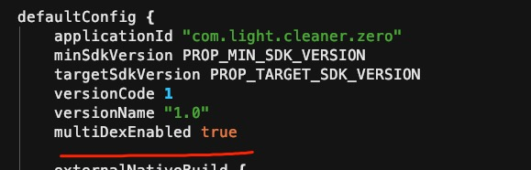

#### 3.3配置<uses-sdk tools:overrideLibrary="com.bun.miitmdid"/>

#### 4、添加SDK

将libs压缩包解压，导入到proj.andorid-studo/libs

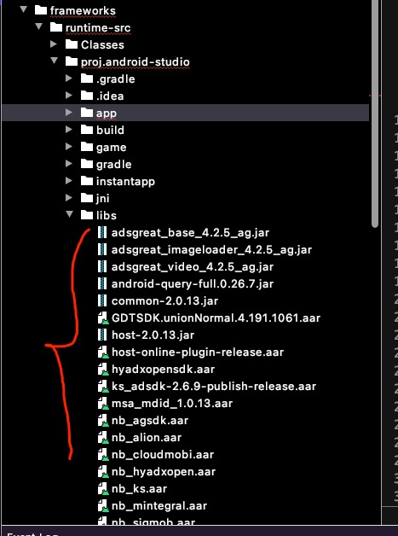

#### 5、添加代码到AppActivity.java

public static void initNBMediation(final String appid){  
 app.runOnUiThread(new Runnable() {  
 @Override  
 public void run() {  
 NmSdk.init(app**,** appid**,** null)**;** }  
 })**;**}  
  
public static void loadBanner(final String appid) {  
 NmSdk.loadBanner(app**,** appid)**;**}  
  
public static void showBanner(final String appid) {  
 NmSdk.showBanner(app**,** appid)**;**}  
  
public static void hideBanner(final String appid) {  
 NmSdk.hideBanner(app**,** appid**,** true)**;**}  
  
public static boolean isBannerReady(final String appid) {  
 return NmSdk.isBannerReady(appid)**;**}

# 附件

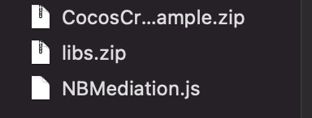

1、CocosCreator的demo工程

2、AndroidStudio使用的原生SDK包

3、CocosCreator中，聚合SDK的js接口封装。