**Request for Proposal**

**Incident Safety System**

**For**

**ION Exchange Limited, Hyderabad.**

Prepared by: Venu Madhav Thirukachi

Document Version: 1.0

Date: 27 Dec 2021

**TABLE OF CONTENTS**

1 Statement of Purpose 3

2 Background and current status 4

3 Scope of work 5

3.1 Project structure 5

3.2 Techincal stack 5

3.3 Hard ware stack 5

4 screens information 6

5 Architecture 7

6 Schedule 8

7 COST 9

8 Deliverables 10

9 MAIntenance 11

10 Contact information 12

# Statement of Purpose

The Purpose of this document is to give the solution for managing the Incident, Safety Management system for ION Exchange Limited.

# Background and current status

At Present ION Exchange is not having any software to enter the data and doing the analysis.

# Scope of work

This section describes the scope of the work. Below are the points

1. Safety Website
2. Integrating to their SSO system
3. Safety Observations
4. Track Incidents
5. Track Incident Investigations
6. Track Kaizen Systems

## Project structure

The project should be developed in MVC, Web API with SQL Server.

## Techincal stack

ASP.NET, C#, MVC, SQL Server, Web API, JQuery

## Hard ware stack

**Development**

* Windows 7 & Up
* Visual Studio 2013 & UP
* SQL Server 2012 & UP

**Deployment**

* Windows 2012 Server
* IIS 7
* .Net Framework 4.0 & UP
* SQL Server 2012 & UP

# screens information

Attached screens ppt.



# Architecture

**High Level Architecture**

This gives the high-level design document. Each layer we are having Exception and logging technics. From the UI layer the calls will go to Service Layer and from Service Layer to Data Base Layer. From Data Base Layer to Data will be flowed to Database.

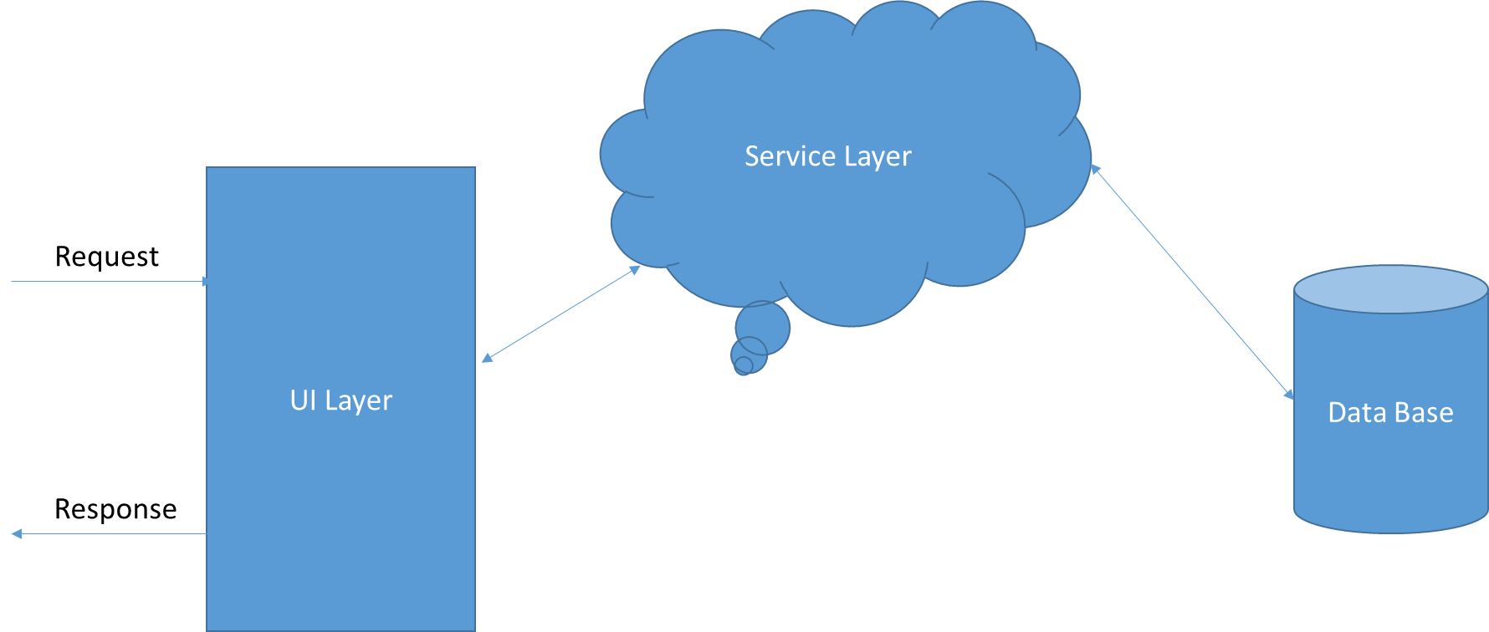

**UI Layer:** This layer is developed by using the HTML, CSS in MVC

**Service Layer:** This consists of holding the business logic and connecting to the database.

**DB:** This is holding the SQL Server. All the data will be stored here.

# Schedule

In order to complete the agreed scope it will take 4 weeks of time.

# COST

It costs around 75thousand below is the splitting of the application into various activities.



It includes

1. Total Application Development
2. Deployment
3. Training to the Users
4. Friendly & Responsive Design
5. 1 Month Maintenance

# Deliverables

As Part of the deliverables below are the deliverables.

1. Source Code of the Project
2. Deployed version of the application

# MAIntenance

Post Deployment of the application **1-month** free maintenance will be provided by Mahi Techno Systems. After Completing this free maintenance period, it will be charged **5000/- INR** per Month for the first year thereafter we can discuss further.

In this period, we will fix the bugs if any found.

For any Changes ION Exchange must raise Change Request and Mahi Techno System will analyze and provides separate quotation.

# Contact information

**ION SPOC:** Ravi Shankar 9849233710

**SPOC:** Venu Madhav 8801002444