Social Network of YouTube Videos

Advanced Database Management Systems

Final Project

By: Rajat Agrawal

# **Problem Statement**

* Analysis of social media data set “YouTube” based on different columns fields.
* YouTube Video Recommendation to a user based on rating
* Followers recommendation

# **Summary**

The data-set used in this project is provided by Simon Fraser University. The data-set has five different files based on the data collected by the crawler.

The dataset was available on the following Url:

<http://netsg.cs.sfu.ca/youtubedata/>

For Friends recommendation and Video recommendation we have taken the following data set for our analysis:

<http://socialcomputing.asu.edu/datasets/YouTube2>

We record the following information of a YouTube video in order; they are divided by '\t' in the data file.

|  |  |
| --- | --- |
| video ID | an 11-digit string, which is unique |
| uploader | a string of the video uploader's username |
| age | an integer number of days between the date when the video was uploaded and Feb.15, 2007 (YouTube's establishment) |
| category | a string of the video category chosen by the uploader |
| length | an integer number of the video length |
| views | an integer number of the views |
| rate | a float number of the video rate |
| ratings | an integer number of the ratings |
| comments | an integer number of the comments |
| related IDs | up to 20 strings of the related video IDs |

**Datasets of User Information**

We have collected the information about YouTube users. The crawler retrieves information on the number of uploaded videos and friends of each user from the YouTube API, for a total of more than 1 million users. There is "user.txt", containing the information of number of uploads, watches and friends in order.

2 files are included:

1. nodes.csv

-- it's the file of all the users. This file works as a dictionary of all the users in this data set. It's useful for fast reference. It contains all the node ids used in the dataset

2. edges.csv

-- this is the friendship network among the users. The user's friends are represented using edges.

Since the network is symmetric, each edge is represented only once. Here is an example.

1,2

This means user with id "1" is friend with user id "2".

All the source files required lot of data cleaning and pre-processing which was done in Python. After these steps the csv files were brought to use by making different analysis using the MapReduce computing paradigm which is used popularly for working with high volume of data.JAVA was the primary language used to write all the MapReduce programs and implement its different design patterns like:

1. Filtering
2. Join Patterns
3. Data Organization
4. Summarization

Recommendation of videos to the users was also done by using content based recommendation technique using Mahout.

Some of the analysis performed on the data-set consisting of data of Restaurants in United states are:

1. Max Rating Total Rating and Total Comment by Video ID
2. Moving Rating Average by Video_ID
3. Best Youtuber based on videos uploaded
4. Top 50 Favorite YouTube Videos
5. Total YouTube Videos by Category
6. Binning by Categories
7. Chaining on Binning result to get Top 25 Videos per category
8. Follower recommendation based on connected followers
9. Video based Recommendation using Mahout.
10. Total Views based on Video ID

# **Description of Analysis**

**Moving Rating Average by Video_ID.**

This analysis involved calculating the average rating of videos uploaded by the users and the rating provided on the videos by different users.

**Max Rating Total Rating and Total Comment by Video ID**

This analysis was to analyses the total comment, total rating and Maximum rating provided to a YouTube video based on which we can determine which movies need to be removed in future prospect.

**Best Youtuber based on videos uploaded**

This analysis represents the top YouTuber who contributed to most of the videos to YouTube.

**Top 50 Favorite YouTube Videos**

**This analysis help to find the top 50 YouTube videos.**

**Total YouTube Videos by Category**

This analysis help to find the total videos based on the categories.

**Binning by Categories**

**Segregate the videos based on the categories.**

**Chaining on Binning result to get Top 25 Videos per category**

**We get all the top 25 videos based on the category.**

**Follower recommendation based on connected followers**

**To increase the followers, we have created a recommendation where we can suggest a user to follow the set of users.**

**Video based Recommendation using Mahout.**

**Used Mahout Library to find the user liked videos and recommend them based on the similarity of rating.**

**Total Views based on Video ID**

**Total views a video got from the users.**

**Code:**

**Max Rating Total Rating and Total Comment by Video ID**

**/\***

**\* To change this license header, choose License Headers in Project Properties.**

**\* To change this template file, choose Tools | Templates**

**\* and open the template in the editor.**

**\*/**

**package rating_summerization;**

**import java.io.DataInput;**

**import java.io.DataOutput;**

**import java.io.IOException;**

**import org.apache.hadoop.io.Writable;**

**/\*\***

**\***

**\* @author Rajat**

**\*/**

**public class MinMaxCountTuple implements Writable {**

**private float averageRating;**

**private float totalRating;**

**private float totalComment;**

**public float getAverageRating() {**

**return averageRating;**

**}**

**public void setAverageRating(float averageRating) {**

**this.averageRating = averageRating;**

**}**

**public float getTotalRating() {**

**return totalRating;**

**}**

**public void setTotalRating(float totalRating) {**

**this.totalRating = totalRating;**

**}**

**public float getTotalComment() {**

**return totalComment;**

**}**

**public void setTotalComment(float totalComment) {**

**this.totalComment = totalComment;**

**}**

**@Override**

**public void write(DataOutput d) throws IOException {**

**d.writeFloat(averageRating);**

**d.writeFloat(totalRating);**

**d.writeFloat(totalComment);**

**}**

**@Override**

**public void readFields(DataInput di) throws IOException {**

**averageRating = di.readFloat();**

**totalRating = di.readFloat();**

**totalComment = di.readFloat();**

**}**

**@Override**

**public String toString() {**

**return (averageRating + "\t" + totalRating + "\t" + totalComment);**

**}**

**}**

**package rating_summerization;**

**import java.io.IOException;**

**import java.util.logging.Level;**

**import java.util.logging.Logger;**

**import org.apache.hadoop.conf.Configuration;**

**import org.apache.hadoop.fs.Path;**

**import org.apache.hadoop.io.Text;**

**import org.apache.hadoop.mapreduce.Job;**

**import org.apache.hadoop.mapreduce.lib.input.FileInputFormat;**

**import org.apache.hadoop.mapreduce.lib.output.FileOutputFormat;**

**/\*\***

**\***

**\* @author Rajat**

**\*/**

**public class Rating_Summerization {**

**/\*\***

**\* @param args the command line arguments**

**\*/**

**public static void main(String[] args) throws IOException {**

**try {**

**Configuration conf = new Configuration();**

**Job job = Job.getInstance(conf, "VideoMinMaxRating");**

**job.setJarByClass(Rating_Summerization.class);**

**job.setMapperClass(Summ_Mapper.class);**

**job.setCombinerClass(Summ_Reducer.class);**

**job.setReducerClass(Summ_Reducer.class);**

**job.setOutputKeyClass(Text.class);**

**job.setOutputValueClass(MinMaxCountTuple.class);**

**FileInputFormat.addInputPath(job, new Path(args[0]));**

**FileOutputFormat.setOutputPath(job, new Path(args[1]));**

**System.exit(job.waitForCompletion(true) ? 0 : 1);**

**} catch (InterruptedException | ClassNotFoundException ex) {**

**Logger.getLogger(Rating_Summerization.class.getName()).log(Level.SEVERE, null, ex);**

**}**

**}**

**}**

**/\***

**\* To change this license header, choose License Headers in Project Properties.**

**\* To change this template file, choose Tools | Templates**

**\* and open the template in the editor.**

**\*/**

**package rating_summerization;**

**import java.io.IOException;**

**import org.apache.hadoop.io.Text;**

**import org.apache.hadoop.mapreduce.Mapper;**

**/\*\***

**\***

**\* @author Rajat**

**\*/**

**class Summ_Mapper extends Mapper<Object, Text, Text, MinMaxCountTuple> {**

**private Text video_ID = new Text();**

**private MinMaxCountTuple outTuple = new MinMaxCountTuple();**

**protected void map(Object key, Text value, Context context) throws IOException, InterruptedException {**

**String[] input = value.toString().split(",");**

**video_ID.set(input[0]);**

**outTuple.setTotalRating(Float.valueOf(input[7]));**

**outTuple.setAverageRating(Float.valueOf(input[6]));**

**outTuple.setTotalComment(Float.valueOf(input[8]));**

**context.write(video_ID, outTuple);**

**}**

**}**

**/\***

**\* To change this license header, choose License Headers in Project Properties.**

**\* To change this template file, choose Tools | Templates**

**\* and open the template in the editor.**

**\*/**

**package rating_summerization;**

**import java.io.IOException;**

**import org.apache.hadoop.io.Text;**

**import org.apache.hadoop.mapreduce.Reducer;**

**/\*\***

**\***

**\* @author Rajat**

**\*/**

**class Summ_Reducer extends Reducer<Text, MinMaxCountTuple, Text, MinMaxCountTuple> {**

**private MinMaxCountTuple result = new MinMaxCountTuple();**

**@Override**

**protected void reduce(Text key, Iterable<MinMaxCountTuple> values, Context context) throws IOException, InterruptedException {**

**// Initialize our result**

**result.setAverageRating(0);**

**result.setTotalRating(0);**

**result.setTotalComment(0);**

**int sum = 0;**

**for (MinMaxCountTuple val : values) {**

**if (result.getAverageRating()== 0 || val.getAverageRating() < result.getAverageRating()) {**

**result.setAverageRating(val.getAverageRating());**

**}**

**if (result.getTotalRating()== 0**

**|| val.getTotalRating() > (result.getTotalRating())) {**

**result.setTotalRating(val.getTotalRating());**

**}**

**sum += val.getTotalComment();**

**}**

**result.setTotalComment(sum);**

**context.write(key, result);**

**}**

**}**

**Moving Rating Average by Video_ID**

**/\***

**\* To change this license header, choose License Headers in Project Properties.**

**\* To change this template file, choose Tools | Templates**

**\* and open the template in the editor.**

**\*/**

**package averagerating_youtube;**

**import java.io.DataInput;**

**import java.io.DataOutput;**

**import java.io.IOException;**

**import org.apache.hadoop.io.Writable;**

**/\*\***

**\***

**\* @author Rajat**

**\*/**

**public class AverageRating_CommentCountTuple implements Writable {**

**private int comment_count = 0;**

**private double video_rating = 0;**

**public int getComment_count() {**

**return comment_count;**

**}**

**public void setComment_count(int comment_count) {**

**this.comment_count = comment_count;**

**}**

**public double getVideo_rating() {**

**return video_rating;**

**}**

**public void setVideo_rating(double video_rating) {**

**this.video_rating = video_rating;**

**}**

**@Override**

**public void write(DataOutput d) throws IOException {**

**d.writeInt(comment_count);**

**d.writeDouble(video_rating);**

**}**

**@Override**

**public void readFields(DataInput di) throws IOException {**

**comment_count = di.readInt();**

**video_rating = di.readDouble();**

**}**

**@Override**

**public String toString() {**

**return Integer.toString(comment_count) + " " + Double.toString(video_rating);**

**}**

**}**

**/\***

**\* To change this license header, choose License Headers in Project Properties.**

**\* To change this template file, choose Tools | Templates**

**\* and open the template in the editor.**

**\*/**

**package averagerating_youtube;**

**import org.apache.hadoop.conf.Configuration;**

**import org.apache.hadoop.conf.Configured;**

**import org.apache.hadoop.fs.Path;**

**import org.apache.hadoop.io.Text;**

**import org.apache.hadoop.mapreduce.Job;**

**import org.apache.hadoop.mapreduce.lib.input.FileInputFormat;**

**import org.apache.hadoop.mapreduce.lib.output.FileOutputFormat;**

**import org.apache.hadoop.util.Tool;**

**import org.apache.hadoop.util.ToolRunner;**

**/\*\***

**\***

**\* @author Rajat**

**\*/**

**public class AverageRating_Youtube extends Configured implements Tool {**

**/\*\***

**\* @param args the command line arguments**

**\*/**

**@Override**

**public int run(String[] args) throws Exception {**

**Job job = new Job(getConf());**

**job.setJobName("AverageRating_Youtube");**

**job.setJarByClass(AverageRating_Youtube.class);**

**FileInputFormat.setInputPaths(job, new Path(args[0]));**

**FileOutputFormat.setOutputPath(job, new Path(args[1]));**

**job.setMapperClass(AvgRating_CommCountMapper.class);**

**job.setMapOutputKeyClass(Text.class);**

**job.setMapOutputValueClass(AverageRating_CommentCountTuple.class);**

**job.setCombinerClass(AvgRating_CommCountCombiner.class);**

**job.setReducerClass(AvgRating_CommCountReducer.class);**

**job.setOutputKeyClass(Text.class);**

**job.setOutputValueClass(AverageRating_CommentCountTuple.class);**

**boolean success = job.waitForCompletion(true);**

**return success ? 0 : 1;**

**}**

**public static void main(String[] args) throws Exception {**

**// TODO code application logic here**

**int exitCode = ToolRunner.run(new Configuration(),**

**new AverageRating_Youtube(), args);**

**System.exit(exitCode);**

**}**

**}**

**/\***

**\* To change this license header, choose License Headers in Project Properties.**

**\* To change this template file, choose Tools | Templates**

**\* and open the template in the editor.**

**\*/**

**package averagerating_youtube;**

**import java.io.IOException;**

**import org.apache.hadoop.io.Text;**

**import org.apache.hadoop.mapreduce.Reducer;**

**/\*\***

**\***

**\* @author Rajat**

**\*/**

**public class AvgRating_CommCountCombiner extends Reducer<Text, AverageRating_CommentCountTuple, Text, AverageRating_CommentCountTuple> {**

**private AverageRating_CommentCountTuple result = new AverageRating_CommentCountTuple();**

**protected void reduce(Text key, Iterable<AverageRating_CommentCountTuple> values, Reducer.Context context) throws IOException, InterruptedException {**

**float sum = 0;**

**int count = 0;**

**for (AverageRating_CommentCountTuple val : values) {**

**sum += val.getComment_count() * val.getVideo_rating();**

**count += val.getComment_count();**

**}**

**result.setVideo_rating(sum / count);**

**result.setComment_count(count);**

**context.write(key, result);**

**}**

**}**

**/\***

**\* To change this license header, choose License Headers in Project Properties.**

**\* To change this template file, choose Tools | Templates**

**\* and open the template in the editor.**

**\*/**

**package averagerating_youtube;**

**import java.io.IOException;**

**import org.apache.hadoop.io.Text;**

**import org.apache.hadoop.mapreduce.Mapper;**

**/\*\***

**\***

**\* @author Rajat**

**\*/**

**public class AvgRating_CommCountMapper extends Mapper<Object, Text, Text, AverageRating_CommentCountTuple> {**

**// Our output key and value Writables**

**private Text video_name = new Text();**

**private float v_rate;**

**private AverageRating_CommentCountTuple outTuple = new AverageRating_CommentCountTuple();**

**@Override**

**protected void map(Object key, Text value, Context context) throws IOException, InterruptedException {**

**String[] fields = value.toString().split(",");**

**String videoId = (fields[0]);**

**if (!fields[6].isEmpty()) {**

**this.v_rate = Float.parseFloat(fields[6]);**

**} else {**

**this.v_rate = 0;**

**}**

**video_name.set(videoId);**

**outTuple.setComment_count(1);**

**outTuple.setVideo_rating(this.v_rate);**

**context.write(video_name, outTuple);**

**}**

**}**

**Best Youtuber based on videos uploaded**

**package youtubeuploader;**

**import java.io.IOException;**

**import org.apache.hadoop.io.IntWritable;**

**import org.apache.hadoop.io.LongWritable;**

**import org.apache.hadoop.io.Text;**

**import org.apache.hadoop.mapreduce.Mapper;**

**import org.apache.hadoop.mapreduce.Reducer;**

**import org.apache.hadoop.conf.Configuration;**

**import org.apache.hadoop.mapreduce.Job;**

**import org.apache.hadoop.mapreduce.lib.input.TextInputFormat;**

**import org.apache.hadoop.mapreduce.lib.output.TextOutputFormat;**

**import org.apache.hadoop.mapreduce.lib.input.FileInputFormat;**

**import org.apache.hadoop.mapreduce.lib.output.FileOutputFormat;**

**import org.apache.hadoop.fs.Path;**

**public class Youtubetopuploader {**

**public static class Map extends Mapper<LongWritable, Text, Text, IntWritable> {**

**private Text uploader = new Text();**

**private final static IntWritable occurance = new IntWritable(1);**

**@Override**

**public void map(LongWritable key, Text value,**

**Context context) throws IOException, InterruptedException {**

**String record = value.toString();**

**String str[] = record.split(",");**

**if (str.length >= 7) {**

**uploader.set(str[1]);**

**}**

**context.write(uploader, occurance);**

**}**

**}**

**public static class Reduce extends Reducer<Text, IntWritable, Text, IntWritable> {**

**@Override**

**public void reduce(Text key, Iterable<IntWritable> values,**

**Context context) throws IOException, InterruptedException {**

**int totaloccurance = 0;**

**for (IntWritable value : values) {**

**totaloccurance += value.get();**

**}**

**context.write(key, new IntWritable(totaloccurance));**

**}**

**}**

**public static void main(String[] args) throws IOException, ClassNotFoundException, InterruptedException {**

**Configuration conf1 = new Configuration();**

**@SuppressWarnings("deprecation")**

**Job = new Job(conf1, "myyoutube");**

**job.setJarByClass(Youtubetopuploader.class);**

**job.setMapperClass(Map.class);**

**job.setReducerClass(Reduce.class);**

**job.setOutputKeyClass(Text.class);**

**job.setOutputValueClass(IntWritable.class);**

**job.setInputFormatClass(TextInputFormat.class);**

**job.setOutputFormatClass(TextOutputFormat.class);**

**FileInputFormat.addInputPath(job, new Path(args[0]));**

**FileOutputFormat.setOutputPath(job, new Path(args[1]));**

**System.exit(job.waitForCompletion(true) ? 0 : 1);**

**}**

**}**

**Top 50 Favorite YouTube Videos**

**package top_youtuber;**

**import org.apache.hadoop.conf.Configuration;**

**import org.apache.hadoop.fs.Path;**

**import org.apache.hadoop.io.Text;**

**import org.apache.hadoop.mapreduce.Job;**

**import org.apache.hadoop.mapreduce.Mapper;**

**import org.apache.hadoop.mapreduce.Reducer;**

**import org.apache.hadoop.mapreduce.lib.input.FileInputFormat;**

**import org.apache.hadoop.mapreduce.lib.output.FileOutputFormat;**

**import java.io.IOException;**

**import java.util.*;**

**import org.apache.hadoop.io.FloatWritable;**

**public class Top_Youtube {**

**public static void main(String[] args) throws Exception {**

**Configuration conf = new Configuration();**

**Job job = Job.getInstance(conf, "Top50");**

**job.setJarByClass(Top_Youtube.class);**

**job.setMapperClass(TopNMapper.class);**

**job.setReducerClass(TopNReducer.class);**

**job.setOutputKeyClass(Text.class);**

**job.setOutputValueClass(FloatWritable.class);**

**FileInputFormat.addInputPath(job, new Path(args[0]));**

**FileOutputFormat.setOutputPath(job, new Path(args[1]));**

**System.exit(job.waitForCompletion(true) ? 0 : 1);**

**}**

**public static class TopNMapper**

**extends Mapper<Object, Text, Text, FloatWritable> {**

**private FloatWritable video_rating = new FloatWritable();**

**private Text video_id = new Text();**

**public void map(Object key, Text value, Mapper.Context context**

**) throws IOException, InterruptedException {**

**String[] fields = value.toString().split(",");**

**video_id = new Text(fields[0]);**

**if (!fields[6].isEmpty()) {**

**video_rating = new FloatWritable(Float.parseFloat(fields[6]));**

**}**

**context.write(video_id, video_rating);**

**}**

**}**

**public static class TopNReducer extends Reducer<Text, FloatWritable, Text, FloatWritable> {**

**private Map<Text, FloatWritable> countMap = new HashMap<>();**

**@Override**

**public void reduce(Text key, Iterable<FloatWritable> values, Context context) throws IOException, InterruptedException {**

**// computes the number of occurrences of a single word**

**float sum = 0.0f;**

**int count = 0;**

**for (FloatWritable val : values) {**

**sum += val.get();**

**count++;**

**}**

**countMap.put(new Text(key), new FloatWritable(sum / count));**

**}**

**@Override**

**protected void cleanup(Context context) throws IOException, InterruptedException {**

**Map<Text, FloatWritable> sortedMap = sortByValues(countMap);**

**int counter = 0;**

**for (Text key : sortedMap.keySet()) {**

**if (counter++ == 50) {**

**break;**

**}**

**context.write(key, sortedMap.get(key));**

**}**

**}**

**}**

**private static <K extends Comparable, V extends Comparable> Map<K, V> sortByValues(Map<K, V> map) {**

**List<Map.Entry<K, V>> entries = new LinkedList<Map.Entry<K, V>>(map.entrySet());**

**Collections.sort(entries, new Comparator<Map.Entry<K, V>>() {**

**@Override**

**public int compare(Map.Entry<K, V> o1, Map.Entry<K, V> o2) {**

**return o2.getValue().compareTo(o1.getValue());**

**}**

**});**

**//LinkedHashMap will keep the keys in the order they are inserted**

**//which is currently sorted on natural ordering**

**Map<K, V> sortedMap = new LinkedHashMap<K, V>();**

**for (Map.Entry<K, V> entry : entries) {**

**sortedMap.put(entry.getKey(), entry.getValue());**

**}**

**return sortedMap;**

**}**

**}**

**Total YouTube Videos by Category**

**/\***

**\* To change this license header, choose License Headers in Project Properties.**

**\* To change this template file, choose Tools | Templates**

**\* and open the template in the editor.**

**\*/**

**package top10_categories;**

**import org.apache.hadoop.io.IntWritable;**

**import org.apache.hadoop.io.WritableComparable;**

**import org.apache.hadoop.io.WritableComparator;**

**/\*\***

**\***

**\* @author Rajat**

**\*/**

**class SortKeyComparator extends WritableComparator {**

**protected SortKeyComparator() {**

**super(IntWritable.class, true);**

**}**

**@Override**

**public int compare(WritableComparable a, WritableComparable b) {**

**IntWritable key1 = (IntWritable) a;**

**IntWritable key2 = (IntWritable) b;**

**int result = key1.get() < key2.get() ? 1 : key1.get() == key2.get() ? 0 : -1;**

**return result;**

**}**

**}**

**/\***

**\* To change this license header, choose License Headers in Project Properties.**

**\* To change this template file, choose Tools | Templates**

**\* and open the template in the editor.**

**\*/**

**package top10_categories;**

**import java.io.IOException;**

**import org.apache.hadoop.conf.Configuration;**

**import org.apache.hadoop.fs.FSDataInputStream;**

**import org.apache.hadoop.fs.FSDataOutputStream;**

**import org.apache.hadoop.fs.FileStatus;**

**import org.apache.hadoop.fs.FileSystem;**

**import org.apache.hadoop.fs.Path;**

**import org.apache.hadoop.io.DoubleWritable;**

**import org.apache.hadoop.io.FloatWritable;**

**import org.apache.hadoop.io.Text;**

**import org.apache.hadoop.mapreduce.Job;**

**import org.apache.hadoop.mapreduce.Mapper;**

**import org.apache.hadoop.mapreduce.Reducer;**

**import org.apache.hadoop.mapreduce.lib.input.FileInputFormat;**

**import org.apache.hadoop.mapreduce.lib.output.FileOutputFormat;**

**/\*\***

**\***

**\* @author Rajat**

**\*/**

**public class Top10_Categories {**

**public static class Map1 extends Mapper<Object, Text, Text, FloatWritable> {**

**private FloatWritable video_rating = new FloatWritable();**

**private Text video_id = new Text();**

**public void map(Object key, Text value, Mapper.Context context**

**) throws IOException, InterruptedException {**

**String[] fields = value.toString().split(",");**

**video_id = new Text(fields[0]);**

**if (!fields[6].isEmpty()) {**

**video_rating = new FloatWritable(Float.parseFloat(fields[6]));**

**}**

**context.write(video_id, video_rating);**

**}**

**}**

**public static class Reduce1 extends Reducer<Text, FloatWritable, Text, FloatWritable> {**

**private FloatWritable result = new FloatWritable();**

**@Override**

**protected void reduce(Text key, Iterable<FloatWritable> values, Context context)**

**throws IOException, InterruptedException {**

**int count = 0;**

**float sum = 0, avg = 0;**

**for (FloatWritable val : values) {**

**sum += val.get();**

**++count;**

**}**

**avg = sum / count;**

**result.set(avg);**

**context.write(key, result);**

**}**

**}**

**public static class Map2 extends Mapper<Object, Text, FloatWritable, Text> {**

**@Override**

**protected void map(Object key, Text value, Mapper.Context context) throws IOException, InterruptedException {**

**String row[] = value.toString().split("\\t");**

**Text video_id = new Text(row[0]);**

**String rating = row[1];**

**try {**

**FloatWritable ratingg = new FloatWritable(Float.parseFloat(rating));**

**context.write(ratingg, video_id);**

**} catch (Exception e) {**

**e.printStackTrace();**

**}**

**}**

**}**

**public static class Reduce2 extends Reducer<FloatWritable, Text, Text, FloatWritable> {**

**private static int count = 25;**

**@Override**

**protected void reduce(FloatWritable key, Iterable<Text> values, Context context) throws IOException, InterruptedException {**

**for (Text val : values) {**

**if (count > 0) {**

**context.write(val, key);**

**--count;**

**} else {**

**break;**

**}**

**}**

**}**

**}**

**/\*\***

**\* @param args the command line arguments**

**\*/**

**public static void main(String[] args) throws IOException, InterruptedException, ClassNotFoundException {**

**Configuration conf1 = new Configuration();**

**Configuration conf = new Configuration();**

**Path inputDir = new Path(args[0]);**

**Path hdfsFile = new Path(args[1]);**

**FileSystem hdfs = FileSystem.get(conf);**

**FileSystem local=FileSystem.getLocal(conf);**

**try {**

**FileStatus[] inputFiles = local.listStatus(inputDir);**

**FSDataOutputStream out = hdfs.create(hdfsFile);**

**for (int i = 0; i < inputFiles.length; i++) {**

**System.out.println(inputFiles[i].getPath().getName());**

**FSDataInputStream in = local.open(inputFiles[i].getPath());**

**byte[] buffer = new byte[256];**

**int bytesRead = 0;**

**while ((bytesRead = in.read(buffer)) > 0) {**

**out.write(buffer, 0, bytesRead);**

**}**

**in.close();**

**}**

**out.close();**

**} catch (IOException e) {**

**e.printStackTrace();**

**}**

**Job job1 = Job.getInstance(conf1, "Chaining");**

**job1.setJarByClass(Top10_Categories.class);**

**job1.setMapperClass(Map1.class);**

**job1.setMapOutputKeyClass(Text.class);**

**job1.setMapOutputValueClass(FloatWritable.class);**

**job1.setReducerClass(Reduce1.class);**

**job1.setOutputKeyClass(Text.class);**

**job1.setOutputValueClass(DoubleWritable.class);**

**job1.setCombinerClass(Reduce1.class);**

**FileInputFormat.addInputPath(job1, hdfsFile);**

**FileOutputFormat.setOutputPath(job1, new Path(args[2]));**

**boolean complete = job1.waitForCompletion(true);**

**Configuration conf2 = new Configuration();**

**Job job2 = Job.getInstance(conf2, "Chaining");**

**if (complete) {**

**job2.setJarByClass(Top10_Categories.class);**

**job2.setMapperClass(Map2.class);**

**job2.setMapOutputKeyClass(FloatWritable.class);**

**job2.setMapOutputValueClass(Text.class);**

**job2.setReducerClass(Reduce2.class);**

**job2.setOutputKeyClass(Text.class);**

**job2.setOutputValueClass(FloatWritable.class);**

**job2.setSortComparatorClass(SortKeyComparator.class);**

**job2.setNumReduceTasks(1);**

**FileInputFormat.addInputPath(job2, new Path(args[2]));**

**FileOutputFormat.setOutputPath(job2, new Path(args[3]));**

**System.exit(job2.waitForCompletion(true) ? 0 : 1);**

**}**

**}**

**}**

**Binning by Categories**

**/\***

**\* To change this license header, choose License Headers in Project Properties.**

**\* To change this template file, choose Tools | Templates**

**\* and open the template in the editor.**

**\*/**

**package binningbycategories;**

**import java.io.IOException;**

**import org.apache.hadoop.conf.Configuration;**

**import org.apache.hadoop.fs.Path;**

**import org.apache.hadoop.io.NullWritable;**

**import org.apache.hadoop.io.Text;**

**import org.apache.hadoop.mapreduce.Job;**

**import org.apache.hadoop.mapreduce.Mapper;**

**import org.apache.hadoop.mapreduce.lib.input.TextInputFormat;**

**import org.apache.hadoop.mapreduce.lib.output.FileOutputFormat;**

**import org.apache.hadoop.mapreduce.lib.output.MultipleOutputs;**

**import org.apache.hadoop.mapreduce.lib.output.TextOutputFormat;**

**/\*\***

**\***

**\* @author Rajat**

**\*/**

**public class BinningbyCategories {**

**public static class YouTubeBinMapper extends Mapper<Object, Text, Text, NullWritable> {**

**private MultipleOutputs<Text, NullWritable> mos = null;**

**@Override**

**protected void setup(Mapper.Context context) throws IOException, InterruptedException {**

**mos = new MultipleOutputs<Text, NullWritable>(context);**

**}**

**@Override**

**protected void map(Object key, Text value, Mapper.Context context)**

**throws IOException, InterruptedException {**

**String[] input = value.toString().split(",");**

**Text Name = new Text(input[3]);**

**String line = Name.toString();**

**if (line.contains("UNA ")) {**

**mos.write("bins", value, NullWritable.get(), "UNA");**

**} else if (line.contains("Autos & Vehicles")) {**

**mos.write("bins", value, NullWritable.get(), "Autos & Vehicles");**

**} else if (line.contains("Comedy")) {**

**mos.write("bins", value, NullWritable.get(), "Comedy");**

**} else if (line.contains("Entertainment")) {**

**mos.write("bins", value, NullWritable.get(), "Entertainment");**

**} else if (line.contains("Film & Animation")) {**

**mos.write("bins", value, NullWritable.get(), "Film & Animation");**

**} else if (line.contains("Gadgets & Games")) {**

**mos.write("bins", value, NullWritable.get(), "Gadgets & Games");**

**} else if (line.contains("Howto & DIY")) {**

**mos.write("bins", value, NullWritable.get(), "Howto & DIY");**

**} else if (line.contains("Music")) {**

**mos.write("bins", value, NullWritable.get(), "Music");**

**} else if (line.contains("News & Politics")) {**

**mos.write("bins", value, NullWritable.get(), "News & Politics");**

**} else if (line.contains("People & Blogs")) {**

**mos.write("bins", value, NullWritable.get(), "People & Blogs");**

**} else if (line.contains("Pets & Animals")) {**

**mos.write("bins", value, NullWritable.get(), "Pets & Animals");**

**} else if (line.contains("Sports")) {**

**mos.write("bins", value, NullWritable.get(), "Sports");**

**} else if (line.contains("Travel & Places")) {**

**mos.write("bins", value, NullWritable.get(), "Travel & Places");**

**} else {**

**mos.write("bins", value, NullWritable.get(), "UnCatogrized");**

**}**

**}**

**@Override**

**protected void cleanup(Mapper.Context context)**

**throws IOException, InterruptedException {**

**mos.close();**

**}**

**}**

**/\*\***

**\* @param args the command line arguments**

**\* @throws java.lang.Exception**

**\*/**

**public static void main(String[] args) throws Exception {**

**Configuration conf = new Configuration();**

**Job job = new Job(conf, "Binning");**

**job.setJarByClass(BinningbyCategories.class);**

**job.setMapperClass(YouTubeBinMapper.class);**

**job.setNumReduceTasks(0);**

**TextInputFormat.setInputPaths(job, new Path(args[0]));**

**FileOutputFormat.setOutputPath(job, new Path(args[1]));**

**// Configure the MultipleOutputs by adding an output called "bins"**

**// With the proper output format and mapper key/value pairs**

**MultipleOutputs.addNamedOutput(job, "bins", TextOutputFormat.class,**

**Text.class, NullWritable.class);**

**// Enable the counters for the job**

**// If there is a significant number of different named outputs, this**

**// should be disabled**

**MultipleOutputs.setCountersEnabled(job, true);**

**System.exit(job.waitForCompletion(true) ? 0 : 2);**

**}**

**}**

**Chaining on Binning result to get Top 25 Videos per category**

**package top_youtuber;**

**import org.apache.hadoop.conf.Configuration;**

**import org.apache.hadoop.fs.Path;**

**import org.apache.hadoop.io.Text;**

**import org.apache.hadoop.mapreduce.Job;**

**import org.apache.hadoop.mapreduce.Mapper;**

**import org.apache.hadoop.mapreduce.Reducer;**

**import org.apache.hadoop.mapreduce.lib.input.FileInputFormat;**

**import org.apache.hadoop.mapreduce.lib.output.FileOutputFormat;**

**import java.io.IOException;**

**import java.util.*;**

**import org.apache.hadoop.io.FloatWritable;**

**public class Top_Youtube {**

**public static void main(String[] args) throws Exception {**

**Configuration conf = new Configuration();**

**Job job = Job.getInstance(conf, "Top50");**

**job.setJarByClass(Top_Youtube.class);**

**job.setMapperClass(TopNMapper.class);**

**job.setReducerClass(TopNReducer.class);**

**job.setOutputKeyClass(Text.class);**

**job.setOutputValueClass(FloatWritable.class);**

**FileInputFormat.addInputPath(job, new Path(args[0]));**

**FileOutputFormat.setOutputPath(job, new Path(args[1]));**

**System.exit(job.waitForCompletion(true) ? 0 : 1);**

**}**

**public static class TopNMapper**

**extends Mapper<Object, Text, Text, FloatWritable> {**

**private FloatWritable video_rating = new FloatWritable();**

**private Text video_id = new Text();**

**public void map(Object key, Text value, Mapper.Context context**

**) throws IOException, InterruptedException {**

**String[] fields = value.toString().split(",");**

**video_id = new Text(fields[0]);**

**if (!fields[6].isEmpty()) {**

**video_rating = new FloatWritable(Float.parseFloat(fields[6]));**

**}**

**context.write(video_id, video_rating);**

**}**

**}**

**public static class TopNReducer extends Reducer<Text, FloatWritable, Text, FloatWritable> {**

**private Map<Text, FloatWritable> countMap = new HashMap<>();**

**@Override**

**public void reduce(Text key, Iterable<FloatWritable> values, Context context) throws IOException, InterruptedException {**

**// computes the number of occurrences of a single word**

**float sum = 0.0f;**

**int count = 0;**

**for (FloatWritable val : values) {**

**sum += val.get();**

**count++;**

**}**

**countMap.put(new Text(key), new FloatWritable(sum / count));**

**}**

**@Override**

**protected void cleanup(Context context) throws IOException, InterruptedException {**

**Map<Text, FloatWritable> sortedMap = sortByValues(countMap);**

**int counter = 0;**

**for (Text key : sortedMap.keySet()) {**

**if (counter++ == 50) {**

**break;**

**}**

**context.write(key, sortedMap.get(key));**

**}**

**}**

**}**

**private static <K extends Comparable, V extends Comparable> Map<K, V> sortByValues(Map<K, V> map) {**

**List<Map.Entry<K, V>> entries = new LinkedList<Map.Entry<K, V>>(map.entrySet());**

**Collections.sort(entries, new Comparator<Map.Entry<K, V>>() {**

**@Override**

**public int compare(Map.Entry<K, V> o1, Map.Entry<K, V> o2) {**

**return o2.getValue().compareTo(o1.getValue());**

**}**

**});**

**//LinkedHashMap will keep the keys in the order they are inserted**

**//which is currently sorted on natural ordering**

**Map<K, V> sortedMap = new LinkedHashMap<K, V>();**

**for (Map.Entry<K, V> entry : entries) {**

**sortedMap.put(entry.getKey(), entry.getValue());**

**}**

**return sortedMap;**

**}**

**}**

**Follower recommendation based on connected followers**

**package com.neu.edu.followerreco;**

**import java.io.IOException;**

**import java.util.ArrayList;**

**import java.util.Arrays;**

**import java.util.Comparator;**

**import java.util.HashMap;**

**import java.util.Map.Entry;**

**import java.util.TreeMap;**

**import org.apache.hadoop.conf.Configuration;**

**import org.apache.hadoop.conf.Configured;**

**import org.apache.hadoop.fs.Path;**

**import org.apache.hadoop.io.IntWritable;**

**import org.apache.hadoop.io.LongWritable;**

**import org.apache.hadoop.io.Text;**

**import org.apache.hadoop.mapreduce.Job;**

**import org.apache.hadoop.mapreduce.Mapper;**

**import org.apache.hadoop.mapreduce.Reducer;**

**import org.apache.hadoop.mapreduce.lib.input.FileInputFormat;**

**import org.apache.hadoop.mapreduce.lib.input.TextInputFormat;**

**import org.apache.hadoop.mapreduce.lib.output.FileOutputFormat;**

**import org.apache.hadoop.mapreduce.lib.output.TextOutputFormat;**

**import org.apache.hadoop.util.Tool;**

**import org.apache.hadoop.util.ToolRunner;**

**public class NewFollowers extends Configured implements Tool {**

**@SuppressWarnings("deprecation")**

**@Override**

**public int run(String[] args) throws Exception {**

**System.out.println(Arrays.toString(args));**

**Job job = new Job(getConf(), "NewFollowers");**

**job.setJarByClass(NewFollowers.class);**

**job.setOutputKeyClass(Text.class);**

**job.setOutputValueClass(Text.class);**

**job.setMapperClass(Map.class);**

**job.setReducerClass(Reduce.class);**

**job.setInputFormatClass(TextInputFormat.class);**

**job.setOutputFormatClass(TextOutputFormat.class);**

**FileInputFormat.addInputPath(job, new Path(args[0]));**

**FileOutputFormat.setOutputPath(job, new Path(args[1]));**

**job.waitForCompletion(true);**

**return 0;**

**}**

**/\*\***

**\* @param args**

**\* @throws Exception**

**\*/**

**public static void main(String[] args) throws Exception {**

**System.out.println(Arrays.toString(args));**

**int res = ToolRunner.run(new Configuration(), new NewFollowers(), args);**

**System.exit(res);**

**}**

**}**

**class Map extends Mapper<LongWritable, Text, Text, Text> {**

**private Text user = new Text();**

**private Text user1 = new Text();**

**private Text user2 = new Text();**

**@Override**

**public void map(LongWritable key, Text value, Context context)**

**throws IOException, InterruptedException {**

**int i, j;**

**String s[] = value.toString().split("\\t");**

**String val[];**

**if (s.length > 1) {**

**val = s[1].split(",");**

**} else {**

**val = null;**

**}**

**user.set(s[0]);**

**if (val != null) {**

**for (i = 0; i < val.length - 1; i++) {**

**user2.set(val[i] + "#-3000");**

**context.write(user, user2);**

**for (j = i + 1; j < val.length; j++) {**

**user1.set(val[i]);**

**user2.set(val[j] + "#1");**

**context.write(user1, user2);**

**user1.set(val[j]);**

**user2.set(val[i] + "#1");**

**context.write(user1, user2);**

**}**

**}**

**user2.set(val[i] + "#-3000");**

**context.write(user, user2);**

**}**

**}**

**}**

**class Reduce extends Reducer<Text, Text, IntWritable, Text> {**

**class ValueComparator implements Comparator<String> {**

**HashMap<String, Integer> base;**

**public ValueComparator(HashMap<String, Integer> base) {**

**this.base = base;**

**}**

**// Note: this comparator imposes orderings that are inconsistent with equals.**

**public int compare(String a, String b) {**

**if (base.get(a) >= base.get(b)) {**

**return -1;**

**} else {**

**return 1;**

**} // returning 0 would merge keys**

**}**

**}**

**@Override**

**public void reduce(Text key, Iterable<Text> values, Context context)**

**throws IOException, InterruptedException {**

**HashMap<String, Integer> map1 = new HashMap<String, Integer>();**

**ValueComparator cmp = new ValueComparator(map1);**

**TreeMap<String, Integer> map2 = new TreeMap<String, Integer>(cmp);**

**while (values.iterator().hasNext()) {**

**String s[] = values.iterator().next().toString().split("#");**

**if (!map1.containsKey(s[0])) {**

**map1.put(s[0], 0);**

**}**

**map1.put(s[0], map1.get(s[0]) + Integer.parseInt(s[1]));**

**}**

**map2.putAll(map1);**

**ArrayList<String> list = new ArrayList<String>();**

**int i = 0;**

**for (Entry<String, Integer> e : map2.entrySet()) {**

**if (i < 10 && e.getValue() > 0) {**

**list.add(e.getKey());**

**}**

**;**

**i++;**

**}**

**String out = list.toString();**

**context.write(new IntWritable(Integer.parseInt(key.toString())), new Text(out));**

**}**

**}**

**Video based Recommendation using Mahout.**

**ragraw26@ubuntu:/usr/local/lib/mahout/bin$ mahout recommenditembased -s SIMILARITY_LOGLIKELIHOOD -i /path/to/input/file -o /path/to/desired/output --numRecommendations 25**

**Total Views based on Video ID**

**package youtubeviews;**

**import java.io.IOException;**

**import org.apache.hadoop.io.IntWritable;**

**import org.apache.hadoop.io.LongWritable;**

**import org.apache.hadoop.io.Text;**

**import org.apache.hadoop.mapreduce.Mapper;**

**import org.apache.hadoop.mapreduce.Reducer;**

**import org.apache.hadoop.conf.Configuration;**

**import org.apache.hadoop.mapreduce.Job;**

**import org.apache.hadoop.mapreduce.lib.input.TextInputFormat;**

**import org.apache.hadoop.mapreduce.lib.output.TextOutputFormat;**

**import org.apache.hadoop.mapreduce.lib.input.FileInputFormat;**

**import org.apache.hadoop.mapreduce.lib.output.FileOutputFormat;**

**import org.apache.hadoop.fs.Path;**

**import org.apache.hadoop.io.FloatWritable;**

**public class Topviewed {**

**public static class Map extends Mapper<LongWritable, Text, Text, FloatWritable> {**

**private Text video_name = new Text();**

**private FloatWritable views = new FloatWritable();**

**@Override**

**public void map(LongWritable key, Text value, Context context)**

**throws IOException, InterruptedException {**

**String line = value.toString();**

**String str[] = line.split(",");**

**if (str.length >= 5) {**

**video_name.set(str[0]);**

**float temp = Float.parseFloat(str[5]); //typecasting string to Integer**

**views.set(temp);**

**}**

**context.write(video_name, views);**

**}**

**}**

**public static class Reduce extends Reducer<Text, FloatWritable, Text, FloatWritable> {**

**@Override**

**public void reduce(Text key, Iterable<FloatWritable> values, Context context)**

**throws IOException, InterruptedException {**

**int sum = 0;**

**for (FloatWritable val : values) {**

**sum += val.get();**

**}**

**context.write(key, new FloatWritable(sum));**

**}**

**}**

**@SuppressWarnings("deprecation")**

**public static void main(String[] args) throws Exception {**

**Configuration conf = new Configuration();**

**Job job = new Job(conf, "Top Videos");**

**job.setJarByClass(Topviewed.class);**

**job.setMapOutputKeyClass(Text.class);**

**job.setMapOutputValueClass(FloatWritable.class);**

**job.setOutputKeyClass(Text.class);**

**job.setOutputValueClass(FloatWritable.class);**

**job.setMapperClass(Map.class);**

**job.setReducerClass(Reduce.class);**

**job.setInputFormatClass(TextInputFormat.class);**

**job.setOutputFormatClass(TextOutputFormat.class);**

**FileInputFormat.addInputPath(job, new Path(args[0]));**

**FileOutputFormat.setOutputPath(job, new Path(args[1]));**

**job.waitForCompletion(true);**

**}**

**}**

**Pig Analysis:**

infiles = load 'hdfs://localhost:9000//user/ragraw26/FinalProject/Input/youtube_data.csv' using PigStorage(',') as

(videoid:chararray,uploader:chararray,age:int,category:chararray,length:int,views:int,rate:int,rating:int,comments:int,related_id:chararray);

files = FILTER infiles BY category is not null;

grpn_for_catagories = group files by category;

cnt_for_catagories = foreach grpn_for_catagories generate group, COUNT(files.videoid) as counting;

sorted_for_catagories_desc = order cnt_for_catagories by counting desc;

top5_for_catagories = limit sorted_for_catagories_desc 5;

STORE top5_for_catagories INTO 'hdfs://localhost:9000//user/ragraw26/FinalProject/Top5Catagories' using PigStorage(',');

order_rated_video = order files by rating desc;

top10_rated_video = limit order_rated_video 10;

final_top10_rated_video = foreach top10_rated_video generate $0,$3,$7;

STORE final_top10_rated_video INTO 'hdfs://localhost:9000//user/ragraw26/FinalProject/Top10Rated' using PigStorage(',');

order_viewed_video = order files by views desc;

top10_viewed_video = limit order_viewed_video 10;

final_top10_viewed_video = foreach top10_viewed_video generate $0,$3,$5;

STORE final_top10_viewed_video INTO 'hdfs://localhost:9000//user/ragraw26/FinalProject/Top10Viewed' using PigStorage(',');

top10_rated_catagories = foreach grpn_for_catagories{

sorted = order files by rating desc;

top10 = limit sorted 10;

generate flatten(top10);

};

top10_rated_by_catagories = foreach top10_rated_catagories generate $0,$3,$7;

STORE top10_rated_by_catagories INTO 'hdfs://localhost:9000//user/ragraw26/FinalProject/Top10RatedByCatagories' using PigStorage(',');

top10_viewed_catagories = foreach grpn_for_catagories{

sorted = order files by views desc;

top10 = limit sorted 10;

generate flatten(top10);

};

top10_viewed_by_catagories = foreach top10_viewed_catagories generate $0,$3,$5;

STORE top10_viewed_by_catagories INTO 'hdfs://localhost:9000//user/ragraw26/FinalProject/Top10ViewedByCatagories' using PigStorage(',');

**Analysis and Tableau Dashboard:**

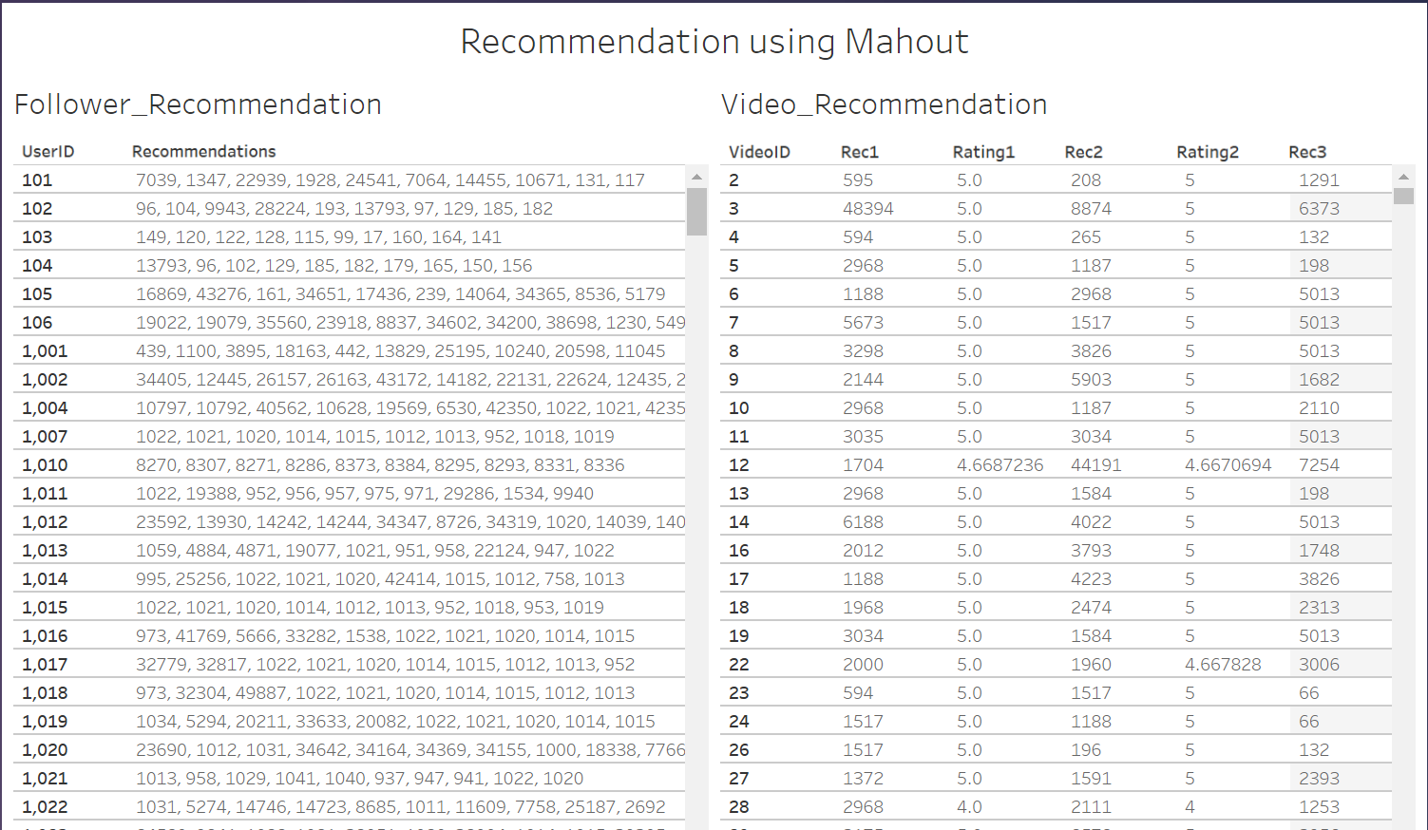

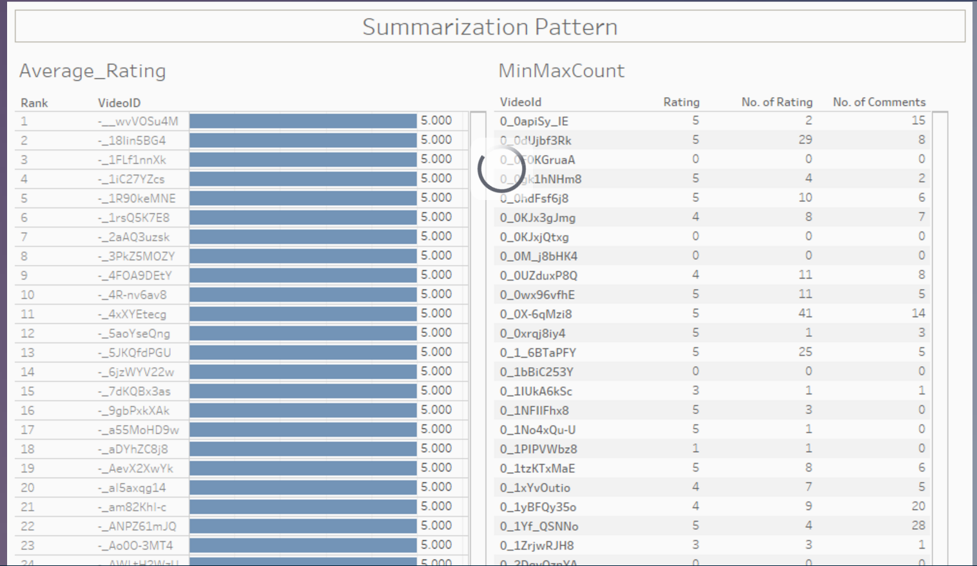

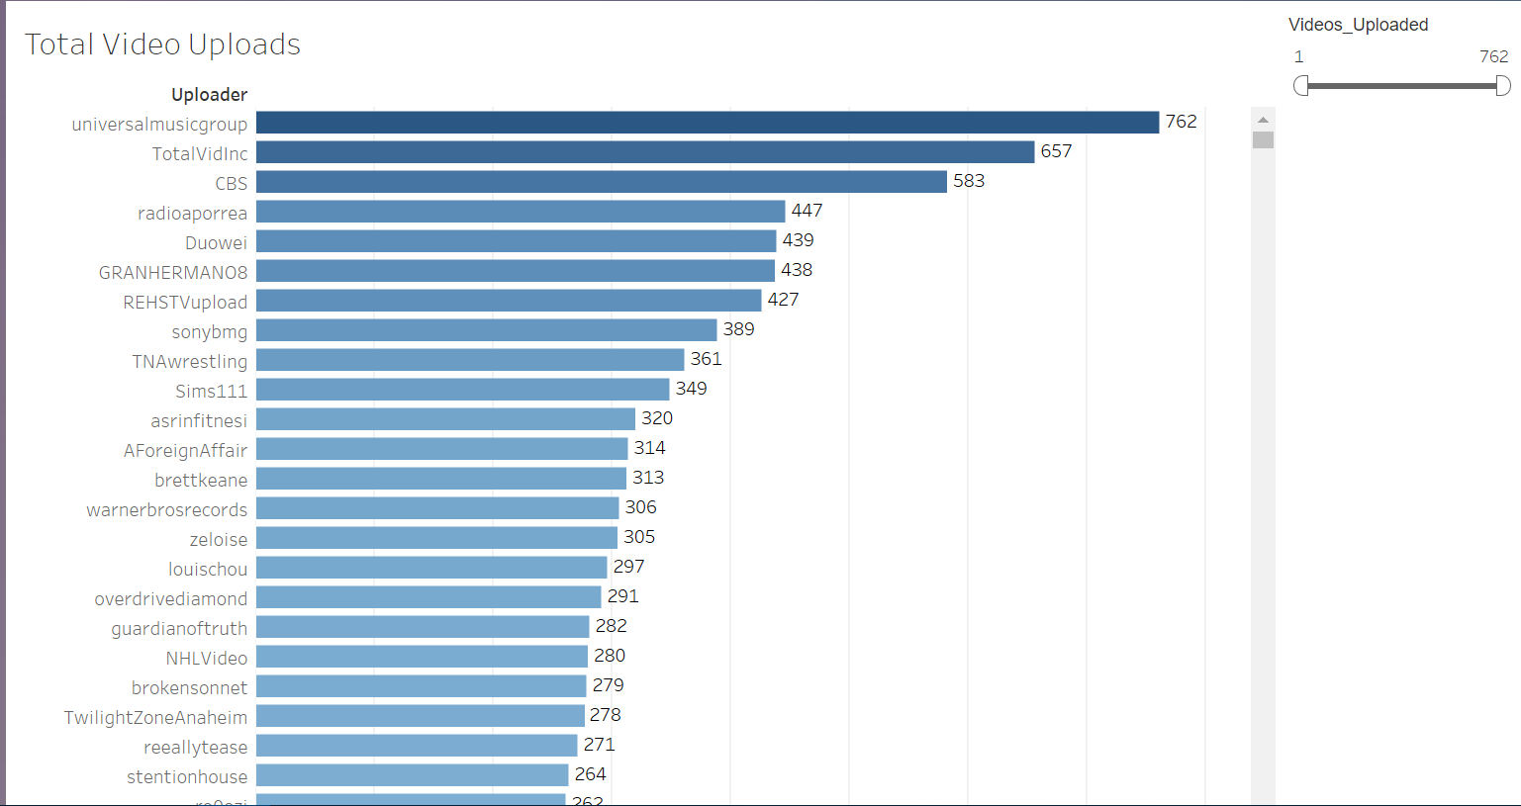

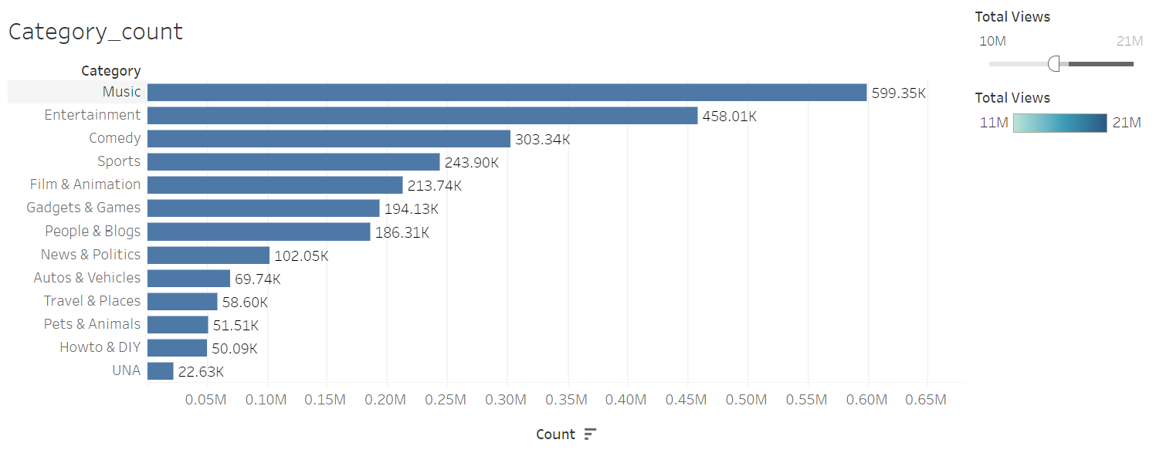

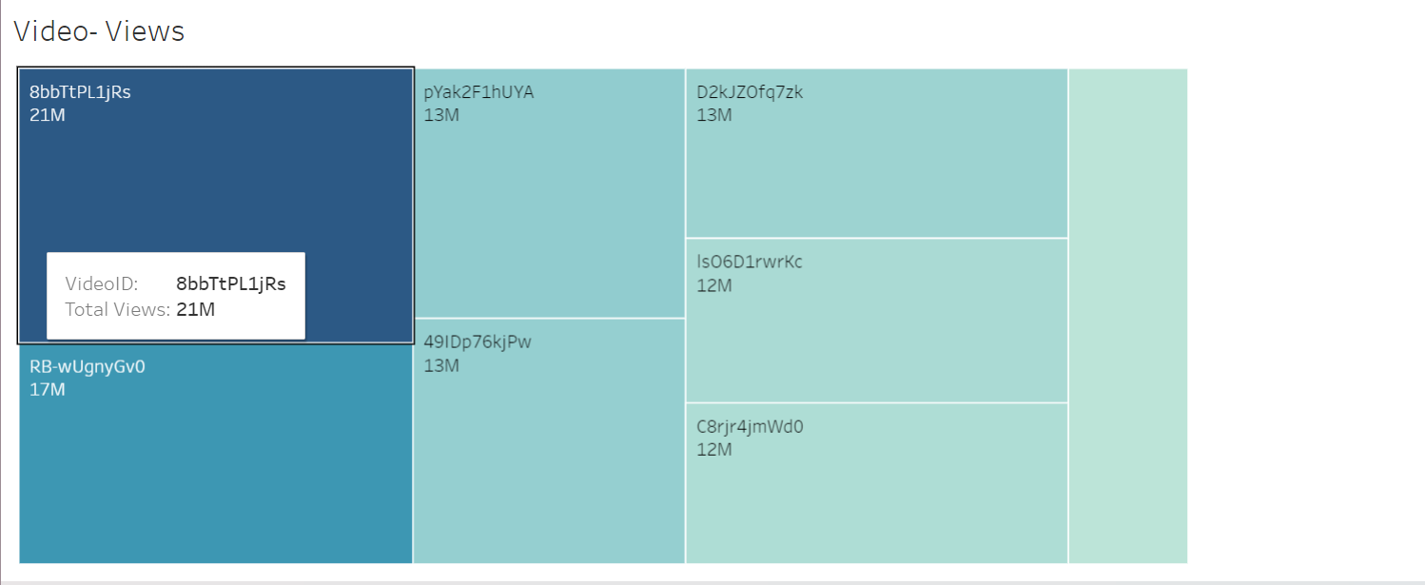

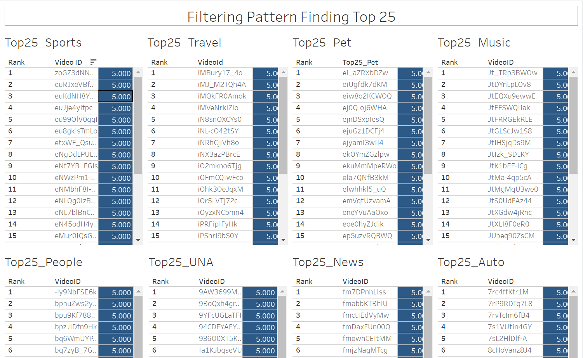

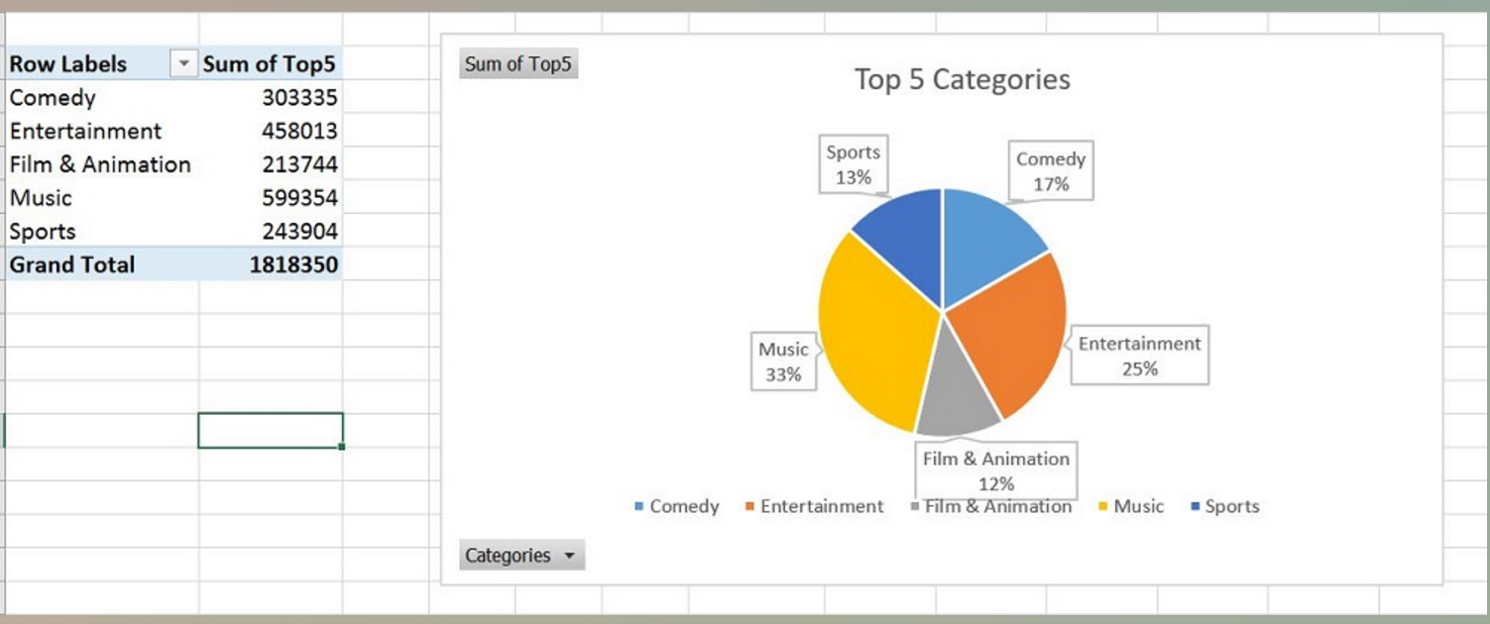

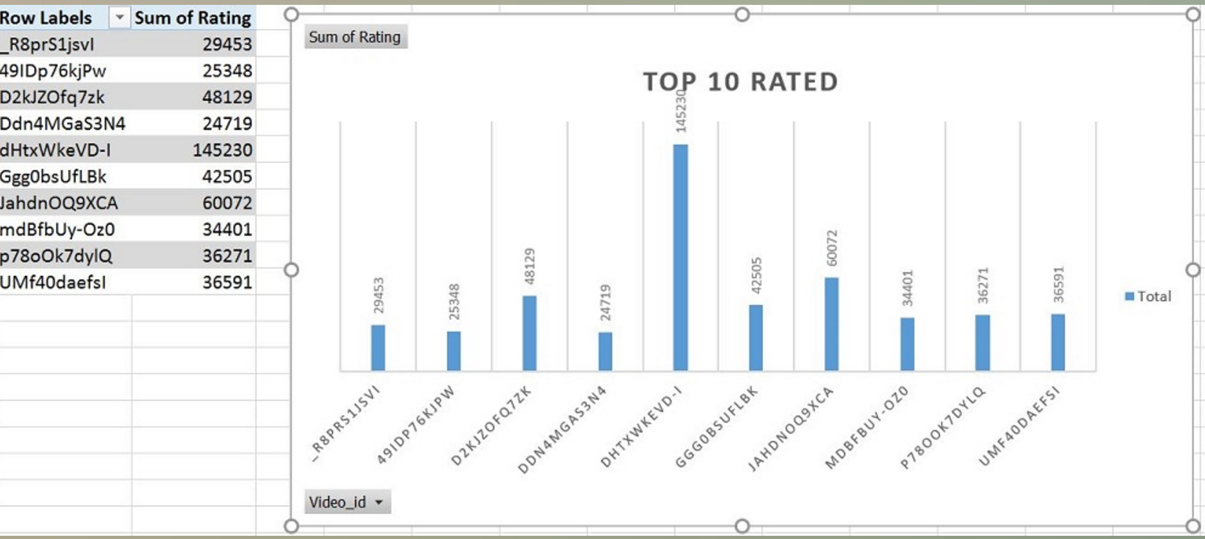

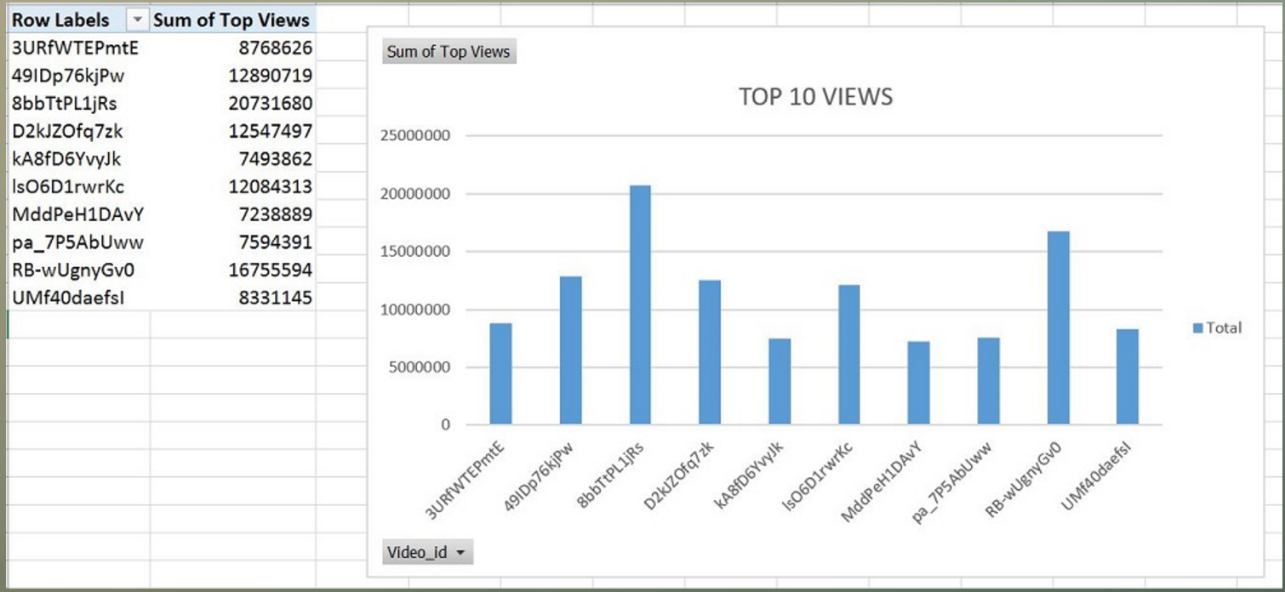

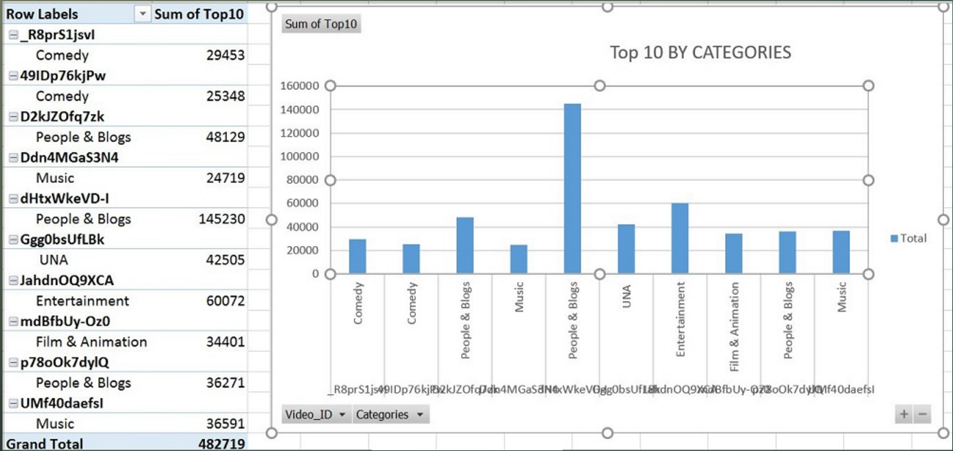

**Link to Github and Website**

<https://ragraw26.github.io/ADBMSFINALPROJECT/>

# **Thank you**