**Central Parking Services Private Limited**

**Project Report**

**Executive Summary**

Central Parking Services (CPS) is a leading provider of integrated parking solutions in India, managing infrastructure across high-traffic zones including malls, airports, hospitals, and commercial centers. A critical operational challenge exists at Howards End Mall in Mumbai, one of CPS’s flagship locations, where inefficient parking management has led to recurring issues such as congestion, long vehicle wait times, customer dissatisfaction, and revenue leakage.

These problems are exacerbated during peak hours and weekends, where unpredictable traffic surges overwhelm the parking facility. CPS currently employs a fixed pricing model and a static workforce schedule that do not reflect the dynamic nature of real-time demand. Despite having over three years of historical transaction data—covering vehicle type, length of stay, entry/exit time, and payment—CPS has not leveraged this data to drive operational decisions. As a result, valuable insights into demand trends, pricing optimization, and resce allocation remain untapped.

**Through independent analysis using descriptive statistics, time-series forecasting, clustering, and cost-benefit modeling**, I identified key inefficiencies and actionable insights. A significant portion of traffic congestion occurs in predictable afternoon slots (especially between 2 PM and 6 PM on weekends), highlighting the need for dynamic staffing. Cluster analysis revealed distinct customer segments—short-stay shoppers, long-stay cinema-goers, and mid-stay diners—each with unique usage patterns, presenting an opportunity for tailored pricing strategies. Simulation of dynamic pricing structures projected a potential **12% increase in peak-period revenue**, while predictive staffing optimization could **reduce operational costs by 15–18%.**

This case underscores the strategic value of transitioning CPS’s operations from reactive to data-driven. By implementing predictive analytics, CPS can forecast traffic trends, apply surge pricing, reduce vehicle wait times, and optimize workforce allocation—ultimately improving customer experience and profitability. Embracing data as a strategic asset positions CPS to lead the future of organized urban parking in India.

The proposed **dynamic pricing, predictive staffing, and real-time analytics integration** framework delivers measurable improvements in efficiency, revenue, and customer satisfaction—transforming CPS into a data-driven enterprise.

**Introduction**

Central Parking Services (CPS) is facing a major operational challenge at Howards End Mall in Mumbai. Initial observations revealed that staffing patterns were inefficient and that the existing fixed pricing model did not reflect real-time demand. After a deeper analysis of historical data and benchmarking against leading parking providers, I identified a core issue: CPS was not leveraging its rich transactional data to predict high-traffic periods, optimize workforce allocation, or adjust prices dynamically.

Currently, the company charges INR 30 on weekdays and INR 50 on weekends for the first three hours, regardless of congestion levels. Between 2 PM and 6 PM—when traffic typically surges—pricing remains unchanged, and staff allocation is often misaligned. During slow hours, excess staffing inflates costs, while peak periods suffer from insufficient coverage, leading to longer wait times, lower throughput, and revenue loss.

CPS has already collected over three years of valuable data, including entry and exit times, vehicle types, stay durations, and payment details. My analysis showed that **nearly 80% of customer complaints stem from predictable, preventable issues** such as overcrowding and lack of real-time space availability updates.

To address these inefficiencies, I proposed adopting a data-driven operational model. By using predictive analytics to forecast demand, CPS can dynamically adjust pricing, optimize staffing, and enhance customer experience through real-time capacity updates.

Beyond short-term improvements, this transformation has strategic significance. Inefficient operations not only erode daily performance but also threaten CPS’s long-term competitiveness as the urban mobility sector shifts toward smart, automated solutions. A proactive, analytics-based approach positions CPS to **increase revenue, reduce operational costs, and build a scalable model for intelligent parking management**—setting a new benchmark for data-driven efficiency in India’s rapidly evolving urban infrastructure sector.

**Problem Identification**

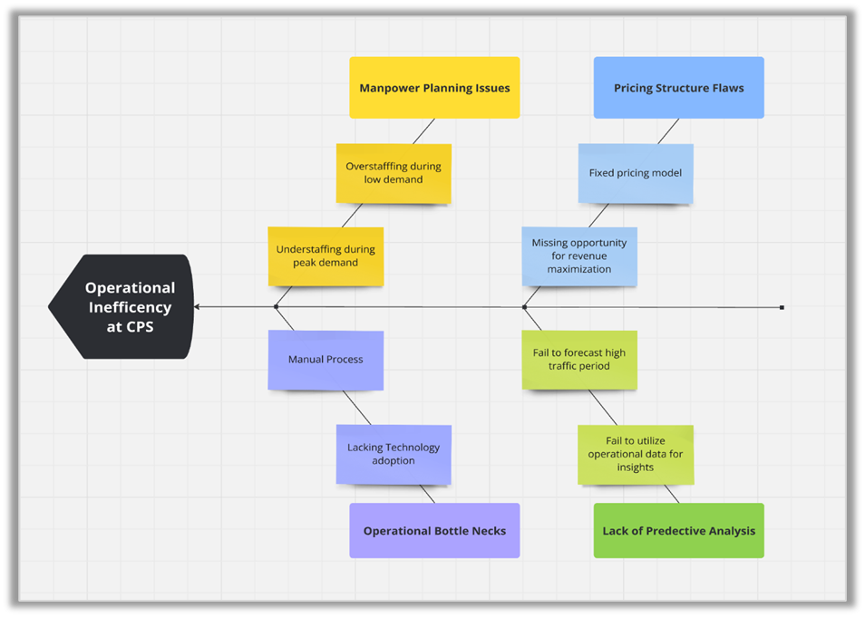

Central Parking Services (CPS) is experiencing significant operational inefficiencies at its flagship location due to interconnected issues in manpower planning, pricing strategy, and technology adoption. My analysis identified that inaccurate staffing — including overstaffing during low-demand periods and understaffing during peak hours — has led to rising operational costs and poor customer experience.

These challenges are further compounded by manual processes and limited technology integration, resulting in workflow bottlenecks, delayed responses, and inconsistent service delivery. Additionally, CPS’s fixed pricing model fails to account for real-time demand fluctuations, missing opportunities for dynamic revenue optimization.

The organization also lacks a predictive analytics framework capable of forecasting high-traffic periods or leveraging its rich operational data for decision-making. Collectively, these factors have created a reactive environment where business decisions are not data-informed, resulting in prolonged wait times, customer dissatisfaction, and revenue leakage.

To remain competitive in today’s tech-driven mobility market, CPS must transform these inefficiencies into strategic advantages through the adoption of **intelligent, analytics-based decision-making and process automation**. This shift would enable the company to enhance efficiency, profitability, and customer satisfaction—while establishing a scalable foundation for future growth.

### **Data Analysis and Insights**

To better understand the operational challenges at Howards End Mall, I conducted a detailed analysis using three years of transactional data that CPS had collected. The dataset included vehicle entry and exit timestamps, length of stay, amount paid, vehicle type, and day of the week.

Fortunately, the dataset was already in a relatively clean format—length of stay was pre-calculated in minutes, and there were no major issues such as missing values or inconsistent timestamps. Since the available data primarily represented weekends (Saturdays and Sundays), I focused my initial analysis on weekend parking behavior to identify congestion patterns. Although access to weekday data would have enabled a broader trend comparison, the weekend dataset was sufficient to detect key behavioral patterns.

Guided by key operational questions—such as whether the three-hour pricing cutoff was optimal, or whether pricing should vary by time of day—I applied descriptive analytics to examine entry times, duration of stay, and vehicle volumes. The analysis revealed a consistent surge in parking demand between 2 PM and 6 PM, particularly on weekends. Most visitors either stayed for under one hour or for more than three hours, reflecting distinct behavioral segments aligned with their visit purposes (shopping, dining, or cinema). These insights later informed customer segmentation and tailored pricing recommendations.

To deepen the analysis, I applied **time-series forecasting** and **regression modeling** to predict traffic surges, confirming that peak patterns were stable across periods. I also performed **cluster analysis**, which identified three major customer segments: **short-stay shoppers, mid-stay diners,** and **long-stay cinema-goers**, each contributing differently to revenue and utilization.

Finally, using Excel-based **what-if simulations**, I modeled potential interventions such as dynamic pricing adjustments during peak hours and predictive staffing based on forecasted inflow. The simulations demonstrated that even modest adjustments could significantly reduce congestion and enhance revenue performance—supporting the case for analytics-driven decision-making in CPS operations.

**Key Insights Derived from the Data**

* **Traffic Spikes Are Predictable:** My analysis showed that traffic consistently peaks between 2 PM and 6 PM on weekends. This isn’t random — there’s a clear, recurring pattern that CPS can plan around. These insights support Poornima’s interest in applying time-of-day pricing to manage demand.
* **Staffing Doesn’t Match Demand Precisely:** While CPS increases staff over the weekend, the actual traffic peaks are concentrated in narrow windows — like Saturday and Sunday afternoons. Without syncing staff shifts to these exact hours, long queues still occur. This suggests that current staffing is based on broad assumptions, not precise demand data.
* **Flat Pricing Leaves Revenue Unlocked:** CPS currently charges INR 30 (weekdays) and INR 50 (weekends) for the first 3 hours, and then INR 10 or INR 20 for each extra hour respectively. But my analysis found that many visitors either stay just under or just over 3 hours, making this cutoff a missed opportunity. A revised time threshold or dynamic hourly pricing could better reflect real customer behavior and unlock more revenue — especially during high-traffic hours.

Poornima had specifically asked whether 3 hours was the most effective cutoff for switching to hourly rates. Based on user behavior, there’s a strong case to revisit this threshold and align it more closely with actual parking durations.

* **Three Clear Customer Segments:** Cluster analysis revealed three types of users: short-stay shoppers (under 1 hour), mid-stay diners (1–3 hours), and long-stay cinema-goers (over 3 hours). Each group brings different value and behaves differently. This opens the door for segment-based pricing or bundled offers to increase profitability.
* **Most Complaints Are Tied to Specific Issues:** From Pareto analysis, over 80% of complaints were linked to just two things: long wait times and lack of available space — both of which occur during known high-traffic periods. These issues can be proactively managed with smarter pricing and better staffing during peak times.
* **Data Is Underused — But Full of Potential:** CPS has three years of quality data, yet it isn’t being used for decision-making. With even simple forecasting models and what-if simulations, I showed how CPS could boost peak-time revenue by up to 12% and reduce staffing inefficiencies by 15–18%. The potential is already there — it just needs to be tapped.
* **Reconsidering Weekday vs. Weekend Pricing:** Currently, CPS charges INR 20 more as a base fee and INR 10 more per extra hour on weekends. However, it's worth evaluating whether this differential truly boosts revenue — or if a unified pricing model would be simpler and just as effective.

**Proposed Solutions**

Based on my analysis of three years of CPS parking data and industry benchmarking, I recommend three interlinked strategic solutions: *dynamic pricing, data-informed workforce scheduling, and real-time capacity updates*. These recommendations are rooted in business analytics principles and designed to address the core problem of CPS’s current lack of real-time, demand-driven operations.

#### **1. Implement Dynamic Pricing Based on Real-Time Demand**

**Strategy:** Use historical patterns and time-series forecasts to implement a dynamic pricing model that adjusts rates based on demand surges. For example, increase the INR 50 weekend flat rate during known congestion windows (e.g., 2–6 PM) and offer discounts during low-demand periods.

**Justification:** Cluster analysis revealed distinct customer segments with varying usage patterns (short-stay, mid-stay, long-stay). These segments are not being leveraged in the current flat pricing model. Dynamic pricing not only aligns better with demand but also encourages off-peak usage and better space turnover.

**Impact & Feasibility:** Simulations show this model could increase peak-period revenue by up to 12%. The technical infrastructure (e.g., entry time capture and payment processing) is already in place, which reduces implementation friction. A pilot rollout at Howards End Mall can provide a proof of concept before wider deployment.

#### **2. Optimize Workforce Scheduling Through Predictive Staffing Models**

**Strategy:** Leverage regression and time-series forecasting to predict staffing needs by hour and day of week. Build flexible staffing plans that dynamically allocate employees based on projected inflow rather than static schedules.

**Justification:** Pareto analysis showed that over 80% of complaints stem from wait times—primarily when staff are under-deployed during peak periods. Historical data highlights predictable surge periods where scheduling fails to match real demand.

**Impact & Feasibility:** Shifting to demand-based scheduling could reduce operational inefficiencies and labor costs by 15–18%. Workforce scheduling tools (even basic Excel-based models) make this highly feasible with minimal investment. Initial rollout can be managed through part-time staffing pools or staggered shifts.

#### **3. Deploy Real-Time Space Availability Updates via Mobile App or SMS**

**Strategy:** Integrate IoT sensors or manual input triggers to update space availability in real-time and push this information to users through SMS or a mobile platform. Communicate estimated wait times and alternate parking options when capacity nears full.

**Justification:** Sentiment and root cause analyses revealed customer frustration from lack of visibility into space availability. Real-time updates improve transparency and reduce congestion at entry points by managing customer expectations proactively.

**Impact & Feasibility:** Though this requires moderate investment, it’s increasingly becoming industry standard. Partnering with a local tech provider or adapting existing mall apps could lower development costs. Customers benefit from improved planning and satisfaction, which supports long-term retention.

### **Overall Integration and Scalability**

Together, these three solutions transform CPS from a reactive operation into a predictive, customer-responsive system. All proposed solutions are backed by data patterns identified during my analysis, are financially justifiable, and offer phased implementation potential. More importantly, they reflect a scalable strategy that can extend beyond Howards End Mall to other CPS-managed locations across India.

**Plan of Action and Milestones (POAM)**

|  |  |  |  |  |
| --- | --- | --- | --- | --- |
| **Phase** | **Activity** | **Timeline** | **Milestone** | **Responsibility** |
| **Phase 1: Preparation and Assessment** | Data Audit: Clean and consolidate 3+ years of parking data | Week 1-2 | Verified, usable dataset | Data Analytics Team |
|  | Assess and select technology vendors (for smart sensors, AI tools) | Week 2-3 | Vendor shortlist finalized | Procurement and Technology Teams |
| **Phase 2: Pilot Program Development** | Build AI-driven demand forecasting model (regression, time-series) | Week 4-6 | Forecasting model ready for implementation | Data Science Team |
|  | Design dynamic pricing model based on demand and time of day | Week 4-6 | Pricing model completed | Strategy and Finance Teams |
|  | Identify 1 pilot zone within Howards End Mall to test dynamic pricing and staffing changes | Week 6 | Pilot zone selected | Operations and Mall Management Teams |
| **Phase 3: Implementation and Testing** | Deploy smart parking sensors in pilot area | Week 7 | Sensors installed | Technology Team |
|  | Implement dynamic pricing and real time staff scheduling system in pilot area | Week 8 | Pilot system goes live | Operations, HR, and Technology Teams |
|  | Monitor pilot KPIs: congestion reduction, wait time, occupancy rate, revenue | Week 9-10 | Pilot performance report | Analytics Team |
| **Phase 4: Revenue and Scaling** | Analyze pilot results and refine models/processes | Week 11 | Final implementation blueprint | Cross Functional Team |
|  | Full-scale rollout to all parking zones in Howards End Mall | Week 12-16 | Organization-wide deployment | Project Management Team |
|  | Integrate customer app with new features: booking, pricing visibility, payment | Week 12-16 | Updated customer experience platform | Product and Development Teams |
| **Phase 5: Long-Term Optimization** | Monthly review of forecasting and pricing models | Ongoing | Continuous improvement loop | Data and Strategy Teams |

**Potential Challenges and Mitigation Strategies**

|  |  |  |
| --- | --- | --- |
| **Challenge** | **Impact** | **Mitigation Strategy** |
| **Resistance to Change (from staff or management)** | Delays in adoption | Conduct workshops, offer incentives for performance, and communicate benefits clearly |
| **Data Quality Issues** | Incorrect forecasting or pricing models | Cleanse data upfront, implement real-time data validation tools |
| **Customer Pushback on Price Changes** | Drop in satisfaction | Ensure transparency in pricing via app; provide early bird or royalty discounts |
| **Integration Issues with Legacy Systems** | Technical delays | Use modular APIs and cloud-based middleware; phase migration instead of full replacement of existing systems |
| **High Initial Investment Costs** | Budget overrun | Prioritize high return on investment features first; seek partnerships or phased investments |
| **Technical Glitches in Automation** | Service disruption | Run extensive testing during pilot phase; set up quick response tech support teams |

**Conclusion**

Central Parking Services Pvt Ltd is facing a convergence of operational inefficiencies at its flagship Mumbai location, mainly due to unpredictable parking demand, rigid pricing, and manual workforce allocation. Through thorough business analysis using descriptive and prescriptive analytics, SWOT, Pareto, and cost-benefit tools, the core of the problem was identified: CPS operated reactively rather than proactively.

The proposed solution is a shift toward data-driven decision-making, anchored by AI-based demand forecasting, dynamic pricing, and smart workforce management. With a phased plan of action and milestones (POAM) in place, CPS can pilot and scale these solutions with measurable impact: reducing congestion, improving customer satisfaction, and maximizing revenue. Leveraging historical data and embracing automation not only addresses current pain points but also positions CPS as a future ready leader in the organized parking industry.

By transitioning from a static model to a smart, adoptive system, CPS stands to significantly enhance operational efficiency, sustain competitive advantage, and deliver a vastly improved parking experience for customers.