Assignment Kit for Simpson’s rule
Overview

Overview | This assignment kit covers the following topics.
 | Section | See Page
 | Prerequisites | 2
 | Program 5 requirements | 3
 | Numerical integration with Simpson’s rule | 4
 | The t distribution | 6
 | Using the t distribution in the PSP | 6
 | An example | 9
 | Assignment instructions | 11
 | Guidelines and evaluation criteria | 20

Requirements

Simpson’s rule requirements | Using Matlab, write a program to numerically integrate a function using Simpson’s rule. Use the t distribution as the function.  Thoroughly test the program. At a minimum, calculate the values for the t distribution integral for the values in Table 1. Expected values are also included in Table 1.

Test |  | Expected Value | Actual Value
x | dof | p
0 to x= 1.1 | 9 | 0.35006
0 to x= 1.1812 | 10 | 0.36757
0 to x= 2.750 | 30 | 0.49500
Table 1

Numerical integration with Simpson’s rule

Overview | Numerical integration is the process of determining the area “under” some function.  Numerical integration calculates this area by dividing it into vertical “strips” and summing their individual areas.  The key is to minimize the error in this approximation. | 

Simpson’s rule | Simpson’s rule can be used to integrate a symmetrical statistical distribution function over a specified range (e.g., from 0 to some value x).  https://es.wikipedia.org/wiki/Regla_de_Simpson  - num_seg = initial number of segments, an even number  - W = x/num_seg, the segment width  - E = the acceptable error, e.g., 0.00001  - Compute the integral value with the following equation.  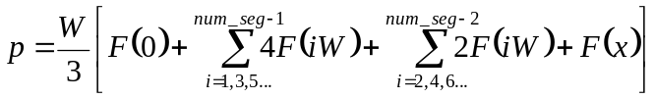  - Compute the integral value again, but this time with num_seg = num_seg*2.  - If the difference between these two results is greater than E, double num_seg and compute the integral value again. Continue doing this until the difference between the last two results is less than E. The latest result is the answer.
Continued on next page
Numerical integration with Simpson’s rule, Continued

A simple example | Let’s look at a simple function, where F(x) = 2x.  Note: This example is a triangle. The area of a triangle is  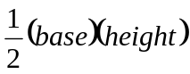  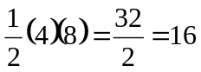 | F(x) = 2x  num_seg = 4  W = 4/4 = 1  x = 4

In this example, we can expand Simpson’s rule

to
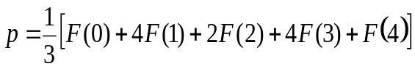
and then substitute calculated values for the function F(x)= 2x
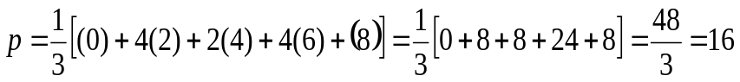

The t distribution

Overview | The t distribution is a very important statistical tool. It is used instead of the normal distribution when the true value of the population variance is not known and must be estimated from a sample.  https://es.wikipedia.org/wiki/Distribuci%C3%B3n_t_de_Student  The shape of the t distribution is dependent on the number of points in your dataset. As n gets large, the t distribution approaches the normal distribution. For lower values, it has a lower central “hump” and fatter “tails.”  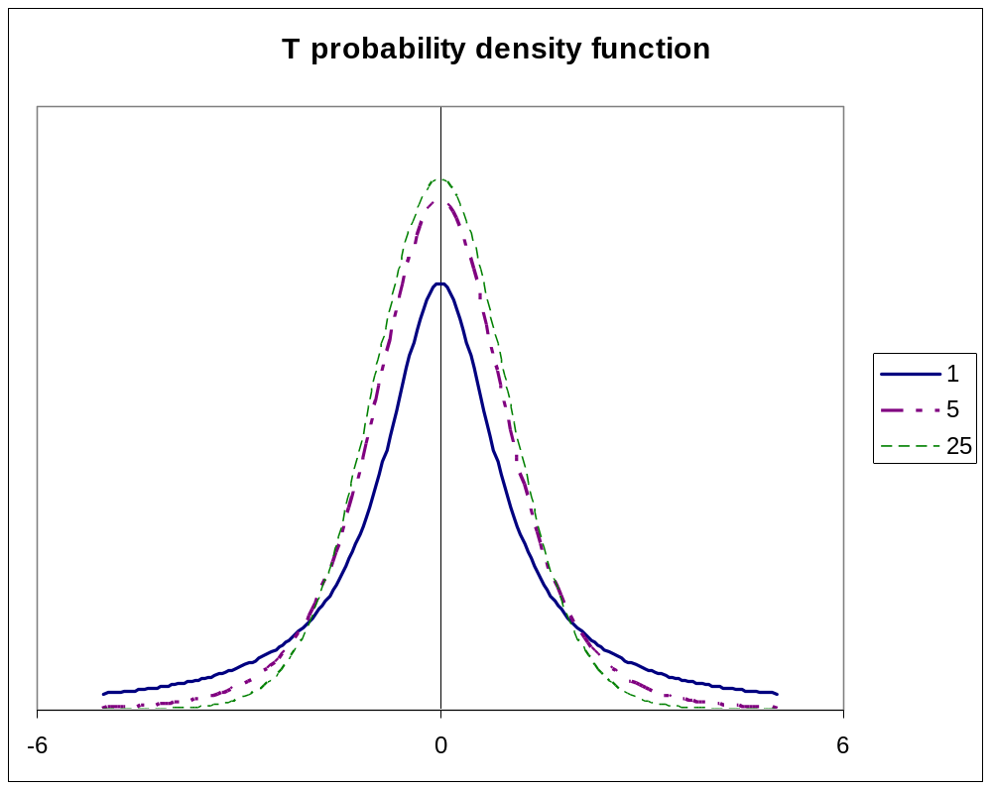

The t distribution, Continued

T distribution function | When numerically integrating the t distribution with Simpson’s rule, use the following function.  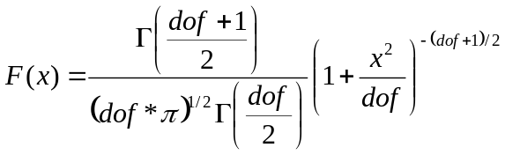  where  • dof = degrees of freedom  • Γ is the gamma function  The gamma function is  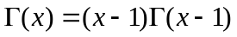, where  • 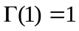  • 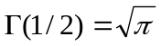
Continued on next page
The t distribution, Continued

An example of calculating gamma for an integer value | 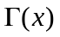for integer values is 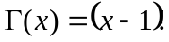.  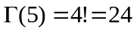

An example of calculating gamma for a non-integer value | 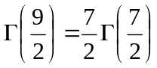  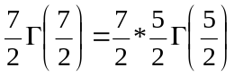  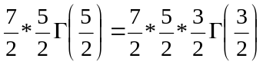  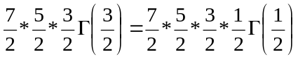  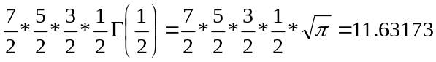

An example

An example | In this example, we’ll calculate the values for the t distribution integral from 0 to x =1.1 with 9 degrees of freedom.  - First we’ll set num_seg = 10 (any even number)  - W = x/num_seg = 1.1/10 = 0.11  - E = 0.00001  - dof = 9  - x = 1.1  - Compute the integral value with the following equation.  where  - We can solve the first part of the equation:  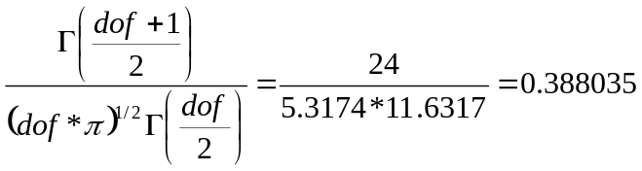  The intermediate values for this are in the Table 2.

i | x_{i} | 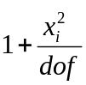 | 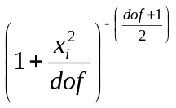 | 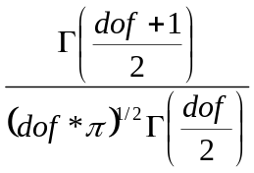 | 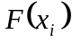 | Multiplier |  | Terms  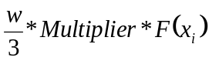
0 | 0 | 1 | 1 | 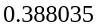 | 0.38803 | 1 |  | 0.01423
1 | 0.11 | 1.00134 | 0.9933 |  | 0.38544 | 4 |  | 0.05653
2 | 0.22 | 1.00538 | 0.97354 |  | 0.37777 | 2 |  | 0.0277
3 | 0.33 | 1.0121 | 0.94164 |  | 0.36539 | 4 |  | 0.05359
4 | 0.44 | 1.02151 | 0.89905 |  | 0.34886 | 2 |  | 0.02558
5 | 0.55 | 1.03361 | 0.84765 |  | 0.32892 | 4 |  | 0.04824
6 | 0.66 | 1.0484 | 0.78952 |  | 0.30636 | 2 |  | 0.02247
7 | 0.77 | 1.06588 | 0.72688 |  | 0.28205 | 4 |  | 0.04137
8 | 0.88 | 1.08604 | 0.66185 |  | 0.25682 | 2 |  | 0.01883
9 | 0.99 | 1.1089 | 0.5964 |  | 0.23142 | 4 |  | 0.03394
10 | 1.1 | 1.13444 | 0.53221 |  | 0.20652 | 1 |  | 0.00757
Result |  |  |  |  |  |  | 0.3500589
Table 2
Continued on next page
An example, Continued

Example, continued | - Compute the integral value again, but this time with num_seg = 20. The new result is 0.35005864.  - We compare the new result to the old result.  - 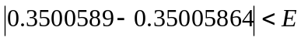  - We can then return the value p =0.35005864.

