Linear regression

Overview

Overview | This assignment kit covers the following topics.
 | Section | See Page
 | Prerequisites | 2
 | Requirements | 3
 | Regression overview | 5
 | Correlation overview | 6
 | Calculating regression and correlation | 8
 | An example | 9
 | Assignment instructions | 11
 | Guidelines and evaluation criteria | 18

Prerequisites | Reading  •  Additional lecture  https://koldopina.com/regresion-lineal-simple/

Requirements

Program requirements | Using Matlab, write a program to  • calculate the linear regression parameters 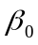 and 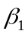 and correlation coefficients 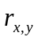 and 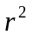 for a set of n pairs of data,  • given an estimate, 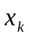 calculate an improved prediction, 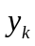 where  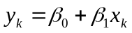  Table 1 contains historical estimated and actual data for 10 programs. For program 11, the developer has estimated a proxy size of 386 LOC.  Thoroughly test the program. At a minimum, run the following four test cases.  • Test 1: Calculate the regression parameters and correlation coefficients between estimated proxy size and actual added and modified size in Table 1. Calculate plan added and modified size given an estimated proxy size of = 386.  • Test 2: Calculate the regression parameters and correlation coefficients between estimated proxy size and actual development hours in Table 1. Calculate time estimate given an estimated proxy size of = 386.  • Test 3: Calculate the regression parameters and correlation coefficients between plan added and modified size and actual added and modified size in Table 1. Calculate plan added and modified size given an estimated proxy size of = 386.  • Test 4: Calculate the regression parameters and correlation coefficients between plan added and modified size and actual development hours in Table 1. Calculate time estimate given an estimated proxy size of = 386.  Expected results are provided in Table 2.

Program Number | Estimated Proxy Size | Plan Added and Modified size | Actual Added and Modified Size | Actual Development Hours
1 | 130 | 163 | 186 | 15.0
2 | 650 | 765 | 699 | 69.9
3 | 99 | 141 | 132 | 6.5
4 | 150 | 166 | 272 | 22.4
5 | 128 | 137 | 291 | 28.4
6 | 302 | 355 | 331 | 65.9
7 | 95 | 136 | 199 | 19.4
8 | 945 | 1206 | 1890 | 198.7
9 | 368 | 433 | 788 | 38.8
10 | 961 | 1130 | 1601 | 138.2
Table 1
Continued on next page

Program 3 requirements, Continued

Expected
results

Test | Expected Values |  |  |  |  | Actual Values
Test 1 | -22.55 | 1.7279 | 0.9545 | 0.9111 | 644.429
Test 2 | -4.039 | 0.1681 | 0.9333 | .8711 | 60.858
Test 3 | -23.92 | 1.43097 | .9631 | .9276 | 528.4294
Test 4 | -4.604 | 0.140164 | .9480 | .8988 | 49.4994
Table 2

Regression

Overview | Linear regression is a way of optimally fitting a line to a set of data. The linear regression line is the line where the distance from all points to that line is minimized. The equation of a line can be written as  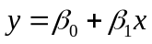  In Figure 1, the best fit regression line has parameters of = -4.0389 and = 0.1681.  y = -4.0389 +0.1681x  0  50  100  150  200  250  0  200  400  600  800  1000  1200  Estimated Proxy Size  Actual Development Hours

Figure 1
Correlation

Overview | The correlation calculation determines the relationship between two sets of numerical data.  The correlation can range from +1 to -1.  • Results near +1 imply a strong positive relationship; when x increases, so does y.  • Results near -1 imply a strong negative relationship; when x increases, y decreases.  • Results near 0 imply no relationship.

Using correlation | Correlation is used to judge the quality of the linear relation in various historical process data that are used for planning. For example, the relationships between estimated proxy size and actual time or plan added and modified size and actual time.  For this purpose, we examine the value of the relation r_{xy} squared, or .
 |  | If is | the relationship is
 |  | .9 ≤ | predictive; use it with high confidence
 |  | .7 ≤ < .9 | strong and can be used for planning
 |  | .5 ≤ < .7 | adequate for planning but use with caution
 |  | < .5 | not reliable for planning purposes

Limitations of correlation | Correlation doesn’t imply cause and effect.  A strong correlation may be coincidental.  From 1840 to 1960, no U.S. president elected in a year ending in 0 survived his presidency. Coincidence or Correlation?  Many coincidental correlations may be found in historical process data.  To use a correlation, you must understand the cause-and-effect relationship in the process.

Calculating regression and correlation

Calculating regression and correlation | The formulas for calculating the regression parameters and are  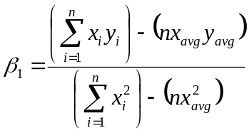  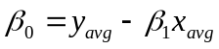  The formulas for calculating the correlation coefficient and are  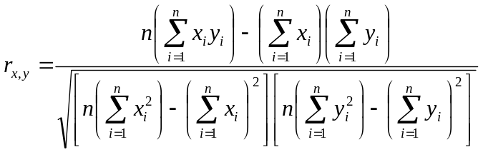  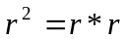  where  • Σ is the symbol for summation  • i is an index to the n numbers  • x and y are the two paired sets of data  • n is the number of items in each set x and y  • 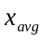 is the average of the x values  • 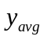 is the average of the y values

An example

An example | In this example, we will calculate the regression parameters ( and values) and correlation coefficients and of the data in the Table 3.

n | x | y
1 | 130 | 186
2 | 650 | 699
3 | 99 | 132
4 | 150 | 272
5 | 128 | 291
6 | 302 | 331
7 | 95 | 199
8 | 945 | 1890
9 | 368 | 788
10 | 961 | 1601
Table 3

- In this example there are 10 items in each dataset and therefore we set n = 10.
- We can now solve the summation items in the formulas.

n | x | y | x² | x*y | y²
1 | 130 | 186 | 16900 | 24180 | 34596
2 | 650 | 699 | 422500 | 454350 | 488601
3 | 99 | 132 | 9801 | 13068 | 17424
4 | 150 | 272 | 22500 | 40800 | 73984
5 | 128 | 291 | 16384 | 37248 | 84681
6 | 302 | 331 | 91204 | 99962 | 109561
7 | 95 | 199 | 9025 | 18905 | 39601
8 | 945 | 1890 | 893025 | 1786050 | 3572100
9 | 368 | 788 | 135424 | 289984 | 620944
10 | 961 | 1601 | 923521 | 1538561 | 2563201
Total | 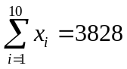 | 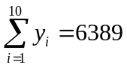 | 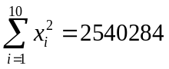 | 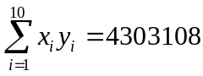 | 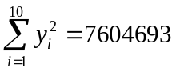
 | 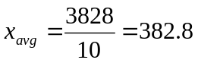 | 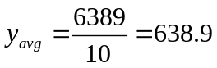
Continued on next page
An example, Continued

An example, cont. | - We can then substitute the values into the formulas  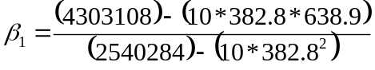  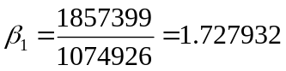  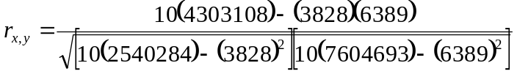  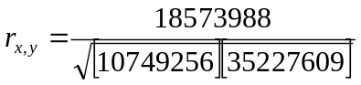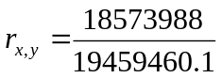  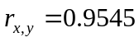  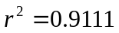  - We can then substitute the values in the formula  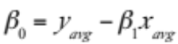  - We now find from the formula

