**Test Driven Development & Continuous Integration**

1.- Go to <https://github.com>

2.- **Fork** the repository:<https://github.com/adsoftsito/bigdata-maps>

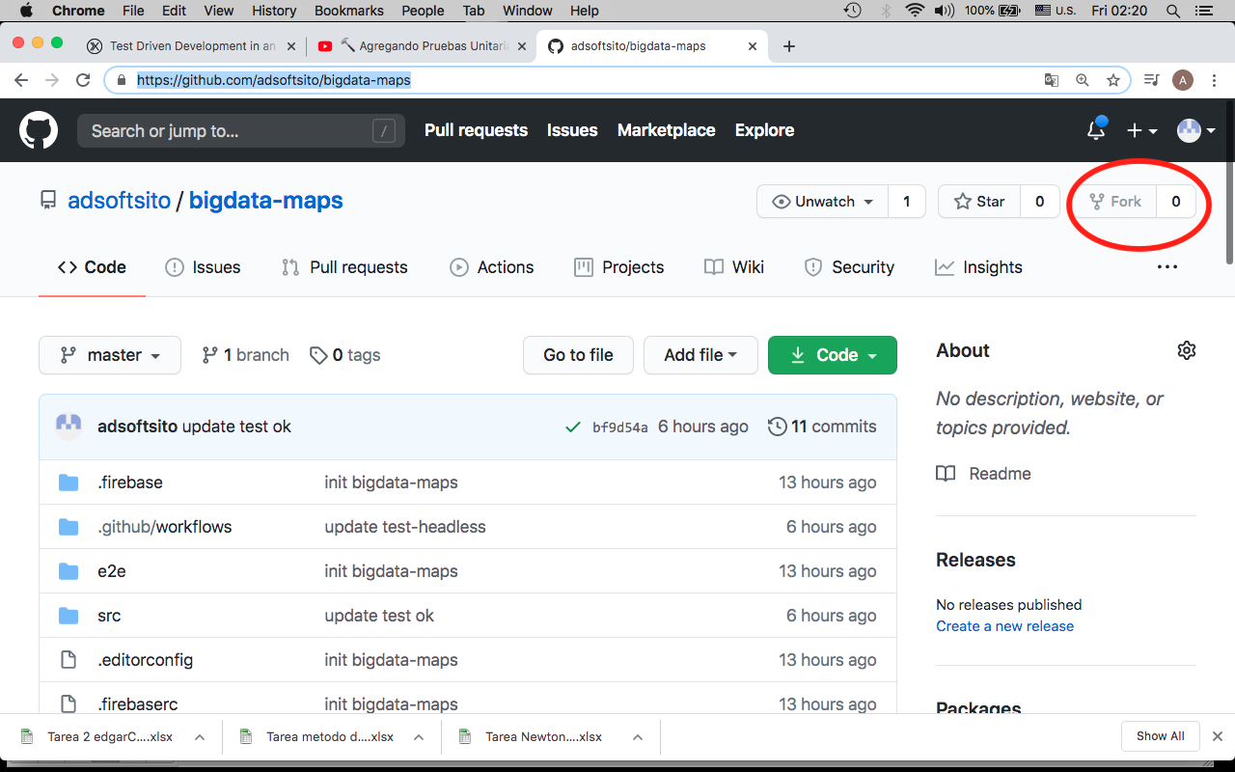

3.- Clone you own repository in wokstation and Change to repo directory

*$ git clone* [*https://github.com/<your-user>/project-demo.git*](https://github.com/%3cyour-user%3e/project-demo.git)

*$ cd bigdata-maps*

4.- Check url repository, install, serve, test and build.

*$ pwd*

*$ git remote –v*

*origin https://github.com/<your-user>/bigdata-maps.git (fetch)*

*origin https://github.com/<your-user>/ bigdata-maps.git (push)*

$ npm install

$ ng serve

$ ng test code--coverage

$ npm test-headless

$ ng build

4.- Edit README.md, add # v0.1 tag

*$ vi README.md*

**BigdataMaps**

# v0.1 tag

…

…

:wq

5.- Commit, push changes

*$ git add .*

*$ git commit -m "update README maps with v0.1 tag"*

*$ git push –u origin master*

6.- Tag base code with v0.1

*$ git tag -a v0.1 -m "my maps version 0.1"*

*$ git tag*

*$ git show v0.1*

7.- Publish tag

*$ git push origin v0.1*

8.- create branch hotfixes, release and develop

*$ git checkout master*

*$ git branch hotfixes*

*$ git checkout hotfixes*

*$ vi HOTFIXES.md*

*# hotfixes maps here*

*:wq*

*$ git add .*

*$ git commit –m “init hotfixes branch”*

*$ git push –u origin hotfixes*

##############################

$ git checkout master

$ git branch release

$ git checkout release

*$ vi RELEASE.md*

*# release maps here*

*:wq*

*$ git add .*

$ git commit –a –m “init release branch”

$ git push –u origin release

#############################

*$ git checkout master*

*$ git branch develop*

*$ git checkout develop*

*$ vi DEVELOP.md*

*# develop maps here*

*:wq*

*$ git add .*

*$ git commit –a –m “init develop branch”*

*$ git push –u origin develop*

9.- Configure CI in Github Actions

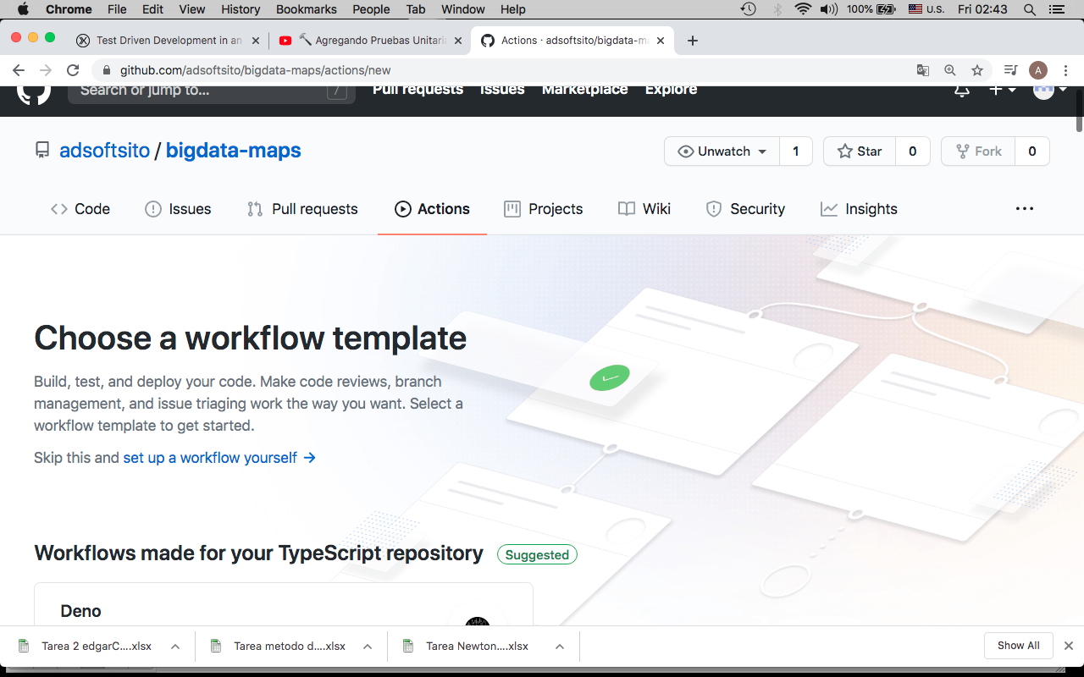

Select nodejs template

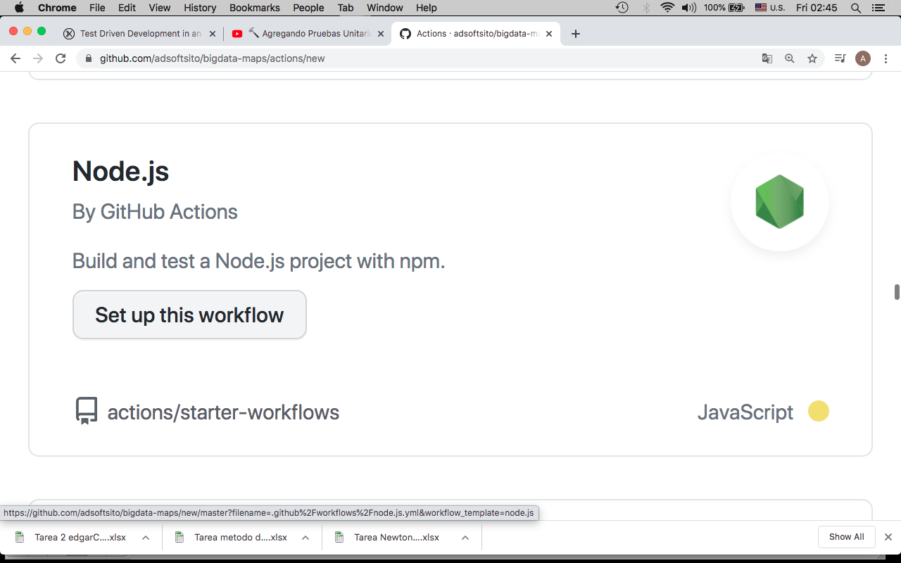

Edit nodejs template :

|  |
| --- |
| name: Node.js CI |
|  |  |
|  | on: |
|  | push: |
|  | branches: [ master, hotfixes, release, develop ] |
|  | pull_request: |
|  | branches: [ master, hotfixes, release, develop ] |
|  |  |
|  | jobs: |
|  | build: |
|  |  |
|  | runs-on: ubuntu-latest |
|  |  |
|  | strategy: |
|  | matrix: |
|  | node-version: [10.x] |
|  |  |
|  | steps: |
|  | - uses: actions/checkout@v2 |
|  | - name: Use Node.js ${{ matrix.node-version }} |
|  | uses: actions/setup-node@v1 |
|  | with: |
|  | node-version: ${{ matrix.node-version }} |
|  | - run: npm ci |
|  | - run: npm run test-headless |
|  | - run: npm run build --if-present |

10.- Configure branchs protection

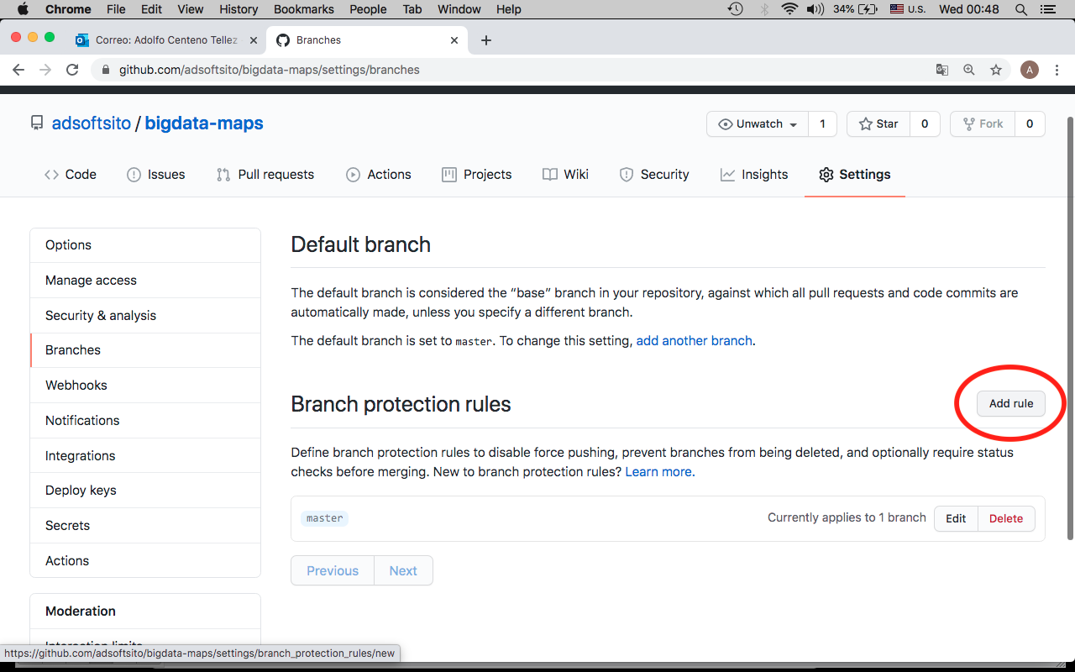

- Create master rule

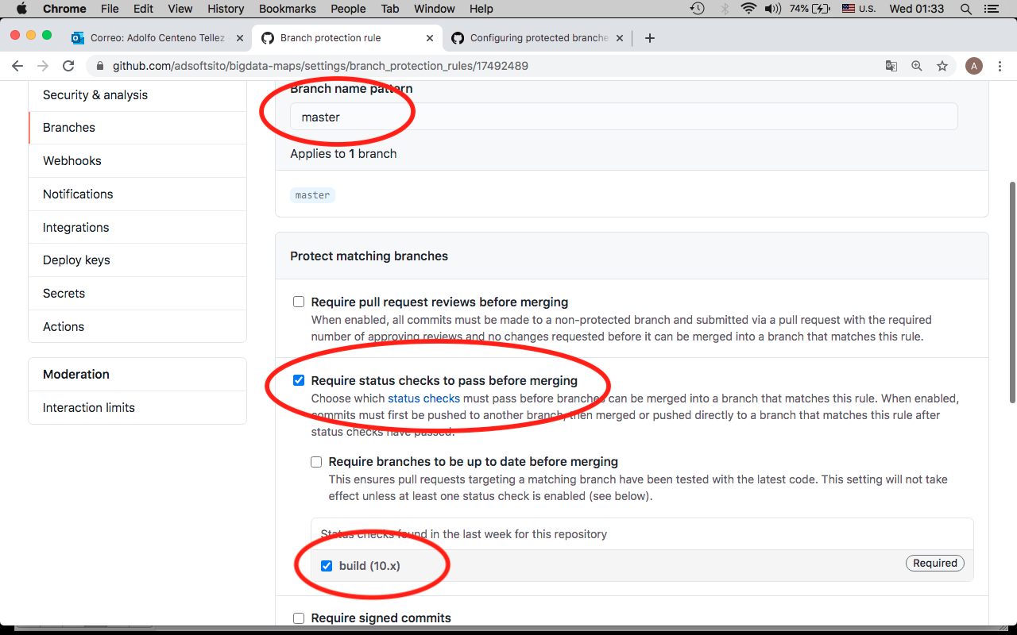

- Repeat for hotfixes, release and develop branch

