Form:

ZITEMPO_TT ZITEMPO
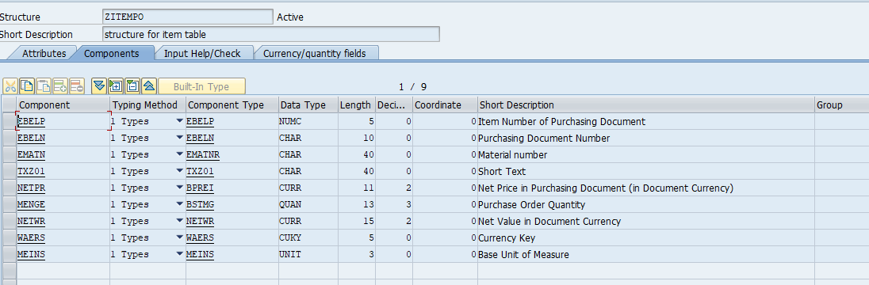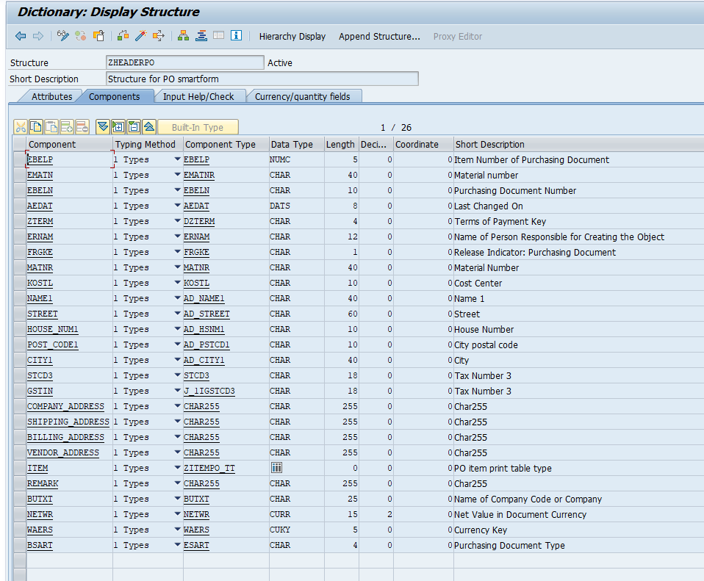ZMS_PO_ITEMS_TT ZMS_PO_ITEMS
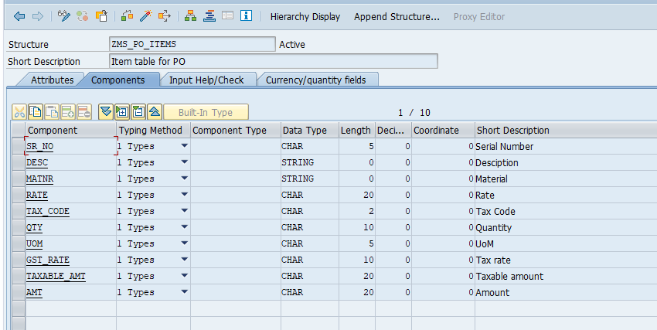
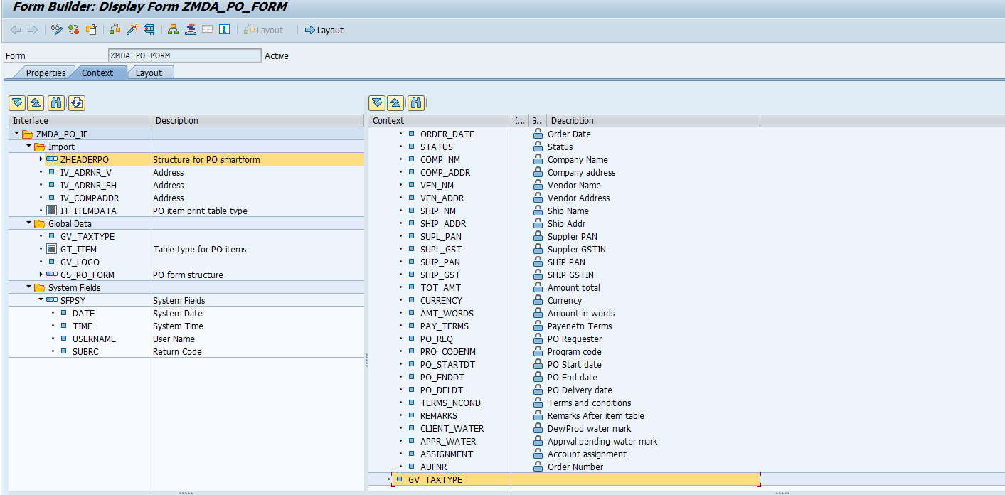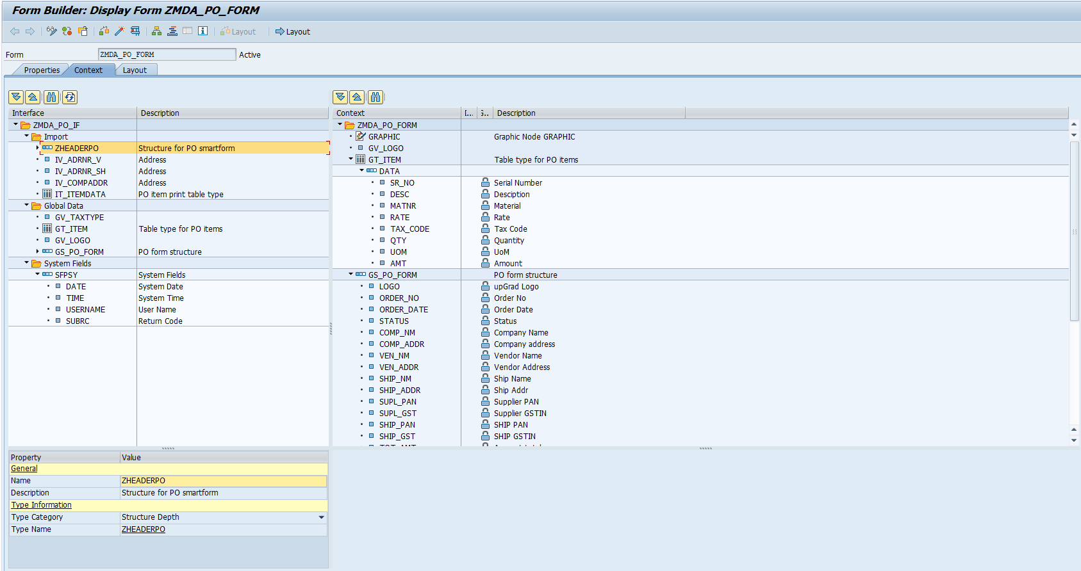
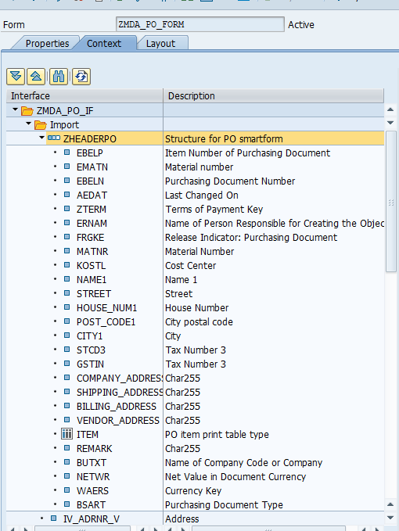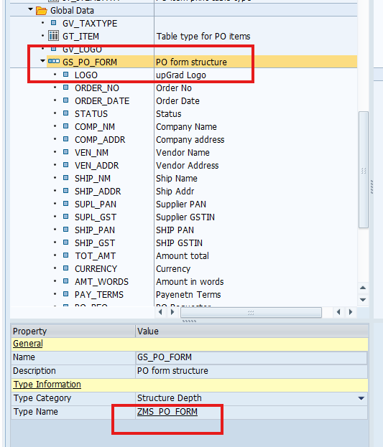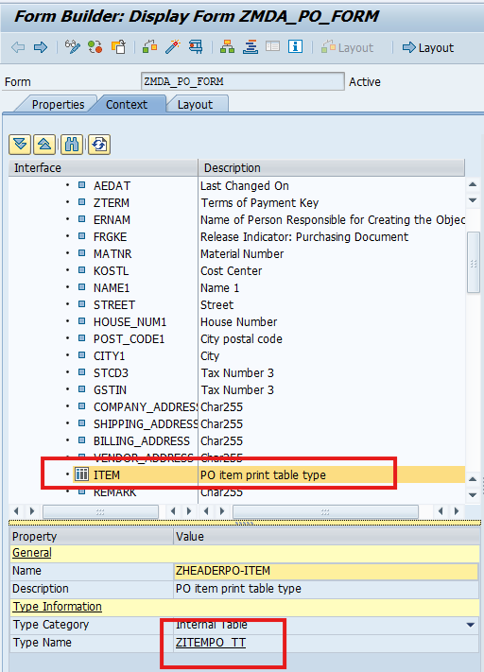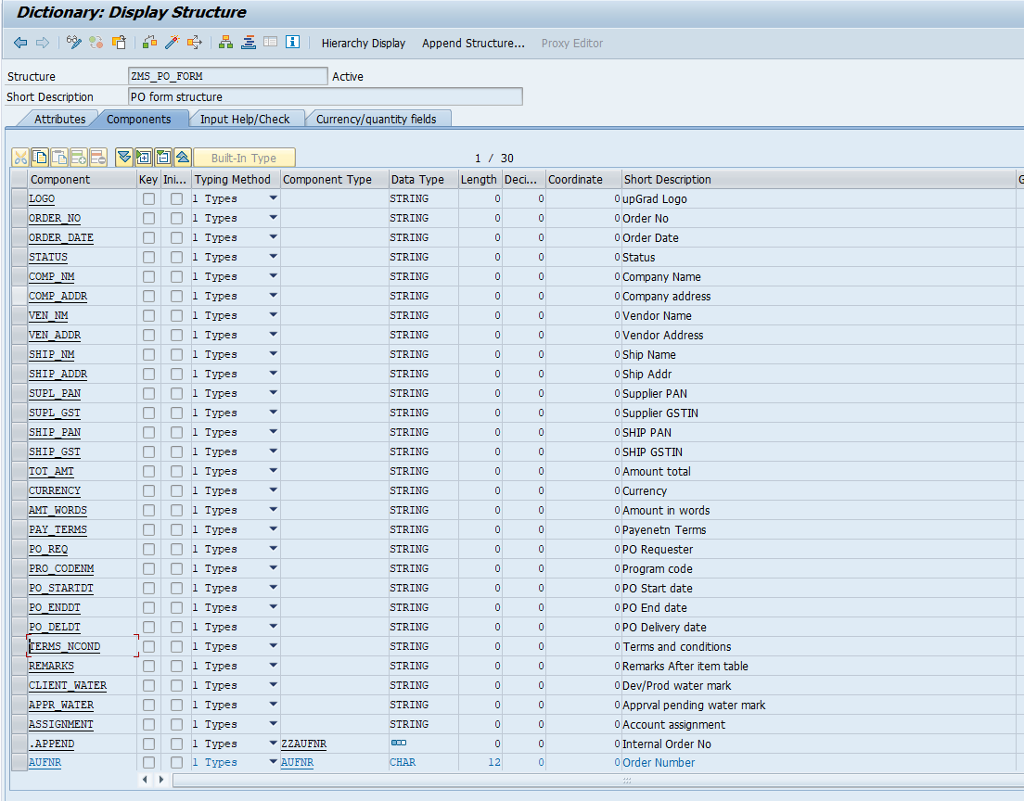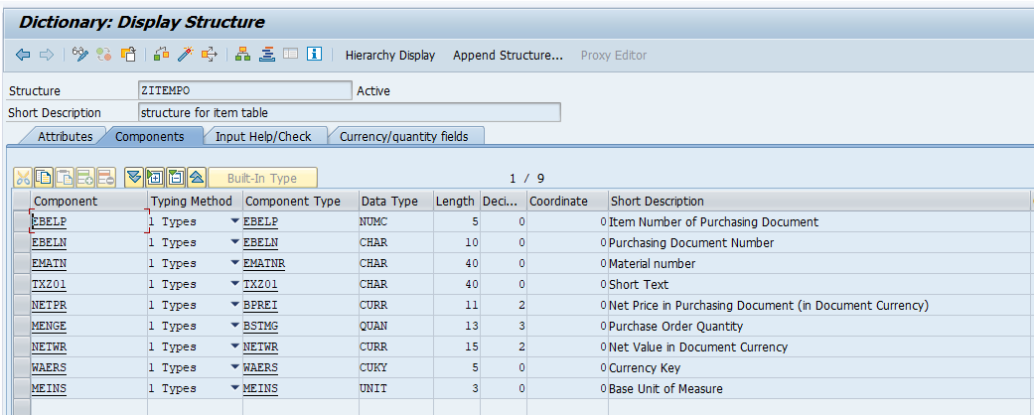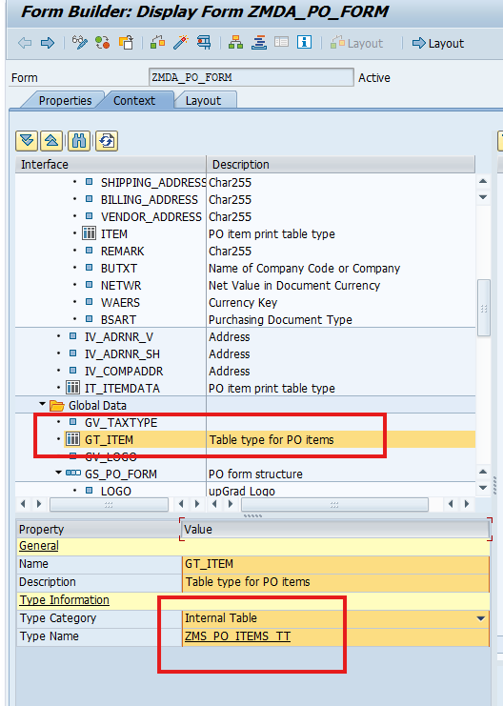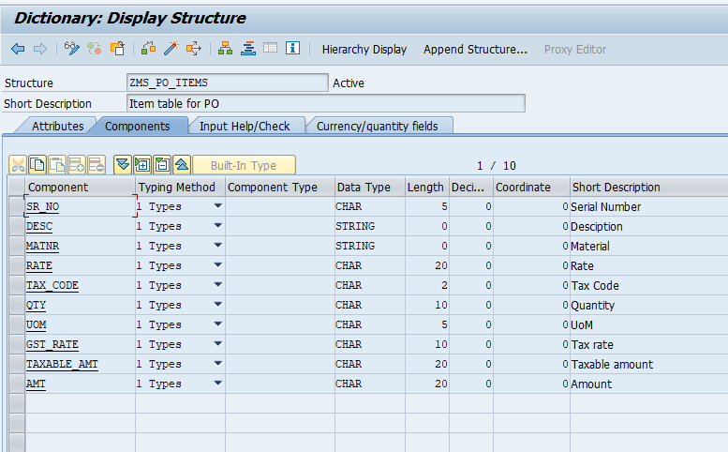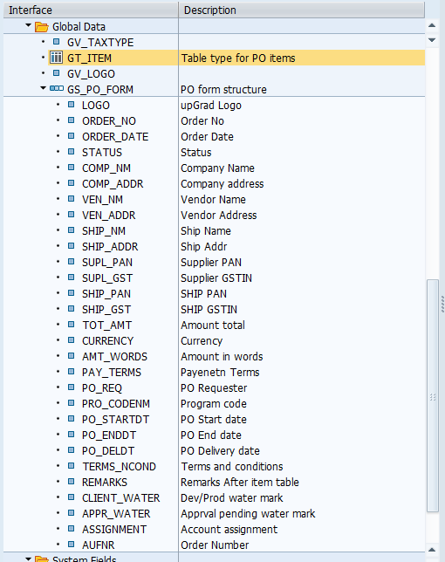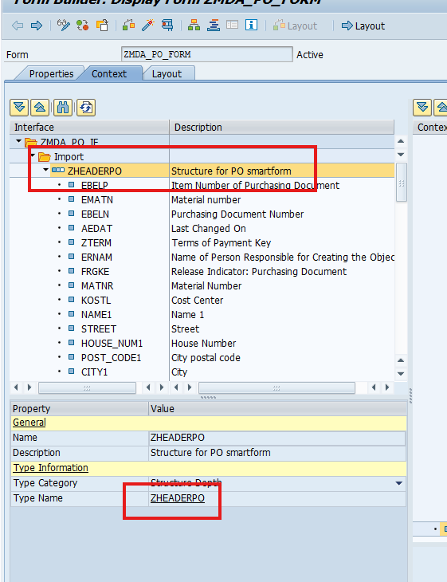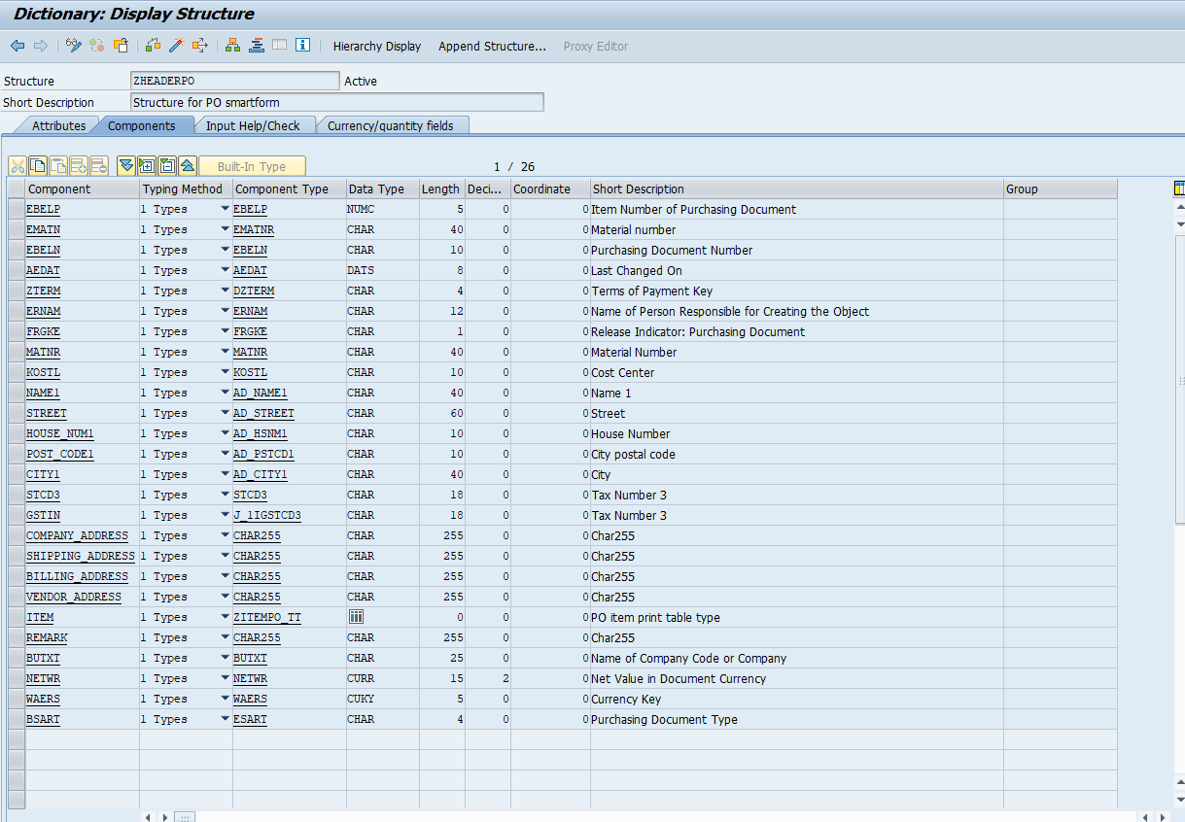

XML SOURCE LAYOUT

<?xml version="1.0" encoding="UTF-8"?>
<?xfa generator="AdobeLiveCycleDesigner_V11.0.9.20240701.1.52_SAP" APIVersion="3.6.24183.0"?>
<xdp:xdp xmlns:xdp="http://ns.adobe.com/xdp/" timeStamp="2025-11-27T17:06:42Z" uuid="4980699f-2bb5-4683-aa32-98573b7c9340">
<template xmlns:xliff="urn:oasis:names:tc:xliff:document:1.1" xmlns="http://www.xfa.org/schema/xfa-template/3.3/">
<?formServer defaultPDFRenderFormat acrobat10.0dynamic?>
<subform layout="tb" locale="en_IN" name="data" restoreState="auto">
<pageSet>
<pageArea id="Page1" name="Master_Body">
<contentArea h="235.332mm" id="contentArea_ID" w="190.5mm" x="12.7mm" y="55.748mm"/>
<medium long="297mm" short="210mm" stock="a4"/>
<draw anchorType="middleCenter" h="41.546mm" hAlign="center" name="Text12" w="109.952mm" x="109.15mm" y="168.436mm">
<ui>
<textEdit/>
</ui>
<value>
<exData contentType="text/html">
<body xmlns="http://www.w3.org/1999/xhtml" xmlns:xfa="http://www.xfa.org/schema/xfa-data/1.0/"><p style="text-decoration:none;letter-spacing:0in"><span xfa:embed="#floatingField009741" xfa:embedMode="raw" xfa:embedType="uri"/></p></body>
</exData>
</value>
<font baselineShift="0pt" size="48pt" typeface="Arial" weight="bold">
<fill>
<color value="193,193,193"/>
</fill>
</font>
<margin bottomInset="0.5mm" leftInset="0.5mm" rightInset="0.5mm" topInset="0.5mm"/>
<para hAlign="center" marginLeft="0pt" marginRight="0pt" spaceAbove="0pt" spaceBelow="0pt" textIndent="0pt" vAlign="middle"/>
<border>
<edge presence="hidden">
<color value="192,192,192"/>
</edge>
<corner join="round" presence="hidden" radius="2mm" thickness="0.175mm">
<color value="192,192,192"/>
</corner>
</border>
</draw>
<subform name="LogoBlock" w="190.958mm" x="12.383mm" y="6.459mm">
<draw anchorType="middleCenter" h="18.505mm" hAlign="center" name="Text12" w="139.7mm" x="95.976mm" y="27.3mm">
<ui>
<textEdit/>
</ui>
<value>
<exData contentType="text/html">
<body xmlns="http://www.w3.org/1999/xhtml" xmlns:xfa="http://www.xfa.org/schema/xfa-data/1.0/"><p style="text-decoration:none;letter-spacing:0in"><br/><span xfa:embed="#floatingField026962" xfa:embedMode="raw" xfa:embedType="uri"/></p></body>
</exData>
</value>
<font baselineShift="0pt" size="20pt" typeface="Arial" weight="bold">
<fill>
<color value="193,193,193"/>
</fill>
</font>
<margin bottomInset="0.5mm" leftInset="0.5mm" rightInset="0.5mm" topInset="0.5mm"/>
<para hAlign="center" marginLeft="0pt" marginRight="0pt" spaceAbove="0pt" spaceBelow="0pt" textIndent="0pt" vAlign="middle"/>
<border>
<edge presence="hidden">
<color value="192,192,192"/>
</edge>
<corner join="round" presence="hidden" radius="2mm" thickness="0.175mm">
<color value="192,192,192"/>
</corner>
</border>
</draw>
<bind match="none"/>
<draw anchorType="middleCenter" h="13.337mm" name="Text9" w="55.061mm" x="89.451mm" y="19.114mm">
<ui>
<textEdit/>
</ui>
<value>
<text xliff:rid="4BE6931F-256A-4C29-B18F-6315B81E5450">Purchase Order</text>
</value>
<font baselineShift="0pt" size="20pt" typeface="Arial Narrow" weight="bold"/>
<margin bottomInset="0.5mm" leftInset="0.5mm" rightInset="0.5mm" topInset="0.5mm"/>
<para hAlign="center" marginLeft="0pt" marginRight="0pt" spaceAbove="0pt" spaceBelow="0pt" textIndent="0pt" vAlign="middle"/>
</draw>
<field h="25.4mm" name="UPGRAD_LOGO" w="38.1mm" x="2.951mm" y="4.201mm">
<ui>
<imageEdit/>
</ui>
<caption placement="bottom" reserve="5mm">
<font typeface="Arial"/>
<para vAlign="middle"/>
</caption>
<bind match="dataRef" ref="$.GRAPHIC"/>
<desc>
<exData name="Schema Annotation">Graphic Node GRAPHIC
URL-FIELD = GV_LOGO</exData>
</desc>
</field>
<border>
<edge/>
<corner thickness="0.175mm"/>
</border>
<field access="readOnly" h="9mm" id="floatingField006334" name="TextField" presence="hidden" w="62mm" x="0.117mm">
<ui>
<textEdit>
<border>
<edge stroke="lowered"/>
</border>
<margin/>
</textEdit>
</ui>
<font typeface="Arial"/>
<margin bottomInset="1mm" leftInset="1mm" rightInset="1mm" topInset="1mm"/>
<para vAlign="middle"/>
<bind match="dataRef" ref="$.GS_PO_FORM.ORDER_NO"/>
</field>
<draw h="6.35mm" name="Text13" w="47.739mm" y="36.721mm">
<ui>
<textEdit/>
</ui>
<value>
<exData contentType="text/html" xliff:rid="41EF57E0-CBB7-4805-86A6-47284E914654">
<body xmlns="http://www.w3.org/1999/xhtml" xmlns:xfa="http://www.xfa.org/schema/xfa-data/1.0/"><p style="text-decoration:none;letter-spacing:0in">PO Number :<span style="xfa-spacerun:yes"> </span><span style="font-weight:normal"><span xfa:embed="#floatingField006334" xfa:embedMode="raw" xfa:embedType="uri"/></span></p></body>
</exData>
</value>
<font baselineShift="0pt" typeface="Arial Narrow" weight="bold"/>
<margin bottomInset="1.0008mm" leftInset="1.0008mm" rightInset="1.0008mm" topInset="1.0008mm"/>
<para marginLeft="0pt" marginRight="0pt" spaceAbove="0pt" spaceBelow="0pt" textIndent="0pt" vAlign="middle"/>
<border>
<edge/>
<edge/>
<edge/>
<edge presence="hidden"/>
<corner/>
</border>
</draw>
<field access="readOnly" h="9mm" id="floatingField019169" name="TextField" presence="hidden" w="62mm" x="0.117mm">
<ui>
<textEdit>
<border>
<edge stroke="lowered"/>
</border>
<margin/>
</textEdit>
</ui>
<font typeface="Arial"/>
<margin bottomInset="1mm" leftInset="1mm" rightInset="1mm" topInset="1mm"/>
<para vAlign="middle"/>
<bind match="dataRef" ref="$.GS_PO_FORM.ORDER_DATE"/>
</field>
<draw h="6.35mm" name="Text13" w="47.739mm" x="48.069mm" y="36.721mm">
<ui>
<textEdit/>
</ui>
<value>
<exData contentType="text/html" xliff:rid="C5604BC0-3EC5-4519-836E-EC7335E2A6CD">
<body xmlns="http://www.w3.org/1999/xhtml" xmlns:xfa="http://www.xfa.org/schema/xfa-data/1.0/"><p style="text-decoration:none;letter-spacing:0in">PO Date :<span style="xfa-spacerun:yes"> </span><span style="font-weight:normal"><span xfa:embed="#floatingField019169" xfa:embedMode="raw" xfa:embedType="uri"/></span></p></body>
</exData>
</value>
<font baselineShift="0pt" typeface="Arial Narrow" weight="bold"/>
<margin bottomInset="1.0008mm" leftInset="1.0008mm" rightInset="1.0008mm" topInset="1.0008mm"/>
<para marginLeft="0pt" marginRight="0pt" spaceAbove="0pt" spaceBelow="0pt" textIndent="0pt" vAlign="middle"/>
<border>
<edge/>
<edge/>
<edge/>
<edge presence="hidden"/>
<corner/>
</border>
</draw>
<field access="readOnly" h="9mm" id="floatingField011478" name="COMP_NM" presence="hidden" w="62mm" x="0.117mm">
<ui>
<textEdit>
<border>
<edge stroke="lowered"/>
</border>
<margin/>
</textEdit>
</ui>
<font typeface="Arial Narrow"/>
<margin bottomInset="1mm" leftInset="1mm" rightInset="1mm" topInset="1mm"/>
<para vAlign="middle"/>
<bind match="dataRef" ref="$.GS_PO_FORM.COMP_NM"/>
</field>
<field access="readOnly" h="9mm" id="floatingField024464" name="COMP_ADDR" presence="hidden" w="62mm" x="0.117mm">
<ui>
<textEdit>
<border>
<edge stroke="lowered"/>
</border>
<margin/>
</textEdit>
</ui>
<font typeface="Arial"/>
<margin bottomInset="1mm" leftInset="1mm" rightInset="1mm" topInset="1mm"/>
<para vAlign="middle"/>
<bind match="dataRef" ref="$.GS_PO_FORM.COMP_ADDR"/>
</field>
<draw h="30.344mm" name="Text14" w="57.744mm" x="132.584mm" y="4.201mm">
<ui>
<textEdit/>
</ui>
<font baselineShift="0pt" typeface="Arial Narrow" weight="bold"/>
<margin bottomInset="1.0008mm" leftInset="1.0008mm" rightInset="1.0008mm" topInset="1.0008mm"/>
<value>
<exData contentType="text/html" xliff:rid="66E7B156-9AC9-4495-BA60-4EDF01586587">
<body xmlns="http://www.w3.org/1999/xhtml" xmlns:xfa="http://www.xfa.org/schema/xfa-data/1.0/"><p style="letter-spacing:0in"><span xfa:embed="#floatingField011478" xfa:embedMode="raw" xfa:embedType="uri"/><br/><span style="font-weight:normal"><span xfa:embed="#floatingField024464" xfa:embedMode="raw" xfa:embedType="uri"/></span></p><p style="font-weight:normal;letter-spacing:0in"><span style="xfa-spacerun:yes"> </span></p></body>
</exData>
</value>
<para marginLeft="0pt" marginRight="0pt" spaceAbove="0pt" spaceBelow="0pt" textIndent="0pt"/>
</draw>
<?templateDesigner expand 0?>
<field access="readOnly" h="9mm" id="floatingField000153" name="TextField" presence="hidden" w="62mm" y="0mm">
<ui>
<textEdit>
<border>
<edge stroke="lowered"/>
</border>
<margin/>
</textEdit>
</ui>
<font typeface="Arial"/>
<margin bottomInset="1mm" leftInset="1mm" rightInset="1mm" topInset="1mm"/>
<para vAlign="middle"/>
<bind match="dataRef" ref="$.GS_PO_FORM.CURRENCY"/>
</field>
<draw h="6.35mm" name="Text13" w="47.739mm" x="95.567mm" y="36.721mm">
<ui>
<textEdit/>
</ui>
<value>
<exData contentType="text/html" xliff:rid="5446A42B-999E-4F44-8458-0A0D55D426A8">
<body xmlns="http://www.w3.org/1999/xhtml" xmlns:xfa="http://www.xfa.org/schema/xfa-data/1.0/"><p style="letter-spacing:0in">Currency :<span style="xfa-spacerun:yes"> </span><span style="font-weight:normal"><span xfa:embed="#floatingField000153" xfa:embedMode="raw" xfa:embedType="uri"/></span></p></body>
</exData>
</value>
<font baselineShift="0pt" typeface="Arial Narrow" weight="bold"/>
<margin bottomInset="1.0008mm" leftInset="1.0008mm" rightInset="1.0008mm" topInset="1.0008mm"/>
<para marginLeft="0pt" marginRight="0pt" spaceAbove="0pt" spaceBelow="0pt" textIndent="0pt" vAlign="middle"/>
<border>
<edge/>
<edge/>
<edge/>
<edge presence="hidden"/>
<corner/>
</border>
</draw>
<field access="readOnly" h="9mm" id="floatingField026962" name="APPRL_PEND" presence="hidden" w="62mm" x="93.147mm" y="177.415mm">
<ui>
<textEdit>
<border>
<edge stroke="lowered"/>
</border>
<margin/>
</textEdit>
</ui>
<font typeface="Arial"/>
<margin bottomInset="1mm" leftInset="1mm" rightInset="1mm" topInset="1mm"/>
<para vAlign="middle"/>
<bind match="dataRef" ref="$.GS_PO_FORM.APPR_WATER"/>
</field>
<draw h="6.35mm" name="Text13" w="190.958mm" y="43.071mm">
<ui>
<textEdit/>
</ui>
<value>
<exData contentType="text/html" xliff:rid="8D6D549A-D60B-4090-9D68-49EF837A0981">
<body xmlns="http://www.w3.org/1999/xhtml" xmlns:xfa="http://www.xfa.org/schema/xfa-data/1.0/"><p style="letter-spacing:0in">Contact Person :<span style="xfa-spacerun:yes"> </span><span style="font-weight:normal"><span xfa:embed="#floatingField003902" xfa:embedMode="raw" xfa:embedType="uri"/></span></p></body>
</exData>
</value>
<font baselineShift="0pt" typeface="Arial Narrow" weight="bold"/>
<margin bottomInset="1.0008mm" leftInset="1.0008mm" rightInset="1.0008mm" topInset="1.0008mm"/>
<para marginLeft="0pt" marginRight="0pt" spaceAbove="0pt" spaceBelow="0pt" textIndent="0pt" vAlign="middle"/>
<border>
<edge/>
<edge presence="hidden"/>
<edge/>
<edge presence="hidden"/>
<corner/>
</border>
</draw>
<field access="readOnly" h="9mm" id="floatingField003902" name="TextField" presence="hidden" w="62mm" y="0mm">
<ui>
<textEdit>
<border>
<edge stroke="lowered"/>
</border>
<margin/>
</textEdit>
</ui>
<font typeface="Arial"/>
<margin bottomInset="1mm" leftInset="1mm" rightInset="1mm" topInset="1mm"/>
<para vAlign="middle"/>
<bind match="dataRef" ref="$.GS_PO_FORM.PO_REQ"/>
</field>
<draw h="6.35mm" hAlign="right" name="Pages" w="47.739mm" x="143.027mm" y="36.721mm">
<ui>
<textEdit>
<margin/>
</textEdit>
</ui>
<value>
<exData contentType="text/html" maxLength="0" xliff:rid="502836E5-AAF7-4F0F-B3E9-87610C8B7829">
<body xmlns="http://www.w3.org/1999/xhtml" xmlns:xfa="http://www.xfa.org/schema/xfa-data/1.0/"><p style="text-decoration:none;letter-spacing:0in">Page<span style="xfa-spacerun:yes"> </span><span xfa:embed="#floatingField000041" xfa:embedMode="raw" xfa:embedType="uri"/> of<span style="xfa-spacerun:yes"> </span><span xfa:embed="#floatingField018467" xfa:embedMode="raw" xfa:embedType="uri"/></p></body>
</exData>
</value>
<font baselineShift="0pt" typeface="Arial Narrow"/>
<margin bottomInset="1.0008mm" leftInset="1.0008mm" rightInset="1.0008mm" topInset="1.0008mm"/>
<para marginLeft="0pt" marginRight="0pt" spaceAbove="0pt" spaceBelow="0pt" textIndent="0pt" vAlign="middle"/>
<border>
<edge/>
<edge presence="hidden"/>
<edge/>
<edge presence="hidden"/>
<corner/>
<corner presence="hidden"/>
</border>
</draw>
<field access="readOnly" h="7.5mm" id="floatingField000041" name="CurrentPage" presence="hidden" w="55mm" x="62.914mm" y="196.988mm">
<ui>
<numericEdit>
<border>
<edge stroke="lowered"/>
</border>
<margin/>
</numericEdit>
</ui>
<font typeface="Arial"/>
<margin bottomInset="1mm" leftInset="1mm" rightInset="1mm" topInset="1mm"/>
<para vAlign="middle"/>
<caption reserve="20mm">
<font typeface="Arial Narrow"/>
<para vAlign="middle"/>
<value>
<text xliff:rid="80B592BF-8A45-4762-94A8-16A6E1F0E6B3">Text Field</text>
</value>
</caption>
<calculate override="error"/>
<event activity="ready" name="event__layout_ready" ref="$layout">
<script contentType="application/x-javascript">this.rawValue = xfa.layout.page(this);
</script>
</event>
<?templateDesigner floatingFieldPlaceholder #?>
<bind match="none"/>
</field>
<field access="readOnly" h="7.5mm" id="floatingField018467" name="PageCount" presence="hidden" w="55mm" x="62.914mm" y="196.988mm">
<ui>
<numericEdit>
<border>
<edge stroke="lowered"/>
</border>
<margin/>
</numericEdit>
</ui>
<font typeface="Arial"/>
<margin bottomInset="1mm" leftInset="1mm" rightInset="1mm" topInset="1mm"/>
<para vAlign="middle"/>
<caption reserve="20mm">
<para vAlign="middle"/>
<value>
<text xliff:rid="4CE4AAB2-CAA6-4E7F-94EF-37D981F495E4">Text Field</text>
</value>
</caption>
<calculate override="error"/>
<event activity="ready" name="event__layout_ready" ref="$layout">
<script contentType="application/x-javascript">this.rawValue = xfa.layout.pageCount();
</script>
</event>
<?templateDesigner floatingFieldPlaceholder ##?>
<bind match="none"/>
</field>
</subform>
<field access="readOnly" h="9mm" id="floatingField009741" name="CLIENT" presence="hidden" w="62mm" x="0mm">
<ui>
<textEdit>
<border>
<edge stroke="lowered"/>
</border>
<margin/>
</textEdit>
</ui>
<font typeface="Arial"/>
<margin bottomInset="1mm" leftInset="1mm" rightInset="1mm" topInset="1mm"/>
<para vAlign="middle"/>
<bind match="dataRef" ref="$.GS_PO_FORM.CLIENT_WATER"/>
</field>
<?templateDesigner expand 1?></pageArea>
<?templateDesigner expand 0?></pageSet>
<proto/>
<desc>
<text name="version">11.0.9.20240701.1.52.2</text>
</desc>
<subform hAlign="center" layout="tb" name="Main_Page" w="190.5mm">
<keep previous="contentArea"/>
<breakAfter target="Master_Body.#contentArea" targetType="contentArea"/>
<margin leftInset="0mm"/>
<subform columnWidths="63.5mm 2.54mm 60.96mm 2.54mm 60.96mm" layout="table" name="Table1">
<border>
<edge presence="hidden"/>
<corner presence="hidden"/>
<edge/>
<edge presence="hidden"/>
<edge/>
<corner/>
<corner presence="hidden"/>
<corner/>
</border>
<subform layout="row" name="Row1">
<assist role="TR"/>
<draw h="6.35mm" name="Cell1">
<border>
<edge presence="hidden"/>
<corner presence="hidden" thickness="0.1778mm"/>
</border>
<ui>
<textEdit/>
</ui>
<value>
<text xliff:rid="052848DC-2FD8-4C51-9A2A-FA301D136F0C">Supplier Details: </text>
</value>
<font baselineShift="0pt" typeface="Arial Narrow" weight="bold"/>
<margin bottomInset="1.0008mm" leftInset="1.0008mm" rightInset="1.0008mm" topInset="1.0008mm"/>
<para marginLeft="0pt" marginRight="0pt" spaceAbove="0pt" spaceBelow="0pt" textIndent="0pt" vAlign="middle"/>
</draw>
<draw h="0.244972in" name="Cell2">
<border>
<edge presence="hidden"/>
<corner presence="hidden" thickness="0.1778mm"/>
</border>
<ui>
<textEdit/>
</ui>
<font size="9pt" typeface="Arial Narrow"/>
<margin bottomInset="0.5mm" leftInset="0.5mm" rightInset="0.5mm" topInset="0.5mm"/>
<para hAlign="center" vAlign="middle"/>
</draw>
<draw h="6.35mm" name="Cell3">
<border>
<edge presence="hidden"/>
<corner presence="hidden" thickness="0.1778mm"/>
</border>
<ui>
<textEdit/>
</ui>
<value>
<text xliff:rid="FF2E42BC-55C6-423E-99C4-61F6A4A3951A">Bill To Details: ("Company")</text>
</value>
<font baselineShift="0pt" typeface="Arial Narrow" weight="bold"/>
<margin bottomInset="1.0008mm" leftInset="1.0008mm" rightInset="1.0008mm" topInset="1.0008mm"/>
<para marginLeft="0pt" marginRight="0pt" spaceAbove="0pt" spaceBelow="0pt" textIndent="0pt" vAlign="middle"/>
</draw>
<draw h="0.244972in" name="Cell4">
<border>
<edge presence="hidden"/>
<corner presence="hidden" thickness="0.1778mm"/>
</border>
<ui>
<textEdit/>
</ui>
<font size="9pt" typeface="Arial Narrow"/>
<margin bottomInset="0.5mm" leftInset="0.5mm" rightInset="0.5mm" topInset="0.5mm"/>
<para hAlign="center" vAlign="middle"/>
</draw>
<draw h="6.35mm" name="Cell5">
<border>
<edge presence="hidden"/>
<corner presence="hidden" thickness="0.1778mm"/>
</border>
<ui>
<textEdit/>
</ui>
<value>
<text xliff:rid="7C34D45C-DBF4-4790-8C6A-7575DAE399F5">Ship To Details: ("Company")</text>
</value>
<font baselineShift="0pt" typeface="Arial Narrow" weight="bold"/>
<margin bottomInset="1.0008mm" leftInset="1.0008mm" rightInset="1.0008mm" topInset="1.0008mm"/>
<para marginLeft="0pt" marginRight="0pt" spaceAbove="0pt" spaceBelow="0pt" textIndent="0pt" vAlign="middle"/>
</draw>
<border>
<edge presence="hidden"/>
<corner presence="hidden" thickness="0.175mm"/>
</border>
<bind match="none"/>
<?templateDesigner expand 0?></subform>
<subform layout="row" name="Row2">
<assist role="TR"/>
<field minH="2.002mm" y="0mm">
<ui>
<textEdit multiLine="1">
<margin/>
</textEdit>
</ui>
<font typeface="Arial Narrow" weight="bold"/>
<margin bottomInset="0mm" leftInset="1.0008mm" rightInset="1.0008mm" topInset="1.0008mm"/>
<para vAlign="middle"/>
<border>
<edge presence="hidden"/>
<corner presence="hidden" thickness="0.1778mm"/>
</border>
<bind match="dataRef" ref="$record.GS_PO_FORM.VEN_NM"/>
</field>
<draw h="0.258847in" y="0mm">
<ui>
<textEdit>
<margin/>
</textEdit>
</ui>
<font size="9pt" typeface="Arial Narrow"/>
<para vAlign="middle"/>
<margin bottomInset="0.5mm" leftInset="0.5mm" rightInset="0.5mm" topInset="0.5mm"/>
<border>
<edge presence="hidden"/>
<corner presence="hidden" thickness="0.1778mm"/>
</border>
</draw>
<field minH="2.002mm" y="0mm">
<ui>
<textEdit>
<margin/>
</textEdit>
</ui>
<font baselineShift="0pt" typeface="Arial Narrow" weight="bold"/>
<margin bottomInset="0mm" leftInset="1.0008mm" rightInset="1.0008mm" topInset="1.0008mm"/>
<para vAlign="middle"/>
<border>
<edge presence="hidden"/>
<corner presence="hidden" thickness="0.1778mm"/>
</border>
<bind match="dataRef" ref="$record.GS_PO_FORM.SHIP_NM"/>
</field>
<draw h="0.258847in" y="0mm">
<ui>
<textEdit>
<margin/>
</textEdit>
</ui>
<font size="9pt" typeface="Arial Narrow"/>
<para vAlign="middle"/>
<margin bottomInset="0.5mm" leftInset="0.5mm" rightInset="0.5mm" topInset="0.5mm"/>
<border>
<edge presence="hidden"/>
<corner presence="hidden" thickness="0.1778mm"/>
</border>
</draw>
<field h="0.258847in" y="0mm">
<ui>
<textEdit>
<margin/>
</textEdit>
</ui>
<font baselineShift="0pt" typeface="Arial Narrow" weight="bold"/>
<margin bottomInset="0mm" leftInset="1.0008mm" rightInset="1.0008mm" topInset="1.0008mm"/>
<para vAlign="middle"/>
<border>
<edge presence="hidden"/>
<corner presence="hidden" thickness="0.1778mm"/>
</border>
<bind match="dataRef" ref="$record.GS_PO_FORM.SHIP_NM"/>
</field>
<?templateDesigner expand 0?></subform>
<subform layout="row" name="Row2">
<assist role="TR"/>
<field minH="9.708mm" name="Cell1">
<ui>
<textEdit multiLine="1"/>
</ui>
<font typeface="Arial Narrow"/>
<margin bottomInset="1.0008mm" leftInset="1.0008mm" rightInset="1.0008mm" topInset="0mm"/>
<border>
<edge presence="hidden"/>
<corner presence="hidden" thickness="0.1778mm"/>
</border>
<bind match="dataRef" ref="$record.GS_PO_FORM.VEN_ADDR"/>
</field>
<draw h="0.382222in" name="Cell2">
<border>
<edge presence="hidden"/>
<corner presence="hidden" thickness="0.1778mm"/>
</border>
<ui>
<textEdit/>
</ui>
<font size="9pt" typeface="Arial Narrow"/>
<margin bottomInset="0.5mm" leftInset="0.5mm" rightInset="0.5mm" topInset="0.5mm"/>
<para hAlign="center" vAlign="middle"/>
</draw>
<field minH="9.708mm" name="Cell3">
<ui>
<textEdit multiLine="1"/>
</ui>
<font baselineShift="0pt" typeface="Arial Narrow"/>
<margin bottomInset="1.0008mm" leftInset="1.0008mm" rightInset="1.0008mm" topInset="0mm"/>
<para marginLeft="0pt" marginRight="0pt" spaceAbove="0pt" spaceBelow="0pt" textIndent="0pt"/>
<border>
<edge presence="hidden"/>
<corner presence="hidden" thickness="0.1778mm"/>
</border>
<bind match="dataRef" ref="$record.GS_PO_FORM.SHIP_ADDR"/>
</field>
<draw h="0.382222in" name="Cell4">
<border>
<edge presence="hidden"/>
<corner presence="hidden" thickness="0.1778mm"/>
</border>
<ui>
<textEdit/>
</ui>
<font size="9pt" typeface="Arial Narrow"/>
<margin bottomInset="0.5mm" leftInset="0.5mm" rightInset="0.5mm" topInset="0.5mm"/>
<para hAlign="center" vAlign="middle"/>
</draw>
<field minH="9.708mm" name="Cell5">
<ui>
<textEdit multiLine="1"/>
</ui>
<font baselineShift="0pt" typeface="Arial Narrow"/>
<margin bottomInset="1.0008mm" leftInset="1.0008mm" rightInset="1.0008mm" topInset="0mm"/>
<para marginLeft="0pt" marginRight="0pt" spaceAbove="0pt" spaceBelow="0pt" textIndent="0pt"/>
<border>
<edge presence="hidden"/>
<corner presence="hidden" thickness="0.1778mm"/>
</border>
<bind match="dataRef" ref="$record.GS_PO_FORM.SHIP_ADDR"/>
</field>
<border>
<edge presence="hidden"/>
</border>
<bind match="none"/>
<?templateDesigner expand 0?></subform>
<subform layout="row" name="Row3">
<assist role="TR"/>
<field access="readOnly" h="9mm" id="floatingField005705" name="TextField" presence="hidden" w="62mm" y="0mm">
<ui>
<textEdit>
<border>
<edge stroke="lowered"/>
</border>
<margin/>
</textEdit>
</ui>
<font typeface="Arial"/>
<margin bottomInset="1mm" leftInset="1mm" rightInset="1mm" topInset="1mm"/>
<para vAlign="middle"/>
<bind match="dataRef" ref="$record.GS_PO_FORM.SUPL_GST"/>
</field>
<field access="readOnly" h="9mm" id="floatingField005436" name="TextField" presence="hidden" w="62mm" x="0mm" y="0mm">
<ui>
<textEdit>
<border>
<edge stroke="lowered"/>
</border>
<margin/>
</textEdit>
</ui>
<font typeface="Arial"/>
<margin bottomInset="1mm" leftInset="1mm" rightInset="1mm" topInset="1mm"/>
<para vAlign="middle"/>
<bind match="dataRef" ref="$record.GV_TAXTYPE"/>
</field>
<draw h="6.35mm" name="Cell1">
<border>
<edge presence="hidden"/>
<corner presence="hidden" thickness="0.1778mm"/>
</border>
<ui>
<textEdit/>
</ui>
<value>
<exData contentType="text/html" xliff:rid="555C30F6-0B24-450E-8311-B9B105EE4096">
<body xmlns="http://www.w3.org/1999/xhtml" xmlns:xfa="http://www.xfa.org/schema/xfa-data/1.0/"><p style="text-decoration:none;letter-spacing:0in"><span xfa:embed="#floatingField005436" xfa:embedMode="raw" xfa:embedType="uri"/><span style="xfa-spacerun:yes"> </span><span style="font-weight:normal"><span xfa:embed="#floatingField005705" xfa:embedMode="raw" xfa:embedType="uri"/></span></p></body>
</exData>
</value>
<font baselineShift="0pt" typeface="Arial Narrow" weight="bold"/>
<margin bottomInset="1.0008mm" leftInset="1.0008mm" rightInset="1.0008mm" topInset="1.0008mm"/>
<para marginLeft="0pt" marginRight="0pt" spaceAbove="0pt" spaceBelow="0pt" textIndent="0pt" vAlign="middle"/>
</draw>
<draw h="0.258847in" name="Cell2">
<border>
<edge presence="hidden"/>
<corner presence="hidden" thickness="0.1778mm"/>
</border>
<ui>
<textEdit/>
</ui>
<font size="9pt" typeface="Arial Narrow"/>
<margin bottomInset="0.5mm" leftInset="0.5mm" rightInset="0.5mm" topInset="0.5mm"/>
<para hAlign="center" vAlign="middle"/>
</draw>
<field access="readOnly" h="9mm" id="floatingField023281" name="TextField" presence="hidden" w="62mm" y="0mm">
<ui>
<textEdit>
<border>
<edge stroke="lowered"/>
</border>
<margin/>
</textEdit>
</ui>
<font typeface="Arial"/>
<margin bottomInset="1mm" leftInset="1mm" rightInset="1mm" topInset="1mm"/>
<para vAlign="middle"/>
<bind match="dataRef" ref="$record.GS_PO_FORM.SHIP_GST"/>
</field>
<field access="readOnly" h="9mm" id="floatingField032391" name="TextField" presence="hidden" w="62mm" x="0mm" y="0mm">
<ui>
<textEdit>
<border>
<edge stroke="lowered"/>
</border>
<margin/>
</textEdit>
</ui>
<font typeface="Arial"/>
<margin bottomInset="1mm" leftInset="1mm" rightInset="1mm" topInset="1mm"/>
<para vAlign="middle"/>
<bind match="dataRef" ref="$record.GV_TAXTYPE"/>
</field>
<draw h="6.35mm" name="Cell3">
<border>
<edge presence="hidden"/>
<corner presence="hidden" thickness="0.1778mm"/>
</border>
<ui>
<textEdit/>
</ui>
<value>
<exData contentType="text/html" xliff:rid="0153E1C2-ABF2-447A-B9B2-F97F3863692A">
<body xmlns="http://www.w3.org/1999/xhtml" xmlns:xfa="http://www.xfa.org/schema/xfa-data/1.0/"><p style="text-decoration:none;letter-spacing:0in"><span xfa:embed="#floatingField032391" xfa:embedMode="raw" xfa:embedType="uri"/><span style="xfa-spacerun:yes"> </span><span style="font-weight:normal"><span xfa:embed="#floatingField023281" xfa:embedMode="raw" xfa:embedType="uri"/></span></p></body>
</exData>
</value>
<font baselineShift="0pt" typeface="Arial Narrow" weight="bold"/>
<margin bottomInset="1.0008mm" leftInset="1.0008mm" rightInset="1.0008mm" topInset="1.0008mm"/>
<para marginLeft="0pt" marginRight="0pt" spaceAbove="0pt" spaceBelow="0pt" textIndent="0pt" vAlign="middle"/>
</draw>
<draw h="0.258847in" name="Cell4">
<border>
<edge presence="hidden"/>
<corner presence="hidden" thickness="0.1778mm"/>
</border>
<ui>
<textEdit/>
</ui>
<font size="9pt" typeface="Arial Narrow"/>
<margin bottomInset="0.5mm" leftInset="0.5mm" rightInset="0.5mm" topInset="0.5mm"/>
<para hAlign="center" vAlign="middle"/>
</draw>
<field access="readOnly" h="9mm" id="floatingField014604" name="TextField" presence="hidden" w="62mm" x="0mm" y="0mm">
<ui>
<textEdit>
<border>
<edge stroke="lowered"/>
</border>
<margin/>
</textEdit>
</ui>
<font typeface="Arial"/>
<margin bottomInset="1mm" leftInset="1mm" rightInset="1mm" topInset="1mm"/>
<para vAlign="middle"/>
<bind match="dataRef" ref="$record.GV_TAXTYPE"/>
</field>
<draw h="6.35mm" name="Cell5">
<border>
<edge presence="hidden"/>
<corner presence="hidden" thickness="0.1778mm"/>
</border>
<ui>
<textEdit/>
</ui>
<value>
<exData contentType="text/html" xliff:rid="2B71C3AB-4E11-4E8B-9C73-C4DFC4804947">
<body xmlns="http://www.w3.org/1999/xhtml" xmlns:xfa="http://www.xfa.org/schema/xfa-data/1.0/"><p style="text-decoration:none;letter-spacing:0in"><span xfa:embed="#floatingField014604" xfa:embedMode="raw" xfa:embedType="uri"/><span style="xfa-spacerun:yes"> </span><span style="font-weight:normal"><span xfa:embed="#floatingField023281" xfa:embedMode="raw" xfa:embedType="uri"/></span></p></body>
</exData>
</value>
<font baselineShift="0pt" typeface="Arial Narrow" weight="bold"/>
<margin bottomInset="1.0008mm" leftInset="1.0008mm" rightInset="1.0008mm" topInset="1.0008mm"/>
<para marginLeft="0pt" marginRight="0pt" spaceAbove="0pt" spaceBelow="0pt" textIndent="0pt" vAlign="middle"/>
</draw>
<border>
<edge presence="hidden"/>
<corner presence="hidden" thickness="0.175mm"/>
</border>
<bind match="none"/>
<?templateDesigner expand 0?></subform>
<subform layout="row" name="Row4">
<assist role="TR"/>
<field access="readOnly" h="9mm" id="floatingField028145" name="Aufnr" presence="hidden" w="62mm" x="0mm" y="0mm">
<ui>
<textEdit>
<border>
<edge stroke="lowered"/>
</border>
<margin/>
</textEdit>
</ui>
<font typeface="Arial"/>
<margin bottomInset="1mm" leftInset="1mm" rightInset="1mm" topInset="1mm"/>
<para vAlign="middle"/>
<bind match="dataRef" ref="$record.GS_PO_FORM.AUFNR"/>
</field>
<field access="readOnly" h="9mm" id="floatingField000292" name="TextField" presence="hidden" w="62mm" x="0mm" y="0mm">
<ui>
<textEdit>
<border>
<edge stroke="lowered"/>
</border>
<margin/>
</textEdit>
</ui>
<font typeface="Arial"/>
<margin bottomInset="1mm" leftInset="1mm" rightInset="1mm" topInset="1mm"/>
<para vAlign="middle"/>
<bind match="dataRef" ref="$record.GS_PO_FORM.SUPL_PAN"/>
</field>
<draw h="6.35mm" name="Cell1">
<border>
<edge presence="hidden"/>
<corner presence="hidden" thickness="0.1778mm"/>
</border>
<ui>
<textEdit/>
</ui>
<value>
<exData contentType="text/html" xliff:rid="FCC52514-9206-422D-87FD-D2B9FB6B8642">
<body xmlns="http://www.w3.org/1999/xhtml" xmlns:xfa="http://www.xfa.org/schema/xfa-data/1.0/"><p style="text-decoration:none;letter-spacing:0in">PAN No:<span style="xfa-spacerun:yes"> </span><span style="font-weight:normal"><span xfa:embed="#floatingField000292" xfa:embedMode="raw" xfa:embedType="uri"/></span></p></body>
</exData>
</value>
<font typeface="Arial Narrow" weight="bold"/>
<margin bottomInset="1.0008mm" leftInset="1.0008mm" rightInset="1.0008mm" topInset="1.0008mm"/>
<para vAlign="middle"/>
</draw>
<draw h="0.293903in" name="Cell2">
<border>
<edge presence="hidden"/>
<corner presence="hidden" thickness="0.1778mm"/>
</border>
<ui>
<textEdit/>
</ui>
<font size="9pt" typeface="Arial Narrow"/>
<margin bottomInset="0.5mm" leftInset="0.5mm" rightInset="0.5mm" topInset="0.5mm"/>
<para hAlign="center" vAlign="middle"/>
</draw>
<field access="readOnly" h="9mm" id="floatingField016827" name="TextField" presence="hidden" w="62mm" x="0mm" y="0mm">
<ui>
<textEdit>
<border>
<edge stroke="lowered"/>
</border>
<margin/>
</textEdit>
</ui>
<font typeface="Arial"/>
<margin bottomInset="1mm" leftInset="1mm" rightInset="1mm" topInset="1mm"/>
<para vAlign="middle"/>
<bind match="dataRef" ref="$record.GS_PO_FORM.SHIP_PAN"/>
</field>
<draw h="6.35mm" name="Cell3">
<border>
<edge presence="hidden"/>
<corner presence="hidden" thickness="0.1778mm"/>
</border>
<ui>
<textEdit/>
</ui>
<value>
<exData contentType="text/html" xliff:rid="6A104EF8-C87B-4542-BEDE-884DD9263DE1">
<body xmlns="http://www.w3.org/1999/xhtml" xmlns:xfa="http://www.xfa.org/schema/xfa-data/1.0/"><p style="letter-spacing:0in">PAN No:<span style="xfa-spacerun:yes"> </span><span style="font-weight:normal"><span xfa:embed="#floatingField016827" xfa:embedMode="raw" xfa:embedType="uri"/></span></p></body>
</exData>
</value>
<font baselineShift="0pt" typeface="Arial Narrow" weight="bold"/>
<margin bottomInset="1.0008mm" leftInset="1.0008mm" rightInset="1.0008mm" topInset="1.0008mm"/>
<para marginLeft="0pt" marginRight="0pt" spaceAbove="0pt" spaceBelow="0pt" textIndent="0pt" vAlign="middle"/>
</draw>
<draw h="0.293903in" name="Cell4">
<border>
<edge presence="hidden"/>
<corner presence="hidden" thickness="0.1778mm"/>
</border>
<ui>
<textEdit/>
</ui>
<font size="9pt" typeface="Arial Narrow"/>
<margin bottomInset="0.5mm" leftInset="0.5mm" rightInset="0.5mm" topInset="0.5mm"/>
<para hAlign="center" vAlign="middle"/>
</draw>
<field access="readOnly" h="9mm" id="floatingField009961" name="TextField" presence="hidden" w="62mm" x="0mm" y="0mm">
<ui>
<textEdit>
<border>
<edge stroke="lowered"/>
</border>
<margin/>
</textEdit>
</ui>
<font typeface="Arial"/>
<margin bottomInset="1mm" leftInset="1mm" rightInset="1mm" topInset="1mm"/>
<para vAlign="middle"/>
<bind match="dataRef" ref="$record.GS_PO_FORM.SHIP_PAN"/>
</field>
<draw h="6.35mm" name="Cell5">
<border>
<edge presence="hidden"/>
<corner presence="hidden" thickness="0.1778mm"/>
</border>
<ui>
<textEdit/>
</ui>
<value>
<exData contentType="text/html" xliff:rid="E842B342-4716-40C1-BB57-8A6434DFED13">
<body xmlns="http://www.w3.org/1999/xhtml" xmlns:xfa="http://www.xfa.org/schema/xfa-data/1.0/"><p style="letter-spacing:0in">PAN No:<span style="xfa-spacerun:yes"> </span><span style="font-weight:normal"><span xfa:embed="#floatingField009961" xfa:embedMode="raw" xfa:embedType="uri"/></span></p></body>
</exData>
</value>
<font baselineShift="0pt" typeface="Arial Narrow" weight="bold"/>
<margin bottomInset="1.0008mm" leftInset="1.0008mm" rightInset="1.0008mm" topInset="1.0008mm"/>
<para marginLeft="0pt" marginRight="0pt" spaceAbove="0pt" spaceBelow="0pt" textIndent="0pt" vAlign="middle"/>
</draw>
<border>
<edge presence="hidden"/>
</border>
<bind match="none"/>
<?templateDesigner expand 0?></subform>
<keep intact="contentArea"/>
<bind match="none"/>
<?templateDesigner rowpattern first:1, next:1, firstcolor:f0f0f0, nextcolor:ffffff, apply:0?>
<?templateDesigner expand 1?></subform>
<field access="readOnly" h="9mm" id="floatingField029358" name="REMARKS" presence="hidden" w="62mm" x="0mm" y="0mm">
<ui>
<textEdit>
<border>
<edge stroke="lowered"/>
</border>
<margin/>
</textEdit>
</ui>
<font typeface="Arial"/>
<margin bottomInset="1mm" leftInset="1mm" rightInset="1mm" topInset="1mm"/>
<para vAlign="middle"/>
<bind match="dataRef" ref="$record.GS_PO_FORM.REMARKS"/>
</field>
<draw h="1.27mm" name="Rectangle1" w="190.5mm">
<value>
<rectangle>
<edge/>
<corner radius="5.08mm"/>
</rectangle>
</value>
</draw>
<subform layout="tb" name="INV_TAX_INFO" w="190.5mm">
<bind match="none"/>
<subform layout="tb" minH="25.4mm" name="ITEM" w="190.403mm">
<bind match="none"/>
<subform columnWidths="15.24mm 92.456mm 25.908mm 20.32mm 10.0628mm 26.416mm" layout="table" name="GT_TAX">
<subform id="overflowLeader_ID" layout="row" name="overflowLeader">
<draw h="6.35mm" y="0mm">
<ui>
<textEdit>
<margin/>
</textEdit>
</ui>
<value>
<text xliff:rid="73134959-69D8-4ACD-A28D-12EB6BE34915">Sr.No.</text>
</value>
<font baselineShift="0pt" typeface="Arial Narrow" weight="bold"/>
<para hAlign="center" marginLeft="0pt" marginRight="0pt" spaceAbove="0pt" spaceBelow="0pt" textIndent="0pt" vAlign="middle"/>
<margin bottomInset="0.5mm" leftInset="0.5mm" rightInset="0.5mm" topInset="0.5mm"/>
<border>
<edge/>
<fill>
<color value="221,221,221"/>
</fill>
</border>
<keep intact="none"/>
</draw>
<draw h="6.35mm" y="0mm">
<ui>
<textEdit>
<margin/>
</textEdit>
</ui>
<value>
<text xliff:rid="51757FDF-307C-489E-A881-050584484194">Description </text>
</value>
<font baselineShift="0pt" typeface="Arial Narrow" weight="bold"/>
<para hAlign="center" marginLeft="0pt" marginRight="0pt" spaceAbove="0pt" spaceBelow="0pt" textIndent="0pt" vAlign="middle"/>
<margin bottomInset="0.5mm" leftInset="0.5mm" rightInset="0.5mm" topInset="0.5mm"/>
<keep intact="none"/>
<border>
<edge/>
<fill>
<color value="221,221,221"/>
</fill>
</border>
</draw>
<draw h="6.35mm" y="0mm">
<ui>
<textEdit>
<margin/>
</textEdit>
</ui>
<value>
<text xliff:rid="C8B06593-CAF9-484F-88C8-E498B667A46C">Rate</text>
</value>
<font baselineShift="0pt" typeface="Arial Narrow" weight="bold"/>
<para hAlign="center" marginLeft="0pt" marginRight="0pt" spaceAbove="0pt" spaceBelow="0pt" textIndent="0pt" vAlign="middle"/>
<margin bottomInset="0.5mm" leftInset="0.5mm" rightInset="0.5mm" topInset="0.5mm"/>
<border>
<edge/>
<fill>
<color value="221,221,221"/>
</fill>
</border>
<keep intact="none"/>
</draw>
<draw h="6.35mm" w="0.4in" y="0mm">
<ui>
<textEdit>
<margin/>
</textEdit>
</ui>
<value>
<text xliff:rid="1AA7889F-1B48-4F76-8AFC-25CF8CFFA8E3">Qty</text>
</value>
<font baselineShift="0pt" typeface="Arial Narrow" weight="bold"/>
<para hAlign="center" marginLeft="0pt" marginRight="0pt" spaceAbove="0pt" spaceBelow="0pt" textIndent="0pt" vAlign="middle"/>
<margin bottomInset="0.5mm" leftInset="0.5mm" rightInset="0.5mm" topInset="0.5mm"/>
<border>
<edge/>
<fill>
<color value="221,221,221"/>
</fill>
</border>
<keep intact="none"/>
</draw>
<draw h="6.35mm" y="0mm">
<ui>
<textEdit>
<margin/>
</textEdit>
</ui>
<value>
<text xliff:rid="D68C7872-4F46-48D2-95BF-D7A9F9AB8136">UoM</text>
</value>
<font baselineShift="0pt" typeface="Arial Narrow" weight="bold"/>
<para hAlign="center" marginLeft="0pt" marginRight="0pt" spaceAbove="0pt" spaceBelow="0pt" textIndent="0pt" vAlign="middle"/>
<margin bottomInset="0.5mm" leftInset="0.5mm" rightInset="0.5mm" topInset="0.5mm"/>
<border>
<edge/>
<fill>
<color value="221,221,221"/>
</fill>
</border>
<keep intact="none"/>
</draw>
<draw h="6.35mm" y="0mm">
<ui>
<textEdit>
<margin/>
</textEdit>
</ui>
<value>
<text xliff:rid="A61DB945-FE6F-4EC3-BFF8-0C6401B10C09">Amount</text>
</value>
<font baselineShift="0pt" typeface="Arial Narrow" weight="bold"/>
<para hAlign="center" marginLeft="0pt" marginRight="0pt" spaceAbove="0pt" spaceBelow="0pt" textIndent="0pt" vAlign="middle"/>
<margin bottomInset="0.5mm" leftInset="0.5mm" rightInset="0.5mm" topInset="0.5mm"/>
<border>
<edge/>
<corner/>
<fill>
<color value="221,221,221"/>
</fill>
</border>
<keep intact="none"/>
</draw>
<assist role="TH"/>
<occur max="-1"/>
<bind match="none"/>
<border>
<edge/>
<corner thickness="0.175mm"/>
</border>
<breakAfter target="Master_Body" targetType="pageArea"/>
<keep intact="none"/>
<?templateDesigner expand 0?></subform>
<subform layout="row" name="DATA">
<field minH="6.35mm" name="SR_NO" w="62mm">
<ui>
<textEdit multiLine="1">
<margin/>
</textEdit>
</ui>
<font typeface="Arial Narrow"/>
<margin bottomInset="1mm" leftInset="1mm" rightInset="1mm" topInset="1mm"/>
<para hAlign="center" vAlign="middle"/>
<bind match="dataRef" ref="$.SR_NO"/>
<desc>
<text name="Schema Annotation">3-Byte field</text>
</desc>
<border>
<edge/>
<corner thickness="0.175mm"/>
</border>
</field>
<field minH="6.35mm" w="62mm">
<ui>
<textEdit multiLine="1">
<margin/>
</textEdit>
</ui>
<font typeface="Arial Narrow"/>
<margin bottomInset="1.0008mm" leftInset="1.0008mm" rightInset="1.0008mm" topInset="1.0008mm"/>
<border>
<edge/>
<corner thickness="0.175mm"/>
</border>
<bind match="dataRef" ref="$.DESC"/>
<para spaceBelow="6pt" vAlign="bottom"/>
</field>
<field minH="6.35mm" name="SAC_HSN" w="62mm" x="124mm">
<ui>
<textEdit multiLine="1">
<margin/>
</textEdit>
</ui>
<font typeface="Arial Narrow"/>
<margin bottomInset="1mm" leftInset="1mm" rightInset="1mm" topInset="1mm"/>
<para hAlign="center" vAlign="middle"/>
<value>
<text maxChars="20"/>
</value>
<bind match="dataRef" ref="$.RATE"/>
<desc>
<text name="Schema Annotation">Control code for consumption taxes in foreign trade</text>
</desc>
<border>
<edge/>
<corner thickness="0.175mm"/>
</border>
</field>
<field minH="6.35mm" name="QTY" w="62mm" y="9mm">
<ui>
<textEdit multiLine="1">
<margin/>
</textEdit>
</ui>
<font typeface="Arial Narrow"/>
<margin bottomInset="1mm" leftInset="1mm" rightInset="1mm" topInset="1mm"/>
<para hAlign="center" vAlign="middle"/>
<value>
<text maxChars="10"/>
</value>
<bind match="dataRef" ref="$.QTY"/>
<desc>
<text name="Schema Annotation">Character Field with Length 10</text>
</desc>
<border>
<edge/>
<corner thickness="0.175mm"/>
</border>
</field>
<field minH="6.35mm" name="UNIT_PR" w="62mm" x="62mm" y="9mm">
<ui>
<textEdit multiLine="1">
<margin/>
</textEdit>
</ui>
<font typeface="Arial Narrow"/>
<margin bottomInset="1mm" leftInset="1mm" rightInset="1mm" topInset="1mm"/>
<para hAlign="center" vAlign="middle"/>
<value>
<text maxChars="20"/>
</value>
<bind match="dataRef" ref="$.UOM"/>
<desc>
<text name="Schema Annotation">Char 20</text>
</desc>
<border>
<edge/>
<corner thickness="0.175mm"/>
</border>
</field>
<field minH="6.35mm" name="TOT_AMT" w="62mm" x="62mm" y="27mm">
<ui>
<textEdit multiLine="1">
<margin/>
</textEdit>
</ui>
<font typeface="Arial Narrow"/>
<margin bottomInset="1mm" leftInset="1mm" rightInset="1mm" topInset="1mm"/>
<para hAlign="right" vAlign="middle"/>
<value>
<text maxChars="20"/>
</value>
<bind match="dataRef" ref="$.AMT"/>
<desc>
<text name="Schema Annotation">Char 20</text>
</desc>
<border>
<edge/>
<corner thickness="0.175mm"/>
</border>
</field>
<assist role="TR"/>
<occur max="-1"/>
<bind match="dataRef" ref="$.DATA[*]"/>
<border>
<edge/>
<corner thickness="0.175mm"/>
</border>
<breakAfter target="Master_Body" targetType="pageArea"/>
<breakBefore/>
<keep intact="none"/>
<?templateDesigner expand 0?></subform>
<bind match="dataRef" ref="$record.GT_ITEM"/>
<border>
<edge/>
<corner thickness="0.175mm"/>
</border>
<subform layout="row" name="DATA">
<assist role="TF"/>
<field access="readOnly" h="9mm" id="floatingField000491" name="CURR" presence="hidden" w="62mm" y="0mm">
<ui>
<textEdit>
<border>
<edge stroke="lowered"/>
</border>
<margin/>
</textEdit>
</ui>
<font typeface="Arial"/>
<margin bottomInset="1mm" leftInset="1mm" rightInset="1mm" topInset="1mm"/>
<para vAlign="middle"/>
<bind match="dataRef" ref="$record.GS_PO_FORM.CURRENCY"/>
</field>
<draw colSpan="5" h="6.35mm" w="62mm" y="0mm">
<ui>
<textEdit>
<margin/>
</textEdit>
</ui>
<font baselineShift="0pt" typeface="Arial Narrow" weight="bold"/>
<para marginLeft="0pt" marginRight="0pt" spaceAbove="0pt" spaceBelow="0pt" textIndent="0pt" vAlign="middle"/>
<margin bottomInset="1.0008mm" leftInset="1.0008mm" rightInset="1.0008mm" topInset="1.0008mm"/>
<border>
<edge/>
<edge/>
<edge thickness="0.3556mm"/>
<edge/>
<corner/>
<corner/>
<corner thickness="0.356mm"/>
<corner/>
</border>
<value>
<exData contentType="text/html" xliff:rid="2B174D0C-AB35-4B36-88FC-58BE4A0ACFA0">
<body xmlns="http://www.w3.org/1999/xhtml" xmlns:xfa="http://www.xfa.org/schema/xfa-data/1.0/"><p style="text-decoration:none;letter-spacing:0in">Total Amount Excluding Taxes<span style="letter-spacing:0em"><span style="xfa-spacerun:yes"> </span></span><span style="font-weight:normal;letter-spacing:0em"><span style="xfa-spacerun:yes"> </span></span><span style="letter-spacing:0em"><span xfa:embed="#floatingField000491" xfa:embedMode="raw" xfa:embedType="uri"/></span><span style="letter-spacing:0em"><span style="xfa-spacerun:yes"> </span></span><span style="font-weight:normal;letter-spacing:0em"><span style="xfa-spacerun:yes"> </span></span><span style="letter-spacing:0em"><span style="xfa-spacerun:yes"> </span></span><span style="font-weight:normal;letter-spacing:0em"><span style="xfa-spacerun:yes"> </span></span><span style="letter-spacing:0em"><span style="xfa-spacerun:yes"> </span></span><span style="font-weight:normal;letter-spacing:0em"><span style="xfa-spacerun:yes"> </span></span><span style="letter-spacing:0em"><span style="xfa-spacerun:yes"> </span></span><span style="font-weight:normal;letter-spacing:0em"><span style="xfa-spacerun:yes"> </span></span><span style="letter-spacing:0em"><span style="xfa-spacerun:yes"> </span></span><span style="font-weight:normal;letter-spacing:0em"><span style="xfa-spacerun:yes"> </span></span></p></body>
</exData>
</value>
<keep intact="none"/>
</draw>
<field access="readOnly" h="9mm" id="floatingField015724" name="SUB_TOT" presence="hidden" w="62mm" y="0mm">
<ui>
<textEdit>
<border>
<edge stroke="lowered"/>
</border>
<margin/>
</textEdit>
</ui>
<font typeface="Arial"/>
<margin bottomInset="1mm" leftInset="1mm" rightInset="1mm" topInset="1mm"/>
<para vAlign="middle"/>
<bind match="dataRef" ref="$record.GS_PO_FORM.TOT_AMT"/>
</field>
<draw h="6.35mm" w="62mm" y="0mm">
<ui>
<textEdit>
<margin/>
</textEdit>
</ui>
<font baselineShift="0pt" typeface="Arial Narrow" weight="bold"/>
<para hAlign="right" marginLeft="0pt" marginRight="0pt" spaceAbove="0pt" spaceBelow="0pt" textIndent="0pt" vAlign="middle"/>
<margin bottomInset="1.0008mm" leftInset="1.0008mm" rightInset="1.0008mm" topInset="1.0008mm"/>
<border>
<edge/>
<edge/>
<edge thickness="0.3556mm"/>
<edge thickness="0.1753mm"/>
<corner/>
<corner/>
<corner thickness="0.356mm"/>
<corner thickness="0.175mm"/>
</border>
<value>
<exData contentType="text/html">
<body xmlns="http://www.w3.org/1999/xhtml" xmlns:xfa="http://www.xfa.org/schema/xfa-data/1.0/"><p style="letter-spacing:0in"><span xfa:embed="#floatingField015724" xfa:embedMode="raw" xfa:embedType="uri"/></p></body>
</exData>
</value>
<keep intact="none"/>
</draw>
<keep intact="none"/>
<?templateDesigner expand 0?></subform>
<subform layout="row" name="DATA">
<assist role="TF"/>
<field access="readOnly" h="9mm" id="floatingField026500" name="TextField" presence="hidden" w="62mm" y="0mm">
<ui>
<textEdit>
<border>
<edge stroke="lowered"/>
</border>
<margin/>
</textEdit>
</ui>
<font typeface="Arial"/>
<margin bottomInset="1mm" leftInset="1mm" rightInset="1mm" topInset="1mm"/>
<para vAlign="middle"/>
<bind match="dataRef" ref="$record.GS_PO_FORM.AMT_WORDS"/>
</field>
<draw colSpan="-1" h="6.35mm" w="62mm" y="0mm">
<ui>
<textEdit>
<margin/>
</textEdit>
</ui>
<font baselineShift="0pt" typeface="Arial Narrow" weight="bold"/>
<para marginLeft="0pt" marginRight="0pt" spaceAbove="0pt" spaceBelow="0pt" textIndent="0pt" vAlign="middle"/>
<margin bottomInset="1.0008mm" leftInset="1.0008mm" rightInset="1.0008mm" topInset="1.0008mm"/>
<border>
<edge/>
<corner/>
</border>
<value>
<exData contentType="text/html" xliff:rid="5872ED2D-33BE-414C-A8F7-F3543B67DAB3">
<body xmlns="http://www.w3.org/1999/xhtml" xmlns:xfa="http://www.xfa.org/schema/xfa-data/1.0/"><p style="letter-spacing:0in">Amount In words:<span style="xfa-spacerun:yes"> </span><span xfa:embed="#floatingField026500" xfa:embedMode="raw" xfa:embedType="uri"/> only.</p></body>
</exData>
</value>
<keep intact="none"/>
</draw>
<keep intact="none"/>
<?templateDesigner expand 0?></subform>
<overflow leader="overflowLeader"/>
<?templateDesigner expand 1?></subform>
<?templateDesigner expand 1?></subform>
<breakAfter/>
<?templateDesigner expand 1?></subform>
<border>
<edge/>
<corner thickness="0.175mm"/>
</border>
<field name="TextField1" w="190.5mm">
<ui>
<textEdit multiLine="1"/>
</ui>
<font baselineShift="0pt" typeface="Arial Narrow"/>
<margin bottomInset="1.0008mm" leftInset="1.0008mm" rightInset="1.0008mm" topInset="1.0008mm"/>
<para marginLeft="0pt" marginRight="0pt" spaceAbove="6pt" spaceBelow="6pt" textIndent="0pt" vAlign="middle"/>
<border>
<edge/>
<corner thickness="0.175mm"/>
<edge presence="hidden"/>
<edge/>
<edge presence="hidden"/>
<corner presence="hidden" thickness="0.175mm"/>
<corner thickness="0.175mm"/>
<corner presence="hidden" thickness="0.175mm"/>
</border>
<caption>
<value>
<exData contentType="text/html">
<body xmlns="http://www.w3.org/1999/xhtml" xmlns:xfa="http://www.xfa.org/schema/xfa-data/1.0/"><p><span xfa:embed="#floatingField029358" xfa:embedMode="raw" xfa:embedType="uri"/></p></body>
</exData>
</value>
<para spaceAbove="6pt" spaceBelow="6pt"/>
</caption>
<bind match="dataRef" ref="$record.GS_PO_FORM.REMARKS"/>
</field>
<subform layout="tb" name="FOOTER_PAGE" w="190.5mm">
<bind match="none"/>
<draw minH="6.35mm" name="Text13" w="190.5mm">
<ui>
<textEdit/>
</ui>
<font baselineShift="0pt" typeface="Arial Narrow" weight="bold"/>
<margin bottomInset="1.0008mm" leftInset="1.0008mm" rightInset="1.0008mm" topInset="1.0008mm"/>
<para marginLeft="0pt" marginRight="0pt" spaceAbove="0pt" spaceBelow="0pt" textIndent="0pt" vAlign="middle"/>
<border>
<edge/>
<corner thickness="0.175mm"/>
<edge/>
<edge presence="hidden"/>
<edge/>
<corner thickness="0.175mm"/>
<corner presence="hidden" thickness="0.175mm"/>
<corner thickness="0.175mm"/>
</border>
<value>
<text xliff:rid="E31175B7-192B-4AB5-A253-E7A778382432">General Information:</text>
</value>
<keep next="contentArea"/>
</draw>
<field access="readOnly" h="9mm" id="floatingField002995" name="pay_terms" presence="hidden" w="62mm">
<ui>
<textEdit>
<border>
<edge stroke="lowered"/>
</border>
<margin/>
</textEdit>
</ui>
<font typeface="Arial"/>
<margin bottomInset="1mm" leftInset="1mm" rightInset="1mm" topInset="1mm"/>
<para vAlign="middle"/>
<bind match="dataRef" ref="$record.GS_PO_FORM.PAY_TERMS"/>
</field>
<field access="readOnly" h="9mm" id="floatingField004827" name="PRO_CODENM" presence="hidden" w="62mm">
<ui>
<textEdit>
<border>
<edge stroke="lowered"/>
</border>
<margin/>
</textEdit>
</ui>
<font typeface="Arial"/>
<margin bottomInset="1mm" leftInset="1mm" rightInset="1mm" topInset="1mm"/>
<para vAlign="middle"/>
<bind match="dataRef" ref="$record.GS_PO_FORM.PRO_CODENM"/>
</field>
<field access="readOnly" h="9mm" id="floatingField011942" name="ASSignment" presence="hidden" w="62mm" x="0mm" y="0mm">
<ui>
<textEdit>
<border>
<edge stroke="lowered"/>
</border>
<margin/>
</textEdit>
</ui>
<font typeface="Arial"/>
<margin bottomInset="1mm" leftInset="1mm" rightInset="1mm" topInset="1mm"/>
<para vAlign="middle"/>
<bind match="dataRef" ref="$record.GS_PO_FORM.ASSIGNMENT"/>
</field>
<draw h="22.463mm" name="Text13" w="190.5mm">
<ui>
<textEdit/>
</ui>
<font baselineShift="0pt" typeface="Arial Narrow" weight="bold"/>
<margin bottomInset="1.0008mm" leftInset="1.0008mm" rightInset="1.0008mm" topInset="1.0008mm"/>
<para marginLeft="0pt" marginRight="0pt" spaceAbove="0pt" spaceBelow="0pt" textIndent="0pt"/>
<border>
<edge presence="hidden"/>
<corner presence="hidden" thickness="0.175mm"/>
<edge presence="hidden"/>
<edge/>
<edge presence="hidden"/>
<corner presence="hidden" thickness="0.175mm"/>
<corner thickness="0.175mm"/>
<corner presence="hidden" thickness="0.175mm"/>
</border>
<value>
<exData contentType="text/html" xliff:rid="870E91CB-609F-4B79-9CB3-3AECCB611BAA">
<body xmlns="http://www.w3.org/1999/xhtml" xmlns:xfa="http://www.xfa.org/schema/xfa-data/1.0/"><p style="letter-spacing:0in">Payment Terms<span style="xfa-spacerun:yes"> </span>:<span style="xfa-spacerun:yes"> </span><span style="font-weight:normal"><span xfa:embed="#floatingField002995" xfa:embedMode="raw" xfa:embedType="uri"/></span><span style="font-weight:normal"><span style="xfa-spacerun:yes"> </span></span><span style="font-weight:normal">from the receipt of valid and undisputed invoice, unless agreed otherwise under a definitive agreement or work order.</span><br/>Program Code :<span style="xfa-spacerun:yes"> </span><span style="font-weight:normal"><span xfa:embed="#floatingField004827" xfa:embedMode="raw" xfa:embedType="uri"/></span></p><p style="letter-spacing:0in">Account Assignment :<span style="xfa-spacerun:yes"> </span><span style="font-weight:normal"><span xfa:embed="#floatingField011942" xfa:embedMode="raw" xfa:embedType="uri"/></span></p><p style="letter-spacing:0in">Internal Order No :<span style="xfa-spacerun:yes"> </span><span style="font-weight:normal"><span xfa:embed="#floatingField028145" xfa:embedMode="raw" xfa:embedType="uri"/></span><span style="xfa-spacerun:yes"> </span></p></body>
</exData>
</value>
</draw>
<draw h="11.544mm" name="Text13" w="190.5mm">
<ui>
<textEdit/>
</ui>
<font baselineShift="0pt" typeface="Arial Narrow" weight="bold"/>
<margin bottomInset="1.0008mm" leftInset="1.0008mm" rightInset="1.0008mm" topInset="1.0008mm"/>
<para marginLeft="0pt" marginRight="0pt" spaceAbove="0pt" spaceBelow="0pt" textIndent="0pt"/>
<border>
<edge/>
<corner thickness="0.175mm"/>
<edge/>
<edge presence="hidden"/>
<edge/>
<corner thickness="0.175mm"/>
<corner presence="hidden" thickness="0.175mm"/>
<corner thickness="0.175mm"/>
</border>
<value>
<exData contentType="text/html" xliff:rid="DE829ADE-B3F1-4D41-BD99-27DE2E9987AE">
<body xmlns="http://www.w3.org/1999/xhtml" xmlns:xfa="http://www.xfa.org/schema/xfa-data/1.0/"><p style="letter-spacing:0in">Note:<span style="xfa-spacerun:yes"> </span><span style="font-weight:normal">Kindly ensure that your invoices include the Purchase Order number and Company's GST number. Failure to provide these details may result in non-acceptance of materials/services, delayed or no payments.</span></p></body>
</exData>
</value>
</draw>
<draw h="7.62mm" name="Text13" w="190.5mm">
<ui>
<textEdit/>
</ui>
<font baselineShift="0pt" typeface="ArialNarrow"/>
<margin bottomInset="1.0008mm" leftInset="1.0008mm" rightInset="1.0008mm" topInset="1.0008mm"/>
<para marginLeft="0pt" marginRight="0pt" spaceAbove="0pt" spaceBelow="0pt" textIndent="0pt"/>
<border>
<edge presence="hidden"/>
<corner presence="hidden" thickness="0.175mm"/>
</border>
<value>
<exData contentType="text/html" xliff:rid="944E4A83-D19B-474B-84E6-CC11162727AE">
<body xmlns="http://www.w3.org/1999/xhtml" xmlns:xfa="http://www.xfa.org/schema/xfa-data/1.0/"><p style="font-family:'Arial Narrow';text-decoration:none;letter-spacing:0in">*This is a computer generated purchase order, hence no signature is required.</p></body>
</exData>
</value>
</draw>
<breakAfter/>
<keep previous="contentArea"/>
<?templateDesigner expand 1?></subform>
<?templateDesigner expand 0?></subform>
<?templateDesigner HyphenationExtra allowHow:2?>
<?templateDesigner Hyphenation excludeInitialCap:1, excludeAllCaps:1, wordCharCnt:7, remainCharCnt:3, pushCharCnt:3?>
<subform h="235.331mm" name="TC_PAGE" w="190.425mm">
<bind match="none"/>
<draw h="221.076mm" name="Text15" w="7.484444in" y="11.226mm">
<ui>
<textEdit/>
</ui>
<value>
<exData contentType="text/html" xliff:rid="DDB6B7DA-3DA1-4CA2-B492-8EE4C50AF8AA">
<body xmlns="http://www.w3.org/1999/xhtml" xmlns:xfa="http://www.xfa.org/schema/xfa-data/1.0/"><p style="margin-right:0pt;margin-left:5.35pt;line-height:11pt;letter-spacing:0in">1. Company is pleased to issue this Purchase Order (“PO”). By issuance of this PO, the Supplier agrees to be bound by these Terms and Conditions, in addition to any definitive agreement or work order (if applicable).<span style="xfa-spacerun:yes"> </span></p><p style="margin-right:2.25pt;margin-left:5.3pt;line-height:11pt;letter-spacing:0in">Kindly ensure all the deliveries/ Services are as specified in the definitive agreement/ work order / PO and are as per the absolute satisfaction of the Company. This PO is governed by the terms and conditions outlined in the definitive agreement/ work order executed between the parties. In the absence of a signed definitive agreement/ work order, the terms specified in the PO shall apply. In case PO and definitive agreement/ work order exist, the terms of the definitive agreement/ work order shall apply.<span style="xfa-spacerun:yes"> </span></p><p style="margin-right:2.25pt;margin-left:5.3pt;line-height:11pt;letter-spacing:0in"><span style="xfa-spacerun:yes"> </span></p><p style="margin-right:0pt;margin-left:5.4pt;line-height:11pt;letter-spacing:0in">2. This PO has been digitally approved, therefore physical signatures are not required.<span style="xfa-spacerun:yes"> </span></p><p style="margin-right:2.25pt;margin-left:5.3pt;line-height:11pt;letter-spacing:0in"><span style="xfa-spacerun:yes"> </span></p><p style="margin-right:2.25pt;margin-left:5.3pt;line-height:11pt;letter-spacing:0in">3. The prices mentioned in this PO will be fixed and no increase in price shall be permitted during the issuance and, or execution of the PO unless a written amendment is signed by the Company. PO value is tentative and indicative, and the invoice should be raised based on the actual Services provided by the Supplier and accepted by the Company to its satisfaction.<span style="xfa-spacerun:yes"> </span>Company does not guarantee any specific level of volume commitment or expenditure or any minimum number of projects or Services under this PO.</p><p style="margin-right:0pt;margin-left:5.4pt;line-height:11pt;letter-spacing:0in"><span style="xfa-spacerun:yes"> </span></p><p style="margin-right:0pt;margin-left:5.4pt;line-height:11pt;letter-spacing:0in">4. The price stated above are subject to all prevailing and applicable govt. taxes, duties, levies and octroi etc, as may be applicable in the official currency of the country where the Company in this PO is located, unless specified otherwise in the definitive agreement/ work order.<span style="xfa-spacerun:yes"> </span></p><p style="margin-right:0pt;margin-left:5.5pt;line-height:11pt;letter-spacing:0in"><span style="xfa-spacerun:yes"> </span></p><p style="margin-right:0pt;margin-left:5.5pt;line-height:11pt;letter-spacing:0in">5. The Company reserves the right to immediately cancel the PO in full or part thereof without assigning any reason whatsoever.<span style="xfa-spacerun:yes"> </span></p><p style="margin-right:0pt;margin-left:5.4pt;line-height:11pt;letter-spacing:0in"><span style="xfa-spacerun:yes"> </span></p><p style="margin-right:0pt;margin-left:5.4pt;line-height:11pt;letter-spacing:0in">6. No terms and conditions specified by the Supplier in their SALE Note or otherwise in any other document shall be binding on the Company unless specifically agreed by the Company in writing.<span style="xfa-spacerun:yes"> </span></p><p style="margin-right:0pt;margin-left:5.5pt;line-height:11pt;letter-spacing:0in"><span style="xfa-spacerun:yes"> </span></p><p style="margin-right:0pt;margin-left:5.5pt;line-height:11pt;letter-spacing:0in">7. The Amount mentioned in this PO includes cost of packing delivery charges and all other incidental expenses, unless otherwise stated in writing by the Company.<span style="xfa-spacerun:yes"> </span></p><p style="margin-right:2.15pt;margin-left:5.4pt;line-height:11pt;letter-spacing:0in"><span style="xfa-spacerun:yes"> </span></p><p style="margin-right:2.15pt;margin-left:5.4pt;line-height:11pt;letter-spacing:0in">8. Time schedule specified for the delivery of the goods/Service is the essence of the contract. If delivery / ies is /are delayed beyond stipulated period, the Company reserves the right to immediately cancel this PO (in part or full), levy penalties, and, or,<span style="xfa-spacerun:yes"> </span>procure the material/Services from other sources.<span style="xfa-spacerun:yes"> </span>Any such cost incurred by the Company for such procurement will be solely borne by the Supplier<span style="xfa-spacerun:yes"> </span>and be recovered from the Supplier accordingly, in addition to all the rights that the Company may have under law and equity.<span style="xfa-spacerun:yes"> </span></p><p style="margin-right:1.85pt;margin-left:5.4pt;line-height:11pt;letter-spacing:0in"><span style="xfa-spacerun:yes"> </span></p><p style="margin-right:1.85pt;margin-left:5.4pt;line-height:11pt;letter-spacing:0in">9. The Supplier shall perform the Services professionally, to the best of their capability, and at all times in accordance with applicable laws and industry standards.<span style="xfa-spacerun:yes"> </span></p><p style="margin-right:1.85pt;margin-left:5.4pt;line-height:11pt;letter-spacing:0in"><span style="xfa-spacerun:yes"> </span></p><p style="margin-right:1.85pt;margin-left:5.4pt;line-height:11pt;letter-spacing:0in">10. The Supplier hereby acknowledges and agrees that the Company has commissioned the Supplier to perform the Services in accordance with this PO and that all worldwide perpetual rights, title and interest in any findings, reports, inventions, writings, written, invented, made or conceived by the Supplier in the course of providing Services ("Deliverables") shall be assigned and remain the sole and exclusive property of the Company, without further consideration, The Supplier shall obtain all requisite approval for performance of Services under this PO.<span style="xfa-spacerun:yes"> </span></p><p style="margin-right:1.85pt;margin-left:5.4pt;line-height:11pt;letter-spacing:0in"><span style="xfa-spacerun:yes"> </span></p><p style="margin-right:1.85pt;margin-left:5.4pt;line-height:11pt;letter-spacing:0in">11. The Supplier shall not have the right to use the Company's name, trademark, logo, or slogans without the prior written consent of the Company. Any use of Company's intellectual property, even with Company's written consent must be strictly in accordance with Company's branding guidelines.<span style="xfa-spacerun:yes"> </span></p><p style="margin-right:1.85pt;margin-left:5.4pt;line-height:11pt;letter-spacing:0in"><span style="xfa-spacerun:yes"> </span></p><p style="margin-right:1.85pt;margin-left:5.4pt;line-height:11pt;letter-spacing:0in">12. The Supplier shall, at its sole cost and without delay, rectify any deficiencies or defects in the Services and/or Deliverables provided to Company. Company shall have no obligation to make any payments to the Supplier unless and until the Services and/or Deliverables are completed to the Company's absolute and sole satisfaction.<span style="xfa-spacerun:yes"> </span></p><p style="margin-right:1.85pt;margin-left:5.4pt;line-height:11pt;letter-spacing:0in"><span style="xfa-spacerun:yes"> </span></p><p style="margin-right:2.2pt;margin-left:5.35pt;line-height:11pt;text-decoration:none;letter-spacing:0in">13.Company assumes no liability for infringement of any patent, trademark, design, copyright etc. for using Supplier's material as well as for any product liability claim, arising thereof. The Supplier shall be solely responsible for any such liability. For any liability arising out of the same, Company reserves the right to withhold the payment of the bills/invoices, and the bills will not be processed for payment.</p><p style="margin-right:2.2pt;margin-left:5.35pt;line-height:11pt;text-decoration:none;letter-spacing:0in"><span style="xfa-spacerun:yes"> </span></p><p style="margin-right:2.15pt;margin-left:5.4pt;text-indent:0.05pt;text-decoration:none;letter-spacing:0in">14. The Supplier shall keep confidential any information that can be reasonably construed as being confidential, immaterial of the manner in which it is made available to the Supplier. The Supplier shall at all times take such steps as may be necessary to safeguard all personally identifiable information or sensitive information shared with it by the Company, which shall, in no event, be lesser than industry best practices.<span style="xfa-spacerun:yes"> </span></p><p style="margin-right:2.15pt;margin-left:5.4pt;text-indent:0.05pt;text-decoration:none;letter-spacing:0in"><span style="xfa-spacerun:yes"> </span></p><p style="margin-right:2.15pt;margin-left:5.4pt;text-indent:0.05pt;text-decoration:none;letter-spacing:0in"><span style="xfa-spacerun:yes"> </span></p></body>
</exData>
</value>
<font baselineShift="0pt" size="9pt" typeface="Arial Narrow"/>
<margin bottomInset="1.0008mm" leftInset="1.0008mm" rightInset="6.35mm" topInset="1.0008mm"/>
<para hAlign="justify" lineHeight="12pt" marginLeft="1.2pt" marginRight="1.55pt" spaceAbove="0pt" spaceBelow="0pt" textIndent="0.1pt"/>
<border>
<edge presence="hidden"/>
<corner presence="hidden" thickness="0.175mm"/>
</border>
</draw>
<draw anchorType="middleCenter" h="11.374mm" name="Text9" w="75.019mm" x="96.525mm" y="5.687mm">
<ui>
<textEdit/>
</ui>
<value>
<text xliff:rid="4EE360AF-853C-467A-83E7-10A719DFB55E">GENERAL TERMS &amp; CONDITIONS</text>
</value>
<font baselineShift="0pt" size="12pt" typeface="Arial Narrow" weight="bold"/>
<margin bottomInset="0.5mm" leftInset="0.5mm" rightInset="0.5mm" topInset="0.5mm"/>
<para hAlign="center" marginLeft="0pt" marginRight="0pt" spaceAbove="0pt" spaceBelow="0pt" textIndent="0pt" vAlign="middle"/>
</draw>
<breakBefore startNew="1" targetType="pageArea"/>
<border>
<edge/>
<corner thickness="0.175mm"/>
</border>
<?templateDesigner expand 0?></subform>
<subform h="235.332mm" w="190.5mm">
<bind match="none"/>
<draw h="227.116mm" name="Text16" w="7.468347in" y="0.001mm">
<ui>
<textEdit/>
</ui>
<font baselineShift="0pt" size="9pt" typeface="Arial Narrow"/>
<margin bottomInset="0.5mm" leftInset="0.5mm" rightInset="0.5mm" topInset="0.5mm"/>
<value>
<exData contentType="text/html" xliff:rid="E204E925-6B59-4762-87CC-1D034CF517C5">
<body xmlns="http://www.w3.org/1999/xhtml" xmlns:xfa="http://www.xfa.org/schema/xfa-data/1.0/"><p style="margin-right:2.2pt;margin-left:5.3pt;text-indent:0.25pt"><span style="xfa-spacerun:yes"> </span></p><p style="margin-right:2.2pt;margin-left:5.3pt;text-indent:0.25pt">15. In case any product/Deliverable related liability/ claim/ dispute is received by the Company from any third party, Supplier shall deal with such claim and make good any loss incurred or suffered by the Company. The Supplier shall at all times indemnify &amp; keep indemnified the Company &amp; it's employees, agents and representatives from all claims(s), dispute(s), liability/ ies, loss/ es etc. caused to it due to any reason. Company's total aggregate liability under or in connection with the PO/definitive agreement/work order (whether in contract, tort (including negligence) or otherwise) shall not exceed in aggregate the total fees paid by Company during the preceding one (1) month to which the claim relates or half times the total amount due from Company for the supply of goods whichever is lower.</p><p style="margin-right:2.2pt;margin-left:5.3pt;text-indent:0.25pt"><span style="xfa-spacerun:yes"> </span></p><p style="margin-right:0pt;margin-left:5.3pt">16. The Services to be provided by the Supplier under the definitive agreement/<span style="xfa-spacerun:yes"> </span>work order / PO may be terminated at any time by the Company by giving 48 (forty-eight) hours, suspend and/or alter/reduce/reschedule the scope of work(s)/Services, in whole or in part, or may change the locations or facilities for the Services, with prior written notice, with or without assigning a reason.<span style="xfa-spacerun:yes"> </span></p><p style="margin-right:0pt;margin-left:5.25pt"><span style="xfa-spacerun:yes"> </span></p><p style="margin-right:0pt;margin-left:5.25pt">17. Please acknowledge receipt of this PO in writing within seven days of receiving. Non-receipt of the said acknowledgement within seven days will be presumed as Supplier's unconditional acceptance of this PO.<span style="xfa-spacerun:yes"> </span></p><p style="margin-right:0pt;margin-left:5.25pt"><span style="xfa-spacerun:yes"> </span></p><p style="margin-right:0pt;margin-left:3.35pt">18. Payments shall be made as per our agreed terms and conditions as defined in the definitive agreement/ work order or within such a period as mentioned above in this PO, from the date of receipt of valid and undisputed invoice<span style="xfa-spacerun:yes"> </span></p><p style="margin-right:0pt;margin-left:3.35pt"><span style="xfa-spacerun:yes"> </span></p><p style="margin-right:0pt;margin-left:3.4pt">19. The PO reference number and item code should be mentioned in all future correspondence, Delivery Challans and invoice/s.<span style="xfa-spacerun:yes"> </span></p><p style="margin-right:2.45pt;margin-left:3.4pt"><span style="xfa-spacerun:yes"> </span></p><p style="margin-right:2.45pt;margin-left:3.4pt">20. All invoices and, or, bills shall be submitted to the Company on an immediate basis upon delivery of Services by Supplier and its acceptance thereof by the Company. All invoices submitted to Company should include adequate documentation, including, as applicable: (i) a statement that the Deliverables comply with the provisions of this PO/agreement ; (ii) an explanation of the Deliverables provided during the period covered by the invoice, including applicable purchase order number, invoice number, invoice date, description of the Deliverables and the corresponding price; and (iii) if expense reimbursement is provided for in this PO/ agreement in relation to Supplier's Services and/or Goods, itemized expenses (pre-approved in writing) with receipts or other documentation. Incomplete/invalid invoices, and, or, bills shall not be accepted, and any invoice received after 30 days from the date of receiving Services shall not be accepted and the Company shall not have any obligation to release payments towards such an invoice.<span style="xfa-spacerun:yes"> </span></p><p style="margin-right:0pt;margin-left:3.45pt"><span style="xfa-spacerun:yes"> </span></p><p style="margin-right:0pt;margin-left:3.45pt">21. The Supplier shall comply with all applicable laws, rules, and regulations including labor laws, environmental regulations, and industry-specific compliances. Invoices shall be raised in the format prescribed under the applicable laws of the relevant jurisdiction, including but not limited to the Goods and Services Tax (GST) Act (where applicable), or any other relevant tax legislation. All invoices must contain the necessary details as mandated by applicable law, such as the name, address, and tax registration number (e.g., GSTIN, VAT ID, etc.) of the supplier and the Company, appropriate classification codes (such as HSN/ SAC or equivalent), applicable tax rates, and tax amounts. Invoices that do not comply with these requirements shall be deemed invalid and may be rejected.<span style="xfa-spacerun:yes"> </span></p><p style="margin-right:0pt;margin-left:3.45pt"><span style="xfa-spacerun:yes"> </span></p><p style="margin-right:0pt;margin-left:3.45pt">22. During the term of this PO/ agreement and for a period as required under applicable laws thereafter, Company/select independent third-party auditors will have the right, at its expense, to audit the books and records of Supplier related to Supplier's activities under this PO/agreement.</p><p style="margin-right:0pt;margin-left:3.45pt"><span style="xfa-spacerun:yes"> </span></p><p style="margin-right:0pt;margin-left:3.45pt">23. If the Supplier fails to comply with applicable tax laws (including timely and accurate filing of returns and deposit of collected taxes), and such failure results in denial of input tax credit or equivalent to the Company, Company shall be entitled to recover or deduct the corresponding amount from payments due to the Supplier. Supplier undertakes that it shall extend its full cooperation and shall ensure that it shall make available to Company any documentation including but not limited to the tax payment proofs, if required to be submitted by Company to the tax authorities under GST laws, such as, at the time of tax audit or assessments.</p><p style="margin-right:0pt;margin-left:3.45pt"><span style="xfa-spacerun:yes"> </span></p><p style="margin-right:0pt;margin-left:3.45pt">24. The Supplier shall act as an independent contractor and nothing contained in the definitive agreement/ work order / PO shall be construed as creating any principal-agent relationship between Company and the Supplier.<span style="xfa-spacerun:yes"> </span></p><p style="margin-right:0pt;margin-left:3.45pt"><span style="xfa-spacerun:yes"> </span></p><p style="margin-right:0pt;margin-left:3.45pt">25. Any notices or communications under this PO shall be made in writing and delivered to the respective party's registered address or via email as agreed between the parties.<span style="xfa-spacerun:yes"> </span></p><p style="margin-right:0pt;margin-left:3.449pt"><span style="xfa-spacerun:yes"> </span></p><p style="margin-right:0pt;margin-left:3.449pt">26. The Parties shall make good faith efforts to resolve any and all disputes arising out of or in connection with this PO in a confidential manner, including by escalating the matter to higher levels of management prior to initiating any legal proceedings. This PO shall be governed by and construed in accordance with the laws of India. Subject to the foregoing, the courts at Mumbai shall have exclusive jurisdiction over any dispute arising out of or in connection with this PO, and no other court shall have jurisdiction.</p><p style="margin-right:0pt;margin-left:3.45pt"><span style="xfa-spacerun:yes"> </span></p></body>
</exData>
</value>
<para hAlign="justify" lineHeight="11pt" marginLeft="1.2pt" marginRight="1.55pt" spaceAbove="0pt" spaceBelow="1pt" textIndent="0.1pt"/>
<border>
<edge presence="hidden"/>
<corner presence="hidden"/>
</border>
</draw>
<border>
<edge/>
<corner/>
</border>
<?templateDesigner expand 0?></subform>
<?templateDesigner expand 1?></subform>
<?templateDesigner DefaultPreviewDynamic 1?>
<?templateDesigner DefaultRunAt client?>
<?templateDesigner WidowOrphanControl 0?>
<?templateDesigner DefaultCaptionFontSettings face:Arial;size:10;weight:normal;style:normal?>
<?templateDesigner DefaultValueFontSettings face:Arial;size:10;weight:normal;style:normal?>
<?templateDesigner DefaultLanguage JavaScript?>
<?acrobat JavaScript strictScoping?>
<?templateDesigner Grid show:1, snap:0, units:0, color:ff8080, origin:(0,0), interval:(125000,125000), objsnap:0, guidesnap:0, pagecentersnap:0?>
<?templateDesigner SaveTaggedPDF 1?>
<?templateDesigner SavePDFWithEmbeddedFonts 1?>
<?templateDesigner FormTargetVersion 33?>
<?templateDesigner Rulers horizontal:1, vertical:1, guidelines:1, crosshairs:0?>
<?templateDesigner Zoom 51?></template>
<config xmlns="http://www.xfa.org/schema/xci/3.0/">
<agent name="designer">
<!-- [0..n] -->
<destination>pdf</destination>
<pdf>
<!-- [0..n] -->
<fontInfo/>
</pdf>
<common>
<template>
<base>https://VHUGDDS4CI.SAP.UPGRAD.COM:44300/sap/bc/fp/form/layout/</base>
</template>
</common>
</agent>
<present>
<!-- [0..n] -->
<pdf>
<!-- [0..n] -->
<version>1.7</version>
<adobeExtensionLevel>8</adobeExtensionLevel>
</pdf>
<common>
<data>
<xsl>
<uri/>
</xsl>
<outputXSL>
<uri/>
</outputXSL>
</data>
</common>
<xdp>
<packets>*</packets>
</xdp>
</present>
<psMap>
<font posture="normal" psName="Calibri" typeface="Calibri" weight="normal"/>
<font posture="normal" psName="Calibri-Bold" typeface="Calibri" weight="bold"/>
<font posture="normal" psName="ArialUnicodeMS" typeface="Arial Unicode MS" weight="normal"/>
<font posture="normal" psName="ArialRoundedMTBold" typeface="Arial Rounded MT Bold" weight="normal"/>
</psMap>
</config>
<connectionSet xmlns="http://www.xfa.org/schema/xfa-connection-set/2.8/">
<xsdConnection dataDescription="data" name="ZMDA_PO_FORM">
<uri/>
<rootElement>data</rootElement>
</xsdConnection>
</connectionSet>
<xfa:datasets xmlns:xfa="http://www.xfa.org/schema/xfa-data/1.0/">
<xfa:data xfa:dataNode="dataGroup"/>
<dd:dataDescription xmlns:dd="http://ns.adobe.com/data-description/" dd:name="data">
<data>
<GRAPHIC/>
<GV_LOGO/>
<GT_ITEM dd:minOccur="0">
<DATA dd:maxOccur="-1">
<SR_NO/>
<DESC/>
<MATNR/>
<RATE/>
<TAX_CODE/>
<QTY/>
<UOM/>
<AMT/>
</DATA>
</GT_ITEM>
<GS_PO_FORM>
<LOGO/>
<ORDER_NO/>
<ORDER_DATE/>
<STATUS/>
<COMP_NM/>
<COMP_ADDR/>
<VEN_NM/>
<VEN_ADDR/>
<SHIP_NM/>
<SHIP_ADDR/>
<SUPL_PAN/>
<SUPL_GST/>
<SHIP_PAN/>
<SHIP_GST/>
<TOT_AMT/>
<CURRENCY/>
<AMT_WORDS/>
<PAY_TERMS/>
<PO_REQ/>
<PRO_CODENM/>
<PO_STARTDT/>
<PO_ENDDT/>
<PO_DELDT/>
<TERMS_NCOND/>
<REMARKS/>
<CLIENT_WATER/>
<APPR_WATER/>
<ASSIGNMENT/>
<AUFNR/>
</GS_PO_FORM>
<GV_TAXTYPE/>
</data>
</dd:dataDescription>
</xfa:datasets>
<localeSet xmlns="http://www.xfa.org/schema/xfa-locale-set/2.7/">
<locale desc="English (India)" name="en_IN">
<calendarSymbols name="gregorian">
<monthNames>
<month>January</month>
<month>February</month>
<month>March</month>
<month>April</month>
<month>May</month>
<month>June</month>
<month>July</month>
<month>August</month>
<month>September</month>
<month>October</month>
<month>November</month>
<month>December</month>
</monthNames>
<monthNames abbr="1">
<month>Jan</month>
<month>Feb</month>
<month>Mar</month>
<month>Apr</month>
<month>May</month>
<month>Jun</month>
<month>Jul</month>
<month>Aug</month>
<month>Sep</month>
<month>Oct</month>
<month>Nov</month>
<month>Dec</month>
</monthNames>
<dayNames>
<day>Sunday</day>
<day>Monday</day>
<day>Tuesday</day>
<day>Wednesday</day>
<day>Thursday</day>
<day>Friday</day>
<day>Saturday</day>
</dayNames>
<dayNames abbr="1">
<day>Sun</day>
<day>Mon</day>
<day>Tue</day>
<day>Wed</day>
<day>Thu</day>
<day>Fri</day>
<day>Sat</day>
</dayNames>
<meridiemNames>
<meridiem>AM</meridiem>
<meridiem>PM</meridiem>
</meridiemNames>
<eraNames>
<era>BC</era>
<era>AD</era>
</eraNames>
</calendarSymbols>
<datePatterns>
<datePattern name="full">EEEE D MMMM YYYY</datePattern>
<datePattern name="long">D MMMM YYYY</datePattern>
<datePattern name="med">DD-MMM-YY</datePattern>
<datePattern name="short">DD/MM/YY</datePattern>
</datePatterns>
<timePatterns>
<timePattern name="full">h:MM:SS A Z</timePattern>
<timePattern name="long">h:MM:SS A Z</timePattern>
<timePattern name="med">h:MM:SS A</timePattern>
<timePattern name="short">h:MM A</timePattern>
</timePatterns>
<dateTimeSymbols>GyMdkHmsSEDFwWahKzZ</dateTimeSymbols>
<numberPatterns>
<numberPattern name="numeric">z,zz,zz9.zzz</numberPattern>
<numberPattern name="currency">$ z,zz,zz9.99</numberPattern>
<numberPattern name="percent">z,zz,zz9%</numberPattern>
</numberPatterns>
<numberSymbols>
<numberSymbol name="decimal">.</numberSymbol>
<numberSymbol name="grouping">,</numberSymbol>
<numberSymbol name="percent">%</numberSymbol>
<numberSymbol name="minus">-</numberSymbol>
<numberSymbol name="zero">0</numberSymbol>
</numberSymbols>
<currencySymbols>
<currencySymbol name="symbol">Rs.</currencySymbol>
<currencySymbol name="isoname">INR</currencySymbol>
<currencySymbol name="decimal">.</currencySymbol>
</currencySymbols>
<typefaces>
<typeface name="Myriad Pro"/>
<typeface name="Minion Pro"/>
<typeface name="Courier Std"/>
<typeface name="Adobe Pi Std"/>
<typeface name="Adobe Hebrew"/>
<typeface name="Adobe Arabic"/>
<typeface name="Adobe Thai"/>
<typeface name="Kozuka Gothic Pro-VI M"/>
<typeface name="Kozuka Mincho Pro-VI R"/>
<typeface name="Adobe Ming Std L"/>
<typeface name="Adobe Song Std L"/>
<typeface name="Adobe Myungjo Std M"/>
<typeface name="Adobe Devanagari"/>
</typefaces>
</locale>
</localeSet>
<x:xmpmeta xmlns:x="adobe:ns:meta/" x:xmptk="Adobe XMP Core 9.0-c000 79.cca54b0, 2022/11/26-09:29:55 ">
<rdf:RDF xmlns:rdf="http://www.w3.org/1999/02/22-rdf-syntax-ns#">
<rdf:Description xmlns:xmp="http://ns.adobe.com/xap/1.0/" xmlns:pdfuaid="http://www.aiim.org/pdfua/ns/id/" xmlns:pdf="http://ns.adobe.com/pdf/1.3/" xmlns:xmpMM="http://ns.adobe.com/xap/1.0/mm/" xmlns:desc="http://ns.adobe.com/xfa/promoted-desc/" rdf:about="">
<xmp:MetadataDate>2025-11-27T17:06:42Z</xmp:MetadataDate>
<xmp:CreatorTool>Adobe LiveCycle Designer 11.0</xmp:CreatorTool>
<pdfuaid:part>1</pdfuaid:part>
<pdf:Producer>Adobe LiveCycle Designer 11.0</pdf:Producer>
<xmpMM:DocumentID>uuid:4980699f-2bb5-4683-aa32-98573b7c9340</xmpMM:DocumentID>
<desc:version rdf:parseType="Resource">
<rdf:value>11.0.9.20240701.1.52.2</rdf:value>
<desc:ref>/template/subform[1]</desc:ref>
</desc:version>
</rdf:Description>
</rdf:RDF>
</x:xmpmeta></xdp:xdp>

FORM INTERFACE
ZMDA_PO_IF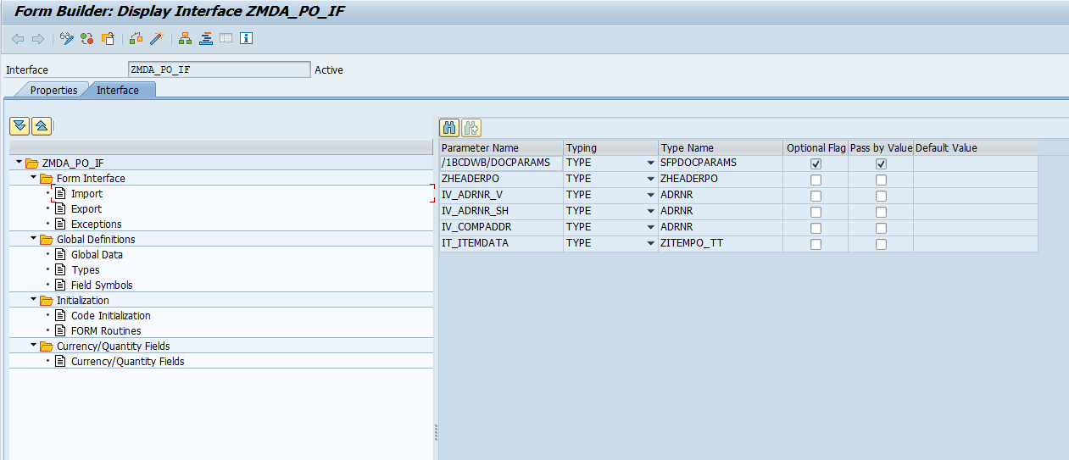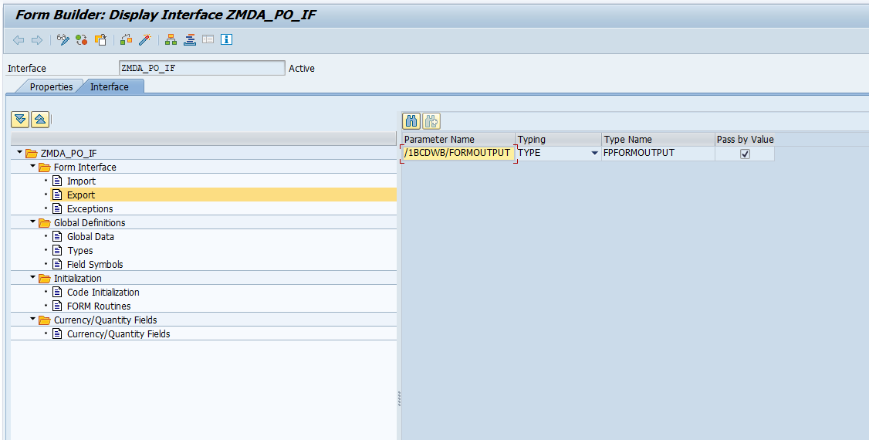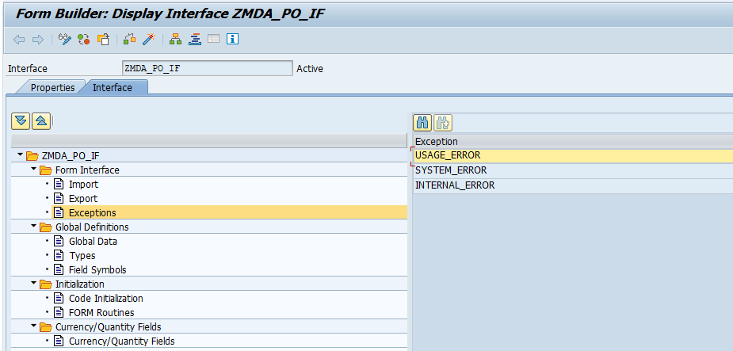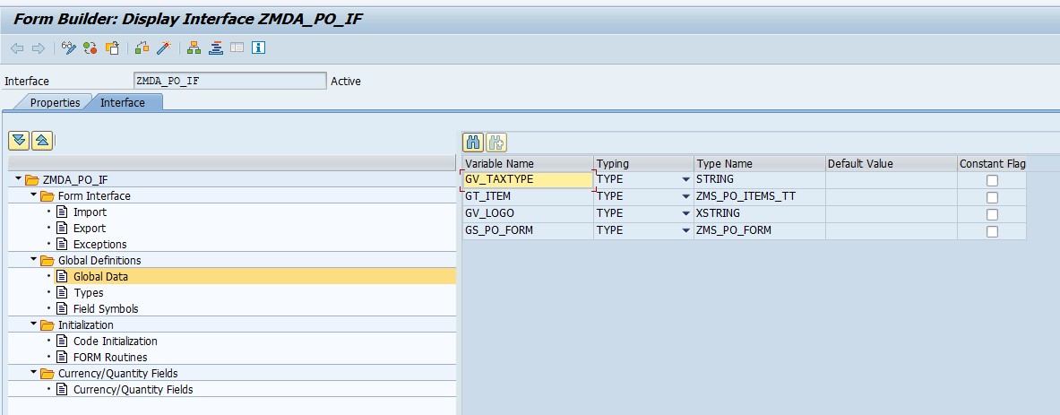

CODE INITILIZATION
*----------------------------------------------------------------------*
* IDENTITY
*----------------------------------------------------------------------*
* Program : Updates Tables ( ) Process data ( )
* Outputs List ( ) Validation ( )
*
* Module : MM
* WRICEF Object Id : MM_DV006
* Functional Specifications : FS_MM_DV006_PO_FORM
* Technical Spec No : TS_MM_DV006_PO_FORM
* Functional Consultant : Amal KV
* Date Created (dd-mm-yyyy) : 13-01-2025
* Technical Consultant : Pravesh Patil
* Client : upGrad
* Project Name : upGrad
* Company : TechWit Business Solutions
*---------------------------------------------------------------------*
DATA(ls_zheaderpo) = zheaderpo.
DATA(lv_adrnr_v) = iv_adrnr_v.
DATA(lv_adrnr_sh) = iv_adrnr_sh.
DATA(l_compaddr) = iv_compaddr.
DATA(lt_line_item) = it_itemdata.
DATA(lo_form) = NEW zcl_mm_poform( ).
lo_form->fetch_po_general(
EXPORTING
iv_adrnr_v = iv_adrnr_v
iv_adrnr_sh = iv_adrnr_sh
iv_compaddr = iv_compaddr
is_zheaderpo = zheaderpo
it_itemdata = it_itemdata
IMPORTING
es_po_form = DATA(ls_po_form) " PO form structure
et_items = gt_item
ev_taxtype = gv_taxtype
).
" PO form structure
gs_po_form = ls_po_form.
gv_logo = gs_po_form-logo.

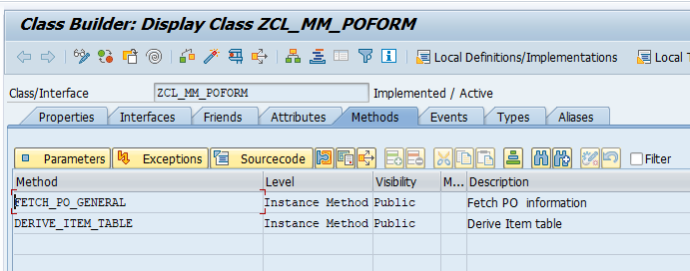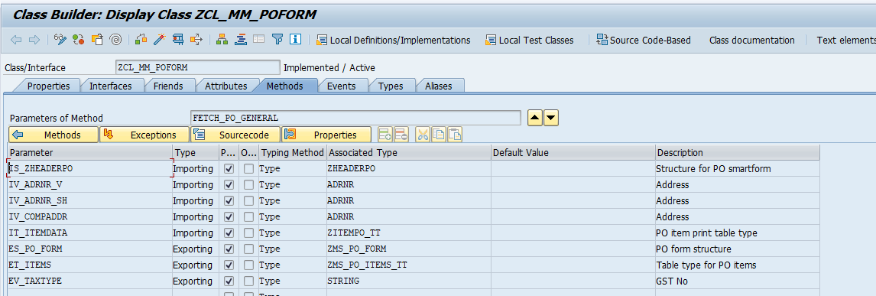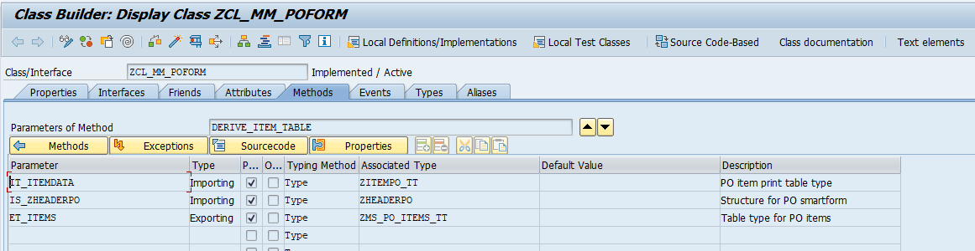 METHOD fetch_po_general.
*----------------------------------------------------------------------*
* IDENTITY
*----------------------------------------------------------------------*
* Program : Updates Tables ( ) Process data ( )
* Outputs List ( ) Validation ( )
*
* Module : MM
* WRICEF Object Id : MM_DV006
* Functional Specifications : FS_MM_DV006_PO_FORM
* Technical Spec No : TS_MM_DV006_PO_FORM
* Functional Consultant : Amal KV
* Date Created (dd-mm-yyyy) : 13-01-2025
* Technical Consultant : Pravesh Patil
* Client : upGrad
* Project Name : upGrad
* Company : TechWit Business Solutions
*---------------------------------------------------------------------*
DATA: lt_addr TYPE szadr_printform_table,
lv_comaddr TYPE string,
lv_venaddr TYPE string,
lv_shipaddr TYPE string,
lv_words(130) TYPE c,
in_words TYPE spell,
it_lines TYPE TABLE OF tline,
lv_itemtext1 TYPE thead-tdname,
lt_terms_lines TYPE STANDARD TABLE OF tline.
CONSTANTS: cv_pi TYPE parvw VALUE 'PI',
cv_rs TYPE parvw VALUE 'RS'.
"Dev water mark
IF sy-mandt EQ |110| OR sy-mandt EQ |120|.
DATA(lv_devcpy) = |Dev copy|.
ENDIF.
"Logo
DATA(lv_logo_1810_sd) = |1810_SD|.
CALL METHOD cl_ssf_xsf_utilities=>get_bds_graphic_as_bmp
EXPORTING
p_object = 'GRAPHICS'
p_name = CONV tdobname( lv_logo_1810_sd ) " Name of the logo as in se78
p_id = 'BMAP'
p_btype = 'BCOL' "( whether the image is in color or black and white )
RECEIVING
p_bmp = DATA(lv_field)
EXCEPTIONS
not_found = 1
internal_error = 2
OTHERS = 3.
"Fetch PO details
SELECT SINGLE ebeln, bukrs, lifnr, kdatb, kdate, lifre, procstat, waers "++PATILP28.10.2025 invoicing party
FROM ekko
INTO @DATA(ls_ekko)
WHERE ebeln = @is_zheaderpo-ebeln.
IF sy-subrc EQ 0.
* *Fetch GST/PAN for vendor and supplier
SELECT SINGLE j_1ipanno FROM lfa1
INTO @DATA(lv_sup_pan)
** WHERE lifnr = @ls_ekko-lifnr. --PATILP28.10.2025 invoicing party
WHERE lifnr = @ls_ekko-lifre. "++PATILP28.10.2025 invoicing party
IF sy-subrc EQ 0.ENDIF.
"Status
IF ls_ekko-procstat EQ |05|.
DATA(lv_frget) = |Released|.
ELSE.
DATA(lv_aprl) = |Pending for Approval|.
ENDIF.
"CIN number
SELECT SINGLE paval
FROM t001z
INTO @DATA(lv_cin_no)
WHERE bukrs = @ls_ekko-bukrs
AND party = 'Z_CIN'.
IF sy-subrc EQ 0.
ENDIF.
ENDIF.
"Order date
IF is_zheaderpo-aedat <> |00000000|.
DATA(lv_po_date) = |{ is_zheaderpo-aedat+6(2) }.{ is_zheaderpo-aedat+4(2) }.{ is_zheaderpo-aedat+0(4) }|.
ENDIF.
"Company adress
CALL FUNCTION 'ADDRESS_INTO_PRINTFORM'
EXPORTING
address_type = '1'
address_number = iv_compaddr
number_of_lines = 15
street_has_priority = 'X'
iv_country_name_separate_line = 'X'
IMPORTING
address_printform_table = lt_addr
EXCEPTIONS
address_blocked = 1
person_blocked = 2
contact_person_blocked = 3
addr_to_be_formated_is_blocked = 4
OTHERS = 5.
IF sy-subrc <> 0.
* Implement suitable error handling here
ENDIF.
DATA(lv_comp_name) = COND string( WHEN line_exists( lt_addr[ 1 ] ) THEN lt_addr[ 1 ]-address_line ).
IF lt_addr IS NOT INITIAL.
DELETE lt_addr INDEX 1.
ENDIF.
IF line_exists( lt_addr[ line_type = 'L' address_line = 'INDIA' ] ).
DELETE lt_addr WHERE line_type = 'R'.
DELETE lt_addr WHERE line_type = 'L'.
ENDIF.
LOOP AT lt_addr INTO DATA(ls_addr).
DATA(lv_line) = sy-tabix.
IF lv_line = 1.
lv_comaddr = |{ ls_addr-address_line }|.
ELSE.
IF ls_addr-line_type = |C|.
lv_comaddr = |{ lv_comaddr } - { ls_addr-address_line }|.
ELSE.
lv_comaddr = |{ lv_comaddr }{ cl_abap_char_utilities=>newline }{ ls_addr-address_line }|.
ENDIF.
ENDIF.
ENDLOOP.
IF ls_ekko-bukrs NE '5200'.
lv_comaddr = |{ lv_comaddr }{ cl_abap_char_utilities=>newline }C.I.N : { lv_cin_no }|. "
ENDIF.
"Vendor address
CLEAR: lt_addr, lv_line.
** DATA(LV_ADRNR_V) = IV_ADRNR_V.
*** SELECT SINGLE *
*** FROM wyt3
*** INTO @DATA(lv_lifn2)
*** WHERE lifnr = @ls_ekko-lifnr
*** AND parvw = @cv_pi.
*** IF sy-subrc EQ 0.
*** SELECT SINGLE adrnr FROM
*** lfa1
*** INTO @DATA(lv_adrnr_v)
*** WHERE lifnr = @lv_lifn2-lifn2.
*** IF sy-subrc EQ 0.
*** ENDIF.
*** ENDIF.
SELECT SINGLE *
FROM ekpa
INTO @DATA(ls_ekpa)
WHERE ebeln = @is_zheaderpo-ebeln
AND parvw = @cv_rs.
IF sy-subrc EQ 0.
"Show GST No og invoicing party
SELECT SINGLE adrnr
FROM lfa1
INTO @DATA(lv_adrnr_v)
WHERE lifnr EQ @ls_ekpa-lifn2.
IF sy-subrc EQ 0.
ENDIF.
ENDIF.
DATA(lv_bp) = ls_ekko-lifnr.
IF ls_ekpa-lifn2 IS NOT INITIAL.
lv_bp = ls_ekpa-lifn2.
ENDIF.
"Vendor to GSTIN
SELECT SINGLE taxnum
FROM dfkkbptaxnum
WHERE partner EQ @lv_bp
AND taxtype EQ 'IN3'
INTO @DATA(lv_ven_gstin).
IF lv_adrnr_v IS INITIAL.
lv_adrnr_v = iv_adrnr_v.
ENDIF.
CALL FUNCTION 'ADDRESS_INTO_PRINTFORM'
EXPORTING
address_type = '1'
address_number = lv_adrnr_v
number_of_lines = 15
street_has_priority = 'X'
iv_country_name_separate_line = 'X'
IMPORTING
address_printform_table = lt_addr
EXCEPTIONS
address_blocked = 1
person_blocked = 2
contact_person_blocked = 3
addr_to_be_formated_is_blocked = 4
OTHERS = 5.
IF sy-subrc <> 0.
* Implement suitable error handling here
ENDIF.
IF line_exists( lt_addr[ line_type = 'A' ] ).
DELETE lt_addr WHERE line_type = 'A'.
ENDIF.
IF line_exists( lt_addr[ line_type = 'L' address_line = 'INDIA' ] ).
DELETE lt_addr WHERE line_type = 'R'.
DELETE lt_addr WHERE line_type = 'L'.
ENDIF.
LOOP AT lt_addr INTO ls_addr.
lv_line = sy-tabix.
IF ls_addr-line_type EQ |1|.
DATA(lv_vend_name) = ls_addr-address_line.
DELETE lt_addr WHERE line_type EQ |1|.
ELSEIF ls_addr-line_type EQ |2|.
lv_vend_name = | { lv_vend_name } { ls_addr-address_line }|.
DELETE lt_addr WHERE line_type EQ |2|.
ENDIF.
IF lv_line = 1.
lv_venaddr = |{ ls_addr-address_line }|.
ELSE.
IF ls_addr-line_type = |C|.
lv_venaddr = |{ lv_venaddr } - { ls_addr-address_line }|.
ELSE.
lv_venaddr = |{ lv_venaddr }{ cl_abap_char_utilities=>newline }{ ls_addr-address_line }|.
ENDIF.
ENDIF.
ENDLOOP.
"Pick ship to and bill to based on storage location from EKPO
SELECT SINGLE adrn2
FROM ekpo
INTO @DATA(lv_ADRN2)
WHERE ebeln = @is_zheaderpo-ebeln.
** AND ebelp = @is_zheaderpo-ebelp.
IF sy-subrc EQ 0.
DATA(lv_adrnr_sh) = lv_adrn2.
ENDIF.
IF lv_adrnr_sh IS INITIAL.
lV_ADRNR_SH = iv_adrnr_sh.
ENDIF.
"Shipping and billing address ( Will be same as per Form logic )
CLEAR: lt_addr, lv_line.
CALL FUNCTION 'ADDRESS_INTO_PRINTFORM'
EXPORTING
address_type = '1'
address_number = lV_ADRNR_SH
number_of_lines = 15
street_has_priority = 'X'
iv_country_name_separate_line = 'X'
IMPORTING
address_printform_table = lt_addr
EXCEPTIONS
address_blocked = 1
person_blocked = 2
contact_person_blocked = 3
addr_to_be_formated_is_blocked = 4
OTHERS = 5.
IF sy-subrc <> 0.
* Implement suitable error handling here
ENDIF.
IF line_exists( lt_addr[ line_type = 'A' ] ).
DELETE lt_addr WHERE line_type = 'A'.
ENDIF.
IF line_exists( lt_addr[ line_type = 'L' address_line = 'INDIA' ] ).
DELETE lt_addr WHERE line_type = 'R'.
DELETE lt_addr WHERE line_type = 'L'.
ENDIF.
LOOP AT lt_addr INTO ls_addr .
lv_line = sy-tabix.
IF ls_addr-line_type EQ |1|.
DATA(lv_ship_name) = ls_addr-address_line.
DELETE lt_addr WHERE line_type EQ |1|.
ELSEIF ls_addr-line_type EQ |2|.
lv_ship_name = | { lv_ship_name } { ls_addr-address_line }|.
DELETE lt_addr WHERE line_type EQ |2|.
ENDIF.
IF lv_line = 1.
lv_shipaddr = |{ ls_addr-address_line }|.
ELSE.
IF ls_addr-line_type = |C|.
lv_shipaddr = |{ lv_shipaddr } - { ls_addr-address_line }|.
ELSE.
lv_shipaddr = |{ lv_shipaddr }{ cl_abap_char_utilities=>newline }{ ls_addr-address_line }|.
ENDIF.
ENDIF.
ENDLOOP.
"Ship pan
SELECT SINGLE paval FROM t001z INTO @DATA(lv_ship_pan)
WHERE party = 'J_1I02' AND bukrs = @ls_ekko-bukrs.
IF sy-subrc EQ 0.ENDIF.
"Total Amount
DATA(lo_mask) = NEW zcl_sd_invoice( ).
lo_mask->mask_currency(
EXPORTING
iv_amount = CONV netwr( is_zheaderpo-netwr ) " Net Value in Document Currency
IMPORTING
ev_masked_amt = DATA(lv_tot_amt) ).
"Amount in words
IF ls_ekko-waers EQ |INR|.
CALL FUNCTION 'HR_IN_CHG_INR_WRDS'
EXPORTING
amt_in_num = is_zheaderpo-netwr
IMPORTING
amt_in_words = lv_words
EXCEPTIONS
data_type_mismatch = 1
OTHERS = 2.
IF sy-subrc <> 0.
* Implement suitable error handling here
ENDIF.
ELSE.
CALL FUNCTION 'SPELL_AMOUNT'
EXPORTING
amount = is_zheaderpo-netwr
currency = ls_ekko-waers
* FILLER = ' '
language = sy-langu
IMPORTING
in_words = in_words
EXCEPTIONS
not_found = 1
too_large = 2
OTHERS = 3.
IF sy-subrc <> 0.
* Implement suitable error handling here
ENDIF.
IF in_words-decword IS INITIAL.
lv_words = in_words-word.
ELSE.
CONCATENATE in_words-word 'AND' in_words-decword
INTO lv_words SEPARATED BY space.
ENDIF.
ENDIF.
TRANSLATE lv_words TO LOWER CASE.
CONDENSE lv_words.
TRANSLATE lv_words+0(1) TO UPPER CASE.
***************Grneral informatrions*******************
"Payment Terms
SELECT SINGLE paymenttermsname
FROM ifipaymenttermst
INTO @DATA(lv_payterm)
WHERE paymentterms = @is_zheaderpo-zterm
AND language = 'E'.
"PO Requestor
SELECT *
FROM ekpo
INTO TABLE @DATA(lt_ekpo)
WHERE ebeln EQ @is_zheaderpo-ebeln.IF sy-subrc EQ 0. ENDIF.
CLEAR lv_itemtext1.
LOOP AT lt_ekpo INTO DATA(ls_ekpo).
CLEAR lv_itemtext1.
CONCATENATE is_zheaderpo-ebeln ls_ekpo-ebelp INTO lv_itemtext1.
***************************************************************************
CALL FUNCTION 'READ_TEXT'
EXPORTING
id = 'F06'
language = 'E'
name = lv_itemtext1
object = 'EKPO'
TABLES
lines = it_lines
EXCEPTIONS
id = 1
language = 2
name = 3
not_found = 4
object = 5
reference_check = 6
wrong_access_to_archive = 7
OTHERS = 8.
IF sy-subrc <> 0.
* Implement suitable error handling here
ENDIF..
READ TABLE it_lines INTO DATA(ls_lines) INDEX 1.
IF sy-subrc EQ 0.
CONCATENATE lv_requestor ',' ls_lines-tdline INTO DATA(lv_requestor) SEPARATED BY space. .
CLEAR ls_lines-tdline.
ENDIF.
SHIFT lv_requestor LEFT DELETING LEADING ' ,'.
SHIFT lv_requestor RIGHT DELETING TRAILING ','.
CLEAR : it_lines,ls_ekpo.
ENDLOOP.
"Program Code <Decouple PROD change PP>
SELECT SINGLE
a~kostl,
a~aufnr,
a~paobjnr
FROM ekkn AS a
JOIN ekpo AS b
ON b~ebeln = a~ebeln
AND b~ebelp = a~ebelp
INTO (@DATA(lv_kostl),@DATA(lv_aufnr),@DATA(lv_paobjnr))
WHERE a~ebeln = @is_zheaderpo-ebeln
AND b~loekz = ''..
IF sy-subrc = 0.
SELECT SINGLE
ww006,
ww007,
ww009
FROM ce4a000_acct
INTO (@DATA(lv_cohort),@DATA(lv_prgcode),@DATA(lv_owner))
WHERE paobjnr = @lv_paobjnr.
IF sy-subrc EQ 0.
SELECT SINGLE maktx
FROM makt
INTO @DATA(lv_maktx)
WHERE matnr EQ @lv_prgcode.
IF lv_prgcode IS NOT INITIAL AND lv_maktx IS NOT INITIAL.
CONCATENATE lv_maktx '-' '(' lv_prgcode ')' INTO DATA(lv_prgcodename). "Program code
ENDIF.
ENDIF.
ENDIF.
"Start date, End date , Delivery date
*** SELECT SINGLE STARTDATE, ENDDATE , EINDT
*** FROM EKET
*** INTO @DATA(LS_EKET)
*** WHERE EBELN = @IS_ZHEADERPO-EBELN.
SELECT SINGLE a~startdate, a~enddate , a~eindt " <Decouple PROD change PP>
FROM eket AS a
JOIN ekpo AS b
ON b~ebeln = a~ebeln
AND b~ebelp = a~ebelp
INTO @DATA(ls_eket)
WHERE b~ebeln = @is_zheaderpo-ebeln
AND b~loekz = ''.
IF sy-subrc EQ 0.
DATA(lv_startdt) = |{ ls_eket-startdate+6(2) }/{ ls_eket-startdate+4(2) }/{ ls_eket-startdate+0(4) }|.
DATA(lv_enddt) = |{ ls_eket-enddate+6(2) }/{ ls_eket-enddate+4(2) }/{ ls_eket-enddate+0(4) }|.
DATA(lv_delvdt) = |{ ls_eket-eindt+6(2) }/{ ls_eket-eindt+4(2) }/{ ls_eket-eindt+0(4) }|.
IF ls_eket-startdate EQ |00000000|.
lv_startdt = |NA|.
ENDIF.
IF ls_eket-enddate EQ |00000000|.
lv_enddt = |NA|.
ENDIF.
IF ls_eket-eindt EQ |00000000|.
lv_delvdt = |NA|.
ENDIF.
ENDIF.
CLEAR: it_lines, lv_itemtext1.
"Remarks
lv_itemtext1 = is_zheaderpo-ebeln.
CALL FUNCTION 'READ_TEXT'
EXPORTING
id = 'F01'
language = 'E'
name = lv_itemtext1
object = 'EKKO'
TABLES
lines = it_lines
EXCEPTIONS
id = 1
language = 2
name = 3
not_found = 4
object = 5
reference_check = 6
wrong_access_to_archive = 7
OTHERS = 8.
IF sy-subrc <> 0.
* Implement suitable error handling here
ENDIF.
DATA(lv_headertext) = CONV string( '' ).
CLEAR lv_headertext.
LOOP AT it_lines INTO DATA(ls_lines1).
IF sy-tabix EQ 1.
lv_headertext = ls_lines1-tdline.
ELSEIF ls_lines1-tdformat = |*| AND ls_lines1-tdline IS NOT INITIAL.
lv_headertext = lv_headertext && cl_abap_char_utilities=>newline && ls_lines1-tdline .
ELSE.
CONCATENATE lv_headertext ls_lines1-tdline INTO lv_headertext SEPARATED BY space.
ENDIF.
ENDLOOP.
SELECT SINGLE knttp
FROM ekpo
INTO @DATA(lv_knttp)
WHERE ebeln = @is_zheaderpo-ebeln.
IF sy-subrc EQ 0.
SELECT SINGLE knttx
FROM t163i
INTO @DATA(lv_acc_assignment)
WHERE spras = 'E'
AND knttp = @lv_knttp.
IF sy-subrc EQ 0.
ENDIF.
ENDIF.
***********Fill structure*****************
es_po_form = VALUE #( logo = lv_field
order_no = is_zheaderpo-ebeln
order_date = lv_po_date
status = lv_frget
comp_nm = lv_comp_name
comp_addr = lv_comaddr
ven_nm = lv_vend_name
ven_addr = lv_venaddr
ship_nm = lv_ship_name
ship_addr = lv_shipaddr
supl_pan = lv_sup_pan
supl_gst = lv_ven_gstin
ship_pan = lv_ship_pan
ship_gst = is_zheaderpo-gstin
tot_amt = lv_tot_amt
currency = ls_ekko-waers
amt_words = lv_words
pay_terms = lv_payterm
po_req = lv_requestor
pro_codenm = lv_prgcodename
po_startdt = lv_startdt
po_enddt = lv_enddt
po_deldt = lv_delvdt
remarks = lv_headertext
client_water = lv_devcpy
appr_water = lv_aprl
assignment = lv_acc_assignment
aufnr = lv_aufnr ).
******************Derive Item table********************
me->derive_item_table(
EXPORTING
is_zheaderpo = is_zheaderpo
it_itemdata = it_itemdata " PO item print table type
IMPORTING
et_items = DATA(lt_items) " Table type for PO items
).
et_items = lt_items.
IF ls_ekko-bukrs EQ '5200'.
CLEAR es_po_form-logo.
* CALL METHOD cl_ssf_xsf_utilities=>get_bds_graphic_as_bmp
* EXPORTING
* p_object = 'GRAPHICS'
* p_name = CONV tdobname( 'ZCF_AF' ) " Name of the logo as in se78
* p_id = 'BMAP'
* p_btype = 'BCOL' "( whether the image is in color or black and white )
* RECEIVING
* p_bmp = es_po_form-logo
* EXCEPTIONS
* not_found = 1
* internal_error = 2
* OTHERS = 3.
CLEAR ev_taxtype.
ELSE.
ev_taxtype = 'GST No:'.
ENDIF.
ENDMETHOD.

METHOD derive_item_table.
*----------------------------------------------------------------------*
* IDENTITY
*----------------------------------------------------------------------*
* Program : Updates Tables ( ) Process data ( )
* Outputs List ( ) Validation ( )
*
* Module : MM
* WRICEF Object Id : MM_DV006
* Functional Specifications : FS_MM_DV006_PO_FORM
* Technical Spec No : TS_MM_DV006_PO_FORM
* Functional Consultant : Amal KV
* Date Created (dd-mm-yyyy) : 13-01-2025
* Technical Consultant : Pravesh Patil
* Client : upGrad
* Project Name : upGrad
* Company : TechWit Business Solutions
*---------------------------------------------------------------------*
DATA: ls_items TYPE zms_po_items.
DATA: it_lines TYPE TABLE OF tline,
lv_itemtexn TYPE thead-tdname,
lv_text TYPE string.
DATA(lv_srno) = 1.
LOOP AT it_itemdata INTO DATA(ls_itemdata).
ls_items-sr_no = ls_itemdata-ebelp / 10. "serial
ls_items-sr_no = lv_srno ."| { LS_ITEMS-SR_NO ALPHA = OUT } |.
ls_items-desc = ls_itemdata-txz01. "desc
"Full description
CONCATENATE is_zheaderpo-ebeln ls_itemdata-ebelp INTO lv_itemtexn.
CALL FUNCTION 'READ_TEXT'
EXPORTING
id = 'F01'
language = 'E'
name = lv_itemtexn
object = 'EKPO'
TABLES
lines = it_lines
EXCEPTIONS
id = 1
language = 2
name = 3
not_found = 4
object = 5
reference_check = 6
wrong_access_to_archive = 7
OTHERS = 8.
IF sy-subrc <> 0.
* Implement suitable error handling here
CLEAR it_lines.
ENDIF.
"Merge Material, short description and long text
CLEAR lv_text.
LOOP AT it_lines INTO DATA(ls_linesn).
lv_text = lv_text && cl_abap_char_utilities=>newline && ls_linesn-tdline.
ENDLOOP.
IF lv_itemtexn IS NOT INITIAL.
ls_items-desc = ls_items-desc && lv_text.
ENDIF.
IF ls_itemdata-ematn IS NOT INITIAL.
ls_items-desc = ls_itemdata-ematn && cl_abap_char_utilities=>newline && ls_items-desc.
ENDIF.
"Adding Activity start,end and Delivery on or before at line item level
SELECT SINGLE a~startdate, a~enddate , a~eindt,b~pstyp,b~knttp " <Decouple PROD change PP>
FROM eket AS a
JOIN ekpo AS b
ON b~ebeln = a~ebeln
AND b~ebelp = a~ebelp
INTO @DATA(ls_eket)
WHERE b~ebeln = @is_zheaderpo-ebeln
AND b~ebelp = @ls_itemdata-ebelp
AND b~loekz = ''.
IF ls_eket-startdate <> ls_eket-enddate.
ls_items-desc = ls_items-desc && cl_abap_char_utilities=>newline && cl_abap_char_utilities=>newline.
DATA(lv_startdt) = |{ ls_eket-startdate+6(2) }/{ ls_eket-startdate+4(2) }/{ ls_eket-startdate+0(4) }|.
DATA(lv_enddt) = |{ ls_eket-enddate+6(2) }/{ ls_eket-enddate+4(2) }/{ ls_eket-enddate+0(4) }|.
ls_items-desc = | { ls_items-desc }Delivery from { lv_startdt } to { lv_enddt } |.
ELSEIF ls_eket-eindt IS NOT INITIAL.
ls_items-desc = ls_items-desc && cl_abap_char_utilities=>newline && cl_abap_char_utilities=>newline.
DATA(lv_delvdt) = |{ ls_eket-eindt+6(2) }/{ ls_eket-eindt+4(2) }/{ ls_eket-eindt+0(4) }|.
ls_items-desc = | { ls_items-desc }Delivery on or before { lv_delvdt } |.
ENDIF.
SELECT SINGLE pstyp,packno,meins,mwskz INTO @DATA(ls_itemc)
FROM ekpo
WHERE ebeln EQ @is_zheaderpo-ebeln
AND ebelp EQ @ls_itemdata-ebelp.
IF ls_itemc-pstyp EQ '9'.
SELECT SINGLE sub_packno FROM esll INTO @DATA(ls_subp) WHERE
packno EQ @ls_itemc-packno.
IF ls_subp IS NOT INITIAL.
SELECT SINGLE packno,menge,tbtwr FROM esll INTO @DATA(ls_sitem) WHERE
packno EQ @ls_subp.
IF ls_sitem IS NOT INITIAL.
ls_itemdata-menge = ls_sitem-menge.
ls_itemdata-netpr = ls_sitem-tbtwr.
ENDIF.
ENDIF.
ENDIF.
DATA(lo_mask) = NEW zcl_sd_invoice( ).
"Rate
lo_mask->mask_currency(
EXPORTING
iv_amount = CONV netwr( ls_itemdata-netpr ) " Net Value in Document Currency
IMPORTING
ev_masked_amt = ls_items-rate " Amount in indian notation
).
"Tax code
ls_items-tax_code = ls_itemc-mwskz.
"Quantity
ls_items-qty = ls_itemdata-menge.
"UoM
** LS_ITEMS-UOM = LS_ITEMDATA-MEINS.
DATA(lv_uom) = ls_itemdata-meins.
CALL FUNCTION 'CONVERSION_EXIT_CUNIT_OUTPUT'
EXPORTING
input = lv_uom
language = sy-langu
IMPORTING
output = lv_uom
EXCEPTIONS
unit_not_found = 1
OTHERS = 2.
IF sy-subrc <> 0.
* Implement suitable error handling here
ENDIF.
ls_items-uom = lv_uom. "Added after discussing with Ameya
IF ls_eket-pstyp EQ |A|.
ls_items-uom = SWITCH #( ls_eket-knttp WHEN 'K' THEN |AU|
WHEN 'A' THEN |EA|
WHEN 'P' THEN |AU|
WHEN 'F' THEN |EA|
WHEN 'X' THEN |AU| ).
ENDIF.
"SOA PP30.06.2025
"Quantity '1' if PSTYP is 'A'
IF ls_eket-pstyp = |A|.
ls_items-qty = |1|.
ENDIF.
"EOA PP30.06.2025
"Amount
lo_mask->mask_currency(
EXPORTING
iv_amount = CONV netwr( ls_itemdata-netwr ) " Net Value in Document Currency
IMPORTING
ev_masked_amt = ls_items-amt " Amount in indian notation
).
CONDENSE: ls_items-rate,ls_items-qty,ls_items-uom,ls_items-amt.
APPEND ls_items TO et_items.
CLEAR ls_items.
lv_srno = lv_srno + 1.
ENDLOOP.
ENDMETHOD.

