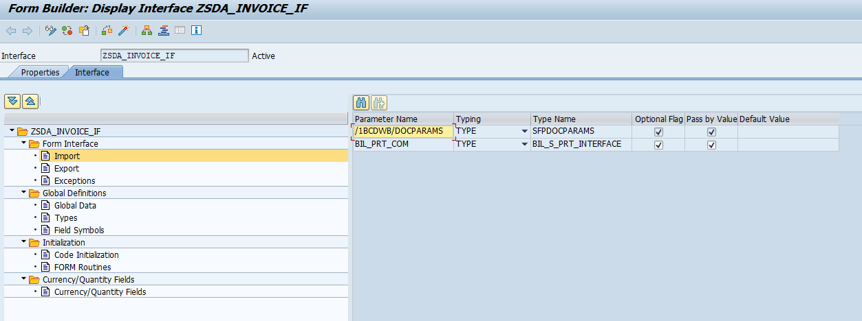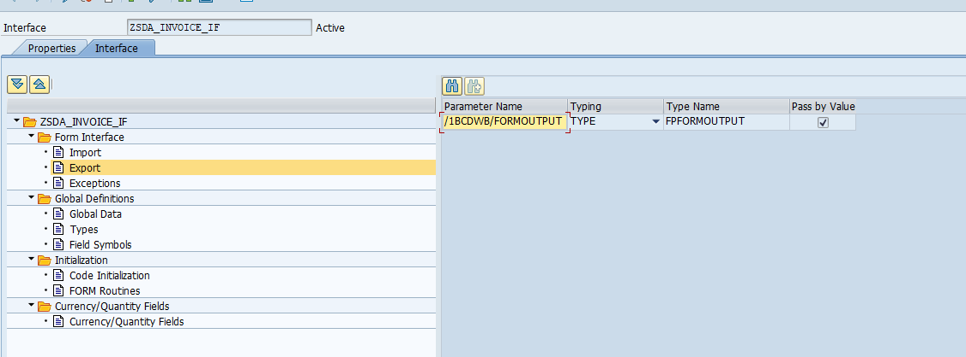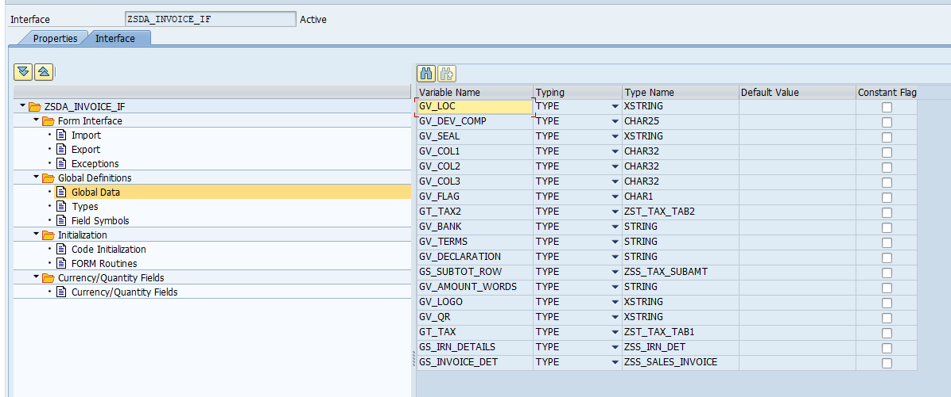

TYPES: TYPES: BEGIN OF TY_TAX,
SR_NO TYPE CHAR3,
DESC TYPE CHAR60,
SAC_HSN TYPE STEUC,
QTY TYPE CHAR10,
UNIT_PR TYPE CHAR20,
DICOUNT TYPE CHAR10,
TAXABLE_AMT TYPE CHAR20,
GST_RATE TYPE CHAR10,
CGST TYPE CHAR20,
SGST TYPE CHAR20,
TOT_AMT TYPE CHAR20 ,
END OF TY_TAX,
BEGIN OF TY_TAX1,
SR_NO TYPE CHAR3,
DESC TYPE CHAR60,
SAC_HSN TYPE STEUC,
QTY TYPE CHAR10,
UNIT_PR TYPE CHAR20,
DICOUNT TYPE CHAR10,
TAXABLE_AMT TYPE CHAR20,
GST_RATE TYPE CHAR10,
IGST TYPE CHAR20,
TOT_AMT TYPE CHAR20 ,
END OF TY_TAX1,
BEGIN OF TY_TAX2,
SR_NO TYPE CHAR3,
DESC TYPE CHAR60,
SAC_HSN TYPE STEUC,
QTY TYPE CHAR10,
UNIT_PR TYPE CHAR20,
DICOUNT TYPE CHAR10,
TAXABLE_AMT TYPE CHAR20,
GST_RATE TYPE CHAR10,
IGST TYPE CHAR20,
TOT_AMT TYPE CHAR20,
TOT_INRAMT TYPE CHAR20,
END OF TY_TAX2,
gty_tax TYPE STANDARD TABLE OF TY_TAX INITIAL SIZE 0,
gty_tax1 TYPE STANDARD TABLE OF TY_TAX1 INITIAL SIZE 0,
gty_tax2 TYPE STANDARD TABLE OF TY_TAX2 INITIAL SIZE 0.

_________________--------------
CODE INITILISATION

*----------------------------------------------------------------------*
* Program : Updates Tables ( ) Process data ( )
* Outputs List ( ) Validation ( )
*
* Module : SD
* WRICEF Object Id : SD_DV020
* Functional Specifications : FS_SD_DV020_SALES_INVOCIE
* Technical Spec No : TS_SD_DV020_SALES_INVOCIE
* Functional Consultant : Parul Singh
* Date Created (dd-mm-yyyy) : 01-12-2024
* Technical Consultant : Pravesh Patil
* Client : upGrad
* Project Name : upGrad
* Company : TechWit Business Solutions
*---------------------------------------------------------------------*
"Call interface method for layout values and tax table valuse
DATA(LO_OBJECT) = NEW ZCL_SD_INVOICE( ).
LO_OBJECT->GET_FORM_DATA(
EXPORTING
IS_BIL_INVOICE2 = BIL_PRT_COM
IMPORTING
ET_TAX1 = GT_TAX
ES_INVOICE_DET = GS_INVOICE_DET
ES_IRN_DETAILS = GS_IRN_DETAILS
ES_SUBTOT_ROW = GS_SUBTOT_ROW
EV_QR = GV_QR
EV_AMOUNT_WORDS = GV_AMOUNT_WORDS
EV_DECLARATION = GV_DECLARATION
EV_TERMS = GV_TERMS
EV_BANK = GV_BANK
EV_COL1 = GV_COL1
EV_COL2 = GV_COL2
EV_COL3 = GV_COL3
EV_LOGO = GV_LOGO
EV_SEAL = GV_SEAL
EV_DEV_COPY = GV_DEV_COMP
EV_LOC = GV_LOC ).
___________

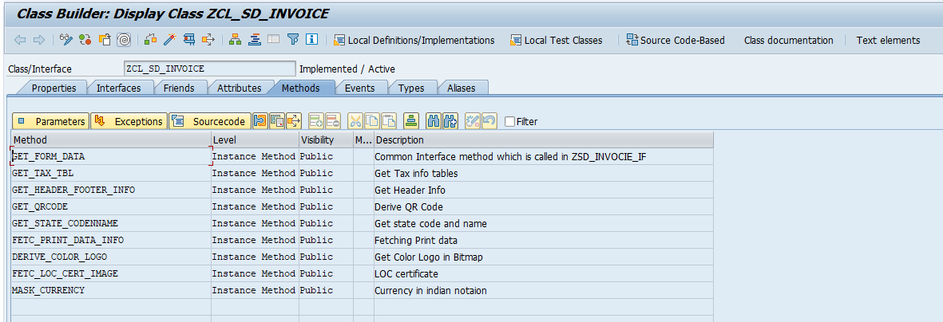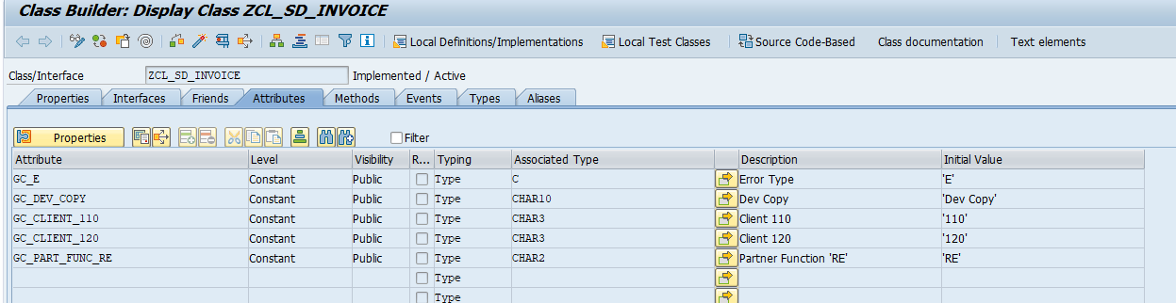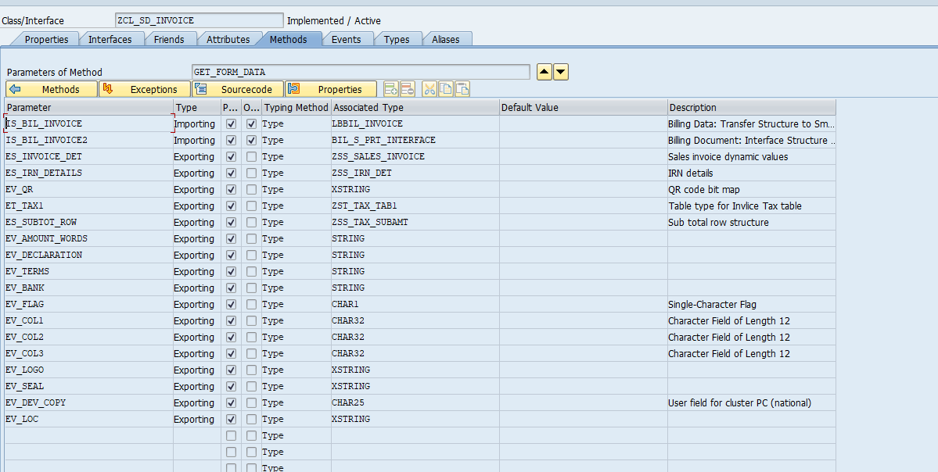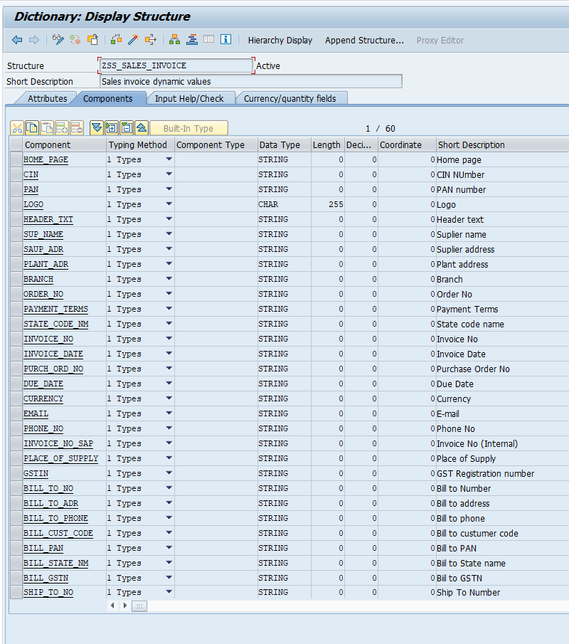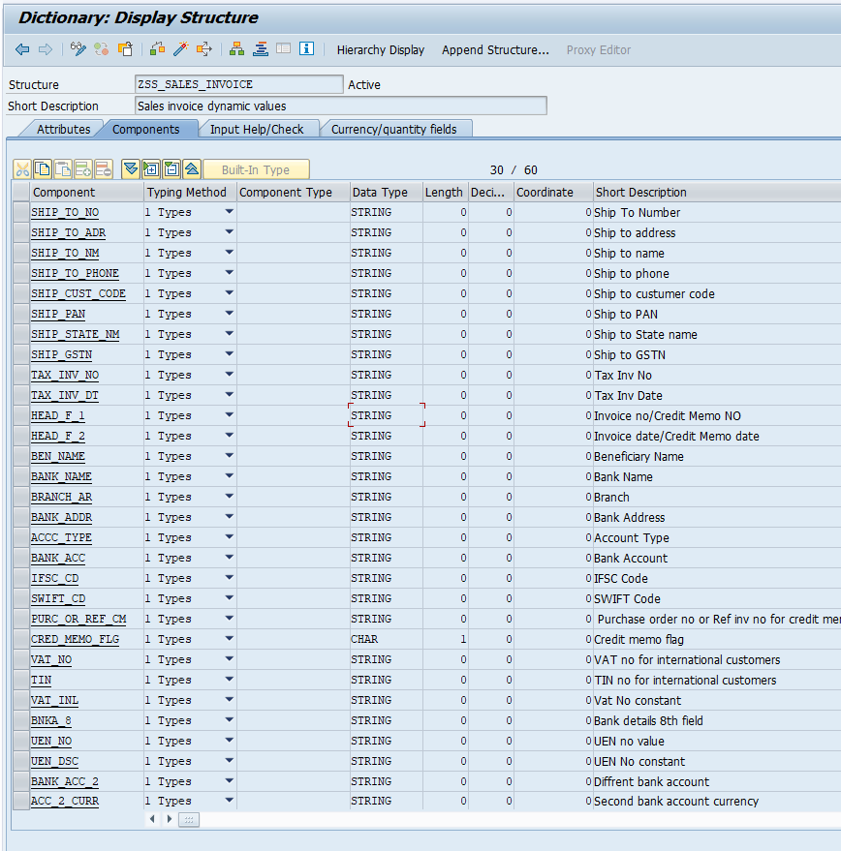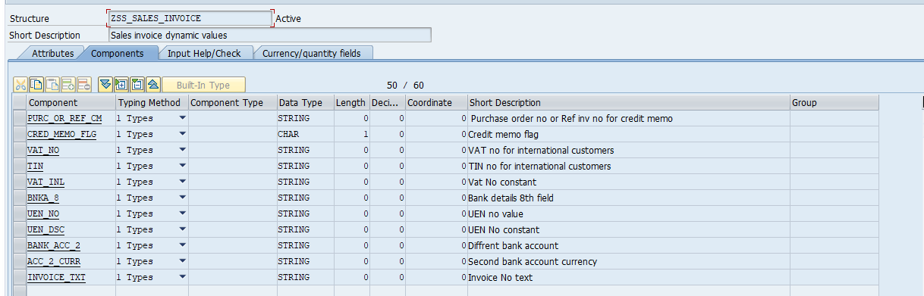

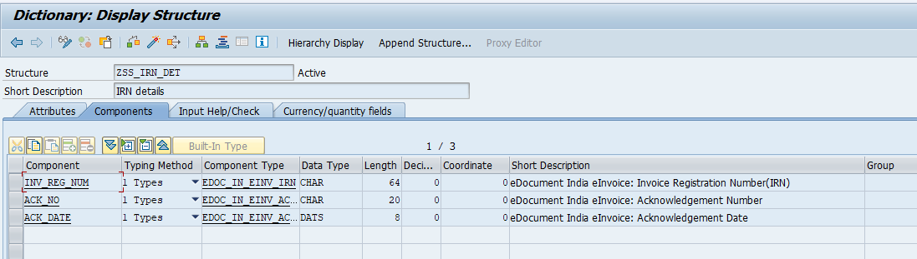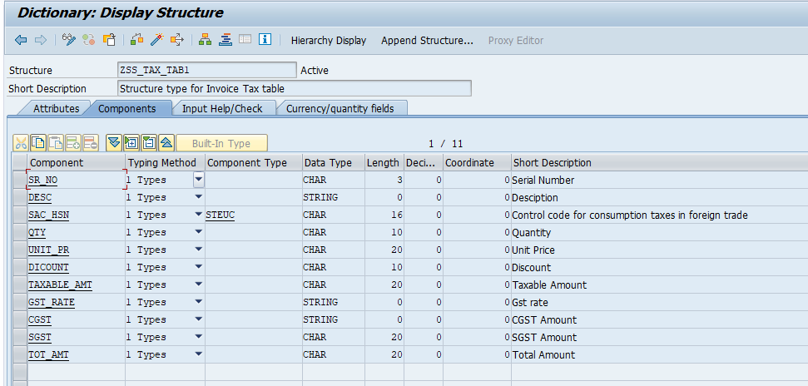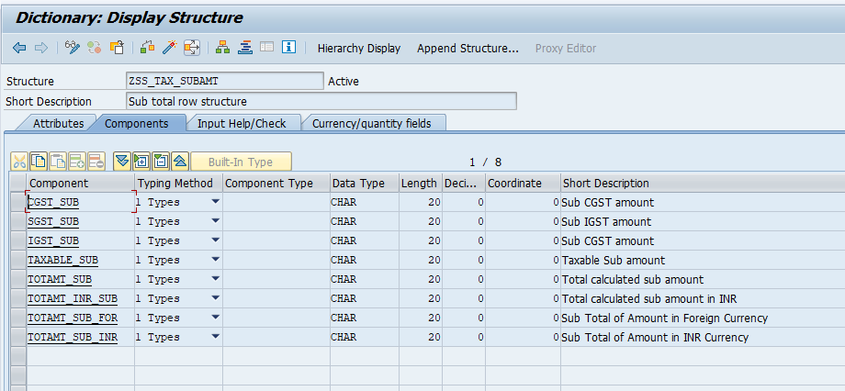 METHOD get_form_data.
*----------------------------------------------------------------------*
* IDENTITY
*----------------------------------------------------------------------*
* Program : Updates Tables ( ) Process data ( )
* Outputs List ( ) Validation ( )
*
* Module : SD
* WRICEF Object Id : SD_DV020
* Functional Specifications : FS_SD_DV020_SALES_INVOCIE
* Technical Spec No : TS_SD_DV020_SALES_INVOCIE
* Functional Consultant : Parul Singh
* Date Created (dd-mm-yyyy) : 01-12-2024
* Technical Consultant : Pravesh Patil
* Client : upGrad
* Project Name : upGrad
* Company : TechWit Business Solutions
*---------------------------------------------------------------------*
"The following line will decide if print is water mark as DEV COPY or no water mark
IF sy-mandt EQ gc_client_110 OR sy-mandt EQ gc_client_120.
ev_dev_copy = gc_dev_copy.
ENDIF.
"Fetch Print data information for more print data
me->fetc_print_data_info( EXPORTING is_bil_invoice2 = is_bil_invoice2
IMPORTING es_bil_invoice = DATA(ls_bil_invoice) ).
"Fetch header data,Supplier data, Bill&Ship info,IRN details, Declaration , Bank details and Other Terms
me->get_header_footer_info(
EXPORTING
is_bil_invoice = ls_bil_invoice "Passing Print data info which got from previous method
is_bil_invoice2 = is_bil_invoice2
IMPORTING
es_irn_details = es_irn_details
es_invoice_det = es_invoice_det
ev_declaration = ev_declaration
ev_terms = ev_terms
ev_bank = ev_bank
ev_seal = ev_seal ).
"Call Tax Table data, Sub row, Amount in words and Dynamic Columns
me->get_tax_tbl(
EXPORTING
is_bil_invoice = ls_bil_invoice
IMPORTING
et_tax1 = et_tax1
es_subtot_row = es_subtot_row
ev_amount_words = ev_amount_words
ev_col1 = ev_col1
ev_col2 = ev_col2
ev_col3 = ev_col3 )..
"QR Code
DATA(lv_bill_no) = ls_bil_invoice-hd_gen-bil_number.
me->get_qrcode( EXPORTING iv_bil_invoice = lv_bill_no
IMPORTING ev_qrbitmap = ev_qr ).
"Logo
me->derive_color_logo( EXPORTING iv_xlogo = es_invoice_det-logo
IMPORTING ev_logo = ev_logo ).
" LOC image
me->fetc_loc_cert_image( EXPORTING iv_fkdat = is_bil_invoice2-head_detail-vbdkr-fkdat "++PATILP14.11.2025 iv_fkdat
IMPORTING ev_loc = ev_loc ).
ENDMETHOD.

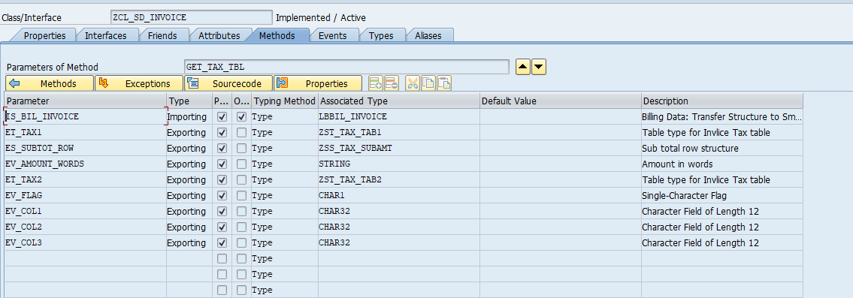

METHOD get_tax_tbl.
*----------------------------------------------------------------------*
* Program : Updates Tables ( ) Process data ( )
* Outputs List ( ) Validation ( )
*
* Module : SD
* WRICEF Object Id : SD_DV020
* Functional Specifications : FS_SD_DV020_SALES_INVOCIE
* Technical Spec No : TS_SD_DV020_SALES_INVOCIE
* Functional Consultant : Parul Singh
* Date Created (dd-mm-yyyy) : 01-12-2024
* Technical Consultant : Pravesh Patil
* Client : upGrad
* Project Name : upGrad
* Company : TechWit Business Solutions
*---------------------------------------------------------------------*
DATA: lv_qty_line TYPE char10,
lv_unit_line TYPE char20,
lv_unit_price TYPE netwr,
lv_gst_tax_line TYPE char10,
lv_cgst_line TYPE char20,
lv_igst_line TYPE char20,
lv_sgst_line TYPE char20,
lv_amt_line TYPE char20,
lv_tot_line TYPE char20,
lv_tot_line_inr TYPE char20,
lv_tot_tot TYPE char20,
lv_t_cgst TYPE kwert,
lv_t_sgst TYPE kwert,
lv_t_igst TYPE kwert,
lv_t_total_amount TYPE kwert,
lv_t_total_amount_inr TYPE kwert,
lv_t_amount TYPE kwert.
DATA: lv_words(130) TYPE c,
lv_words_i TYPE spell,
lv_tot_amt TYPE pc207-betrg.
DATA: ls_tax1 TYPE zss_tax_tab1,
ls_komk TYPE komk,
ls_komp TYPE komp,
ls_komk_e TYPE komk,
ls_komp_e TYPE komp.
DATA: lt_komv TYPE STANDARD TABLE OF komv,
lt_komvd TYPE STANDARD TABLE OF komvd,
lt_mat_dsc TYPE STANDARD TABLE OF tline,
lt_bill_dsc TYPE STANDARD TABLE OF tline.
DATA(lt_gen) = is_bil_invoice-it_gen.
DATA(lt_price) = is_bil_invoice-it_price.
DATA(lv_srno) = 0.
DATA(ls_komkinr) = is_bil_invoice-hd_komk.
DATA(lv_exchange_rt) = ls_komkinr-kurrf.
DATA(lv_currency) = ls_komkinr-waerk..
LOOP AT lt_gen INTO DATA(ls_gen).
"SR No
lv_srno = lv_srno + 1.
"Discription and Matarial text and Billing text
DATA(lv_bill_ins) = CONV tdobname( ls_gen-bil_number && ls_gen-itm_number ).
DATA(lv_desc) = CONV string( '' ).
*** IF lv_bill_ins IS NOT INITIAL.
*** CALL FUNCTION 'READ_TEXT'
*** EXPORTING
*** client = sy-mandt
*** id = '0001'
*** language = sy-langu
*** name = lv_bill_ins
*** object = 'VBBP'
*** TABLES
*** lines = lt_mat_dsc
*** EXCEPTIONS
*** id = 1
*** language = 2
*** name = 3
*** not_found = 4
*** object = 5
*** reference_check = 6
*** wrong_access_to_archive = 7
*** OTHERS = 8.
*** IF sy-subrc <> 0.
*** ELSEIF lt_mat_dsc IS NOT INITIAL.
*** LOOP AT lt_mat_dsc INTO DATA(ls_mat).
*** lv_desc = lv_desc && ls_mat-tdline && cl_abap_char_utilities=>newline.
*** ENDLOOP.
*** ENDIF.
lv_desc = lv_desc && ls_gen-short_text .
CALL FUNCTION 'READ_TEXT'
EXPORTING
client = sy-mandt
id = 'TX05'
language = sy-langu
name = lv_bill_ins
object = 'VBBP'
TABLES
lines = lt_bill_dsc
EXCEPTIONS
id = 1
language = 2
name = 3
not_found = 4
object = 5
reference_check = 6
wrong_access_to_archive = 7
OTHERS = 8.
IF sy-subrc <> 0.
* Implement suitable error handling here
ELSEIF lt_bill_dsc IS NOT INITIAL.
LOOP AT lt_bill_dsc INTO DATA(ls_bill).
lv_desc = lv_desc && cl_abap_char_utilities=>newline && ls_bill-tdline.
ENDLOOP.
ENDIF.
*** ENDIF.
SELECT SINGLE werks FROM vbrp INTO @DATA(lv_werks)
WHERE vbeln = @ls_gen-bil_number
AND posnr = @ls_gen-itm_number.
IF sy-subrc = 0.
"HSN/SAC
SELECT SINGLE steuc INTO @DATA(lv_hsn) FROM marc
WHERE matnr = @ls_gen-material
AND werks = @lv_werks.
IF sy-subrc = 0.ENDIF.
ENDIF.
"Qunatity
CLEAR lv_qty_line.
DATA(lv_val) = trunc( ls_gen-fkimg ).
WRITE lv_val TO lv_qty_line.
CONDENSE lv_qty_line.
"Unit Price
READ TABLE lt_price INTO DATA(ls_price) WITH KEY bil_number = ls_gen-bil_number
itm_number = ls_gen-itm_number.
IF ls_gen-fkimg IS NOT INITIAL AND sy-subrc EQ 0.
lv_unit_price = ls_price-netwr / ls_gen-fkimg.
CLEAR lv_unit_line.
me->mask_currency(
EXPORTING
iv_amount = lv_unit_price " Net Value in Document Currency
IMPORTING
ev_masked_amt = lv_unit_line ).
CONDENSE lv_unit_line.
ENDIF.
"GST Rate
CLEAR: ls_komk, ls_komp.
DATA(ls_head) = is_bil_invoice-hd_gen.
CALL FUNCTION 'RV_PRICE_PRINT_REFRESH'
TABLES
tkomv = lt_komv.
REFRESH lt_komv.
ls_komk_e-belnr = ls_head-bil_number.
ls_komk_e-knumv = ls_head-kond_numb.
ls_komp_e-kposn = ls_gen-itm_number.
CALL FUNCTION 'RV_PRICE_PRINT_ITEM'
EXPORTING
comm_head_i = ls_komk_e
comm_item_i = ls_komp_e
language = sy-langu
IMPORTING
comm_head_e = ls_komk
comm_item_e = ls_komp
* ET_QTYCNVFACT =
TABLES
tkomv = lt_komv
tkomvd = lt_komvd.
IF lt_komv IS NOT INITIAL.
BREAK patilp.
READ TABLE lt_komv INTO DATA(ls_komv)
WITH KEY kschl = 'JOCG' kposn = ls_gen-itm_number.
IF sy-subrc = 0 AND ls_komv-kbetr <> 0.
DATA(lv_cgst_tax) = CONV kbetr( ls_komv-kbetr / 10 ).
DATA(lv_tax) = lv_cgst_tax.
ENDIF.
READ TABLE lt_komv INTO ls_komv
WITH KEY kschl = 'JOSG' kposn = ls_gen-itm_number.
IF sy-subrc = 0 AND ls_komv-kbetr <> 0.
DATA(lv_sgst_tax) = CONV kbetr( ls_komv-kbetr / 10 ).
lv_tax = lv_cgst_tax + lv_sgst_tax.
ENDIF.
READ TABLE lt_komv INTO ls_komv
WITH KEY kschl = 'JOIG' kposn = ls_gen-itm_number.
IF sy-subrc = 0 AND ls_komv-kbetr <> 0.
DATA(lv_igst_tax) = CONV kbetr( ls_komv-kbetr / 10 ).
lv_tax = lv_igst_tax.
ENDIF.
CLEAR lv_gst_tax_line.
IF lv_tax <> 0.
WRITE lv_tax TO lv_gst_tax_line.
SPLIT lv_gst_tax_line AT '.' INTO lv_gst_tax_line DATA(lv_extra).
IF lv_gst_tax_line IS NOT INITIAL.
CONCATENATE lv_gst_tax_line '%' INTO lv_gst_tax_line.
CONDENSE lv_gst_tax_line.
ENDIF.
ELSE.
CONCATENATE lv_gst_tax_line '0%' INTO lv_gst_tax_line.
CONDENSE lv_gst_tax_line.
ENDIF.
ENDIF.
"Reading TAX conditions
CALL FUNCTION 'RV_PRICE_PRINT_REFRESH'
TABLES
tkomv = lt_komv.
REFRESH lt_komv.
ls_komk-belnr = ls_head-bil_number.
ls_komk-knumv = ls_head-kond_numb.
ls_komp-kposn = ls_gen-itm_number.
CALL FUNCTION 'RV_PRICE_PRINT_ITEM'
EXPORTING
comm_head_i = ls_komk_e
comm_item_i = ls_komp_e
language = sy-langu
IMPORTING
comm_head_e = ls_komk
comm_item_e = ls_komp
* ET_QTYCNVFACT =
TABLES
tkomv = lt_komv
tkomvd = lt_komvd.
"CGST
DATA(ls_it_kond) = is_bil_invoice-it_kond.
CLEAR: ls_komk, ls_komp, lv_tax.
IF lt_komv IS NOT INITIAL.
"CGST
READ TABLE lt_komv INTO ls_komv
WITH KEY kschl = 'JOCG' kposn = ls_gen-itm_number.
IF sy-subrc = 0.
DATA(lv_cgst_amt) = ls_komv-kwert.
me->mask_currency(
EXPORTING
iv_amount = CONV netwr( ls_komv-kwert ) " Net Value in Document Currency
IMPORTING
ev_masked_amt = lv_cgst_line " Amount in indian notation
).
CONDENSE lv_cgst_line.
ENDIF.
"SGST
READ TABLE lt_komv INTO ls_komv
WITH KEY kschl = 'JOSG' kposn = ls_gen-itm_number.
IF sy-subrc = 0.
DATA(lv_sgst_amt) = ls_komv-kwert.
me->mask_currency(
EXPORTING
iv_amount = CONV netwr( ls_komv-kwert ) " Net Value in Document Currency
IMPORTING
ev_masked_amt = lv_sgst_line ).
CONDENSE lv_sgst_line.
ENDIF.
"IGST
READ TABLE lt_komv INTO ls_komv
WITH KEY kschl = 'JOIG' kposn = ls_gen-itm_number.
IF sy-subrc = 0.
DATA(lv_igst_amt) = ls_komv-kwert.
me->mask_currency(
EXPORTING
iv_amount = CONV netwr( ls_komv-kwert ) " Net Value in Document Currency
IMPORTING
ev_masked_amt = lv_igst_line ).
CONDENSE lv_igst_line.
ELSE.
lv_igst_line = |0.00|.
ENDIF.
ENDIF.
DATA(ls_org) = is_bil_invoice-hd_org.
CLEAR lv_amt_line.
DATA(lv_valtaxable) = ls_price-netwr.
me->mask_currency(
EXPORTING
iv_amount = lv_valtaxable " Net Value in Document Currency
IMPORTING
ev_masked_amt = lv_amt_line " Amount in indian notation
).
CONDENSE lv_amt_line.
"Total amount
DATA(lv_total_amount) = CONV netwr( ls_price-netwr + ls_price-mwsbp ) .
DATA: lv_amount TYPE bf_wrbtr.
lv_amount = lv_total_amount.
lv_total_amount = lv_amount.
CLEAR : lv_tot_line,lv_tot_line_inr.
me->mask_currency(
EXPORTING
iv_amount = lv_total_amount " Net Value in Document Currency
IMPORTING
ev_masked_amt = lv_tot_line " Amount in indian notation
).
CONDENSE lv_tot_line.
"Total Amount in INR
DATA(lv_tot_amt1) = CONV netwr( ls_price-netwr + ls_price-mwsbp ).
DATA(lv_totinr) = CONV netwr( lv_tot_amt1 * lv_exchange_rt ).
me->mask_currency(
EXPORTING
iv_amount = lv_totinr " Net Value in Document Currency
IMPORTING
ev_masked_amt = lv_tot_line_inr " Amount in indian notation
).
CONDENSE lv_tot_line_inr.
"Fill tax table
IF lv_cgst_line IS NOT INITIAL.
ls_tax1 = VALUE #( sr_no = lv_srno
desc = lv_desc
sac_hsn = lv_hsn
qty = lv_qty_line
unit_pr = lv_unit_line
taxable_amt = lv_amt_line
gst_rate = lv_gst_tax_line
cgst = lv_cgst_line
sgst = lv_sgst_line
tot_amt = lv_tot_line
).
APPEND ls_tax1 TO et_tax1.
ELSE.
ls_tax1 = VALUE #( sr_no = lv_srno
desc = lv_desc
sac_hsn = lv_hsn
qty = lv_qty_line
unit_pr = lv_unit_line
taxable_amt = lv_amt_line
gst_rate = lv_gst_tax_line
cgst = lv_igst_line
* SGST = LV_TOT_LINE
sgst = COND #( WHEN is_bil_invoice-hd_gen-bil_waerk <> 'INR' THEN lv_tot_line )
tot_amt = lv_tot_line_inr
).
APPEND ls_tax1 TO et_tax1.
ENDIF.
"Taxable amount
lv_t_amount = lv_t_amount + lv_valtaxable.
"Total For Taxes
"CGST
lv_t_cgst = lv_t_cgst + lv_cgst_amt.
"SGST
lv_t_sgst = lv_t_sgst + lv_sgst_amt.
"IGST
lv_t_igst = lv_t_igst + lv_igst_amt.
"Total Amount
lv_t_total_amount = lv_t_total_amount + lv_total_amount.
"Total INR Amount
lv_t_total_amount_inr = lv_t_total_amount_inr + lv_totinr.
CLEAR: ls_tax1,lv_tax, lv_hsn, lv_qty_line,lv_unit_price, lv_unit_line.
ENDLOOP.
"Deciding name of laste three columns based on CGST/SGST or IGST values
IF lv_cgst_line IS NOT INITIAL.
ev_col1 = |CGST|.
ev_col2 = |SGST|.
ev_col3 = |Total Amount|.
ELSE.
ev_col1 = |IGST|.
ev_col3 = |Total Amount|.
IF is_bil_invoice-hd_gen-bil_waerk <> 'INR' .
ev_col2 = |Total Amount| && ' (' && is_bil_invoice-hd_gen-bil_waerk && ')'.
ev_col3 = |Total Amount (INR)|.
ENDIF.
ENDIF.
"*****************************************************Sub Total row and Amount in words
"Fill sub total row
IF lv_cgst_line IS NOT INITIAL.
me->mask_currency(
EXPORTING
iv_amount = CONV netwr( lv_t_amount ) " Net Value in Document Currency
IMPORTING
ev_masked_amt = es_subtot_row-taxable_sub " Amount in indian notation
).
CONDENSE es_subtot_row-taxable_sub .
me->mask_currency(
EXPORTING
iv_amount = CONV netwr( lv_t_cgst ) " Net Value in Document Currency
IMPORTING
ev_masked_amt = es_subtot_row-cgst_sub " Amount in indian notation
).
CONDENSE es_subtot_row-cgst_sub .
me->mask_currency(
EXPORTING
iv_amount = CONV netwr( lv_t_sgst ) " Net Value in Document Currency
IMPORTING
ev_masked_amt = es_subtot_row-sgst_sub " Amount in indian notation
).
CONDENSE es_subtot_row-sgst_sub .
me->mask_currency(
EXPORTING
iv_amount = CONV netwr( lv_t_total_amount ) " Net Value in Document Currency
IMPORTING
ev_masked_amt = es_subtot_row-totamt_sub " Amount in indian notation
).
CONDENSE es_subtot_row-totamt_sub .
ELSE.
me->mask_currency(
EXPORTING
iv_amount = CONV netwr( lv_t_amount ) " Net Value in Document Currency
IMPORTING
ev_masked_amt = es_subtot_row-taxable_sub " Amount in indian notation
).
CONDENSE es_subtot_row-taxable_sub .
me->mask_currency(
EXPORTING
iv_amount = CONV netwr( lv_t_igst ) " Net Value in Document Currency
IMPORTING
ev_masked_amt = es_subtot_row-cgst_sub " Amount in indian notation
).
CONDENSE es_subtot_row-cgst_sub .
IF is_bil_invoice-hd_gen-bil_waerk <> 'INR' .
me->mask_currency(
EXPORTING
iv_amount = CONV netwr( lv_t_total_amount ) " Net Value in Document Currency
IMPORTING
ev_masked_amt = es_subtot_row-sgst_sub " Amount in indian notation
).
CONDENSE es_subtot_row-sgst_sub .
ENDIF.
me->mask_currency(
EXPORTING
iv_amount = CONV netwr( lv_t_total_amount_inr ) " Net Value in Document Currency
IMPORTING
ev_masked_amt = es_subtot_row-totamt_sub " Amount in indian notation
).
CONDENSE es_subtot_row-totamt_sub .
ENDIF.
CLEAR: lv_tot_tot.
me->mask_currency(
EXPORTING
iv_amount = CONV netwr( lv_t_total_amount ) " Net Value in Document Currency
IMPORTING
ev_masked_amt = lv_tot_tot " Amount in indian notation
).
CONDENSE lv_tot_tot .
"Fill sub total row
IF is_bil_invoice-hd_gen-bil_waerk <> |INR|.
es_subtot_row-totamt_sub_for = lv_tot_tot.
ELSE.
es_subtot_row-totamt_sub_inr = lv_tot_tot.
ENDIF.
"Amount in words
* lv_tot_amt = trunc( lv_t_total_amount ).
lv_tot_amt = lv_t_total_amount.
IF ls_head-bil_waerk = 'INR'. " for India
CALL FUNCTION 'HR_IN_CHG_INR_WRDS'
EXPORTING
amt_in_num = lv_tot_amt
IMPORTING
amt_in_words = lv_words
EXCEPTIONS
data_type_mismatch = 1
OTHERS = 2.
IF sy-subrc <> 0.
* Implement suitable error handling here
ENDIF.
TRANSLATE lv_words TO LOWER CASE.
CONDENSE lv_words.
TRANSLATE lv_words+0(1) TO UPPER CASE.
DATA(lv_amount_words) = CONV string( lv_words ).
ELSE. " For other countries
CALL FUNCTION 'SPELL_AMOUNT'
EXPORTING
amount = lv_tot_amt
currency = ls_head-bil_waerk
language = sy-langu
IMPORTING
in_words = lv_words_i
EXCEPTIONS
not_found = 1
too_large = 2
OTHERS = 3.
IF sy-subrc <> 0.
* Implement suitable error handling here
ENDIF.
IF lv_words_i-decword IS INITIAL.
lv_words = lv_words_i-word.
ELSE.
CONCATENATE lv_words_i-word 'AND' lv_words_i-decword
INTO lv_words SEPARATED BY space.
ENDIF.
TRANSLATE lv_words TO LOWER CASE.
CONDENSE lv_words.
TRANSLATE lv_words+0(1) TO UPPER CASE.
DATA(lv_waers) = CONV waers_curc( is_bil_invoice-hd_gen-bil_waerk ).
SELECT SINGLE ktext
FROM tcurt
INTO @DATA(lv_curr_word)
WHERE spras EQ 'E'
AND waers EQ @lv_waers.
IF sy-subrc EQ 0.
TRANSLATE lv_curr_word TO UPPER CASE.
CONCATENATE lv_curr_word lv_words INTO lv_words SEPARATED BY space.
ENDIF.
lv_amount_words = lv_words.
ENDIF.
ev_amount_words = lv_amount_words.
ENDMETHOD. 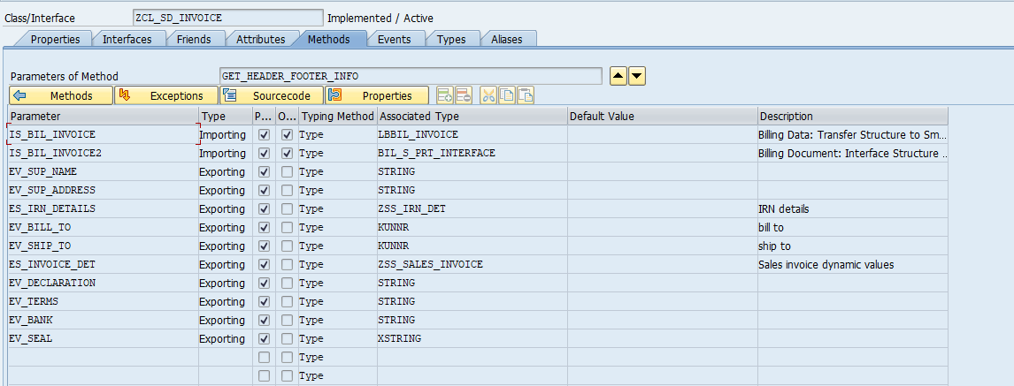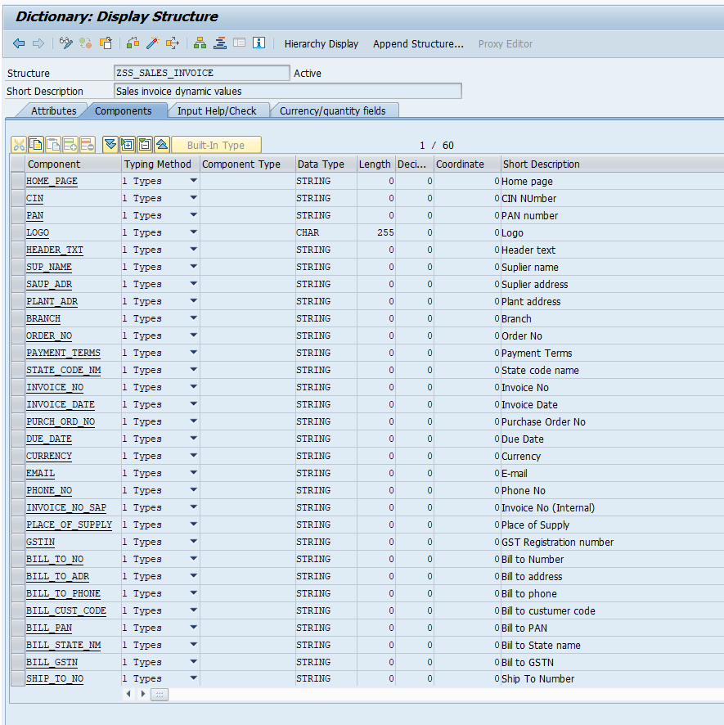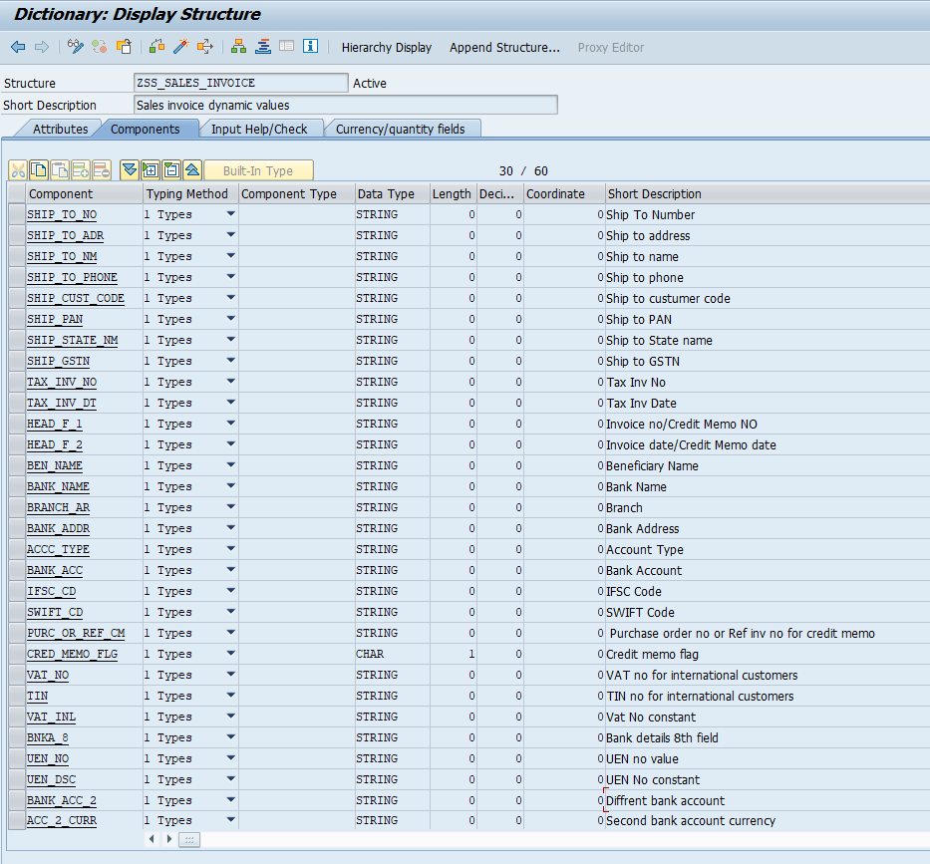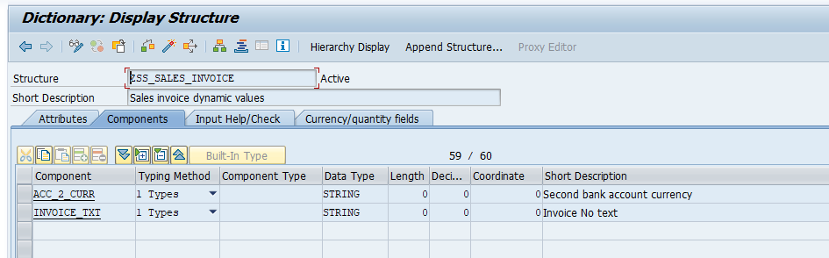
METHOD get_header_footer_info.
*----------------------------------------------------------------------*
* Program : Updates Tables ( ) Process data ( )
* Outputs List ( ) Validation ( )
*
* Module : SD
* WRICEF Object Id : SD_DV020
* Functional Specifications : FS_SD_DV020_SALES_INVOCIE
* Technical Spec No : TS_SD_DV020_SALES_INVOCIE
* Functional Consultant : Parul Singh
* Date Created (dd-mm-yyyy) : 01-12-2024
* Technical Consultant : Pravesh Patil
* Client : upGrad
* Project Name : upGrad
* Company : TechWit Business Solutions
*---------------------------------------------------------------------*
*Pravesh Patil | 08.07.2025 | PP08.07.2025 | Added to fetch sez number dynamic based on billing date
*----------------------------------------------------------------------*
*Amritansu Das | 06.11.2025 | Added correction for reference date
*----------------------------------------------------------------------*
CONSTANTS: cv_1810 TYPE char4 VALUE '1810',
cv_5 TYPE c VALUE '5',
cv_m TYPE c VALUE 'M',
cv_o TYPE c VALUE 'O',
cv_p TYPE c VALUE 'P',
cv_u TYPE c VALUE 'U',
cv_c TYPE c VALUE 'C',
cv_upgrad TYPE string VALUE 'upGrad Education Private Limited',
cv_outside_ind TYPE string VALUE '97 - Outside India',
cv_cin_upgrad TYPE char30 VALUE 'U80902MH2012PTC258559',
cv_na TYPE char2 VALUE 'NA',
cv_tax_inv TYPE char25 VALUE 'TAX INVOICE',
cv_bos TYPE char25 VALUE 'BILL OF SUPPLY',
cv_credit_memo TYPE char25 VALUE 'CREDIT MEMO',
cv_debit_memo TYPE char25 VALUE 'DEBIT MEMO',
cv_performa TYPE char25 VALUE 'PROFORMA INVOICE',
cv_inv_no TYPE char25 VALUE 'Invoice No:',
cv_inv_dt TYPE char25 VALUE 'Invoice Date:',
cv_cred_memo_no TYPE char25 VALUE 'Credit Memo No:',
cv_cred_memo_dt TYPE char25 VALUE 'Credit Memo Date:',
cv_purc_ord_no TYPE char20 VALUE 'Purchase Order No: ',
cv_reference_cm TYPE char20 VALUE 'Ref Inv No: '.
DATA: lv_logo_bukrs TYPE char255,
lv_spart TYPE spart.
DATA: lt_lines TYPE STANDARD TABLE OF string,
it_payterms TYPE TABLE OF ttext.
DATA: ls_addr TYPE szadr_addr1_complete,
wa_item TYPE lbbil_it_gen,
wa_bill TYPE msr_s_lbbil_it,
wa_price TYPE lbbil_it_price,
ls_suppaddr TYPE szadr_printform_table,
ls_compcdddr TYPE szadr_printform_table,
ls_suppgst TYPE stcd3,
ls_billaddr TYPE szadr_printform_table,
ls_shipaddr TYPE szadr_printform_table,
ls_kopf TYPE vbdkr.
DATA: lt_decla_lines TYPE STANDARD TABLE OF tline,
lt_terms_lines TYPE STANDARD TABLE OF tline,
lt_bank TYPE STANDARD TABLE OF tline,
lv_declaration TYPE string,
lv_terms TYPE string,
lv_bank TYPE string.
DATA(it_item) = is_bil_invoice-it_gen.
DATA(gs_it_gen) = is_bil_invoice-it_gen.
DATA(gs_head) = is_bil_invoice-hd_gen.
DATA(gs_org) = is_bil_invoice-hd_org.
DATA(ls_ref) = is_bil_invoice-hd_ref.
DATA(it_addr) = is_bil_invoice-hd_adr.
************************ Header Part
******* Header Text
IF gs_org-salesorg EQ cv_1810.
DATA(lv_header) = COND string( WHEN gs_head-bil_vbtype+0(1) = cv_5 THEN cv_tax_inv
WHEN gs_head-bil_vbtype+0(1) = cv_m THEN cv_tax_inv
WHEN gs_head-bil_vbtype+0(1) = cv_o THEN cv_credit_memo
WHEN gs_head-bil_vbtype+0(1) = cv_p THEN cv_debit_memo
WHEN gs_head-bil_vbtype+0(1) = cv_u THEN cv_performa
).
ENDIF.
DATA(lv_bukrs) = gs_org-comp_code.
DATA(lv_vkorg) = gs_org-salesorg.
lv_spart = gs_org-division.
DATA(lv_vtweg) = gs_org-distrb_channel.
SELECT SINGLE *
FROM zsd_inv_div
INTO @DATA(ls_inv_div)
WHERE sales_org = @lv_vkorg
AND dist_chnl = @lv_vtweg
AND division = @lv_spart.
IF sy-subrc EQ 0.
ENDIF.
**************IRN details
SELECT SINGLE *
FROM vbrk
INTO @DATA(ls_vbrk)
WHERE vbeln = @gs_head-bil_number.
IF sy-subrc EQ 0.
SELECT SINGLE
qrcode ,
inv_reg_num ,
ack_no ,
ack_date
FROM edoineinv
INTO @DATA(gs_irndetails)
WHERE inv_num = @ls_vbrk-xblnr.
* IF SY-SUBRC EQ 0.
IF gs_irndetails-ack_date IS INITIAL.
CLEAR gs_irndetails-ack_date.
gs_irndetails-ack_date = cv_na.
ENDIF.
IF gs_irndetails-ack_no IS INITIAL.
gs_irndetails-ack_no = cv_na.
ENDIF.
IF gs_irndetails-inv_reg_num IS INITIAL.
gs_irndetails-inv_reg_num = cv_na.
ENDIF.
es_irn_details = CORRESPONDING #( gs_irndetails ).
* ENDIF.
ENDIF.
"Error Billing document is not released to accounting at Print Preview
IF ls_vbrk-buchk <> cv_c AND ls_vbrk-fkart <> |F5|.
MESSAGE TEXT-002 TYPE gc_e DISPLAY LIKE gc_e.
ENDIF.
**************Logo Name in SE74
IF lv_spart = 14.
lv_logo_bukrs = |1840_SD|.
ELSEIF lv_spart = 40 .
lv_logo_bukrs = |1820_SD|.
ELSEIF lv_spart = 41 .
*** LV_LOGO_BUKRS = |ZREKRUT_LOGO|.
lv_logo_bukrs = |1810_41_SD|.
ELSE.
lv_logo_bukrs = |1810_SD|.
ENDIF.
*************Branch
DATA(lv_bupla) = CONV j_1bbranc_( is_bil_invoice2-head_detail-vbdkr-bupla ).
SELECT SINGLE name
FROM j_1bbranch
WHERE branch = @lv_bupla
AND bukrs = @lv_bukrs
INTO @DATA(lv_branch).
IF sy-subrc EQ 0.ENDIF.
************supplier name - Plant address
READ TABLE it_item INTO DATA(ls_item) INDEX 1.
SELECT SINGLE werks FROM vbrp
INTO @DATA(lv_werks)
WHERE vbeln = @ls_item-bil_number
AND posnr = @ls_item-itm_number.
IF sy-subrc EQ 0.
SELECT SINGLE adrnr, land1, regio
FROM t001w
INTO (@DATA(lv_adrnr), @DATA(lv_cntry), @DATA(lv_reg))
WHERE werks = @lv_werks.
IF sy-subrc EQ 0.ENDIF.
ENDIF.
"Check if salse address is available then update same instead plant address
SELECT SINGLE vgbel
FROM vbrp
INTO @DATA(lv_vgbel)
WHERE vbeln = @gs_head-bil_number.
IF sy-subrc EQ 0 AND lv_vgbel IS NOT INITIAL.
SELECT SINGLE vkbur
FROM vbak
INTO @DATA(lv_vkbur)
WHERE vbeln = @lv_vgbel.
IF lv_vkbur IS NOT INITIAL.
SELECT SINGLE adrnr
FROM tvbur
INTO @lv_adrnr
WHERE vkbur = @lv_vkbur.
ENDIF.
ENDIF.
IF gs_head-bil_waerk = 'INR'.
SELECT SINGLE * FROM vbrp
INTO @DATA(ls_vbrp)
WHERE vbeln EQ @ls_item-bil_number.
IF sy-subrc EQ 0 AND
( ls_vbrp-taxm1 = '3' AND ( ls_vbrp-taxm2 = '3' OR ls_vbrp-taxm3 = '3' OR ls_vbrp-taxm4 = '3' ) ).
DATA(lv_aland) = ls_vbrp-aland.
DATA(lv_wkreg) = ls_vbrp-wkreg.
SELECT SINGLE legal_state_code, bezei
INTO @DATA(ls_sup_place)
FROM j_1istatecdm
WHERE land1 EQ @lv_aland
AND std_state_code EQ @lv_wkreg.
ELSE.
SELECT c~legal_state_code, c~bezei FROM vbpa
AS a INNER JOIN kna1 AS b ON a~kunnr = b~kunnr
INNER JOIN j_1istatecdm AS c ON b~land1 EQ c~land1
AND b~regio EQ c~std_state_code
WHERE vbeln = @ls_item-bil_number
AND parvw = 'RE'
ORDER BY c~bezei
INTO @ls_sup_place UP TO 1 ROWS.
ENDSELECT.
IF sy-subrc EQ 0.ENDIF.
ENDIF.
DATA(gv_sup_place) = ls_sup_place-legal_state_code && | - | && ls_sup_place-bezei.
ELSE.
gv_sup_place = cv_outside_ind.
ENDIF.
"Update Header to Bill Of Supply based on MAtarial Tax classification
IF ls_vbrk-fkart <> |F5|.
lv_header = COND #( WHEN ls_vbrp-taxm1 EQ '1' THEN cv_bos
ELSE lv_header ).
ENDIF.
CALL FUNCTION 'ADDRESS_INTO_PRINTFORM'
EXPORTING
address_type = '1'
address_number = lv_adrnr
number_of_lines = 15
street_has_priority = 'X'
iv_country_name_separate_line = 'X'
IMPORTING
address_printform_table = ls_suppaddr
EXCEPTIONS
address_blocked = 1
person_blocked = 2
contact_person_blocked = 3
addr_to_be_formated_is_blocked = 4
OTHERS = 5.
IF sy-subrc <> 0.
* Implement suitable error handling here
ENDIF.
IF line_exists( ls_suppaddr[ line_type = 'L' address_line = 'INDIA' ] ).
DELETE ls_suppaddr WHERE line_type = 'R'.
DELETE ls_suppaddr WHERE line_type = 'L'.
ENDIF.
LOOP AT ls_suppaddr INTO DATA(wa_suppaddr).
CONCATENATE ls_plantadr wa_suppaddr-address_line INTO DATA(ls_plantadr)
SEPARATED BY space."GC_NEWLINE.
ENDLOOP.
"company code adress
SELECT SINGLE adrnr
FROM t001 INTO @DATA(lv_adrnr1)
WHERE bukrs = @lv_bukrs.
CALL FUNCTION 'ADDRESS_INTO_PRINTFORM'
EXPORTING
address_type = '1'
address_number = lv_adrnr1
number_of_lines = 15
street_has_priority = 'X'
iv_country_name_separate_line = 'X'
IMPORTING
address_printform_table = ls_compcdddr
EXCEPTIONS
address_blocked = 1
person_blocked = 2
contact_person_blocked = 3
addr_to_be_formated_is_blocked = 4
OTHERS = 5.
IF sy-subrc <> 0.
* Implement suitable error handling here
ENDIF.
DATA(lv_sup_name) = COND string( WHEN line_exists( ls_compcdddr[ 1 ] ) THEN ls_compcdddr[ 1 ]-address_line ).
IF ls_compcdddr IS NOT INITIAL.
DELETE ls_compcdddr INDEX 1.
ENDIF.
IF line_exists( ls_compcdddr[ line_type = 'L' address_line = 'INDIA' ] ).
DELETE ls_compcdddr WHERE line_type = 'R'.
DELETE ls_compcdddr WHERE line_type = 'L'.
ENDIF.
LOOP AT ls_compcdddr INTO DATA(wa_compadr).
CONCATENATE ls_compadr wa_compadr-address_line INTO DATA(ls_compadr)
SEPARATED BY space. "GC_NEWLINE.
ENDLOOP.
"fetch the phone num, homepage, supp mail id
CALL FUNCTION 'ADDR_GET_COMPLETE'
EXPORTING
addrnumber = gs_org-salesorg_adr
IMPORTING
addr1_complete = ls_addr
EXCEPTIONS
parameter_error = 1
address_not_exist = 2
internal_error = 3
wrong_access_to_archive = 4
address_blocked = 5
OTHERS = 6.
IF sy-subrc <> 0.
* Implement suitable error handling here
ENDIF.
READ TABLE ls_addr-adtel_tab INTO DATA(wa_adtel) INDEX 1.
READ TABLE ls_addr-adsmtp_tab INTO DATA(wa_adsmtp) INDEX 1.
READ TABLE ls_addr-adrct_tab INTO DATA(wa_adrct) INDEX 1.
"supplier GST
CALL FUNCTION 'J_1IG_GET_PLANT_DETAILS'
EXPORTING
im_werks = lv_werks
im_bukrs = gs_org-comp_code
IMPORTING
* EX_BRANCH =
ex_gstin = ls_suppgst.
"fetch the bill to party address
** Getting address number from adr table
READ TABLE it_addr INTO DATA(gs_hd_adr) WITH KEY partn_role = 'RE'.
DATA(gv_bp) = gs_hd_adr-partn_numb.
* EV_BILL_TO = GS_HD_ADR-PARTN_NUMB.
DATA(gvbpadr) = gs_hd_adr-addr_no. " use to print
CALL FUNCTION 'ADDRESS_INTO_PRINTFORM'
EXPORTING
address_type = '1'
address_number = gs_hd_adr-addr_no
number_of_lines = 15
street_has_priority = 'X'
iv_country_name_separate_line = 'X'
IMPORTING
address_printform_table = ls_billaddr
EXCEPTIONS
address_blocked = 1
person_blocked = 2
contact_person_blocked = 3
addr_to_be_formated_is_blocked = 4
OTHERS = 5.
IF sy-subrc <> 0.
* Implement suitable error handling here
ENDIF.
DELETE ls_billaddr WHERE line_type = 'A'.
IF line_exists( ls_billaddr[ line_type = 'L' address_line = 'INDIA' ] ).
DELETE ls_billaddr WHERE line_type = 'R'.
DELETE ls_billaddr WHERE line_type = 'L'.
ENDIF.
LOOP AT ls_billaddr INTO DATA(wa_billaddr).
CONCATENATE ls_bill wa_billaddr-address_line INTO DATA(ls_bill)
SEPARATED BY space." gc_newline.
ENDLOOP.
"Bill to PAN
SELECT SINGLE regio, j_1ipanno
FROM kna1
WHERE kunnr EQ @gv_bp
INTO @DATA(ls_bill_pan).
"Bill to GSTIN
SELECT SINGLE taxnum
FROM dfkkbptaxnum
WHERE partner EQ @gv_bp
AND taxtype EQ 'IN3'
INTO @DATA(lv_bill_gstin).
"Bill to State code and name
me->get_state_codenname( EXPORTING
iv_regio = ls_bill_pan-regio
IMPORTING
ev_state_codenm = DATA(lv_bill_statenmcd) ).
"fetch the shill to party address
READ TABLE it_addr INTO gs_hd_adr WITH KEY partn_role = 'WE'.
DATA(gv_sp) = gs_hd_adr-partn_numb.
DATA(gvspadr) = gs_hd_adr-addr_no. "use to print
CALL FUNCTION 'ADDRESS_INTO_PRINTFORM'
EXPORTING
address_type = '1'
address_number = gs_hd_adr-addr_no
number_of_lines = 15
street_has_priority = 'X'
iv_country_name_separate_line = 'X'
IMPORTING
* ADRSWA_OUT =
address_printform_table = ls_shipaddr
EXCEPTIONS
address_blocked = 1
person_blocked = 2
contact_person_blocked = 3
addr_to_be_formated_is_blocked = 4
OTHERS = 5.
IF sy-subrc <> 0.
* Implement suitable error handling here
ENDIF.
DELETE ls_shipaddr WHERE line_type = 'A'.
IF line_exists( ls_shipaddr[ line_type = 'L' address_line = 'INDIA' ] ).
DELETE ls_shipaddr WHERE line_type = 'R'.
DELETE ls_shipaddr WHERE line_type = 'L'.
ENDIF.
*READ TABLE ls_shipaddr INTO wa_shipaddr INDEX 1.
LOOP AT ls_shipaddr INTO DATA(wa_shipaddr).
CONCATENATE ls_ship wa_shipaddr-address_line INTO DATA(ls_ship)
SEPARATED BY space.
ENDLOOP.
"Ship to PAN
SELECT SINGLE j_1ipanno, regio
FROM kna1
WHERE kunnr EQ @gv_sp
INTO @DATA(ls_ship_pan).
IF sy-subrc EQ 0.ENDIF.
"Ship to GSTIN
SELECT SINGLE taxnum
FROM dfkkbptaxnum
WHERE partner EQ @gv_sp
AND taxtype EQ 'IN3'
INTO @DATA(lv_ship_gstin).
IF sy-subrc EQ 0.ENDIF.
"Ship to State code and name
me->get_state_codenname( EXPORTING
iv_regio = ls_ship_pan-regio
IMPORTING
ev_state_codenm = DATA(lv_ship_statenmcd) ).
"fetch the buyer GST
READ TABLE it_addr INTO gs_hd_adr WITH KEY partn_role = 'RE'.
SELECT SINGLE land1 INTO @DATA(lv_land1) FROM kna1
WHERE kunnr = @gs_hd_adr-partn_numb.
IF sy-subrc EQ 0.ENDIF.
SELECT SINGLE high
FROM tvarvc
INTO @DATA(lv_taxtype)
WHERE name = 'ZSD_CUST_TAX_TYPE' AND low = @lv_land1.
IF sy-subrc EQ 0.ENDIF.
IF lv_taxtype IS NOT INITIAL .
SELECT SINGLE taxnum
FROM dfkkbptaxnum
INTO @DATA(lv_taxnum)
WHERE partner = @gs_hd_adr-partn_numb AND
taxtype = @lv_taxtype.
IF sy-subrc EQ 0.ENDIF.
ENDIF.
"duedate
DATA: ls_comwa TYPE vbco3,
lt_pos TYPE TABLE OF vbdpr.
ls_comwa-vbeln = gs_head-bil_number.
CALL FUNCTION 'RV_BILLING_PRINT_VIEW'
EXPORTING
comwa = ls_comwa
IMPORTING
kopf = ls_kopf
TABLES
pos = lt_pos
EXCEPTIONS
terms_of_payment_not_in_t052 = 1
OTHERS = 2.
IF sy-subrc <> 0.
* Implement suitable error handling here
ENDIF.
"payment terms
DATA(lv_other_terms) = is_bil_invoice-hd_gen_descript-name_paymterm.
"company pan
SELECT SINGLE paval FROM t001z INTO @DATA(lv_pan)
WHERE party = 'J_1I02' AND bukrs = @gs_org-comp_code.
IF sy-subrc EQ 0.ENDIF.
* SELECT SINGLE xblnr FROM vbrk INTO @DATA(lv_xblnr) --commeneted by amritansu for fetching date
* WHERE vbeln = @gs_head-bil_number.
SELECT SINGLE zuonr, xblnr FROM vbrk INTO @DATA(ls_vbrk1) " ++ amritansu for fetching date
WHERE vbeln = @gs_head-bil_number.
* IF sy-subrc = 0 AND lv_xblnr IS NOT INITIAL. --amritansu
IF sy-subrc = 0 AND ls_vbrk1-xblnr IS NOT INITIAL.
DATA(lv_zounr) = CONV xblnr( ls_vbrk1-zuonr ). " ++ amritansu for fetching date
SELECT SINGLE fkdat, xblnr FROM vbrk INTO @DATA(ls_vbrk2) " ++ amritansu for fetching date
WHERE xblnr = @lv_zounr.
ENDIF.
"PO NUMBER
DATA(gt_po) = is_bil_invoice-it_refpurord.
READ TABLE gt_po INTO DATA(gs_po) INDEX 1.
IF sy-subrc EQ 0.
ENDIF.
"SEAL
"Get State code and name
me->get_state_codenname( EXPORTING
iv_bukrs = lv_bukrs
iv_bupla = lv_bupla
IMPORTING
ev_state_codenm = DATA(lv_statenmcd) ).
"CIN Constant for now
SELECT SINGLE paval
FROM t001z
INTO @DATA(lv_cin_no)
WHERE bukrs = @lv_bukrs
AND party = 'Z_CIN'.
"Invocie/Invoice date or Credit memo or credit memo date
IF gs_head-bil_vbtype+0(1) = cv_o.
DATA(lv_head_f1) = cv_cred_memo_no.
DATA(lv_head_f2) = cv_cred_memo_dt.
ELSE.
lv_head_f1 = cv_inv_no.
lv_head_f2 = cv_inv_dt.
ENDIF.
"Credit memo reference number based on document number
"Purchase order number for normal invocie / reference number for credit memo
DATA(lv_po_or_ref_inv) = cv_purc_ord_no.
IF gs_head-bil_vbtype+0(1) = cv_o.
DATA(lv_cred_memo_flg) = abap_true.
SELECT SINGLE aubel
FROM vbrp
INTO @DATA(lv_aubel)
WHERE vbeln EQ @gs_head-bil_number.
IF sy-subrc EQ 0 AND lv_aubel IS NOT INITIAL.
SELECT SINGLE xblnr, erdat
FROM vbak
INTO (@DATA(lv_cm_ref),@DATA(lv_refcre_dt))
WHERE vbeln = @lv_aubel.
IF sy-subrc EQ 0 AND lv_cm_ref IS NOT INITIAL.
* GS_PO-PURCH_NO_C = LV_CM_REF.
lv_po_or_ref_inv = cv_reference_cm.
ENDIF.
ENDIF.
ELSE.
lv_cred_memo_flg = 'Y'.
CONDENSE lv_po_or_ref_inv.
ENDIF.
"++ Pravesh Patil added if ref details not found
IF lv_aubel IS NOT INITIAL.
SELECT SINGLE bstkd, bstdk
FROM vbkd
INTO @DATA(ls_vbkd)
WHERE vbeln = @lv_aubel.
IF sy-subrc EQ 0.
IF lv_cm_ref IS INITIAL.
lv_cm_ref = ls_vbkd-bstkd.
ENDIF.
IF ls_vbrk2-fkdat IS INITIAL.
ls_vbrk2-fkdat = ls_vbkd-bstdk.
ENDIF.
ENDIF.
ENDIF.
"Assigning all required data in common structure to fill form layout
es_invoice_det = VALUE #(
home_page = COND #( WHEN ls_inv_div-website IS NOT INITIAL THEN ls_inv_div-website
ELSE cv_na )
cin = COND #( WHEN lv_cin_no IS NOT INITIAL THEN lv_cin_no ELSE cv_cin_upgrad )
pan = COND #( WHEN lv_pan IS NOT INITIAL THEN lv_pan ELSE cv_na )
logo = lv_logo_bukrs
header_txt = lv_header
head_f_1 = lv_head_f1
head_f_2 = lv_head_f2
sup_name = COND #( WHEN lv_sup_name IS NOT INITIAL THEN lv_sup_name ELSE cv_na )
saup_adr = COND #( WHEN ls_compadr IS NOT INITIAL THEN ls_compadr ELSE cv_na )
plant_adr = COND #( WHEN ls_plantadr IS NOT INITIAL THEN ls_plantadr ELSE cv_na )
branch = COND #( WHEN lv_branch IS NOT INITIAL THEN lv_branch ELSE cv_na )
order_no = COND #( WHEN ls_ref-order_numb IS NOT INITIAL THEN ls_ref-order_numb ELSE cv_na )
payment_terms = COND #( WHEN lv_other_terms IS NOT INITIAL THEN lv_other_terms ELSE cv_na )
state_code_nm = COND #( WHEN lv_statenmcd IS NOT INITIAL THEN lv_statenmcd ELSE cv_na )
* invoice_no = COND #( WHEN lv_xblnr IS NOT INITIAL THEN lv_xblnr ELSE cv_na ) --amritansu
invoice_no = COND #( WHEN ls_vbrk1-xblnr IS NOT INITIAL THEN ls_vbrk1-xblnr ELSE cv_na ) "++amritansu
invoice_date = gs_head-bil_date+6(2) && |-| && gs_head-bil_date+4(2) && |-| && gs_head-bil_date+0(4) "20241221
purch_ord_no = COND #( WHEN gs_po-purch_no_c IS NOT INITIAL THEN gs_po-purch_no_c ELSE cv_na )
due_date = ls_kopf-payment_due_date+6(2) && |-| && ls_kopf-payment_due_date+4(2) && |-| && ls_kopf-payment_due_date+0(4)
currency = COND #( WHEN gs_head-bil_waerk IS NOT INITIAL THEN gs_head-bil_waerk ELSE cv_na )
email = COND #( WHEN ls_inv_div-email IS NOT INITIAL THEN ls_inv_div-email ELSE cv_na )
phone_no = COND #( WHEN wa_adtel-adtel-tel_number IS NOT INITIAL THEN wa_adtel-adtel-tel_number ELSE cv_na )
invoice_no_sap = COND #( WHEN gs_head-bil_number IS NOT INITIAL THEN gs_head-bil_number ELSE cv_na )
place_of_supply = COND #( WHEN gv_sup_place IS NOT INITIAL THEN gv_sup_place ELSE cv_na )
gstin = COND #( WHEN ls_suppgst IS NOT INITIAL THEN ls_suppgst ELSE cv_na )
bill_to_no = COND #( WHEN gv_bp IS NOT INITIAL THEN gv_bp ELSE cv_na )
bill_to_adr = COND #( WHEN ls_bill IS NOT INITIAL THEN ls_bill ELSE cv_na )
bill_cust_code = COND #( WHEN gv_bp IS NOT INITIAL THEN gv_bp ELSE cv_na )
bill_pan = COND #( WHEN ls_bill_pan-j_1ipanno IS NOT INITIAL THEN ls_bill_pan-j_1ipanno ELSE cv_na )
bill_state_nm = COND #( WHEN lv_bill_statenmcd IS NOT INITIAL THEN lv_bill_statenmcd ELSE cv_na )
bill_gstn = COND #( WHEN lv_bill_gstin IS NOT INITIAL THEN lv_bill_gstin ELSE cv_na )
ship_to_no = COND #( WHEN gv_sp IS NOT INITIAL THEN gv_sp ELSE cv_na )
ship_to_adr = COND #( WHEN ls_ship IS NOT INITIAL THEN ls_ship ELSE cv_na )
ship_cust_code = COND #( WHEN gv_sp IS NOT INITIAL THEN gv_sp ELSE cv_na )
ship_pan = COND #( WHEN ls_ship_pan-j_1ipanno IS NOT INITIAL THEN ls_ship_pan-j_1ipanno ELSE cv_na )
ship_state_nm = COND #( WHEN lv_ship_statenmcd IS NOT INITIAL THEN lv_ship_statenmcd ELSE cv_na )
ship_gstn = COND #( WHEN lv_ship_gstin IS NOT INITIAL THEN lv_ship_gstin ELSE cv_na )
* TAX_INV_NO = COND #( WHEN LV_CM_REF IS NOT INITIAL THEN LV_CM_REF ELSE CV_NA )
tax_inv_no = lv_cm_ref
* tax_inv_dt = COND #( WHEN lv_refcre_dt IS NOT INITIAL THEN
* lv_refcre_dt+6(2) && |-| && lv_refcre_dt+4(2) && |-| && lv_refcre_dt+0(4)
* ELSE cv_na ) -amritansu
tax_inv_dt = COND #( WHEN ls_vbrk2-fkdat IS NOT INITIAL THEN
ls_vbrk2-fkdat+6(2) && |-| && ls_vbrk2-fkdat+4(2) && |-| && ls_vbrk2-fkdat+0(4)
ELSE cv_na ) "++amritansu
purc_or_ref_cm = lv_po_or_ref_inv
cred_memo_flg = lv_cred_memo_flg ).
*****************************Footer Part
** IF lv_spart = |40| OR lv_spart = |41|. "++PP13.05.2025 Stamp added as per business
DATA(gv_seal) = CONV thead-tdname( gs_org-salesorg && '_LOGO_SD' ). "Graphics
DATA(lv_seal_name) = CONV char255( gv_seal ).
me->derive_color_logo(
EXPORTING
iv_xlogo = lv_seal_name " Char255
IMPORTING
ev_logo = ev_seal
).
** ENDIF.
***************Declaration logic
SELECT SINGLE taxkd
FROM knvi
INTO @DATA(lv_taxkd)
WHERE kunnr = @gs_hd_adr-partn_numb
AND taxkd = '3'.
IF sy-subrc = 0.
DATA(gv_sez_flag) = 'X'.
ELSE.
gv_sez_flag = space.
ENDIF.
IF gv_sez_flag IS NOT INITIAL.
DATA(lv_so10_decl) = CONV thead-tdname( |ZSD_SEZ_DECL| ).
ENDIF.
*< SOA | PP08.07.2025 | Added to fetch sez number dynamic based on billing date >
"Get declaration number from set table based on fkdat
SELECT SINGLE * FROM setleaf
INTO @DATA(ls_setleaf)
WHERE setname = 'ZSD_SEZ_LUTNO'
AND valfrom < @ls_vbrk-fkdat
AND valto > @ls_vbrk-fkdat.
IF sy-subrc EQ 0.
SELECT SINGLE descript
FROM setlinet INTO @DATA(lv_sez_num)
WHERE setname = 'ZSD_SEZ_LUTNO'
AND lineid EQ @ls_setleaf-lineid
AND langu = 'E'.
ENDIF.
*< EOA | PP08.07.2025 | Added to fetch sez number dynamic based on billing date >
IF lv_so10_decl IS NOT INITIAL.
CALL FUNCTION 'READ_TEXT'
EXPORTING
client = sy-mandt
id = 'ST'
language = sy-langu
name = lv_so10_decl
object = 'TEXT'
TABLES
lines = lt_decla_lines
EXCEPTIONS
id = 1
language = 2
name = 3
not_found = 4
object = 5
reference_check = 6
wrong_access_to_archive = 7
OTHERS = 8.
IF sy-subrc <> 0.ENDIF.
IF lt_decla_lines IS NOT INITIAL.
LOOP AT lt_decla_lines INTO DATA(ls_lines).
lv_declaration = lv_declaration && ls_lines-tdline.
ENDLOOP.
* REPLACE '&SEZ_YEAR&' IN lv_declaration WITH 'AD270324178879C'. --PP08.07.2025 Change for Sez text
REPLACE '&SEZ_YEAR&' IN lv_declaration WITH lv_sez_num. "++PP08.07.2025 Change for Sez text
ENDIF.
ev_declaration = lv_declaration.
ENDIF.
IF is_bil_invoice-hd_gen-dlv_land <> |IN|.
CLEAR ev_declaration.
ev_declaration = TEXT-001.
ENDIF.
**********Other terms and conditions based on sales org, distrib chanl and division wrt user registered or not for tax
"deriving so10 for other terms
IF lv_bukrs EQ |1810| AND ls_vbrk-taxk1 <> 1. "If registered for TAX
DATA(gv_terms) = CONV thead-tdname( |TCREG_{ lv_vkorg }_{ lv_vtweg }_{ lv_spart }| ).
CALL FUNCTION 'READ_TEXT'
EXPORTING
client = sy-mandt
id = 'ST'
language = sy-langu
name = gv_terms
object = 'TEXT'
TABLES
lines = lt_terms_lines
EXCEPTIONS
id = 1
language = 2
name = 3
not_found = 4
object = 5
reference_check = 6
wrong_access_to_archive = 7
OTHERS = 8.
IF sy-subrc <> 0.
gv_terms = |TCREG_{ lv_vkorg }_{ lv_vtweg }_ALL| .
CALL FUNCTION 'READ_TEXT'
EXPORTING
client = sy-mandt
id = 'ST'
language = sy-langu
name = gv_terms
object = 'TEXT'
TABLES
lines = lt_terms_lines
EXCEPTIONS
id = 1
language = 2
name = 3
not_found = 4
object = 5
reference_check = 6
wrong_access_to_archive = 7
OTHERS = 8.
ENDIF.
ELSEIF lv_bukrs EQ |1810| AND ls_vbrk-taxk1 EQ 1. "If not registered for TAX
gv_terms = |TCUREG_{ lv_vkorg }_{ lv_vtweg }_{ lv_spart }|.
CALL FUNCTION 'READ_TEXT'
EXPORTING
client = sy-mandt
id = 'ST'
language = sy-langu
name = gv_terms
object = 'TEXT'
TABLES
lines = lt_terms_lines
EXCEPTIONS
id = 1
language = 2
name = 3
not_found = 4
object = 5
reference_check = 6
wrong_access_to_archive = 7
OTHERS = 8.
IF sy-subrc <> 0.
gv_terms = |TCUREG_{ lv_vkorg }_{ lv_vtweg }_ALL| .
CALL FUNCTION 'READ_TEXT'
EXPORTING
client = sy-mandt
id = 'ST'
language = sy-langu
name = gv_terms
object = 'TEXT'
TABLES
lines = lt_terms_lines
EXCEPTIONS
id = 1
language = 2
name = 3
not_found = 4
object = 5
reference_check = 6
wrong_access_to_archive = 7
OTHERS = 8.
ENDIF.
ENDIF.
"Fill other terms
IF lt_terms_lines IS NOT INITIAL.
LOOP AT lt_terms_lines INTO DATA(ls_terms).
IF sy-tabix EQ 1.
lv_terms = lv_terms && ls_terms-tdline.
ELSEIF ls_terms-tdformat = '*'.
lv_terms = lv_terms && cl_abap_char_utilities=>newline && ls_terms-tdline.
ELSE.
lv_terms = |{ lv_terms } { ls_terms-tdline }|.
ENDIF.
ENDLOOP.
ENDIF.
ev_terms = lv_terms.
IF lt_terms_lines IS INITIAL.
ev_terms = cv_na.
ENDIF.
"Bank details
es_invoice_det-ben_name = cv_upgrad. "upGrad Education Private Limited
DATA(lv_accid) = CONV char5( ls_inv_div-acc_key ).
SELECT SINGLE *
FROM t012k
INTO @DATA(ls_t012l)
WHERE bukrs = @lv_vkorg
AND hbkid = @ls_inv_div-house_bank
AND hktid = @ls_inv_div-acc_key .
IF sy-subrc EQ 0.
es_invoice_det-bank_acc = ls_t012l-bankn.
ENDIF.
SELECT SINGLE *
FROM bnka
INTO @DATA(ls_bnka)
WHERE banks = 'IN'
AND bankl = @ls_inv_div-bank_key.
IF sy-subrc EQ 0.
es_invoice_det-bank_name = ls_bnka-banka.
es_invoice_det-branch_ar = ls_bnka-brnch.
es_invoice_det-bank_addr = |{ ls_bnka-stras } { ls_bnka-ort01 }|.
es_invoice_det-accc_type = |Current|.
es_invoice_det-ifsc_cd = ls_inv_div-bank_key.
es_invoice_det-swift_cd = ls_bnka-swift.
ENDIF.
* IF LS_VBRK-TAXK1 EQ 1. "If customer is unregistred for TAX then no bank details
* ES_INVOICE_DET-BEN_NAME = CV_NA.
* ES_INVOICE_DET-BANK_NAME = CV_NA.
* ES_INVOICE_DET-BRANCH_AR = CV_NA.
* ES_INVOICE_DET-BANK_ADDR = CV_NA.
* ES_INVOICE_DET-ACCC_TYPE = CV_NA.
* ES_INVOICE_DET-BANK_ACC = CV_NA.
* ES_INVOICE_DET-IFSC_CD = CV_NA.
* ES_INVOICE_DET-SWIFT_CD = CV_NA.
* ENDIF.
DATA(gv_bank1) = CONV thead-tdname( gs_head-bil_number ).
DATA(gv_bank) = CONV thead-tdname( 'ZSD_INV_BANK_' && gs_org-salesorg ).
IF gv_bank1 IS NOT INITIAL.
CALL FUNCTION 'READ_TEXT'
EXPORTING
client = sy-mandt
id = 'ZBNK'
language = sy-langu
name = gv_bank1
object = 'VBBK'
TABLES
lines = lt_bank
EXCEPTIONS
id = 1
language = 2
name = 3
not_found = 4
object = 5
reference_check = 6
wrong_access_to_archive = 7
OTHERS = 8.
IF sy-subrc <> 0.ENDIF.
ENDIF.
IF lt_bank IS NOT INITIAL.
DATA(gv_flag_text) = 'X'.
ELSE.
gv_flag_text = ' '.
ENDIF.
IF gv_flag_text IS INITIAL.
CALL FUNCTION 'READ_TEXT'
EXPORTING
client = sy-mandt
id = 'ST'
language = sy-langu
name = gv_bank
object = 'TEXT'
TABLES
lines = lt_bank
EXCEPTIONS
id = 1
language = 2
name = 3
not_found = 4
object = 5
reference_check = 6
wrong_access_to_archive = 7
OTHERS = 8.
IF sy-subrc <> 0.ENDIF.
ENDIF.
IF lt_bank IS NOT INITIAL.
LOOP AT lt_bank INTO DATA(ls_bank).
lv_bank = |Bank Details:{ cl_abap_char_utilities=>newline }|.
IF ls_terms-tdformat = '*'.
lv_bank = lv_bank && ls_bank-tdline && cl_abap_char_utilities=>newline.
ELSE.
lv_bank = lv_bank && ls_bank-tdline.
ENDIF.
ENDLOOP.
ev_bank = lv_bank.
ENDIF.
ENDMETHOD. 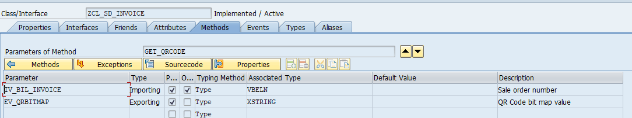
METHOD GET_QRCODE.
*----------------------------------------------------------------------*
* Program : Updates Tables ( ) Process data ( )
* Outputs List ( ) Validation ( )
*
* Module : SD
* WRICEF Object Id : SD_DV020
* Functional Specifications : FS_SD_DV020_SALES_INVOCIE
* Technical Spec No : TS_SD_DV020_SALES_INVOCIE
* Functional Consultant : Parul Singh
* Date Created (dd-mm-yyyy) : 01-12-2024
* Technical Consultant : Pravesh Patil
* Client : upGrad
* Project Name : upGrad
* Company : TechWit Business Solutions
*---------------------------------------------------------------------*
CONSTANTS: LC_A TYPE C VALUE 'A',
LC_H TYPE C VALUE 'H'.
DATA(LV_SALES_ORDER) = IV_BIL_INVOICE.
***************QR Code
SELECT SINGLE XBLNR
FROM VBRK
INTO @DATA(LV_XBLNR)
WHERE VBELN = @LV_SALES_ORDER.
IF SY-SUBRC EQ 0.
SELECT SINGLE
QRCODE ,
INV_REG_NUM ,
ACK_NO ,
ACK_DATE
FROM EDOINEINV
INTO @DATA(LS_IRNDETAILS)
WHERE INV_NUM = @LV_XBLNR.
IF SY-SUBRC EQ 0.
IF LS_IRNDETAILS-QRCODE IS NOT INITIAL.
CL_RSTX_BARCODE_RENDERER=>QR_CODE(
EXPORTING
I_MODULE_SIZE = 20
I_MODE = LC_A
I_ERROR_CORRECTION = LC_H
I_BARCODE_TEXT = LS_IRNDETAILS-QRCODE
IMPORTING
E_BITMAP = DATA(LV_BITQRCODE)
).
EV_QRBITMAP = LV_BITQRCODE.
ENDIF.
ENDIF.
ENDIF.
ENDMETHOD. 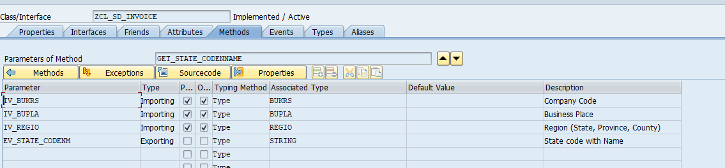 METHOD GET_STATE_CODENNAME.
*----------------------------------------------------------------------*
* Program : Updates Tables ( ) Process data ( )
* Outputs List ( ) Validation ( )
*
* Module : SD
* WRICEF Object Id : SD_DV020
* Functional Specifications : FS_SD_DV020_SALES_INVOCIE
* Technical Spec No : TS_SD_DV020_SALES_INVOCIE
* Functional Consultant : Parul Singh
* Date Created (dd-mm-yyyy) : 01-12-2024
* Technical Consultant : Pravesh Patil
* Client : upGrad
* Project Name : upGrad
* Company : TechWit Business Solutions
*---------------------------------------------------------------------*
DATA : LS_ADDR_BUPLA TYPE ADDR1_VAL.
IF IV_REGIO IS NOT INITIAL.
DATA(LV_REG) = IV_REGIO.
ENDIF.
IF IV_BUKRS IS NOT INITIAL AND IV_BUPLA IS NOT INITIAL.
CALL FUNCTION 'GET_BUPLA_ADDRESS'
EXPORTING
BUKRS = IV_BUKRS
BUPLA = IV_BUPLA
IMPORTING
ADRESSE = LS_ADDR_BUPLA.
LV_REG = LS_ADDR_BUPLA-REGION.
ENDIF.
IF LV_REG IS NOT INITIAL.
SELECT SINGLE * FROM J_1ISTATECDM
INTO @DATA(LS_STATECDM)
WHERE LAND1 EQ 'IN'
AND STD_STATE_CODE = @LV_REG.
IF SY-SUBRC EQ 0.
EV_STATE_CODENM = LS_STATECDM-LEGAL_STATE_CODE && | - | && LS_STATECDM-BEZEI.
ENDIF.
ENDIF.
ENDMETHOD.
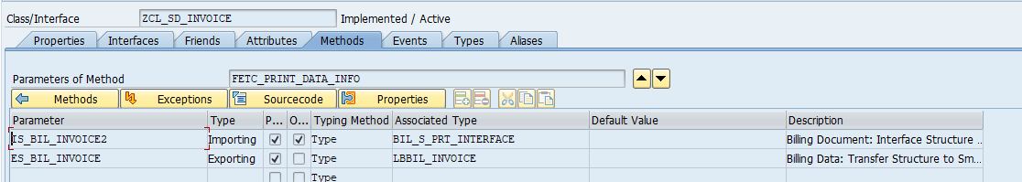 METHOD FETC_PRINT_DATA_INFO.
*----------------------------------------------------------------------*
* Program : Updates Tables ( ) Process data ( )
* Outputs List ( ) Validation ( )
*
* Module : SD
* WRICEF Object Id : SD_DV020
* Functional Specifications : FS_SD_DV020_SALES_INVOCIE
* Technical Spec No : TS_SD_DV020_SALES_INVOCIE
* Functional Consultant : Parul Singh
* Date Created (dd-mm-yyyy) : 01-12-2024
* Technical Consultant : Pravesh Patil
* Client : upGrad
* Project Name : upGrad
* Company : TechWit Business Solutions
*---------------------------------------------------------------------*
DATA: LS_PRINT_DATA_TO_READ TYPE LBBIL_PRINT_DATA_TO_READ,
LS_BIL_INVOICE TYPE LBBIL_INVOICE.
DATA(LV_VBELN) = CONV NA_OBJKEY( IS_BIL_INVOICE2-HEAD_DETAIL-VBDKR-VBELN ).
DATA(LV_SPRAS) = CONV NA_SPRAS( IS_BIL_INVOICE2-HEAD_DETAIL-VBDKR-SPRAS_VKO ).
DATA(LV_KUNWE) = CONV CHAR10( IS_BIL_INVOICE2-HEAD_DETAIL-VBDKR-KUNWE ).
"Fill all flags to get All Print data
LS_PRINT_DATA_TO_READ = VALUE #( HD_GEN = ABAP_TRUE
HD_ADR = ABAP_TRUE
HD_GEN_DESCRIPT = ABAP_TRUE
HD_ORG = ABAP_TRUE
HD_PART_ADD = ABAP_TRUE
HD_KOND = ABAP_TRUE
HD_FIN = ABAP_TRUE
HD_REF = ABAP_TRUE
HD_TECH = ABAP_TRUE
IT_GEN = ABAP_TRUE
IT_ADR = ABAP_TRUE
IT_PRICE = ABAP_TRUE
IT_KOND = ABAP_TRUE
IT_REF = ABAP_TRUE
IT_REFDLV = ABAP_TRUE
IT_REFORD = ABAP_TRUE
IT_REFPURORD = ABAP_TRUE
IT_REFVAG = ABAP_TRUE
IT_REFVG2 = ABAP_TRUE
IT_REFVKT = ABAP_TRUE
IT_TECH = ABAP_TRUE
IT_FIN = ABAP_TRUE
IT_CONFITM = ABAP_TRUE
IT_CONFBATCH = ABAP_TRUE
MSR_HD = ABAP_TRUE
MSR_IT = ABAP_TRUE ).
*Read print data from FM
CALL FUNCTION 'LB_BIL_INV_OUTP_READ_PRTDATA'
EXPORTING
IF_BIL_NUMBER = LV_VBELN
IF_PARVW = GC_PART_FUNC_RE
IF_PARNR = LV_KUNWE
IF_LANGUAGE = LV_SPRAS
IS_PRINT_DATA_TO_READ = LS_PRINT_DATA_TO_READ
IMPORTING
ES_BIL_INVOICE = LS_BIL_INVOICE
EXCEPTIONS
RECORDS_NOT_FOUND = 1
RECORDS_NOT_REQUESTED = 2
OTHERS = 3.
IF SY-SUBRC <> 0.
ENDIF.
ES_BIL_INVOICE = LS_BIL_INVOICE.
ENDMETHOD.
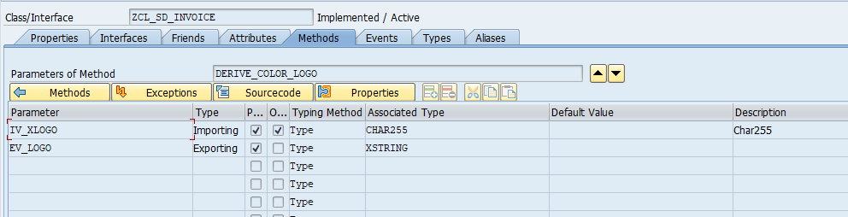
METHOD DERIVE_COLOR_LOGO.
*----------------------------------------------------------------------*
* Program : Updates Tables ( ) Process data ( )
* Outputs List ( ) Validation ( )
*
* Module : SD
* WRICEF Object Id : SD_DV020
* Functional Specifications : FS_SD_DV020_SALES_INVOCIE
* Technical Spec No : TS_SD_DV020_SALES_INVOCIE
* Functional Consultant : Parul Singh
* Date Created (dd-mm-yyyy) : 01-12-2024
* Technical Consultant : Pravesh Patil
* Client : upGrad
* Project Name : upGrad
* Company : TechWit Business Solutions
*---------------------------------------------------------------------*
"Get upGrad Logo in Bitmap
DATA(LV_LOGO) = CONV TDOBNAME( IV_XLOGO ).
CALL METHOD CL_SSF_XSF_UTILITIES=>GET_BDS_GRAPHIC_AS_BMP
EXPORTING
P_OBJECT = 'GRAPHICS'
P_NAME = LV_LOGO " Name of the logo as in se78
P_ID = 'BMAP'
P_BTYPE = 'BCOL' "( whether the image is in color or black and white )
RECEIVING
P_BMP = DATA(LV_FIELD)
EXCEPTIONS
NOT_FOUND = 1
INTERNAL_ERROR = 2
OTHERS = 3.
EV_LOGO = LV_FIELD.
ENDMETHOD. 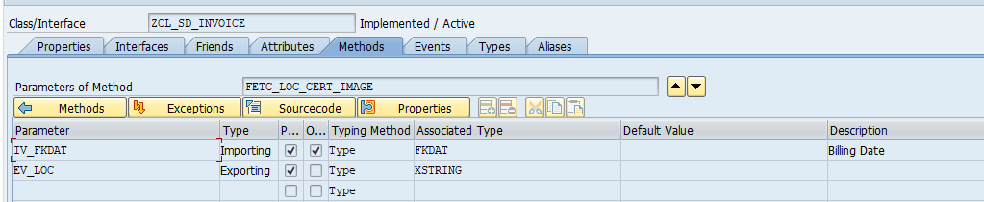
METHOD fetc_loc_cert_image.
*----------------------------------------------------------------------*
* Program : Updates Tables ( ) Process data ( )
* Outputs List ( ) Validation ( )
*
* Module : SD
* WRICEF Object Id : SD_DV020
* Functional Specifications : FS_SD_DV020_SALES_INVOCIE
* Technical Spec No : TS_SD_DV020_SALES_INVOCIE
* Functional Consultant : Parul Singh
* Date Created (dd-mm-yyyy) : 01-12-2024
* Technical Consultant : Pravesh Patil
* Client : upGrad
* Project Name : upGrad
* Company : TechWit Business Solutions
*---------------------------------------------------------------------*
CALL METHOD cl_mime_repository_api=>if_mr_api~get_api
RECEIVING
r_mr_api = DATA(lr_mr_api). " MIME REPOSITORY API
IF iv_fkdat <= |20250331|.
DATA(lv_url) = 'SAP/PUBLIC/LOC_CERTIFICATE/LDC_2024-25_LAND.jpeg'.
ELSE.
lv_url = 'SAP/PUBLIC/LOC_CERTIFICATE/LDC_FY_2025-26.jpg'.
ENDIF..
CALL METHOD lr_mr_api->get
EXPORTING
* I_URL = 'SAP/PUBLIC/LOC_CERTIFICATE/LDC_2024-25.jpeg' "Object url
* I_URL = 'SAP/PUBLIC/LOC_CERTIFICATE/LDC_2024-25_LAND.jpeg' "Object url
i_url = lv_url
IMPORTING
e_content = DATA(logo) "OBJECT CONTENTS
e_mime_type = DATA(mime_type) "MIME TYPE
EXCEPTIONS
parameter_missing = 1
error_occured = 2
not_found = 3
permission_failure = 4
OTHERS = 5.
ev_loc = logo.
ENDMETHOD.
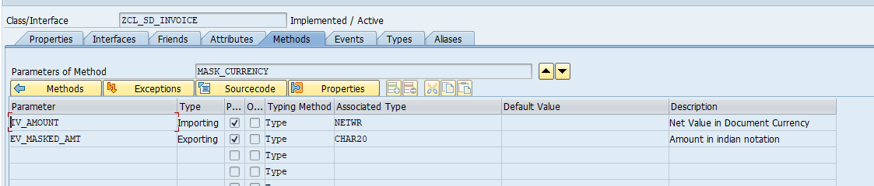

METHOD MASK_CURRENCY.
*----------------------------------------------------------------------*
* Program : Updates Tables ( ) Process data ( )
* Outputs List ( ) Validation ( )
*
* Module : SD
* WRICEF Object Id : SD_DV020
* Functional Specifications : FS_SD_DV020_SALES_INVOCIE
* Technical Spec No : TS_SD_DV020_SALES_INVOCIE
* Functional Consultant : Parul Singh
* Date Created (dd-mm-yyyy) : 01-12-2024
* Technical Consultant : Pravesh Patil
* Client : upGrad
* Project Name : upGrad
* Company : TechWit Business Solutions
*---------------------------------------------------------------------*
DATA : LV_AMOUNT TYPE CHAR20,
LV_MASK TYPE CHAR25.
LV_AMOUNT = IV_AMOUNT.
SPLIT LV_AMOUNT AT '.' INTO DATA(LV_NUMBER) DATA(LV_DEC) .
CONDENSE:LV_DEC, LV_NUMBER, LV_AMOUNT.
DATA(LV_LEN) = STRLEN( LV_NUMBER ).
LV_MASK = SWITCH #( LV_LEN
WHEN 12
THEN | { LV_AMOUNT+0(1) },{ LV_AMOUNT+1(2) },{ LV_AMOUNT+3(2) },{ LV_AMOUNT+5(2) },{ LV_AMOUNT+7(2) },{ LV_AMOUNT+9(3) }.{ LV_AMOUNT+13(2) } |
WHEN 11
THEN | { LV_AMOUNT+0(2) },{ LV_AMOUNT+2(2) },{ LV_AMOUNT+4(2) },{ LV_AMOUNT+6(2) },{ LV_AMOUNT+8(3) }.{ LV_AMOUNT+12(2) } |
WHEN 10
THEN | { LV_AMOUNT+0(1) },{ LV_AMOUNT+1(2) },{ LV_AMOUNT+3(2) },{ LV_AMOUNT+5(2) },{ LV_AMOUNT+7(3) }.{ LV_AMOUNT+11(2) } |
WHEN 9
THEN | { LV_AMOUNT+0(2) },{ LV_AMOUNT+2(2) },{ LV_AMOUNT+4(2) },{ LV_AMOUNT+6(3) }.{ LV_AMOUNT+10(2) } |
WHEN 8
THEN | { LV_AMOUNT+0(1) },{ LV_AMOUNT+1(2) },{ LV_AMOUNT+3(2) },{ LV_AMOUNT+5(3) }.{ LV_AMOUNT+9(2) } |
WHEN 7
THEN | { LV_AMOUNT+0(2) },{ LV_AMOUNT+2(2) },{ LV_AMOUNT+4(3) }.{ LV_AMOUNT+8(2) } |
WHEN 6
THEN | { LV_AMOUNT+0(1) },{ LV_AMOUNT+1(2) },{ LV_AMOUNT+3(3) }.{ LV_AMOUNT+7(2) } |
WHEN 5
THEN | { LV_AMOUNT+0(2) },{ LV_AMOUNT+2(3) }.{ LV_AMOUNT+6(2) } |
WHEN 4
THEN | { LV_AMOUNT+0(1) },{ LV_AMOUNT+1(3) }.{ LV_AMOUNT+5(2) } |
WHEN 3
THEN | { LV_AMOUNT+0(3) }.{ LV_AMOUNT+4(2) } |
WHEN 2
THEN | { LV_AMOUNT+0(2) }.{ LV_AMOUNT+3(2) } |
WHEN 1
THEN | { LV_AMOUNT+0(1) }.{ LV_AMOUNT+2(2) } |
WHEN 0
THEN | 0.{ LV_AMOUNT+0(2) } |
).
CONDENSE LV_MASK.
EV_MASKED_AMT = LV_MASK.
ENDMETHOD.

