A

B

C

D

E

F

|  |  |  |  |  |  |  |  |
| --- | --- | --- | --- | --- | --- | --- | --- |
| 1 | 2 | 3 | 4 | 5 | 6 | 7 | 8 |
|  |  |  |  |  |  |  |  |

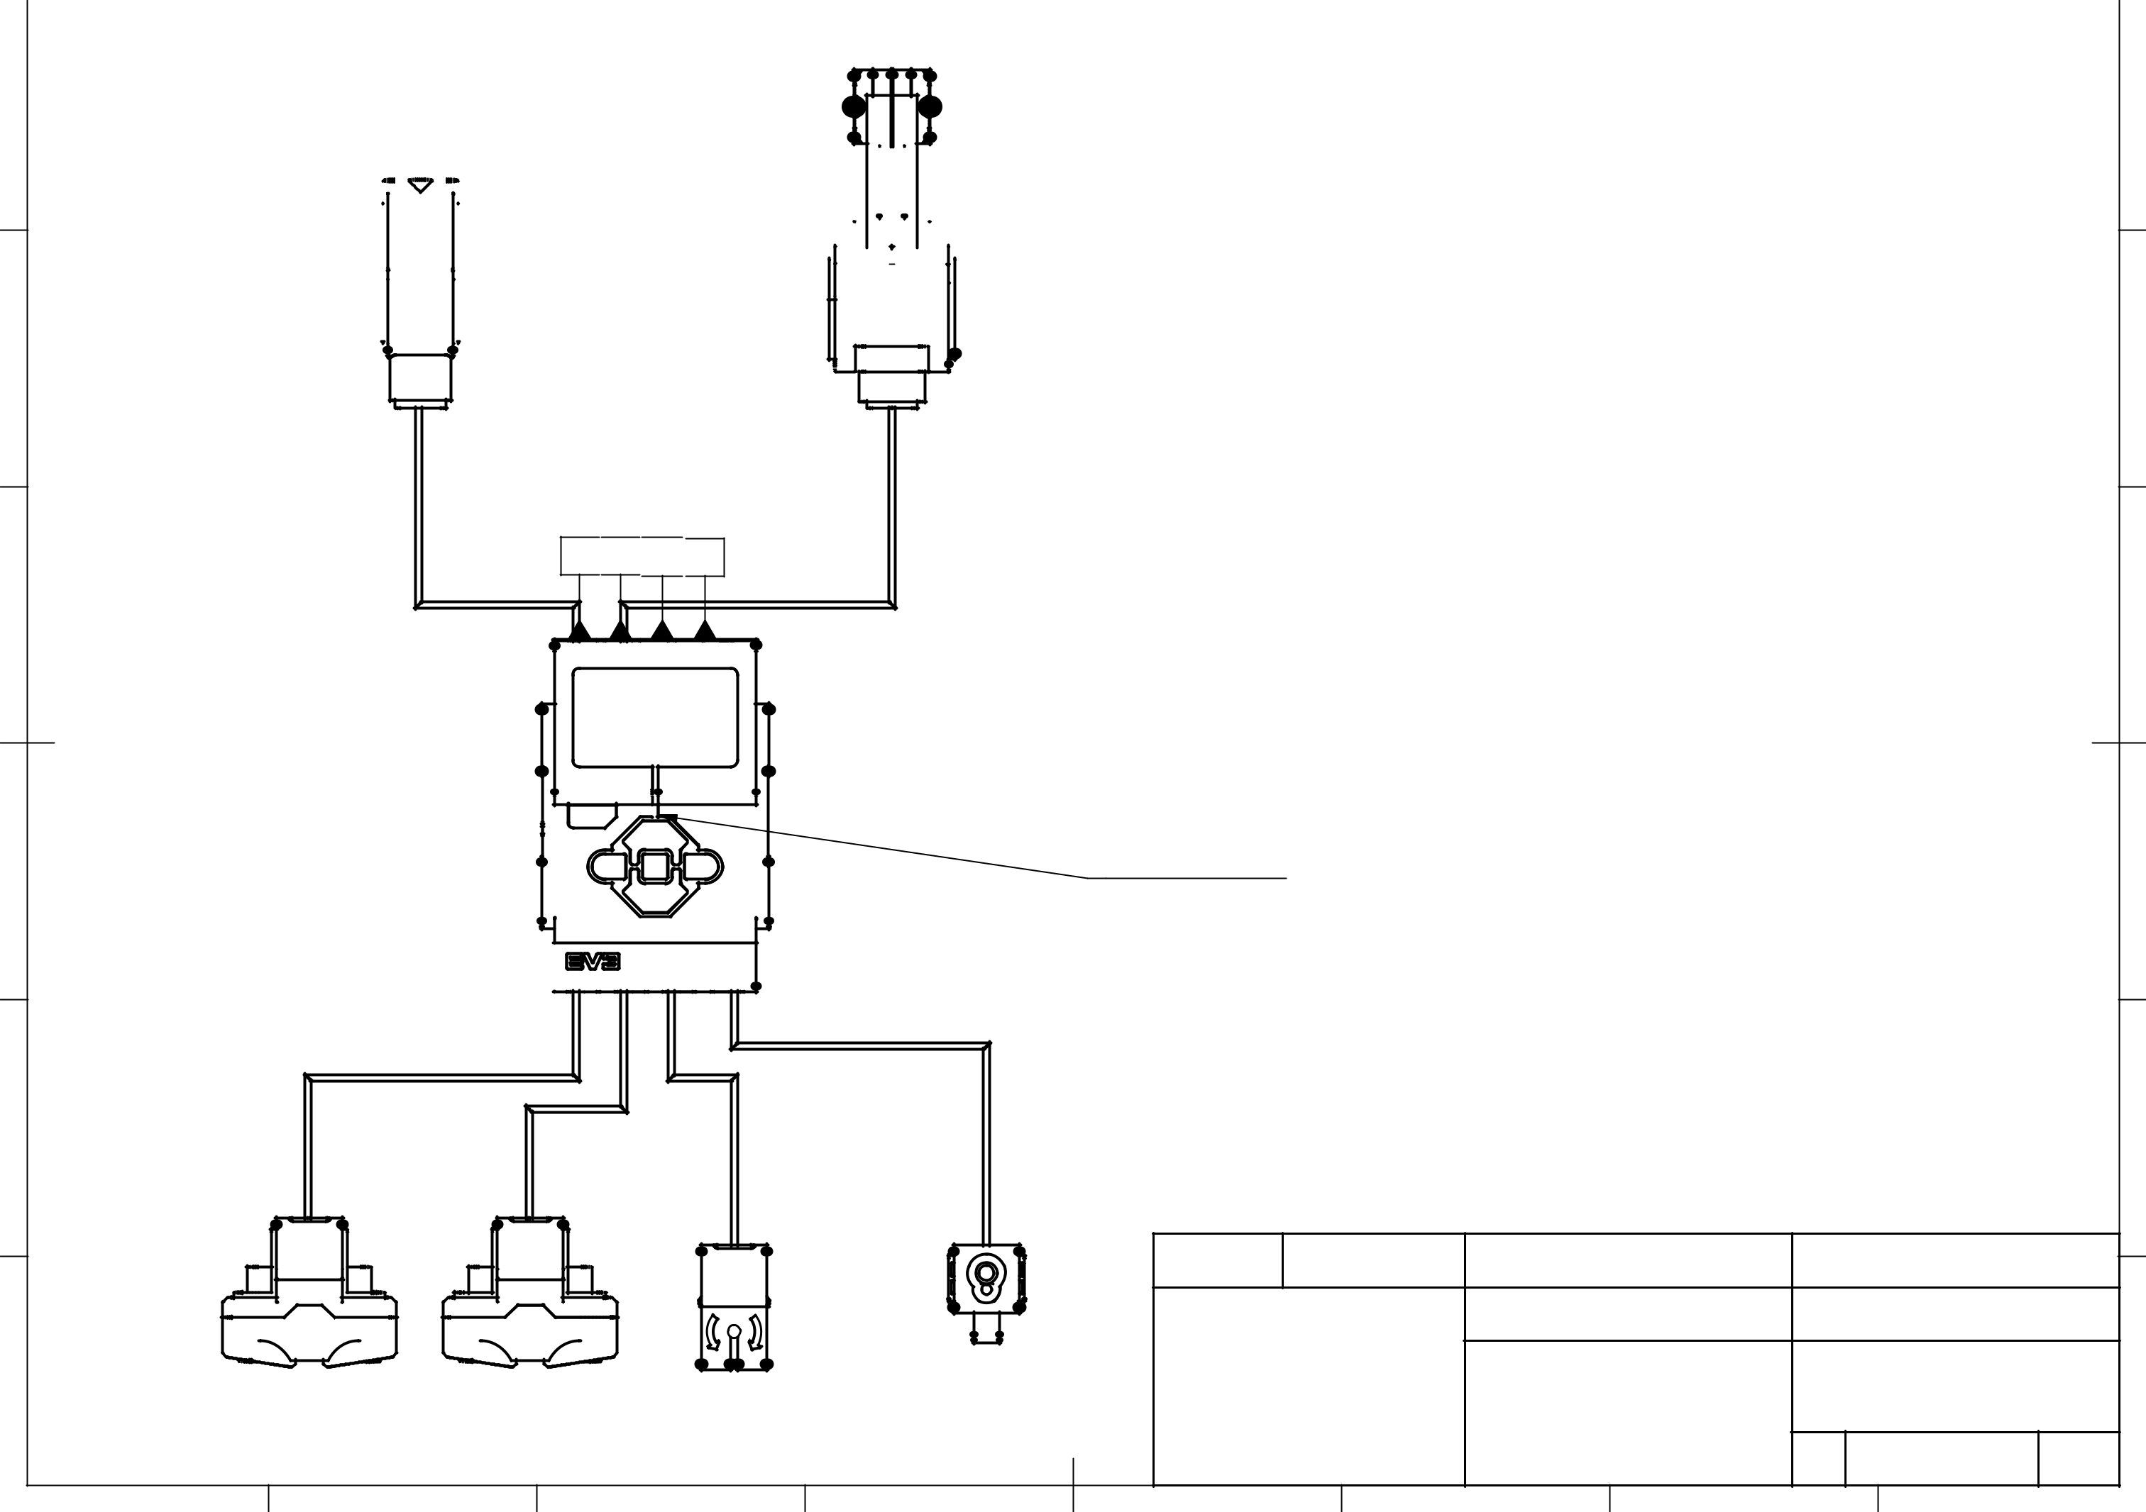

A

|  |  |  |  |  |  |  |  |  |  |  |  |  |  |  |  |  |  |  |  |  |  |  |  |
| --- | --- | --- | --- | --- | --- | --- | --- | --- | --- | --- | --- | --- | --- | --- | --- | --- | --- | --- | --- | --- | --- | --- | --- |
| Средний мотор |  |  |  |  |  |  |  |  |  |  |  |  |  |  |  |  |  |  |  |  |  | Большой мотор |  |
|  |  |  |  |  |  |  |  |  |  |  |  |  |  |  |  |  |  |  |  |  |  |
|  |  |  |  |  |  |  |  |  |  |  |  |  |  |  |  |  |  |  |  |  |  |
|  |  |  |  |  |  |  |  |  |  |  |  |  |  |  |  |  |  |  |  |  |  |
|  |  |  |  |  |  |  |  |  |  |  |  |  |  |  |  |  |  |  |  |  |  |
|  |  |  |  |  |  |  |  |  |  |  |  |  |
|  |  |  |  |  |  |  |  |  |  |  |  |  |  |  |  |  |  |  |
|  |  |  |  |  |  |
|  |  |  |  |  |  |  |  |  |  |  |  |  |  |  |  |  |  |  |  |  |  |  |  |
|  |  |  |  |  |  |  |  |  |  |  |  |  |  |  |  |  |  |  |  |  |  |  |  |

B

A  B  C  D

C

|  |  |
| --- | --- |
| EV3 - компьютер | D |

 1 2 3 4

E

|  |  |  |  |  |  |  |  |  |  |  |
| --- | --- | --- | --- | --- | --- | --- | --- | --- | --- | --- |
|  |  |  |  | Dept. | Technical reference | Created by |  | Approved by |  |  |
|  |  |  |  |  |  | Daulet / Adil 15/08/2022 | | Adil | 15/08/2022 |  |
|  |  |  |  |  |  | Document type |  | Document status |  |  |
|  |  |  |  |  |  |  |  | done |  |  |
|  |  |  | Датчик цвета |  |  | Title |  | DWG No. |  |  |
|  | Ультразвуковой Ультразвуковой | Гироскоп |  |  | circuit diagram |  |  | F |  |
|  |  |  |  |  |  |  |  |
|  |  |  |  |  |  | non-obstacles |  | Rev.Date of issue | Sheet |  |
|  |  |  |  | 5 |  |  |  | 15/08/2022 | 1/1 |  |
| 1 | 2 | 3 | 4 |  | 6 | 7 |  | 8 |  |