Andrew Stiles
CSD-340
4/6/2025
Assignment 3.2
HTML Validation:
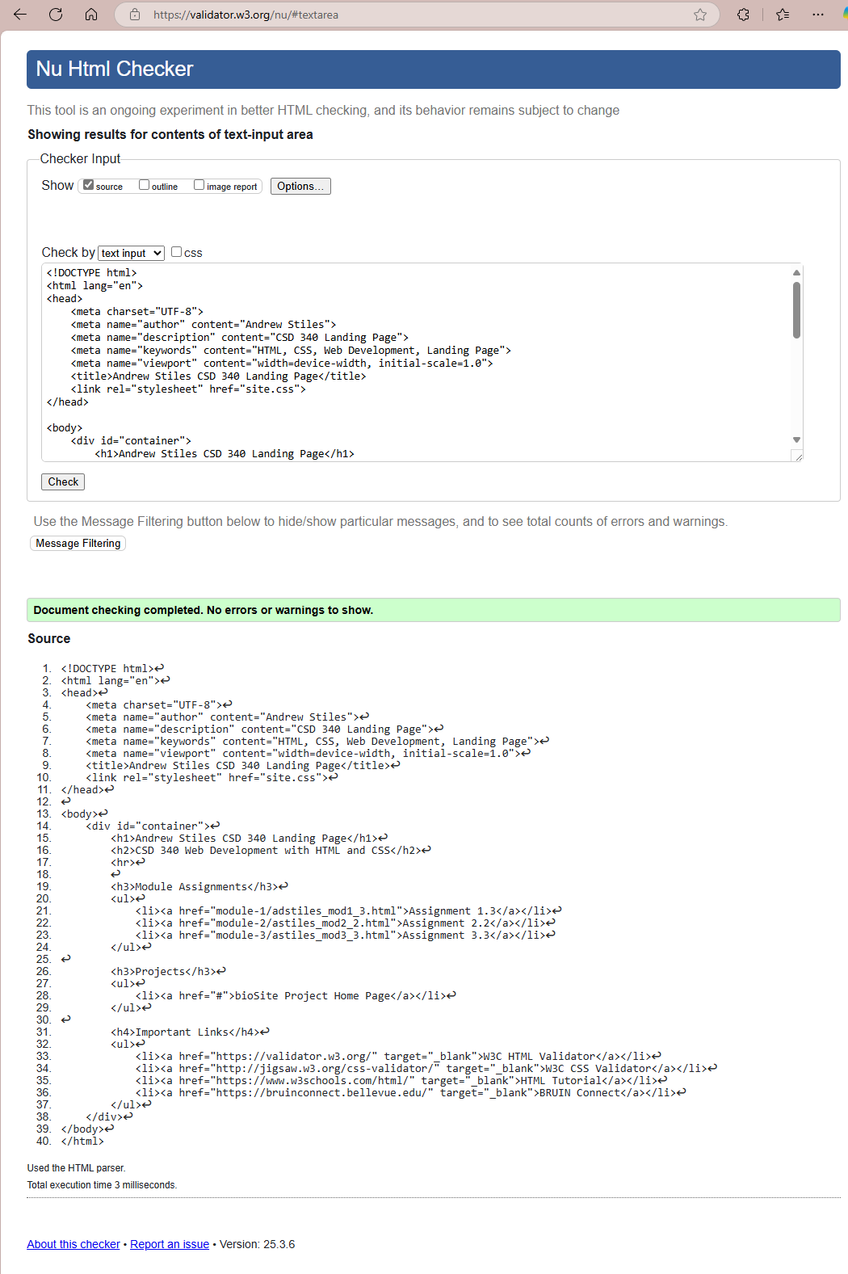
CSS Validation:
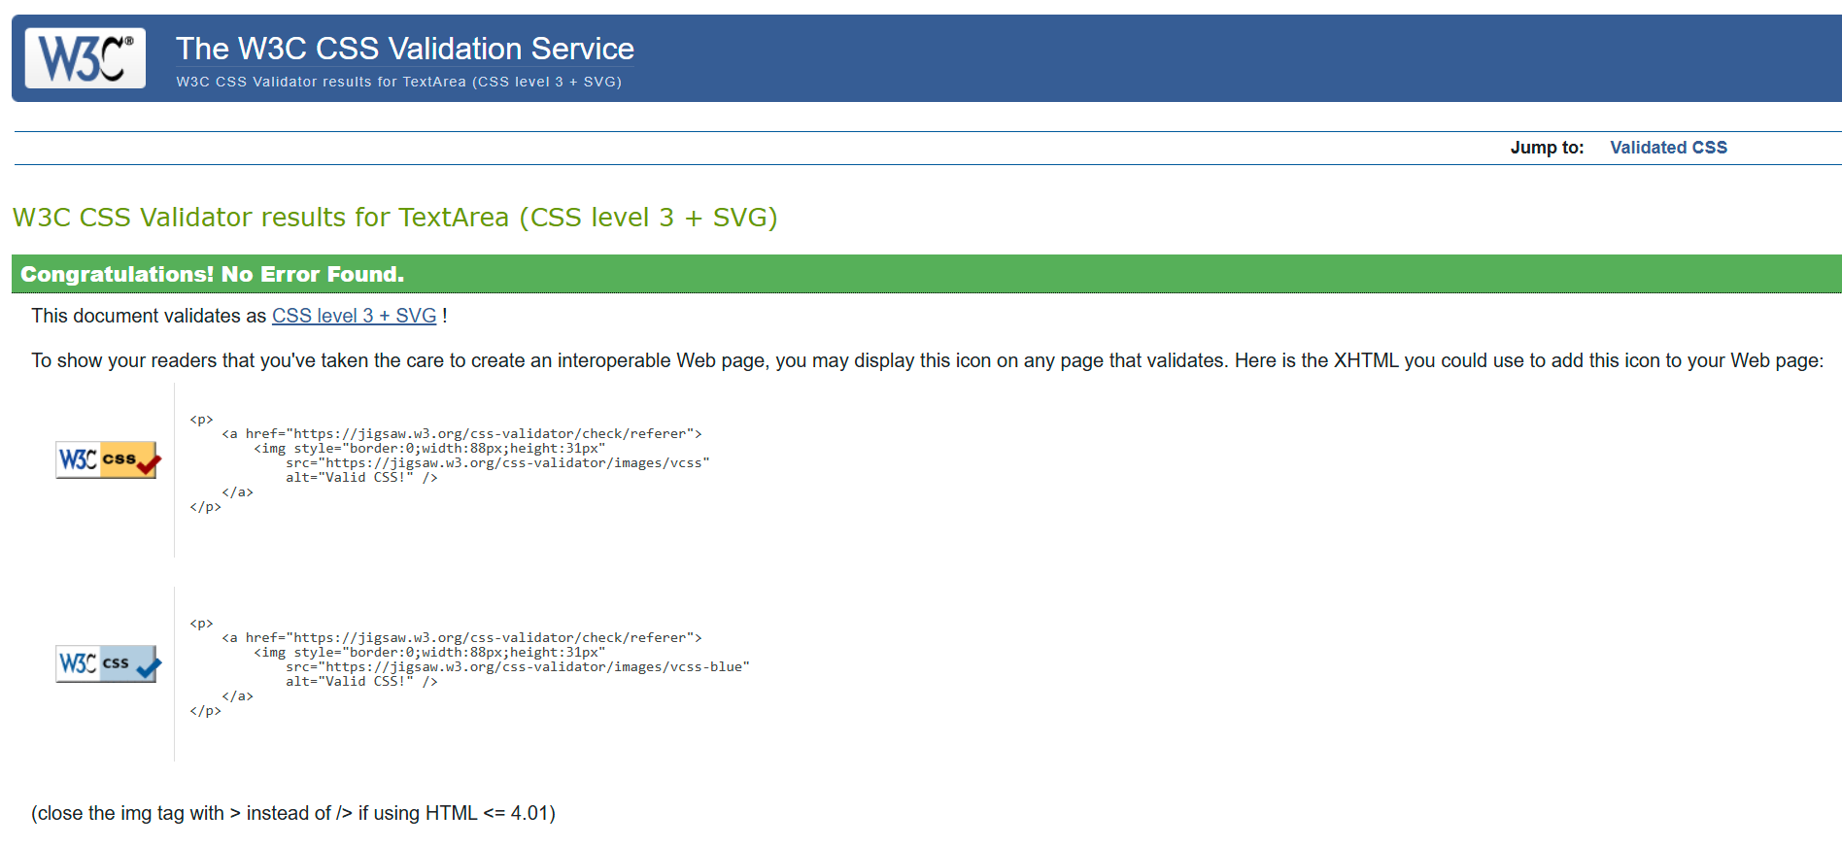

Index.html:
