Group 1 Moffat Bay Lodge Project Final Updates

Landing Page

Text is now larger and easier to read.


Header
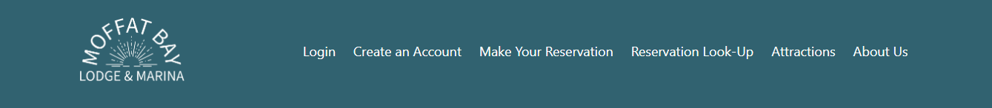
Tightened up the spacing


Create Account Page
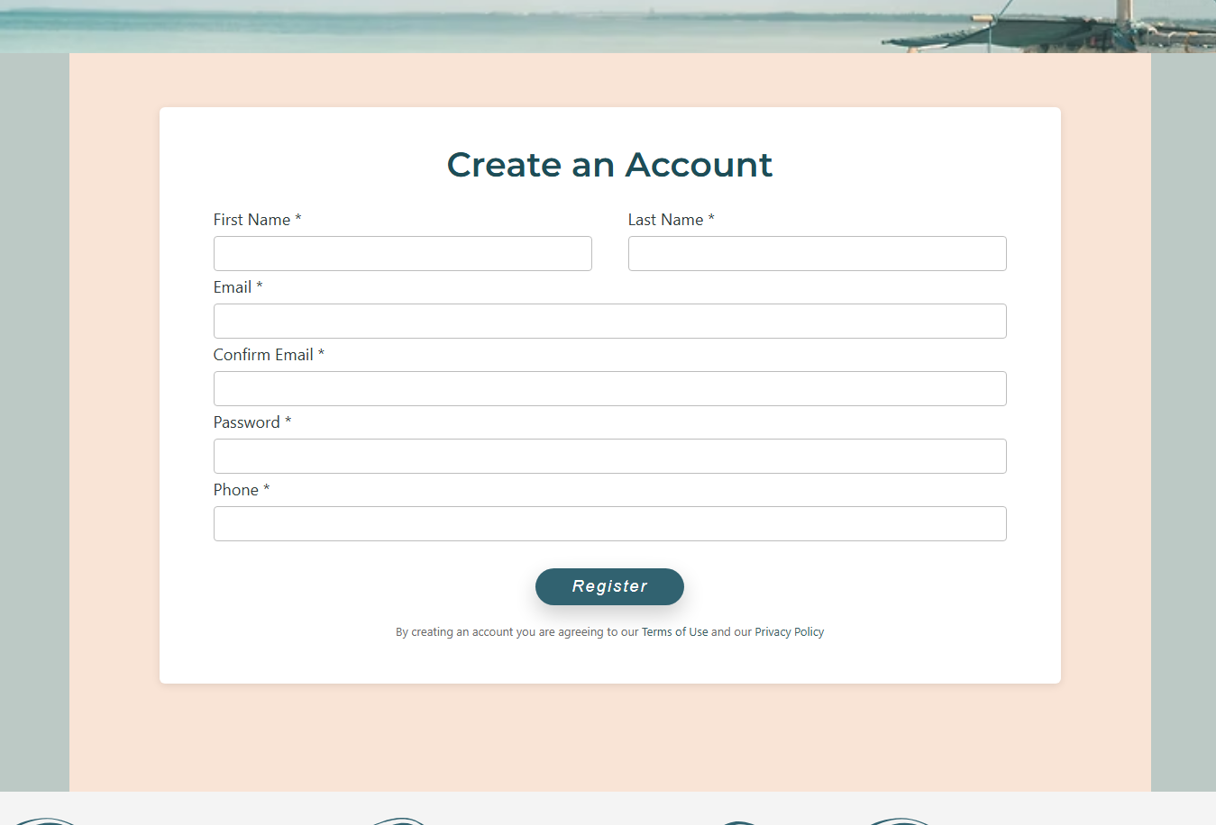
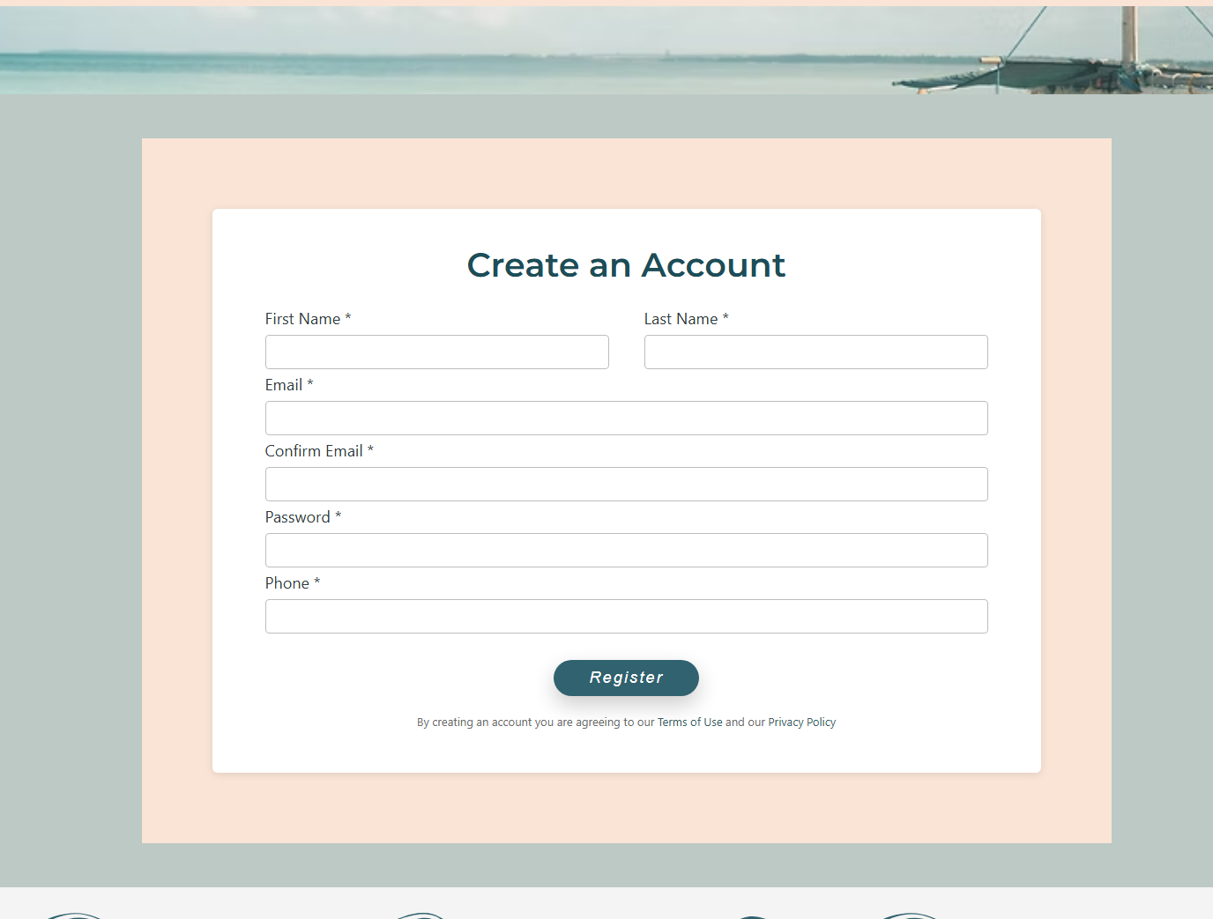
Look-up Reservation Page
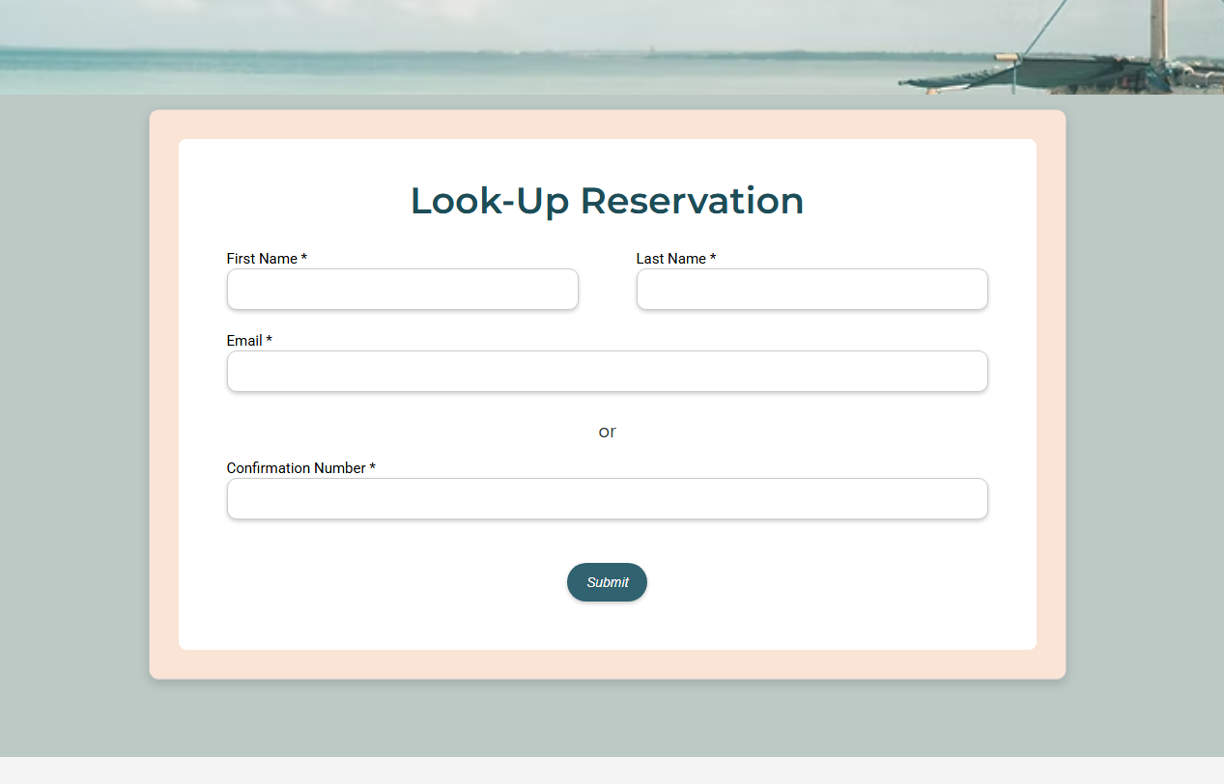
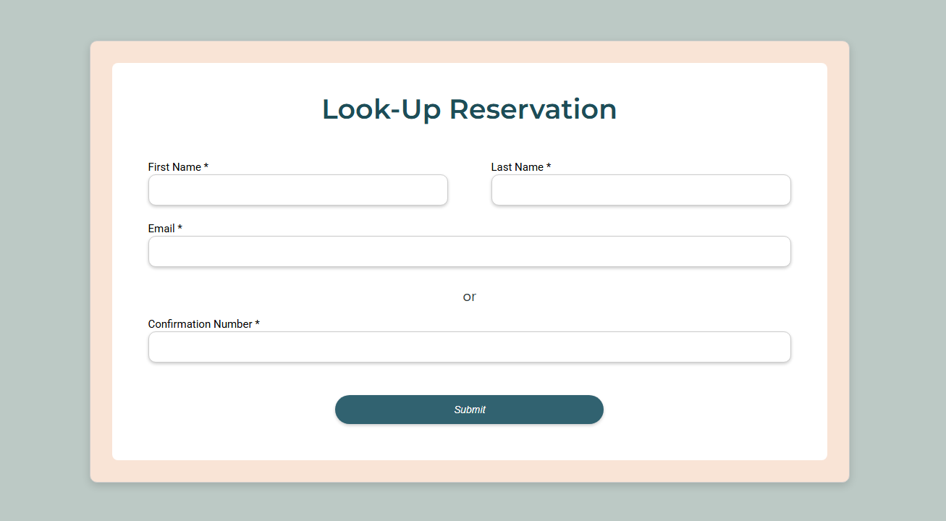

Create Account Page
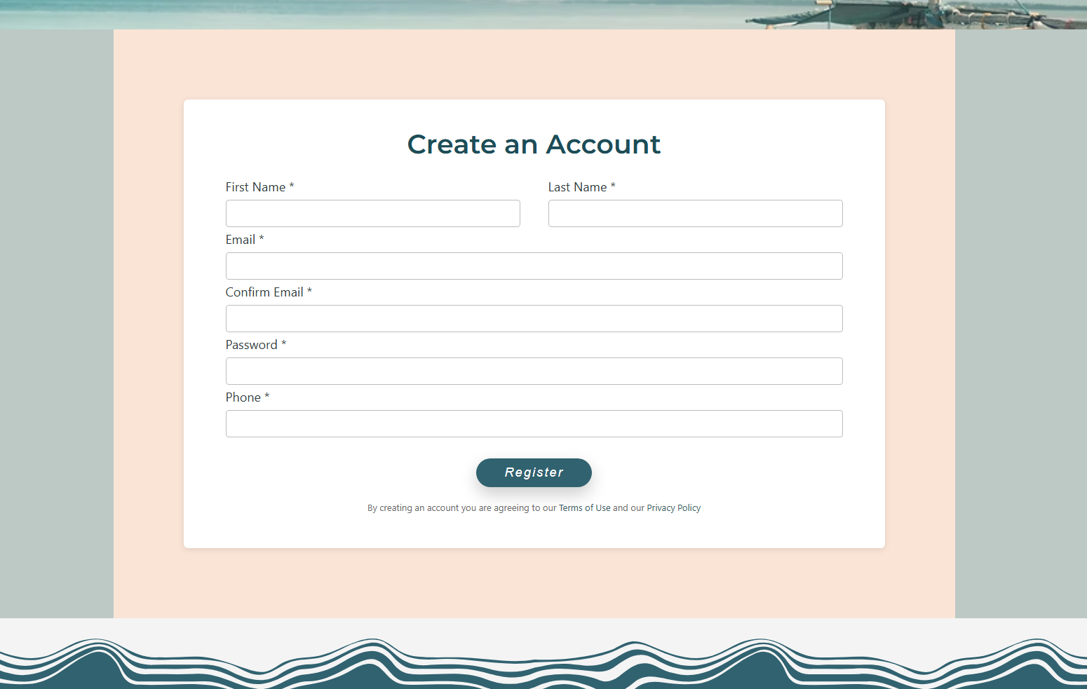
Buttons are now more uniform in size and style
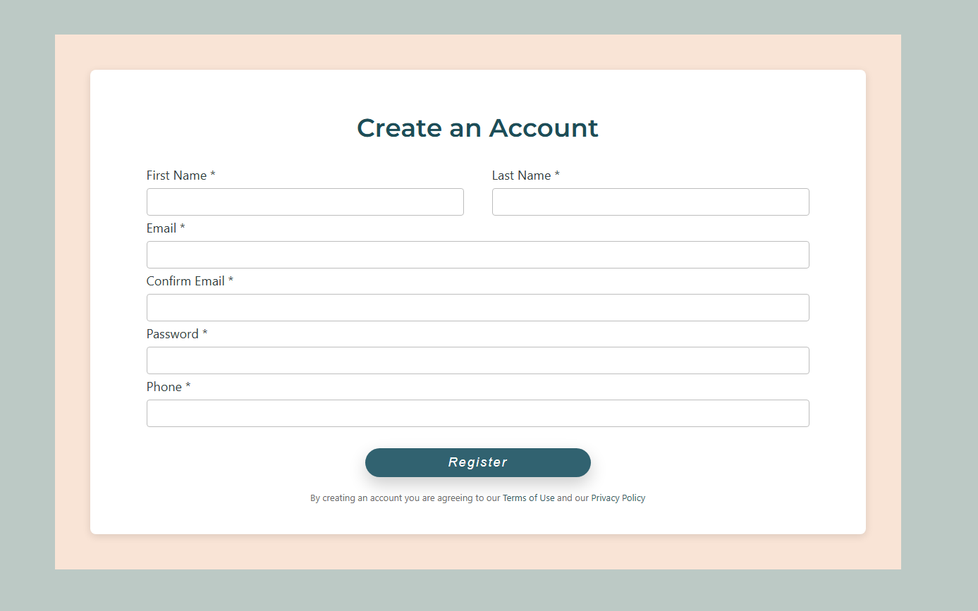

Coming Soon Page Update:
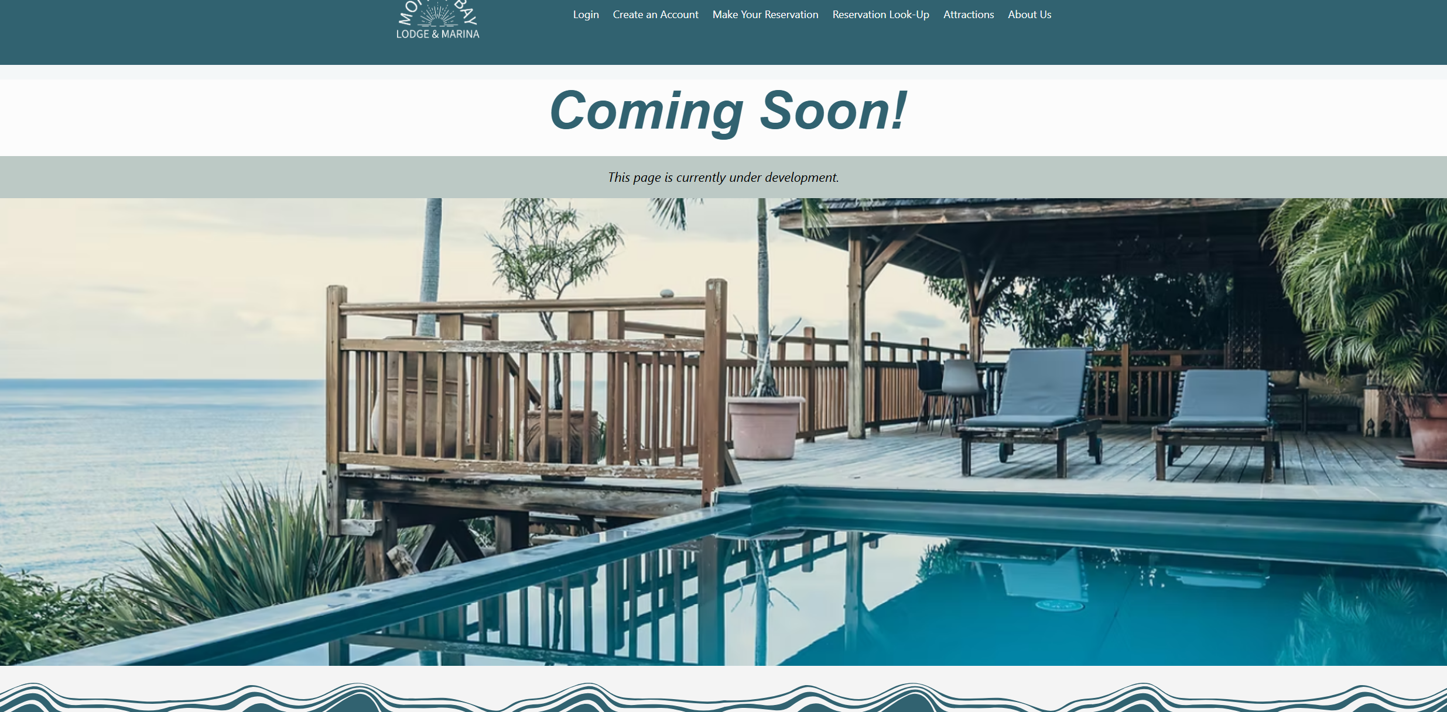

Reservation System Footer Issue Fix:
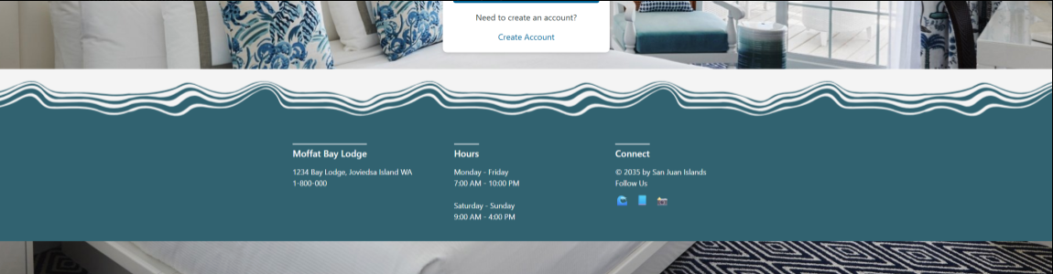
Footer Now Sticks to the Bottom of these pages
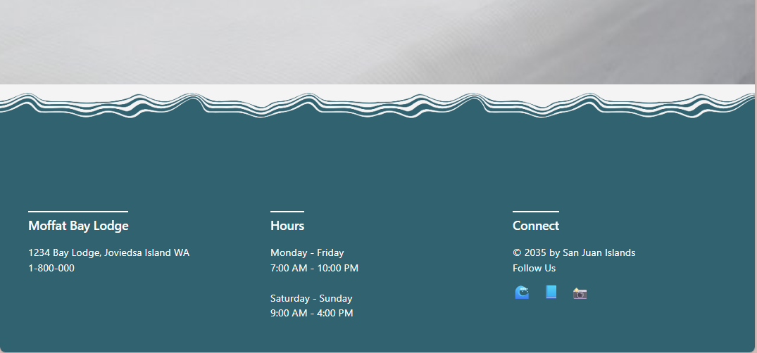
Reservation Cancellation Fix:
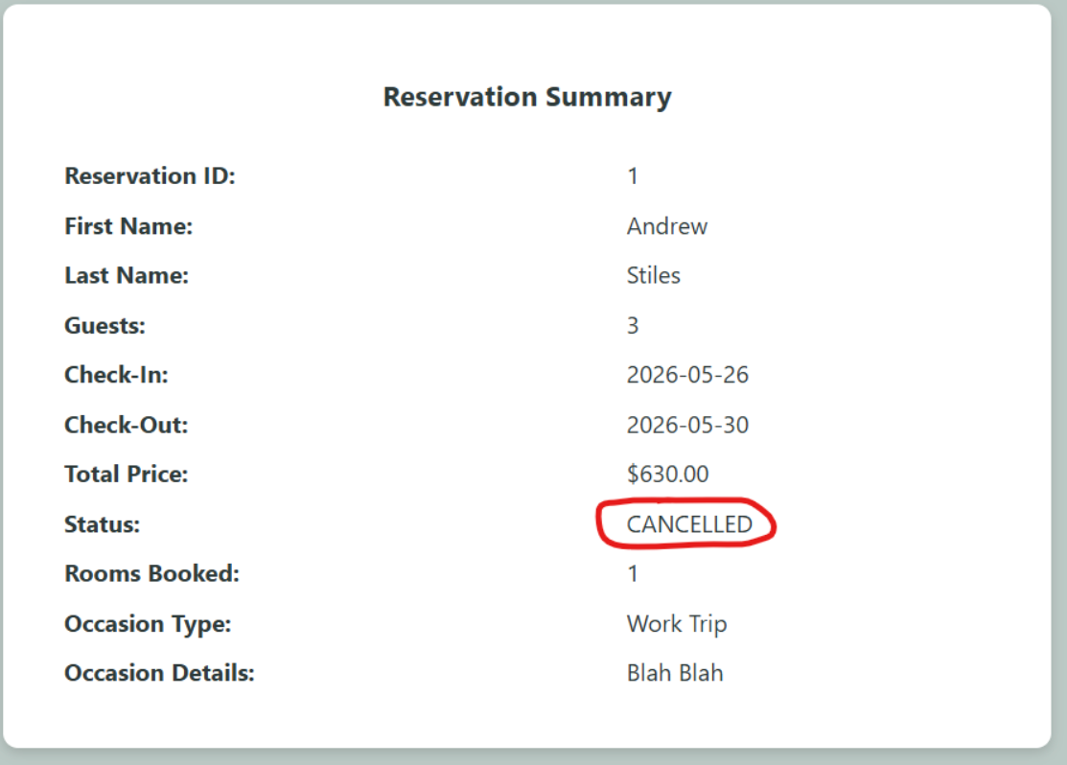
Both Reservation Cancellation buttons on the site no longer delete the reservation entry, but rather, they mark the reservation CANCELLED in the status area.

