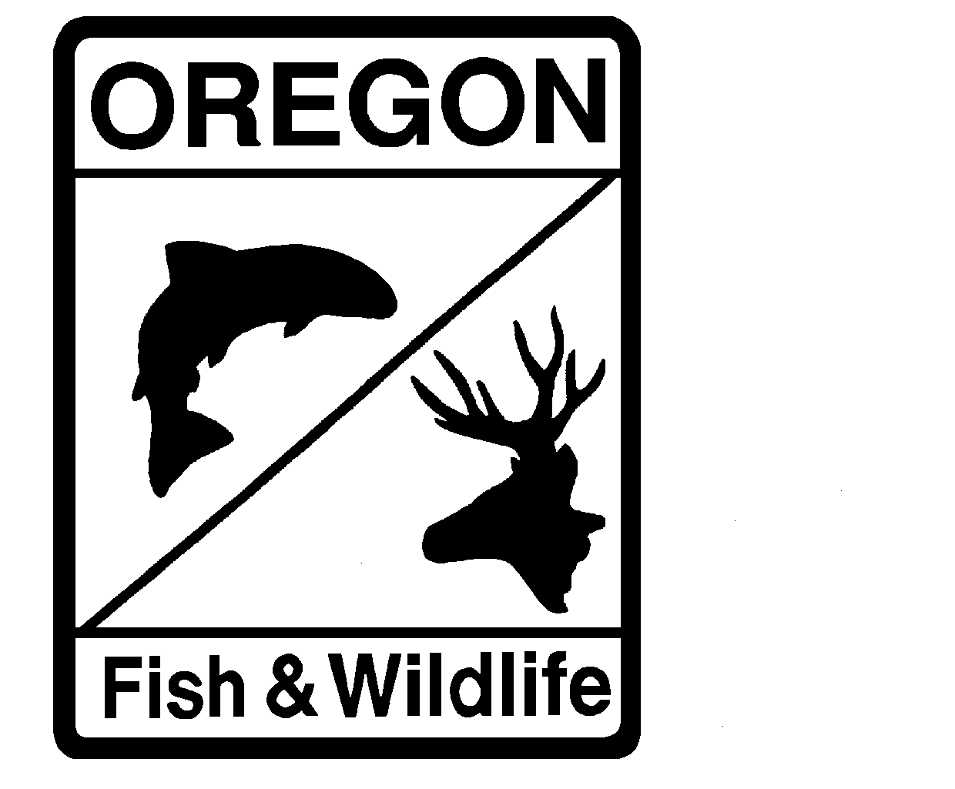

**MEMORANDUM**

**Department of Fish and Wildlife**

**Intra Departmental**

**Date:** December 7, 2022

**To:** Files

**From:** Adam Storch

**Subject:** 2022Willamette River Spring Chinook Run and 2023 Forecast

**Summary of 2022 Willamette River Spring Chinook Return**

The total Willamette River spring Chinook return to the Columbia River mouth during 2022 is estimated to be 57,317 fish (Table 1). An estimated 10,728 of these fish were unmarked (~19%). The 2022 total reconstructed return was approximately 108% of forecast. The Clackamas River component was approximately 151% of forecast, with 6,432 spring Chinook returning to the Clackamas River compared to 4,247 (95% credible interval: 2,479–7,291) fish expected.

The total return of adipose-fin-marked hatchery fish to the Columbia River mouth in 2022 is estimated to be 46,589, compared to 39,090 fish expected. Counts at the Willamette Falls fishway indicate that 31,937 fin-marked hatchery fish and 6,692 unmarked fish passed the fish ladder. The full reconstruction of the 2022 return is shown in Table 2.

Table 1. 2022 forecasted and reconstructed return of Willamette River spring Chinook to Columbia River mouth.



The forecast for 2022 assumed 26% of the return would be comprised of unmarked fish based on the mean percentage of unmarked fish seen in the 2017–2021 returns. The actual unmarked rate for the full 2022 return is estimated to have been approximately 19%.

Table 2. Preliminary summary of the 2022 Willamette River spring Chinook return.



**Forecasted Willamette River Spring Chinook Return for 2023**

**Projections for Age-3 fish returning in 2023**

The projected 2023 age-3 return was estimated as the product of the age-2 count at Willamette Falls in brood year 2020 and a cohort ratio predicted from a Bayesian implementation of a state-space model (i.e., Kalman Filter) where the process was a time-varying intercept for the linear regression of the logarithm of age-3 Columbia River return:age-2 Willamette Falls counts versus the logarithm of age-2 Willamette Falls counts. This approach produced an prediction of 1,974 (95% credible interval: 973–3,052) Age-3 fish returning to the Columbia River mouth.

**Projections for Age-4 fish returning in 2023**

Of the suite of models considered to predict the number age-4 Willamette River spring Chinook returning to the mouth of the Columbia River, the best supported was a state-space formulation of the linear regression of the logarithm of age-4 returns to the Columbia River mouth versus the logarithm of age-3 returns to the Columbia River mouth and an ocean productivity metric (i.e., the ranking of NOAA ocean ecosystem indicators). In this application, the state or unobserved processes included a time-varying intercept and a time-varying slope for the age-3 predictor. The model predicts 52,010 (95% credible interval: 2,5310–80,370) Age-4 fish returning to the Columbia River mouth in 2023.

**Projections of Age-5 fish returning in 2023**

The best supported model predicting age-5 returns of Willamette River spring Chinook to the Columbia River mouth in 2023 was again a state-space parameterization of the linear regression of the logarithm of age-5 returns versus the logarithm of age-4 returns, spring PDO (mean of May–August), spring transition date, and index of ichthyoplankton biomass and an index of copepod richness where the state process was a time-varying intercept. This model projects a 2023 age-5 return to the Columbia River mouth of 18,926 (95% credible interval: 6,226 –34,180).

**Projections for Age-6 fish returning in 2023**

The projection for age-6 Willamette River spring Chinook returning to the Columbia River mouth in 2023 is 109 (95% credible interval: 0–381), estimated based on the running 5-year average age-6:age-5 cohort ratio.

**2023 Clackamas River Forecasted Return**

The best performing model predicting the total Clackamas River return applied the Kalman Filter method, where the state process was a time-varying intercept for the linear regression of the logarithm of the total return size versus of the sum of the prior two year’s jack (age-3) returns. This produced a forecasted return of 6,604 (95% credible interval: 3,424–10,340) spring Chinook to the mouth of the Clackamas River.

**2023 Forecast Summary**

Table 3. 2023 projected Willamette basin (Clackamas included) spring Chinook return to Columbia River mouth and 95% credible intervals (95% CrI).



The 2022 return included an estimated 19% unmarked fish. Using the most recent five-year average of unmarked fish (~25%), the total number of hatchery fish returning to the Columbia River mouth in 2023 is forecasted to be 54,620 (Table 4).

Table 4. 2023 projected Willamette basin (Clackamas included) spring Chinook **hatchery** fish return to Columbia River mouth and hatchery proportions of the 95% credible intervals (95% CrI) calculated for estimates of the total return (Table 3).



**Hatchery Surplus Estimates**

The harvestable surplus of the 2023 return of hatchery fish is calculated by subtracting the hatchery fish escapement goals specified in the Willamette River Spring Chinook Fisheries Management and Evaluation Plan (FMEP) from the total forecasted hatchery component of the return. Based on the FMEP, at a total hatchery-fish run size of 54,620 fish, the escapement goals for Willamette Falls and the Clackamas River are 24,000 and 3,600 fish, respectively. This results in a harvestable surplus of 27,020 fish. Per the allocation schedule included in the FMEP, 76% of this surplus is to be allocated to recreational fisheries and 24% is to be allocated to commercial fisheries.