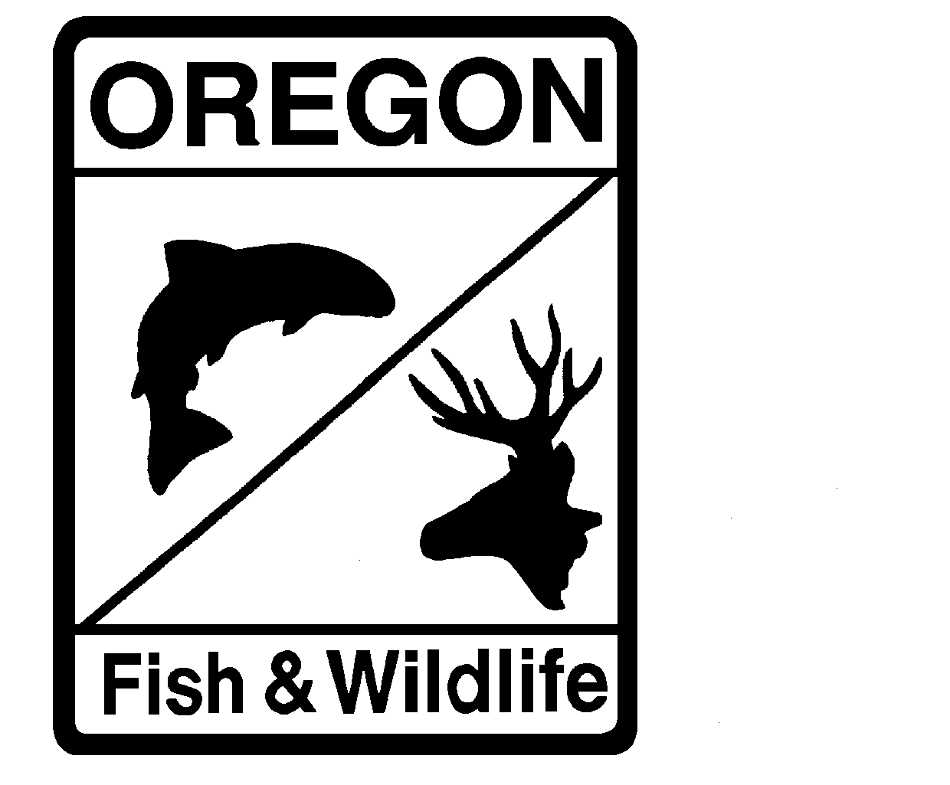

**MEMORANDUM**

**Department of Fish and Wildlife**

**Intra Departmental**

**Date:** January 26, 2023

**To:** Files

**From:** Adam Storch

**Subject:** Revisions to Willamette spring Chinook Salmon prediction model

**Introduction**

Since 2015, I have been updating periodically age-specific models to project (t+1) return abundance of Willamette spring Chinook to the Columbia River Mouth. This has resulted in four models representing each age-class (age-3–age-6). While the models for each age-class may be parameterized differently, they have all been formulated in a similar framework (i.e., Bayesian implementation in JAGS). Previously (through 2023 projections), models have been run separately and adult (age-4–age-6) and total (age-3–age-6) predictions have been generated by summing the components (without credible intervals specific to that sum). Recently, I have developed a more-or-less “unified” model where each component is estimated (with error), and the sum of the components, whether representing total Chinook or adult Chinook, are modeled, and thus credible intervals for those prediction are generated.

In 2021, John requested I examine alternative means to project non-clipped rates to be applied to predict hatchery returns in any return year t+1. Since I began this modeling exercise in 2015, we have adjusted total (predicted) returns by the five-year running average of reconstructed non-clipped rates. Particularly in recent years, this has overpredicted non-clipped rates. To try to overcome this error, I examined the predictive performance of four different classes of time series model: (1) the five-year running mean, (2) a random walk model (essentially ascribing the non-clipped rate from year t to year t+1), (4) a first order auto-regressive model, and (4) a univariate state-space model (where parameters are allowed to vary with time steps). As you can see from the figure below, the predictive performance (difference between reconstructed [black lines] and predicted [blue dots] non-clipped rates) was comparable among the five-year running mean and the AR(1) model and among the random walk and state-space models. The latter two did, however, seem much better at picking-up variation in the reconstructed values (error/residuals appeared much lower). As such, I have incorporated the state-space parameterization into the “unified” model described above. In addition to providing a hopefully better annual prediction of hatchery returns in any given year, this should allow us to better estimate uncertainty.

